Critical Evaluation of Non-Traditional Machining Equipment for Manufacturing Industry

BEng Engineering

Mechanical Engineering

Advanced Processes and Materials

M6X00414

Tristan Quilter

P143454

​Submitted: 16/03/18

Table of Contents
Table of Contents 2
Table of Figures 3
1. Introduction 4
2. The Component 5
2.1. Assumptions 5
3. Traditional Methods 7
3.1. CNC Die Cutting 7
Process 7
Advantages 7
Disadvantages 7
4. Non-Traditional Methods 8
4.1. Water Jet Cutting 8
Process 8
Advantages 8
Disadvantages 8
4.2. Artificial Intelligence CNC Die Cutting 8
Process 8
Advantages 8
Disadvantages 8
5. Argument 9
5.1. Water Jet Cutting Versus CNC Die Cutting 9
5.2. AI CNC Die Cutting Versus CNC Die Cutting 9
Pros of Using AI in Die Cutting 9
Cost and Draw Backs of Using AI 9
6. Conclusion 10
7. Bibliography 11

Table of Figures
Figure 1 – Custom Gasket (Alexander, 2018) 5
Figure 2 – Triple Clamp (R-dubb, 2007) 5

Introduction
This report will investigate non-traditional methods of manufacturing components from a bicycle. The chosen component is a custom gasket. The gasket is designed to contain fluid within the forks on a bicycle.
The background of the component and its manufacturing method will be discussed. As well as viable non-traditional methods to manufacture the same component. The two suggested non-traditional methods will be compared to the traditional method for pros and cons. A conclusion will be given describing the possible outcomes and recommendations for future steps to be taken.

The Component

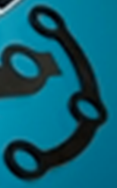
Figure 1 – Custom Gasket (Alexander, 2018)
As seen in Figure 1 a custom gasket is being manufactured using traditional methods. Assuming this component given the other components in the image, it belongs to a bicycle fork system. This component being a gasket to contain fluid within the forks. This sits between a lower triple clamp and the forks themselves.

Assumptions
As specifications for this component are not given. All assumptions are based on that this is a gasket for a fork assembly for a bicycle. A few assumptions are being made as follows:
- Component size
The component will need to be manufactured to the following engineering drawing.(R-dubb, 2007 #1)(R-dubb, 2007 #1)(R-dubb, 2007 #1)(R-dubb, 2007 #1)(R-dubb, 2007 #1)
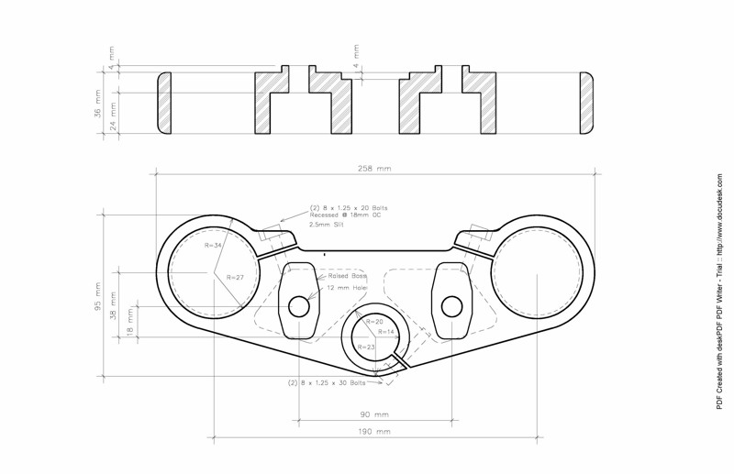
Figure 2 – Triple Clamp (R-dubb, 2007)(R-dubb, 2007 #1)(R-dubb, 2007 #1)(R-dubb, 2007 #1){R-dubb, 2007 #1}
- Component material
Gaskets need to be compressible and can be made from rubbers or cork. This component is usually made from rubber. Therefore, it is assumed this component is made from rubber.
- Current volume being produced
Mass production is being assumed as the investment in non-traditional methods would not be profitable for lower production.

Traditional Methods
The component is manufactured using the following method.

CNC Die Cutting

Process
Using a press and cutters, by simple force the desired shape can be made by pressing downwards into the material. (Atom, 2016)
A tool is manufactured to cut rubber to give the desired end shape. This cutter is forced downwards and cuts the component out of a sheet of rubber.

Advantages
Die cutting can produce components very quickly. All components will be identical due to the same cutter being used.
There are no secondary processes necessary to make any alterations to the components as they are the specified shape and size after leaving the cutter.
Same machine can be used even if the cutting tool is changed.

Disadvantages
Die cutting can put stress in the component as the force pulls the material to breaking point. This would leave stressed areas near cuts. It can also cause additional material to be taken out that was not intended.
Die cutting can also lead to a lot of waste material due to the material coming in sheet form. Even with a CNC swivel head to increase number of components per sheet, there is still waste.
If design is changed a new tool will need to be fabricated.

Non-Traditional Methods
Non-traditional methods for manufacturing the component needs to meet the following categories to achieve the same results:
- Geometry matching
- Separate holes
- Cutting through rubber

Water Jet Cutting

Process
Water jet cutting uses high press water (60,000 – 90,000 psi (Fairchold, n.d.)), through a small nozzle to cut through material.

Advantages
- No heat affected zones (Fairchold, n.d.)
- Can cut through thick, hard materials
- Quicker compared to certain types of cutting
- Average running costs of £15-£20p/h (WardJet, 2018){WardJet, 2018 #2}

Disadvantages
- Slow compared to certain types of cutting
- When cutting thicker material the water jet can wander from the centre axis (EduPack, 2018)

Artificial Intelligence CNC Die Cutting

Process
AI CNC Die Cutting implements the same procedures of die cutting but uses AI to allow for better efficiency. Efficiency can optimise any of the following:
- Material wastage (Jinjiang Wang, 2018)
- Energy efficiency (Jinjiang Wang, 2018)
- Operation speed (Jinjiang Wang, 2018)
- Tool wear (Jinjiang Wang, 2018)
Not all the above can be achieved at the same time, rather each can be achieved but with a compromise between them. For example, operation speed and tool wear cannot be achieved at the same time, a trade of must be made between them. Artificial intelligence can find the balance between these, leaning towards any desired output.

Advantages
- Artificial intelligence is versatile, it can find improvements where other methods could not. It can also gain vast experience within a short period of time.
- Can be implemented with pre-existing machines and tools.
- Up to 82% efficiency improvements (Jinjiang Wang, 2018)(Jinjiang Wang, 2018 #3)(Jinjiang Wang, 2018 #3)(Jinjiang Wang, 2018 #3)

Disadvantages
- Costly set-up
- Mechanical damage can occur trying to perform a theoretical solution if not set-up correctly (Future of Life Institute, 2016)

Argument

Water Jet Cutting Versus CNC Die Cutting
Water jet cutting could be used with multiple sheets of rubber stacked on top of each other. This would combat the speed disadvantage water jet cutting has against CNC die cutting.

Pros of Using Water Jet Cutting in Die Cutting
Water jet cutting would provide cleaner cuts to the gasket

Cost and Draw Backs of Using Water Jet Cutting
Two main draw backs are as follows:
- Not all parts would be identical
  - As sheets are stacked on top of each other the lower sheets would not be the same as higher sheets due to wander of the water during cutting
- Water could affect the rubber and cause swelling

AI CNC Die Cutting Versus CNC Die Cutting
Die cutting is a simplistic and effective way to manufacture gaskets. However artificial intelligence can be used to help improve the effectiveness of the existing die cutting process.

Pros of Using AI in Die Cutting
If AI was implemented the following could be achieved:
- Greater number of components per sheet
  - Resulting in less waste
- Less energy required
  - Exact amount of force can be calculated per punch, rather than always over punching.
  - The most energy efficient path of cutting can be found to reduce energy amongst the whole system
- Longer tool life

Cost and Draw Backs of Using AI
AI is expensive to set up and programme. The maintenance of AI is only the components of the computer which is low.
If the original programme does not have enough fail safes the AI can cause extreme damage to the CNC die cutter. As it may try to perform a theoretical possible task but when implemented is not physically possible. This may lead to damage of the CNC die cutter.

Conclusion
In conclusion Artificial intelligence would be more beneficial over water jet cutting. Therefore, if Artificial Intelligence implemented on a CNC die cutter would result in a more efficient machine. However, if this is implemented have the programming done by a trusted source. Express concern for fail safes and ensure programming is done to the best standards.
If this is done the CNC die cutter can see up to 82% combined efficiency.

Bibliography
Alexander, R. (2018). Critical evaluation of non-traditional machining equipment for the manufacturing industry. University of Wales Trinity Saint David.
Atom. (2016). Automatic CNC die cutting press. Retrieved from Atom CNC: http://atom-uk.com/automatic-cnc-die-cutting-press/
EduPack, C. (2018).
Fairchold, R. (n.d.). Water Jet: No Heat Addected Zone. Retrieved from http://www.cuttingedgewaterjet.com
Future of Life Institute. (2016). Benefits & Risks of Artificial Intelligence. Retrieved March 8, 2018, from Future of life institute: https://futureoflife.org/background/benefits-risks-of-artificial-intelligence/
Jinjiang Wang, Y. M. (2018, January). Deep learning for smart manufacturing: Methods and applications. Journal of Manufacturing Systems, 13.
R-dubb. (2007). Air Head Triple clamp. San Fransico. Retrieved March 9, 2018, from http://advrider.com/index.php?threads/airhead-triple-clamp-group-buy.216212/
WardJet. (2018). Cost to Run a Waterjet. Retrieved March 15, 2018, from Wardjet: https://wardjet.com/waterjet/cost-to-run-a-waterjet

