Event Strategic Planning and Delivery Considerations for an International Meeting

Event Strategic Planning and Delivery Considerations for an International Meeting

Event – Technology and Innovation -Virtual Wellness in Hospitality

Student: Anca Mihaela Marian
Student ID: 2130340
Lecturer: Kathryn Flynn
Module: International Meetings Management BMIH6007

Executive Summary
The "Virtual Wellness in Hospitality" event, with the theme of Technology and Innovation, is planned to be a strategic step forward for the hospitality industry by bringing in the new virtual experiences that promote wellness and sustainable practices. This event moves forward from the starting feasibility analysis and concentrates on the strategic planning and implementation of the project. Major outcomes reveal the need to build the event's conceptual frame around the truth that the industry's trends go towards digital health solutions, especially due to the boost of demand for these kinds of products. This narrative provides a clear basis to support the robust digital infrastructure and compelling content delivery as key factors to improve participation and user satisfaction. The strategic method is developing the strategic partnerships with the technology vendors to use the cutting-edge utilities like virtual reality and AI, to make the virtual experience for all participants irrespective of their physical location seamless and powerful. This method not only holds certain industry trends now but also becomes a rule for those that will follow in the hospitality industry.
Table of Contents

Event - Innovation and Technology 6
1 Introduction 6
1.1 Event Description 6
1.2 Justification for Choice 6
1.3 Background 7
2 The Event Cycle 8
3 Event Concept 9
3.1 Event Details 9
4 Aim and Objectives of the Meeting / Event 11
5 Event Operations 11
6 Event Budget 12
7 Industry Trends / Issues / Impacts 13
7 .1 SWOT Analysis 14
7.2 PESTEL Analysis……………………………………………………………14
8 Cultural and Situational Considerations………………………………….14
8.1 Cultural Impact………………………………………………………… ……16
8.2 Situational Considerations 16
8.3 Relevance 16
9 Conclusion 17
10 References 19

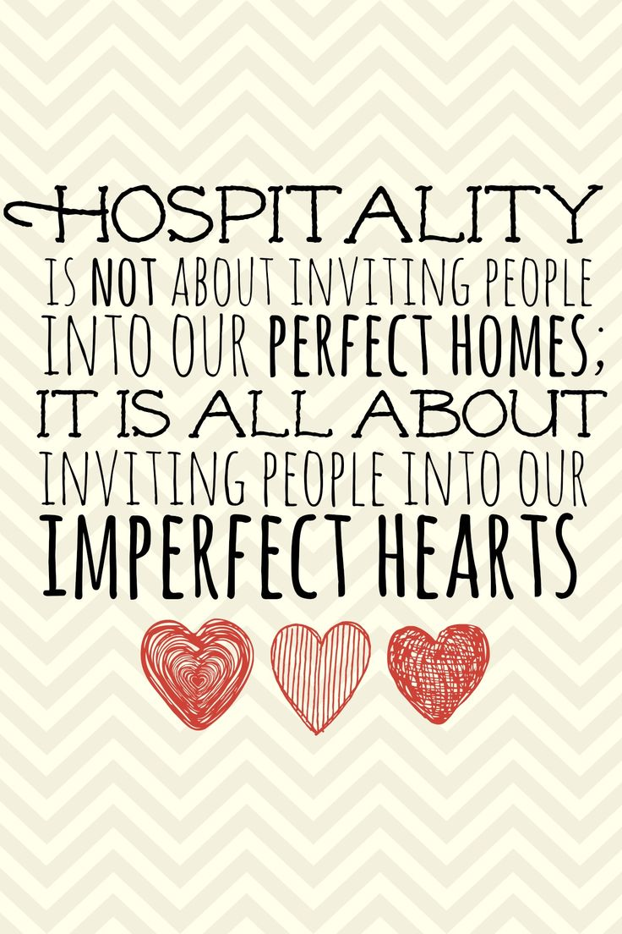
This Photo by Unknown Author is licensed under CC BY-NC

Event - Innovation and Technology

1 Introduction

1.1 Event Description
The "Virtual Wellness in Hospitality" event is a breakthrough project that integrates both well-being and hospitality immersive experiences that uses the latest technology to make them happen (De Lurdes Calisto and Sarkar, 2024). Anca Marian, a fitness enthusiast working in hospitality, and Rajat Verma, a senior wellness professional and business manager in the industry, have come together to create this groundbreaking event (Rajat Verma - Travelodge Hotels Limited, 2024). This innovative initiative combines wellness and advanced technology to elevate the guest experience in the hospitality sector. The project is scheduled to be exhibited at London Olympia, a location chosen for its rich history as the site of Hyrox fitness competitions, in which Anca is competing. With its prime location in central London and timing after the Hyrox fitness race on May 8th, 2024, the event is expected to draw in a larger than anticipated crowd (The home of inspirational events, 2024). Considering conversations with participant Anca, Hyrox's complete sponsorship of the event showcases their strategic dedication to advancing groundbreaking wellness solutions within the hospitality sector. The "Virtual Wellness in Hospitality" event highlights the growing relationship between health-oriented lifestyle practices and the hospitality industry. This transformative meeting will offer participants from around the world the chance to explore cutting-edge technological tools that promote mental and physical health, mindfulness, and sustainable living. These interactive sessions cater to a diverse audience, including both leisure and business guests, hospitality employees, and the public. By taking an integrative approach, this event aims to improve personal and professional well-being, showcasing its potential impact on modern hospitality practices.

1.2 Justification for Choice
The decision to focus on "Virtual Wellness in Hospitality" for the event stems from a recognition of the evolving needs of modern travelers and the expanding role of digital solutions in enhancing guest experiences. The integration of virtual wellness into the hospitality sector represents a significant shift towards personalised and technology-driven service models, enhancing guest experience through tailored health and wellness offerings. Hotels now have the capability to offer bespoke services, such as dietary recommendations and customised fitness programs, facilitated by advanced AI systems. These systems analyse data from past behavior patterns or current physiological metrics gathered via wearable technologies, enabling real-time health monitoring and dynamic adjustments to the guest environment—including lighting, room temperature, and ambient scents—to optimise both physical and emotional comfort (Smith & Johnson, 2020). Furthermore, the incorporation of Virtual Reality (VR) sessions, mindfulness applications, and online fitness classes allows hotels to transcend traditional service limitations by offering guests the flexibility to engage in wellness activities at their convenience. This approach not only expands accessibility for individuals with physical limitations or social preferences but also positions hospitality brands as innovators in customer care.

1.3 Background
In response to the growing demand for holistic wellness services and the ongoing influence of digital transformation in hospitality, the industry has seen a significant trend towards virtual wellness events. Recognising the potential to tap into a market of health-conscious travelers and local patrons alike, the event is designed around the unique needs of individuals seeking rejuvenation from the comfort of hotel rooms. The concept emerged from observing heightened guest interest in maintaining regular health routines while traveling. This event will incorporate an array of sessions focused on mental and physical well-being, including guided meditations, expert-led fitness classes, nutrition workshops, and mindfulness practices—all delivered through a high-quality digital platform that ensures interactive participation and personalised experiences. By integrating state-of-the-art technology with expert knowledge from wellness professionals, the event aims not only to inspire participants but also to provide practical tools and strategies for sustaining a healthy lifestyle amidst changing environments.

2 The Event Cycle
The Event Cycle is the guideline for the "Virtual Wellness in Hospitality" event, where the incubation phase is in front stage, during this phase the core idea of the "integration of wellness and technology into the hospitality industry" is defined (Dwivedi et al., 2022).
The event cycle of the "Virtual Wellness in Hospitality" initiative is meticulously designed to ensure a seamless integration of all elements, from conception to execution and post-event evaluation.
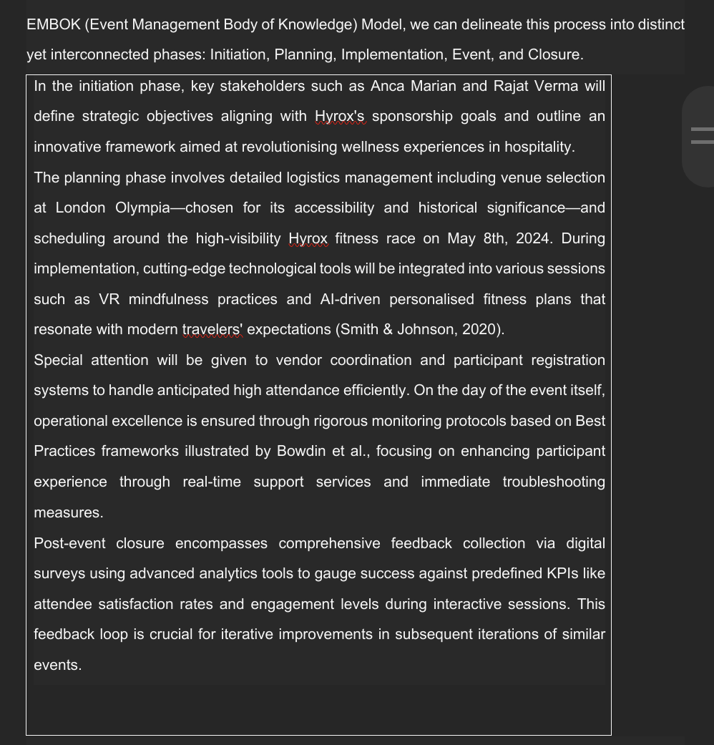

3 Event Concept
The event “Virtual Wellness in Hospitality" is prepared as a highly practical event integrating knowledge on wellness with technological progress, which is suitable for the hotel professionals and wellness enthusiasts (Deri and Ragavan, 2023). The event is organised as a series of sessions and workshops face to face but also over a platform that is virtual, and it arises from this that the audience who cannot attend in person because of geographical location which may be a different town or country can still take part in the event (Becerra et al., 2021).

3.1 Event Details
Participants would be provided with a guide of the topics that would be covered which will include both personal and professional well-being. The agenda of the meetings has sessions regarding mental health, physical fitness, nutritional advice, and wellness techniques that can be integrated in hospitality workplaces and into daily routines (Casu, Gillespie, and Nisbett, 2020; Vella et al., 2023). Technology event will demonstrate that technology and improved health can go hand in hand with virtual reality meditation sessions, live-streamed yoga classes, and presentations covering the topic of available wellness technologies.

3.2 Itinerary
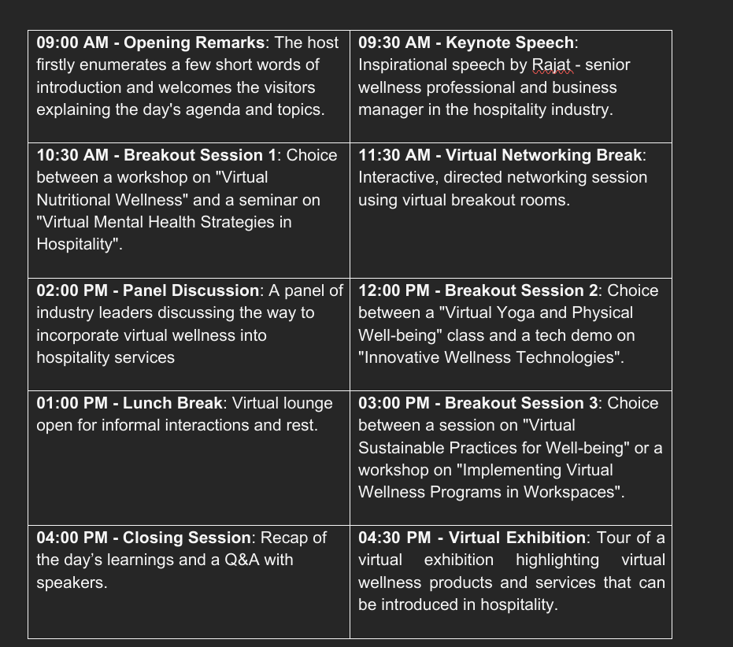

The well-planned schedule guarantees a balance of learning, interaction, and personal growth, all of which reflecting the dynamic sector of the hospitality industry.

4 Aim and Objectives of the Meeting / Event
The primary purpose of the event on "Virtual Wellness in Hospitality" is to create a platform where practitioners from the hospitality industry will receive virtual holistic considerations about how virtual wellness practices can be implemented together with the technology optimisation to improve the overall wellness of the guests in both personal and organisational levels in the hospitality sector (Lee, Lee and Cheng, 2019; Frew, 2005). This event is not only designed to enlighten participants but also proves to be a viable technology platform that can enable technology in promoting health and wellness concepts.
To realise this ultimate target, groups of SMART targets have been set up. The main objective of this event is to enhance the knowledge of the attendees about the practices of wellness, which are applicable to the hospitality industry by 30%, and you can measure this by the means of before and after surveys (Zhang, Kandampully and Choi, 2014). Diversify mental health management; physical fitness and nutritional wellness are among the areas to be taken into consideration (Dalle Grave, 2020). The second purpose of this show is to present, among others, five innovative technological solutions that can be implemented within hospitality settings to run wellness programs that should be attended by at least 25% of participants at this event (Zhang, 2018). Furthermore, the goal is to enable networking events targeting to enhance the number of interactions to 40% among participants with suitable mentors, collaborators or innovation tools during events, thus fostering long-term bonds and future collaboration. These objectives of the event are to make it possible for the participants to walk away with proven benefits and keep them interested and engaged in wellness and technology integration in the hotel industry.

5 Event Operations
Efficient contribution of the "Virtual Wellness in Hospitality" event is dependent on a well-organised combination of skills and resources adapted to the numerous multifaceted requirements of a virtual setting (Haque, 2023). This requires a cross-functional team with different skill sets such as event management, technology, wellness programming, and customer service.
Maintaining the digital expertise is key, thus the virtual instructors must have a good background in platforms administration to allow successful online sessions through applications (Kaputa, Loučanová and Tejerina-Gaite, 2022). The offerings of live streaming or conferencing applications, virtual reality, and webinar interactions allow for a seamless connection between physically attendees and those who are participating remotely (Bailey, Okuda and Reiner, 2023). Training technical staff that ensures fast mode operations, even without an internet access as well as expert error resolution is vital in provision of the best user experience.
Resource allocation also takes a significant role to be sure that the event goes nicely. The IT team must set up a system with high-definition quality videos and back-end operations for networking and engagement. Various digital tools such as chat rooms, polls, and Q&A are included in the technology ensemble. The provision of content resources such as experienced video production and editing services from which all visual information can be up to the standard level that can be accepted by the attendees is another factor in the technical team (Duan et al. 2022).
Additionally, a successful management of a project will be an essential requirement to ensure the coordination of a wide range of stakeholders consisting of speakers, sponsors, and visitors. Communication and organising, through proper planning are elements that help to make sure all the elements of event are in line with the schedules that are set and the standards that so set the course of the event. The systems approach to operations of the event will probably be rationalised to some extent. The aim of this is to provide the participants with a streamlined and entertaining experience, and possibly lead to making the occasion an incredible success.

6 Event Budget
The analytical section of the financial portion of the "Virtual Wellness in Hospitality" event is designed to maintain the mark of profitability through the effective use of income and expenditure. The entire envisaged amount for all the main investments such as lighting (£6,800), catering (£22,000), land rent (£3,400), parking facilities (£5,200) and seats (£5,000) is estimated at £42,400. These charges are essential for creating a convenient, technologically inclined, and health-promoting atmosphere for the event.
The event considers different sources of revenue in order to cover the expenses as well as to earn a profit from the event. The revenue is mainly derived from the tickets with projected £40,000-£48,000 from 500-600 tickets with tickets priced at £80 each. Further funding is allocated by sponsorship which Hyrox is the vital contributor with £50000, emphasizing its role in health and technology in hospitality development. The retail sales are expected to add £10,000 - £12,000 to the sales figure while the cross-promotions are aimed to generate a revenue of £25,000 - £30,000. The income streams, which are expected to reach a total sum of £140,000 to £175,000, could possibly lead to profit margins within the range of £97,600 to £132,600, manifesting the event's financial feasibility and strategic planning effectiveness.

7 Industry Trends / Issues / Impacts
The blending of technology and virtual wellness within the hospitality industry is greatly dependent on some emerging trends (Ezzaouia and Bulchand-Gidumal, 2020). Particularly crucial is customers' need for customised experiences, which can be efficiently achieved by means of AI technology that adapts hospitality and wellness services to personal tastes (Kandampully, Zhang and Jaakkola, 2018). This trend is more and more raising the satisfaction level of customers and the productivity, making new levels for the service delivery.

7 .1 SWOT Analysis

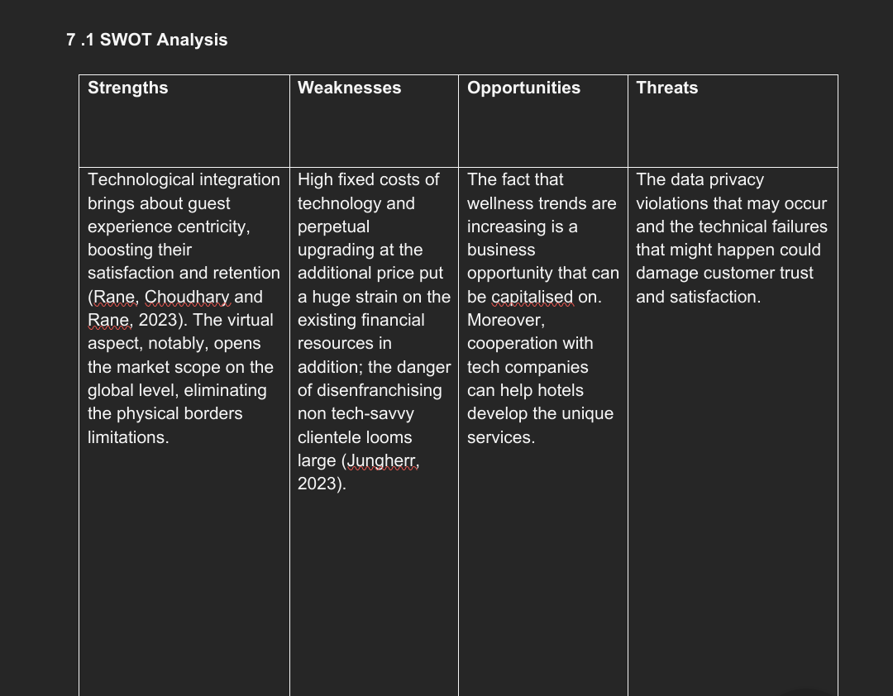

7.2 PESTLE Analysis
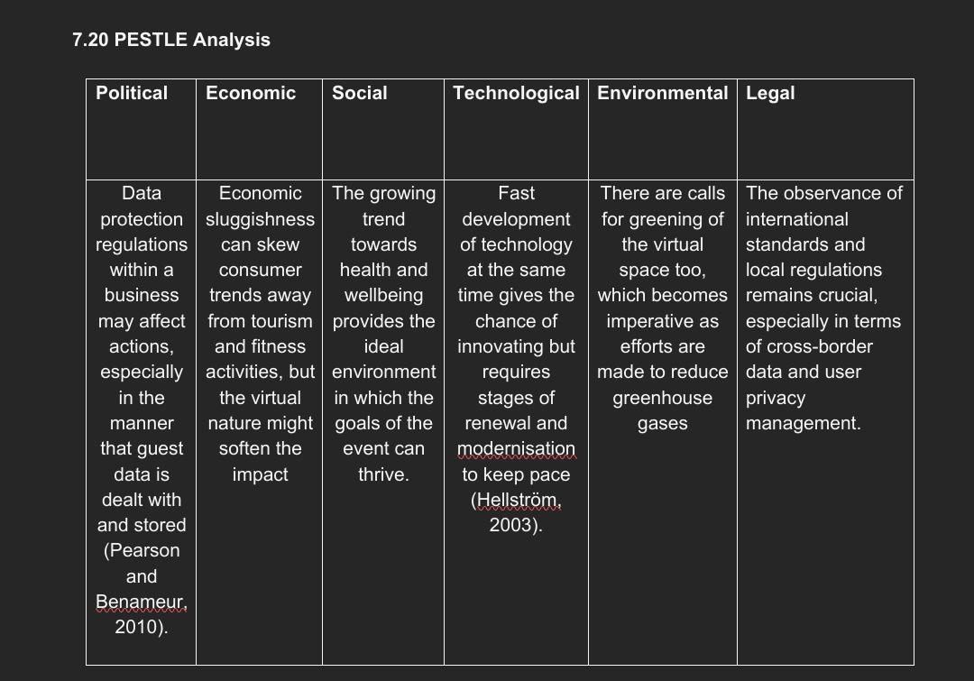

8 Cultural and Situational Considerations
The cultural aspects of the event planning and execution are very pivotal when working with a virtual format, given that the format allows one to breach geographical as well as cultural barriers (Allison, Shuffler and Wallace, 2015).
Individuals who embrace diverse cultures tend to have better recall and retention of their experiences (Kim and Jang, 2016).
This global impact brings about a sharp comprehension of the cultural variations, customs and habits of various participants that may willing to take part in my program.

8.1 Cultural Impact
The event must be very inclusive and sensitive to cultural differences and accordingly, the wellness programs should be designed taking into account the cultural specificities and the communication styles employed (Brooks, Manias and Bloomer, 2019). Take for example dietary recommendations in workshops must give respect to and acknowledge various dietary limitations and preferences across cultures such as vegetarianism, kosher, and halal diets. Moreover, mindfulness and meditation courses must be modified considering the various cultural preferences regarding mental health and self-care practices.

8.2 Situational Considerations
The event session schedule needs to cover the different time zones so that maximum participation can be achieved. Considering the technology choice and platform interface, the differences in access to, and familiarity with digital tools across different demographic and socioeconomic groups, should be taken into account as well. Carefully examining situations and using safety devices that will lead to the participation of a worldwide audience will demand the implementation of creative strategies.

8.3 Relevance
The salient aspect of this is the finding and solving of these cultural and situational problems at all levels which would not only help widen inclusivity and accessibility for participants but also enhance their engagement and satisfaction. It develops the image and relevance of the event by showing the organizers acknowledgment and relevance to the diverse backgrounds of its attendees. This approach not only helps adhere to global diversity and inclusion standards; rather by using cultural diversity as a strength it both enriches the experience for all participants and provides a cozier and well-rounded event environment.

9 Conclusion
The “Virtual Wellness in Hospitality” meeting is a critical milestone in the integration field technology and wellness that is driven by vision of future scenarios and efficient implementation. This report has examined and stressed the vital role of technology as well as marketing, business plan, and financial management to endeavor Mars’ ability to piece together the on the ground outpost.
The strategic insights established from the analysis indicate the event's ability to set new benchmarks in hospitality through personalised, technology-fueled health solutions as part of efforts to escalate customer experience. The event's focus on the real-world application of advanced technologies like AI and VR not only aims at boosting operational productivity, but also promotes the hospitality industry as a leader in innovation. In this partnership with technology, this is not just a trend but also a forward-looking approach to face the various modern demands of today's travelers.
Furthermore, the discussions on the limitations of a virtual environment bring out the need for a global virtual event that is inclusive and accessible. Through the accomplishment of these factors, this event could not only expand its coverage but also consolidate it by involving a diverse audience and therefore providing an opportunity for increased engagement and satisfaction.
In comparison to other sporting events, the "Virtual Wellness in Hospitality" event stands out as a unique and innovative initiative that goes beyond traditional fitness competitions. While most sporting events focus solely on physical performance, this event takes a holistic approach by incorporating advanced technology and promoting mental and emotional well-being. Additionally, the event's location at London Olympia, known for its history of hosting Hyrox fitness competitions, adds to its credibility and potential for success. The event's collaboration with Hyrox further emphasises the growing relationship between health and the hospitality industry, showcasing their dedication to advancing wellness solutions. With its inclusive and diverse audience, the "Virtual Wellness in Hospitality" event has the potential to make a significant impact on both personal and professional well-being in the modern hospitality sector.

10 References

Allison, B.B., Shuffler, M.L. and Wallace, A.M. (2015) 'The successful facilitation of virtual team meetings,' in Cambridge University Press eBooks, pp. 680–706. https://doi.org/10.1017/cbo9781107589735.029.
Bailey, S.K.T., Okuda, Y. and Reiner, C.C. (2023) 'Pros, cons, and considerations of implementing live virtual reality in medical education,' in Routledge eBooks, pp. 215–229. https://doi.org/10.4324/9781003329718-15.
Becerra, Z. M., Fereydooni, N., Kun, A. L., McKerral, A., Riener, A., Schartmuller, C., Walker, B. N., & Wintersberger, P. (2021). Interactive Workshops in a Pandemic: The Real Benefits of Virtual Spaces. IEEE pervasive computing, 20(1), 35–39. https://doi.org/10.1109/MPRV.2020.3044072
Bowdin, G., Allen, J., O’Toole, W., Harris, R. and McDonnell, I. (2011) Events Management. Oxford: Elsevier. (Chapter 11)
Brooks, L.A., Manias, E. and Bloomer, M.J. (2019) 'Culturally sensitive communication in healthcare: A concept analysis,' Collegian, 26(3), pp. 383–391. https://doi.org/10.1016/j.colegn.2018.09.007.
Casu, L., Gillespie, S., and Nisbett, N. (2020). Integrating nutrition and physical activity promotion: A scoping review. PloS one, 15(6), e0233908. https://doi.org/10.1371/journal.pone.0233908
Dalle Grave R. (2020). Nutrition and Fitness: Mental Health. Nutrients, 12(6), 1804. https://doi.org/10.3390/nu12061804
De Lurdes Calisto, M. and Sarkar, S. (2024) 'A systematic review of virtual reality in tourism and hospitality: The known and the paths to follow,' International Journal of Hospitality Management, 116, p. 103623. https://doi.org/10.1016/j.ijhm.2023.103623.
Deri, M.N. and Ragavan, N.A. (2023) 'Digital Future of the Global Hospitality Industry and Hospitality Education: Review of Related literature,' Deleted Journal [Preprint]. https://doi.org/10.58946/apjfes-2.2.p5.
Duan, H., Huang, Y., Zhao, Y., Huang, Z. and Cai, W., 2022, August. User-generated content and editors in video games: Survey and vision. In 2022 IEEE conference on games (CoG) (pp. 536-543). IEEE.
Dwivedi, Y.K. et al. (2022) 'Metaverse beyond the hype: Multidisciplinary perspectives on emerging challenges, opportunities, and agenda for research, practice and policy,' International Journal of Information Management, 66, p. 102542. https://doi.org/10.1016/j.ijinfomgt.2022.102542.
Ezzaouia, I. and Bulchand-Gidumal, J. (2020) 'Factors influencing the adoption of information technology in the hotel industry. An analysis in a developing country,' Tourism Management Perspectives, 34, p. 100675. https://doi.org/10.1016/j.tmp.2020.100675.
Frew, A.J. (2005) Information and Communication Technologies in Tourism 2005. https://doi.org/10.1007/b138872.
Haque, Saw.Mu.S. (2023) 'THE IMPACT OF REMOTE WORK ON HR PRACTICES: NAVIGATING CHALLENGES, EMBRACING OPPORTUNITIES,' European Journal of Human Resource Management Studies, 7(1). https://doi.org/10.46827/ejhrms.v7i1.1549.
Hellström, T., 2003. Systemic innovation and risk: technology assessment and the challenge of responsible innovation. Technology in Society, 25(3), pp.369-384.
Jungherr, A. (2023) 'Artificial Intelligence and Democracy: A Conceptual framework,' Social Media + Society, 9(3). https://doi.org/10.1177/20563051231186353.
Kandampully, J., Zhang and Jaakkola, E. (2018) 'Customer experience management in hospitality,' International Journal of Contemporary Hospitality Management, 30(1), pp. 21–56. https://doi.org/10.1108/ijchm-10-2015-0549.
Kim, J. H. and Jang, S. (2016) ‘Memory Retrieval of Cultural Event Experiences, Examining Internal and External Influences’, Journal of Travel Research, Vol. 55(3).
Kaputa, V., Loučanová, E. and Tejerina-Gaite, F.A. (2022) 'Digital transformation in higher education institutions as a driver of social oriented innovations,' in Innovation, technology and knowledge management, pp. 61–85. https://doi.org/10.1007/978-3-030-84044-0_4.
Lee, P.C., Lee, M.J. and Cheng, T.-T. (2019) 'Importance of Wellness Concepts in the Hotel Industry: Perspectives from the Millennials,' Journal of Quality Assurance in Hospitality & Tourism, 20(6), pp. 729–752. https://doi.org/10.1080/1528008x.2019.1616041.
Pearson, S. and Benameur, A., 2010, November. Privacy, security and trust issues arising from cloud computing. In 2010 IEEE Second International Conference on Cloud Computing Technology and Science (pp. 693-702). IEEE.
Rajat Verma - Travelodge hotels limited (2024) LinkedIn. Available at: Rajat Verma | LinkedIn

Rane, N., Choudhary, S. and Rane, J. (2023) 'Metaverse for Enhancing Customer loyalty: Effective strategies to improve customer relationship, service, engagement, satisfaction, and experience,' Social Science Research Network [Preprint]. https://doi.org/10.2139/ssrn.4624197.
The home of inspirational events (2024) London Event & Exhibition Venue | Olympia Events. Available at London Event & Exhibition Venue | Olympia Events
Vella, S.A. et al. (2023) 'Optimising the effects of physical activity on mental health and wellbeing: A joint consensus statement from Sports Medicine Australia and the Australian Psychological Society,' Journal of Science and Medicine in Sport, 26(2), pp. 132–139. https://doi.org/10.1016/j.jsams.2023.01.001.
Zhang, T. (2018) 'Employee wellness innovations in hospitality workplaces: Learning from high-tech corporations,' Journal of Global Business Insights, 3(2), pp. 52–66. https://doi.org/10.5038/2640-6489.3.2.1003.
Zhang, T., Kandampully, J. and Choi, H.Y. (2014) 'The role of employee wellness programme in the hospitality industry: a review of concepts, research, and practice,' Research in Hospitality Management, 4(1–2), pp. 45–54. https://doi.org/10.1080/22243534.2014.11828313.

Appendix
Rajat Verma | LinkedIn Anca Marian – personal archive photo



Personal archive photo – Hyrox Event https://images.app.goo.gl/TZxKW2stwiiHqtXTA

