Resonance Lab Report

ACDA4006

L4 – Electrical and Electronic Principles

Iwan Evans
Student No: 2521063

Electrical and Electronic Engineering Degree Apprenticeship

Table of Contents
Abstract 3
Introduction 4
Simulation Setup 5
Practical Breadboard Setup 6
Theoretical resonant Frequency 7
Simulation Results 8
Practical Breadboard Results 10
Resonant Frequency Comparison 11
Q Factor Calculations 12
Simulated Q Factor 12
Practical Breadboard Q Factor 13
Comparison of Results 14
Discussion 15
Conclusion 17
References 18

Abstract
In this experiment, the frequency response of an RLC (resistor, inductor and capacitor) circuit was tested using both software simulation (Proteus) and a practical measurement using a breadboard. The circuit contained a 1kΩ resistor, 1mH inductor and a 1μF capacitor. A sinusoidal input signal of 2V peak to peak was applied, and the output voltage was measured over a frequency range of 100Hz to 20kHz. The attenuation was calculated in decibels using the formula below:
$$A=20\log_{10}\left(\frac{V_{out}}{V_{in}}\right)$$
The simulated resonant frequency was found to be approximately 5000Hz, compared to the theoretical value of 5033Hz. It was found that the practical breadboarded circuit produced a resonant frequency of approximately 5200Hz. The simulated Q factor, using the half amplitude method, was calculated to be approximately 16.4, while the practical circuit’s Q factor was approximately 1.26. The results showed that even though the practical response had a much lower amplitude and wider bandwidth, it followed the same general resonant trend of the simulation.

Introduction
An RLC circuit is an electrical circuit containing a resistor, conductor and capacitor. These circuits are commonly used in applications where frequency selection is required, such as filters, tuning circuits, oscillators and signal-processing systems [1], [2].
The behaviour of inductors and capacitors changes with frequency. The reactance of an inductor increases as frequency increases and is calculated [1]:
$$X_{L}=2πfL$$
The reactance of a capacitor decreases as frequency increases and is calculated [1]:
$$X_{C}=\frac{1}{2πfC}$$
Resonance occurs when the inductive reactance and capacitive reactance are equal in magnitude [1], [3]:
$$f_{r}=\frac{1}{2π\sqrt{LC}}$$
The Q factor describes how “sharp” or selective the resonant peak is. A high Q factor indicates a narrow, sharp peak. While a low Q factor indicates a broader, less selective response [2], [4]:
The Q factor can be calculated from the graph [4]:
$$Q= \frac{f_{r}}{f_{2}-f_{1}}$$
Where $f_{r}$ is the resonant frequency, $f_{1}$ is the lower half-amplitude frequency and $f_{2}$ is the upper half-amplitude frequency.

In standard filter theory, Q is normally calculated using the -3dB half-power points [4]. However, this assignment brief asks for the voltage across the inductor to be reduced to half of maximum voltage, so the half amplitude method has been used in the main analysis.

Simulation Setup
The circuit was first built in Proteus, using the following component values:
Component | Value
Resistor (R) | 1kΩ
Inductor (L) | 1 mH
Capacitor (C) | 1 μF
Table 1: Simulated Circuit component values
The signal generator was set to:
$$V_{in}=2V_{pk-pk}$$
The frequency was varied from 100Hz – 20kHz. At each frequency the output voltage was measured and the attenuation calculated:
$$A=20\log_{10}\left(\frac{V_{out}}{V_{in}}\right)$$
Decibel calculations are most used when analysing frequency response as they allow large changes in voltage ratio to be shown more clearly when plotted on a graph [1], [2].
The frequency was adjusted more closely around the resonant peak to improve accuracy of the resonant frequency and half-amplitude points.
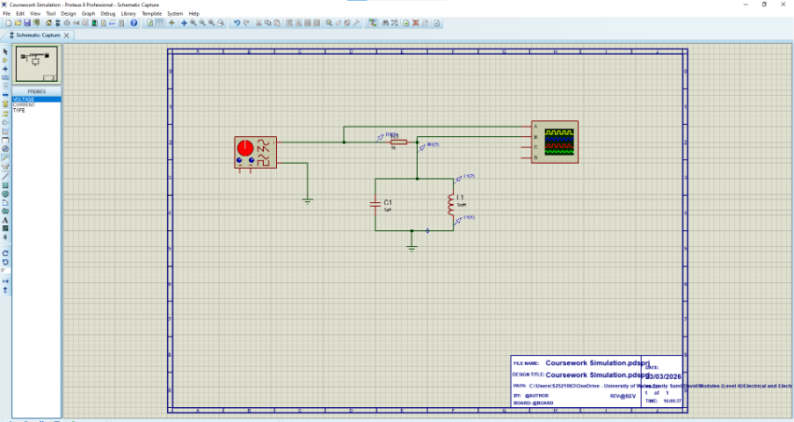
Figure 1: Drawing of simulated circuit on Proteus

Practical Breadboard Setup
The circuit was then built physically on a breadboard using the same nominal component values as the simulation. A signal generator was used to apply a 2Vpk-pk sinusoidal input signal. The output voltage was measured using an oscilloscope while the frequency was increased from 100Hz to 20kH.
Additional readings were taken around the expected resonant frequency, especially between 4800Hz and 5400Hz, to allow the resonant peak to be identified more accurately. The practical readings were recorded in the same format as the simulated readings so that the simulated and practical results could be compared directly.
Practical oscilloscope measurements can be affected by probe loading and the way the measuring instrument interacts with the circuit under test [5], [6]. Therefore, practical results may not exactly match the simulation, especially when measuring small voltages or high-impedance points.

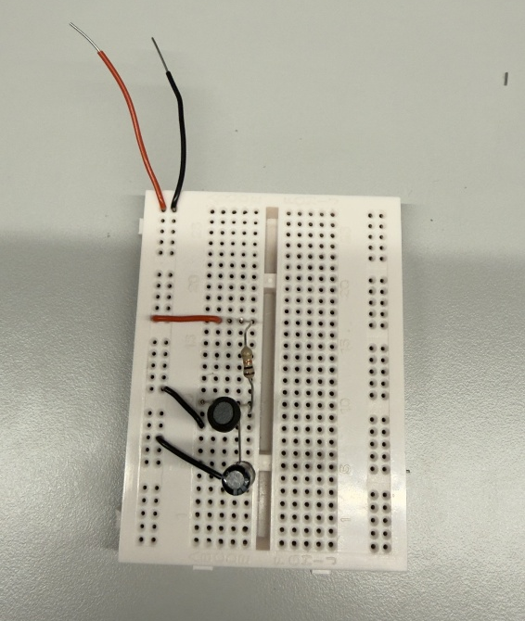
Figure 2: Breadboarded RLC Circuit

Theoretical resonant Frequency
The theoretical resonant frequency was calculated using [1], [3]:
$$f_{r}= \frac{1}{2π\sqrt{LC}}$$
Substituting the component values:
$$C=1μF=1×{10}^{-6}F \\ f_{r}=\frac{1}{2π\sqrt{0.001×1×{10}^{-6}}} \\ f_{r}=5032.9Hz$$Therefor:
$$f_{r}≈5033Hz$$
The theoretical resonant frequency of the circuit was approximately 5033Hz.

Simulation Results
The simulation results showed a clear resonant peak at approximately 5000Hz. The maximum simulated output voltage was:
$$V_{out(max)}=1.93V$$
This occurred at:
$$f_{r}=5000Hz$$
Frequency (Hz) | Vin | Vout | Amplitude
100 | 2 | 0.0013 | -63.74173287
500 | 2 | 0.0025 | -58.06179974
1000 | 2 | 0.0132 | -43.60912129
2500 | 2 | 0.042 | -33.55561411
3000 | 2 | 0.059 | -30.60355968
4000 | 2 | 0.138 | -23.22301819
4500 | 2 | 0.285 | -16.92370271
4800 | 2 | 0.665 | -9.564167007
4900 | 2 | 1.105 | -5.153354353
5000 | 2 | 1.93 | -0.309453733
5100 | 2 | 1.4 | -3.0980392
5200 | 2 | 0.81 | -7.850899536
5300 | 2 | 0.56 | -11.05683937
5400 | 2 | 0.42 | -13.55561411
6000 | 2 | 0.18 | -20.91514981
7000 | 2 | 0.095 | -26.46612781
10000 | 2 | 0.042 | -33.55561411
20000 | 2 | 0.017 | -41.41162149
Table 2: Simulation results
The attenuation at resonance was:
$$A=20\log_{10}\left(\frac{1.93}{2}\right)$$
$$A= -0.31dB$$
This shows that the output voltage at resonance was almost equal to the input voltage.
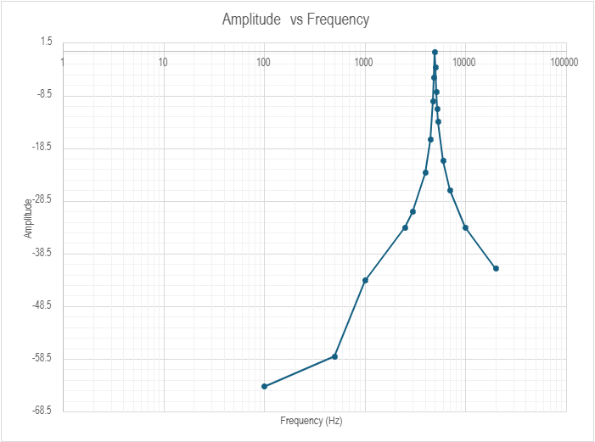
Graph 1: Logarithmic graph of simulated results

Practical Breadboard Results
The breadboard circuit also showed a resonant peak, but the measured output voltage was much lower than in the simulation. The maximum practical output voltage was:
$$V_{out(max)}=0.0196V$$
This occurred at:
$$f_{r}=5200Hz$$
Frequency (Hz) | Vin | Vout | Amplitude
100 | 2 | 0.00184 | -60.7242435
500 | 2 | 0.00256 | -57.8558006
1000 | 2 | 0.0026 | -57.721133
2500 | 2 | 0.0046 | -52.7654433
3000 | 2 | 0.0068 | -49.3704217
4000 | 2 | 0.011 | -45.1927462
4500 | 2 | 0.0146 | -42.7335428
4800 | 2 | 0.017 | -41.4116215
4900 | 2 | 0.0178 | -41.0121999
5000 | 2 | 0.0184 | -40.7242435
5100 | 2 | 0.0188 | -40.5374429
5200 | 2 | 0.0196 | -40.1754785
5300 | 2 | 0.0194 | -40.2645653
5400 | 2 | 0.019 | -40.4455279
6000 | 2 | 0.0166 | -41.6184382
7000 | 2 | 0.0114 | -44.8825029
10000 | 2 | 0.0056 | -51.0568394
20000 | 2 | 0.00288 | -56.8327502
Graph 3: Practical breadboard results
The breadboard result showed a much broader and lower-amplitude response than the simulation. This suggests that the practical circuit had greater losses and damping compared to the simulated circuit.

Resonant Frequency Comparison
The theoretical, simulated and practical resonant frequencies are compared in Table 4.
Method | Resonant Frequency
Theory | 5033Hz
Simulation | 5000Hz
Practical Breadboard | 5200Hz
Table 4: Resonant Frequency Comparison
The difference between the theoretical and simulated resonant frequencies was:
$$5033-5000=33Hz$$
The percentage difference was:
$$\frac{33}{5033}×100=0.66\%$$
The difference between the theoretical and practical resonant frequencies was:
$$5200-5033=167Hz$$
The percentage difference was:
$$\frac{167}{5033}×100=3.32\%$$
The practical resonant frequency was slightly higher than both the theoretical and simulate values, but it was still reasonably close. Small differences are expected as real components have varying tolerances and are not ideal [1], [2].

Q Factor Calculations

Simulated Q Factor
The maximum simulated output voltage was:
$$V_{out(max)}=1.93V$$
The half-amplitude voltage was:
$$V_{half}= \frac{1.93}{2}$$
$$V_{half}=0.965V$$
Using interpolation from the simulation data:
$$f_{1}≈4868Hz$$
$$f_{2}≈5174Hz$$
The bandwidth (BW) was:
$$BW=f_{2}-f_{1}$$
$$BW=5174-4868$$
$$BW=306Hz$$
The Q factor was calculated using [4]:
$$Q=\frac{f_{r}}{BW}$$
$$Q= \frac{5000}{306}$$
$$Q≈16.4$$
Therefore, the simulated Q factor using the half amplitude method was approximately:
$$Q≈16.4$$

Practical Breadboard Q Factor
The maximum practical output voltage was:
$$V_{out(max)}=0.0196V$$
The half amplitude voltage was:
$$V_{half}=\frac{0.0196}{2}$$
$$V_{half}=0.0098V$$
Using interpolation from the breadboard results:
$$f_{1}≈3714Hz$$
$$f_{2}≈7828Hz$$
The bandwidth was:
$$BW=f_{2}-f_{1}$$
$$BW=7828-3714$$
$$BW=4114Hz$$
The practical Q factor was:
$$Q=\frac{5200}{4114}$$
$$Q≈1.26$$
Therefore, the practical breadboard Q factor was approximately:
$$Q≈1.26$$

Comparison of Results
Result | Theory | Simulation | Practical Breadboard
Resonant Frequency | 5033Hz | 5000Hz | 5200Hz
Maximum Output Voltage | N/A | 1.93V | 0.0196V
Lower half amplitude | N/A | 4868Hz | 3714Hz
Upper half amplitude | N/A | 5174Hz | 7828Hz
Bandwidth | N/A | 306Hz | 4114Hz
Q factor | N/A | 16.4 | 1.26
Table 5: Overall comparison of theory simulation and practical results
The simulated resonant frequency was very close to the theoretical value. The practical resonant frequency was slightly higher but still followed the same general behaviour. The main difference was that the practical circuit had a much lower maximum output voltage and a much wider bandwidth.

Discussion
The simulation results show a clear resonant response. The voltage increased as the frequency approached 5000Hz, reached a maximum at resonance, then decreased as the frequency moved above resonance. This is expected as resonance occurs when the inductive and capacitive resistances are equal in magnitude [1], [3].
The theoretical resonant frequency was calculated as 5033Hz, while the simulated resonant frequency was 5000Hz. The percentage difference was only 0.66%, showing strong agreement between theory and simulation. The small difference is likely due to the chosen measurement points, as the exact resonant frequency ma lie between recorded frequencies.
The practical breadboard circuit produced its resonant frequency at 5200HZ. This was sightly higher than the theoretical value, with a percentage difference of approximately 3.32%. This difference is reasonable for a practical circuit because real components have tolerances. For example, the actual value of the capacitor or inductor may not be exactly equal to the value used in the simulation.
The practical Q factor was much lower than the simulated Q factor. The simulated Q factor was approximately 16.4, while the practical Q factor was approximately 1.26. This shows that the practical circuit had a much wider bandwidth and a much less selective response. A lower Q factor usually means that the circuit has more damping or losses [4].
The practical output voltage was also much lower than the simulated output voltage. The maximum simulated output voltage was 1.93V, while the maximum breadboard output voltage was only 0.0196V.
This is a significant difference. Possible reasons include internal resistance, poor connections, oscilloscope probe loading, signal generator output impedance and measurement point differences. Oscilloscope probes can affect the circuit being measured as the probe become part of the measurement system and can load the circuit [5], [6].
The practical circuit still showed a peak around the expected resonant frequency, but the response was much flatter and lower in amplitude. This suggests that the practical circuit was more heavily damped compared to the simulated circuit. In a simulator, components are often teared as ideal unless additional resistance or parasitic effects are added. In a real breadboard circuit, these non-ideal effects are always present [1], [2].
It is also important to note that the assignment uses the half amplitude methos for determining $f_{1}$ and $f_{2}$. This means that the voltage is reduced to half of the maximum value. In decibels, this is a reduction of:
$$20\log_{10}\left(0.5\right)=-6.02dB$$
However, standard Q factor calculations normally use the -3dB half power points, where the voltage is approximately $0.707V_{max}$ [4]. Therefore, the calculated Q factor depends on whether the half amplitude or half power method is used. In his report, the half amplitude method was used as it was what the assignment brief requested.

Conclusion
In this experiment, the resonant frequency and Q factor of an RLC circuit were investigated using both simulation and a practical breadboard circuit. The aim was to observe how the output voltage changed as the input frequency was varied, and to compare the simulation and practical results with theoretical calculations.
The theoretical resonant frequency was calculated as 5033Hz. The simulation gave a resonant frequency of 5000Hz, which only had a 0.66% difference from the theoretical value. This shows that the simulation closely resembled the expected theoretical behaviour of an RLC circuit.
The practical breadboard circuit gave a resonant frequency of 5200Hz, a 3.32% difference from the theoretical value. This indicates that the practical circuit followed the same general frequency response as the simulation, although the peak occurred at a slightly higher frequency.
Using the half amplitude method, the simulated factor was approximately 16.4, with the practical Q factor was approximately 1.26. This shows that the practical circuit had a much wider bandwidth and lower selectivity than the simulated circuit. The lower practical Q factor indicates that the breadboarded circuit has greater damping and losses compared to the ideal simulated RLC circuit.
The maximum simulated output voltage was 1.93V, whereas the maximum practical output voltage was only 0.0196V. this large difference shows that the practical circuit did not behave exactly like the simulation in terms of output amplitude. Possible reasons could include component tolerances, internal resistance of inductor, breadboard contact resistance, oscilloscope probe loading, signal generator output impedance and measurement uncertainty.
Overall, the experiment demonstrated that RLC circuits produce a resonant response at a specific frequency. the simulation closely matched the theoretical resonant frequency, while the practical circuit showed the same general trend but with lower amplitude and a wider response. This confirms that theoretical calculations and simulations are useful for predicting circuit behaviour, but practical measurements are affected by real-world component and measurement limitations.

References
[1] J. Bird, Electrical Circuit Theory and Technology, 6th ed. Abingdon, UK: Routledge, 2017.
[2] A. R. Hambley, Electrical Engineering: Principles and Applications, 7th ed. Harlow, UK: Pearson, 2018.
[3] Electronics Tutorials, “Series Resonance in a Series RLC Resonant Circuit,” Electronics Tutorials. [Online]. Available: https://www.electronics-tutorials.ws/accircuits/series-resonance.html. [Accessed: 14-May-2026].
[4] CircuitBread, “Q and Bandwidth of a Resonant Circuit,” CircuitBread. [Online]. Available: https://www.circuitbread.com/textbooks/lessons-in-electric-circuits-volume-ii-ac/resonance/q-and-bandwidth-of-a-resonant-circuit. [Accessed: 14-May-2026].
[5] Keysight Technologies, “Oscilloscope Probing for High-speed Signals,” Application Note, Keysight Technologies. [Online]. Available: https://www.keysight.com/us/en/assets/7018-01895/application-notes/5989-9177.pdf. [Accessed: 14-May-2026].
[6] Tektronix, “How Oscilloscope Probes Affect Your Measurement,” Tektronix. [Online]. Available: https://www.tek.com/en/documents/application-note/how-oscilloscope-probes-affect-your-measurement. [Accessed: 14-May-2026].

