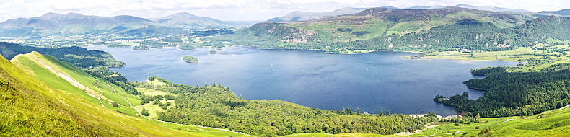
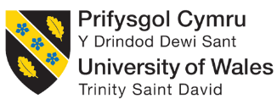
MATEUSZ MORGA (1705592)
sTRATEGIC mANAGEMENT fOR cONSERVATIOn (aCBA7007)
March 2021
Covid-19 Pandemic Implications for Green Space Functionality in the UK

Contents
1.Introduction 2
Pandemic Crisis in General 2
Covid-19 Impacts on the UK. 2
Green Spaces & Access Restrictions 3
2. Methods for Assessment 4
3. Data and Assessment of Impact and Implications 5
The potential scale of impact 8
Assessment of Actions and Example Implications 8
Some Positive Outcomes 11
Financial impact (economics) 12
Affected Ecosystem Services and the Well-being Sustainable Goals 13
An Optimistic Future 15
5. Conclusions and Potential Improvements 16
6. References 17
7. Appendix (SLS Presentation -Group Findings) 21

Picture 1 Pen-y-fan and MTB Afan Park closed due to the Covid-19 restrictions (Bike Park Wales, 2021; Sky TV, 2020). 3
Picture 2 Illegal parking near Pen-y-Pass in Snowdonia, blocking off the clearway (Pidd, 2021). 9
Picture 3 Litter caused by ‘Covid-campers’ in Lake District National Park (Robshow-Bryan, 2020). 10
Picture 4 Strava Segment Explorer Shows Eight Newly Created, Illegal MTB Trails in Treherbert (STRAVA, 2021). 10
Picture 5 Goats Take Over Deserted Llandudno (BBC NEWS WALES, 2020). 11

Table 1 BB Park Authorities-Example Responses to Covid Crisis (Brief Timeline) (Brecon Beacons National Park Authority, 2021a, Natural Resources Wales, 2020, Natural Resources Wales, 2021). 5
Table 2 Negative Social, Economic and Environmental Implications of Park Closures in Wales during Pandemic Lockdowns. 7
Table 3 Positive Social, Economic and Environmental Implications of Park Closures in Wales during Pandemic Lockdowns. 8

1.Introduction

Pandemic Crisis in General
The recent Covid-19 Pandemic has proven to have a significant influence on most aspects of our life, including our health and well-being, social aspects, the economy, and the environment in the broad sense. It began in Wuhan (China) in December 2019, and soon first official arrival of person-to-person transmissions was confirmed in Europe in January-February (2020) in countries like Italy and the UK (World Economic Forum, 2020; Wright, 2020).
According to the official Covid-19 up-to-date statistics, over 122 million confirmed cases across 221 countries, including over 2.7 million deaths and almost 99 million recovered Worldwide (Worldometer, 2021). According to the World Health Organisation joint statement, ‘nearly half of the world’s 3.3 billion global workforces are at risk of losing their livelihoods’ (WHO, 2020).
Among most European governments’ primary responses to rapidly growing daily cases were the ‘national lockdowns’, quarantines, social distancing measures, and movement and access restrictions implemented on an unprecedented global scale. Surprisingly, even the annual meeting of the World Economic Forum in Davos (Davos Summit 2021) was postponed over Coronavirus fears (Badkar and Edgecliffe-Johnson, 2021), and it was later hosted as a ‘virtual summit’ online (Pramanick, 2021).

Covid-19 Impacts on the UK.
In the UK, many people were put on a ‘work from home scheme, most of the ‘unessential’ shops and services were closed, and individuals’ movement was restricted to few miles in all three UK countries. However, according to media and scientific reports, the UK Government decision-making process was suggested to be chaotic (Conway, 2020; Weaver, 2021). Moreover, according to the British Medical Journal reports, scientific advice was not always well communicated (Griffin, 2020; Asimakopoulou et al., 2021).
Office of National Statistics revealed that 21% of adult respondents (over two thousand households) said their relationship was affected due to ‘lockdowns’ and almost 50% declared their well-being being affected due to boredom, loneliness, stress or anxiety and (Office for National Statistics, 2020).
Similarly, an economic impact assessment showed half of the businesses seeing a decrease in turnover and 7% of businesses expecting to be temporary or even permanently closed. Also, accommodation, recreation and food service operating at 63% and recreation and entertainment at 75% rates compared to 2019 levels (Office for National Statistics, 2021).

Green Spaces & Access Restrictions
Along the sectors highly affected by the pandemic is recreation, including green spaces. According to the 2018 Fields in Trust’s report, ‘green-spaces in the UK provide people with over £34 billion of health and well-being benefits per year and manage to save the NHS a staggering £111 million per year’ (Fields In Trust, 2018, p:6).
This report’s primary focus is national parks, including popular ‘beauty spots’, small local country parks and mountain bike parks (MTB) which were highly affected due to falling under the strict ‘lockdown’ regimes. Nevertheless, different parks authorities’ approach was observed throughout the world. For example, the famous Yellowstone National Park in the US saw almost 1 million visitors in the summer months of 2020 (2% increase compared to 2019) (Budd, 2020) while Yosemite National Park was closed to the public since March 2020, almost the beginning of the crisis in the US Interestingly, various other parks reported many signs of reclaiming wildlife due to the lack of tourism (Miller, 2020; Rust, 2020).
There was a very mixed approach observed in the UK since the beginning of the crisis. Some prominent park authorities, e.g., National Trust, were closing down all their parks, gardens and car parks as early as March 2020, or others like Peak District National Park remained open but urging tourist ‘not to visit’ or London Victoria park closing down at first only to reopen with reduced hours and Covid safety measures in place (BBC News, 2020a).
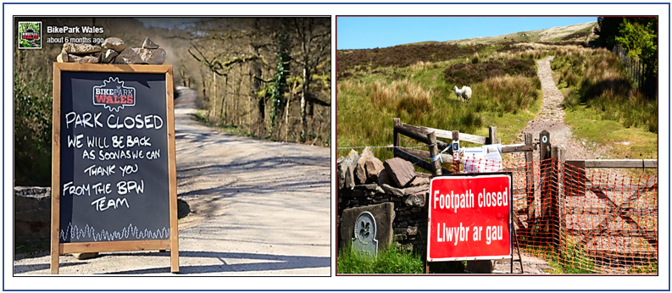
In Wales, all three national parks were shut by the end of April, including many popular ‘beauty spots’ like Pen-y-fan (Picture1) or Snowdon, including many local country and mountain biking parks (Picture 1) (Afan Forest Park, 2020; Wales Online, 2020; Brecon Beacons National Park Authority, 2021a).
Picture 1 pen-y-fan and MTB Afan Park closed due to the Covid-19 restrictions (Bike Park Wales, 2021; Sky TV, 2020).
Only a few woodlands and nature reserves managed by Natural Resources Wales remained open. However, visitor centres, including utilities, were closed for months (Natural Resources Wales, 2020). Unfortunately, some tensions between local communities and park rangers, including local police, were reported due to the overall chaos and parking fines issued for illegal parking (BBC News, 2020b). Moreover, some unexpected, new pressures on the park’s environment and cleanness have emerged due to growing illegal camping in more secluded green spaces (Pidd, 2021).
There is plentiful research and collected data on Covid-related issues available worldwide by now. Therefore, it is viable to assess parks authorities’ responses and evaluate the short and long-term implications to the green environment in the UK.

2. Methods for Assessment

To analyse parks authorities' actions and their outcomes to prevent the spread of the Covid-19 virus, the ‘updated timelines of actions’ available on the park’s website were analysed, and example decisions or significant shifts in parks authorities’ approach were presented.
Next, reports informing and highlighting the consequences of those actions were assessed, and positive/negative consequences based on the report (and press) findings were grouped into three themes (social, economic and environmental) and collated in two tables (Chapter 3). It is worth mentioning that individual observed consequences are interlining and fit within all three Sustainable Development themes.
Importantly, it must be reminded that, although initial reactions were rather drastic and chaotic, the present global situation has significantly improved, and presented findings may better correlate with the situation from January 2020 (the beginning of the pandemic in Europe and the UK).
Lastly, for this report's purpose, the political aspects, including varied approach methods and fluctuating restriction and sanitary regime levels, were purposely omitted. The main focus was only the actions taken by the individual park authorities (direct responses to the pandemic crisis) and their environmental consequences (short and long-term), including local communities issues based on the official information’s.

3. Data and Assessment of Impact and Implications

Data presented in Table 1 were derived from the analysis of the ‘timeline’ of actions presented on the official Brecon Beacons National Park (BBNP) website, including Natural Resources Wales (NRW) official reports. NRW manages all three national parks in Wales, including many local country parks. The presented timeline only covers selected significant actions from March 2020 to January 2021. They are only a few examples; however, they reflect park authorities' responses across the majority of parks authorities across the entire UK.

Table 1 BB Park Authorities-Example Responses to Covid Crisis (Brief Timeline) (Brecon Beacons National Park Authority, 2021a, Natural Resources Wales, 2020, Natural Resources Wales, 2021).
BB Park Authorities-Example Responses to Covid Crisis (Brief Timeline)
Date | Parks Response to Covid
March 2020 | 1. BB. National Park Authority HQ in Brecon closed during the first ‘lockdown’.
March 2020 | 2. No access to the mainland/public paths; the BB car park closed to the public.
April/May 2020 | 3. Mountain summits, ridges, picturesque parts of the park, and access routes closed in April across all three major Parks in Wales, including Pembrokeshire Coast Path in May.
June 2020 | 4. NRW involvement in June 2020. Staff on Work-From-Home scheme, Covid Restrictions Guidance issued for all national parks (17-page long document). Data collection limited to significant environmental incidents only.
October 2020 | 5. Craig y Nos Country Park, closed (the café, shops, toilets and car park). BB Park Authority encourage visitors “to find less crowded, new favourite places to visit” (October 2020).
January 2021 | 6. Pembrokeshire Coast National Park opened a ‘Special email account’ for the concerned public in case of potential issues/questions/complaints (January 2021).

When assessing park authorities' actions, the predominant approach observed across the board was a significant restriction of public access by the local public, and in many places, the full closures were introduced since the beginning of the Covid-19 Pandemic in the UK. The longer the pandemic has lasted, the less professional staff was present in parks, even the regular (including volunteer) duties were restricted to an absolute minimum (e.g. most of the NRW staff was furloughed) (Natural Resources Wales, 2020), so daily maintenance and monitoring of parks were reported to be affected significantly (Wildlife and Countryside, 2020).
All utilities and services were closed permanently in most places, and no designated alternatives for local elderly/disabled residents were appointed (no easy access to managed green spaces for some regular senior users was provided). Many public complains emerged across the UK, while some local tensions were reported to rise (BBC News, 2020b, 2020a; Pidd, 2021). Many have argued that parks were closing to easy and too soon ((e.g. National Trust (NT) members and regular visitors have bombarded the NT Twitter account with comments full of criticism for closing all the parks in the UK to easily without discussing their actions with NT members)) (Holt, 2020).
Also, massive financial losses were reported due to the loss of income through public access restrictions implemented across the board (Local Government Association, 2020; Wildlife and Countryside, 2020).
Next, Table 2 presents exemplar negative impacts and implications to the environment, including residents (social) and the economic issues. It is worth noticing that all individual SD themes (i.e., environmental, social, and economic) are strongly correlated and can be influenced positively or negatively by any presented examples of implication related to Covid-19 responses. For example, overcrowding and can cause disagreement over spaces in car parks (social) as well as some adverse consequences through excessive damage and litter (environment) and increasing maintenance costs for parks authorities (economic).

Table 2 Negative Social, Economic and Environmental Implications of Park Closures in Wales during Pandemic Lockdowns.
Negative Consequences of Park Closures (Red Coloured)

Environmental | Social | Economic
1. Three Welsh National Parks cover approximately 4,122 km², so potential impact (1/5 of Wales Territory) (UK National Parks, 2012). | 4. Well-being of Future Generations (Wales) Act 2015 (Undermined) (Pouso et al., 2021). | 8. Before the pandemic, UK parks were visited by 100 million tourist every year- now lost (National Parks UK, 2021).

2. Increased environmental pressure due to illegal parking, overcrowding. Also, raising local tensions causing the uncontrolled spread of tourism (BBC News, 2020b).  3. Illegal MTB trails development across the Rhondda Valleys (Local Strava App Maps). | 5. ‘New tourist’ and ‘Fly camping’ (brand new issues) (Pidd, 2021).  6. Ecosystem Services affected, parks services in a vulnerable state, park members complaints (Finsterwalder and Kuppelwieser, 2020).  7. Health inequalities escalated by COVID-19 restrictions (‘unequal access to green spaces’) (Geary et al., 2021). | 9. Suspended volunteer contribution (up to £1.56 million losses reported) (Local Government Association, 2020).  10. Over 53% income budget loss in Leeds park due to business closures, £1.2 million loss for Lake District Park, National Trust membership loss, redundancies (Lake District National Park, 2020).

Table 3 below shows some positive outcomes of the pandemic to the environment, including socio-economic aspects of the park’s functionality. Once again, anyone positive outcome can influence positively or negatively any of the three (i.e., environmental, social and economic) aspects of the sustainable management and ecosystem services of UK green spaces.

Table 3 Positive Social, Economic and Environmental Implications of Park Closures in Wales during Pandemic Lockdowns.
Positive Consequences of Park Closures (Green Coloured)

Environmental | Social | Economic
1. Significant nature recovery reported in many green places across the UK (Miller, 2020).  2. Increased support for wildlife conservation policies due to Covid-19 effect (Shreedhar and Mourato, 2020). | 3. 60-70% Increase in positive interest in visiting nature by people (post-pandemic) (Lemmey, 2020b).  4. Forest of Dean remained open during Pandemic (Covid-safe measures implemented) (Good practise example) (Forestry England, 2020). | 5. New Interim Supplementary Planning Guidance- the latest (03/2021) positive legislative action from Brecon Beacons NP Authorities (Brecon Beacons National Park Authority, 2021b).  6. Huge Investments promised to improve green-spaces post-pandemic (e.g. Afan Forest Park, Scotland’ Borderlands growth deal’) (Afan Forest Park, 2020; Rinaldi, 2021).

It is undoubtedly by now that the recent Pandemic crisis has had a significant influence on the environment and social and economic aspects of our lives, including the recreation and interactions with urban/rural green spaces. Moreover, UK parks authorities’ response to the Covid-19 issue and the Government guidance on accessing green spaces (e.g., ‘stay local’-travel bans, minimalisation of visitors in parks and popular beauty spots) (DEFRA, 2020; Welsh Government, 2021) have all contributed to the number of short and long-term implications. Exemplary effects, both positive and negative) were collated and presented in Tables 2 (negative) and Table 3 (positive) above.

The Potential Scale of Impact
It must be mentioned that UK parks, just before the pandemic were highly popular with recreation, sports activity, and tourism, starting with some negatives. According to the UK National Parks Survey, over 100 million visited UK parks in 2019 (Table 2, 8), boosting the parks incomes and environmental investments (National Parks UK, 2021). It is vital to mention that parks cover a vast percentage of the UK territory. For example, in Wales, only the three main national parks cover a fifth of Welsh territory (4,122 km²) (Table 2,1.) (UK National Parks, 2012) statistics shows that pandemic inferred decisions could potentially be of a large scale and have a significant impact on the Welsh environment as well as the well-being of the stakeholder communities (Table 2, 4).

Assessment of Actions and Example Implications
The next observed implication was the highly increased environmental pressure caused by the overcrowding of new gathering places widely reported across Europe (McGinlay et al., 2020). Most visitors would travel to unmanaged, unprepared sections of the parks and ‘dump’ their vehicles in large clusters (illegally) anywhere they possibly could (Table 2, 2.) (example, Picture 2).
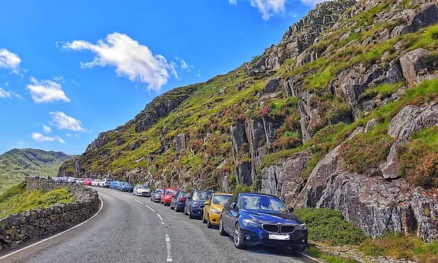
Picture 2 Illegal parking near Pen-y-Pass in Snowdonia, blocking off the clearway (Pidd, 2021).
The reason for that was the blockades of park main entrances and carparks, located in popular beauty spots, mountain biking parks, including all parks amenities being inoperative (Wales Online, 2020; Pidd, 2021).
Unfortunately, the Brecon Beacons National Park authority has unintentionally contributed to the overall chaos encouraging visitors to spread around the park by saying, “The National Park is 520 square miles so why not visit one of the less crowded places, and find your new favourite place” (Brecon Beacons National Park Authority, 2021a, p. 7).
Unfortunately, some local tensions were also reported due to the park wardens and the police issuing fines for illegal parking (Table 2, 2.) (Wales Online, 2020). Parking rows and even abuse of National Park wardens were also reported (Aubrey, 2018; BBC News, 2020b).
During the Summer months, an interesting, however problematic socio-environmental phenomenon called ‘fly camping caused by so-called ‘new tourist’ has been observed across the UK parks (Table 2, 5.). According to a survey, a quarter of people visiting parks during pandemic has never been to a park once in their entire life. Moreover, Snowdonia or Lake District National Parks ‘new visitors’ were found to be secretly travelling to the most secluded areas of the parks (to avoid fines) and enjoyed their illegal camping causing trampling, fires, and leaving behind their cheap camping equipment and litter behind (Picture 3) (Aubrey, 2018; Robshow-Bryan, 2020).
Interestingly, some reports suggested that although environmental damage was visible, in many places, ’ new tourist’ have gathered in the same newly chosen ‘hotspots’, which helped to control and manage the unexpected situation (Perkinson, 2021). Emyr Williams (the chief executive of Snowdonia NP) stated that for any park authorities' ‘the usual dilemma was whether to encourage visitors to spread out or to stay in the newly chosen locations’. According to his calculations, it was more sustainable to keep tourist in the same honeypot (Pidd, 2021, p:2).
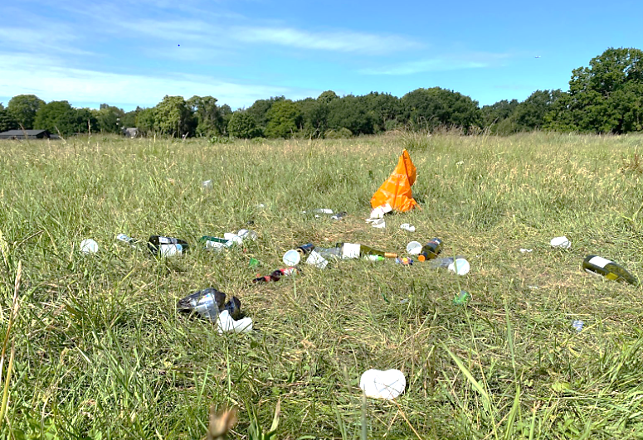
Picture 3 Litter caused by ‘Covid-campers’ in Lake District National Park (Robshow-Bryan, 2020).

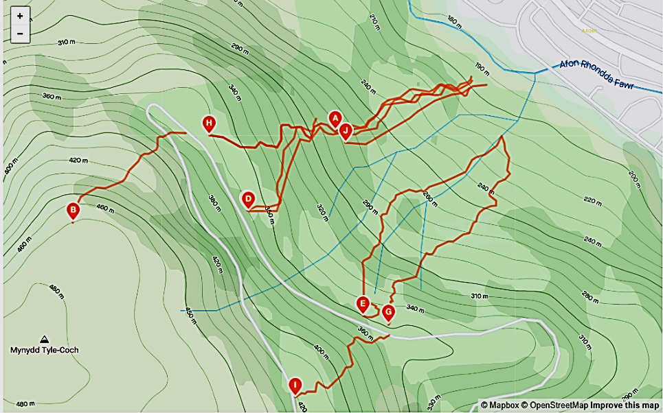
A similar, unexpected consequence of the pandemic crisis was the increased number of visitors observed in Rhondda Valleys area where large groups of mountain bikers (MTB) would travel to most secluded areas of the Valleys due to all MTB parks being closed until further notice.
Picture 4 STRAVA SEGMENT EXPLORER SHOWS EIGHT NEWLY CREATED, ILLEGAL MTB TRAILS IN TREHERBERT (STRAVA, 2021).
They would construct numbers of illegal single-trail channels digging across the hillsides, causing tremendous devastation to trees and foliage, not to mention increased erosion and run-off within those steep-sided valleys (Table 2, 3.) (example map, Picture 4). None of those was either consulted with the local community or with the NRW (site manager). The above picture also shows how all the newly created channels are running down towards Afon Rhondda Fewr (river), potentially contributing to the increased river flow during prolonged precipitations, so frequent in Rhondda Valleys.

Some Positive Outcomes
A much appreciated, positive environmental outcome of the Pandemic’ restrictions was an unexpected one. A significant nature recovery within public lands was observed in many parks and green spaces restricted from public access across the World (Table 3, 1.). In Yosemite national park (USA), staff workers reported ‘quadrupling bear populations’ and ‘an omnipresent wildlife abundance not recorded in the last 100 years (Miller, 2020). Also, a herd of goats abandoning their every-day environment (North Wales cliffs) and descending to enjoy running around deserted Llandudno town (Picture 5) or a cuckoo calling being heard at Osterley Park (London) first time in 20 years (BBC News Wales, 2020; Morris, 2020).
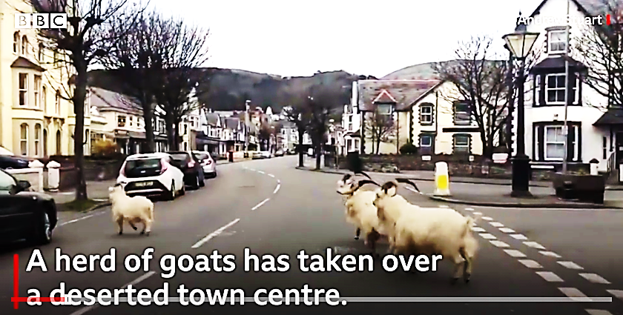
Picture 5 GOATS TAKE OVER DESERTED LLANDUDNO (BBC NEWS WALES, 2020).

Other positives presented are research results revealed by the University of Cumbria at the end of 2020 involving 704 adults across all UK nations. Some of the key findings were that “72% of women and 60% of men reported that they are more likely to spend time in nature in future” (Table 3, 3.) and that the overall drive for spending more time with nature is observed across all age groups (Lemmey, 2020a, p. 3). Some engaging participants comment (e.g., “Laying under a tree and realising I need to be amongst nature for my mental well-being. I want to do more to protect it.”) were encouraging (Lemmey, 2020b). They also show a positive trend and the overall perception shift suggesting a more robust appreciation of ordinary people's natural environment (post-pandemic).
(Shreedhar and Mourato, 2020) suggests that a narrative of an ‘animal-human cause’ of the Covid-19 virus spread is widely accepted and is strongly linked to nature destruction and Climate change caused by humans. This kind of approach was exacerbated by the latest World Health Organisation report highlighting a link between human induced Climate change and infectious disease proliferation (World Health Organisation, 2021).
Those standard views are, in turn, seen as significantly increasing support for wildlife conservation and wildlife extinction prevention policy in a much longer-term (Table 3, 2.) (Shreedhar and Mourato, 2020). Those findings can be crucial for future environmental policy creation in the post-Pandemic world.

Financial Impact (Economics)
Data collated for this report (Tables 2, 3) show that Covid-19 pandemic implications for many UK parks business strategy and economic situation were profound. According to the report findings, the pandemic crisis has had a strong, negative impact on the UK parks' volunteering services. Some of the large national parks reported losses estimated at over £1.5 million due to suspension of regular volunteer work (Local Government Association, 2020), leading to maintenance backlog (Local Government Association, 2020).
Moreover, visitor centre closures and significant redundancies of staff (up to almost 50% in Lake District National Park), including increasing costs, resulted in a staggering £1.2 million parks budget shortages for some (Table 2, 8,9.) (Lake District National Park, 2020). Additionally, the excessive littering vane resulted in a doubling of the Peak District's litter-picking services (a rise from £36 to almost £72 thousand in 2020) (Joanne Parkinson, 2021).
Unfortunately, the National Trust (NT) has announced a £200 million loss as a result of the pandemic due to the ‘almost every aspect of NT being affected by the Covid-19 restrictions’ including a considerable loss of membership and income from visitors and businesses operating within the NT premisses. Adding to the negative consequences, the parks General Director proposed substantial spending cuts, including up to 1,200 redundancies (Table 2, 10.) (National Trust, 2020).
Luckily, there are also many positives on the horizon for UK parks, including the latest (March 2021) announcements of the New Interim Supplementary Planning Guidance proposed by the Brecon Beacons National Park (BBNP) Authority in collaboration with the Welsh Government (Table 3, 4.). It is a very positive legislative action that recognises the effect of pandemic restrictions “causing a devastating effect to the retail industry” within the BBNP and allows for the reopening of businesses on more flexible terms (the Brecon Beacons National Park Authority, 2021b).
Furthermore, based on the overall increase in interest in the natural environment and active lifestyle induced by the pandemic crisis, several major Government investments across the UK are implemented to improve green-spaces infrastructure in the post-pandemic scenario. For example, Scotland’ Borderlands Growth Deal (the UK and Scottish government collaboration) (Table 3, 5.) is looking to invest £24 million in creating a new Mountain Bike Innovation Centre, including MTB trails and facilities. The investment also includes an ambitious project called the ‘Mental Health Pilot Program ‘(aimed to improve mental health through MTB biking activities). All are expected to benefit and supplement the rapidly growing ‘two-wheeled UK tourism’ (Alicia Leggett, 2021; Rinaldi, 2021).
Overall, there are many positive signs, including unprecedented support for conservation, Government induced multimillion investments and many grants available for post-pandemic park improvements (e.g., Rethink Parks grant scheme available to UK parks through the collaboration of National Trust and National Lottery Fund).
Some environmental NGO’s reports emphasise that one of the most unexpected, positive implications of the pandemic crisis has been the ‘increased attention that has been given to the role of parks and green-spaces (Nesta, 2021). Nevertheless, the policymakers and the parks authorities need to keep up with those rapid, long-term changes and improve the decision-making processes to allowing for more sustainable, future-proofed green space infrastructures.

Affected Ecosystem Services and the Well-being Sustainable Goals
Lastly, some of the pandemic implications for green spaces were directly linked to Covid-19 restrictions, which unexpectedly caused disrupted communities' interactions with the green environment, affecting parks ecosystem services, especially on the local (urban/rural) level (Table2, 6.). For example, the closure of National Trust (NT) owned parks across the UK has triggered a heated debate. Many NT Members flooded their Twitter account with complaints:
“Bad decision. Spent 10 hours walking and saw nearly no one. Selected closures of open land maybe but not blanket. All you will get is hazardous parking. Keeping fit is essential to survive. Rethink” (Holt, 2020, no page number).
, and
“So disappointed that you have decided to close your parks and gardens. People need open spaces at a time like this for their health and mental well-being. Surely there could have been ways of keeping them open!” (Dianne Tonner, 2020, no page number).
It must be mentioned that among the many negative comments, including threats of the NT membership cancellations (should all parks remain closed to the public), there were also some very positive comments, praising the Parks Authorities for a prompt response to the pandemic crisis.
The following important aspect is that in most urban environments, green spaces are the only place for some (people living in flats with no access to gardens) where people can spend time with nature and exercise away from the polluted streets. An interesting BBC News article (form April 2020) has added to the debate by publishing statements from prominent figures, including Local Government Secretary Robert Jenrick. He stated that “People need parks, and councils must keep them open” (BBC News, 2020a, p.1). Also, a professor of Public Health Linda Bauld (University of Edinburgh), pointed out other important implications of Covid-19 measures by saying:
“The health implications of the lockdown that we anticipate - increased alcohol consumption, domestic violence, anxiety and depression, poor diet and decreased physical activity - will get worse if we confine more of us to our homes, without the hugely important respite that outdoor exercise provides” (BBC News, 2020a, p:5)

The report analysis suggests, so far, that it can be inferred that the unprecedented Pandemic crisis has strongly influenced the need and strong desire for spending more time with nature, especially in urban areas. Therefore, it can be assumed that ‘lockdown restrictions’ and parc closures were not the most welcomed solutions, even when introduced as Government regulations/recommendations. (Finsterwalder and Kuppelwieser, 2020, p:19) have suggested that:
“Perhaps the bigger lesson from pandemics crisis is to advance from COVID to co viability of social and ecological systems by reconnecting societies to the systems they are embedded in”.

According to the British Medical Journal (BMJ) (Opinion Section) and Office for National Statistics, some significant health inequalities are suggested to be a consequence of Covid pandemic restrictions. In Wales, “one in eight households did not have access to a back garden, yard or even a balcony” during the Covid-19 pandemic ‘lockdowns’ according to BMJ survey (Table 2, 7.) (The BMJ Opinion, 2020; Flint, 2021). Also, (Geary et al., 2021, p. 1) suggested that BAME communities, including ageing communities, are often more vulnerable to adverse impact SARS-CoV-2 virus spread. Unfortunately, they happen to be the same groups being impacted by Covid safety measures due to” limiting their activity and access to preventive or health promotion services”, all linked to large scale green space closures.
Another exciting research from the University of Exeter indicated that entire communities’ well-being and mental health are directly linked to positive, unrestricted exposure to ‘green-blue spaces’ (Table 2, 4.). According to his research, this link was tested in the most extreme conditions during the pandemic ‘lockdowns’. Based on over 5000 responses (from 9 countries, including the UK), it was revealed that:
“lockdown severity significantly affected mental health, while contact with nature helped people to cope with these impacts, especially for those under strict lockdown’ (Pouso et al., 2021, p:1).
It is very promising to see researchers as well as the international press calling for investment and redesigning of urban and rural green space infrastructure to allow for equal distribution of available public green spaces and to improve access mainly in the more secluded, deprived community areas (Flint, 2021; Geary et al., 2021; Pouso et al., 2021).

An Optimistic Future
Many published research on Covid Pandemic implications to green spaces and well-being are available today, including access issues concerns. (Geary et al., 2021, p.1) suggested that parks and urban green spaces accessed with ‘social distancing measures may mitigate some of the predicted adverse health effects of COVID-19 restrictions’. He emphasised that unrestricted access to urban green spaces, especially in most deprived areas, is in line with Sustainable Development Goals.
It is vital to say that the lack of Government efforts in securing green space access, especially for the most vulnerable communities in Wales, may prove to be counterproductive for implementation of the Well-being of Future Generations (Wales) Act 2015 Goals like ‘A more equal’ and ‘A more Healthier’ Wales (Future Generations Commissioner for Wales, 2021).
There is some positive, good practice example in the UK presented by the Forest of Dean Authorities approach to the crisis. They decided to leave the park opened through the duration of the pandemic crisis, including toilet facilities (Table 3, 3.), highlighting the need for access by local communities in order to support their well-being and mental health. The park has introduced all possible Covid safety measures across the whole park, including frequent toilets and car park machines, introducing ‘Covid safety social distancing’ signage across the whole park (Forestry England, 2020).
Lastly, there is also excellent news for Wales as the Welsh Government has promised to invest £110 million into the greening of Welsh towns in line with the tackling of Climate Change and health and well-being issues (Flint, 2021).

5. Conclusions and Potential Improvements

Concluding, this report highlights the severity of the implications caused by the unprecedented pandemic crisis affecting humans and nature in many ways. The analysis of these reports' findings revealed many responses to the pandemic crisis having a significant influence on the functionality of the green spaces globally, including those in the UK. Some consequences were very drastic, including unpredicted, environmental destruction, substantial income losses and redundancy.
Trying to balance the prevention of the virus's spread while maintaining the green space ecosystem services has proven to be impossible if tackled through permanent closures of parks and restricting public access. It also highlighted that provision of the green spaces during the pandemic ‘lockdowns’ is perceived by many as key to their mental health and well-being, especially for the urban and more vulnerable, deprived rural communities.
This report's timing (over a year into the Covid-19 crisis in the UK) gives us a massive advantage due to the considerable availability of research numbers investigating the links between the park’s authorities’ responses to the pandemic crisis and their consequences. Also, there are already many data collected in research regarding the environmental, social, and economic aspects of parks linked to the communities affected by the response processes. The consensus highlighted in this report seems that our health and well-being are directly linked to green spaces' access, and equal provisions are crucial to all human beings, especially under strict ‘lockdown’ measures.
Moreover, the pandemic crisis has stimulated the interest in green environment healthy lifestyles, which the governments and park authorities should be encouraged to capitalise on. It should help attract more investment into urban public green spaces and secure more sustainable conservation and green spaces development in more deprived areas. Those more vulnerable areas again seem to be suffering the most during the pandemic lockdowns.
Learning from our mistakes and using the Covid pandemic crisis to turn the negative experiences into positive outcomes prove to be the only way forward. Today, a year into the pandemic, some of the positive processes have already been initiated in some UK parts.

6. References

Afan Forest Park (2020) Mountain Biking, Neath Port Talbot Council. Available at: http://www.afanforestpark.co.uk/1866 (Accessed: 20 March 2021).
Alicia Leggett (2021) Mountain Biking in Scotland Receives £24 Million Investment for Trails, a Bike Park, and an Innovation Centre, Pinkbike. Available at: https://www.pinkbike.com/news/mountain-biking-in-scotland-receives-multi-million-pound-investment-for-trails-bike-parks-and-innovation-centre.html (Accessed: 24 March 2021).
Asimakopoulou, K. et al. (2021) ‘Covid-19: Social and behavioural responses to chaotic decision making’, The BMJ. BMJ Publishing Group, 372. doi: 10.1136/bmj.n249.
Aubrey, P. (2018) Litter, Litter, Everywhere - Pembrey Country park and beach, Discover Carmarthenshire. Available at: http://www.pembreycountrypark.wales/blog/litter-litter-everywhere/ (Accessed: 25 November 2018).
Badkar, M. and Edgecliffe-Johnson, A. (2021) WEF postpones Davos 2021 over coronavirus fears, Financial Times. Available at: https://www.ft.com/content/e9a3d0c9-f5d2-4e57-af20-bfa0c0752e17 (Accessed: 19 March 2021).
BBC News (2020a) Coronavirus: Should outdoor exercise be banned and parks closed? Available at: https://www.bbc.co.uk/news/explainers-52183137 (Accessed: 20 March 2021).
BBC News (2020b) Covid: Snowdonia National Park wardens’ getting abuse’ during lockdown -. Available at: https://www.bbc.co.uk/news/uk-wales-55516368 (Accessed: 10 March 2021).
BBC News Wales (2020) Coronavirus: Goats take over deserted Llandudno, BBC local News. Available at: https://www.bbc.co.uk/news/av/uk-wales-52109712 (Accessed: 23 March 2021).
Brecon Beacons National Park Authority (2021a) Coronavirus (COVID-19) Update. Available at: https://www.beacons-npa.gov.uk/coronavirus-covid-19/ (Accessed: 2 March 2021).
Brecon Beacons National Park Authority (2021b) Members of Brecon Beacons National Park Authority have given the green light for consultation period of new Interim Supplementary Planning Guidance. Available at: https://www.beacons-npa.gov.uk/the-authority/press-and-news/press-releases/march-2021/members-of-brecon-beacons-national-park-authority-have-given-the-green-light-for-consultation-period-of-new-interim-supplementary-planning-guidance/ (Accessed: 10 March 2021).
Budd, K. (2020) Status of National Parks During Coronavirus Pandemic, AARP. Available at: https://www.aarp.org/travel/travel-tips/safety/info-2020/national-parks-during-coronavirus-outbreak.html (Accessed: 19 March 2021).
Conway, E. (2020) Coronavirus: The inside story of how UK’s ‘chaotic’ testing regime ‘broke all the rules’, Sky News. Available at: https://news.sky.com/story/coronavirus-the-inside-story-of-how-uks-chaotic-testing-regime-broke-all-the-rules-12022566 (Accessed: 19 March 2021).
DEFRA (2020) Coronavirus (COVID-19): advice on accessing green spaces safely, GOV.UK. Available at: https://www.gov.uk/guidance/coronavirus-covid-19-advice-on-accessing-green-spaces-safely (Accessed: 23 March 2021).
Dianne Tonner (2020) National Trust on Twitter, twitter.com. Available at: https://twitter.com/nationaltrust/status/1241701418316247041 (Accessed: 24 March 2021).
Fields In Trust (2018) Measuring their economic and well-being value to individuals.
Finsterwalder, J. and Kuppelwieser, V. G. (2020) ‘Equilibrating resources and challenges during crises: a framework for service ecosystem well-being’, Journal of Service Management, 31(6), pp. 1107–1129. doi: 10.1108/JOSM-06-2020-0201.
Flint, R. (2021) Covid: Call for all homes in Wales to be minutes from green space, BBC News. Available at: https://www.bbc.co.uk/news/uk-wales-56320917 (Accessed: 23 March 2021).
Forestry England (2020) Coronavirus visitor guide. Available at: https://www.forestryengland.uk/article/coronavirus-visitor-guide (Accessed: 23 March 2021).
Future Generations Commissioner for Wales (2021) Well-being of Future Generations (Wales) Act 2015 – The Future Generations Commissioner for Wales. Available at: https://www.futuregenerations.wales/about-us/future-generations-act/ (Accessed: 10 March 2021).
Geary, R. S., Wheeler, B., Lovell, R., Jepson, R., Hunter, R., Rodgers, S. (2021) ‘A call to action: Improving urban green spaces to reduce health inequalities exacerbated by COVID-19’, Preventive Medicine. Academic Press Inc., p. 106425. doi: 10.1016/j.ypmed.2021.106425.
Griffin, S. (2020) ‘Covid-19: Chaotic decision making and failure to communicate undermined government response, says report’, BMJ. BMJ, 371, p. m4940. doi: 10.1136/bmj.m4940.
Holt, J. (2020) National Trust on Twitter, twitter.com. Available at: https://twitter.com/nationaltrust/status/1241701418316247041/photo/1 (Accessed: 21 March 2021).
Joanne Parkinson (2021) The impact of Covid on the UK’s national parks | , tutor2u. Available at: https://www.tutor2u.net/geography/blog/the-impact-of-covid-on-the-uks-national-parks (Accessed: 24 March 2021).
Lake District National Park (2020) Lake District National Park Authority announces financial plan to secure future. Available at: https://www.lakedistrict.gov.uk/aboutus/media-centre/latest-news/news-releases/lake-district-national-park-authority-announces-financial-plan-to-secure-future (Accessed: 21 March 2021).
Lemmey, T. (2020a) Connection with Nature in the UK during the COVID-19 Lockdown.
Lemmey, T. (2020b) University research records new love of nature during coronavirus lockdown, University of Cumbria. Available at: https://www.cumbria.ac.uk/about/news/articles/articles/university-research-records-new-love-of-nature-during-coronavirus-lockdown-.html (Accessed: 10 March 2021).
Local Government Association (2020) Financial impact of COVID-19 on parks 2020-21 - case study key findings. Available at: https://www.local.gov.uk/financial-impact-covid-19-parks-2020-21-case-study-key-findings (Accessed: 2 March 2021).
McGinlay, J., Gkoumas, V., Holtvoeth, J., Fuertes, R. F. A., Bazhenova, E., Benzoni, A., Botsch, K., Martel, C. C., Sánchez, C. C., Cervera, I., Chaminade, G., Doerstel, J., Fagundo J., Jones, A., Lammertz, M., Lotman, K., Odar, M., Pastor, T., Ritchie, C., Santi, S., Smolej, M., Rico, Francisco S., Waterman, H., Zwijacz-Kozica, T., Kontoleon, A., Dimitrakopoulos, P. G., Jones, N. (2020) ‘The impact of COVID-19 on the management of European protected areas and policy implications’, Forests, 11(11), pp. 1–15. doi: 10.3390/f11111214.
Miller, J. (2020) ‘We’ve never seen this’: wildlife thrives in closed US national parks, The Guardian. Available at: https://www.theguardian.com/environment/2020/may/21/wildlife-national-parks-covid-19-shutdown-death-valley (Accessed: 19 March 2021).
Morris, S. (2020) Rare UK wildlife thriving in lockdown, reveals National Trust | Wildlife |, The Guardian. Available at: https://www.theguardian.com/environment/2020/may/20/rare-uk-wildlife-thriving-in-lockdown-reveals-national-trust (Accessed: 23 March 2021).
National Parks UK (2021) Be More Outside. Available at: https://www.nationalparks.uk/ (Accessed: 23 March 2021).
National Trust (2020) National Trust announces spending cuts and redundancies in face of coronavirus losses. Available at: https://www.nationaltrust.org.uk/press-release/national-trust-announces-spending-cuts-and-redundancies-in-face-of-coronavirus-losses (Accessed: 24 March 2021).
Natural Resources Wales (2020) Our response to the coronavirus pandemic. Available at: https://naturalresources.wales/about-us/news-and-events/statements/our-response-to-the-coronavirus-pandemic/?lang=en (Accessed: 2 March 2021).
Nesta (2021) Rethinking Parks: Visions to shape the future of parks . Available at: https://www.nesta.org.uk/feature/rethinking-parks-visions-future-innovation-parks/ (Accessed: 24 March 2021).
Office for National Statistics (2020) Coronavirus and the social impacts on Great Britain. Available at: https://www.ons.gov.uk/peoplepopulationandcommunity/healthandsocialcare/healthandwellbeing/bulletins/coronavirusandthesocialimpactsongreatbritain/7may2020 (Accessed: 19 March 2021).
Office for National Statistics (2021) Coronavirus and the latest indicators for the UK economy and society. Available at: https://www.ons.gov.uk/peoplepopulationandcommunity/healthandsocialcare/conditionsanddiseases/bulletins/coronavirustheukeconomyandsocietyfasterindicators/latest (Accessed: 20 March 2021).
Perkinson, J. (2021) The impact of Covid on the UK’s national parks | Geography, Tutor2u. Available at: https://www.tutor2u.net/geography/blog/the-impact-of-covid-on-the-uks-national-parks (Accessed: 10 March 2021).
Pidd, H. (2021) ‘The litter was a shock’: 2020’s Covid-driven rush on UK national parks, The Guardian. Available at: https://www.theguardian.com/environment/2021/jan/01/the-litter-was-a-shock-2020-covid-rush-on-uk-national-parks (Accessed: 10 March 2021).
Pouso, S., Borja, Á., Fleming, L. E., Gómez, B., Erik, W., Mathew, P., Uyarra, M. C. (2021) ‘Contact with blue-green spaces during the COVID-19 pandemic lockdown beneficial for mental health’, Science of the Total Environment. Elsevier BV, 756, p. 143984. doi: 10.1016/j.scitotenv.2020.143984.
Pramanick, A. (2021) Davos 2021 to become a virtual affair, summit content spread across diverse themes, Times Now. Available at: https://www.timesnownews.com/business-economy/world-news/article/davos-2021-to-become-a-virtual-affair-summit-content-spread-across-diverse-themes/709034 (Accessed: 19 March 2021).
Rinaldi, G. (2021) Multi-million pound Borderlands deal signed, BBC News. Available at: https://www.bbc.co.uk/news/uk-scotland-south-scotland-56416393 (Accessed: 23 March 2021).
Robshow-Bryan, S. (2020) The Unwelcome Rise of Anti-Social, Lazy, Littering “Covid Campers”, Camping With Style. Available at: https://www.campingwithstyle.co.uk/the-unwelcome-rise-of-anti-social-lazy-littering-covid-campers-idiots-guide-to-camping-etiquette/ (Accessed: 23 March 2021).
Rust, S. (2020) Amid coronavirus shutdown, Yosemite wildlife roams free, Los Angeles Times. Available at: https://www.latimes.com/california/story/2020-04-13/yosemite-national-park-closed-wildlife-waterfalls-muir (Accessed: 19 March 2021).
Shreedhar, G. and Mourato, S. (2020) ‘Linking Human Destruction of Nature to COVID-19 Increases Support for Wildlife Conservation Policies’, Environmental and Resource Economics. Springer, 76(4), pp. 963–999. doi: 10.1007/s10640-020-00444-x.
The BMJ Opinion (2020) Covid-19 has highlighted the inadequate, and unequal, access to high quality green spaces, British Medical journal. Available at: https://blogs.bmj.com/bmj/2020/07/03/covid-19-has-highlighted-the-inadequate-and-unequal-access-to-high-quality-green-spaces/ (Accessed: 24 March 2021).

UK. National Parks (2012) National Parks of Wales. Available at: https://www.npapa.org.uk/national-parks-of-wales.html (Accessed: 23 March 2021).
Wales Online (2020) Car parks in Brecon Beacons closed because too many people are driving there for walks. Available at: https://www.walesonline.co.uk/news/wales-news/brecon-beacons-car-parks-coronavirus-19716520 (Accessed: 2 March 2021).
Weaver, M. (2021) Covid in the UK: how first cases exposed flaws in response, The Guardian. Available at: https://www.theguardian.com/world/2021/jan/26/covid-in-the-uk-how-first-cases-exposed-flaws-in-response (Accessed: 19 March 2021).
Welsh Government (2021) Coronavirus (COVID-19), GOV.WALES. Available at: https://gov.wales/coronavirus (Accessed: 23 March 2021).
WHO (2020) Impact of COVID-19 on people’s livelihoods, their health and our food systems. Available at: https://www.who.int/news/item/13-10-2020-impact-of-covid-19-on-people’s-livelihoods-their-health-and-our-food-systems (Accessed: 20 March 2021).
Wildlife and Countryside (2020) Huge nature, well-being and climate cost of coronavirus. Available at: https://www.wcl.org.uk/huge-nature-cost-of-coronavirus.asp (Accessed: 10 March 2021).
World Economic Forum (2020) Coronavirus: When was the first COVID-19 case in Italy? Available at: https://www.weforum.org/agenda/2020/11/coronavirus-italy-covid-19-pandemic-europe-date-antibodies-study (Accessed: 19 March 2021).
World Health Organisation (2021) Climate Change and Infectious Diseases.
Worldometer (2021) Coronavirus Pandemic Update (Live). Available at: https://www.worldometers.info/coronavirus/?utm_campaign=homeAdUOA?Si%23countries#countries (Accessed: 19 March 2021).
Wright, O. (2020) Coronavirus: How the UK dealt with its first Covid case, BBC News. Available at: https://www.bbc.co.uk/news/uk-england-55622386 (Accessed: 19 March 2021).

7. Appendix (SLS Presentation -Group Findings)

SLS Presentation and Discussion findings:
1. Unequal distribution and access to green spaces
The first question discussed during the student seminar was access to green spaces in local areas of attendees. A student who was leaving closer to see side had no issues accessing the ‘green-blue spaces’ in contrast to a person leaving closer to Rhondda Valleys, where almost everything was being locked up during the pandemic crisis.
2. Interestingly, some students living closer to coastal areas have reported some locally arising tension in coastal communities between the local surfers and the near-beach communities due to potential breaches of Covid ‘lockdown; rules by the surfers.
3. Also, an issue of small, local parks being restricted for public access was raised even when there was a common agreement of the importance of closing the most popular ‘beauty spots’ in a country. Students have indicated that small, local country parks that are never too busy with visitors and are huge contributors to the well-being and mental health during ‘lockdowns’ should remain open for as long as possible.
4. Additionally, the importance of science-based decisions was discussed. Decisions made on data that is constantly updated through the latest scientific research are crucial to more sustainable management of parks in the future (should there be more global pandemics).
It was also emphasised during the conversation that although decision-making based purely on science is important, sometimes the Government and park authorities need to compromise their actions and decisions to satisfy the various needs of different community groups.
6. Some concerns for the Wellbeing of Future Generations Act implementation being affected by the potential future pandemic crisis were also discussed. Public participation, so different stakeholders’ involvement in the decision-making process was suggested to be crucial to maintain thriving green spaces that serve communities through ecosystem services. Also, equal access to green spaces during pandemic ‘lockdowns’, especially for urban and more vulnerable communities, would be crucial for reaching some of the well-being goals like ‘A healthy Wales’ and ‘An equal Wales’.
The student-led seminar was summarised with a statement that the World Health Organization links the increased proliferation of infectious virus’s ant the rising global temperatures (Climate Change); therefore, we may expect more pandemics in the coming year. It is vital to ‘learn our lessons from this pandemic and make sure that the Well-being policy and its Sustainable Goals stay high up in the hierarchy to achieve more sustainable, future proofed communities and therefore thriving, biodiverse green spaces in the UK.

BAME (Black, Asian and Minority Ethnic) Communities (Gov.Uk).

