
PROJECT MANAGEMENT
CRITICALLY EVALUATE THE HINKLEY POINT C PROJECT OF UK

Student’s number: 2113318
Student’s name: Paolina Markova
Lecturer’s name: Dr Xavier Matieni
Date: 04/08/23

Table of Contents
1. Introduction 3
2. Discussion 3
3. Conclusion 10
References 12
Appendices 14
Appendix 1: Employment rate 14
Appendix 2: Protecting the Environment 15
Appendix 3: Most expensive construction project 16
Appendix 4: Largest nuclear power reactors under construction 17
Appendix 5: EDF's Hinkley Point C 18

1. Introduction
Hinkley Point C mainly focuses on developing the construction of a new nuclear power plant in Somerset, London with the aim of providing a significant contribution to the decarbonization efforts of the UK. Nuclear power is considered a low-carbon energy source that further helps in reducing greenhouse gas emissions and mitigating climate change. The project aims at enhancing the energy security of the country by minimizing dependence on imported energy sources. Hinkley Point C with a capacity of 3.2 gigawatts focuses on providing a substantial portion of the country's electricity (Kyriakopoulou, Xia and Xie, 2023). The Hinkley Point C project creates numerous jobs, in the construction phase along with the operational lifetime. The project has benefited the economic growth of the country as it attracts investment. However, this project comes with a number of disadvantages as well. High costs and financial risks are one of the most significant disadvantages of the project work.
The project has faced significant delays leading to further cost escalations and technical challenges. Moreover, it is observed that the complexity of building new nuclear reactors, potential safety concerns and raises questions on the ability in delivering the project within the time and within budget. Additionally, significant advancements in technology associated with renewable energy raise questions about the long-term viability of the nuclear power project plan. In this study, an effective discussion of the Hinkley Point C project along with the factors that influence significant delays and overruns will be presented.

2. Discussion
Hinkley Point C project: its advantages and disadvantages
Hinkley Point C is one of the most significant construction projects in the UK that aims at providing low-carbon electricity to the country, by contributing to the energy security of the country along with reducing the carbon emission rate. This project work began in 2016 Hinkley Point C is one of the nation’s 15 reactors that is running and expected to close by 2030 (Topalov, 2021). It has involved a number of activities from the development of infrastructure, facilities, resources and other aspects required for constructing the power station. This project work is considered advantageous to the government in various ways. It enhances the employment rate of the country in this context changes in the project activities hamper the project outcomes as well.
The report highlights that 71,000 jobs will be supported by Hinkley Point C in the county. Additionally, this report also suggested that this project invested about £20 million in building new facilities, creating new careers along with additional training opportunities. In this context, 1400 people have been trained with effective construction skills (edfenergy, 2021). In this regard, it is seen that with the help of this particular project, people are becoming more productive and effective with constructional activities that can be beneficial for them in their future life as well. Nuclear power is considered an effective and low-carbon energy source that further can help in reducing greenhouse gas emissions. Furthermore, maintaining sustainability by using renewable energy is yet another advantage of the project. [Referred to Appendix 1]
It is seen that about 40,000 trees and shrubs have been planted around the site of the project which further helps in enhancing biodiversity value. Apart from that, it also focuses on achieving carbon emissions hence, it is believed that such sustainable activities are the advantages of the project work. This project is considered the most expensive energy project hence, financial risk is the disadvantage here. The management of nuclear waste generated by the project is a significant concern as it further leads to environmental risks and can raise questions about the sustainability of the project (Alwaeli and Mannheim, 2022). It is seen that the investment in the project could be allocated towards renewable sources including wind and solar power, as they are considered cost-effective with greater flexibility. In this context, the advancements in renewable energy technology are a significant concern to the visibility of the project. [Referred to appendix 2]
The core elements of the project: budget, time, quality stakeholders and risk factors
Budget and Time
The estimated budget for Hinkley Point C was £25–£26 billion in its first proposal (case study). However, with time, the estimated cost has increased, it is seen that in September 2021, the cost had increased to about £22.5 billion (Haas and Lutz Mez, 2019). This increase is influenced by various factors, such as changes in design, inflation, regulatory requirements and engineering complexities. In this context, the lack of an effective budget plan is considered a significant issue that may have prevented the project from meeting its deadlines. This report highlights the share in EDF, it is seen that shares in Électricité de France SA (EDF) had fallen by 6.35% to 10.03 due to the equity trading on the French exchange. It was the lowest price as compared with the past rolling of 12 months. Moreover, the shares in EDF have tumbled by 27.61% cf. in the past. Apart from that, changes in the project activities along with requirements lead to financial constraints as well. The main reason behind this dramatic decline is that EDF issued a warning after rectifying the dramatic increase of the construction cost by £2.9 billion that was estimated previously (Forbes, 2023).
Apart from that, it blamed "challenging ground conditions as well. Moreover, it is observed that rising costs are the reason behind the frequent delays that required investigations into the situation as well. It is seen that cost estimation is one of the most significant activities in a project. Seddeeq et al., (2019) stated that estimating the budget along with significant concern on the expenses along with the difference between the estimating and real-time cost is required for dealing with the cost overrunning. This particular project plan has gone through significant issues due to the pandemic situation, their lack of communication and collaboration with the stakeholders and investors create financial constraints for the project.
Stakeholders
The project involves many stakeholders, including the UK government, local communities, China General Nuclear Power Group, EDF Energy, and environmental organizations. According to Zaman et al. (2022), the complex nature of managing multiple stakeholders further leads to challenges and delays the project execution and decision-making activities. This project involves a number of risk factors that put a significant impact on the Hinkley Point C Project. These include public opposition, regulatory uncertainties, financial risks, natural disasters and concerns regarding nuclear safety. In this context, it is seen that with the help of effective risk management strategies addressing the factors can be done effectively. In this context, the government is suggested to put significant attention to these energy efficiency programmes that help in speeding up the renewable energy schemes. Apart from that during the initial period of the project work, the budget was estimated, however, the frequency of changes in demands along with the rise in raw material along with other accommodations caused a rise in the budget.
Risk Factors
It is seen that the most expensive construction project in the United Kingdom, it is seen that the most valuable construction project awarded was the Hinkley Point C project in Somerset, England with a value of 350 MBP (Statista, 2022). The report stated that the Hinkley Point C project was delayed by a year due to the sudden rise in the cost which went up to £3bn. Additionally, the pandemic situation forces the project planner to reduce the number of workers due to safety measures. The report also suggested that 180 suppliers were shut down in April 2020 and in the present year due to COVID 19, more than 60 suppliers were operating with reduced productivity (British Broadcasting Corporation, 2022). The Hinkley Point C Project has faced significant delays in generating electricity but it was in its operational period in the middle of 2020. There are some factors such as supply chain issues, technical challenges during construction activities, safety concerns and regulatory scrutiny that are considered the reason behind the delays. [Referred to Appendix 3]
Inflation along with frequent changes in market conditions put a significant impact on increased costs. As per the viewpoint of Each-Gates et al. (2020) changes in commodity prices, labour costs and currency exchange rates can contribute to cost overruns. Supply chain issues are one of the most significant factors that influence the days of The Hinkley Point C Project. This project relies on a global supply chain for materials, equipment and expertise. Hence, disruptions in the supply chain activities, such as delays in deliveries lead to project delays that further increase the overall costs. The construction project of nuclear power plants is complex, in this context, the EPR technology has been chosen for Hinkley Point C however, it faced technical difficulties in previous projects. Therefore, the significant concern about such adoption leads to delays in the operational activities of the project plan. Apart from that due to the global pandemic situation, significant restriction over transportation activities creates issues regarding raw material sourcing that further creates delays in the construction operations.
The above figure illustrates that in the UK, the largest nuclear power reactors were Hinkley Point C1 and C2 with a gross capacity of 1,720 megawatts electrical (Statista, 2023). In this context, mainly the project management plan with significant activities and mismanagement in such aspects lead to significant delays. Additionally, there are some reasons for possible delays with this project arose after Government’s Low Carbon Contracts Company (LCCC) negotiated a deal with the EDF over the £92.50 per megawatt hour ‘strike price’ that is generated to receive the first 35 years of the project (West Somerset Free Press, 2023). Such negotiation further creates pressure on EDF which further influences the project activities as well. Moreover, effective collaboration with stakeholders is very important in terms of completing a project work with its desired outcomes. Lack of communication and collaboration prevents project work from mitigating the potential risks. It is very important to identify the factor and areas with potential risk as it helps in rectifying the most suitable activities for mitigating or avoiding the risks [Referred to appendix 4]
Factors behind the huge overruns and delays of the project work
Financial challenges are the most significant factor that creates project delays, the rise in the cost of raw materials along with other resources causes overruns. The complexity of the Hinkley Point C project along with the requirements of advanced and innovative technological solutions have contributed to significant delays and huge overruns. Nuclear power projects need to follow safety standards and regulatory requirements that further lead to additional inspections, design modifications and approvals, resulting in increased costs and delays as well. Lack of concern in such aspects prevents the workers from dealing with the activities. Glasson et al. (2020) stated that dealing with a complex project may require additional resources and support as well. This project is the first new nuclear power plant in the UK and its complexity and scale have presented challenges. Giving significant effort to the project work is required in order to deal with these identified issues. The Hinkley Point C Project is a massive project that involves numerous intricate engineering, and stakeholders, moreover, coordination of different contractors and subcontractors are included.
In this context, managing this project required effective project management activities including effective coordination, and communication with every parties involved. EDF is constructing two reactors with a capacity of 3,260MWe for this project work which is expected to be finished within 2030. However, the costs of the project are expected to remain in the range between £22 billion and £23 billion. But the increase of approximately half a billion from the estimated range announced in September 2019 was from £21.5 billion to £22.5 billion putting a significant impact on the overall budget. As per the previous estimation, there was a rise between £1.9 and £2.9 billion. This clearly hampers the projected return it is seen that In July 2017, EDF stated that the IRR remained between 8.5% and 9% (Topalov, 2021). Such changes in estimate3d cost clearly denote issues in its budget plan. It is seen that there is no other nuclear plant at the developing stage except this Hinkley Point C and the main reason is the difficult situation that creates so many issues regarding the project activities due to the pandemic situation. [Referred to appendix 5]
It is observed that a lack of experience in large-scale nuclear construction projects has limited the ability to deal with potential risks, manage project timelines and estimate costs effectively. in this context motivation and a sense of security need to be improved. In this context, the project team must analyse the other large project work before dealing with this one. Furthermore, the COVID-19 pandemic put a significant impact on construction projects, as disruptions in the supply chain and labour shortages prevent the project team to deal with the project activities within the deadlines (Badesa et al., 2021). Additionally, delays in approvals regarding public safety and environmental concerns created issues in this project that further resulted in in delays the overall project activities as well. It is seen that a rise in temperature due to the discharge of the heated water from Hinkley Point C further increases the temperature of the water in the Severn Estuary SAC. Additionally, changes in water quality are one of the significant issues due to the delays in project activities.

3. Conclusion
Hinkley Point C is one of the most significant projects in the UK that helps provide job facilities to a large population. This project has been fine through various issues that lead to significant delays. Among them, the increase in the cost of raw materials, disruption in transportation activities due to the pandemic situation, and poor negotiation with the government is the most significant challenge that prevents the project from its estimated date. Moreover, this project work has various social and economic benefits. It is seen that the main aim of the project work is to provide sustainable energy to the county that can help in minimizing the use of other sources of energy. In this context, in order to deal with the financial constraints, the project team can negotiate with the governmental authorities in a better way. Positive environmental impact is one of the significant benefits that the project focused on, however, climate change is considered a significant backdrop of the project here.
Apart from that, effective analysis of the large project work could be taken into account by the project team as it can help in identifying the potential issues that may take place in the time developing the project work. Additionally, experienced and skilled labourers need to be hired as they have great potential to deal with any kind of situation that may hinder the project work from accomplishing its desired outcomes. Making changes as per the current situation could be done in order to deal with the delays, significant concerns regarding the project activities can help the project work to deal with the budget constraints. Apart from that, the adoption of advanced and innovative technologies such as AI, IoT and blockchain can help the project team with the project activities in more effective ways.

References
Alwaeli, M. and Mannheim, V. (2022). Investigation into the Current State of Nuclear Energy and Nuclear Waste Management—A State-of-the-Art Review. Energies, [online] 15(12), p.4275. doi:https://doi.org/10.3390/en15124275.
Badesa, L., Strbac, G., Magill, M. and Stojkovska, B. (2021). Ancillary services in Great Britain during the COVID-19 lockdown: A glimpse of the carbon-free future. Applied Energy, 285, p.116500. doi:https://doi.org/10.1016/j.apenergy.2021.116500.
British Broadcasting Corporation (2022). Hinkley Point C delayed by a year as cost goes up by £3bn. BBC News. [online] 20 May. Available at: https://www.bbc.com/news/uk-england-somerset-61519609.
Eash-Gates, P., Klemun, M.M., Kavlak, G., McNerney, J., Buongiorno, J. and Trancik, J.E. (2020). Sources of Cost Overrun in Nuclear Power Plant Construction Call for a New Approach to Engineering Design. Joule, [online] 4(11), pp.2348–2373. doi:https://doi.org/10.1016/j.joule.2020.10.001.
Edfenergy (2021). Hinkley Point C Socio-economic Impacts Report 2021 Start. [online] Available at: https://www.edfenergy.com/sites/default/files/2021_hpc_socio_economic_brochure_-_web.pdf.
Forbes, 2023, Shares In EDF Collapse Amid Mounting Costs And Falling Profits. [online] Available at: https://www.forbes.com/sites/stephenpope/2019/09/25/shares-in-edf-collapse-amid-mounting-costs-and-falling-profits/
Glasson, J., Durning, B., Broderick, M. and Welch, K. (2020). Monitoring and auditing the local socio-economic and environmental impacts of the early stage construction of Hinkley Point C Nuclear Power Station, UK. Impact Assessment and Project Appraisal, pp.1–12. doi:https://doi.org/10.1080/14615517.2020.1838237.
Haas, R. and Lutz Mez (2019). The Technological and Economic Future of Nuclear Power Energiepolitik und Klimaschutz Energy Policy and Climate Protection. [online] Available at: https://library.oapen.org/bitstream/handle/20.500.12657/23165/1006988.pdf?sequence#page=122.
Kyriakopoulou, D., Xia, L. and Xie, C. (2023). Internationalism in climate action and China’s role. [online] Available at: https://www.lse.ac.uk/granthaminstitute/wp-content/uploads/2022/01/Internationalism-in-climate-action-and-Chinas-role.pdf.
Seddeeq, A.B., Assaf, S., Abdallah, A. and Hassanain, M.A. (2019). Time and Cost Overrun in the Saudi Arabian Oil and Gas Construction Industry. Buildings, 9(2), p.41. doi:https://doi.org/10.3390/buildings9020041.
Statista. (2022). Construction sector: biggest projects awarded by value. [online] Available at: https://www.statista.com/statistics/820311/construction-sector-biggest-projects-by-value-february-uk/.
Statista. (2023). Largest nuclear power reactors under construction 2022. [online] Available at: https://www.statista.com/statistics/267354/largest-nuclear-power-plants-by-electricity-generation/.
Topalov, M. (2021). EDF’s Hinkley Point C delayed a further six months as costs continue to grow. [online] Current News. Available at: https://www.current-news.co.uk/edfs-hinkley-point-c-delayed-a-further-six-months-as-costs-continue-to-grow/ [Accessed 12 Jul. 2023].
West Somerset Free Press, 2023, Hinkley C ‘on schedule’ despite new delay claim after new agreement. [online] Available at: https://www.wsfp.co.uk/news/hinkley-c-on-schedule-despite-new-delay-claim-after-new-agreement-586884
Zaman, U., Florez-Perez, L., Abbasi, S., Nawaz, S., Farías, P. and Pradana, M. (2022). A Stitch in Time Saves Nine: Nexus between Critical Delay Factors, Leadership Self-Efficacy, and Transnational Mega Construction Project Success. Sustainability, 14(4), p.2091. doi:https://doi.org/10.3390/su14042091.

Appendices

Appendix 1: Employment rate
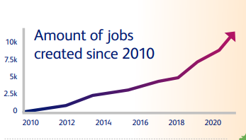
(Source: edfenergy, 2021)

Appendix 2: Protecting the Environment
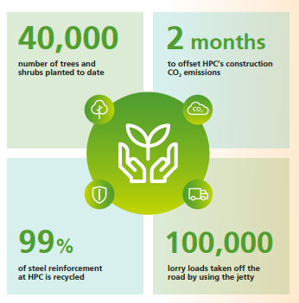
(Source: edfenergy, 2021)

Appendix 3: Most expensive construction project
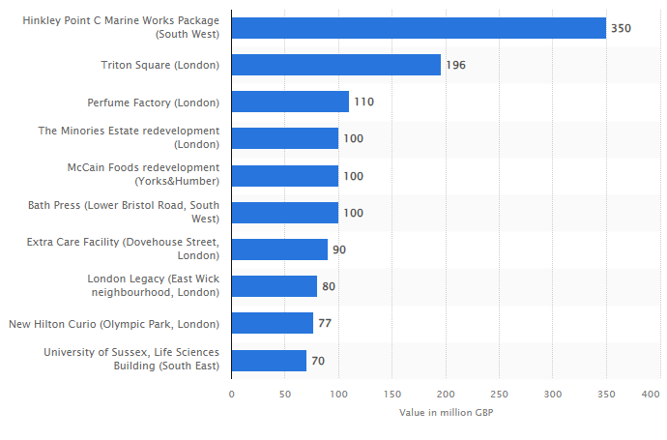(Source: Statista, 2022)

Appendix 4: Largest nuclear power reactors under construction
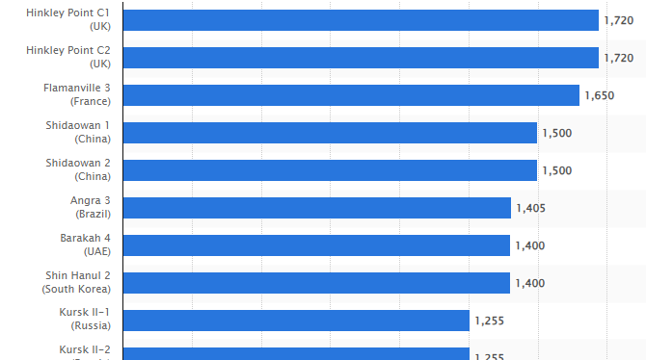(Source: Statista, 2023)

Appendix 5: EDF's Hinkley Point C
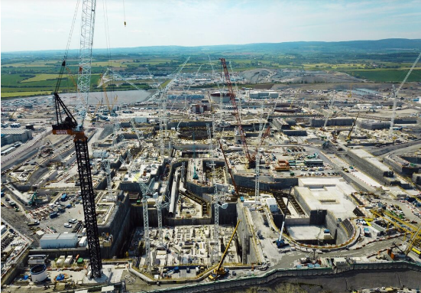
(Source: Topalov, 2021)

