Lv.5 Advanced CHEMISTY – ACDA6020, LAB SESSION 4
BEN LLOYD - 2219811

PURITY TESTING OF METHYL-3 NITROBENZOATE
- Abstract

Samples of Methyl-3 Nitrobenzoate were manufactured during a visit to the Laboratory facilities at the Defence Academy, Shrivenham. Following this visit, the Samples were then subjected to high-temperature Testing using a Melting Point Microscope (MPM) to ascertain the Purity of the “handmade” Samples.

Table Of Contents
- Abstract (Page 1)
- Introduction (Page 1 – Page 2)
- Experiment Conditions (Page 2 – Page 3)
- Experiment Results (Page 3 – Page 5)
- Analysis Of Results (Page 5 – Page 6)
- Conclusion (Page 6 – Page 7)
- References & Appendices (Page 7)

- Introduction

Methyl-3 Nitrobenzoate (C₈H₇NO₄) sits within the Nitro Ester Functional Group, these are a class of explosive compounds that contain NO2 groups bonded to an oxygen atom attached to a carbon [1]. Nitro Esters also include PETN and EGDN and are often used as Primary Explosives due to their high energy and sensitivity. Methyl-3 Nitrobenzoate specifically is often used in the production of Dyes, Pesticides and some Energetic Materials (EM).
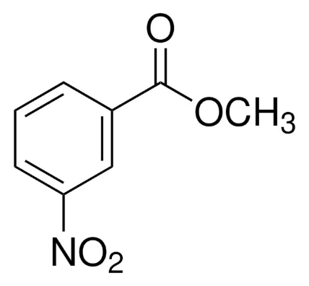

Figure 1 – Methyl-3 Nitrobenzoate Structure [2]

A substance’s Melting Point is the temperature where it transitions from Solid to Liquid state and has long been used to determine its overall Purity: substances that exhibit a precise state change within one or two degrees Celsius of the established Melting Point are purer while samples that melt over a broader range, such as five or six Celsius, are less pure. Generally speaking, a deviation of one degree or more from the establish Melting Point are to be considered unacceptably impure [3].
Melting Point is also influenced by a range of Factors such as presence of Impurities within the Substance. Impurities will melt at a lower temperature and can be filtered out, leaving behind a purer product that can then be recrystallised. As this has not happened in this case, the tested Samples will likely show a trend of Melting before the defined temperature.

Other factors affecting Melting behaviour are the quality of the Crystal Lattice Structure and Intermolecular Forces (IMF). Lattice is important as an ordered Structure creates tighter Bonds between atoms which require more energy to break. Introducing impurities disorders the Crystals, leading to a weaker Structure that is more easily broken [4]. Therefore, fewer impurities lead to a higher melting temperature.

IMF’s such as Dipole-Dipole Interactions affect Melting Point, bonded Atoms form a Positive and a Negative end which are attracted to the Negative and Positive ends of other bonded Atoms. Stronger attractions require more energy to break and this manifests as a higher overall Melting Point. [5]

Use of Purity Testing also has knock-on effects for OME: impurities result in poor quality explosives which may be disproportionately affected by Heat during storage or use and show unexpectedly high sensitivity, massively increasing the Risk of inadvertent detonation and posing a serious threat to human life. There is also the element of Performance: impure EM may not function correctly or at all, which could be the difference between an objective being achieved or failed. EM Purity therefore have serious Safety Management and Operational implications.

- Experiment Conditions

This experiment shall be run for a total of eight times: each sample will be melted twice and there are four samples to be tested, the melting temperatures of each will be captured and compared to an established baseline. From this, an assessment of purity can be made. Each Sample was also assessed visually under a Microscope.

Several tools are needed such as the previously mentioned Melting Point Microscope (MPM), specifically a Cole-Parmer M200 model which can gradually heat each of the Samples to melting temperatures while allowing detailed observation.

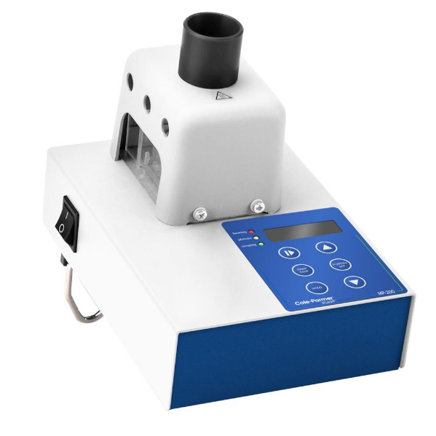

Figure 2 – Cole-Parmer M200 MPM

Also needed are glass Capillaries such as the ones shown in Figure 3, these will hold the Samples and then be inserted into the MPM. The Capillaries will be slowly heated and the magnifying glass in the MPM allows for the melting of the samples to be observed.
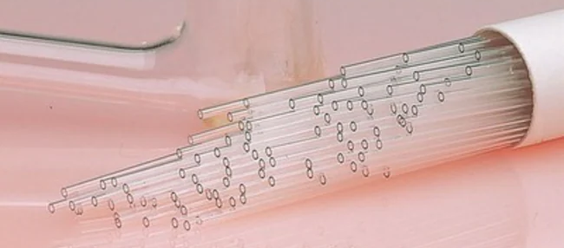

Figure 3 – Glass Capillaries

- Experiment Results

As stated, the experiment was run for all eight iterations and each Sample was inspected under a Microscope. As shown in Figure 4, most Samples looked very similar taking on the appearance of a coarse white power, not dissimilar to dried coconut. Sample D was the exception; it was noticeably darker than other samples and emitted a pungent aroma where the others did not. It was clear that this was the least pure of all samples and this is reflected in the Analysis.
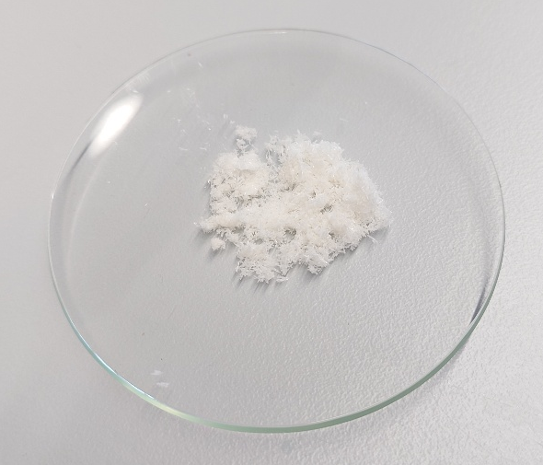

Figure 4 – Visual inspection of Sample



Figure 5 – Microscope view of Sample A
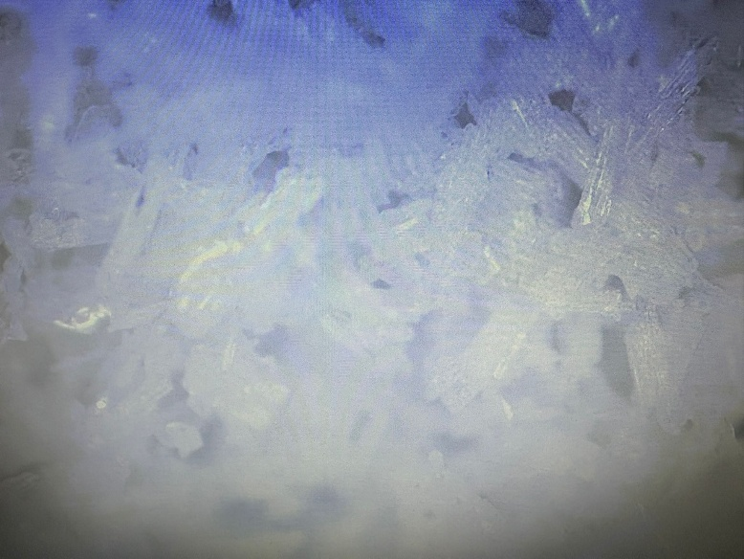

Figure 5 – Microscope view of Sample B



Figure 6 – Microscope view of Sample C

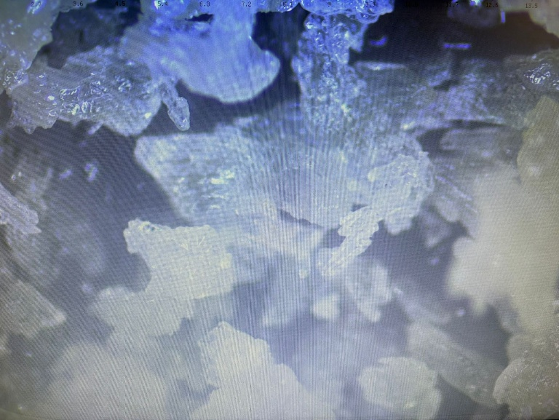

Figure 7 – Microscope view of Sample D

- Analysis of Results

The Results from the Experiment were recorded and a table created to show the melting behaviour of each Sample.

Sample | Appearance | Trial 1 | Trial 2
Sample | Appearance | Melting Point, °C | Melting Point, °C
A | White crystalline Structure. Long, thin and needle like appearance of crystals. | 77 | 77
B | White crystalline structure. Needle like appearance with some  irregularities. | 76 | 77
C | White crystalline structure. Needle like appearance of some  crystals, comparatively shorter in length to other samples. | 77 | 78
D | Crystalline structures visible, however no evidence of “needles”. Crystals were amorphous  in shape where identifiable. Brown. | 72 | 73

Sigma Aldrich is one of many manufacturers that produce Methyl-3 and their Safety Data Sheet [2] indicates that a 99% pure sample will melt between 78°C and 80°C. For the purposes of this report, a median value of 79°C will be assumed to be the “concrete” Melting Point. As expected, Sample D was the least pure and showed the lowest overall median melting temperature of 72.5°C, a drop of 6.5°C from the baseline. Given the poor crystalline structure, the noticeable odour and brown discolouration of the Sample, it is reasonable to assume that high level of impurities are present

Sample C by contrast had the highest melting temperature and is of this selection despite exhibiting a less crystalline structure than Sample A, which had the best appearance of all Samples. Bearing this in mind, Sample C melted at a median value of 77.5°C and despite showing the best purity, it still would not be acceptable for use based on criteria outlined in Para ii.

Sample B fell between this range, it showed decent crystalline structure and appearance with a middling melting point. From this it can be assumed that the Sample was impure but not to the same extent as Sample D.

- Conclusions

This experiment was run to prove how Purity of a Sample can be determined by heating it and observing the point at which it melts, and the experiment was successful in this goal but it was not without flaw. The experiment was highly subjective as what constitutes melting can be interpreted differently between users; one may observe the beginnings of liquidation as melting and another may see the Sample becoming fully liquid as melting. Subjecting the Samples to a less subjective method of Testing would provide a more concrete temperature value.

This experiment also highlights how narrow margins are for chemical purity, the Melting Point of a substance being just one degree short of an established baseline means it is unacceptable for use and the substance must be disposed of. If manufacture is happening at an industrial scale, that could be a massive quantity of waste and the cost of disposal and replacement of the defective batch could be exorbitant. Therefore, purity is vital for efficiency.

The experiment Sample size was also too small to truly create an accurate impression of each Sample’s behaviour, running more iterations of the Test would provide a more accurate picture of the true characteristics of each Sample and this is likely what would be done in a real OME manufacturing environment.

- References & Appendices

[1] – C. Mocella, January 2019, CRC Press Boca Ranton Florida, Chemistry of Pyrotechnics Basic Principles and Theory, Third Edition https://taylorandfrancis.com/knowledge/Engineering_and_technology/Chemical_engineering/Nitrate_esters/
[2] – Sigma Aldrich Chemicals, January 2025, Merck Life Science UK Limited, https://www.sigmaaldrich.com/GB/en/product/aldrich/155977?srsltid=AfmBOooGF3bXS9W6O4EgCFWM5WmKJ-wj6VHodv17JOJhbi_CQe7X-WxU
[3] – A. Santorv, April 2017, University of Oslo, Melting Point Analysis – Identity & Purity, https://chem.libretexts.org/Bookshelves/Organic_Chemistry/Book%3A_How_to_be_a_Successful_Organic_Chemist_(Sandtorv)/05%3A_HOW_TO_INTERPRET_YOUR_RESULTS/5.03%3A_MELTING_POINT_ANALYSIS-_IDENTITY_AND_PURITY
[4] – C. Caroll, June 2025, University of Cambridge, Lattice Structures, https://www.savemyexams.com/a-level/chemistry/cie/25/revision-notes/4-states-of-matter/4-2-bonding-and-structure/lattice-structures/
[5] – M. Alviar-Agnew, September 2025, Mount Royal University, Intermolecular Forces, https://chem.libretexts.org/Courses/Mount_Royal_University/Chem_1201/Unit_5%3A_Intermolecular_Forces/5.2%3A_Intermolecular_Forces

