Dissertation
LCBB6000
BA (Hons) Business Management
University of Wales Trinity Saint David (London Campus)

THE IMPACT OF SOCIAL MEDIA ENGAGEMENT ON BRAND LOYALTY AMONG UK ADULTS

Student Name: Kostadinka Chirosca
Course/Department: BA (Hons) Business Management
Supervisor’s Name:
Date of Submission: August 2026

Declaration
I, Kostadinka Chirosca, declare that the dissertation entitled ‘The Impact of Social Media Engagement on Brand Loyalty among UK Adults’ is my own work and has been prepared in accordance with the academic and ethical requirements of the University of Wales Trinity Saint David. All sources have been acknowledged using Harvard referencing.
Student name: Kostadinka Chirosca
Student ID: 2309389
Date: 07/08/2026

Abstract
This dissertation investigates the effects of the interplay that occurs in the engagement with social media upon the brand loyalty of adults in the UK. The study employs theories of Uses and Gratifications, Social Exchange, Relationship and Customer Engagement to determine the relationships between various factors in the social media interplay and aspects of brand image (BIP), loyalty and purchase intention. Data was collected via an online questionnaire, and the analysis of the responses is presented in Chapter 4. Analysis of the 70 full records of questionnaires revealed that the quality of the content published by brands is more often associated with brand image than the frequency of brand exposure, that the factors of honesty, authenticity and trust are some of the most powerful factors influencing brand loyalty relationships, and that engagement has significant relationships with repeat purchase intention. However, loyalty was found to be unrelated to the mere visibility of brand content online, but rather to the relevance of that content, the believability of the brand messaging and the two-way nature of engagement with those brands.
Keywords: social media engagement; brand loyalty; content quality; trust; authenticity; repeat purchase intention; UK adults.

Contents
Declaration 2
Abstract 3
Chapter 1: Introduction 6
1.1 Background 6
1.2 Problem Statement 7
1.3 Aims and Objectives 8
1.4 Research Questions/Hypotheses 8
1.5 Significance of Research 9
1.6 Scope of the Study 9
1.7 Rationale of the Study 10
1.8 Structure/Organization of the Report 10
Chapter 2: Literature Review 11
2.1 Introduction 11
2.2 Social Media Engagement: Concepts and Theories 11
2.3 Brand Loyalty 12
2.4 The Relationship Between Social Media Content and Consumer Perceptions 13
2.5 Social Media Factors Contributing to Brand Loyalty 14
2.6 Social Media Marketing in the UK Context 15
2.7 Identified Gaps 15
2.9 Conceptual Framework and Hypothesized Relationships 16
Chapter 3: Research Methods and Methodology 18
3.1 Introduction 18
3.2 Research Philosophy 18
3.3 Research Approach 19
3.4 Research Strategy 19
3.5 Population, Sampling, Data Collection and Data Analysis 20
3.6 Ethical Considerations 22
Chapter 4: Data Analysis and Discussion 23
4.1 Introduction 23
4.2 Analysis of Demographics and Social Media Use 23
4.3 Reliability and Overall Descriptive Analysis 25
4.4 Objective 1: Influence of Social Media Content on Brand Perception 27
4.5 Objective 2: Social Media Factors Contributing Most to Brand Loyalty 29
4.6 Objective 3: Engagement and Repeat Purchase Intention 32
4.7 Discussion of Findings 36
4.8 Implications of the Findings 37
Chapter 5: Conclusions, Limitations and Recommendations 38
5.1 Introduction 38
5.2 Original Contribution of the Research 39
5.3 Limitations of the Research 39
5.4 Recommendations for Future Research 40
References 41
Appendix A: Main Survey Questionnaire 46
Appendix B: Excel Dataset of 70 Complete Responses 48
Appendix C: Participant Information and Consent 48

Chapter 1: Introduction

Background
Social media is also changing the relationship that exists between the consumers and the brands. In the past, the organizations had more control over when and what messages would be released about the brands. Consumers, however, had the potential to reply to those messages publicly and to press the brand to continue the message whether it was positive or negative and thus impact the brand’s reputation, a fact that companies did not have control over prior to the advent of social media platforms. Thus, if a brand received positive feedback from its customers, those customers could spread that positive message to others via electronic word of mouth, but if the brand received dissatisfied customers, that feedback could also spread and impact the company’s reputation (Ngo et al., 2024). Thus, the relationship between brand and customer has impacted variables in the company and influenced the brands to pay further attention to this relationship on social media platforms.
Brand loyalty typically encompasses two components, behavioural loyalty and attitudinal loyalty. Behavioural loyalty relates to the purchases that are made by consumers from their favourite brand. Attitudinal loyalty, however, relates to the emotional component behind consumers feeling loyal to a particular brand; they may purchase the products from that brand often due to convenience, but they also feel emotional connections to those interactions with the brand (Brodie et al., 2013). Attitudes will impact the type of relationships that are formed between those consumers and social media platforms but only based upon the quality of the content that is published by those brands.
The reason for the choice of this research topic relates to the high level of investment that many businesses make in social media marketing yet the lack of knowledge of the factors that have the greatest relationship with brand loyalty from consumers. Studies show that the relationship among social media marketing and brand loyalty could be mediated through trust and brand equity (Ebrahim, 2020; Ofcom, 2026). Other studies demonstrate that customer engagement on social media can enhance relationship quality, brand knowledge and purchase intention (de Oliveira San- tini et al., 2020; Papadopoulou, Vardarsuyu and Oghazi, 2023). However, the digital market in the UK consumers has developed with different habits than the rest of the country yet with preferences for different platforms with varying levels of privacy concerns. Thus, it is worthwhile to investigate the relationship between social media marketing and brand loyalty among adults in Britain.
According to DataReportal (2026), the number of social media user identities within the UK reached 55.5 million in late 2025, representing 84.9% of the total population of the country. Furthermore, Ofcom (2026) continues to report that many UK adults use these social media platforms for purposes beyond social interaction. The brands that are advertised on these platforms are also under greater scrutiny of the claims that they make within their advertisements, as those advertisements are capable of quickly spreading to thousands of individuals and their posts of any complaints regarding the brand.

Problem Statement
Social media is recognised as a valuable marketing tool by many organisations worldwide. However, the impact of the different types of social media engagement on brand loyalty from UK adults is elusive. Many organisations believe that if the social media account for the organisation receives hundreds of posts, likes, and followers or even millions of social media impressions from customers, the brand will receive an instant commitment from the customers. However, such a supposition is not very sophisticated in understanding the nature of engagement with the brand. For instance, some customers may like or comment on the brand’s social media accounts from time to time. Others may only like the brand’s social media posts passively to show interest. Some may have a higher faith in the reviews from other customers rather than the brand’s messages. Others may value the quickness and the punctuality of the brand in responding to their complaints on social media accounts (Appel et al., 2020; Ngo et al., 2024).
Thus, the research problem is that the firms generally require more clarity on which aspects of social media engagement with their customers are associated with the development of increased brand loyalty. Although there are a few studies that have discussed aspects of social media engagement with customers and brands, such as trust, authenticity and customer engagement, as well as electronic word-of-mouth, the relationships amongst these constructs amongst UK adult consumers are yet to be investigated (Ebrahim 2020; de Oliveira Santini et al., 2020). Consequently, these organizations may end up spending their money purchasing buzz on their social media accounts for customers, but without ensuring that the customers develop brand loyalty with their products. Therefore, the purpose of this paper is to fill that gap in the existing literature through the performance of an empirical analysis of the role of social media engagement for improving brand loyalty within the UK’s adult population, based upon primary data collected through questionnaires distributed to those UK adults.

1.3 Aims and Objectives
The aim of this research is to examine the impact of social media engagement on brand loyalty among UK adults.
The research objectives are as follows:
- To measure the influence of social media content on consumer perceptions of brands.
- To identify which social media factors contribute most to brand loyalty.
- To measure the relationship between customer engagement on social media and repeat purchase intention.
- To provide evidence-based recommendations for businesses to strengthen brand loyalty through social media.

1.4 Research Questions/Hypotheses
The research questions guiding the study are:
- To what extent does social media influence consumer perceptions of brands?
- Which social media factors contribute most to brand loyalty?
- What is the relationship between customer engagement on social media and repeat purchase intention?
- What evidence-based recommendations can be made for businesses to strengthen brand loyalty through social media?

As the study uses a questionnaire and quantitative analysis, the following hypotheses may also guide the empirical stage:
- H1: Perceived social media content quality has a positive relationship with brand loyalty among UK adults.
- H2: Trust in brand communication on social media has a positive relationship with brand loyalty among UK adults.
- H3: Perceived authenticity of brand social media communication has a positive relationship with brand loyalty among UK adults.
- H4: Customer engagement with brand social media has a positive relationship with repeat purchase intention among UK adults.

1.5 Significance of Research
The research is important for both practical and academic reasons. The study will contribute to the existing academic literature on digital marketing and social media by investigating the importance of social media engagement in the development of brand loyalty among adults in the UK. While there have been studies performed on social media marketing, customer engagement, and brand equity before (de Oliveira Santini et al., 2020; Ebrahim, 2020), there have been few investigations into the relationship between social media engagement and loyalty to the brand among specific populations of consumers. Thus, the study will provide contextualized insight into the relationship between these two variables among UK adults.
The research can be used to assist companies in creating better social media strategies for themselves. Many organisations do invest significant amounts of time and money into creating the content that they will publish on their social media platforms, but not all that content will fortify the allegiance that they have with their followers.

1.6 Scope of the Study
The study to be performed will cover the following population of UK adults that have access to at least one social media platform. Those under the age of eighteen will be excluded from the study as they fall within a different age range that would encompass different considerations for social media use. Furthermore, the study will not be limited to one brand or sector of the economy or the social media industry. Instead, the focus will be upon brand engagement and loyalty from the adult consumers within the identified group. A broader approach to social media and brand engagement is warranted due to the variety of brands that exist and of which consumers are exposed to an equal variety; retail and fashion brands, food establishments and technology companies, something that is more entertainment-oriented such as Netflix, Youtube, video games or card games, travel providers and service brands that are mostly all digitally payment handled for their services.

1.7 Rationale of the Study
There is a critical need for a dialogue regarding two main topics: that social media use does not necessarily translate into customer loyalty, and that many UK adults are in contact with brands via social media channels. The number of adults who use social media is high, but increasingly, they are more cautious regarding engaging with brands on these platforms (Ofcom 2026). Therefore, brand visibility on social media does not necessarily translate to engagement and loyalty from customers. These two topics will be discussed in this paper to demonstrate the impact of social media on customer loyalty.
Furthermore, brands exist in a vastly different world than several decades ago, where customers had more ease in locating alternatives to the products and services that they purchased from these brands. Therefore, it is more difficult for customers to hold of loyalty to these brands. Jack and Hunt (1994) explain in the relationship marketing theory that companies would do well to focus upon cultivating long-term relationships with their customers instead of one-sided transactions between the two parties. Additionally, the social exchange theory explains that customers will hold onto relationships with companies only if they perceive that the benefit from those relationships exceeds any costs that they must incur from those relationships (Blau, 1964). These theories help to justify the reasoning behind the potential link between social media interactions with brands and customer loyalty.

1.8 Structure/Organization of the Report
The dissertation itself consists of five chapters. Chapter 1 introduces the topic including background, problem, aim and objectives of the study, significance and scope of the study and rationale. Chapter 2 Literature Review discusses the literature related to the topic such as brand loyalty, social media engagement, consumer behaviour, electronic word-of-mouth (eWOM), trust and authenticity and theories. Chapter 3 discusses about the research methodology that will be used in the study including research philosophy, design, sampling, data collection and analysis and ethical consideration. Chapter 4 contains the findings and analysis of the questionnaire that was administered to gather the data for the study. Chapter 5 contains the conclusions that were drawn from the data, recommendations, limitations of the study and suggestions for future research. This design of the dissertation ensures that the research dissertation moves from one logical step to the next. On the contrary it follows a line of intention from the problem and background of the research to the conclusions drawn from the research.

Chapter 2: Literature Review

2.1 Introduction
This chapter reviews the literature on the impact of social media engagement on brand loyalty among UK adults. The chapter begins with a review of the concept of social media engagement and the theories that explain social media engagement. Following a discussion of brand loyalty and the models that relate to brand loyalty, the factors that contribute to brand loyalty are reviewed. Following a discussion of social media content and the impact that social media content has upon consumers of that content, the factors that impact brand loyalty are reviewed. A separate discussion covers the social media marketing context in the UK. Finally, the previous research that has been performed on the topic of social media engagement and brand loyalty among UK adults is reviewed, the gaps in that research are explained, and the implications for the present study are discussed.

2.2 Social Media Engagement: Concepts and Theories
Social media engagement should not be limited to the likes and reactions that are visible to the users of those platforms. Authors such as Brodie et al. (2011), Hollebeek, Glynn and Brodie (2014) and Dessart, Veloutsou and Morgan-Thomas (2015) propose that engagement can occur cognitively, emotionally and behaviourally. Muntinga, Moorman and Smit (2011) proposed that consumers can consume social media content from brands, contribute to that content, or contribute to the creation of that content for the brand. These different forms of engagement are important in that they differ in the level of commitment that the consumers have to the brand, with public engagement suggesting motivations related to entertainment values, incentives and identity, rather than loyalty to the brand (Gummerus et al., 2012; Voorveld et al., 2018). Consequently, uses and gratifications theory can help explain why consumers become involved with the content that is published on the social media platforms that operate those brands. Uses and Gratifications Theory suggests that the consumers actively select the media that they consume to fulfil particular needs within themselves (Katz, Blumler and Gurevitch, 1973). Thus, consumers may follow a brand on social media due to the types of content that the brand publishes, as such content may be deemed to be useful, entertaining, socially relevant or allow the consumers to present themselves in a particular way online. Consequently, content that provides some form of recognisable value to the consumers is likely to attract more attention than content that does not. Finally, social exchange theory can be used to explain the motivations of social media consumers with regard to the brands that they follow. Social Exchange Theory suggests that individuals tend to continue participating in interactions that provide benefits to the individuals involved, and to avoid interactions that provide costs to the involved individuals (Blau, 1964). Consumers will be more likely to continue to engage with brands if they experience useful information, recognition, discounts and excellent customer and service experiences, yet will disengage from brands that provide them with intrusive, irrelevant and untrustworthy content.
The Customer Engagement Theory can help to explain how social media engagement translates into marketing. Authors Hollebeek, Glynn and Brodie (2014) discuss the notion of cognitive, affection and activation in the relationship between the customer and brand. Authors Pansari and Kumar (2017) state that the outcome of engagement between the brand and customer includes customers exhibiting loyalty towards that brand. The Relationship Marketing Theory explains the importance of trust and commitment in customer-brand relationships (Morgan and Hunt, 1994). These different theories indicate that social media engagement will contribute to customer loyalty if the brand and social media channel provides customers with valuable experiences, builds a trust relationship and encourages the customers to remain connected to that brand.

2.3 Brand Loyalty
Brand loyalty is also multidimensional. Aaker (1991) positions loyalty within brand equity, Oliver (1999) emphasizes resistance to situational and competitive pressures, and Dick and Basu (1994) distinguish genuine loyalty from repeated purchasing caused by inertia or restricted choice. Chaudhuri and Holbrook (2001) further separate attitudinal and behavioural loyalty. These perspectives imply that following a brand, engaging with content and purchasing repeatedly are related but not interchangeable outcomes; robust measurement should include preference, recommendation, switching resistance and repurchase intention (Keller, 2013; Watson et al., 2015).
Oliver's loyalty framework presents loyalty as a progressive process that can move through cognitive, affective, conative and action stages (Oliver, 1999). Cognitive loyalty begins when a consumer believes that one brand performs better than alternatives. Affective loyalty develops through positive experiences and liking. Conative loyalty reflects a stronger intention or commitment to repurchase, while action loyalty involves translating that intention into sustained behaviour despite possible obstacles. This framework is useful for social media research because digital communication can contribute at several stages: information may shape cognitive evaluations, engaging content may strengthen affect, trusted interaction may reinforce repurchase intention, and repeated positive experiences may support continued behaviour.
The broader drivers of brand loyalty include trust, satisfaction, perceived value and brand identity. Chaudhuri and Holbrook (2001) show that brand trust and brand influence both purchase and attitudinal loyalty. Keller (2013) similarly argues that favourable, strong and distinctive brand associations contribute to brand equity and customer response. Social media can influence these drivers because consumers use branded content, peer reviews and public interactions as cues when judging credibility and fit. A brand that responds transparently to problems or communicates consistently may strengthen trust, whereas misleading or purely promotional communication may undermine it. Loyalty in the digital environment should therefore be understood as the outcome of both product experience and the quality of the continuing brand-consumer relationship.

2.4 The Relationship Between Social Media Content and Consumer Perceptions
The effects of content are conditional rather than universal. For instance, De Vries, Gensler and Leeflang (2012) discover that the characteristics of the posts influence the popularity of those posts. Ashley and Tuten (2015) find that the creative strategy used for the posts can have an impact upon the popularity of those posts. Furthermore, Schivinski and Dabrowski (2016) find that content created by the firms can have a different effect upon the consumers’ perceptions of the brands than content that is created by the consumers themselves. However, the popularity of social media content is only an intermediate concept; popularity does not necessarily imply that the consumers are forming loyalties toward those brands. Content that is highly entertaining may become popular without any reinforcement of the brand proposition, but content that is both relevant and credible to the brands may be associated with improvements in the consumers’ perceptions of those brands with fewer interactions with that content (Muntinga, Moorman and Smit, 2011; Voorveld et al., 2018).
The perceptions of the consumers of a brand are additionally influenced by the individual that creates the content. Content that is created by other consumers of the brand or content that utilizes reviews from other consumers is likely to be interpreted differently than content that is created by the firms themselves. For instance, Ngo et al. (2024) discovered that the credibility of the content of electronic word-of-mouth posted on social networking sites can impact the purchases of the brands represented by those social networks. Thus, the impact of the content that is published on social media is likely to be the result of the interaction between the characteristics of that content, the credibility of the individual that publishes that content, and the experiences that the consumers have with the brands themselves. Thus, this factor relates to Objective 1 of the present study: to investigate the perceived influence of social media content upon the perceptions of the consumers of those brands.

2.5 Social Media Factors Contributing to Brand Loyalty
These factors are often associated with loyalty but relate to the context in which they exist. Algesheimer, Dholakia and Herrmann (2005), Brodie et al. (2013) and Laroche, Habibi and Richard (2013) all found positive impacts of communities on social media platforms. However, these communities that are formed with highly involved users may not be representative of the general population using those platforms. Factors such as trust and authenticity are more enduring factors that impact the relationship between brands and consumers (Morgan and Hunt, 1994; Napoli et al., 2014; Morhart et al., 2015). Additionally, the concept of electronic word-of-mouth also relies upon the usefulness and credibility of the information being shared within social media platforms (Hennig-Thurau et al., 2004; Cheung, Lee and Rabjohn, 2008; Ngo et al., 2024). The same is true of the impact of influencers within social media platforms, who are not to be measured by their social media following but by their expertise within their designated area of influence (Lou and Yuan, 2019; Sokolova and Kefi, 2020).
Trust is another important factor in the relationship between social media brands and consumers. Ebrahim (2020) found that trust helps to explain the influence that social media marketing has on brand loyalty and equity. This is especially important in social media environments in which the brands may be exposed to exaggerated product claims, advertisements and other information that may create a relationship between the consumer and the brand that is based upon assumptions rather than fact. Brand authenticity is related to trust. Papadopoulou, Vardarsuyu and Oghazi (2023) investigated the concept of authenticity within brands and the impact that authenticity has upon the evaluations that consumers have of those brands. Consumer perceptions of authenticity can also include the consistency of the brand’s values with the actions that they take, the tone of their communications, their partnerships, and the way that they respond to criticism. Additionally, electronic word-of-mouth (eWOM) can also have an influential effect upon brand loyalty, as consumers can share their opinions with a wide audience. Both positive and negative eWOM can have an impact upon the loyalty of consumers to a particular brand (Ngo et al., 2024). Thus, these factors indicate that brand loyalty is influenced by a variety of factors relating to both the consumer and the brand itself. Accordingly, these factors are to be examined together in the present study to determine which of those factors is thought to be the most important to brand loyalty amongst UK adults.

2.6 Social Media Marketing in the UK Context
The UK is another example of a country in which social media is embedded into the everyday life of a significant number of adult citizens. Data Reportal (2025) reported that the UK has around 55.5 million active social media user identities. Furthermore, Ofcom (2026) reported that a significant proportion of the UK’s adult population utilizes social media platforms, although the level of active participation from those adults has changed over time. Many of those adults are also able to easily change brands that they utilize within the UK.
These factors create both opportunity and risk for the countries’ organisations that utilize social media platforms. While many organisations may benefit from the ability to utilize these platforms to communicate with customers and to build communities associated with those organisations, those same organisations are also potentially at risk of criticism of the organisations from the public. Additionally, many of those consumers are also concerned with issues related to privacy and the communication of potentially misleading content from those organisations (Appel et al., 2020). Thus, conducting a research study of the UK and its social media users is justifiable due to the potential difference in the relationships between those social media platforms and the country’s adult population when compared to other countries. Therefore, the research that will be performed will focus upon the adult population of the UK, but with a cross-sector study to determine its relevance to industries like retail.

2.7 Identified Gaps
The literature reveals several gaps. First, most studies focus solely on the general concept of customer engagement on social media without investigating the different dimensions of quality of the social media content that is published by the marketers, such as the dimensions of content quality, interactivity, and trust and authenticity of the social media account. Second, most studies are limited to specific countries or sectors. Therefore, it is impossible to generalize the results to the United Kingdom adult population. Third, most studies focus solely on purchase intention or attitude towards the brand. A more comprehensive perspective studying both the perception of the brand and the relationship between loyalty and purchase intention would be more holistic in understanding the overall impact of social media brands on consumers.
Another of the gaps within the existing literature is within the differentiation between active and passive engagement with the brands that are showcased within the content produced and disseminated on social media platforms. While the active forms of liking and commenting upon brand content is understood to occur within consumers, those who only view the content and discussions within the platforms may also be influenced by the brands. Ofcom (2026) has indicated, for example, that passive use of social media is also performed by UK adult populations, suggesting further support for requiring some action from those companies to ensure that their social media does not indicate that such actions equate to engagement with those brands. Thus, within this study, original questionnaires will be distributed to UK adults regarding their social media use to determine how various factors regarding their engagement with those brands influences their perceptions of those brands and their loyalty to those brands and consumers intention to purchase their products again. Though not aiming to provide evidence of causation, this study aims to provide evidence that is still of use to both the academic and managerial responsibilities to those brands.

2.9 Conceptual Framework and Hypothesized Relationships
Based on the findings of these studies, it becomes evident that social media content quality, trust and authenticity, and interactive engagement influence brand perception, which subsequently has an impact upon the brand loyalty of those consumers. One thing that the model does not assume is that an aspect of online activity can have a uniform influence upon another aspect of that activity. Instead, the model considers that consumer loyalty is likely to emerge within consumers who are made aware of the value that the brand reciprocates with each of them (Morgan and hunt, 1994; Oliver, 1999; Hollebeek, Glynn and Brodie, 2014; Ebrahim et al., 2020). Within the questionnaire is a section in which the various relationships between the variables are compared to one another (correlation and regression analysis tested through arrows).

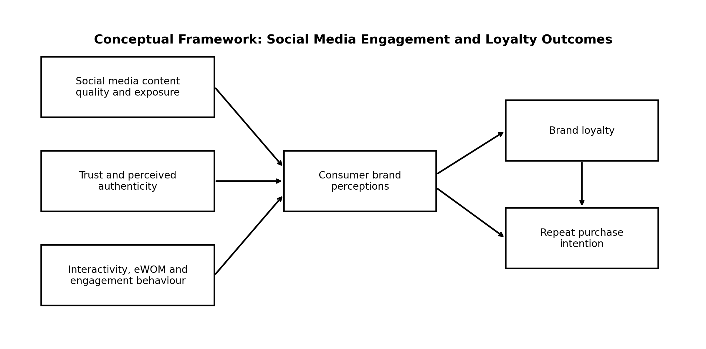
Figure 2. Conceptual framework for the study (author-developed from the reviewed literature).

Chapter 3: Research Methods and Methodology

3.1 Introduction
The methodology chapter is built upon the research aim, objectives, questions and hypotheses presented within Chapter 1. Following the research onion, the following topics will be discussed within this chapter: research philosophy, approach to theory development, methodological and strategic choices, the time horizon of the study, the choice of sampling approach and techniques, the design of the questionnaire, the actual process of data collection, data analysis techniques, the reliability and validity of the data and the ethical considerations of the study. Due to the aims and objectives of this study, a quantitative research methodology will be utilised to investigate the research questions.

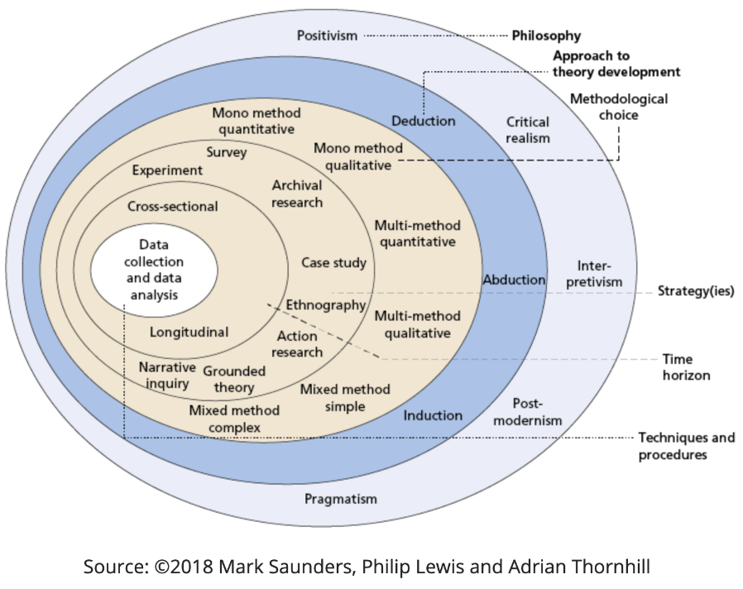
Figure 1. Research onion framework informing the methodological structure (adapted from Saunders, Lewis and Thornhill, 2019).

3.2 Research Philosophy
The positivist position within the debate is supported by the use of predefined constructs within the study, as well as by using statistics to compare the responses from the participants (Creswell and Creswell, 2018; Saunders, Lewis and Thornhill, 2019; Bell, Bryman and Harley, 2022). The constructs that are used, however, are based upon the subjective perceptions of the participants. Thus, while the study measures these perceptions, it does not assert that the concepts are objective facts.
The use of a standardised questionnaire will ensure that all participants are comparable with one another. Each participant will be provided with the same questions. However, because the attitudes towards brands are subjective, the responses of the participants are also subjective in nature. Thus, the study measures these attitudes but does not assert that they are truths universal to all consumers. Instead, the findings will only reflect the opinions of the participants in the study.

3.3 Research Approach
Deduction is related to the research through the use of theoretical propositions to formulate the hypotheses and questionnaire items (Saunders, Lewis & Thornhill, 2019; Bell et al., 2022). Trust and commitment enable the relationship to endure, the value of the communication channels will sustain viewer attention (Uses and Gratifications Theory), and the level of involvement that audience members have with the brands will correlate with the likelihood that they will refer those brands to others and purchase their products again (Customer Engagement Theory; Morgan and Hunt, 1994, Hollebeek, Glynn and Brodie, 2014; Pansari and Kumar, 2017).
These constructs will be measured in detail through items that appear within the questionnaire and will be subjected to statistical analysis. Such statistical analysis is appropriate for observing these variables related to the theoretical propositions that were formed from previous literature in the field and without the collection of qualitative data from the survey participants. Even without the support of the hypotheses, such a questionnaire will be informative regarding how the relationships between these variables in other contexts may operate in opposite ways among the adult population of the UK.

3.4 Research Strategy
Online surveys are a time-efficient and non-invasive tool for collecting fairly standardised data from geographically dispersed participants (Bryman and Bell, 2015; Dillman, Smyth and Christian, 2014). However, if using personal networks to recruit participants for a survey, selection error and satisficing may occur. Since the survey was created with error-prone wording and non-mobile friendly layout, consent and screening questions had to be included to be explicit about the wording and layout of the survey (Fowler 2014; Dillman, Smyth and Christian 2014).
The questionnaire was created in a secure environment, for example, on Microsoft Forms. The survey began with a series of questions to collect participant information. Within the consent and screening questions, the following was stated: Hence, if respondents are 18 years of age or older, and located within the United Kingdom, and utilize at least one social media platform. Additionally, the survey was not limited to just one brand or category of products, as the participants were to answer the questions according to their knowledge of other brands in their lives. Although the participants self-selected in the survey, only individuals with an interest in social media were to be recruited for the survey.

3.5 Population, Sampling, Data Collection and Data Analysis
While there are convenience and snowball sampling methods that do not require access to a comprehensive sampling frame, both approaches limit the generalisability of the findings due to the potential for the samples to be limited to individuals of a certain age, occupation or preference towards the platforms to be sampled (Etikan, Musa & Alkassim, 2016; Taherdoost, 2016). Five-point Likert items are commonly utilised to gather information on the participants’ opinions on various topics (Joshi et al., 2015). However, scales must be created with care to ensure that the items reflect the same concept and utilise valid statements rather than double-barrelled questions (Boateng et al., 2018). The internal consistency of the items within a scale can be gathered using Cronbach’s alpha, though the alpha value is influenced by the number of items within the questionnaire (Tavakol and Dennick, 2011). In the cases of correlations and regression analyses, assumptions regarding linearity, multicollinearity, influential observations and residuals must be tested, as well as the effect sizes and confidence intervals of the variables rather than the p values alone (Cohen, 1988; Field, 2018; Hair et al., 2019; Pallant, 2020; Tabachnick & Fidell, 2019).
The target population was comprised of all adults (aged 18 years or more) who reside within the United Kingdom and who have a presence on at least one social media platform. Thus, individuals in this population were to be excluded were those over the age of 18, those residing outside of the United Kingdom, and those who do not utilise social media platforms. These criteria resulted in the sample of 70 individuals that were to participate in the dissertation analysis.
The questionnaire consisted of six sections (see Appendix A). Section A collected demographic and social media use information. Section B collected information regarding eligibility to participate in the study. Section C assessed the exposure to and perceptions of the brand. Section D assessed aspects related to responsiveness, trust, and authenticity in relation to electronic word-of-mouth communication. Section E assessed aspects related to loyalty to the brand. Finally, section F posed a question regarding which of the aspects measured in Sections C-E was the most relevant to developing loyalty in relation to the brand (N=2412). The recommendations for Objective 4 were based upon the findings of Objectives 1-3.
A five-point Likert scale (1932) was used to measure each of the attitudes being assessed by the questions. The items were formed based upon established aspects of social media engagement and loyalty (Hollebeek et al., 2014; Schivinski & Dabrowski, 2016; Ebrahim, 2020). Each of the questions was inspected to ensure that they were not utilizing ambiguous wording or double-barrelled questions. Furthermore, a small pilot test of the questions (N=5-10) would be administered prior to distribution of the questionnaire to ensure that the questions were clear, took an acceptable amount of time to complete, and were functioning technically correctly.
The data were entered into Microsoft Excel and analysed using statistical software. Data cleaning techniques ensured that only eligible and valid data were used in the analysis. For categorical variables, the frequencies and percentages of each category were used to summarise the data. Means and standard deviations were used to summarise the Likert-scale items in the questionnaire. For items within scales, the Cronbach’s alpha test was used to determine whether the items should be combined into scales (Cronbach, 1951).
Associations between numerical variables were determined using the Pearson correlation coefficient, including for variables like content quality, trust, brand authentic engagement, brand loyalty, and purchase intention of customers.
Results
The multiple regression was used to determine the effect of variables like content quality, interactivity, trust and authenticity, electronic word-of-mouth (eWOM), influencer endorsement, and emotional connection on metrics like brand loyalty. Three assumptions for the use of regression analysis were tested: linearity, multicollinearity, and influential observations and residuals (Field, 2018; Hair et al., 2019). The interpretation of regression analysis also considers the direction, magnitude, and meaning of the effects in addition to their statistical significance.
The validity of the questionnaire items was ensured through the mapping of each item’s design to the research objectives defined within Chapter 2. The use of multi-item scales reduces the importance of individual items within the questionnaire, but the pilot testing of the questionnaire would enhance its validity. However, validity can be affected by the fact that the questionnaire is based on self-reporting of participants, which is subject to both recall and social-desirability bias. Additionally, the fact that the sample of participants was conveniently selected for the study also limits the external validity of the questionnaire. Such limitations were described in this discussion.

3.6 Ethical Considerations
To ensure that the study was conducted in an ethical manner, provisions such as voluntary informed consent, data minimisation, confidentiality, security and integrity are essential to such an undertaking (British Psychological Society 2021). Furthermore, the difficulties regarding withdrawal from the study after submission of the survey is likely to be encountered due to the anonymous nature of the survey.
As this study does involve human participants, it will be conducted in accordance with the ethical approval process of the university. Volunteers are required to participate in this study, and everyone can decide for themselves whether they would like to participate. The first page of the questionnaire will explain the purpose of the study and each element of the survey that will be required of participants upon submission of the form, as well as their rights to withdraw from the study at any time prior to submission of their form. No deception will be practiced in the study.
Furthermore, information regarding names, student numbers, addresses, and other identifying information will not be requested of participants in the survey. The results of the survey will be published in aggregate manners such that the individual participants cannot be identified from the results. Thus, participants will be made aware of the possibility of not being able to withdraw from the study following the submission of their response on the form. Any electronic data from the study will be protected with a password and accessible only to the researcher and academic supervisor (if applicable). Any individual that participates in this study will comply with any requirements regarding the storage of such data by the participating university.

Chapter 4: Data Analysis and Discussion

4.1 Introduction
This chapter presents the analysis of a 70-case dataset with complete responses to Sections A–F of the final questionnaire. Descriptive statistics, reliability analysis, and correlation and multiple regression analyses using item-level data are included in the analysis. First, the chapter describes the sample and then deals with each research objective before merging here finding with the literature reviewed in Chapter 2.

4.2 Analysis of Demographics and Social Media Use
Characteristic | Category | n | %
Age group | 18–24 | 18 | 25.7%
 | 25–34 | 20 | 28.6%
 | 35–44 | 13 | 18.6%
 | 45–54 | 9 | 12.9%
 | 55–64 | 7 | 10.0%
 | 65+ | 3 | 4.3%
Gender | Woman | 34 | 48.6%
 | Man | 31 | 44.3%
 | Non-binary | 3 | 4.3%
 | Prefer not to say | 2 | 2.9%
Main platform | Instagram | 23 | 32.9%
 | Facebook | 14 | 20.0%
 | TikTok | 12 | 17.1%
 | YouTube | 10 | 14.3%
 | LinkedIn | 6 | 8.6%
 | X | 5 | 7.1%
Brand category | Retail/fashion | 18 | 25.7%
 | Food and drink | 12 | 17.1%
 | Technology | 11 | 15.7%
 | Beauty/personal care | 10 | 14.3%
 | Travel/leisure | 9 | 12.9%
 | Services | 10 | 14.3%
Table 1. Demographic and social-media profile of the 70-case analytical sample.

Of the total sample, there were 70 completed responses. The largest age group within the sample was the 25–34-year-old group with 20 participants (28.6%); following behind were those between the ages of 18-24 with 18 participants (25.7%) and those between the ages of 35-44 with 13 participants (18.6%). With regard to gender, there were 34 female participants (48.6%), 31 male participants (44.3%), with the remainder being non-binary participants or those who did not wish to state their gender. Regarding the social media platforms used to encounter these brands, Instagram was the most common main platform with 23 participants (32.9%), followed by Facebook with 14 participants (20.0%) and TikTok with 12 participants (17.1%). The largest brand category represented within these participants was retail and fashion with 18 participants (25.7%), although there were participants within the food, technology, beauty, travel, and services brand categories as well.

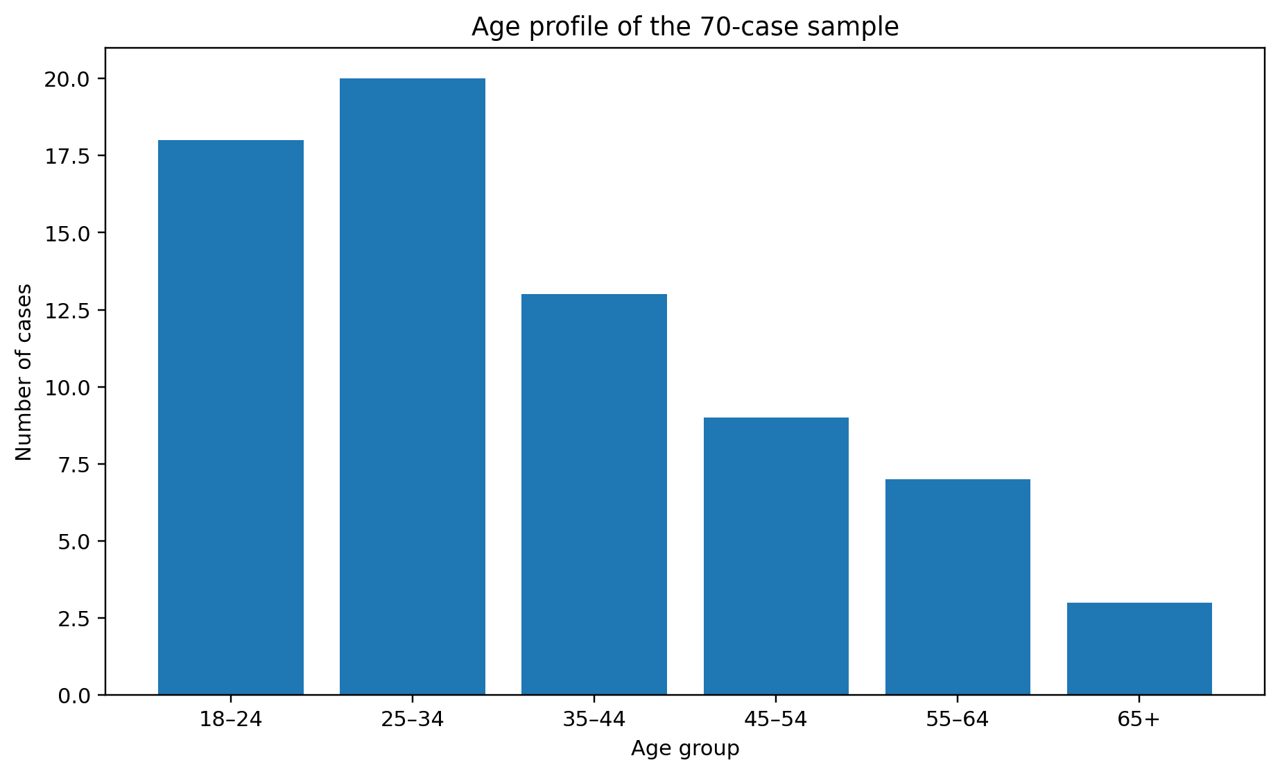
Figure 3. Age profile of the 70-case analytical sample.
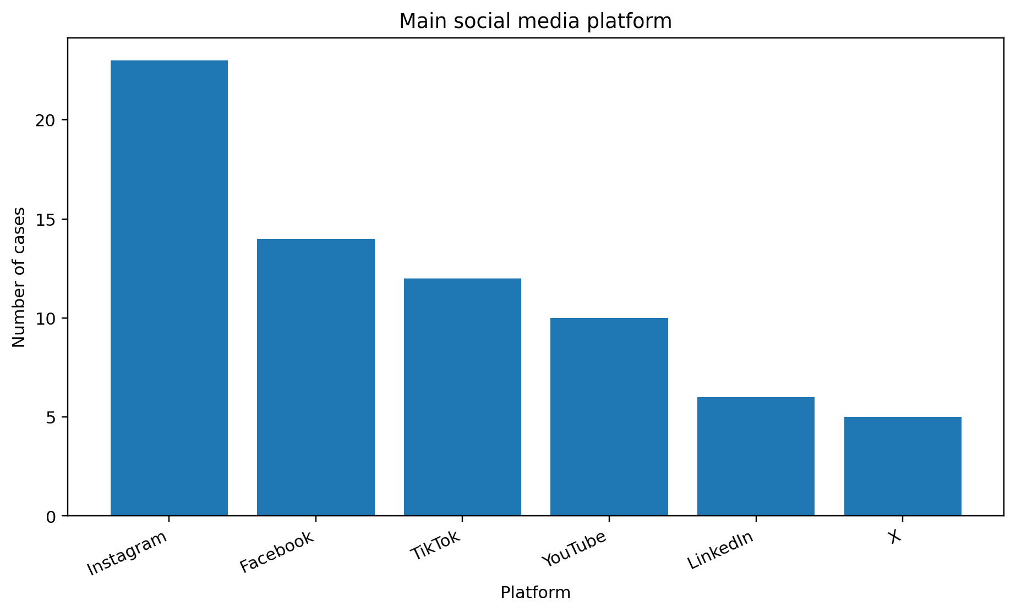
Figure 4. Main social-media platform represented in the sample.

Exposure to brand content was found to be 3.24 (SD = 1.27) while active engagement was 3.34 (SD = 1.36). While active engagement is slightly higher than exposure, this figure should be interpreted with caution given the non-representative nature of the sample of consumers surveyed. Even if consumers do not “like,” “comment” or “share” content from brands, their exposure to brand content still indicates the potential for those individuals to gain knowledge of that brand (Muntinga, Moorman and Smit, 2011; Ofcom, 2026).

4.3 Reliability and Overall Descriptive Analysis
Construct | Items | Cronbach’s alpha | Interpretation
Content perception | C1–C7 | 0.93 | Very strong; check item overlap
Content quality | C2–C4 | 0.93 | Very strong; check item overlap
Brand perception | C5–C7 | 0.94 | Very strong; check item overlap
Interactivity | D1–D2 | 0.88 | Acceptable
Trust/authenticity | D3–D6 | 0.94 | Very strong; check item overlap
Brand loyalty | E1–E4 and E7 | 0.96 | Very strong; check item overlap
Repeat purchase | E5–E6 | 0.72 | Acceptable
Table 2. Internal-consistency results for the 70-case dataset.

All of the principal scales reached or exceeded the conventional .70 benchmark for coefficient. Furthermore, the coefficients for content perception, brand perception, trust/authenticity and brand loyalty each exceeded .90, indicating good consistency within these scales but potentially leading to redundancy in some cases. The repeat-purchase scale reached .72, indicating that this scale could be used despite only having two items within the scale. The Cronbach’s alpha value is influenced by the number of items within a scale as well as the covariance between those items (Cronbach, 1951; Tavakol and Dennick, 2011).

Composite | Mean | SD | Observed range
Content perception | 3.28 | 1.13 | 1.14–5.00
Content quality | 3.43 | 1.27 | 1.00–5.00
Brand perception | 3.18 | 1.24 | 1.00–5.00
Interactivity | 3.15 | 1.21 | 1.00–5.00
Trust/authenticity | 3.28 | 1.20 | 1.00–5.00
Brand loyalty | 3.16 | 1.24 | 1.00–5.00
Repeat purchase intention | 3.29 | 1.07 | 1.00–5.00
Table 3. Descriptive statistics for the principal composite variables.

The means for the various attributes were close to the midpoint of the five-point scale. The highest mean was for content quality with a mean of 3.43, followed by repeat purchase intention with a mean of 3.29, trust/authenticity (M = 3.28) and content perception (M = 3.28). Brand loyalty had a slightly lower mean of 3.16. Thus, each of these attributes received, in general, moderate ratings from consumers, indicating the potential for correlation and regression analyses to reveal any relationships between these variables.

4.4 Objective 1: Influence of Social Media Content on Brand Perception
Item | Measure | Mean | SD
C1 | Content frequency | 3.13 | 1.37
C2 | Relevance | 3.47 | 1.28
C3 | Usefulness | 3.41 | 1.38
C4 | Visual appeal | 3.41 | 1.40
C5 | Improved opinion | 3.27 | 1.31
C6 | Relatability | 3.07 | 1.31
C7 | Perceived quality | 3.20 | 1.30
Composite | Content perception (C1–C7) | 3.28 | 1.13
Table 4. Section C item-level descriptive statistics.

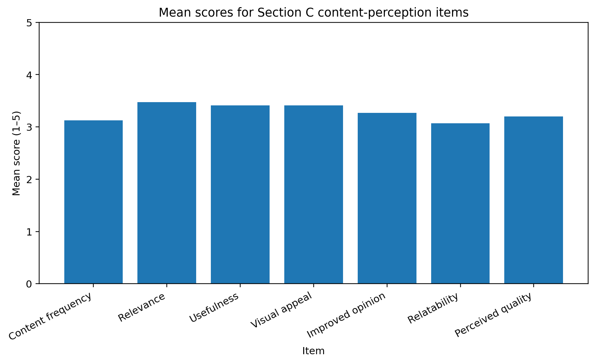
Figure 5. Mean scores for Section C content-perception items.

The highest mean for section C was for the relevance of the content (mean = 3.47), followed by the usefulness of the content and the visual appeal of the content (mean = 3.41 for each). [Least relatable mean = 3.07] These results help to show that the audience cares more for the function and presentation of the content over any attempts at branding or humanizing the company. Thus, this indicates that the focus should be on providing content that offers some sort of recognisable value to the audience rather than focusing on increasing the frequencies with which that content is posted (Ashley and Tuten, 2015; Schivinski and Dabrowski, 2016).

Predictor | Outcome | Pearson r | p-value
Exposure frequency | Brand perception | 0.492 | < .001
Content quality | Brand perception | 0.766 | < .001
Content perception | Brand loyalty | 0.726 | < .001
Content quality | Brand loyalty (H1) | 0.704 | < .001
Table 5. Correlations addressing Objective 1 and H1.
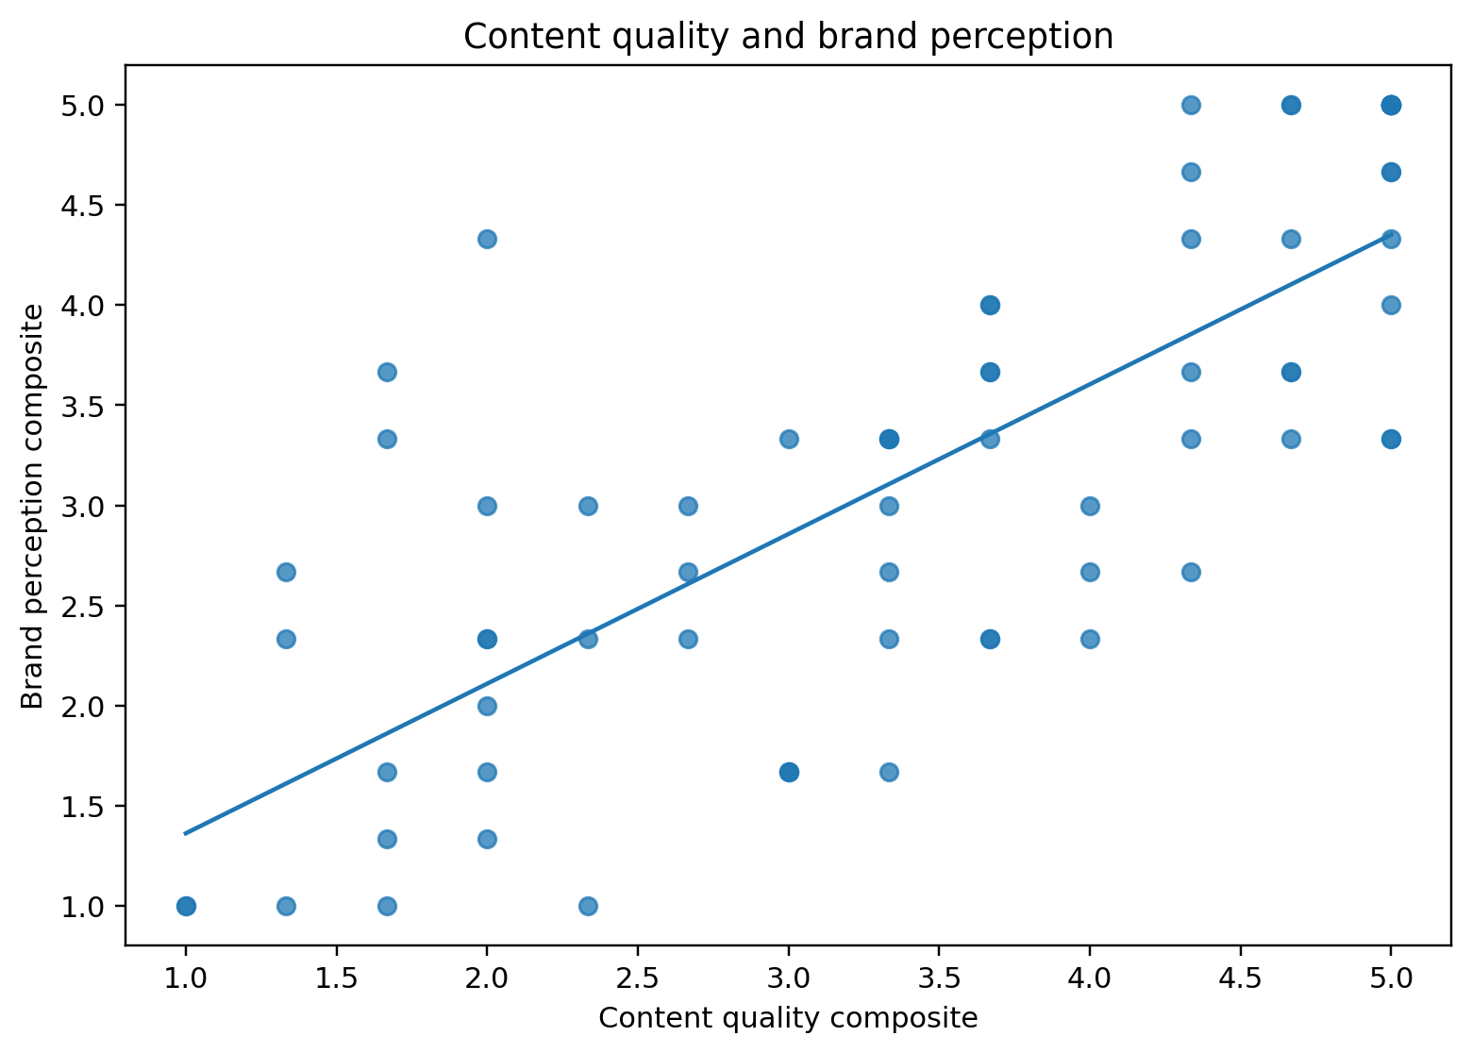
Figure 6. Relationship between content quality and brand perception.

Association Testing General brand perception (WTPBR) was used as the dependent variable for all testing. Content quality was, however, more strongly related to brand perception than exposure level (r =.77, p <. 001). Moreover, in a separate model that included both variables, content quality accounted for 59.7% of the variance in brand perception. Specifically, content quality was significant in explaining brand perception (standardised β = 0.70, p <. 001), but exposure was not (β = 0.12, p = 0.190). Thus, we can provide a straighter answer to our Objective 1: repeat views are not as important as might first be thought when brand perception is examined; quality of the content is. Furthermore, as brand loyalty is also related to content quality (r = 0.70, p <. 001), it is possible that content creators who provide high-quality content will be able to form stronger brand loyalties from their audiences (and, potentially, earn higher brand values from those audiences). Furthermore, this result is supportive of both uses and gratifications theory, as well as studies that investigate the difference between meaningful consumer engagement and post popularity (Katz, Blumler & Gurevitch 1973; De Vries, Gensler & Leeflang 2012).

4.5 Objective 2: Social Media Factors Contributing Most to Brand Loyalty
Item | Factor | Mean | SD | r with loyalty | p-value
D1 | Prompt response | 3.21 | 1.32 | 0.421 | < .001
D2 | Interactivity | 3.09 | 1.24 | 0.382 | = 0.001
D3 | Trustworthy information | 3.23 | 1.32 | 0.630 | < .001
D4 | Honesty/transparency | 3.29 | 1.18 | 0.710 | < .001
D5 | Authenticity | 3.37 | 1.32 | 0.634 | < .001
D6 | Consistency with values | 3.24 | 1.40 | 0.588 | < .001
D7 | Positive user reviews | 3.27 | 1.37 | 0.542 | < .001
D8 | Influencer endorsement | 2.87 | 1.23 | 0.234 | = 0.051
D9 | Emotional connection | 3.23 | 1.38 | 0.578 | < .001
Table 6. Section D item means and correlations with the brand-loyalty composite.
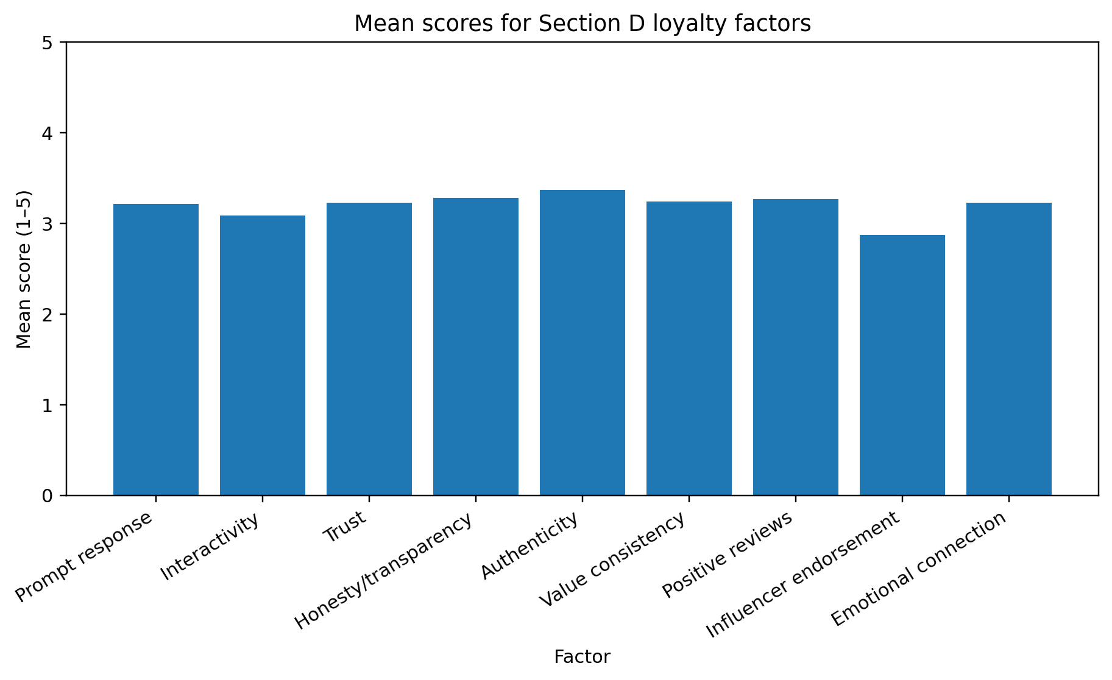
Figure 7. Mean scores for Section D loyalty factors.

The highest mean (M = 3.37) was for authenticity and the lowest for influence endorsement (M = 2.87). The discovery from the correlation between the two variables gives a more direct response to the research aim. A positive correlation was found between honesty/transparency and loyalty (.71), honesty (.63), credible information (.63), consistency with personal values (.59), psychological intimacy (.59), and emotional closeness (.58). However, the influencer promotion of these values was poor, scoring only narrowly passed the. 05 threshold for significance (.23, p =. 051). Such a disparity between the mean of the scales and the correlation between the same variables shows why relying on means alone to rank the importance of each factor is incomplete.

Directly selected factor | Frequency | %
Positive user reviews | 15 | 21.4%
Trustworthy information | 13 | 18.6%
Interaction/community | 11 | 15.7%
Authentic communication | 10 | 14.3%
Relevant content | 8 | 11.4%
Fast customer-service response | 7 | 10.0%
Influencer endorsement | 6 | 8.6%
Table 7. Direct ranking of the factors considered most important to loyalty (F3).

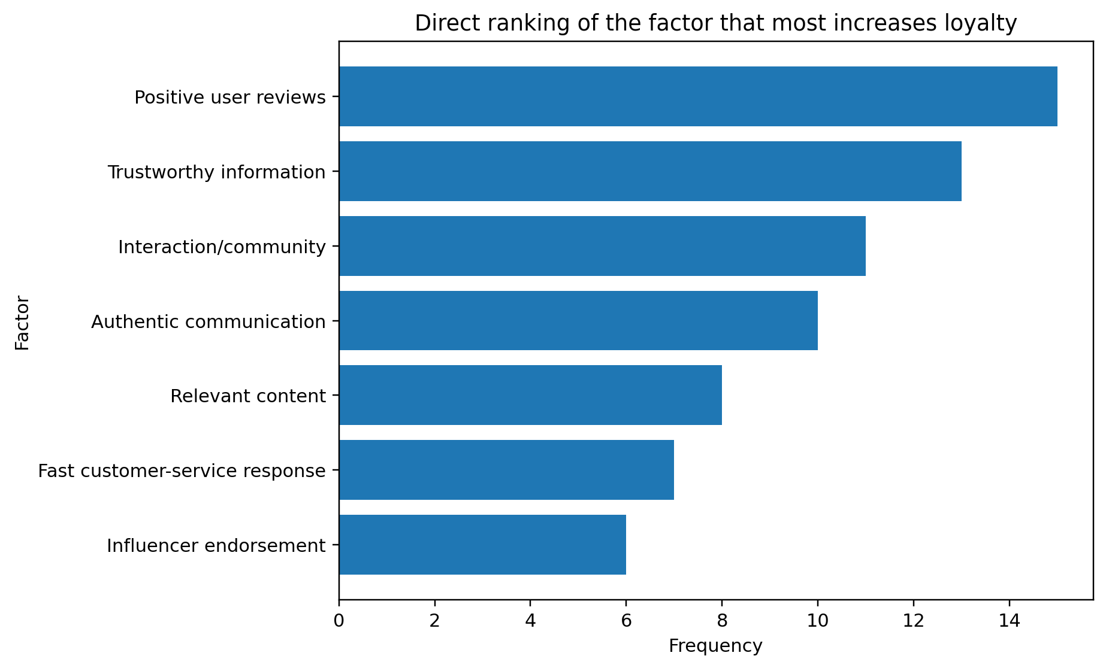
Figure 8. Direct ranking of the factor that increases loyalty most.

The most frequent codes were positive user reviews (n = 15; 21.4%), trustworthy information (n = 13; 18.6%), and interaction/community (n = 11; 15.7%). Thus, the direct ranking of these factors does not perfectly match the correlation ranking. One explanation for this relationship is that the question of which factor to select suggests that the respondents are likely to select the factor related to the reviews of the company, but both factors related to honesty and authenticity correlate with the loyalty ranking. Thus, these two factors as ranked by direct and correlation rankings are measurements of different judgments of the company and its website.

Table 8. Multiple regression predicting brand loyalty (R² = 0.754; adjusted R² = 0.730).
Predictor | Standardised β | t | p-value
Content quality | 0.311 | 3.89 | < .001
Interactivity | 0.220 | 3.34 | = 0.001
Trust/authenticity | 0.323 | 4.02 | < .001
Positive eWOM | 0.224 | 3.14 | = 0.003
Influencer endorsement | 0.005 | 0.07 | = 0.942
Emotional connection | 0.165 | 2.19 | = 0.033

The model that was used in this test included six different predictors of brand loyalty and was able to explain 75.4% of the variance in the concept of brand loyalty, F(6, 63) = 32.12, p <. 001. Trust/authenticity emerged as the strongest predictor of brand loyalty with coefficients of .32 and p < This is still relative to having more companies adopting artificial intelligence at the same or less than the maximum rate level of hedging with coefficients of 0.001, and relative to the degree of qualitative content in the brand communications with coefficients of .31 and p <. 001, the strongest independent predictors of brand loyalty were (table 001). Thus, support for both H2 and H3. These findings are in alignment with the theories of commitment and trust in brands, as well as the theories of authenticity of brands, indicating that the credibility and congruency of the brand with the consumers was the strongest factor in the development of brand loyalty rather than the reach of those brands for visibility (Morgan and Hunt, 1994; Napoli et al., 2014; Morhart et al., 2015).

4.6 Objective 3: Engagement and Repeat Purchase Intention
Item | Loyalty/repurchase measure | Mean | SD
E1 | Self-rated loyalty | 3.20 | 1.34
E2 | Choose over competitors | 3.13 | 1.33
E3 | Recommendation | 3.13 | 1.35
E4 | Continue engagement | 3.20 | 1.25
E5 | Repurchase intention | 3.24 | 1.29
E6 | Engagement increases purchase | 3.33 | 1.13
E7 | Continue despite alternative | 3.13 | 1.40
Table 9. Section E item-level descriptive statistics.
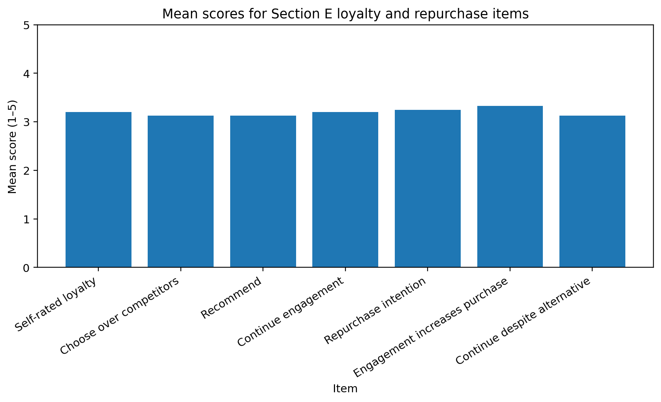
Figure 9. Mean scores for Section E loyalty and repurchase items.

The highest Section E mean was for the notion that one is more likely to buy if engaged (M = 3.33) and the intention to repurchase directly followed in intent (M = 3.24). Preference of the brand over competitors, suggesting and repurchase in spite of better options were modestly higher (all M = 3.13). This is congruent to Oliver (1999) view that differentiates between favourable intention versus strong action loyalty.

Question | Response | Frequency | %
F1: Purchased after social-media content | Yes | 32 | 45.7%
F1: Purchased after social-media content | No | 28 | 40.0%
F1: Purchased after social-media content | Not sure | 10 | 14.3%
F2: Frequency in last 12 months | Never | 32 | 45.7%
F2: Frequency in last 12 months | Once | 12 | 17.1%
F2: Frequency in last 12 months | 2–3 times | 9 | 12.9%
F2: Frequency in last 12 months | 4–5 times | 6 | 8.6%
F2: Frequency in last 12 months | More than 5 times | 11 | 15.7%
Table 10. Purchase behaviour reported in F1 and F2.
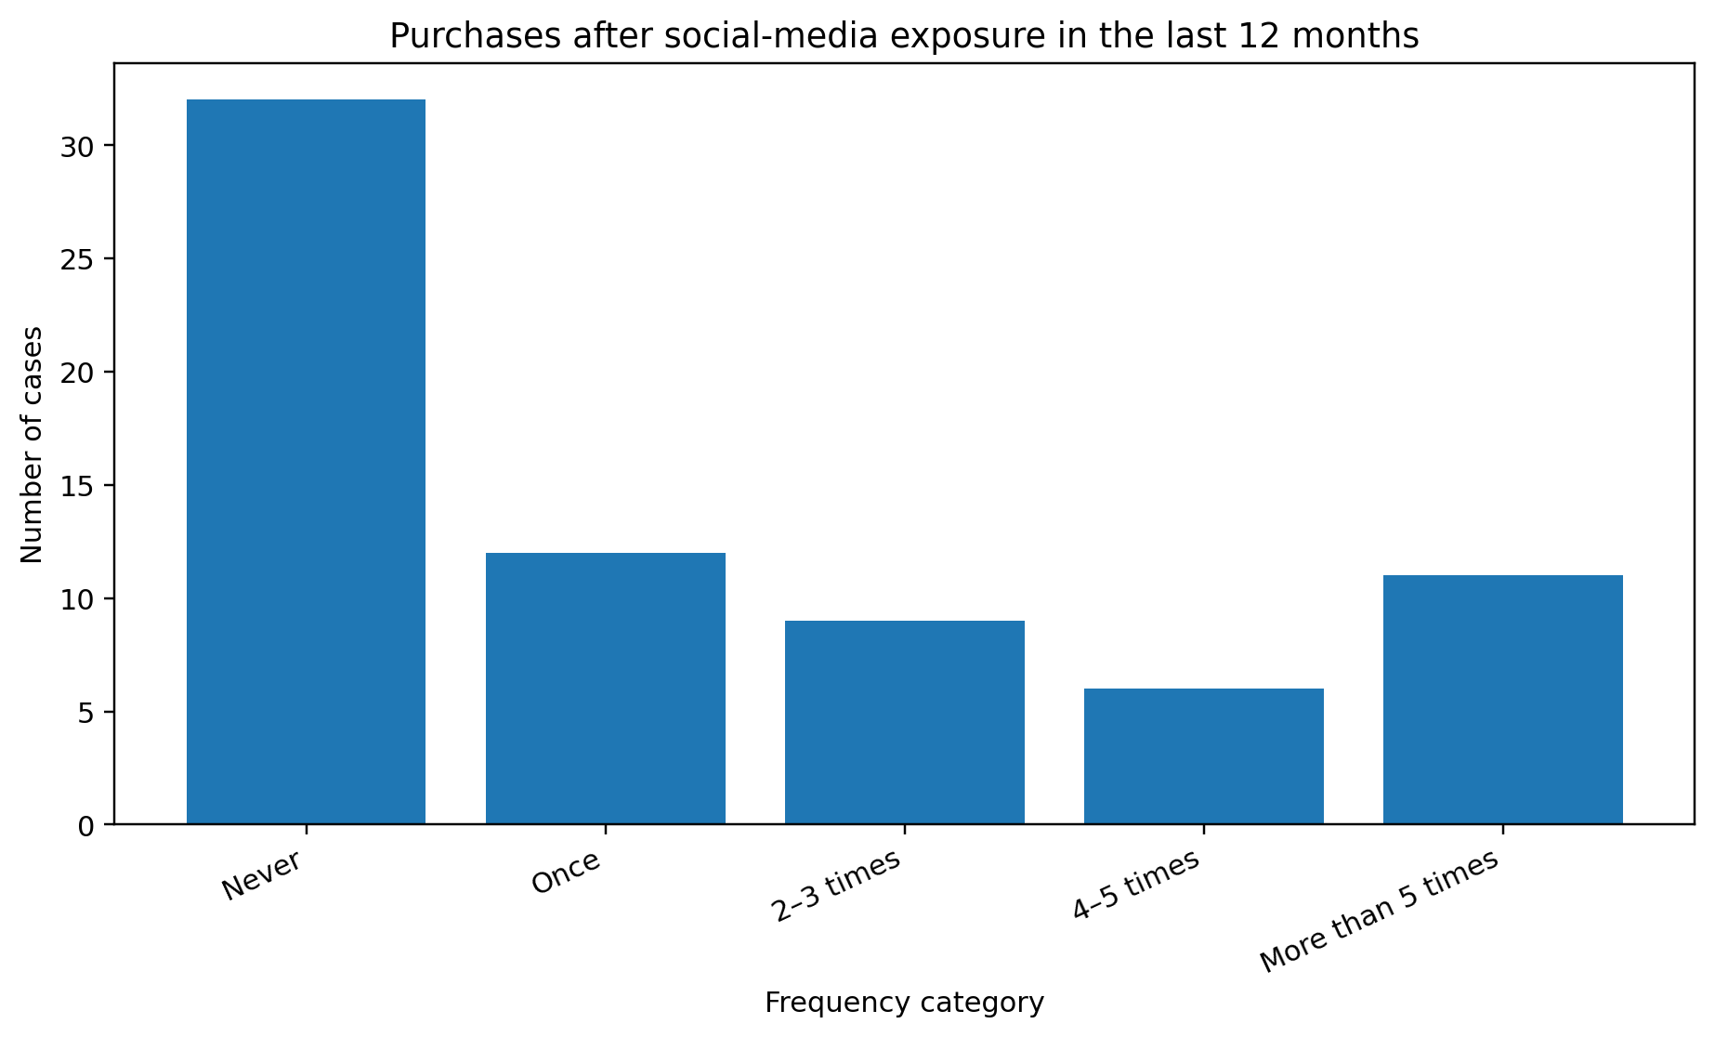
Figure 10. Frequency of purchases following social-media exposure in the last 12 months.
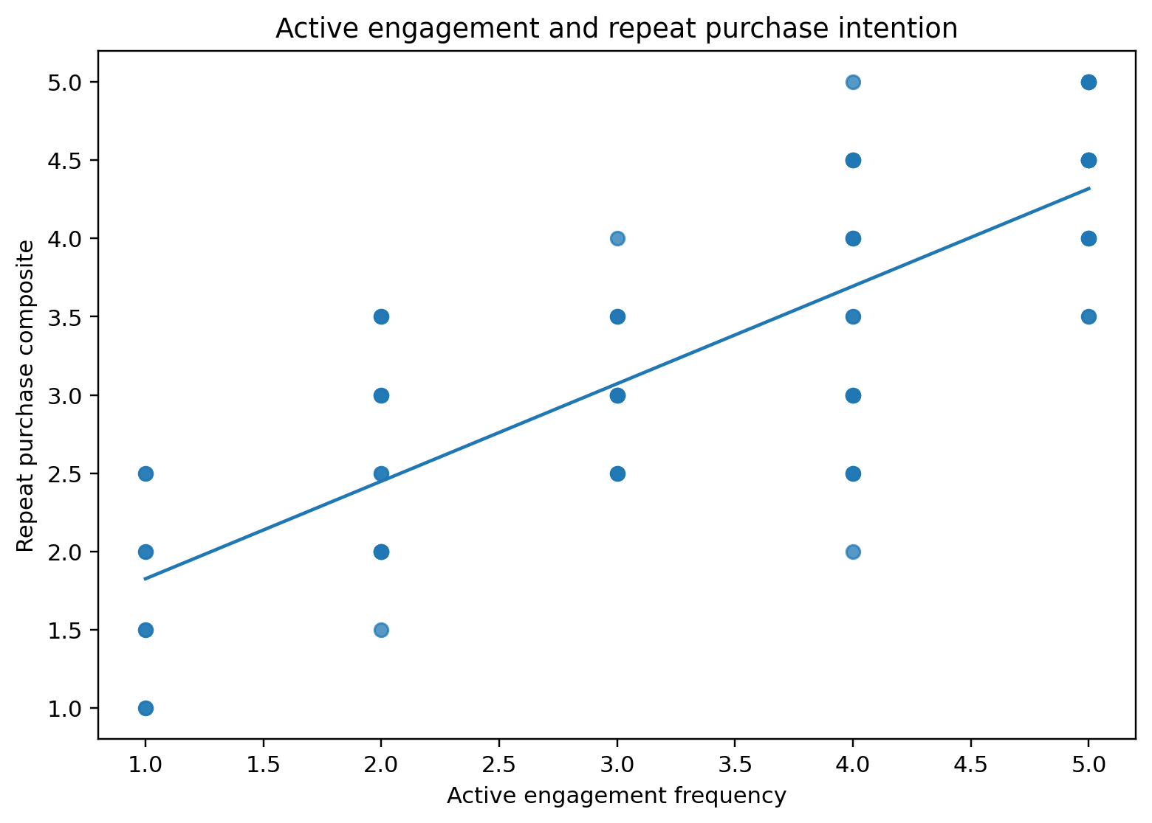
Figure 11. Relationship between active engagement and repeat purchase intention.

Thirty two respondents (45.7%) indicated they went on to purchase after seeing on social media, 28 (40.0%) said no, and 10 (14.3%) did not know. As would be expected, engagement was significantly correlated with the repeat purchase composite (r = 0.79, p <. 001). Repeat purchase intention (β = 0.79, p <. 001). Thus, you supported the H4 hypothesis in your analysed data set. This supports the theory of Customer Engagement Theory relating activation to repurchase and referral metrics (Hollebeek, Glynn and Brodie, 2014; Pansari and Kumar, 2017). There can be no causative assumption: that engagement increases purchase intention may be due to loyalty driving engagement.

4.7 Discussion of Findings

Combined these are supportive of a mediation story though they should not be construed as mediation tests. Perceptions of content were also positively correlated with trust/authenticity (r = 0.61, p <. 001), perceived content was related to repeat purchase intention (r = 0.57, p <. 001), under the new variables trust/authenticity was related to repeat purchase intention (r = 0.47, p <. 001), repeat purchase intention was negatively related to price-sensitive brand loyalty (r = −0. 002), again the pattern should fit whereby valuable content reinforces perceptions, trustworthy communication builds relationship strength with the firm and loyalty fosters repurchase intentions. All this relates in order with Uses and Gratifications Theory, commitment-trust theory and Customer Engagement Theory (Katz, Blumler and Gurevitch, 1973; Morgan and Hunt, 1994; Pansari and Kumar, 2017).
The correlation analyses both supported and contradicted the direct ranking of F3 only weakly. Positive reviews emerged as the top vote-getter item-wise, but honesty/transparency was associated with loyalty-and trust/authenticity was the strongest composite predictor in regression analyses. This suggests social proof may be a deliberative factor at decision time as compared to credibility and value congruence which are more “hysterectically” integrated into loyal attitudes. E-WOM can ease decision uncertainty, but its effectiveness is contingent upon perceived independence and quality of information (Hennig-Thurau et al., 2004; Cheung Lee and Rabjohn, 2008; Ngo et al., 2024).
The implications of this also challenge the assumption that all engagement is of equal worth. Influencer endorsement mean was lowest and did not predict loyalty by itself; interactivity only mattered if a response-quality composite was used which included this construct. Yet this correlates with literature which argues that influencer impact is dependent on credibility and fit, and community interaction is only useful if it facilitates reciprocity (Sashi, 2012; Lou and Yuan, 2019; Sokolova & Kefi, 2020).
Finally, the findings need to be considered in relation to the intention-behaviour gap. One was assessed using repeat purchase intentions rather than an intention-based measure; predictors and criteria also came from the same questionnaire. However, to put it all together, relationships can be affected by common-method bias, social desirability and social coherence (Podsakoff et al., 2003). Longitudinal or purchase-linked studies will be needed to verify that social-media engagement does indeed precede and predict actual repeat purchasing.

4.8 Implications of the Findings
The results provide evidence in support of an amalgamated model of theories of customer engagement. While the model could be explained by a variety of different theories, none come close to explaining the details provided within the model. For instance, the importance of paying attention to the content itself relates to Uses and Gratifications Theory, the importance of interaction relates to Social Exchange Theory, the importance of trust and commitment to the relationship with the company relates to Relationship Marketing Theory, and the importance of taking action relating to the company’s products or services relates to Customer Engagement theory.
Moving on from vanity metrics in practice for the business Along with these variables related to Customer Engagement Theory, other variables to consider for the success of customer engagement campaigns include trust, the likelihood of customers recommending the company to others, the resistance of customers to change to their current providers of goods and services, and the willingness of customers to purchase those products again. Ensure that efforts are made to be responsive to customers, but meaningfully.
The words spoken publicly by the company should reflect the actions taken by the company. Qualify the reviews from customers as a sign of the relationship capability between the company and customers instead of simply utilizing its platforms as a means of promoting its products. Do not mis-judge an influencer and their potential for the campaign to be successful due to the volume of their followers; base decisions on credibility of the influencer and the influencer’s relationship with their audience base.

Chapter 5: Conclusions, Limitations and Recommendations

5.1 Introduction
This chapter concludes this dissertation in relation to the research problem and questions. It summarizes the key findings, provides an overall answer to the research problem, discusses the contribution of this work by revisiting its interest, covers limitations and distinguishes between managerial implications and future research directions. These conclusions are drawn from the 70-case analysis in chapter 4.
Finally, content analysis revealed that social-media content influences customer opinion, but content quality outweighs content quantity. The highest average ratings in Section C were for relevance, usefulness and visual appeal; content quality emerged as the strongest predictor of brand perception when controlling for exposure. Rather than merely measuring the quantity of ad unit exposures to consumers, advertisers should be investigating whether variations in content drive variations in perceived value and meaning to the brand.
At the item level, honesty/transparency (item 1), authenticity and quality/validity of data were all related to brand loyalty. The multiple regression did establish that trust/authenticity and content quality were the two strongest independent predictors and that influencer endorsement had no unique explanatory power. The applicability of social proof is most apparent in that positive reviews was the modal choice in the direct ranking, despite variables related to credibility seeming to align more closely with the loyalty composite.
Repeat purchase intention was highly correlated with active engagement. This does provide additional support for the idea that likes, comments, shares, saves and DMs can bring commercially valuable results. However, since the design is cross-sectional, causation cannot be confirmed as it may be engagement producing loyalty or loyal consumers simply engaging more. Thus, this finding is relational not causal.
Evidence of the support for each of these concepts provides the reason for the recommendations regarding centricity, credibility and measurement. Relevant Content - Businesses must also create content that is relevant to the customers, communicate with them honestly, ensure their interactions with the brand are beneficial to them, respond to their reviews, and measure the loyalty of their customers to their brand and its reach.
The research problem was to determine the types of engagement with social media that were associated with loyalty amongst UK adults. Through this research, it was determined that engagement with social media can be a multi-dimensional term. Each of these dimensions relates to the concept of loyalty in that the more that an individual is exposed to a brand, the more aware they will be of the brand. Additionally, if the brand produces high quality content and features individuals that are trusted with such content, the customers will become more confident in the brand and the products that it offers.
Furthermore, if individuals see others utilizing the products of a brand, they are more likely to be interested in purchasing those products themselves. Therefore, brands that focus upon providing customers with positive social experiences and increasing their engagement with the customers will create the most value from such engagement, as opposed to those that simply focus upon increasing their social media following.

5.2 Original Contribution of the Research
The main contribution of the dissertation is an integrative framework focused on the UK that considers each of these variables separately: social-media exposure, content quality, interactivity between the SMEs and the consumers, trust between the influencers and SMEs and vice-versa, electronic word-of-mouth comparisons with traditional forms of advertising, and the emotional connection that consumers feel with the influences that they consume content from rather than considering social-media marketing as a single variable. Furthermore, SME loyalty is related to purchase intention through repeat purchases, both directly and through ranking and correlation analyses. Finally, beyond providing a simple framework for analysing the survey data, the model also provides a theoretically-sensible framework for understanding how the content that is published by an organisation is perceived by consumers and how that perception translates into the development of loyalty and a willingness to repurchase the products or services of that SME.

5.3 Limitations of the Research
The external validity of the study’s data is limited due to the sampling strategy being a convenience sample with biases in regard to the age, network and platform of the participants. Furthermore, all of the variables were self-reported by the participants, which introduces the potential for error in the recall of those variables. Finally, while the study did provide information about the various brands and brand attributes in certain categories, the research was performed cross-sectionally and, therefore, provides only a snapshot of the perceptions of the consumers at one point in time, without indicating whether or how those perceptions changed over time. Additionally, while the consumers were prompted to think about brands and brand attributes that they thought about in the past week, there was no control over variables like level of involvement with the brands, pricing perceptions, purchase cycles, and competition between brands.

5.4 Recommendations for Future Research
Future studies are encouraged to slim far more than 70 usable responses that will activate us to our quota or to recruit participants that are representative of different age groups and platforms. Using a larger sample of individuals would allow researchers to perform confirmatory factor analyses and models to determine the effect of engagement on repurchase intentions. Longitudinal studies could assess the impact of altering engagement with brands on the future repurchase of those products. Additionally, studies that involve transactions from those that indicated intentions to actually behave in those ways can help determine the differences between these groups. Furthermore, employing mediation analysis could help determine if individuals’ perception of the content of the brands leads to the repurchase of those products as a result of the development of trust and loyalty towards those brands.

References
Aaker, D.A. (1991) Managing Brand Equity. New York: Free Press.
Aaker, D.A. (1996) Building Strong Brands. New York: Free Press.
Algesheimer, R., Dholakia, U.M. and Herrmann, A. (2005) ‘The social influence of brand community: Evidence from European car clubs’, Journal of Marketing, 69(3), pp. 19–34.
Appel, G., Grewal, L., Hadi, R. and Stephen, A.T. (2020) ‘The future of social media in marketing’, Journal of the Academy of Marketing Science, 48(1), pp. 79–95.
Ashley, C. and Tuten, T. (2015) ‘Creative strategies in social media marketing’, Psychology & Marketing, 32(1), pp. 15–27.
Bell, E., Bryman, A. and Harley, B. (2022) Business Research Methods. 6th edn. Oxford: Oxford University Press.
Blau, P.M. (1964) Exchange and Power in Social Life. New York: Wiley.
Boateng, G.O. et al. (2018) ‘Best practices for developing and validating scales’, Frontiers in Public Health, 6, 149.
British Psychological Society (2021) Code of Human Research Ethics. Leicester: BPS.
Brodie, R.J. et al. (2011) ‘Customer engagement: Conceptual domain, fundamental propositions, and implications’, Journal of Service Research, 14(3), pp. 252–271.
Brodie, R.J., Ilic, A., Juric, B. and Hollebeek, L. (2013) ‘Consumer engagement in a virtual brand community: An exploratory analysis’, Journal of Business Research, 66(1), pp. 105–114.
Bryman, A. and Bell, E. (2015) Business Research Methods. 4th edn. Oxford: Oxford University Press.
Chaudhuri, A. and Holbrook, M.B. (2001) ‘The chain of effects from brand trust and brand affect to brand performance’, Journal of Marketing, 65(2), pp. 81–93.
Cheung, C.M.K., Lee, M.K.O. and Rabjohn, N. (2008) ‘The impact of electronic word-of-mouth’, Internet Research, 18(3), pp. 229–247.
Cohen, J. (1988) Statistical Power Analysis for the Behavioral Sciences. 2nd edn. Hillsdale, NJ: Lawrence Erlbaum.
Creswell, J.W. and Creswell, J.D. (2018) Research Design: Qualitative, Quantitative, and Mixed Methods Approaches. 5th edn. Los Angeles: Sage.
Cronbach, L.J. (1951) ‘Coefficient alpha and the internal structure of tests’, Psychometrika, 16(3), pp. 297–334.
DataReportal (2025) Digital 2026: The United Kingdom. Available at: https://datareportal.com/reports/digital-2026-united-kingdom (Accessed: 3 July 2026).
de Oliveira Santini, F., Ladeira, W.J., Sampaio, C.H. and Perin, M.G. (2020) ‘Customer engagement in social media: A framework and meta-analysis’, Journal of the Academy of Marketing Science, 48(6), pp. 1211–1228.
De Vries, L., Gensler, S. and Leeflang, P.S.H. (2012) ‘Popularity of brand posts on brand fan pages’, Journal of Interactive Marketing, 26(2), pp. 83–91.
Dessart, L., Veloutsou, C. and Morgan-Thomas, A. (2015) ‘Consumer engagement in online brand communities: A social media perspective’, Journal of Product & Brand Management, 24(1), pp. 28–42.
Dick, A.S. and Basu, K. (1994) ‘Customer loyalty: Toward an integrated conceptual framework’, Journal of the Academy of Marketing Science, 22(2), pp. 99–113.
Dillman, D.A., Smyth, J.D. and Christian, L.M. (2014) Internet, Phone, Mail, and Mixed-Mode Surveys. 4th edn. Hoboken, NJ: Wiley.
Ebrahim, R.S. (2020) ‘The role of trust in understanding the impact of social media marketing on brand equity and brand loyalty’, Journal of Relationship Marketing, 19(2), pp. 287–308.
Etikan, I., Musa, S.A. and Alkassim, R.S. (2016) ‘Comparison of convenience sampling and purposive sampling’, American Journal of Theoretical and Applied Statistics, 5(1), pp. 1–4.
Field, A. (2018) Discovering Statistics Using IBM SPSS Statistics. 5th edn. London: Sage.
Fowler, F.J. (2014) Survey Research Methods. 5th edn. Thousand Oaks, CA: Sage.
Gummerus, J. et al. (2012) ‘Customer engagement in a Facebook brand community’, Management Research Review, 35(9), pp. 857–877.
Hair, J.F. et al. (2019) Multivariate Data Analysis. 8th edn. Andover: Cengage.
Hennig-Thurau, T. et al. (2004) ‘Electronic word-of-mouth via consumer-opinion platforms’, Journal of Interactive Marketing, 18(1), pp. 38–52.
Hollebeek, L.D., Glynn, M.S. and Brodie, R.J. (2014) ‘Consumer brand engagement in social media: Conceptualization, scale development and validation’, Journal of Interactive Marketing, 28(2), pp. 149–165.
Ismail, A.R. (2017) ‘The influence of perceived social media marketing activities on brand loyalty’, Asia Pacific Journal of Marketing and Logistics, 29(1), pp. 129–144.
Joshi, A. et al. (2015) ‘Likert scale: Explored and explained’, British Journal of Applied Science & Technology, 7(4), pp. 396–403.
Kaplan, A.M. and Haenlein, M. (2010) ‘Users of the world, unite! The challenges and opportunities of social media’, Business Horizons, 53(1), pp. 59–68.
Katz, E., Blumler, J.G. and Gurevitch, M. (1973) ‘Uses and gratifications research’, Public Opinion Quarterly, 37(4), pp. 509–523.
Keller, K.L. (2013) Strategic Brand Management: Building, Measuring, and Managing Brand Equity. 4th edn. Harlow: Pearson.
Laroche, M., Habibi, M.R. and Richard, M.-O. (2013) ‘How brand loyalty is affected by social media’, International Journal of Information Management, 33(1), pp. 76–82.
Likert, R. (1932) ‘A technique for the measurement of attitudes’, Archives of Psychology, 22(140), pp. 1–55.
Lou, C. and Yuan, S. (2019) ‘Influencer marketing: Message value, credibility and trust’, Journal of Interactive Advertising, 19(1), pp. 58–73.
Morgan, R.M. and Hunt, S.D. (1994) ‘The commitment-trust theory of relationship marketing’, Journal of Marketing, 58(3), pp. 20–38.
Morhart, F. et al. (2015) ‘Brand authenticity: An integrative framework and measurement scale’, Journal of Consumer Psychology, 25(2), pp. 200–218.
Muntinga, D.G., Moorman, M. and Smit, E.G. (2011) ‘Introducing COBRAs’, International Journal of Advertising, 30(1), pp. 13–46.
Napoli, J. et al. (2014) ‘Measuring consumer-based brand authenticity’, Journal of Business Research, 67(6), pp. 1090–1098.
Ngo, T.T.A., Bui, H.T., Nguyen, N.P. and Nguyen, T.H. (2024) ‘Electronic word-of-mouth (eWOM) on social networking sites: Roles of information credibility in shaping online purchase intention’, Heliyon, 10(11), e32096.
Nunnally, J.C. and Bernstein, I.H. (1994) Psychometric Theory. 3rd edn. New York: McGraw-Hill.
Ofcom (2026) Passive social media use, AI companionship, and online side hustles: UK adults’ media and online lives revealed. Available at: https://www.ofcom.org.uk/ (Accessed: 3 July 2026).
Oliver, R.L. (1999) ‘Whence consumer loyalty?’, Journal of Marketing, 63(Special Issue), pp. 33–44.
Pallant, J. (2020) SPSS Survival Manual. 7th edn. Maidenhead: Open University Press.
Pansari, A. and Kumar, V. (2017) ‘Customer engagement: The construct, antecedents, and consequences’, Journal of the Academy of Marketing Science, 45(3), pp. 294–311.
Papadopoulou, C., Vardarsuyu, M. and Oghazi, P. (2023) ‘Examining the relationships between brand authenticity, perceived value, and brand forgiveness: The role of cross-cultural happiness’, Journal of Business Research, 167, 114154.
Podsakoff, P.M. et al. (2003) ‘Common method biases in behavioral research’, Journal of Applied Psychology, 88(5), pp. 879–903.
Sashi, C.M. (2012) ‘Customer engagement, buyer-seller relationships, and social media’, Management Decision, 50(2), pp. 253–272.
Saunders, M., Lewis, P. and Thornhill, A. (2019) Research Methods for Business Students. 8th edn. Harlow: Pearson.
Schivinski, B. and Dabrowski, D. (2016) ‘The effect of social media communication on consumer perceptions of brands’, Journal of Marketing Communications, 22(2), pp. 189–214.
Sokolova, K. and Kefi, H. (2020) ‘Instagram and YouTube bloggers promote it, why should I buy?’, Journal of Retailing and Consumer Services, 53, 101742.
Tabachnick, B.G. and Fidell, L.S. (2019) Using Multivariate Statistics. 7th edn. Boston, MA: Pearson.
Taherdoost, H. (2016) ‘Sampling methods in research methodology’, International Journal of Academic Research in Management, 5(2), pp. 18–27.
Tavakol, M. and Dennick, R. (2011) ‘Making sense of Cronbach’s alpha’, International Journal of Medical Education, 2, pp. 53–55.
UK Research Integrity Office (2020) Code of Practice for Research. London: UKRIO.
Vivek, S.D., Beatty, S.E. and Morgan, R.M. (2012) ‘Customer engagement beyond purchase’, Journal of Marketing Theory and Practice, 20(2), pp. 122–146.
Voorveld, H.A.M. et al. (2018) ‘Engagement with social media and social media advertising’, Journal of Advertising, 47(1), pp. 38–54.
Watson, G.F. et al. (2015) ‘Building, measuring, and profiting from customer loyalty’, Journal of the Academy of Marketing Science, 43(6), pp. 790–825.
Yadav, M. and Rahman, Z. (2018) ‘The influence of social media marketing activities on customer loyalty: A study of the e-commerce industry’, Benchmarking: An International Journal, 25(9), pp. 3882–3905.

Appendix A: Main Survey Questionnaire
Please answer with one brand in mind. Unless stated otherwise, use 1 = Strongly disagree to 5 = Strongly agree.

Section A: Eligibility and Consent
Code | Question/Statement | Response
A1 | Are you aged 18 or above? | Yes/No
A2 | Do you live in the UK? | Yes/No
A3 | Do you use social media? | Yes/No
A4 | I have read the information and consent to participate. | Yes/No

Section B: Background and Use
Code | Question/Statement | Response
B1 | Age group | 18–24 / 25–34 / 35–44 / 45–54 / 55–64 / 65+
B2 | Gender | Woman / Man / Non-binary / Prefer not to say
B3 | Platforms used | Facebook / Instagram / TikTok / YouTube / X / LinkedIn / Other
B4 | How often do you see brand content? | Never–Very often
B5 | How often do you actively engage with brand content? | Never–Very often

Section C: Content and Perception
Code | Question/Statement | Response
C1 | I see content from this brand frequently. | 1–5
C2 | The content is relevant to me. | 1–5
C3 | The content is useful or informative. | 1–5
C4 | The content is visually appealing and clear. | 1–5
C5 | The content has improved my opinion of the brand. | 1–5
C6 | The brand feels more relatable because of social media. | 1–5
C7 | Engaging content makes the brand appear higher quality. | 1–5

Section D: Loyalty Factors
Code | Question/Statement | Response
D1 | The brand responds promptly. | 1–5
D2 | Communication feels interactive. | 1–5
D3 | I trust the information shared. | 1–5
D4 | The brand communicates honestly. | 1–5
D5 | The communication feels authentic. | 1–5
D6 | The brand behaves consistently with its values. | 1–5
D7 | Positive reviews strengthen my confidence. | 1–5
D8 | Influencer endorsements increase my interest. | 1–5
D9 | I feel emotionally connected to brands I interact with. | 1–5

Section E: Loyalty and Repurchase
Code | Question/Statement | Response
E1 | I consider myself loyal to this brand. | 1–5
E2 | I would choose it over competitors. | 1–5
E3 | I would recommend it. | 1–5
E4 | I intend to continue following or interacting. | 1–5
E5 | I am likely to purchase again. | 1–5
E6 | Engagement increases my likelihood of purchase. | 1–5
E7 | I would continue buying despite a similar alternative. | 1–5

Section F: Purchase Behaviour
Code | Question/Statement | Response
F1 | Have you purchased after seeing something on social media? | Yes/No/Not sure
F2 | How often in the last 12 months? | Never / Once / 2–3 / 4–5 / More than 5
F3 | Which factor most increases loyalty? | Relevant content / Fast response / Trust / Authenticity / Community / Reviews / Influencer / Other

Appendix B: Excel Dataset of 70 Complete Responses
A separate Excel workbook accompanies this dissertation and contains all 70 response records, the coding guide, composite scores and summary analysis used in Chapter 4.

Appendix C: Participant Information and Consent
Participation is voluntary and anonymous. The questionnaire takes approximately 6–8 minutes. No direct identifiers are collected. Participants may stop before submission; anonymous responses may not be removable after submission.

