Targed/Target 1 | Expand further reading.
Targed/Target 2 | Explain idea’s in more detail.
Targed/Target 3 | Try and maintain awareness of contrasting perspectives.
Targed/Target 4 | Make links to literature.
Targed/Target 5 | Check for punctuation errors.

ECAD5007 – Intervention Lucy Badham-1800114

Choose an intervention that supports the learning and development of a pupil / group of pupils. Reflect critically on its potential for ensuring pupil progression and the possible challenges that may arise.

Throughout this assignment, an intervention will be discussed thoroughly, aiming to assist a group of pupils to improve their social, emotional and behavioural skills within a school environment in order to aim to improve behaviour of pupils by simply talking. NASUWT (2018) recognises the importance of interventions within a school environment as they suggest that interventions are one of the key strategies available to support the progress of pupils. Additionally, the Welsh Government (2016) would agree that interventions are an asset to schools as they state that if interventions are put in place early, then they will provide success not only for the school, but the pupils who need assistance. The intervention chosen will focus on improving the behaviour and emotional skills of pupils and it will have many components. The aim for the intervention was to not be too restrictive, as pupils will then be able to discuss aspects that they feel are important to them, instead of just being led by a more knowledgeable other. HM Government (2019) would support the fact that interventions should be less restrictive as they suggest that a restrictive intervention should only be used when absolutely necessary. Furthermore, another component that needed to be considered when developing the intervention was to understand the cause for the intervention, that is why the intervention chosen is on a group of pupils who were present in my professional teaching practice. It is essential that you have a good understanding of the cause of the behaviour of the child before trying to change it all together. FIND (No Date) imply that behaviour can be caused by a range of different things and will be different for each individual. Therefore, if you do not understand it, then it can lead to the specific behaviour being ingrained over time. Specifically focusing on the intervention chosen by myself, the ‘Circle of Friends’ has been chosen. The intervention was originally developed by Forest (1993) and focuses on the approach of full inclusion for all. The approach can be used to develop a sense of community not only in a classroom, but in a school. It is thought of as an important tool to enhance the social cohesion of pupils. ‘Circle of Friends’ aims to get pupils who struggle socially due to their behaviour to learn and have a session with their friends help and guide them to be more socially understanding. For example, a certain pupil within the class runs around the playground whipping a skipping rope around his head, however they are oblivious to the fact that they have hurt other pupils. There is no aggression or malice in the way that the pupil has acted, but their friends are upset due to the fact that they have been hurt and they have not received an apology. The ‘Circle of Friends’ would then be conducted, and the circle discusses what has just taken place, discussing how all of the parties feel and how it has effected them emotionally and physically. Therefore, the hope is that this intervention will help the pupils explain how they feel and get the children to understand rather than the more knowledgeable other. The ‘Circle of Friends’ intervention has been used in multiple schools and is highly recognised as being an intervention that is successful. For this specific intervention, the aim is to focus on a pupil who is on the autistic spectrum as seen in ‘Appendix 1’. Norwood (2013) focuses on this specific intervention and suggests that this is successful and effective for children who struggle specifically with friendships including those who have specific emotional and social needs and autistic. This could be due to the fact that pupils are able to make their own decisions and discuss what works for them as an individual as they can generate their own ideas and strategies to help them in their everyday lives, as Norwood (2013) discusses. Additionally, the decision was made to focus this intervention on a pupil who is on the autistic spectrum as there has been personal experiences during professional teaching practice, and I believe that it is essential that you understand the child and their needs before trying to change anything. Furthermore, the intervention chosen will last around six to eight weeks, which will include around six members of the class of all different abilities, including the pupil who the intervention is focused on. The meetings will take place once a week to discuss any aspects that need to be discussed and it will provide an opportunity for all of the pupils to express their emotions in a safe environment. Croner (2012) suggests that in order for pupils to flourish and reach their full potential, then they need to have a positive emotional environment, so that is why pupils will be encouraged to express their feelings freely. The sessions that will take place over the course of a few weeks, will focus on pupils discussing events that might have occurred during the school week and any aspects that they feel should be discussed to assist them emotionally and physically.
Throughout the intervention that has been chosen, there are multiple aims to the approach that have been created prior to selecting the intervention used for the specific pupil/group. The main aims of the approach are to increase the level of acceptance of the pupil or pupils who are excluded from the peer group. However, it is vital that prior to focusing on this specific aim, the practitioner needs to understand why the pupil or pupils are excluded. Mulvey, Boswell and Zheng (2017) suggest that there are many causes of social exclusion such as interpersonal rejection and intergroup exclusion, so therefore, it is vital that you understand the reasoning for exclusion before trying to address the situation. Furthermore, another aim for the approach is to harness and further develop the skills of pupils who are regarded to be highly skills in terms of providing support and friendship to others. Coleman, Sykes and Groom (2017) suggest that peer support is great as they state in their independent review that studies imply that there is a positive effect regarding the participation for peer support. Additionally, another aim for the approach is to encourage pupils to express their emotions and feelings, whatever they may be. Smout (2018) suggest that if you encourage pupils to recognise and acknowledge their emotions then they will be able to cope with their emotions better. Clifton (2016) would agree as she suggests that young people should be encouraged to engage with not only their emotions, but their peers also, so they can understand them and respond to them in the correct way. Therefore, this would suggest that the intervention discussed would work well as pupils are able to delve into their feelings and make their peers aware of why they are feeling that way, encouraging empathy and understanding.

Now more than ever, progression in learning is vital as the government suggests in ‘Curriculum for Wales 2022’ (2020). The Welsh Government promote progression in learning and recognise the importance it also. Progression should be at the centre of the curriculum design and learning should be shaped around that. The government further suggests that their national mission is to develop multiple experiences, skills and knowledge that pupils can use for their lives and interventions used in schools across Wales can help to achieve this mission. Anilkumar (2020) would agree that interventions could assist to achieve the ‘national mission’ as he implies that interventions are used to assist pupils who need support; therefore, this suggests that interventions would help as pupils will then gain the skills and knowledge to use. Progression in learning is vital as it enables educators to understand every student’s needs, so they can therefore provide an intervention to help the pupil if required. For this specific intervention, progress will be expected, and it will be measured throughout the intervention. Progression will be measured by the aims that are set prior to every meeting. Following each session, myself or another more knowledgeable other will assess if the target/aim has been met throughout the session. If the target/aim has not been met, then it will be carried over to the next session to ensure that progress is made.

It is essential that progression is made for pupils throughout the intervention chosen, in order to ensure that there is development regarding their behaviour and to make the intervention worthwhile. In order for the intervention to be successful for myself and more importantly the pupil/pupils, a plan for the intervention has been created to ensure that progression is made and to make sure that the children develop. Ofsted (2009) suggests that the most successful interventions are the ones when there is detailed planning and which meet the needs of the individual child successfully, therefore, that is why a plan has been created. The intervention, as mentioned previously will last around six to eight weeks and each session will take place during break or lunch time as the timing of the sessions need to be placed at the correct time to benefit all pupils involved. Ofsted (2009) suggest that the sessions need to be placed at the correct time as they have found that withdrawing pupils from classes such as English will cause other difficulties. Additionally, each week will focus specifically on a target, to ensure progression for the pupil. Targets will be set each week by the facilitator (more knowledgeable other) prior to the meeting detailing how the focussed pupil will be supported by their peers during the meeting. For example, there will be meetings which will focus specifically on good news about the focussed child which occurred throughout the week to boost confidence and recognise that they have in fact achieved something. Additionally, another target that may be set throughout the approach would be to focus on the bad news about the focus pupil, which will allow the pupils within the group an opportunity to discuss their feelings, possibly if they were upset about a certain incident that occurred during the week involving the focused child. Focusing on bad news regarding the focus child will provide an opportunity for the focussed child to understand how their peers feel. Due to this specific intervention being focused specifically on a pupil who has autism, it is clear autistic children can find it difficult to understand how their peers might be feelings, therefore this intervention provides an opportunity for the pupil to use speech as a tool for understanding others and becoming more empathetic, as mentioned in The National Autistic Society (2018) suggests. Lastly, another target that will be used during the course of the intervention will be to review the information that has been shared throughout and set targets to help the pupil focused on. Community Tool Box (2019) discusses how to develop an intervention and suggests that setting goals and targets should be an essential component of an intervention as you should know exactly where your intervention should go. It is vital that targets are set not only by the facilitator, but the pupils who are involved also to ensure that they get the most out of the approach.
The facilitator plays a key role throughout the course of the intervention due to the need for organisation for the meetings and to offer support and guidance to the whole group when required. The facilitator will be a teaching assistant as knowledge suggests that the teaching assistant would be more suited to the intervention as the pupils might be hesitant to discuss their behaviour to the class teacher, as mentioned in the video by Online Teaching and Learning (2013). The chosen facilitator should encourage the pupils within the group to explore issues that might be difficult and challenging to discuss, but the facilitator should intervene if the pupils become distressed or if the chosen topic becomes too difficult to discuss. It can be extremely difficult for anyone to reveal their emotions, therefore, it is clear the facilitator needs to be aware of the difficulty regarding this in order to understand and empathise with the group. It can be difficult for the focus child to cope with the comments from their peers describing their behaviour and it can lead to them becoming upset or even angry, but it is imperative that the facilitator reassures and offers comfort to the focus child and any other pupil that needs comforting. However, it is also important that the facilitator encourages pupils to manage their own emotions, so they can then use this vital life skill throughout their lives. Although this role is vital throughout the process, it is clear that the facilitator does not take complete control over the meetings as pupils need to be given the opportunity to discuss what they feel needs to be discussed in order for the children to get the most out of the experience. At times, it may be vital for the facilitator to re-take control of the meeting to diffuse any negative situations that occur, but the priority is to provide an opportunity for the pupils within the group to express their feelings and help the focused child.
There are many roles that play a vital part in this specific intervention, not just the facilitator and the focused child. The volunteer children play an essential role throughout. Newton and Wilson (1996) suggests that some people only think of a peer group as having a negative influence on children, however, they suggest that the reality is that there are great benefits regarding a peer group to support the focused child. It is essential that the pupils are not influenced or cohered by each other to volunteer to join the ‘Circle of Friends’ when asked by myself in front of the class when an explanation has been given about the intervention. It will be made clear to all of the pupils within the class that they will not be expected or forced into joining if they do not wish. From the pupils that have mentioned that they would feel comfortable joining the ‘Circle of Friends’, around six of them will be selected, however it is imperative that there is a balance of representatives such as some pupils who are more able and some pupils who might have difficulties of their own possibly with making friends. Subsequently, a letter will be sent home to the pupils who have been selected to join the ‘Circle of Friends’ to retrieve permission from their parents. This will be achieved by sending a letter home informing the parents that their child has volunteered to be part of an intervention and it will include information about what the intervention involves (Letter as seen in ‘Appendix 2’).
Johnson-Schroetlin (2000) suggests that it is extremely important to provide pupils and children with the opportunity to express and identify their feelings and emotions in a non-judgemental environment by which they feel safe to do so, therefore this will be a vital component throughout the process. Throughout the whole process and throughout the sessions, pupils will be encouraged to discuss any problems that may be bothering them, and they want to address in a trusted environment. Phillips (2014) would agree as he suggests that making students feel safe is a vital element for producing a healthy environment. Furthermore, after multiple sessions have been conducted which have focused on multiple different topics, as mentioned previously, a final meeting will be conducted to evaluate the topics discussed. The aim of the final meeting will be to evaluate progress made throughout the ‘Circle of Friends’ process and decide on the actions that are needed subsequent to the intervention, this could be done by creating brainstorms created by the pupils and the facilitator. It is essential that actions are produced from the intervention, so not only the focused pupil, but the rest of the pupils will be able to use the actions to assist them in their lives.
The intervention chosen does provide multiple benefits for not only the focused child, but the children who volunteered to join in with the intervention and that is why this intervention was chosen. The volunteered pupils will gain benefits from this specific intervention as they will be able to assist and help their peers and the focused child and they will develop the skill regarding expressing their emotions, which they will need throughout their lives. The Department for education and skills (2005) suggest that educators should not assume that children know how to handle their emotions, therefore, it is essential that we, as educators provide children with the opportunity to develop their emotional, social and behavioural skills, and this intervention will allow pupils with the opportunity to do so. So subsequently, the intervention creates and provides a network for all of the pupils, including the focused child a safe environment to express their emotions and feelings. Esswein (2015) recognises the importance of creating a safe environment for pupils to express their emotions. She implies that creating an emotionally safe environment is a component in teaching as they need to be able to express themselves and learn who they are. Estyn (2020) would agree that pupils need to be supported emotionally, as they suggest that successful schools recognise that pupils with complex learning needs need to be supported emotionally and socially in order to reach what they should be achieving. Additionally, the intervention provides an opportunity for all of the pupils to have an increased understanding about the link between feelings and behaviour. This would then benefit the pupils as they will develop empathy. However, specifically focusing on the pupil that this intervention is focused on, there will be multiple benefits. Firstly, the intervention of ‘Circle of Friends’ will enable the pupil to recognise multiple achievements throughout the course of the intervention and it will enable the focus pupil to see the progress that they have made throughout also. This would then hopefully develop the focus pupil’s confidence. Following this, the pupil will also be able to identify their difficulties and they can then generate idea’s and actions to support the difficulties that they have identified. This will benefit the pupil, as it will offer an opportunity for the pupils to understand and come to terms with their difficulties and therefore, they will then try to put these actions into practice to improve their problems. Lastly, due to the intervention involving multiple pupils, the focus pupil will be supported by their peers and they will therefore feel welcomed by their peers, instead of the pupil feeling frustrated by their peers not understanding the way that they behave. Hamm and Faircloth (2005) (As mentioned in Kiefer, Teacher and Peer Support for Young Adolescents’ Motivation, Engagement, and School Belonging, 2015).
Although many benefits and strengths come along with this specific intervention, there can be multiple challenges also. Firstly, one of the challenges that may be presented at the beginning of the intervention would be if zero or a few pupils did volunteer for the ‘Circle of Friends’ intervention. This would present a challenge as the intervention aims to include multiple peers of the focused child in order for the focus child to feel welcomed and supported, and for their peers to understand why they behave in the way that they do. This challenge however could be tackled, as you could present some of the benefits that the other pupils may receive if they took part such as helping their friend. Furthermore, another challenge that may occur throughout is the amount of planning that needs to be done, such as the timing of each session. It is essential that the timings of the sessions are placed correctly, as they should not affect learning. It is clear, as mentioned previously, that the meetings should be placed at break or lunch time as then it would not clash with core teaching. Additionally, another challenge that may occur is if boundaries are not set by the facilitator, which may be a problem for the teaching and learning of the intervention. Newton, Taylor and Wilson (2015) suggest that they have identified a need for clear boundaries to be set, as pupils can sometimes disclose content that may be distressing or something that the group facilitator may not be able to handle. Therefore, the success of the intervention could rely on the strengths and the style of the facilitator. This implies that there needs to be careful consideration about who the facilitator of ‘Circle of Friends’ is as they need to be confident and comfortable about what they can handle. Lastly, another challenge of this specific approach would be that the sessions would not provide a significant effect on the pupils involved, more importantly on the focus child and would not be enough to help the pupil alone. Brennan (2015) suggests that the sessions alone would not be enough. He further suggests that the intervention would not be successful if it was not supported by additional resources that the focus child may need. This suggests that the components of the intervention need to carry on every day to benefit the pupil, such as peers supported the vulnerable pupil.

It is clear that the ‘Circle of Friends’ intervention provides multiple benefits for not only the focus pupil, but the other participants also. However, there are many considerations that need to be contemplated prior to starting the intervention to make sure that the intervention provides benefits and is worthwhile for the focus pupil. For example, on consideration, training needs to be provided for the facilitator so they can be trained properly before beginning the intervention, as if some of the pupils disclose personal information then the facilitator will be able to deal with the events that occur correctly. The intervention discussed will be used, as mentioned previously aims to help the focus pupil develop their behavioural skills and will hopefully further develop their social and emotional skills. It is recognised that pupils will encounter difficulties throughout their school lives, and they need to be identified quickly to assist the pupils which is what this intervention is all about (Donaldson, 2015). Although this intervention aims to help a certain pupil who was identified during my professional teaching practice, the intervention can be used across the school if required. This specific intervention can be used across the whole school due to the intervention not being restrictive. The intervention could be used to assist pupils who struggle to make friends for example. Forest and Pearpoint (1992) suggest that the ‘Circle of Friends’ members are ‘potential friends’. However, they further suggest that if the ‘potential friends’ turn into real friends then it can change the life of the focus pupil. Therefore, this implies that ‘Circle of Friends’ intervention could be used to not only help pupils who have learning difficulties, but pupils who struggle socially and emotionally. From research, it is clear that behaviour can affect schools greatly, having detrimental effects, if behaviour is poor, on learning and social development, as suggested by Tomlin (2012). But if interventions are implemented early, then educators will be able to support pupils and help them to reach their full potential. Educators main priority should be to help pupils reach their full potential and feel happy and content in the school environment, and this intervention would provide this for many pupils who need support.

References.
Brennan, R (2015) With a Little Help from my Friends: 'Circle of Friends' - supporting children and young people with additional support in Scotland's mainstream school. (Online). (Accessed: 1st April 2020). Available from: https://lx.iriss.org.uk/sites/default/files/final_project_raymond_brennan.pdf

Clifton, J (2016) The importance of recognising feelings and exploring emotions. (Online). (Accessed: 2nd April 2020). Available from: http://www.innovatemyschool.com/ideas/the-importance-of-recognising-feelings-and-exploring-emotions

Coleman, Sykes and Groom (2017) Peer support and children and young people's mental health. (Online). (Accessed: 20th March 2020). Available from: https://assets.publishing.service.gov.uk/government/uploads/system/uploads/attachment_data/file/603107/Children_and_young_people_s_mental_health_peer_support.pdf

Community Tool Box (2019) Developing an Intervention. (Online). (Accessed: 28th March 2020].Available from: https://ctb.ku.edu/en/developing-intervention

Department for Education and Skills (2005) The importance of emotions in the classroom. (Online). (Accessed: 4th April 2020). Available from: https://dera.ioe.ac.uk/5358/1/ba_cpdcd174505modn.pdf
Department for Education, Lifelong Learning and Skills. (2016) Inclusion and Pupil Support, Cardiff: Welsh Assembly Government. Available at: http://gov.wales/docs/dcells/publications/160318- inclusion-and-pupil-support-en.pdf
Donaldson, G. (2015) Successful Futures. Crown Copyright. Cardiff. Available at: http://gov.wales/docs/dcells/publications/150317- successful-futures-en.pdf
Esswein, J (2015) Emotionally Safe Classrooms. (Online). (2nd April 2020). Available from: https://pdfs.semanticscholar.org/0a93/636ec5b89508b9573f298cb24e1b3d273fa4.pdf

Estyn (2020) Effective school support for disadvantaged and vulnerable pupils - case studies of good practice. (Online). (Accessed: 29th March 2020). Available from: https://www.estyn.gov.wales/sites/www.estyn.gov.wales/files/documents/Effective%20school%20support%20for%20disadvantaged%20and%20vulnerable%20pupils%20en_0.pdf
FIND (No Date) Interventions for Behaviours that Challenge. (Online). (Accessed: 18th March 2020). Available from: https://www.findresources.co.uk/the-syndromes/prader-willi/interventions-for-challenging-behaviour
Forest, M., & Pearpoint, J. (1992) Commonsense tools: maps and circles Inclusion Papers Inclusion Press
Government, H, M (2019) Reducing the Need for Restraint and Restrictive Intervention. (Online). (Accessed: 20th March 2020) Available from: https://assets.publishing.service.gov.uk/government/uploads/system/uploads/attachment_data/file/812435/reducing-the-need-for-restraint-and-restrictive-intervention.pdf

Hodgman, L (c2020) The Emotional Environment. (Online) (Accessed: 1st April 2020). Available from: https://app.croneri.co.uk/feature-articles/emotional-environment
Johnson-Schroetlin, C. A. (2000). Childhood grief: Are bereavement support groups beneficial for latency age children? Dissertation Abstracts International
Kiefer, S (2015) Teacher and Peer Support for Young Adolescents' Motivation, Engagement and School Belonging. (Online). (Accessed: 29th March 2020). Available from: https://files.eric.ed.gov/fulltext/EJ1074877.pdf

Mulvey, Boswell and Zheng (2017). Causes and Consequences of Social Exclusion and Peer Rejection Among Children and Adolescents. (Online). (Accessed: 1st April 2020). Available from: https://www.ncbi.nlm.nih.gov/pmc/articles/PMC6085085/

NASUWT (2018) Effective Interventions: Promoting Learning, Tackling Workload. (Online). (Accessed: 26th March 2020). Available from: https://www.nasuwt.org.uk/uploads/assets/uploaded/68ddda7f-afca-420c-a18798ea9271695f.pdf
National autistic society (2018) Social interaction for children. (Online). (Accessed: 3rd April 2020). Available from: https://www.autism.org.uk/about/communication/social-children.aspx
Newton, C & Wilson, D. (1999) Circle of Friends Dunstable: Folens Publishers Ltd
Newton, Taylor and Wilson (2015) Circle of Friends Article. (Online). (Accessed: 2nd April 2020). Available from: https://inclusive-solutions.com/circles/circle-of-friends/circle-of-friends-article/

Norwood, S (2013) Happy Learners. (Online). (Accessed: 28th March 2020). Available from: https://happylearners.info/circleoffriends.html

Oftsed (2009) An Evaluation of National Strategy intervention programmes. (Online). (Accessed: 18th March 2020). Available from: https://dera.ioe.ac.uk/326/1/An%20evaluation%20of%20National%20Strategy%20intervention%20programmes.pdf

Online Teaching and Learning (2014) Primary SEN-Circle of Friends-Ben. (Online) (Accessed: 28th March 2020) Available from: https://www.youtube.com/watch?v=OCh1KzUeb4I

Phillips, M (2014) Creating an Emotionally Healthy Classroom Environment. (Online). (6th April 2020). Available from: https://www.edutopia.org/blog/creating-emotionally-healthy-classroom-environment-mark-phillips

Smout, K (2018) How teachers can help kids deal with negative emotions in the classroom. (Online). (Accessed: 2nd April 2020). Available from: https://developingminds.net.au/teacherhelpworriedmadsadkids
Third Space Learning (2020) Primary School Interventions. (Online). (Accessed: 4th April 2020). Available from: https://thirdspacelearning.com/blog/primary-school-interventions/
Tomlin, L (2012) Impact of School-Wide Positive Behaviour Interventions and Supports. (Online). (Accessed: 18th March 2020). Available from: https://www.nationalelfservice.net/education/wellbeing/impact-of-school-wide-positive-behaviour-interventions-and-supports/

Welsh Government (2020) Curriculum for Wales Guidance 2022. (Online). (Accessed: 28th March 2020). Available from: https://hwb.gov.wales/storage/afca43eb-5c50-4846-9c2d-0d56fbffba09/curriculum-for-wales-guidance-120320.pdf

Appendix.
Appendix 1 – Pupil Profile.
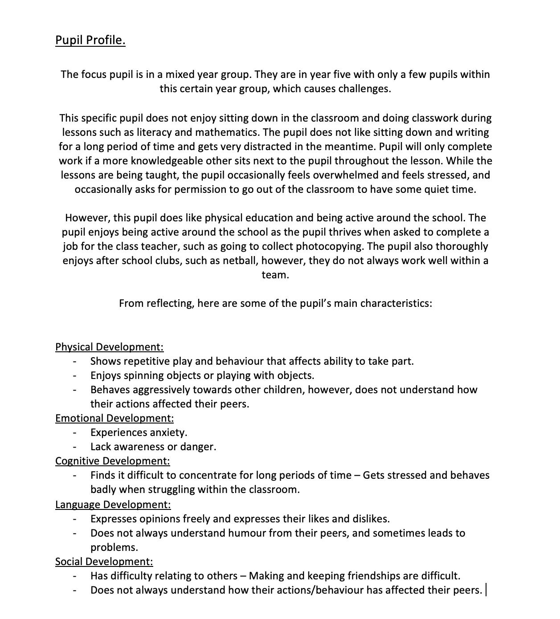

Appendix 2 – Letter regarding permission.


