
My Journal
Gemma Littlejohns

Note:
This journal provides some reflections on my learning whilst undertaking my postgraduate diploma in HR. I have used the Gibbs (1988) reflective model as it links well with continuous learning.

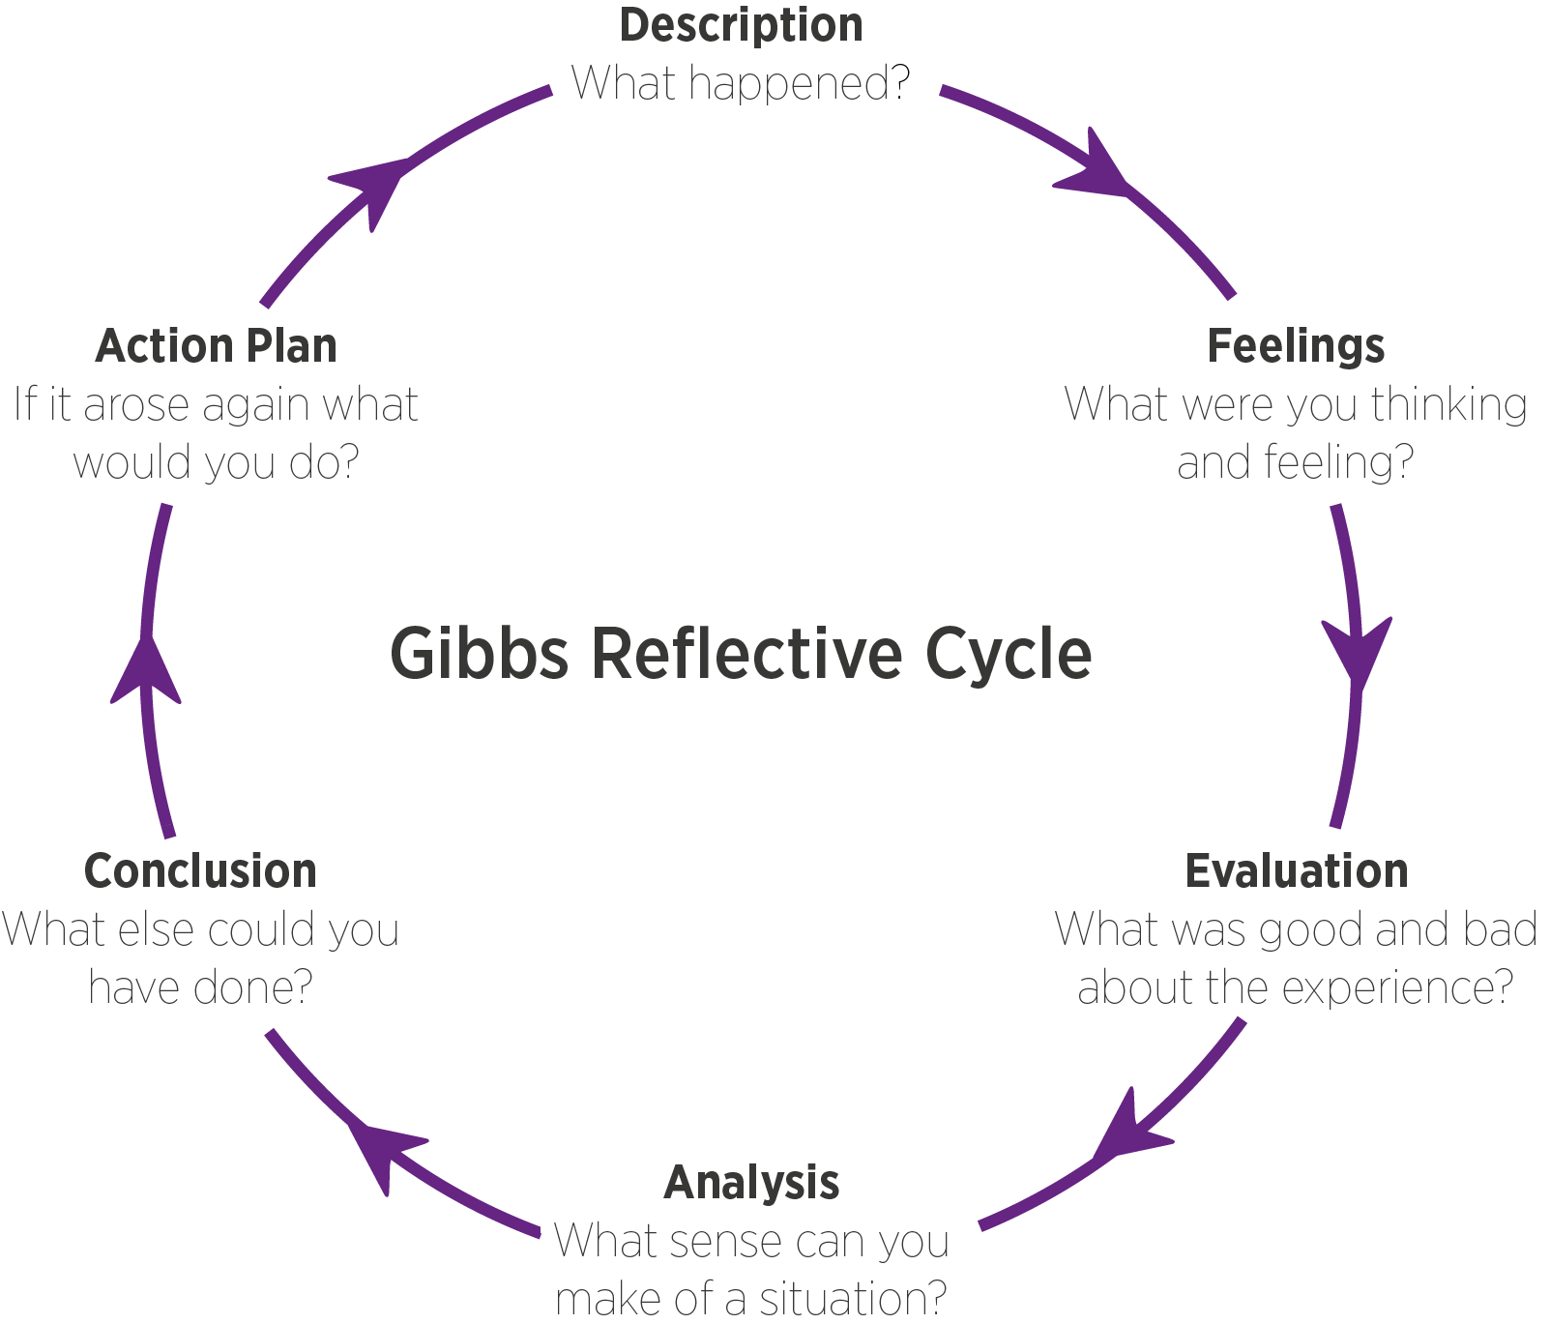


Figure 1 Gibbs Reflective Cycle (taken from leap like a salmon.com)
Designing learning that sticks (LO3&4)
- Description
Whilst working at Chwarae Teg (CT), a director emailed asking me to create a video covering equality, diversity and inclusion (ED&I). This was to be used to induct new employees and board members as ED&I were intrinsic to all organisational activities. I had recently completed the learning and development module and I knew this ‘content dump’ would not be an effective method to improve knowledge and understanding of ED&I (Shackleton-Jones, 2019). I had a decision to make. Do I agree to the request or do I push back as a chartered CIPD member, making “well-judged decisions by considering all available evidence in the context of the specific situation?” I went with the latter. I replied to the director informing them that yes, I would produce resources and requested a meeting to discuss further.
Before our meeting, I held a focus group and gleaned information from new employees regarding ED&I information they would like to have received during their induction. Focus groups are a useful tool to gather insight into a product/service from people with similar characteristics or shared experiences (CIPD, 2021). Suggestions included a glossary of terms, access to case studies with work-related scenarios and a workshop to discuss and test their understanding. Matching learning methods with learning requirements is an essential step in securing good learning outcomes (Stewart, 2014; Knowles, et al., 2011; Mezirow, 1991).

I attended my meeting with the director and advised her that in my professional opinion one video on the whole topic was not the best approach and shared with her my learning from my studies and feedback from the focus group. The director was surprised that I was pushing back on what she'd requested, because whilst I was agreeing to produce resources, I wasn't agreeing to produce what she had requested. She agreed with my recommendations and we negotiated a new timeline to get some of the resources ready for new board members that were about to join us. I put together a work plan and allocated tasks to my team who put together a fantastic suite of resources which was piloted with the focus group.

2. Feelings
When I first saw the email request, I was excited to be involved in developing something new but instantly felt uncomfortable knowing that I was going to have to push back and challenge a decision (to just produce one video) that had been made by the whole senior leadership team. I made evidence-based recommendations to “make sound and justifiable decisions to solve this problem effectively” (CIPD.a, 2009). During the meeting, I could see the Director was annoyed, and it made me feel uncomfortable. But I was confident in my knowledge. Additionally, the feedback from the focus group reflected what I had learned about ‘resources not courses’ in my L&D module (Kim, et al., 2014; Ertmer & Newby, 2013).
3. Evaluation
There were several positives to take away from this situation. I felt that I demonstrated the expertise and knowledge I'd acquired through my professional study, well. As a chartered member of the CIPD during situational decision making, I am expected to “consider different options and make decisions by balancing opportunity, risk, and alignment to professional values” (CIPD.a, 2009) and I felt I did that. Additionally, as a chartered member, I am meant to “enable others' continuous professional development using a range of appropriate methods”. I achieved this by planning an effective ED&I induction programme (ibid).
The biggest challenge for me was my concern that the director would say ‘no’ and pull rank. I would have been left in the situation of producing a resource that I knew wouldn't be effective, would be perceived as a tick box exercise and that my name (and reputation) would be associated with it. I'm just glad that I was never actually in that situation.
4. Analysis
During this scenario, I led and influenced others effectively although I didn't necessarily anticipate it to be ‘upwards’ leadership. However, it did result in a positive impact because what was produced exceeded the expectations of the senior leadership team. The directors have since come back with requests for other learning programmes, and this time they have provided me with objectives rather than actions which allows me to use my professional judgement and expertise to decide how to achieve those objectives (Gold & Anderson, 2017).

5. Conclusion
Overall, it was a positive experience and outcome, in that my professional advice was taken, and I was able to provide a suite of very professional and effective resources. However, I think I did shock my director during our meeting when I said I’d already held a focus group to discuss what was needed. That could’ve made her feel undermined and affected our professional relationship. My actions came from a place of anticipating pushback from her. Therefore, if I was to do anything differently, I wouldn’t hold the focus group before our meeting.
6. Action plan
Whilst I applied a systematic and evidence-based approach to decision making which involved testing ideas and team-based decision making, I am “committed to evaluating the outcome and impact of my decisions to inform on my future approach” (CIPD.a, 2009). So in the interests of protecting professional relationships, if faced with this situation again, I would change the sequence of events and explore more external evidence to support my recommendations. I will look more into improving my negotiation skills so that I can respectfully challenge (see PDP).

Spending money on this, not that (LO5&6)
- Description
At the start of the first lockdown in 2020, my organisation continued operations as normal, albeit from home. The nature of our services was HR consultancy and leadership training. Continuing the consultancy via Microsoft Teams was not a problem. What the team struggled with was delivering online learning.
Over the years I have developed enhanced IT proficiency and was able to learn how to use MS Teams by myself. I provided my team with training and ongoing support, each time a new feature was rolled out by Microsoft.
I was concerned with the quality of our online training. They were originally 2.5-hour classroom-style sessions with activities. All we had done was condense them into two, one-hour sessions. I regularly access online training for my CPD and I observed a distinct difference between how they were delivered and how ours were delivered. Therefore, I did some research into good quality ‘train the online trainer’ CPD for my team.
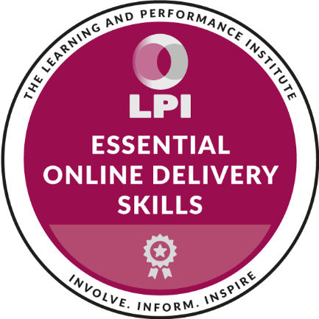
I found a suitable course and when I looked at our budget and the rules around expenditure, I could see that this was not deemed an ‘eligible cost’. However, on further analysis of the budget and the accompanying policy, I could see that there was a significant budget allocated to travel and subsistence. To achieve a degree of stability, our CEO had already advised us we would be working from home for a minimum of 3 months. I calculated that the 3 months of travel and subsistence would more than cover the costs of this training.
I put together a business case and put it to my project manager who presented it to the directors. They approved the spend and re-allocated the budget to cover the training.
My team accessed the training and modified our resources accordingly. Feedback was excellent so we continued to develop more content.
- Feelings
I felt excited after the online training session as I knew my team could apply the new learning straight away, which could help us remain on track with our engagement targets and growth plans. Online learning has been linked to growth (Koksal, 2020; Gartner, 2022.).
I was initially disappointed when I saw the budget constraints but I was determined to find a way to cover these costs. I was pleased that I was able to correctly interpret financial information to effectively manage financial resources. Additionally, I was able to communicate to the directors, my knowledge of current and future trends in adult learning which is chartered level knowledge, acquired during the CIPD programme.
- Evaluation
I have limited knowledge of managing budgets however this opportunity was possible due to the transparency and support provided by my manager. My manager has always encouraged me to be involved in decision-making and she provided access to the budget and associated policy documents. As a chartered CIPD member, I am expected to understand “the role and purpose of governance, its structure in my area of work, and the broader regulatory environment I work in”, within this situation, I demonstrated that well.
I provided my team with (free) IT training to make the best use of the resources available to us and our customers, followed by professional external training. Consequently, my team were able to achieve their targets and maintain their performance.
- Analysis
As a chartered member, I must have business acumen. I am aware of our strategic objectives relating to growth and the main source of income for growth is consultancy and training. By correctly interpreting financial information and evaluating the changes and trends in how it was being used in the external environment, I demonstrated how my team could contribute to business performance by reviewing and forecasting spending and calculating return on investment (CIPD.a, 2009) as part of my business case.

- Conclusion
Understanding “how to assess the impact of current and future technology on the workforce and people practices” (CIPD.a, 2009) played a significant part in making an effective business case to use the budget differently.
On this occasion, the outcome went in my favour. Had it not, we could have paid to send one person and relied on them to cascade the training to the rest of the team. This was an option within my proposal however not my preferred option. I wanted all the trainers to have access to the course provider, ask questions and check understanding which would not have been possible via cascade training (Lancaster, 2019).
- Action plan
Understanding the financial implications of work is a core behaviour associated with commercial drive (CIPD.a, 2009). My knowledge of managing budgets and approving spending is still quite limited and to progress in my career, I should develop my skills in this area. I also have no knowledge of the procurement process so I need to better understand that to understand timeframes and processes involved (See PDP.)

To Discipline or Not to Discipline? That is the question! (LO1&2)
- Description
CT has written its disciplinary procedure in line with the ACAS code of practice on disciplinary and grievance (ACAS, 2015) and recently a manager took an issue to HR and HR appointed another manager to investigate. The investigating manager produced a report and their conclusion was to escalate the issue to disciplinary. I was appointed as the Disciplinary Chair.
I was presented with the report and evidence of the complaint. A member of staff had received a 12-month driving ban due to drink-driving (Gov.UK, n.d.) and took two weeks to notify their manager. CT’s policy states that employees should notify their manager immediately if they are convicted of drunk driving on company business (Chwarae Teg, 2021).
I had completed the Employment Law module and whilst drink-driving was not covered, this Code of Conduct was. I knew that we had a duty as an employer to establish the facts of the case (ACAS, 2015) however on reading the investigation report I noted the complaint from the line manager was investigated however there was nothing to explain the relevance of the offence to the employer, or the impact the ban would have on the employees’ ability to fulfil the role. I had further questions:
- Is the reason within the organisational policy, to notify the manager of a driving offence, in anticipation that the offence took place whilst carrying out duties on behalf of the employer? The Director responsible for governance and organisational policy confirmed that yes, it was so they could respond appropriately under company liability.
- Did the offence take place on company time? The answer was no. Therefore there was no reprisal for CT.
- Is driving an essential requirement for the role? The answer was no. Furthermore, all employees had recently been given home-working contracts.
I was satisfied that the only mistake that the employee made, was delaying telling her line manager about the driving ban. I advised the HR Manager ahead of the hearing that I was going into the hearing with the intention of not taking any further action against the employee. The HRM agreed and understood my rationale.
At the disciplinary meeting, I confirmed the details of the investigation and my additional questions with the employee. I confirmed that there was a failure by the employee to notify her line manager immediately but I accepted that the employee was distressed. (She had explained that as a single parent she was in a panic about how she would get her children to school and their clubs and was dealing with the family fall-out.) I advised her that because driving was not an essential element of her role and because the offence was not on company time or whilst carrying out duties on behalf of CT, we would not be taking any action.
I felt it necessary to make recommendations to CT to avoid this/similar situation again:
1. The policy wording should be amended to reflect under what circumstances a manager would need to take action. Furthermore, a blanket policy could be discriminatory should a person lose their licence due to a disciplinary.
2. Guidance should be produced, for investigating officers so they don’t just investigate the complaint on behalf of the complainant, but they take an objective view and investigate the issue from the perspective of the organisation and the employee.
3. Guidance should be provided for line managers as to how they can resolve workplace issues informally without unnecessary escalation.
- Feelings
When I saw the name of the person going through disciplinary, I immediately felt very sorry for them. I knew this person was a very conscientious employee and they would be extremely embarrassed about the situation. But it was important to remain professional and objective and do right by both the employee and the organisation in my capacity as the Disciplinary Chair. Managers need to be emotionally intelligent and be able to recognise and manage their own emotions as well as others’ (Goleman, 2055). I must maintain self-awareness and ensure ethical and professional approaches at work.
As my questions were answered, I felt relief to be in a position to ease the pain of someone I knew would have been distraught over the ban. I was also extremely proud of myself for being able to apply the learning from my Employment Law module when we were taught about how to conduct a thorough investigation. I had achieved a very high mark for my assignment and it felt rewarding to be able to transfer those skills to a real-life scenario where I could make a difference to the organisation and the employee.
- Evaluation
There was a good outcome for both the employee and the organisation. CT has benefitted from no further time lost through any potential appeals. They also benefitted by avoiding a grievance because I ensured all facts were considered in the lead up to the final decision. Additionally, the policy has been reviewed and managers will receive guidance which will go some way to protecting the employment relationship. I struggled, emotionally, to know the conclusion of the hearing and waiting a further three days until the hearing itself. I felt awful knowing the employee would be in distress until then. However, I needed to handle emotion well and act ethically to deliver the policy correctly.
- Analysis
I adopted an integrative negotiation approach which generally seeks out a win-win scenario (Volkema, et al., 2016). I ensured that each stakeholder was represented and heard. I obtained as much information as possible and sought clarification on areas of uncertainty. A high degree of professionalism is important to maintain credibility and trust, especially in situations such as these (CIPD, 2022), as is managing interpersonal relationships, effective negotiation and handling of emotion and conflict (Ibid).
- Conclusion
The complaint was raised by one manager who suggested disciplinary action and was investigated by another manager who also recommended disciplinary action. When I explained my rationale behind taking no action, all were in agreement. Power and authority ‘emerge’ when a formal hierarchy is put in place (Introduction to Sociology, n.d.) and I was able to make positive use of my authority during this process.
As a chartered member, I am required to “Make responsible decisions by considering different ethical perspectives and finding the best possible way forward for all stakeholders” (CIPD.a, 2009). Furthermore, I had to challenge the decisions made up to that point as they were not necessarily ethical and presented some risk to CT. However, if there was a failure to agree, or if a stakeholder was not satisfied with the outcome, then it would’ve instigated another process.
- Action plan
Should CT not have been supportive of my decision, then I do not know what the next step would be. This has highlighted a gap in my knowledge when it comes to dispute resolution and organisational policy. This is something I will need to develop and I have added this to my PDP. Additionally, I enjoyed the Employment Law module and got a lot of satisfaction from being able to apply my knowledge. I am aware that things move on in law quite quickly so I will need to maintain my knowledge in this area to remain effective. (See PDP.)
Developing a new induction programme (LO 7 &8)
- Description
At the beginning of this year, I was appointed to a new role within a completely new organisation. I am now the Learning and Development Manager for Hywel Dda Health Board (HDD). When I joined my new team were undertaking a project to develop a new induction programme whilst delivering the normal day-to-day operational duties. My predecessor retired a few months previous and the team were just coming out the other side of delivering a rapid onboarding process through the pandemic. They were tired, jaded and lacking direction. Little progress had been made and they were behind all previously agreed deadlines.
The first objective issued to me was to conclude the development of the induction programme. This was going to require my project management skills and as I soon discovered, managing poor performance too. One member of my team frequently missed deadlines, made mistakes and failed to carry out tasks. It was suggested that maybe she wasn’t capable of fulfilling the duties of the role and I was inclined to agree however I like to believe that nobody comes to work to do a bad job. As a chartered member, I should “demonstrate compassion, humanity and fairness in my approach” (CIPD.a, 2009) so I set about determining the cause of poor performance.
I arranged regular one-to-one meetings with all those I line manage. By the second one-to-one, the employee opened up to me explaining they hadn’t received an induction, were struggling to understand their role and were experiencing menopausal symptoms such as brain fog. This was the cause of the poor performance. I was immediately able to put support in place. I managed the work plan for the new induction programme and re-allocated work to the correct people. This immediately returned her workload to a manageable volume. I also suggested that the constant interruptions in the office were not helping her concentrate and possibly making her experience of brain fog worse. I suggested she work from home occasionally to get some peace and reduce distractions (Marx et al 2021; Worksmart, n.d). After a week or so, the employee reported a definite improvement. By the next monthly one to one, she said she was far happier, was no longer considering leaving and was enjoying her job.
Meanwhile, I was working hard to provide the team with direction in developing the induction programme. The project management skills acquired in my last role helped and the team worked well to deliver a fantastic suite of resources.
I also identified an opportunity to develop a new system to manage the induction process. I was a ‘Tech Champion’ in my last job so I had been exposed to a range of ICT resources. I was aware that the team could be more efficient. They were receiving complaints due to mistakes being made. I was aware of the technical expertise within the team (Surridge, 2021) so I provided a design brief and requested the team build a new ICT system to support the induction process. The result was remarkable. Since implementing the new system there have been no errors to date and the staffing hours spent typing have been reduced by around 80% due to the new ICT systems.
- Feelings
I am delighted with the outcome for the team. I love enabling other people to perform however this was to be to my detriment. I was exhausted. I took on far too much and like my direct report, I didn’t receive an induction. I was trying to get on with other elements of my role, whilst learning on the job. Project managing plus providing additional support pushed me to the edge of almost quitting my dream job. I knew I was capable but there was just too much work and it felt never-ending. I wasn’t sleeping and didn’t feel like I was having quality time with my family because I couldn’t switch off.
- Evaluation
Initially, my team knew they weren’t doing a good job which was doing nothing for their self-esteem and performance. It’s great that the result was a well-received effective programme, improved service and a happy team.
This experience provided an excellent opportunity for me to show my manager and my team, my true capabilities when it comes to project and people management and to inspire trust (Ouslis, 2018).
I do wish that I didn’t have to suffer to achieve that. It affected my initial experience of the organisation and there were days when I felt very disappointed that my dream job was not all I hoped for.
- Analysis
Future situations like this will include a far more detailed project management plan which would see the allocation of tasks and progress monitored at an earlier stage. Now that I have more knowledge about how the NHS operates, I am better positioned to negotiate more reasonable deadlines with senior management. This would go some way to reduce the burden that I experienced. Additionally, I have an improved understanding of my team and what else could be delegated to make good use of skillsets and capacity within the team.

- Conclusion
I put too much pressure on myself. I learned a lot from my research and talent planning (RTP) module and developed new research skills as part of my studies, therefore, I was keen to use them. I should have delegated more which would have gone some way to reducing the extra hours I was working and reducing my stress.
I produced a report for the executive team outlining the changes to the induction programme and seeing it all in one place demonstrated the significant improvements that have been made under my leadership and guidance. When I wrote the report, I was able to draw on information I learned during the RTP module and the postgraduate study skills I’d acquired. I underpinned my recommendations with evidence-based research which assured the executive team that the new induction programme was going to make a difference.
- Action plan
Going forward I will ensure that I find a much quicker way of ascertaining the skillsets and capacity of project teams to deliver a successful project that is not to the detriment of my wellbeing. Whilst I have good project management skills, I believe I am lacking in project management knowledge. I will need to explore this further. As a chartered member, I should understand, “How to make good work design choices (e.g. who does what work, how work is done)” (CIPD.a, 2009) however I would say that currently, I am operating as an Associate which is described as understanding “How to design good work (volumetric, meaningful work, human/automated processes)”. Therefore, I will need to plan CPD around organisation development and design to enhance my skills further. (See PDP.)
PROFESSIONAL DEVELOPMENT PLAN
DEVELOPMENT NEED | SPECIFIC ACTIONS | RESOURCE REQUIREMENT | DESIRED OUTCOME | REVIEW & TARGET DATES
Improve skills at debating and/or having challenging conversations | Research through reading/watching tutorials  Prep for a practice session with a colleague  Offer to present information to SLT and anticipate and prepare for the challenge | Laptop and internet access. Ask for recommendations.  Ask CM as she has demonstrated good skills  SLT meeting invite | Improved confidence and increased ability to make sound and evidence-based arguments to support my point. | 31/03/2022  06/04/2022  11/04/2022
Maintain knowledge in contemporary learning design in a post-pandemic work environment | Research changes to the impact on learning approaches | Laptop and internet access. Ask for recommendations.  Sign up for webinars/bitesize sessions from VLE and CIPD | Maintained expertise as an L&D specialist | Ongoing however check quarterly as a minimum for any new research or best practice
Improved knowledge and skill in interpreting financial information and making financial decisions. | Familiarise myself with my departmental budget, allowable expenditure and associated rules.  Identify a mentor who can guide me and provide insight into ‘lessons learnt.  Identify suitable training courses designed for non-finance managers. | Laptop and internet access. Ask for recommendations.  Ask AG to help me, secure a mentor.  Request recommendations and research any training opportunities. | Improved understanding of financial information and ability to make viable recommendations on large spending/investments.  Able to correctly analyse and report on financial spending and forecasting for my department. | 30/06/2022  30/09/2022
Improve knowledge of procurement processes | Familiarise myself with the organisational policy  Ask to shadow the next departmental procurement process  Take an active part in a procurement process  Evaluate learning and identify any further actions | Organisational Procurement Policy  Access to communications and decisions relating to real-time procurement process via colleagues | Detailed understanding of organisational procurement process which will inform on future recommendations and working practices | 31/10/2022
Improve knowledge of dispute resolution | Research best practice  Familiarise myself with the organisational policy? | Make use of CIPD membership to research literature and discuss experiences with peers at members’ events. | Improved underpinning knowledge of effective dispute resolution in preparedness for future events. | 31/10/2022
Maintain knowledge and skills in Employment Law | Read updates from CIPD, online cases, attend free webinars when possible | Make use of CIPD membership to research literature  Continue to use Red Kite Law updates on cases | Maintained knowledge and skillset in current Employment Law practices | Quarterly  Note new year changes: 31/03/2022
Develop project management knowledge | Explore what project management training is available, ask for recommendations from colleagues.  Make use of a mentor with experience of project management in a Health Board. | 1 to 5 days of training depending on the recommendations received from my colleagues.  Request mentor – ask line manager for recommendations. Ask resourcing manager if I could join the buddy scheme. | Improved underpinning knowledge on effective project management | 31/10/2022  31/12/2022
Improved understanding of organisational culture and how to better manage opportunities and identify issues. | Make use of mentor – possibly the same mentor as the project management activities.  Link in with Culture and Employee Experience Manager for advice and direction. | Request mentor – ask line manager for recommendations. Ask resourcing manager if I could join the buddy scheme.  Book time in with Rob Blake. | Improved awareness of the organisational culture and ability to make better use of teams, resources and colleagues across the health board. | 31/12/2022  31/11/2022

References
ACAS, 2015. Code of Practice on disciplinary and grievance procedures. [Online]
Available at: https://www.acas.org.uk/acas-code-of-practice-for-disciplinary-and-grievance-procedures/html
[Accessed 5 May 2022].
Chwarae Teg, 2021. Grievance and Disciplinary Policy (Internal Document). s.l.:s.n.
CIPD.a, 2009. Explore the Profession Map. [Online]
Available at: https://peopleprofession.cipd.org/profession-map
[Accessed 12 January 2022].
CIPD, 2021. Guide to using group voice channels. [Online]
Available at: https://www.cipd.co.uk/Images/guide-to-using-group-voice-channels-web_tcm18-100118.pdf?msclkid=32749f31ceb411eca4e8f83e470223c5
[Accessed 05 May 2022].
CIPD, 2022. Ethical practice and the role of people professionals. [Online]
Available at: https://www.cipd.co.uk/knowledge/culture/ethics/role-hr-factsheet?msclkid=d6e1e19acecf11ec9842bbca81a67a68
[Accessed 6 May 2022].
Ertmer, P. & Newby, T., 2013. Behaviourism, cognitivism, and constructivism: Comparing Critical Features From an Instructional Design Perspective.. Performance Improvement Quarterly, 26(2), pp. 43-71.
Gartner, 2022. Gartner Top Strategic Technology Trends for 2022. [Online] Available at: https://www.gartner.com/en/information-technology/insights/top-technology-trends [Accessed 02 April 2022].
Gibbs, G., 2013. Learning by doing: A Guide to Teaching and Learning Methods. Oxford: Brookes University.
Gold, J. & Anderson, L., 2017. Developing leadership and management skills. London: Kogan Page.
Goleman, D., 2055. Emotional intelligence:Why it can matter more than IQ. New York: Bantam Books.
Gov.UK, n.d. Drink-driving penalties. [Online]
Available at: https://www.gov.uk/drink-driving-penalties
[Accessed 5 May 2022].
Hywel Dda, 2014. Learning and Development Policy (Internal document)
Hywel Dda, 2020. Strategic objectives, Planning objectives and Specific Requirements (Internal document)
Introduction to Sociology, n.d. Power and Authority. [Online]
Available at: https://courses.lumenlearning.com/wmopen-introtosociology/chapter/power-and-authority/?msclkid=9491fe72cec311ec9f2e2cb3275d8dca
[Accessed 5 May 2022].
Kim, R., Olfman, L., Ryan, T. & Eryilmaz, E., (2014). Leveraging a personalized system to improve self-directed learning in online educational environments. Volume 70, pp. 150-170.
Knowles, M., Holton, I. & Swanson, R., 2011. The Adult Learner. London: Elsevier.
Koksal, I., 2020. The Rise Of Online Learning, https://www.forbes.com/sites/ilkerkoksal/2020/05/02/the-rise-of-online-learning/?sh=4709800672f3: Forbes.
Kontoghiorghes, 2016. Linking high-performance organizational culture and talent management: satisfaction/motivation and organizational commitment as mediators. International Journal of Human Resource Management, 27(16), pp. 1833-1853.
Lancaster, A., 2019. Driving performance through learning. London: Kogan Page.
Marx, C. K., Reimann, M. & Diewald, M., 2021. Do Work-Life Measures Really Matter? The Impact of Flexible Working Hours and Home-Based Teleworking in Preventing Voluntary Employee Exits.. Social Sciences, 10(1), p. 9.
Mezirow, J., 1991. Transformative Dimensions of Adult Learning. San Francisco: Jossey-Bass.
Ouslis, N., 2018. Trust in Leadership – One Key Factor During Organizational Change. [Online]
Available at: https://scienceforwork.com/blog/trust-in-leadership-change/
[Accessed 12 January 2022].
Sargeant, M., 2011. Age Discrimination: Ageism in Employment and Service Provision. Surrey: Gower Publishing Ltd.
Shackleton-Jones, N., 2019. How people learn : designing education and training that works to improve performance. London: Kogan Page.
Stewart, J. C. P., 2014. Designing, delivering and evaluating L&D: Essentials for Practice.. London: CIPD.
Surridge, P., 2021. How to spot high-potential employees. [Online]
Available at: https://www.peoplemanagement.co.uk/voices/comment/how-spot-high-potential-employees
[Accessed 6 May 2022].
Turner, S., (2002). Tools for success: a manager's guide. London: McGraw Hill.
Vaske, J. J., 2019. Survey Research and Analysis. 2 ed. s.l.:Sagamore-Venture.
Volkema, R., Kapoutsis, I., Bon, A. & Almeida, J. R., 2016. The Influence of Power and Individualism-Collectivism on Negotiation Initiation. Revista de Administração Contemporânea, May, 20(6), pp. 673-692.
Worksmart, n.d. What are the disadvantages of homeworking?. [Online]
Available at: https://worksmart.org.uk/health-advice/where-you-work/teleworking/what-are-disadvantages-teleworking
[Accessed 5 May 2022].

