Inter-Continental Hotels Organisational Report
Student Name: Bijaya Dip Karki
Student ID:2207937
Lecture Name: Ernest Wavei
Date:31/05/2024
Module Code: Management &Organisational (BMIH5004)

Executive Summary:
The British global hospitality company InterContinental Hotels Group is great at operating, leasing, and franchising hotels, and resorts for a wide range of customers. With a hybrid organizational structure, IHG encourages both practical efficiency and the ability to adapt to local conditions, so the company's culture, which is based on "True Hospitality for Good," focuses on doing the right thing and taking care of the earth. Some of the company's strategic goals are long-term growth, better experiences for guests, and strong reward programs. New programs like IHG LIFT and the IHG Way of Clean have made it easier for everyone to be included and follow cleaning rules. IHG's focus on growing its brand portfolio, going global, and using a "light-asset" business plan will help it keep growing and stay ahead of the competition.

Contents
Executive Summary: 1
1. Introduction 3
2. Organizational Structure 4
2.1. Divisional Strcuture 4
2.2. Matrix Structure 4
3. Organizational Culture 4
3.1. Artifacts 5
3.2. Values 5
3.3. Fundamental Presumptions 5
4. Organizational Goals 5
4.1. Sustainable Growth 5
4.2. Guest Experience 6
4.3. Environmental Sustainability 6
4.4. Loyalty & Engagement 6
5. Change Initiatives 6
5.1. IHG LIFT Program 6
5.2. IHG Way of Clean 7
5.3. Journey to Tomorrow 8
6. Organization’s Strategic Direction 9
6.1. Improving Brand Portfolio 9
6.2. Extending Global Reach 9
6.3. The Model 'Asset-Light' 9
6.4. Driving Direct Reservations 9
6.5. Providing An Appealing Owner Value 9
6.6. Organized Allocation of Capital 9
7. Competitor Analysis 10
8. Conclusion & Recommendations 10
9. References 11

InterContinental Hotels Group (IHG)

Introduction
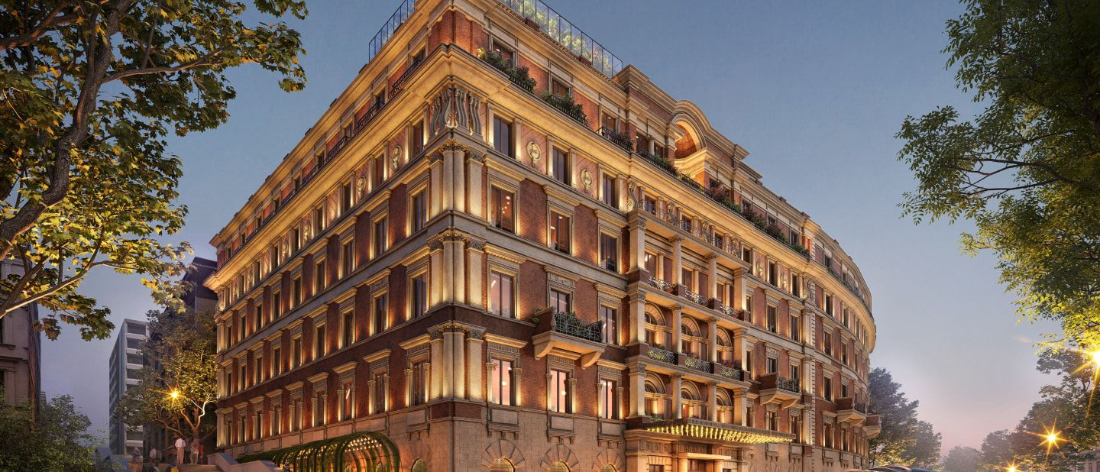
Figure: InterContinental Hotels Group (IHG, 2023b).
The InterContinental Hotels Group (IHG) serves as a British global hospitality firm based in Buckinghamshire, England. IHG, founded in 2003. The corporation is a key player in the worldwide hospitality sector, handling, leasing, & franchising hotels as well as resorts in multiple segments such as midscale, upmarket, and premium. It owns 345000 employs that are striving to offer True Hospitality for Good. IHG offers a varied range within hotel brands, namely InterContinental, Crowne Plaza, Holiday Inn, etc., with over 6,000 active properties in over 100 nations. With an emphasis on client happiness and operational effectiveness, IHG aspires to provide extraordinary experiences that benefit guests as well as hotel owners both, establishing itself as the market leader with a powerful reward scheme that have 48 million people under the name of IHG Rewards Club globally (IHG, 2023). Through this program Through its IHG Rewards loyalty program, the corporation promotes long-term relationships with its customers by providing tailored experiences and unique incentives. having a focus on expansion and solid footing in key worldwide regions, IHG aims to broaden its footprint and impact in the hospitality sector (IHG, 2023b).

Organizational Structure
IHG employs an amalgamated organizational structure which bring divisional and matrix structure together. The Board is liable for assuring leadership by effectively overseeing and reviewing the Group's actions. The business's structure is intended to promote good management of risks, and efficiency in operations. IHG's Board of Directors is in charge of ensuring that culture is aligned with the business's purpose and strategy, whereas the CEO and executive team define the tone from the top, encouraging an open and truthful workspace. The hybrid system of organization is a reaction to the requirement for versatility and local adaptability in a global marketplace, as proposed by contingency theory (Bhardawaj, 2019).

Divisional Strcuture
IHG's activities are divided into geographical areas, comprising Americas, Greater China, Europe, Asia, and Middle East. Every region runs semi-autonomously, with tactics tailored to specific markets. It also structures its activities around its numerous brands, which include InterContinental, Kimpton Hotels, Holiday Inn, etc., so they appeal specific market groups.

Matrix Structure
Human Resource, marketing, operation management, and finance all contribute to the geographic & brand divisions. This enables IHG to use specialist skills throughout the enterprise (IHG, 2019).

Organizational Culture
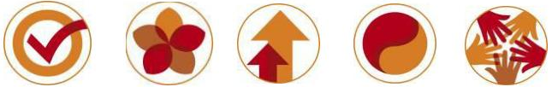
Figure: Organizational Culture (IHG, 2023b).
IHG's culture revolves within their mission of "True Hospitality for Good," that encourages and directs all they conduct. They follow a set of principles that govern their conduct such as right things to be done, prove they care, seek higher, embrace diversity, and work better collectively (IHG, 2019). In regard to culture, IHG prioritizes ethical behavior, workspace respect, as well as safeguarding all stakeholders. prejudice, intimidation, and violence are not tolerated at the organization, and there are methods in place to report problems in a confidential manner.

Artifacts
IHG's belief in innovation with high standards is evident in its visible components, like their Rewards loyalty scheme, brand-specific customer service, along with Green Engage system for environmentalism (IHG, 2022).

Values
Our principles of hospitality, honesty, reverence, and environmental stewardship influence decision-making as well as behavior throughout the business (IHG PLC, 2019). IHG's professed objective is building Great Hotels Guests Love, focusing on customer happiness and excellent service.

Fundamental Presumptions
The value of guest-centric service, constant improvement, and environmental sustainability is deeply instilled. These beliefs guide both daily behaviors and long-term initiatives, establishing a culture promotes excellence and accountability (IHG, 2022). IHG's culture is heavily anchored in Schein's framework, which focuses on artifacts, values, as well as fundamental presumptions (Sridharan, 2022). This is consistent with the Cultural Web Model, that highlights the role of communed values and beliefs in establishing a company's culture (Bhardawaj, 2019).

Organizational Goals
IHG's vision of "Great Hotel Guest Love" reflects its desire to be an established resort company with an excellent record for visitor happiness (IHG, 2019). IHG's objective is to do the right thing, care for customers, achieve higher, celebrate differences, and develop collaboration among workers.

Sustainable Growth
IHG intends to attain sustainable growth by expanding through strategic alliances, franchise deals, and investing directly, especially in high-growing regions (IHG PLC, 2019). This corresponds to Porter's growth tactics and worldwide diversification.

Guest Experience
Investing in technology for better guest experiences and operational effectiveness, like as the IHG Concerto platform, coincides with the resource-based vision (RBV), which focuses on competitive advantage by exploiting internal resources (Edwards, 2019).

Environmental Sustainability
Green Engage system of IHG prioritizes environmental sustainability by promoting energy conservation and minimizing waste. This aim exemplifies stakeholder theory by (Freeman, 2018) addressing the wants and concerns of multiple stakeholders, such as customers, staff members, and the general public (Bhardawaj, 2019).

Loyalty & Engagement
Improving the IHG Rewards scheme to strengthen customer relationships and generate recurring revenue is consistent with customer relationship management (CRM) concepts, which emphasize the significance of loyalty and involvement in long-term profitability (Salesforce, 2023).

Change Initiatives
InterContinental Hotels Group encounters lately implemented many change initiatives which have been having a substantial influence on its operations as well as stakeholders.

IHG LIFT Program
IHG has recently undertaken various reform programs targeted at improving sustainability, diversity, along with customer experience throughout its hospitality business. One significant project is the IHG LIFT program, which aims to encourage diversity along with development by assisting those who have traditionally been marginalized in hotel owning. This program, which is supported by a pledge of more than $30 million in the course of 5 years, offers qualifying hotel owners in the United States and Canada support, accessibility to funding, and direction during the hotel's life cycle. This program represents the company's commitment to Leadership, Inclusivity, Facilitation, & Transformation, which drives good change in the sector by removing obstacles to ownership for various groups (IHG, 2024).

The establishment of IHG LIFT is consistent with IHG's broader mission of providing 'True Hospitality for Good' and its Journey to Tomorrow 2030 sustainable business strategy. It supplements existing DEI programs such as the EPIC Supplier Diversity Program and collaborations with DEI-focused architecture, design, & construction businesses. The initiative has already gotten praise from owners such as Jyoti Sarolia, CEO of Ellis Hospitality, which operates IHG hotels in California. Sarolia noted that IHG LIFT is vital to the industry because it promotes an eclectic owner community reflecting the customers served on a regular basis, so by eliminating hurdles, diversification of ownership, and elevating the industry, IHG LIFT is positioned for a significant contribution to fostering diversity and expansion within the hospitality sector in the coming years.

IHG Way of Clean
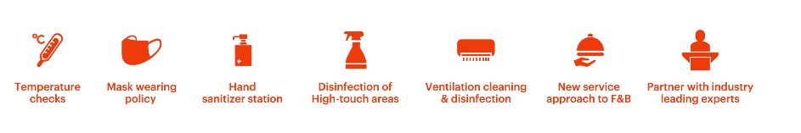
Likewise, as a reaction to a worldwide pandemic in 2019-2021, IHG has concentrated on improving hygiene and security regulations, launching initiatives such as the IHG Way of Clean heightened cleanliness strategy and the IHG Clean Promise. The changes made have been critical in convincing guests and providing a secure and cozy vacation experience. Furthermore, IHG has changed its reservation policies to provide greater versatility, permitting guests to easily amend, delay, or cancel reservations, demonstrating a customer-focused approach to providing assistance amid difficult times (Elliott, 2021).
Figure: Hygiene Policy (IHG, 2023b).
This initiative involves comprehensive cleaning using hospital-grade disinfectants, apparent verification of sterilized things, and the removal of in-room accessories including high-touch items. The IHG Clean Promise assures visitors that their rooms will satisfy IHG's rigorous hygiene requirements. If otherwise, the hotel will set things right. This pledge, together with enhanced information about cleanliness procedures, has served to reassure visitors and regain their trust in being at IHG hotels. The program has allowed IHG hotels to become accustomed to new travel conventions and standards about cleanliness. By collaborating with specialists such as the Cleveland Clinic, Ecolab, and Diversey, IHG has proven able to create science-based protocols to tackle customer concerns and deliver an enjoyable experience. This initiative has been expanded, with many practices already in accordance with CDC and municipal public health guidelines.

Journey to Tomorrow

IHG established "Journey to Tomorrow," a set of ambitious promises that aim to have a positive effect in the lives of its employees, neighborhoods, and the environment throughout the course of the next decade. This program is guided by IHG's commitment to providing True Hospitality for Good. The pledges outlined in IHG's Journey to Tomorrow strategy help to achieve the Sustainable Development Goals set by the United Nations. A worldwide poll undertaken by IHG indicated that customers are more concerned than ever with responsible travel, including 82% believing it is critical to select a hotel company that acts responsibly. Furthermore, research shows that customers will pay a standard of 31% more each night for housing that fits this demand (O’Neill, 2022).
Figure: Journey to Tomorrow (IHG, 2023b).
These reform programs have had a substantial impact, with IHG improving its longevity, inclusion, and guest experience (Report, 2023b). IHG has received favorable scores and recognition in sustainable indexes for their work in environment and water conservation as a result of promoting sustainable practices. The business's commitment to inclusion as seen by programs such as IHG LIFT, indicates that it is dedicated to encouraging inclusivity and helping underrepresented groups within the sector. Furthermore, the emphasis on cleaning and freedom in reservation policies has increased guest trust and contentment, resulting in a pleasant experience for guests that lead to boost loyalty (Report, 2023). These change projects have been managed deliberately and effectively. Keith Barr, CEO of IHG, underlined the significance of doing the right thing rather than just what is necessary. IHG has demonstrated its dedication to collaborative action by partnering with peers, hotel owners, as well as industry stakeholders to build an era of responsible travel. IHG additionally refined its strategic pillars and implemented novel practices that sharpen their mentality for success and drive progress (IHG PLC, 2019).

Organization’s Strategic Direction
InterContinental Hotels Group has a clear strategy orientation aimed at achieving long-term growth and boost shareholder value as well.
  - Improving Brand Portfolio
IHG intends to expand its lineup of favored and distinctive brands, including InterContinental, Holiday Inn, & Crowne Plaza, to appeal to a wide range of customer preferences in the lavishness, sophisticated, and popular categories.

Extending Global Reach
IHG prioritizes expansion in key regions, particularly rising economies such as China, wherein it was the initial global hotel operator to make an entrance in 1984. The corporation additionally emphasizes on serving to Chinese tourists outside of China by means of its China-Ready plan.

The Model 'Asset-Light'
IHG has pursued an "asset-light" approach, focusing on managing hotels and franchises instead of property ownership. This structure enables the organization to grow its reach whilst remaining capital efficient.

Driving Direct Reservations
IHG intends to build long-term relationships with customers and increase income using digital as well as voice channels, utilizing excellent yield management strategies (Report, 2022).

Providing An Appealing Owner Value
The company attempts to offer hotel owners an exceptionally competitive offering that generates superior profits, assuring the longevity of its franchising and management contracts (InterContinental Hotels Group, 2024).

Organized Allocation of Capital
IHG employs a rigorous capital allocation strategy, financing for future brand expansion while providing steady revenue growth and outstanding shareholder returns (Report, 2022).

Competitor Analysis
- Hyatt is a renowned worldwide hotel firm with 20 premium brands. Although IHG has 19 hotels, Hyatt is noted for its dominant position in the luxury market. But IHG has greater revenue.
- Marriott represents the world's biggest hospitality chain, with more than 30 brands. Marriott's large portfolio and robust loyalty program position them as a competitive opponent. Nevertheless, IHG's asset-light strategy and emphasis on high-growth markets provide a competitive advantage (Hollander, 2020).
- Hilton is a further essential participant with an impressive brand portfolio. Hilton's strength is its outstanding loyalty program, Hilton Honors. Yet, IHG's diversified brand portfolio and significant development in key areas make it a formidable opponent (IHG, 2018).
- Wyndham is the globe's leading hotel franchisor, having more than 20 brands. Wyndham's strength comes from its superiority in the economic and midscale categories. Fortunately, IHG's substantial presence in the upmarket and luxury sectors provides a diversified portfolio (Hollander, 2020).

Conclusion & Recommendations
Organizational structure, culture, and goals of company can all be studied and examined utilizing numerous organizational theories. The theories give a framework for comprehending the way IHG operates and works to attain its goals. IHG's change programs have been effective and well-organized, helping to drive their strategic expansion and dedication to environmentally friendly travel, so by sticking to its key objectives, IHG hopes to accomplish industry-leading growth, improve brand recognition, and generate value for its investors, customers, and hotel owners internationally. IHG can strive to innovate and offer content to its IHG One Rewards loyalty program in order to increase its client base and contend with competitors such as Marriott and Hilton. Considering competitors such as Hyatt maintaining an established brand in the luxury area, IHG should explore expanding its services in this category to lure high-end travelers. Given rising consumer awareness of sustainability, IHG ought to keep investing in environmentally friendly procedures and convey these initiatives to customers (Christine, 2022).

References

- Bhardawaj, A. (2019). Organizational Theories: 12 Major Organizational Theories. [online] Economics Discussion. Available at: https://www.economicsdiscussion.net/organisational-structure/organizational-theories/31783.
- Christine (2022). Intercontinental Hotels Group - Crunchbase Company Profile & Funding. [online] Crunchbase. Available at: https://www.crunchbase.com/organization/intercontinental-hotels-group.
- Edwards, J. (2019). Resource-Based Theory – Mastering Strategic Management. [online] Opentextbc.ca. Available at: https://opentextbc.ca/strategicmanagement/chapter/resource-based-theory/.
- Elliott, C. (2021). How IHG Hotels & Resorts Reinvented Itself During The Pandemic. [online] Forbes. Available at: https://www.forbes.com/sites/christopherelliott/2021/02/19/how-ihg-hotels--resorts-reinvented-itself-during-the-pandemic/.
- Freeman, R.E. (2018). Stakeholder Theory. [online] Stakeholdertheory.org. Available at: http://stakeholdertheory.org/about/.
- Hollander, J. (2020). Hotel Brands & Chains: Marriott, Hyatt, Hilton, IHG (Who Owns What?). [online] Hotel Tech Report. Available at: https://hoteltechreport.com/news/hotel-brand-guide.
- IHG (2018). IHG Competitors. [online] Comparably. Available at: https://www.comparably.com/companies/342644/competitors.
- IHG (2019). How our business works. [online] InterContinental Hotels Group PLC. Available at: https://www.ihgplc.com/en/about-us/how-our-business-works.
- IHG (2022). What we stand for. [online] InterContinental Hotels Group PLC. Available at: https://www.ihgplc.com/en/about-us/what-we-stand-for.
- IHG (2023a). About us. [online] InterContinental Hotels Group PLC. Available at: https://www.ihgplc.com/en/about-us.
- IHG (2023b). Annual Report. [online] InterContinental Hotels Group PLC. Available at: https://www.ihgplc.com/en/investors/annual-report.
- IHG (2024). IHG launches IHG LIFT to promote diversity and growth in the hotel industry. [online] Hospitality ON. Available at: https://hospitality-on.com/en/csr/ihg-launches-ihg-lift-promote-diversity-and-growth-hotel-industry [Accessed 18 May 2024].
- IHG PLC (2019). Our Strategy. [online] InterContinental Hotels Group PLC. Available at: https://www.ihgplc.com/en/about-us/our-strategy.
- InterContinental Hotels Group (2024). InterContinental Hotels Group (IHG) Competitors and Alternatives 2024. [online] www.marketbeat.com. Available at: https://www.marketbeat.com/stocks/LON/IHG/competitors-and-alternatives/ [Accessed 18 May 2024].
- O’Neill, S. (2022). IHG Rolls Out Sweeping Loyalty Overhaul Across 17 Hotel Brands. [online] Skift. Available at: https://skift.com/2022/04/13/ihg-rolls-sweeping-loyalty-overhaul-across-17-hotel-brands/ [Accessed 18 May 2024].
- Report (2022). IHG - InterContinental Hotels Group Stock Competitors. [online] www.marketbeat.com. Available at: https://www.marketbeat.com/stocks/NYSE/IHG/competitors-and-alternatives/.
- Report, I. (2023a). Making a difference every day.
- Report, P. (2023b). How we’re creating Room to Belong.
- Salesforce (2023). What is CRM. [online] Salesforce. Available at: https://www.salesforce.com/ap/crm/what-is-crm/.
- Sridharan, M. (2022). Schein’s Organizational Culture Model. [online] Think Insights. Available at: https://thinkinsights.net/consulting/schein-organizational-culture/.

