May 12, 2025
Shalom Joseph
university of wales trinity saint david
Prepared for: Shaker Bitar
seismic analysis literature review
task 1
Table of Contents
1 Introduction 1
2 Literature Review 2
2.1 Seismic Design Principles 2
2.1.1 Multi-Hazard Approach 2
2.1.2 Performance-Based Requirements 2
2.1.3 Collaborative Design Process 2
2.1.4 Structural Systems and Materials 2
2.1.5 Building Configuration and Regularity 3
2.1.6 Foundation and Soil Considerations 3
2.1.7 Integration of Non-Structural Elements 3
2.2 Seismic Design Factors 4
2.2.1 Ductility 4
2.2.2 Torsion 4
2.2.3 Strength and Stiffness 4
2.2.4 Damping 4
3 Design Codes and Standards 5
3.1 Eurocode 8 (BS EN 1998) 5
3.2 ASCE 7 6
3.3 International Building Code (IBC) 6
4 Structural Systems for Earthquake Resistance 7
4.1 Moment-Resisting Frames 7
4.2 Shear Walls 8
4.3 Braced Frames 9
4.4 Base Isolation Systems 10
4.5 Energy Dissipation Devices 11
4.6 Dual Systems 11
5 Case Studies and Examples 12
5.1 Case Study: Taipei 101 and Its Tuned Mass Damper. 12
5.1.1 Tuned Mass Damper (TMD) Design 13
5.1.2 Functionality and Performance 14
5.1.3 Public Engagement and Education 14
5.2 Case Study: Burj Khalifa – Seismic Resilience and Structural Systems 15
5.2.1 Structural System: Buttressed Core 16
5.2.2 Seismic and Wind Considerations 16
5.2.3 Foundation Design 17
6 Conclusion 17
7 References 17

Introduction

Essential elements in civil engineering design encompass a building's resilience and structural integrity during seismic events (Ivanov, 2015). Structures face significant peril from earthquakes, often leading to catastrophic failures and considerable property damage. Seismic design aims to mitigate hazards by employing structural and architectural solutions that enhance a building's ability to withstand seismic forces while maintaining structural integrity and occupant safety (Williams, 2000).

This assignment comprises two primary tasks. Task one analyses the essential structural and architectural criteria necessary for developing buildings to mitigate earthquake-related damage. A comprehensive literature review of design concepts, an analysis of relevant design codes, and a discourse on various structural solutions that enhance earthquake resistance are all incorporated. Optimal methodologies and design considerations in seismic design will be illustrated through case studies and examples.
Task two involves the structural analysis and design of a small office structure, emphasizing the application of design principles under specified load conditions. Grade S275 steel and reinforced concrete will be utilized in the design to assess load distribution and structural performance. Comprehensive computations, diagrams, and structural drawings will be supplied to demonstrate the application of structural analysis and design principles in practice.

This assignment seeks to integrate theoretical concepts with practical applications by addressing both seismic design and structural analysis. This offers a comprehensive foundation for understanding and implementing effective structural design methodologies in civil engineering.

Literature Review

Seismic Design Principles

Multi-Hazard Approach
A thorough seismic design considers a number of risks outside of earthquakes, like blast forces and wind. This method guarantees that buildings are robust against additional dynamic forces in addition to being earthquake resistant (Lorant, 2016). For example, examinations of structures such as the Oklahoma Federal Building after the 1995 bombing show that buildings designed with seismic concerns frequently function better during explosion occurrences.

Performance-Based Requirements
The primary goal of traditional seismic codes is life safety, specifically preventing collapse during major earthquake occurrences. Performance-based design goes beyond this, though, by establishing clear performance goals, including instant occupancy or post-earthquake operational continuity (Lorant, 2016). This approach enables customized design solutions that complement the building's significance and intended use.

Collaborative Design Process
Because seismic forces are dynamic and complicated, it is essential that engineers, architects, and other stakeholders work together. Such cooperation promotes the integration of structural and architectural issues and guarantees a collective understanding of seismic design principles, resulting in more efficient and coherent design solutions (Lorant, 2016).

Structural Systems and Materials
To improve seismic performance, Alan Williams stresses the significance of choosing the right structural systems and materials. To offer lateral stability, systems such as braced frames, shear walls, and moment-resisting frames are frequently used (Lorant, 2016). The ductility and energy dissipation properties of materials, such as structural steel and reinforced concrete, are crucial for absorbing seismic energy and averting catastrophic breakdowns.

Building Configuration and Regularity
A building's seismic reaction is influenced by its configuration. Because of their homogeneous mass and stiffness distribution, regular and symmetrical architectures typically function well during earthquakes (Lorant, 2016). On the other hand, torsional impacts and stress concentrations brought on by irregular configurations can make a person more vulnerable. To reduce these hazards, design techniques should strive for uniformity and simplicity.

Foundation and Soil Considerations
Seismic performance is significantly influenced by the relationship between a building's foundation and the underlying soil. Seismic waves can be amplified by the soil, increasing the stresses acting on the building (Lorant, 2016). In addition to including foundation systems that account for probable ground movements, such as liquefaction or differential settlement, designers must evaluate the geotechnical conditions unique to each site.

Integration of Non-Structural Elements
If not adequately secured, non-structural elements such as cladding, walls, and mechanical systems can provide serious risks during earthquakes. To avoid injuries and preserve building operation after an event, it is crucial to make sure that these components are sufficiently attached and detailed to allow for movements (Lorant, 2016).

Seismic Design Factors

Ductility
Ductility is the capacity of a substance to bend or deform before breaking. Every material has a breaking or failure point at which significant deformation exceeds its maximum strength. Buildings with poor ductility are more likely to collapse after an earthquake, and non-ductile materials, such concrete, tend to crack, and fail suddenly. Joints and reinforcements must be professionally designed for a building to have sufficient ductility (Lorant, 2016).

Torsion
Everything, including buildings, has a center of mass, which allows the object or building to be balanced without rotating. The geometric center of the floor and the center of mass may coincide if the mass is evenly distributed. Stress concentrations will result from "torsion" caused by an uneven mass distribution, which will place the center of mass outside of the geometric center. Every building design will inevitably involve some degree of torsion. However, symmetrical mass arrangement will maintain torsion within a controllable range and produce balanced stiffness against either direction (Lorant, 2016).

Strength and Stiffness
A material's strength is its ability to withstand applied forces within a safe range. A material's stiffness is its level of resistance to deflection or drift, which is defined as a horizontal relative movement from story to story (Lorant, 2016).

Damping
The rate of absorption of natural vibration is known as damping. When a building experiences a dynamic shock, it should be constructed to absorb and dissipate vibration as efficiently as possible to avoid resonation (Lorant, 2016).

Design Codes and Standards
Seismic design codes are crucial frameworks that help engineers build structures that can withstand the forces caused by earthquakes. During and after seismic occurrences, these standards seek to protect inhabitants, reduce structural damage, and preserve the operation of vital facilities.
Important European standards that offer comprehensive instructions for structural design under a range of load circumstances, including seismic stresses, are BS EN 1991, 1992, 1993, 1995, and 1996. Eurocode 8 (BS EN 1998) covers the design of earthquake-resistant structures, defining critical criteria for energy dissipation, ductility, and structural stability (Williams, 2000).

Eurocode 8 (BS EN 1998)
The European standard for designing earthquake-resistant constructions is called Eurocode 8. It offers thorough instructions for planning structures and civil engineering projects in seismic zones, guaranteeing:
- Protection of life.
- Limitation of damage.
- Operational continuity of structures important for civil protection.
Eurocode 8 is divided into several parts, each addressing specific aspects of seismic design:
- EN 1998-1: General Rules, seismic actions, and rules for buildings.
- EN 1998-2: Bridges.
- EN 1998-3: Assessment and retrofitting of buildings.
- EN 1998-4: Silos, tanks, and pipelines.
- EN 1998-5: Foundations, retaining structures, and geotechnical aspects.
- EN 1998-6: Towers, masts, and chimneys.
To improve seismic performance, the standard highlights the significance of ductility, energy dissipation, and structural regularity. Additionally, it offers precise design guidelines for a range of building materials, such as masonry, steel, concrete, and wood (British Standards Institution, 2005).

ASCE 7
The American Society of Civil Engineers (ASCE) produces ASCE 7, a guide that specifies the minimum design loads including seismic forces for buildings and other structures in the US. ASCE 7-22, the most recent edition, considers developments in structural response modelling and seismic hazard assessments.
ASCE 7 offers comprehensive methods for calculating seismic loads depending on variables like:
- Seismic hazard levels
- Site soil conditions
- Building occupancy categories
- Structural systems and their response characteristics
Engineers can choose the best methods based on the complexity and significance of the structure thanks to the standard's introduction of several analytical techniques, including as the Equivalent Lateral Force (ELF) procedure, Modal Response Spectrum analytical, and Nonlinear Response History Analysis (American and Structural Engineering Institute, 2000).

International Building Code (IBC)
The International Code Council (ICC) created the International Building Code (IBC), which is a model building code that is embraced by many US and foreign authorities. Consistency in seismic design procedures is ensured by the IBC's integration of seismic design provisions, which are mostly accomplished through references to ASCE 7 (American and Structural Engineering Institute, 2000).
Important IBC provisions pertaining to earthquake design include:
- Seismic Design Categories:
- Seismic Design Parameters:
- Structural Detailing Requirements:
To ensure structural integrity and life safety during seismic occurrences, the IBC requires that structures be built to withstand seismic forces proportionate to their SDC.

Structural Systems for Earthquake Resistance
To minimize structural damage and protect people, buildings must have earthquake-resistant structural systems that can efficiently absorb and release seismic energy (Tartaglia, D’Aniello and Landolfo, 2023). Different structural systems, each suited to building designs and design specifications, offer differing degrees of resistance.

Moment-Resisting Frames
Designed to withstand lateral forces by means of beam and column bending, MRFs let seismic events dissipate energy and provide flexibility. These frames depend on strong beam-to-column connections to provide stability without the need for further bracing or shear walls.
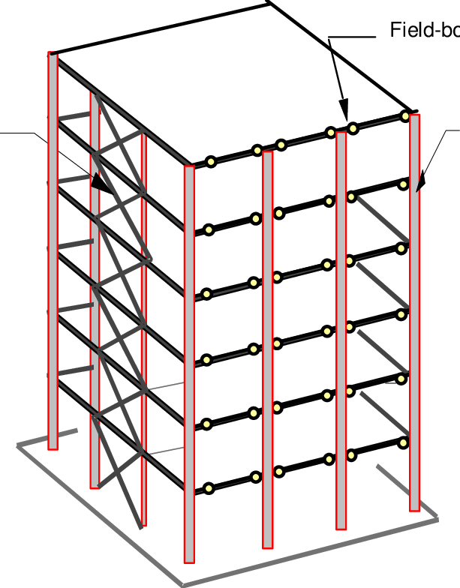
Figure 1 Shows a building made of Moment-Resisting Frames (Flynn and AstanehAsl, 2001)
MRFs are especially efficient in areas with moderate seismic activity and are frequently employed in structures requiring architectural flexibility (Tartaglia, D’Aniello and Landolfo, 2023). Nonetheless, their efficacy is contingent upon the ductility of the materials and the intricacy of the connections.

Shear Walls
Shear walls are vertical components that impart lateral rigidity and strength to structures, effectively countering horizontal seismic stresses (Jamle and Patidar, 2020). They are often fabricated from reinforced concrete or masonry and are strategically positioned throughout the structure to enhance performance.
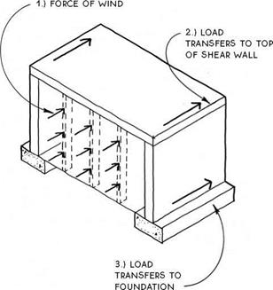
Figure 2 Shows a diagram of a building made of shear walls (CivilDigital, 2017).
Shear walls are particularly advantageous in high-rise structures, as they assist in managing lateral displacements and mitigating the potential for structural damage during seismic events (Smith and Kurama, 2014).

Braced Frames
Braced frames utilize diagonal members (braces) to counter lateral loads, thereby augmenting the structure's rigidity and strength. Numerous designs exist, such as concentric and eccentric bracing systems, each providing distinct benefits for energy dissipation and architectural integration (Karamodin and Zanganeh, 2017).
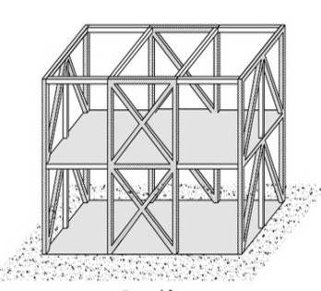
Figure 3 Shows a diagram of a building's structure being made of braced frames (OpenQuake, 2024).
Braced frames are frequently employed in industrial edifices and structures necessitating expansive open areas, as they offer efficient seismic protection while maintaining floor configurations.

Base Isolation Systems
Base isolation entails the installation of flexible bearings or isolators between a building's foundation and superstructure, enabling the building to move independently of ground motion during seismic events (Wellington City Council, 2014). This method markedly diminishes the seismic forces conveyed to the structure.
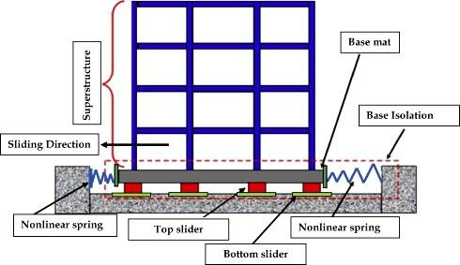
Figure 4 Shows a diagram which depicts elements of Base Isolation Systems (Kumar, 2020).
Base isolation is especially useful for essential facilities such as hospitals and emergency response centres, where it is vital to sustain operational functionality during and after seismic occurrences (Wellington City Council, 2014).

Energy Dissipation Devices
Energy dissipation devices, including dampers, are included into structures to absorb and dissipate seismic energy, thereby alleviating the stress on key structural components. Damper types encompass viscous, friction, and tuned mass dampers, each operating distinctly to alleviate seismic impacts.
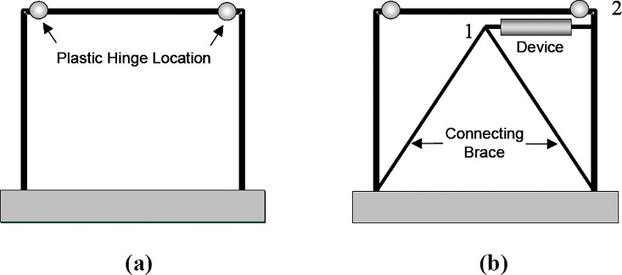
Figure 5 Shows a depiction of energy dissipation devices (D et al., 2008)
These devices are frequently utilized alongside other structural systems to improve overall seismic performance, particularly in the retrofitting of existing buildings.

Dual Systems
Dual systems integrate moment-resisting frames with shear walls or braced frames, utilizing the benefits of both systems to withstand seismic stresses. The moment frames provide ductility, while the shear walls or braced frames offer stiffness and strength.
This hybrid methodology is especially advantageous in high-rise structures, where the regulation of lateral displacements and internal forces is essential for seismic resilience.

Case Studies and Examples

Case Study: Taipei 101 and Its Tuned Mass Damper.
Taipei 101, situated in Taipei, Taiwan, reaches a height of 508 meters and was the highest skyscraper globally upon its completion in 2004. Located in an area susceptible to typhoons and earthquakes, the building employs sophisticated technical techniques to guarantee structural integrity and occupant safety (Wright, 2010).

Figure 6 Shows the Taipai 101 building (Skyscraper, 2024).

Tuned Mass Damper (TMD) Design
A crucial element of Taipei 101's resistance to seismic activity and wind forces is its 660-metric-ton tuned mass damper. The enormous steel sphere, with a diameter of 5.5 meters, is suspended between the 87th and 92nd floors. The TMD consists of forty-one welded steel plates, linked to the building's structure by ninety-two steel cables and eight viscous dampers, enabling it to oscillate and mitigate structural movements induced by external forces (TheCivilEngineer, 2024).
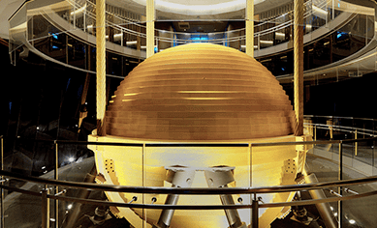
Figure 7 Shows Tuned Mass Damper located in Taipei 101 (Taipei 101, 2024).

Functionality and Performance
The TMD functions by counteracting the building's oscillation during seismic occurrences or high winds, significantly diminishing lateral displacements by as much as 40%. This passive energy dissipation technology improves occupant comfort and structural stability. Significantly, during a 7.4 magnitude earthquake in April 2024, Taipei 101 sustained no damage, illustrating the efficacy of its TMD in practical scenarios (TheCivilEngineer, 2024).
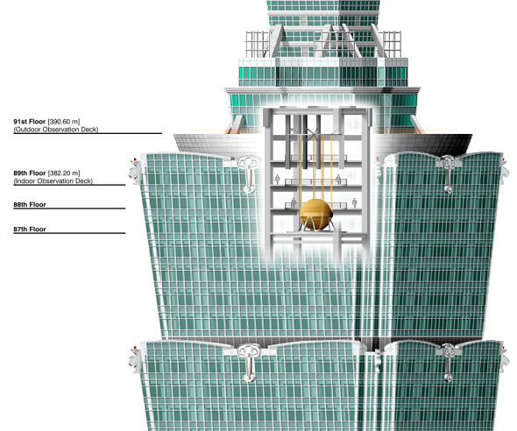
Figure 8 Shows a diagram of the functionaily of the TMD (Morton, 2014).

Public Engagement and Education
In contrast to numerous structural elements concealed from sight, Taipei 101's TMD is publicly accessible via an inside observatory. Visitors may witness the damper in operation, offering educational insight into the architectural engineering feats of the structure. The TMD has evolved into a cultural emblem, exemplified by the development of "Damper Baby" mascots and associated goods, hence enhancing public engagement in structural engineering (Wright, 2010).

Case Study: Burj Khalifa – Seismic Resilience and Structural Systems
The Burj Khalifa, situated in Dubai, United Arab Emirates, is the highest building in the world, measuring 828 meters. Conceived by Skidmore, Owings & Merrill (SOM), the tower incorporates sophisticated engineering methodologies to mitigate obstacles presented by wind and seismic activity.

Figure 9 Shows an image of the Burj Khalifa (AllPlan 2024)

Structural System: Buttressed Core
The principal structural system of the Burj Khalifa is the "buttressed core," characterized by a hexagonal central core supported by three buttresses arranged in a Y-shape. Each wing of the Y-shaped configuration offers lateral reinforcement to the others via the central core, yielding a structure that is both laterally and torsionally rigid. This structure effectively directs gravity and lateral loads to the foundation, negating the necessity for column transfers and facilitating a seamless load passage from the building's apex to the ground.

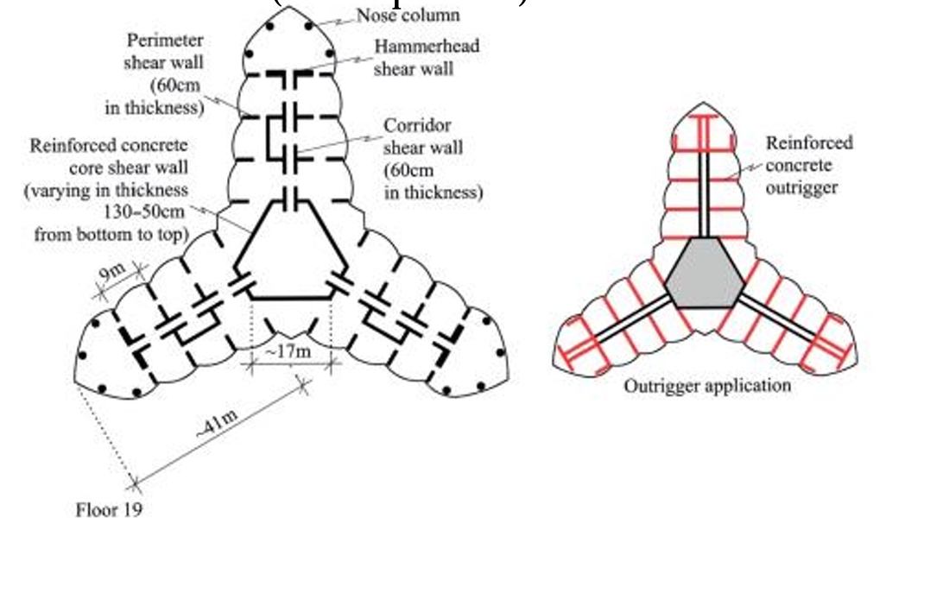
Figure 10 Shows Buttressed Core of Burj Khalifa

Seismic and Wind Considerations
Despite Dubai's location in a seismically stable region, the Burj Khalifa was engineered to endure possible seismic occurrences. The building's structural system offers intrinsic resistance to lateral forces, while its aerodynamic design mitigates wind-induced vibrations. The tower's setbacks and tapering design alter wind patterns, reducing vortex shedding and related oscillations.

Foundation Design
The Burj Khalifa's foundation consists of a substantial reinforced concrete mat, 3.7 meters thick, underpinned by 192 bored reinforced concrete piles. Each pile has a diameter of 1.5 meters and penetrates forty-three meters into the earth. This deep foundation structure was engineered to support the building's substantial weight and to ensure stability against any seismic and wind forces.

Conclusion
The seismic design of buildings is an essential component of structural engineering, guaranteeing that structures can withstand earthquake-induced stresses while preserving structural integrity and occupant safety. This analysis has explored essential structural systems, such as moment-resisting frames, shear walls, braced frames, and base isolation systems, each providing distinct benefits in improving earthquake resistance.
The examination of prominent case studies like Taipei 101 and Burj Khalifa demonstrates that the incorporation of sophisticated structural systems, including tuned mass dampers and buttressed core designs, plays a crucial role in the efficient management of lateral forces and vibration control. The implementation of international standards, such as Eurocode 8, ASCE 7, and the International Building Code (IBC), provide a thorough framework for the design of earthquake-resistant structures that accommodate diverse degrees of seismic risk.
In conclusion, the effective application of seismic design concepts necessitates a comprehensive strategy that integrates structural optimization, material selection, and compliance with existing design rules. This strategy not only preserves structural integrity but also reduces the effects of seismic events, so limiting possible damage and maintaining occupant safety.

References
- AllPlan (2023). Burj Khalifa: the Pinnacle of Architectural Excellence. [online] Allplan.com. Available at: https://www.allplan.com/blog/burj-khalifa/ [Accessed 12 May 2025].
- American and Structural Engineering Institute (2000). Minimum design loads for buildings and other structures. Reston, Va.: American Society Of Civil Engineers.
- British Standards Institution (2005). Eurocode 8 : design of structures for earthquake resistance. London: British Standards Institution.
- CivilDigital (2017). Shear Wall | Functions & Loads Transfer Mechanism | Design Example of Shear Wall | CivilDigital |. [online] CivilDigital. Available at: https://civildigital.com/shear-wall-functions-loads-transfer-mechanism-design-example-shear-wall/ [Accessed 12 May 2025].
- D, S.M., A, C.F., S, W.A., C, C.M., A, K.C., W, J.M. and J, M.R. (2008). Energy Dissipation Systems for Seismic Applications: Current Practice and Recent Developments. Journal of Structural Engineering, [online] 134(1), pp.3–21. doi:https://doi.org/10.1061/(ASCE)07339445(2008)134:1(3).
- Flynn, L. and AstanehAsl, A. (2001). Notes on Design Of Steel Parking Structures Including Seismic Effects.
- Ivanov, D. (2015). Seismic Resistant Design and Technology. CRC Press.
- Jamle, S. and Patidar, M. (2020). Use of different Grades of Concrete in Shear Wall: A Comprehensive Review. International Journal of Advanced Engineering Research and Science, 07, pp.355–359. doi:https://doi.org/10.22161/ijaers.74.44.
- Karamodin, A. and Zanganeh, A. (2017). Seismic Design and Performance of Dual Moment and Eccentrically Braced Frame System Using PBPD Method. Latin American Journal of Solids and Structures, 14(3), pp.441–463. doi:https://doi.org/10.1590/1679-78253425.
- Kumar, A. (2020). SEISMIC ISOLATION AND ENERGY DISSIPATING SYSTEM FOR EARTHQUAKE RESISTANT DESIGN. doi:https://doi.org/10.33564/IJEAST.2020.v04i11.02.
- Lorant, G. (2016). Seismic Design Principles | WBDG - Whole Building Design Guide. [online] Wbdg.org. Available at: https://www.wbdg.org/resources/seismic-design-principles [Accessed 11 May 2025].
- Moehle, J.P. and Hooper, J.D. (2016). Seismic Design of Reinforced Concrete Special Moment Frames: A Guide for Practicing Engineers, Second Edition. [online] doi:https://doi.org/10.6028/nist.gcr.16-917-40.
- Morton, E. (2014). How to Keep a 101-Story Skyscraper Steady in High Winds. [online] Slate Magazine. Available at: https://www.slate.com/blogs/atlas_obscura/2014/11/17/the_tuned_mass_damper_of_taipei_101_in_taiwan.html [Accessed 12 May 2025].
- OpenQuake (2024). Taxonomy - Braced frame [LFBR]. [online] taxonomy.openquake.org. Available at: https://taxonomy.openquake.org/terms/braced-frame-lfbr.
- Patowary, K. (2014). The 728-Ton Tuned Mass Damper of Taipei 101. [online] www.amusingplanet.com. Available at: https://www.amusingplanet.com/2014/08/the-728-ton-tuned-mass-damper-of-taipei.html [Accessed 12 May 2025].
- Skyscraper (2024). Taipei 101. [online] World’s Tallest Towers. Available at: https://skyscraper.org/tallest-towers/taipei-101/ [Accessed 12 May 2025].
- Smith, B. and Kurama, Y. (2014). Seismic design guidelines for solid and perforated hybrid precast concrete shear walls. PCI Journal, 59, pp.43–59. doi:https://doi.org/10.15554/pcij.06012014.43.59.
- Taipei 101 (2024). Features. [online] Taipei 101. Available at: https://www.taipei-101.com.tw/en/observatory/feature.
- Tartaglia, R., D’Aniello, M. and Landolfo, R. (2023). Response of Seismically Damaged Steel Reduced Beam Section Joints under Fire. Applied Sciences, 13, p.3641. doi:https://doi.org/10.3390/app13063641.
- TheCivilEngineer (2024). Taipei 101’s impressive tuned mass damper. [online] www.thecivilengineer.org. Available at: https://www.thecivilengineer.org/news/taipei-101s-impressive-tuned-mass-damper [Accessed 12 May 2025].
- Thornburg, D.W., Kimball, C. and Bracken, W.C. (2018). 2018 International Building Code Illustrated Handbook. New York: McGraw-Hill Education.
- Wellington City Council (2014). Base Isolation. [online] Wellington City Council. Available at: https://wellington.govt.nz/your-council/projects/earthquake-strengthening-projects/town-hall-strengthening/about-the-project/base-isolation.
- Williams, A. (2000). Seismic Design of Buildings and Bridges. Oxford University Press, USA.
- Wright, H. (2010). The skyscraper swing-stopper. [online] WIRED. Available at: https://www.wired.com/story/the-skyscraper-swing-stopper/ [Accessed 12 May 2025].

