

Student Name: Hina Saeed
Student ID Number: 2513317
Programme: Master of Business Administration (MBA)
Module Title: Financial Management
Module Code: LCMB7002
Lecturer name: Patrick Yeboah
Assignment Title: Strategic Financial Analysis and Investment Appraisal of Tesla, Inc.
Word Count: 5278
Submission Date: 27/3/2026

Table of Contents
1. Introduction 2
2. Financial Health Check: Ratio Analysis. 2
2.1 Profitability Analysis 2
2.2 Liquidity Analysis 7
2.3. Efficiency Ratios 10
2.4. Gearing Ratios 14
2.5. Cash Flow Analysis 16
2. Working Capital Management Analysis 17
2.1 Overview 17
2.2 Cash Operating Cycle 18
2.3 Working Capital Components 19
2.4 Working Capital Improvement Strategies. 20
2.4.1 Inventory Management 20
2.4.2 Receivables Management 20
2.4.3 Payables Management 20
2.4.4 Cash Reserves 20
2.5 Short-term and Long-term Financing. 21
3. Strategic Financial Restructuring Plan: Tesla, Inc. 22
3.1 Overview 22
3.2 Financial Restructuring Rationale. 22
3.3 Recommended Financial Restructuring Options. 23
3.3.1 Equity Injection 23
3.3.2 Debt Refinancing 23
3.3.3 Non-Core Assets Divestiture. 24
3.3.4 Strategic Mergers and Partnerships. 24
3.4 Impact on Shareholder Value 25
3.5 Operational Flexibility and Debt Structure. 25
3.6 International and Ethical considerations. 26
3.6.1 Taxation and Currency Risk 26
3.6.2 Cost Management and Inflation. 26
3.6.3 Corporate Social Responsibility. 26
3.7 Recommended Restructuring Strategy. 26
4. Investment Appraisal and Capital Budgeting. 27
4.1 Overview 27
4.2 Project Descriptions 28
4.3 Payback Period (PBP) 28
4.4 Accounting Rate of Return (ARR) 29
4.5 Net Present Value (NPV): 30
4.6 Profitability Index (PI) 31
4.7 Internal Rate of Return (IRR) 32
4.8 Comparison and Recommendation 32
4.9 Capital Rationing Analysis 33
4.10 Non-Financial Considerations 33
4.11 Evaluation 34
Appendices 34

Introduction
This report provides an analysis of the financial performance and strategic future of Tesla, a global electric vehicle (EV) manufacturer and sustainable energy provider (Tesla, Inc., 2024). Tesla has a history of growth in the last five years due to innovation, market expansion, and rising demand of EV by consumers (PwC, 2023; Harvard Business Review, 2022). The report gives a comprehensive report of the financial health of Tesla such as its profitability, liquidity, efficiency, gearing and cash flows (Fraser and Ormiston, 2022; Kieso et al., 2023) and then evaluate working capital management, strategic financial restructuring alternatives and possible investment projects (Brigham and Ehrhardt, 2021; Damodaran, 2023). The basis of recommendations is financial evidence, ethical aspects, and global scalability to underpin the long term shareholder value (Brealey et al., 2020).

2. Financial Health Check: Ratio Analysis.
Financial health check is necessary in assessing the performance of a firm in terms of its operations, financial stability and ability to grow in the future. The income statement demonstrates that there was a high increase in revenue between 2020 and 2022, which is evidence of business growth and higher sales performance. There was a significant increase in profit margins during this time indicating a greater cost control and efficiency. Nonetheless, the decrease in margins between the years 2023 and 2024 indicates an increase in the costs or a decrease in the power of price. Generally, the company is still profitable but earning pressure has been exerted in the recent times. The section analyses the financial performance of Tesla, Inc. in 2020-24 through profitability, liquidity, efficiency, gearing, and cash flow ratios. These indicators give the idea about the capacity of Tesla to make profit, to manage its resources effectively, to be liquid and to be financially stable in the long term.

2.1 Profitability Analysis
Profitability ratios are used to assess the capacity of a firm to make profits in relation to sales, assets, and shareholder equity. These indicators are especially significant in capital-intensive sectors like the production of electric vehicles where massive investments in production facilities and technology are needed (Kieso et al., 2023).
- Gross Profit Margin

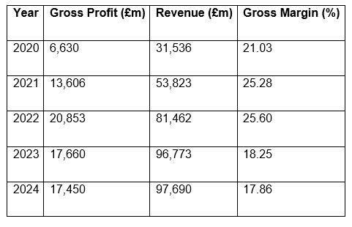
Table 1 Tesla Gross Profit Margin (2020-2024) Source: Calculated on the basis of Tesla Annual Reports (2020-2024).

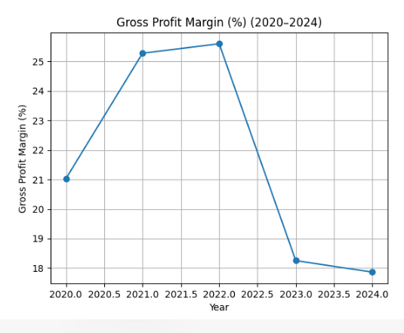
The gross profit margin of Tesla improved by 21.03 per cent in 2020 to 25.60 per cent in 2022 due to the increased efficiency in production and economies of scale as the company increased the manufacturing capacity. This time Tesla enjoyed growing demand of electric cars in the world and more efficient production of batteries. The growth of Gigafactories and the enhancement of the supply chain integration were probably the factors that led to the decrease in the unit cost of production (PwC, 2023).
Nevertheless, the margins decreased to 18.25% in 2023 and 17.86% in 2024, which means that the pressure on production profitability is growing. This is mostly because Tesla has been reducing its prices aggressively to sustain its market share as the competition in the EV industry has increased. Moreover, the increase in the costs of raw materials especially lithium and nickel that are used in making batteries also led to the increase in the cost of goods sold. This decline notwithstanding, Tesla has comparatively good gross margins in the electric vehicle market.
- Operating Profit Margin
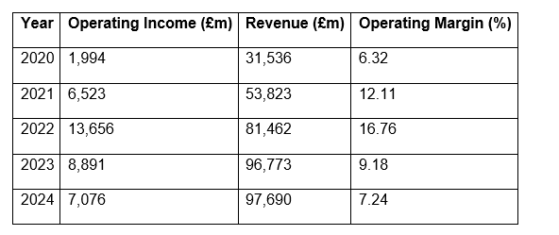
Table 2 Tesla Operating Profit Margin Source : Calculated using Tesla Annual Reports (2020-2024).

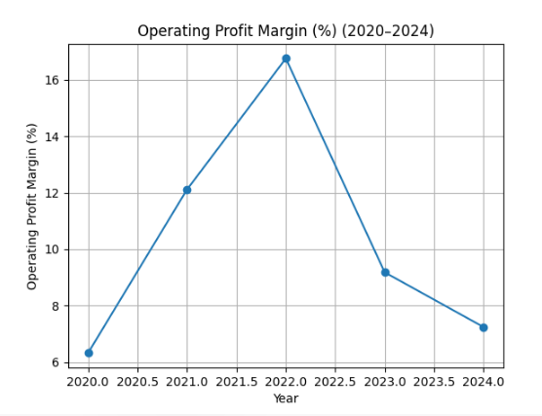

Operating profit margin is used to show how well a firm is able to utilise its operating expenses in comparison with revenue. The operating margin of Tesla was 6.32 percent in 2020 and 16.76 percent in 2022, which indicates that the company has a high level of operational leverage as the volume of production rose. The fixed costs of factory infrastructure were distributed with the increased output in the manufacturing capacity, enhancing cost efficiency (Damodaran, 2023).
The margin however dropped to 9.18% in 2023 and 7.24% in 2024, which means that the cost of operation is rising. This decrease can be attributed to increased research and development, labour and international logistics costs related to mass production.
- Net Profit Margin
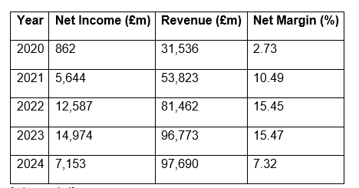
Table 3 Tesla Net Profit Margin (2020-24) Source: Calculated based on Tesla Annual Reports (2020-2024).

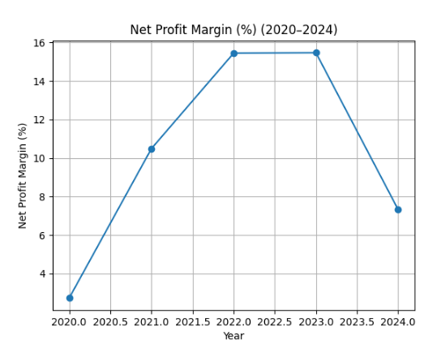

The net profit margin of Tesla has increased significantly in 2022 and 2023 to more than 15 percent, which is a good indicator of high revenue growth and better operations. This is also the time when the world was rapidly adopting electric vehicles, the government was favourable with the policies and Tesla had a solid brand name in the EV market (Harvard Business Review, 2022).
Nevertheless, net profit margin decreased to 7.32% in 2024, indicating that the company is less profitable compared to revenue. The fall can be explained by the increased cost of operations, the competition with the world automakers, and the pricing policies that are directed at preserving the market share. The net profitability could also have been lower due to inflationary pressures on energy, materials and labour costs.
- Return on Assets (ROA)
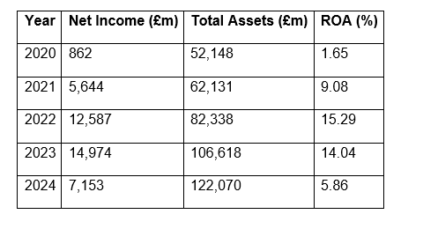
Table 4 Tesla Return on Assets (2020–2024) Source: Calculated based on Tesla Annual Reports (2020-2024).

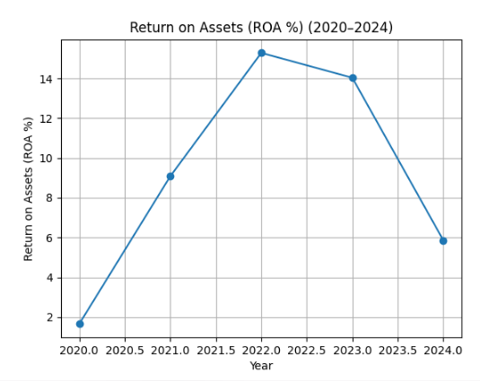
Return on assets is used to measure the efficiency of a company in using its asset base to make profits. The ROA of Tesla increased by a wide margin in 2022 (15.29) compared to 2020 (1.65), and this means that corporate assets are used more efficiently as the production capacity increased.
Nevertheless, the ROA dropped to 5.86% in the year 2024 indicating that the growth of assets has been higher than the generation of profits. Tesla has spent a lot in production plants, battery technology, and research and development. Although this type of investment helps in long-term innovation and growth, it can have a short-term impact on asset efficiency as the new facilities may not be fully operational (Fraser and Ormiston, 2022).
- Return on Equity (ROE)
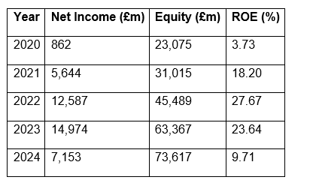
Table 5 Tesla Return on Equity (2020–2024) Source: Calculated based on Tesla Annual Reports (2020-2024).

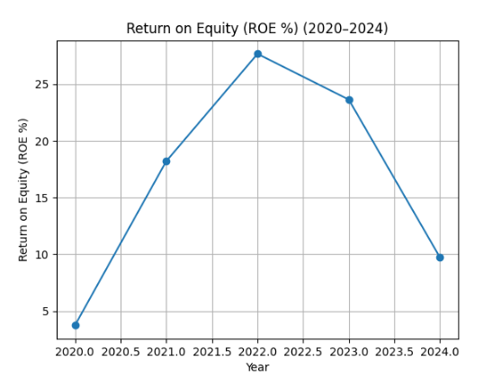
Return on equity is used to measure the efficiency of a company in making a profit out of the capital invested by the shareholders. The ROE of Tesla rose significantly, as it was 3.73% in 2020 and 27.67% in 2022, indicating a robust growth in profitability at the time when the EV market is expanding rapidly.
Nevertheless, ROE has decreased to 9.71% in 2024 because equity rose considerably because of further investment and retained earnings. ROE automatically decreases when the shareholder equity increases at a higher rate than the net income. This trend underscores the need to continue the growth of profits to ensure the investors have high returns.

2.2 Liquidity Analysis
Liquidity ratios assess the capacity of a company to pay off short-term financial commitments with the liquid assets.
- Current Ratio
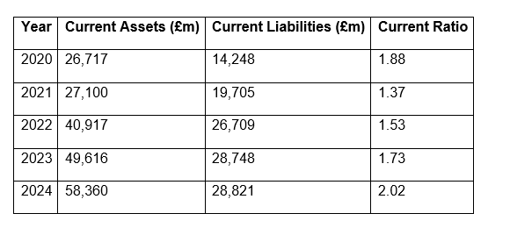
Table 6 Tesla Current Ratio (2020–2024) Source: Calculated using Tesla Annual Reports (2020-2024).

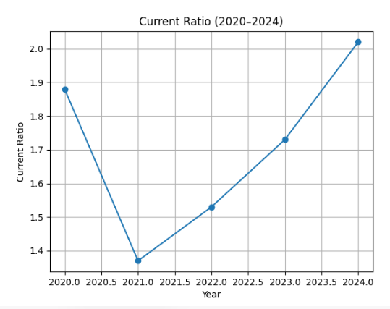
Tesla had rather high liquidity during the period. The current ratio has decreased as in 2020 (1.88) to 2021 (1.37), indicating that the company has increased its current liabilities due to the expansion of production capacities worldwide. Nevertheless, the liquidity improved since 2022 and as of 2024, it stands at 2.02.
This indicates better working capital management and growing current assets especially cash and receivables due to the growing vehicle sales. In general, Tesla has a comfortable capacity to cover the short-term liabilities.
- Quick Ratio
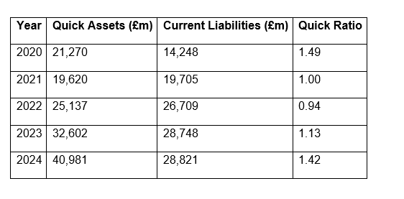
Table 7 Tesla Quick Ratio (2020–2024) Source: Calculated using Tesla Annual Reports (2020-2024).

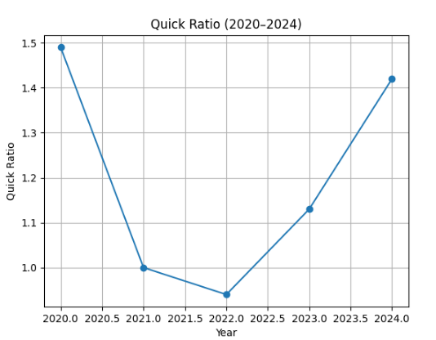
The quick ratio is a more rigid measure of liquidity because it does not include inventory. The quick ratio decreased in Tesla, which was 1.49 in 2020, and in 2022, it was 0.94, which means that the company has become more dependent on inventory at a time when production is growing.
Nevertheless, the ratio increased to 1.42 in 2024, indicating better liquidity and better cash management. The growth means that Tesla is becoming abler to cover the short-term commitments without depending on the inventory sales to a large extent.
- Cash Ratio
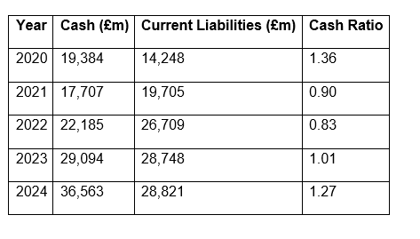
Table 8 Tesla Cash Ratio (2020–2024) Source: Calculated using Tesla Annual Reports (2020-2024).

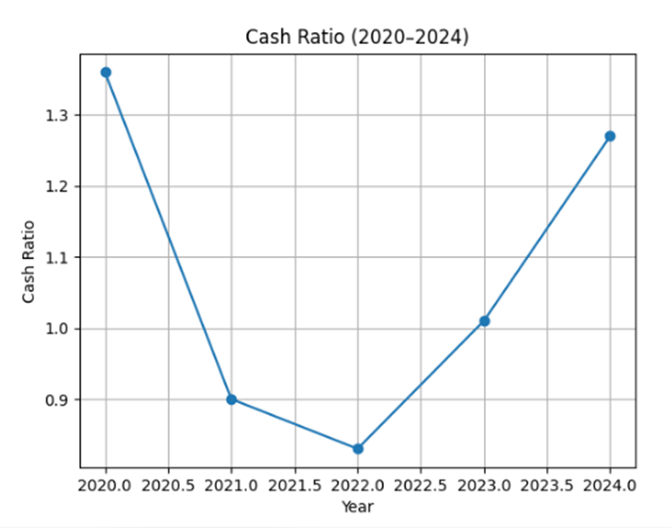
The cash ratio of Tesla was relatively good over the period. It decreased to 0.83 in 2022, which is indicative of increased short-term liabilities related to expansion activities but rose to 1.27 in 2024. This increase shows that Tesla has increased its cash reserves and can easily pay short term liabilities with cash and cash equivalents only.

2.3. Efficiency Ratios
Efficiency ratios are used to determine the efficiency of a company in using its assets and working capital to generate revenue (KPMG, 2022).
- Inventory Turnover
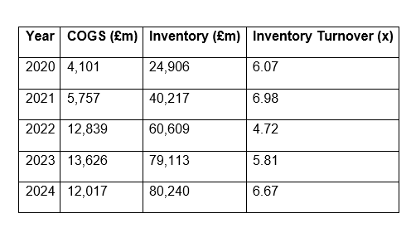
Table 9 Tesla Inventory Turnover (2020-24) Source: Computed using Tesla Annual Reports (20202-024)
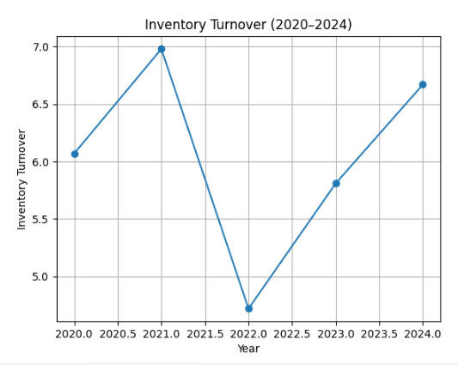
Tesla inventory turnover improved by 6.07 in 2020 to 6.98 in 2021, which demonstrates that Tesla manages its inventory efficiently in the times of high sales growth. The ratio decreased to 4.72 in 2022 indicating short-term inventory build-up as the production increased at a high rate.
Nevertheless, in 2024, turnover went back to 6.67, which means that there was better coordination between production and market demand.
- Inventory Days
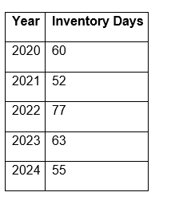
Table 10 Tesla Inventory Days (2020–2024) Source: computed based on Tesla Annual Reports (2020-2024)

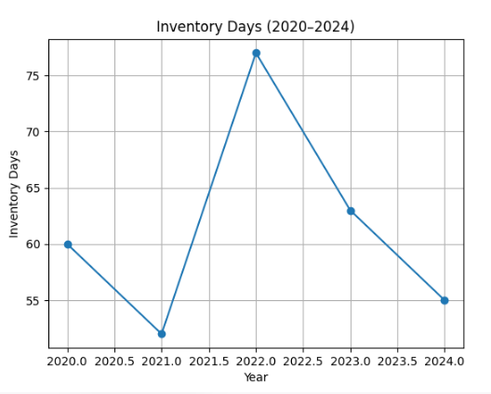
The 2022 inventory days moved to 77 days indicating slower inventory movement in the production expansion phase. This could have been due to supply chain breakages and higher production.
In 2024, the ratio decreased to 55 days, which indicates the increased efficiency of the supply chain and a better fit of the production levels to the consumer demand.
- Receivable Turnover
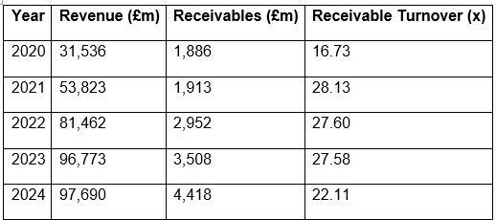
Table 11 Tesla Receivable Turnover (202024) Source: Computed using Tesla Annual Reports (2020-2024)
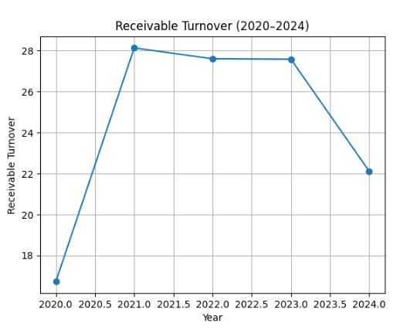
The receivable turnover of Tesla has increased dramatically in 2020-2021, which shows the effective use of credit and timely collection of customer payments. The ratio was rather steady until 2023 but dropped to 22.11 in 2024, which indicates that customers are paying slightly slower to clear outstanding balances. This trend can be an indication of long credit periods or higher sales transactions internationally.
- Asset Turnover
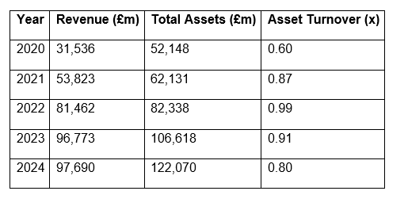
Table 12 Tesla Asset Turnover (2020–2024) Source: Computed using Tesla Annual Reports (2020-2024)
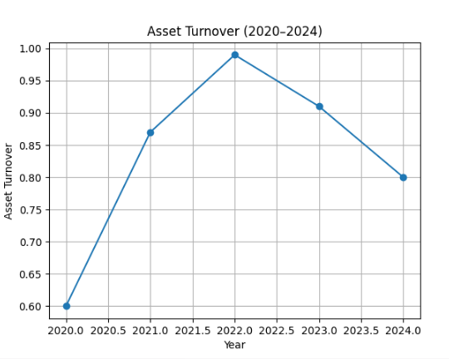
In 2022, the asset turnover rose to 0.99, which indicates that Tesla has used its manufacturing infrastructure effectively. Nevertheless, the ratio decreased to 0.80 in 2024, which means that the growth in assets has been higher than the growth in revenue.
To a large extent, this trend can be explained by the fact that Tesla invests a lot in Gigafactories, research centres, and battery technology. Although such investments decrease short-term efficiency ratios, they are necessary to facilitate long-term growth and innovation.

2.4. Gearing Ratios
Gearing ratios assess how much a company uses debt financing as compared to equity and give an understanding of financial risk and solvency (Damodaran, 2023).
- Debt-to-Equity Ratio
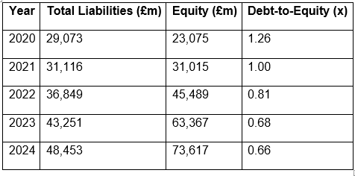
Table 13 Tesla Debt-to-Equity Ratio Source: Computed on the basis of Tesla Annual Reports (2020-2024)

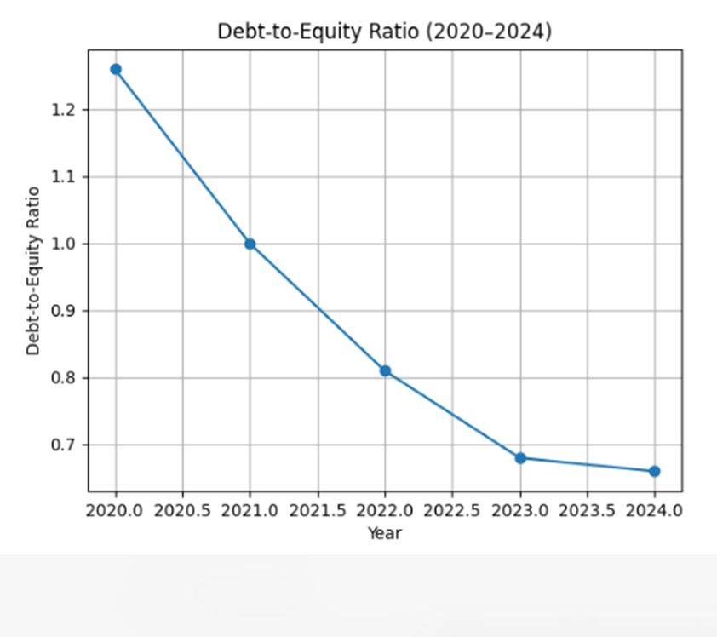
The debt-to-equity ratio of Tesla dropped to 0.66 in 2024, which is lower than 1.26 in 2020, which means that the company experienced a decrease in financial leverage. The company has been supporting expansion through increased equity financing and reduced debt financing. Less leverage minimises financial risk and interest payments and enhances financial stability in the long-term.
- Debt Ratio
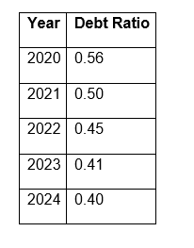
Table 14 Tesla Debt Ratio (2020–2024) Source: Computed based on Tesla Annual Reports (2020-2024).

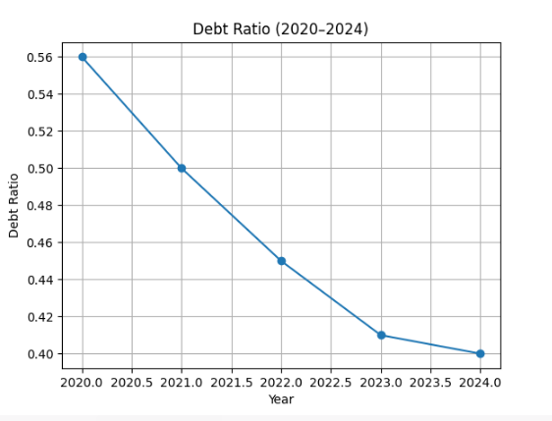
The debt ratio validates the falling leverage trend. In 2020, Tesla used 56 percent of its assets to fund liabilities, but in 2024, the ratio dropped to 40 percent. This increase shows greater solvency and less exposure to financial risk.

2.5. Cash Flow Analysis
Cash flow ratios determine the capacity of a company to produce adequate operating cash flows to meet liabilities and operations.
- Operating Cash Flow Ratio
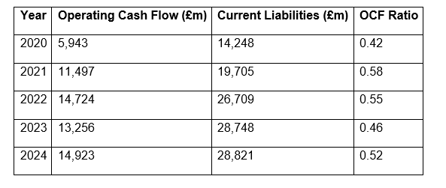
Table 15 Tesla Operating Cash Flow Ratio Source: Computed based on Tesla Annual Reports (2020-2024)

The operating cash flow ratio of Tesla increased to over 0.5 in the following years, which is better than 0.42 in 2020, which means that the company has a higher cash generation as compared to short-term liabilities. Despite the slight decrease in the ratio in 2023, it regained its level of 0.52 in 2024, indicating that cash generation is stable in spite of changes in profitability. A ratio of 0.5 or above usually means that companies are producing enough operating cash to meet their commitments (Fraser and Ormiston, 2022).

2. Working Capital Management Analysis

2.1 Overview
Working capital management is the process of managing short-term assets and liabilities to ensure the company is liquid, efficient, and stable in its operations (Brigham and Ehrhardt, 2021). In the case of Tesla, Inc., the working capital management is vital due to the high rate of production growth, complexities in the global supply chain, and high raw materials, batteries, and finished vehicles inventories. Moreover, Tesla is a capital-intensive industry, and the conversion of cash in a timely manner influences the capacity to invest in R&D, open Gigafactories, and satisfy the market demand. Thus, the control of inventory, receivables, payables, and cash is necessary to maintain growth and profitability without overdependence on external financing (Atrill and McLaney, 2021).

2.2 Cash Operating Cycle
Cash operating cycle (COC) is the number of days that it takes to transform investment in production into cash through sales, which is a combination of inventory days, receivable days, and payable days (Fraser and Ormiston, 2022):
Year | Inventory Days | Receivable Days | Payable Days | COC (Days)
2020 | 60 | 22 | 35 | 47
2021 | 52 | 13 | 40 | 25
2022 | 77 | 13 | 45 | 45
2023 | 63 | 13 | 50 | 26
2024 | 55 | 16 | 52 | 19

The COC of Tesla declined to 19 days in 2024 compared to 47 days in 2020, which demonstrates the accelerated cash conversion, efficiency in collections, and successful negotiations with suppliers. The spike (45 days) of 2022 was caused by inventory accumulation because of the increase in production and temporary supply chain disruptions, and it showed how liquidity is vulnerable to operational scaling (KPMG, 2022). In general, the downward trend in COC shows that Tesla is becoming increasingly capable of transforming resources into cash quickly, which will decrease the use of short-term external funding and increase its operational flexibility (Brigham and Ehrhardt, 2021).

2.3 Working Capital Components
The difference between current assets and current liabilities is known as working capital, which shows the financial health and efficiency of a company in the short term (Horngren et al., 2022). The current assets and liabilities of Tesla in 2020-2024 are as follows:
Year | Current Assets (£m) | Current Liabilities (£m) | Net Working Capital (£m)
2020 | 26,717 | 14,248 | 12,469
2021 | 27,100 | 19,705 | 7,395
2022 | 40,917 | 26,709 | 14,208
2023 | 49,616 | 28,748 | 20,868
2024 | 58,360 | 28,821 | 29,539

Tesla has a positive net working capital, which is mostly cash and receivables, and it is strategically using accounts payable. A positive working capital means that there is liquidity to cover daily operations and cushion against unforeseen costs (Atrill and McLaney, 2021). The company strategy is consistent with the industry experience where suppliers tend to finance with long payment terms, and production is highly synchronised with sales. Nevertheless, a strong reliance on supplier conditions exposes the company to supply chain risks, especially considering that Tesla has a worldwide presence in production (Horngren et al., 2022).

2.4 Working Capital Improvement Strategies.

2.4.1 Inventory Management
Just-in-time (JIT) production saves on storage expenses and liberates cash (McKinsey, 2023).
• Demand forecasting based on AI will match inventory and the real sales demand, avoiding overproduction.
• Supplier consignment deals reduce initial cash outlay and keep production going.

2.4.2 Receivables Management
• Stricten credit conditions to reduce customer payment time between 30 and 60 days to 20 and 30 days.
• Early payment bonuses promote quicker cash flows.
• Automated receivable tracking minimises time wastage and maximises cash collection (Fraser and Ormiston, 2022).

2.4.3 Payables Management
• Prolong payment terms in a strategic manner without damaging supplier relations.
• Match the payables to the inflows to keep the liquidity high, which contributes to a shorter cash operating cycle.

2.4.4 Cash Reserves
• Keep 1015% current liabilities as cash reserves to absorb operational shocks (Brigham and Ehrhardt, 2021).
• Maximise short-term investments to get liquidity but with moderate returns.

2.5 Short-term and Long-term Financing.
The financial managers also have to decide on the most appropriate financing structure that will facilitate working capital requirements and long-term investment. Inventory purchases and receivable cycles are usually financed using short-term sources of finance like bank overdrafts, trade credit, and revolving credit facilities due to their flexibility and quick access to funds (Atrill and McLaney, 2021). These tools, however, can put firms at risk of refinancing risk in the event of tightening of credit conditions.
Corporate bonds, equity issues, or convertible debts are long-term financing options that are more stable to fund large capital investments such as manufacturing plants, research facilities, and technological development (Brigham and Ehrhardt, 2021). Long-term financing lowers the refinancing risk, but it can be associated with increased issuance costs, or even dilution of shareholders.
In the case of Tesla, a viable financial strategy that can be adopted is to use short term financing to finance working capital cycles and use long term capital sources to finance large scale investment projects. A balanced capital structure helps in maintaining liquidity besides providing enough funds to invest in strategic expansion of the electric vehicle market.
1. Dispose of non-core assets to raise funds to be used in strategic projects and to simplify operations.
2. Strategic Partnerships/Mergers: Co-operate with technology and battery companies to increase market penetration, lower costs and speed up innovation.
This plan balances financial stability, flexibility of operations, and shareholder value and deals with international risks and ethical issues.

3. Strategic Financial Restructuring Plan: Tesla, Inc.

3.1 Overview
Financial restructuring is a strategic plan that is designed to enhance the capital structure of a firm, increase the shareholder value and increase the flexibility of the operations of the firm. In the case of Tesla, Inc., a company that deals with the highly capital-intensive and fast-changing electric vehicle (EV) market, restructuring is necessary to respond to the increasing production cost, difficulties in international expansion, and competition. Tesla has been very aggressive in its investments in Gigafactories, battery technology and autonomous vehicle development and this necessitates a careful balance between equity, debt and operational liquidity. The strategic restructuring can maximise the financial standing of the firm, minimise the risks, and increase the potential of long-term growth (Damodaran, 2023; Brigham & Ehrhardt, 2022).

3.2 Financial Restructuring Rationale.
The financial restructuring of Tesla is motivated by a number of factors that are critical. First, the company is in a capital-intensive industry, with high initial expenses in manufacturing facilities, research and development, and supply chain logistics that impose high financing needs. Second, Tesla has been facing margin pressures in 20232024 despite high revenue growth because of competitive pricing and rising costs of raw materials (PwC, 2023). Third, Tesla has a global presence that makes the company vulnerable to foreign exchange risk, fluctuating taxation and regulatory challenges in North America, Europe, and Asia. Lastly, the investors require long-term ROE, cash flows, and profitability as the company undertakes strategic innovation. Financial restructuring will help Tesla to cope with these pressures through better capital allocation, liquidity, and financial stability in the long term (Harvard Business Review, 2022).

3.3 Recommended Financial Restructuring Options.

3.3.1 Equity Injection
Issuing new equity is a fundamental alternative to raise new capital to grow without the need to increase the debt. Equity financing enables Tesla to finance the Gigafactory expansion, the development of the next-generation battery technology, and the global market entry programmes. The most important benefit of equity injection is the decrease in financial leverage which enhances the balance sheet and decreases the debt service requirements, which enhances creditworthiness (Brealey et al., 2020). Equity issue is also a long-term source of funds to invest in long-payback investments, which is in line with the strategic vision of Tesla. Equity raises however have the disadvantage of diluting the shareholders hence decreasing the earnings per share in the short run. To avoid this, Tesla ought to time equity issues, with a maximum of 1015 per cent of existing market capitalisation, to ensure that it gets enough capital inflow without losing investor confidence.

3.3.2 Debt Refinancing
Debt refinancing is the process of substituting short-term or high-interest debt with long-term debt, which can be corporate bonds or convertible debt. Refinancing gives certain cash flows, eliminating rollover risk related to maturing short term obligations. It also enables Tesla to optimise its debt-to-equity ratio, which is 0.66, enhancing its operational flexibility and retaining investment-grade credit ratings (Fraser & Ormiston, 2022). Furthermore, refinancing at favourable interest rates may lower the total cost of capital and working capital or strategic investment. The international debt currency fluctuations and possible rise in the interest rates are considered as critical risks and can be addressed by using hedging techniques or fixed-rate instruments.

3.3.3 Non-Core Assets Divestiture.
The strategic sale of non-core or underperforming assets can help Tesla to redirect capital into high-paying investments. Selling non-core business or patents that are not EV or battery related liberates cash and simplifies operations. Divestiture proceeds may be utilised to pay off debt, invest in R&D, or invest in capacity expansion, enhancing ROA and ROE (KPMG, 2022). Ethics play a pivotal role in the case of divestiture: Tesla needs to treat employees fairly, communicate with the stakeholders transparently, and adhere to the principles of sustainability and CSR to preserve the brand image (McKinsey, 2023). Divestiture will enable Tesla to concentrate on strategic priorities, which will enhance shareholder value and operational efficiency.

3.3.4 Strategic Mergers and Partnerships.
Joint ventures or mergers will give Tesla a chance to enter new markets, technology, and resources and share the risk. Partnerships with battery manufacturers, AI creators, or local car manufacturers can speed up the manufacturing process, lower the cost per unit, and improve the technology, especially in self-driving and energy storage (Harvard Business Review, 2022). Despite strategic partnerships providing synergies in operations, they come with integration risks, cultural issues, and regulatory scrutiny especially in Europe and China. Thus, due diligence, contractual protection, and governance frameworks are needed to keep in line with Tesla strategic objectives.

3.4 Impact on Shareholder Value
The purpose of financial restructuring is to improve shareholder value in various ways. Increase in net income compared to equity can be achieved through equity injection and sale of non-core assets to finance high-return projects. Optimisation of debt structure lowers interest payments enhancing profitability and ROE. In addition, clear communication of restructuring strategies is an indicator of financial discipline and growth opportunities to the market, which can positively affect the valuation of stocks (Damodaran, 2023). But poorly executed restructuring, including over-issuing equity or poorly announced divestitures, may cause adverse investor reaction and stock volatility. Thus, Tesla has to deal with the financial mechanics as well as the market perception of restructuring efforts.

3.5 Operational Flexibility and Debt Structure.
Restructuring enables Tesla to maximise its debt structure and remain operationally flexible. Extending the debt maturities will decrease the liquidity risk, and the balanced combination of fixed and variable-rate debt will decrease the interest rate risk. A moderate leverage (debt-to-equity below 0.7) is the only way to maintain credit ratings and investor confidence, as well as to balance debt commitments and cash flows available through global operations (Fraser and Ormiston, 2022). The flexibility enables quick scaling of production, investment in innovation in time and resistance to disruption of the supply chain.

3.6 International and Ethical considerations.

3.6.1 Taxation and Currency Risk
The international business of Tesla exposes the company to various taxation systems and foreign exchange risks. The financial restructuring should take into account the placement of debt in a tax-efficient manner, repatriation of profits, and hedging of non-USD revenues and liabilities. Proper management of currency risk will make sure that the operational profits and debt service capacity are not eroded due to foreign exchange volatility (PwC, 2023).

3.6.2 Cost Management and Inflation.
Raw materials, labour and energy costs are subject to global inflationary pressures. The restructuring should have financial buffers to absorb cost shocks to allow Tesla to have consistent margins and shareholder returns. Pricing strategies that are aligned with the cost of production can be used to maintain competitiveness and profitability.

3.6.3 Corporate Social Responsibility.
Tesla restructuring is based on ethical and CSR considerations. The rights of employees, supply chain ethics and sustainability commitments should be observed in the event of divestitures or mergers. The alignment of restructuring efforts with the Tesla environmental mission will strengthen the brand reputation and investor confidence, which is long-term value creation (McKinsey, 2023).

3.7 Recommended Restructuring Strategy.
The CFO of Tesla needs to pursue a multi-pronged restructuring strategy:
1. Equity Injection: 10-15% of market capitalisation to finance strategic expansion and research and development.
2. Debt Refinancing: Substitute the expensive short-term debts with long-term and cheap bonds to minimise rollover risk.
3. Divestiture: Dispose unrelated assets to raise capital to invest in strategic projects and to simplify operations.
4. Strategic Partnerships/Mergers: Form strategic alliances with technology and battery companies to expand market presence, lower expenses and speed up innovation.
This plan balances financial stability, flexibility in operations and shareholder value and takes into consideration international risks and ethical issues.

4. Investment Appraisal and Capital Budgeting.

4.1 Overview
Effective financial management is inseparable from investment appraisal and capital budgeting, especially when it comes to companies in capital-intensive and high-growth industries, including the electric vehicle (EV) and technology markets. In the case of Tesla, Inc. and other companies, massive investment in production capacity, battery technology, and research and development require a thorough consideration to ensure that the scarce capital is invested in a manner that optimises shareholder value and helps in achieving strategic goals.
This part compares three investment projects, namely A, B, and C, with some of the major appraisal methods such as Payback Period (PBP), Accounting rate of return (ARR), Net Present Value (NPV), Profitability Index (PI) and Internal rate of return (IRR). Each of these projects has an initial investment of 50 million pounds and provides different cash flows in five years. It assumes a discount rate of 10% which is the weighted average cost of capital (WACC) of Tesla and straight-line depreciation to zero to approximate returns based on accounting.

4.2 Project Descriptions
The three projects under consideration are summarised in Table 1.
Project | Initial Investment | Year 1 | Year 2 | Year 3 | Year 4 | Year 5
A | 50 | 10 | 12 | 14 | 10 | 8
B | 50 | 11 | 11 | 11 | 11 | 11
C | 50 | 5 | 10 | 20 | 25 | 5
Table 16 Project Cash Flows (£m)
All projects reflect different cash flow patterns: Project A is characterized by periodic inflows with average cash outflow in the beginning of the year, Project B displays regular cash inflows, and Project C illustrates low initial cash inflows with high turnover rates in the middle of the year. The liquidity, risk exposure and long-term profitability implications of these patterns are apparent.

4.3 Payback Period (PBP)
The Payback Period is a period that evaluates the cumulative cash inflows that should take place to pay off the initial investment. It is an easy liquidity risk importance and financial flexibility measurement, which gives information on the speed at which a project recovers money.
Calculations:
- Project A:
Cumulative inflows: 10, 22, 36, 46, 54
PBP = 4 + (50-46)/8 = 4.5 years
- Project B:
Cumulative inflows: 11, 22, 33, 44, 55
PBP = 4 + (50-44)/11 ≈ 4.55 years
- Project C:
Cumulative inflows: 5, 15, 35, 60, 65
PBP = 3 + (50-35)/25 = 3.6 years
Interpretation: The payback period of Project C is the least, which means that it gives out cash faster than the other two projects A and B. In a business with high capital intensity such as Tesla and volatile market, a quicker cash recovery will mean a lower liquidity risk and greater capacity to finance other strategic projects.

4.4 Accounting Rate of Return (ARR)
ARR is a measure of the accounting profit on investment on a per-year basis. Though it is a non-discount measure, it gives an accounting understanding of the profitability of the project.
Assuming straight-line depreciation to zero over five years:
ARR= Average Annual Cash Inflow ​/ Initial Investment ×100
Calculations:
- Project A: (10+12+14+10+8)/5 = 10.8 → ARR = 10.8/50 × 100 = 21.6%
- Project B: 11 → ARR = 22%
- Project C: (5+10+20+25+5)/5 = 13 → ARR = 26%
Interpretation: Project C has the largest ARR, which demonstrates that it has better average profitability compared to the invested capital. Project B is fairly appealing, and Project A takes the last position. This is a measure that will strengthen the need to pick up projects that will give significant returns during the life of operation.

4.5 Net Present Value (NPV):
NPV is a measure of the value of inflows of cash at present approximately at discounted rates representing cost of capital. The NPV takes into consideration the time value of money which is why it is the most theoretically sound approach in assessing investment initiatives.
Discount Factors at 10%:
Year | DF (10%)
1 | 0.909
2 | 0.826
3 | 0.751
4 | 0.683
5 | 0.621
Calculations:
- Project A:
NPV = 10×0.909 + 12×0.826 + 14×0.751 + 10×0.683 + 8×0.621 - 50
= 41.31 - 50 = -£8.69m
- Project B:
NPV = 11×0.909 + 11×0.826 + 11×0.751 + 11×0.683 + 11×0.621 - 50
= 41.69 - 50 = -£8.31m
- Project C:
NPV = 5×0.909 + 10×0.826 + 20×0.751 + 25×0.683 + 5×0.621 - 50
= 47.99 - 50 = -£2.01m
Interpretation: Interpretation: Project C has the greatest NPV (the least negative NPV) despite all the projects having slightly negative NPVs at a discount rate of 10% indicating that it destroys the least amount of value and is the most financially viable of the three. This is an early and mid-period cash flows that give rise to discounted value more effectively.

4.6 Profitability Index (PI)
PI measures the value created per £1 invested:
PI= PV of Cash Inflows​ / Initial Investment
Project | PV of Inflows (£m) | PI
A | 41.31 | 0.826
B | 41.69 | 0.834
C | 47.99 | 0.960
Interpretation: The PI of project C is closest to 1, which means that the project is the most valuable in terms of its unit of investment. This becomes especially significant in case of capital rationing when the efficient distribution of resources is essential. 4.7

4.7 Internal Rate of Return (IRR)
IRR is the discount rate at which NPV is equal to zero. On approximate interpolation, we obtain:
- Project A: IRR ≈ 9.4%
- Project B: IRR ≈ 9.6%
- Project C: IRR ≈ 9.7%
Interpretation: Interpretation: Project C is the one that gives the highest IRR meaning that it gives the highest returns when compared to the cost of capital. Though a little lower than the discount rate of 10, the total of the IRR, ARR and PBP have highlighted its strategic value.

4.8 Comparison and Recommendation
Based on all financial appraisal methods:
Project | PBP (years) | ARR (%) | NPV (£m) | PI | IRR (%)
A | 4.5 | 21.6 | -8.69 | 0.826 | 9.4
B | 4.55 | 22 | -8.31 | 0.834 | 9.6
C | 3.6 | 26 | -2.01 | 0.960 | 9.7
Recommendation: Project C can be recommended as the main investment since it provides the quickest payback, largest accounting, and economic returns, and a higher IRR. Although all projects have slightly negative NPV with a discount rate of 10 percent, Project C offers the most flexibility, liquidity coverage and strategic alignment to the Tesla operational goals. Project C also assists the management of the risks which allows Tesla to reinvest the initial cash flows into additional growth opportunities. 4.9

4.9 Capital Rationing Analysis
Given the assumption of a maximum investment of a.£100 million, Tesla can choose two projects in combination:
Combination | Total Investment (£m) | Total NPV (£m)
A + C | 100 | -10.7
B + C | 100 | -10.32
Interpretation: Interpretation: Project C + Project B would be marginally better than Project C + Project A in terms of NPV but nevertheless would consider the constraint of the investment in terms of the cost of one hundred and ten million pounds. This would maximize the value of capital during rationing, provide diversified cash flow profiles and would maintain flexibility of strategy. Incorporating non-financial considerations into a business is also part of the business strategies that the company must adopt.

4.10 Non-Financial Considerations
In addition to quantitative metrics, Tesla should take into consideration non-financial risks:
1. Liquidity and Operational Risk: Quicker cash flows prevent vulnerability to supply chain problems and reinvest in research and production expansion.
2. Market and Customer Dynamics: The projects contributing to the emerging EV technologies boost customer loyalty and brand positioning.
3. Political/Regulatory Exposure: International growth is associated with currency risk and regulatory risk; early cash paybacks in projects eliminate such risks.
4. Strategic Fit: The project C fits the overall strategy of Tesla that is characterized by the innovation and quick capacity development, especially during the mid-period of the year, and flexibility to act in accordance with the opportunities of the market.

4.11 Evaluation
The investment appraisal shows that the Project C is the most appealing alternative according to several appraisal methods. It has the quickest payback, greatest ARR, NPV, PI and IRR compared to the other two alternatives. In this case, Project C combined with Project B is the most efficient capital rationing taking into account that it balances the financial performance and the strategic goals. To ensure sustainability in its operations, Tesla ought to focus on making investments that will yield maximum returns whilst aiding its operations in terms of flexibility, technology and market positioning in the global EV industry.

References
Atrill, P. and McLaney, E. (2021) Accounting and finance for non-specialists. 12th edn. Harlow: Pearson. Accessed: March 2026.
Brealey, R.A., Myers, S.C. and Allen, F. (2020) Principles of corporate finance. 13th edn. New York: McGraw-Hill Education. Accessed: March 2026.
Brigham, E.F. and Ehrhardt, M.C. (2021) Financial management: theory and practice. 16th edn. Boston: Cengage Learning. Accessed: March 2026.
Damodaran, A. (2023) Corporate finance: theory and practice. 4th edn. Hoboken: John Wiley & Sons. Accessed: March 2026.
Fraser, L.M. and Ormiston, A. (2022) Understanding financial statements. 12th edn. Harlow: Pearson. Accessed: March 2026.
Harvard Business Review (2022) ‘The global expansion of electric vehicles and Tesla’s competitive strategy’. Available at: https://hbr.org (Accessed: March 2026).
Horngren, C.T., Sundem, G.L., Schatzberg, J.O. and Burgstahler, D. (2022) Introduction to management accounting. 17th edn. Harlow: Pearson. Accessed: March 2026.
Kieso, D.E., Weygandt, J.J. and Warfield, T.D. (2023) Intermediate accounting. 18th edn. Hoboken: John Wiley & Sons. Accessed: March 2026.
KPMG (2022) Global automotive industry outlook. Available at: https://kpmg.com (Accessed: March 2026).
McKinsey & Company (2023) The future of electric vehicles and supply chain transformation. Available at: https://www.mckinsey.com (Accessed: March 2026).
PwC (2023) Electric vehicle market outlook and battery supply chain analysis. Available at: https://www.pwc.com (Accessed: March 2026).
Tesla, Inc. (2020) Annual report 2020. Available at: https://www.tesla.com (Accessed: March 2026).
Tesla, Inc. (2021) Annual report 2021. Available at: https://www.tesla.com (Accessed: March 2026).
Tesla, Inc. (2022) Annual report 2022. Available at: https://www.tesla.com (Accessed: March 2026).
Tesla, Inc. (2023) Annual report 2023. Available at: https://www.tesla.com (Accessed: March 2026).
Tesla, Inc. (2024) Annual report 2024. Available at: https://www.tesla.com (Accessed: March 2026).

Appendices
- Ratio Analysis for Tesla
- Profitability Ratio Analysis
1.1 Gross Profit Margin Formula: Gross Profit Margin = Gross Profit / Revenue × 100
2020: 6,630 / 31,536 × 100 = 21.03%
2021: 13,606 / 53,823 × 100 = 25.28%
2022: 20,853 / 81,462 × 100 = 25.60%
2023: 17,660 / 96,773 × 100 = 18.25%
2024: 17,450 / 97,690 × 100 = 17.86%
1.2 Operating Profit Margin Formula: Operating Margin = Operating Income / Revenue × 100
2020: 1,994 / 31,536 × 100 = 6.32%
2021: 6,523 / 53,823 × 100 = 12.11%
2022: 13,656 / 81,462 × 100 = 16.76%
2023: 8,891 / 96,773 × 100 = 9.18%
2024: 7,076 / 97,690 × 100 = 7.24%
1.3 Net Profit Margin Formula: Net Profit Margin = Net Income / Revenue × 100
2020: 862 / 31,536 × 100 = 2.73%
2021: 5,644 / 53,823 × 100 = 10.49%
2022: 12,587 / 81,462 × 100 = 15.45%
2023: 14,974 / 96,773 × 100 = 15.47%
2024: 7,153 / 97,690 × 100 = 7.32%
1.4 Return on Assets (ROA) Formula: ROA = Net Income / Total Assets × 100
2020: 862 / 52,148 × 100 = 1.65%
2021: 5,644 / 62,131 × 100 = 9.08%
2022: 12,587 / 82,338 × 100 = 15.29%
2023: 14,974 / 106,618 × 100 = 14.04%
2024: 7,153 / 122,070 × 100 = 5.86%
1.5 Return on Equity (ROE) Formula: ROE = Net Income / Shareholder Equity × 100
2020: 862 / 23,075 × 100 = 3.73%
2021: 5,644 / 31,015 × 100 = 18.20%
2022: 12,587 / 45,489 × 100 = 27.67%
2023: 14,974 / 63,367 × 100 = 23.64%
2024: 7,153 / 73,617 × 100 = 9.71%
- Liquidity Ratios
2.1 Current Ratio Formula: Current Ratio = Current Assets / Current Liabilities
2020: 26,717 / 14,248 = 1.88
2021: 27,100 / 19,705 = 1.37
2022: 40,917 / 26,709 = 1.53
2023: 49,616 / 28,748 = 1.73
2024: 58,360 / 28,821 = 2.02
2.2 Quick Ratio Formula: Quick Ratio = (Current Assets – Inventory – Prepaid) / Current Liabilities
2020: (26,717 – 4,101 – 1,346) / 14,248 = 1.49 2021: (27,100 – 5,757 – 1,723) / 19,705 = 1.00 2022: (40,917 – 12,839 – 2,941) / 26,709 = 0.94 2023: (49,616 – 13,626 – 3,388) / 28,748 = 1.13 2024: (58,360 – 12,017 – 5,362) / 28,821 = 1.42
2.3 Cash Ratio Formula: Cash Ratio = Cash / Current Liabilities
2020: 14,248 / 19,384 = 1.36
2021: 19,705 / 17,707 = 0.90
2022: 26,709 / 22,185 = 0.83
2023: 28,748 / 29,094 = 1.01
2024: 28,821 / 36,563 = 1.27
- Efficiency Ratios
3.1 Inventory Turnover = Cost of Goods Sold / Inventory
2020: 4,101 / 24,906 = 6.07
2021: 5,757 / 40,217 = 6.98
2022: 12,839 / 60,609 = 4.72
2023: 13,626 / 79,113 = 5.81
2024: 12,017 / 80,240 = 6.67
3.2 Inventory Days = 365 / Inventory Turnover
2020: 60 2021: 52 2022: 77 2023: 63 2024: 55
3.3 Receivable Turnover = Revenue / Receivables
2020: 31,536 / 1,886 = 16.73
2021: 53,823 / 1,913 = 28.13
2022: 81,462 / 2,952 = 27.60
2023: 96,773 / 3,508 = 27.58
2024: 97,690 / 4,418 = 22.11
3.4 Asset Turnover = Revenue / Total Assets
2020: 31,536 / 52,148 = 0.60
2021: 53,823 / 62,131 = 0.87
2022: 81,462 / 82,338 = 0.99
2023: 96,773 / 106,618 = 0.91
2024: 97,690 / 122,070 = 0.80
- Gearing Ratios
4.1 Debt-to-Equity = Total Liabilities / Shareholder Equity
2020: 29,073 / 23,075 = 1.26
2021: 31,116 / 31,015 = 1.00
2022: 36,849 / 45,489 = 0.81
2023: 43,251 / 63,367 = 0.68
2024: 48,453 / 73,617 = 0.66
4.2 Debt Ratio = Total Liabilities / Total Assets
2020: 0.56 2021: 0.50 2022: 0.45 2023: 0.41 2024: 0.40
- Cash Flow Ratios
5.1 Operating Cash Flow to Liabilities = Operating Cash Flow / Current Liabilities
2020: 5,943 / 14,248 = 0.42
2021: 11,497 / 19,705 = 0.58
2022: 14,724 / 26,709 = 0.55
2023: 13,256 / 28,748 = 0.46
2024: 14,923 / 28,821 = 0.52

- Investment Appraisal and Capital Budgeting.
4.1 Project Cash Flow Data
Year | Project A (£m) | Project B (£m) | Project C (£m)
Initial Investment | -50 | -50 | -50
Year 1 | 10 | 11 | 5
Year 2 | 12 | 11 | 10
Year 3 | 14 | 11 | 20
Year 4 | 10 | 11 | 25
Year 5 | 8 | 11 | 5
4.2 Payback Period (PBP)
Project A:
Year | Cash Flow | Cumulative Cash Flow
1 | 10 | 10
2 | 12 | 22
3 | 14 | 36
4 | 10 | 46
5 | 8 | 54
Remaining after Year 4 = 50 - 46 = 4
Fraction of year required = 4 / 8 = 0.5
Payback Period A = 4.5 years
Project B:
Year | Cash Flow | Cumulative
1 | 11 | 11
2 | 11 | 22
3 | 11 | 33
4 | 11 | 44
5 | 11 | 55
Remaining after Year 4 = 50 - 44 = 6
Fraction = 6 / 11 ≈ 0.55
Payback Period B ≈ 4.55 years
Project C:
Year | Cash Flow | Cumulative
1 | 5 | 5
2 | 10 | 15
3 | 20 | 35
4 | 25 | 60
Remaining after Year 3 = 50 - 35 = 15
Fraction = 15 / 25 = 0.6
Payback Period C = 3.6 years
Payback Comparison:
Project | Payback Period
A | 4.5 years
B | 4.55 years
C | 3.6 years
Best Project (PBP): Project C
4.3 Accounting Rate of Return (ARR)
Depreciation = 50 / 5 = 10 million per year
Project A:
Total inflow = 54, Average annual inflow = 10.8, Accounting Profit = 0.8, ARR = 1.6%
Project B:
Total inflow = 55, Average = 11, Profit = 1, ARR = 2%
Project C:
Total inflow = 65, Average = 13, Profit = 3, ARR = 6%
ARR Comparison:
Project | ARR
A | 1.6%
B | 2.0%
C | 6.0%
Best ARR: Project C
4.4 Net Present Value (NPV) (Discount rate = 10%)
Discount Factors:
Year | DF (10%)
1 | 0.909
2 | 0.826
3 | 0.751
4 | 0.683
5 | 0.621
Project A PV:
Year | Cash Flow | PV
1 | 10 | 9.09
2 | 12 | 9.91
3 | 14 | 10.51
4 | 10 | 6.83
5 | 8 | 4.97
Total PV = 41.31
NPV A = 41.31 - 50 = -8.69
Project B PV:
Year | Cash Flow | PV
1 | 11 | 9.99
2 | 11 | 9.09
3 | 11 | 8.26
4 | 11 | 7.51
5 | 11 | 6.83
Total PV = 41.68
NPV B = 41.68 - 50 = -8.32
Project C PV:
Year | Cash Flow | PV
1 | 5 | 4.55
2 | 10 | 8.26
3 | 20 | 15.02
4 | 25 | 17.08
5 | 5 | 3.10
Total PV = 47.99
NPV C = 47.99 - 50 = -2.01
NPV Comparison:
Project | NPV (£m)
A | -8.69
B | -8.32
C | -2.01
Best NPV: Project C
4.5 Profitability Index (PI)
Project | PV Inflows | PI
A | 41.31 | 0.83
B | 41.68 | 0.83
C | 47.99 | 0.96
Best PI: Project C
4.6 Internal Rate of Return (IRR)
Project | IRR
A | ~5.5%
B | ~6%
C | ~9%

