Fergus Russell-1810348
1810348@student.uwtsd.ac.uk

ACDA 5008: Digital Signal Processing and Communications Assignment

Contents
Table of Figures 1
1.0-Introduction 2
1.1-DSP Communications and OME 2
2.0-Aim, Method & Background 3
3.0-Simulink Models and Results 5
4.0-Discussion of Results 11
4.0-Conclusion 14
References 15

Table of Figures
Figure 1-Diagram of Tactical Radio Communications Network 2
Figure 2-Russian Tor Missile System 3
Figure 3-System Block Diagram 3
Figure 4-ASK, PSK and FSK Waveforms 4
Figure 5-QPSK Waveforms 4
Figure 6-QAM Constellation table 5
Figure 7-ASK Model 5
Figure 8-PSK Model 5
Figure 9-QPSK Model 6
Figure 10-QAM Model 6
Figure 11-Bernoulli Binary Setting for ASK and PSK 6
Figure 12-ASK Model Carrier Wave 7
Figure 13-PSK Sine Wave 2 8
Figure 14-PSK Sine Wave 1 8
Figure 15-QPSK and QAM Bernoulli Settings 8
Figure 16-BER Vs SNR for ASK Model 9
Figure 17-BER Vs SNR for PSK Model 9
Figure 18-BER Vs SNR for QPSK Model 10
Figure 19-BER Vs SNR for QAM Model 10
Figure 20-BER Vs SNR for all models 11
Figure 21-AT4 "SPIGOT" 12
Figure 22-Tomahawk Cruise Missile 12
Figure 23-BER Vs SNR for ASK and PSK 13
Figure 24-BER Vs SNR for QPSK and QAM 13

1.0-Introduction
Digital signal processing and communications has been one of the fastest developing areas of electronics and computer science since the 1960’s [1]. DSP and digital communications were originally applied to military, healthcare, oil and gas exploration and space exploration, industries that in order to advance had to utilise new technologies. Since the 1980’s and the advent of the personal computer, DSP communications have been making an ever increasing impact in the home [1]. Many modern home devices such as WiFi and Bluetooth operate on DSP principles developed by larger industries many years before and their use is ever more prevalent. With this increased use of DSP communications comes a number of challenges. More digital radio communications make for a noisy radio frequency environment and if care isn’t taken a message may be received by an unintended party. This noisy environment also opens the door for interference as radio communications compete for bandwidth within their frequency range. Data transmission is also another concern and some DSP techniques are better at transmitting larger amounts of data than others with less susceptibility to noise affecting their ability to transmit and receive signals.

1.1-DSP Communications and OME
The modern battlefield has a significant number of DSP radio communications being used. Figure 1 shows a diagram of modern radio communications in a military environment [2]
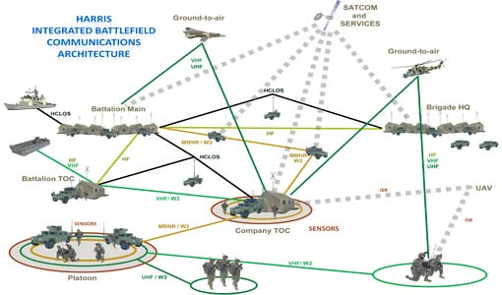
Figure 1-Diagram of Tactical Radio Communications Network
As well as general tactical communications, there are also communications relevant to OME only applications in particular to complete weapon systems and their operation. One such weapon system is the Russian Tor Missile System (NATO-SA15 “GAUNTLET”) shown in Figure 2 [3]. The Tor Missile system utilises a RADAR system mounted to its launch vehicle which tracks the incoming target, once the target is tracked the vehicle then launches the missile which is in communication with the vehicle and the its RADAR system until the missile completes its intercept of the target, the RADAR tracks the target and commands the missile onto it, this method of guidance is what is referred to as semi active guidance [4]. Such systems require large amounts of data to be transmitted very quickly and securely with little to no noise affecting the signal, failure to do this may result in the missile veering of course, missing its target or an unintended detonation of the missile at any point in its flight.
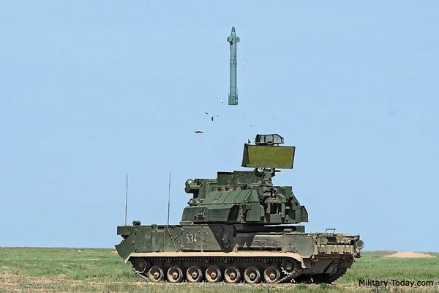
Figure 2-Russian Tor Missile System

2.0-Aim, Method & Background
This section of the assignment will perform an investigation into the performance of two DSP techniques as well as their more advanced variants. The techniques under analysis will be Amplitude Shift Key (ASK), Phase Shift Key (PSK), Quadrature Phase Shift Key (QPSK) and Quadrature Amplitude Modulation (QAM). The block diagram in Figure 3 provides a simplified overview of the system that will make up the individual techniques.
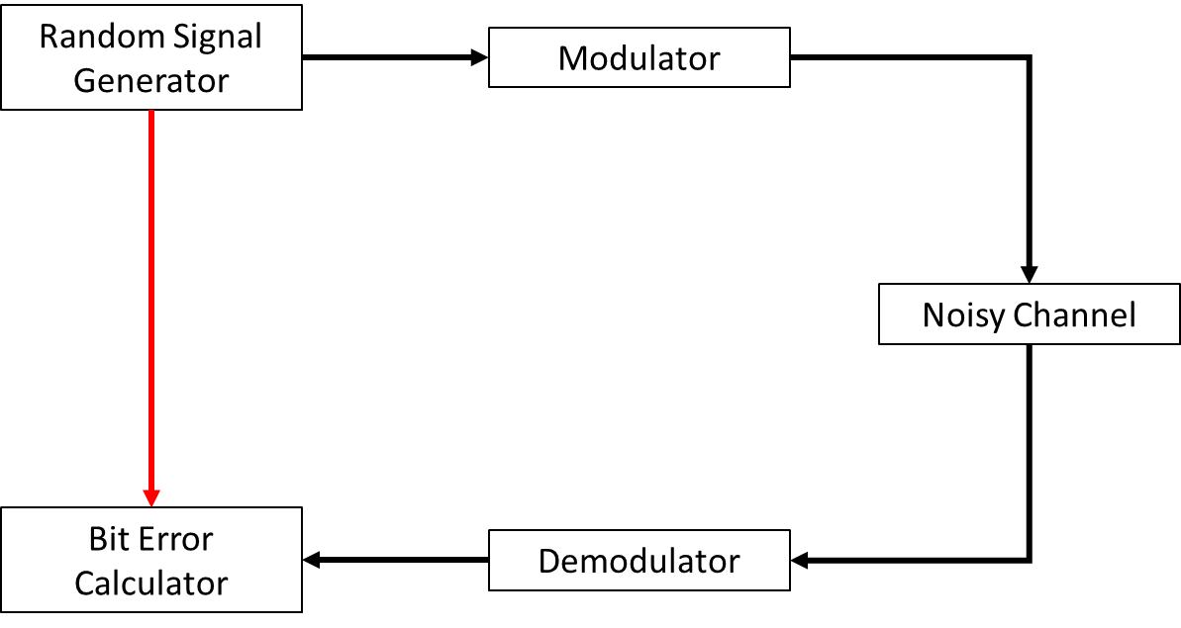
Figure 3-System Block Diagram
The experiment will establish a baseline control by having no noise present in the system and will increase the level of noise present to induce complete failure in the systems.
Amplitude Shift Keying and Phase Shift Keying, along with Frequency Shift Keying (which isn’t covered by the scope of this report) are all forms of modulation techniques [5]. Figure 4 [5] shows the waveforms produced by all three techniques.
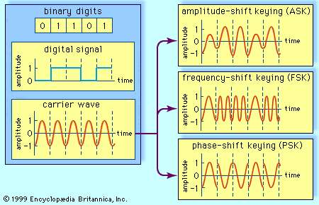
Figure 4-ASK, PSK and FSK Waveforms
The digital signal which contains the information required to be transmitted is combined with a carrier wave which can then be transmitted to the recipient and then demodulated and decoded by the recipient. More advanced forms of these techniques exist called Quadrature Phase Shift Keying and Quadrature Amplitude Modulation. QPSK is capable of sending two bits of information per symbol (00, 01, 10, 11) as opposed to the other techniques single bits per symbol (0, 1) [6]. Figure 5 shows an example of QPSK waveforms.
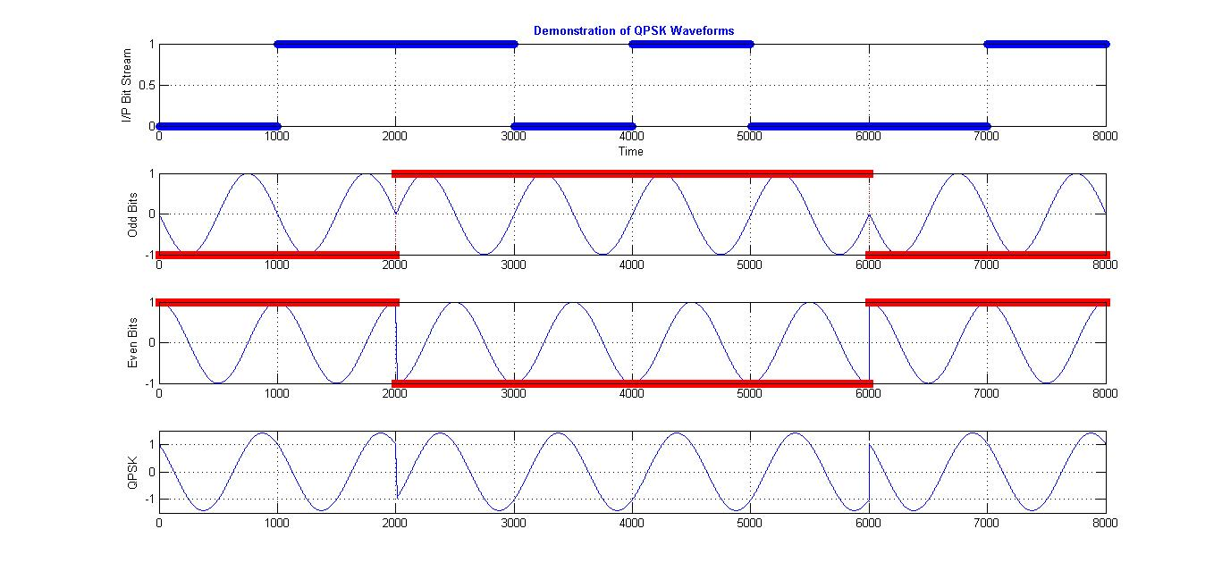
Figure 5-QPSK Waveforms
Quadrature Amplitude Modulation takes this concept a stage further and is capable of combining a PSK and ASK signal together and therefore able to transmit even more data symbols. Figure 6 [7] shows a constellation diagram which shows what data is present in a QAM signal. This diagram also shows the data symbols that are associated with QAM signals (0000, 0001, 0011, 0010, 1000, 1001, 1011, 1010, 1100, 1101, 1111, 1110, 0100, 0110, 0101, 0111)
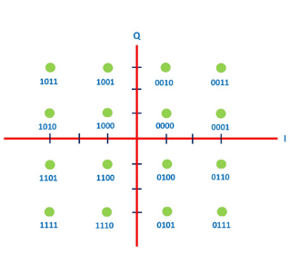
Figure 6-QAM Constellation table
This report will generate Simulink models of each system and increase the amounts of noise present in each system until failure in each system occurs. The data that will be used to establish this will the error that is calculated by the Bit Error Converter module in Simulink and will be graphed as noise is increased.

3.0-Simulink Models and Results
The Simulink models that represent ASK, PSK, QPSK and QAM are shown in Figure 7 through Figure 10.
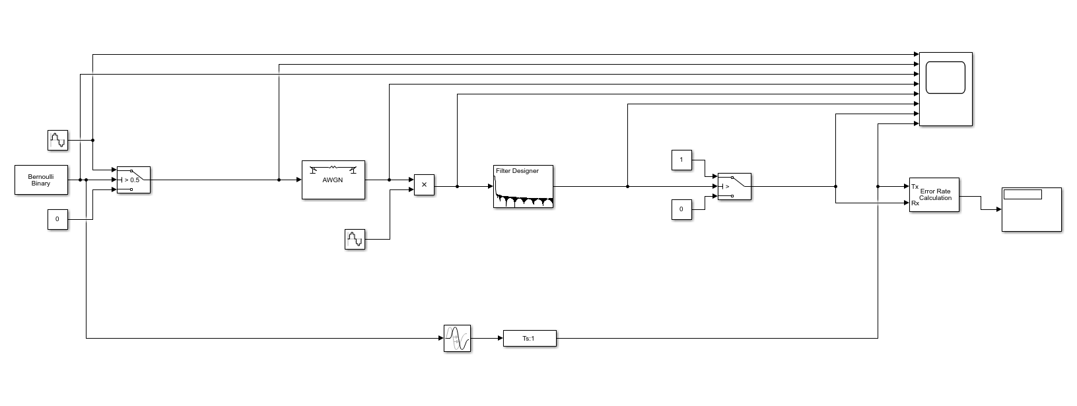
Figure 7-ASK Model
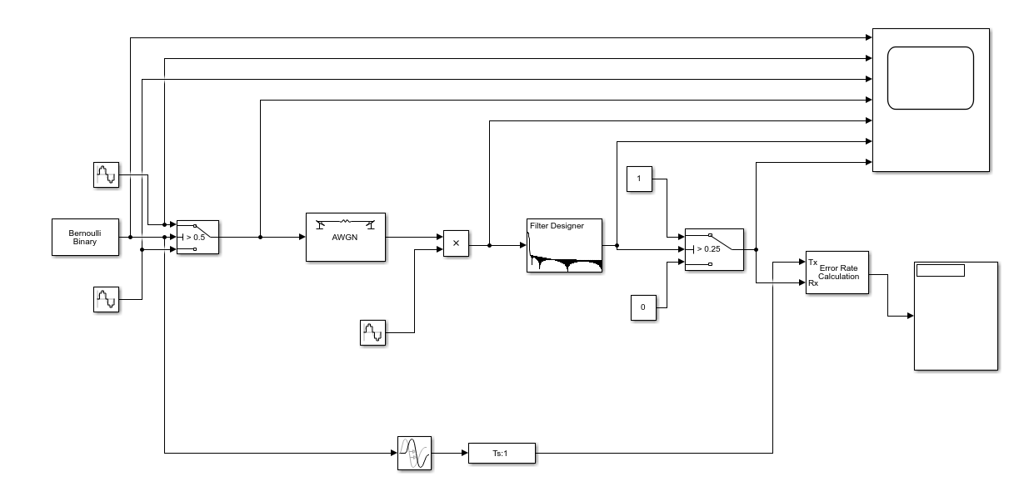
Figure 8-PSK Model
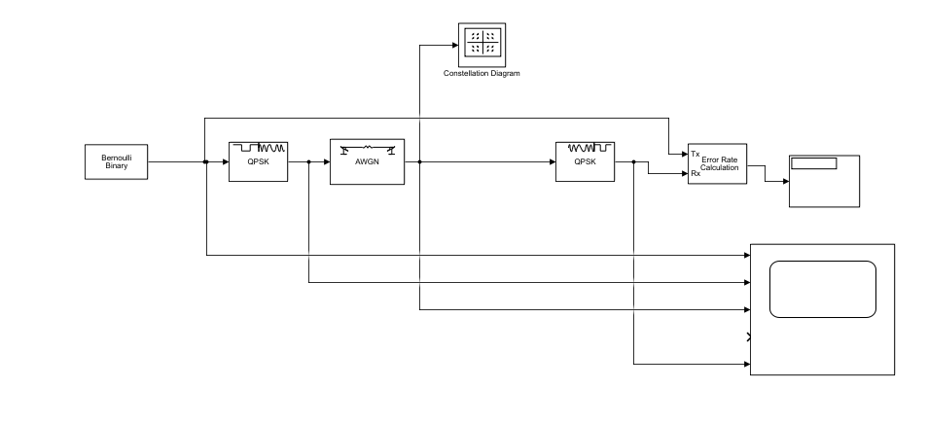
Figure 9-QPSK Model
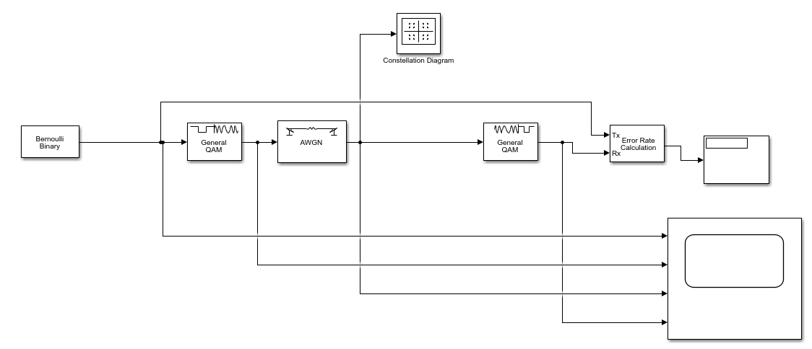
Figure 10-QAM Model
The Bernoulli Binary generator was set up in the manner shown in Figure 11 for the ASK and PSK models.
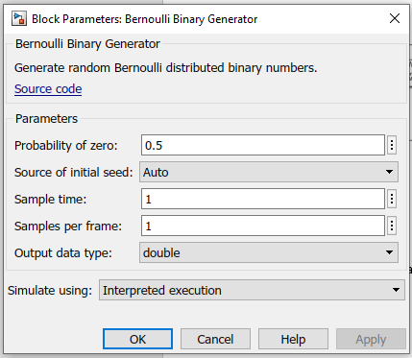
Figure 11-Bernoulli Binary Setting for ASK and PSK
The carrier wave for the ASK model was set up in the manner shown in Figure 12.
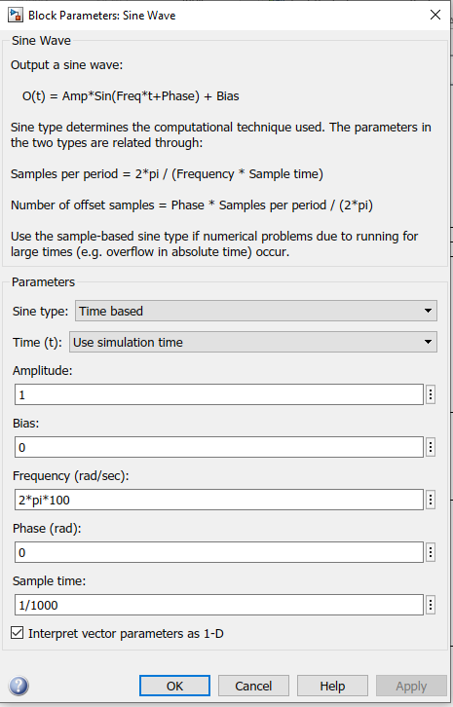
Figure 12-ASK Model Carrier Wave
The PSK model had two different sine waves which were set up in the manner shown in Figure 14 and Figure 13.
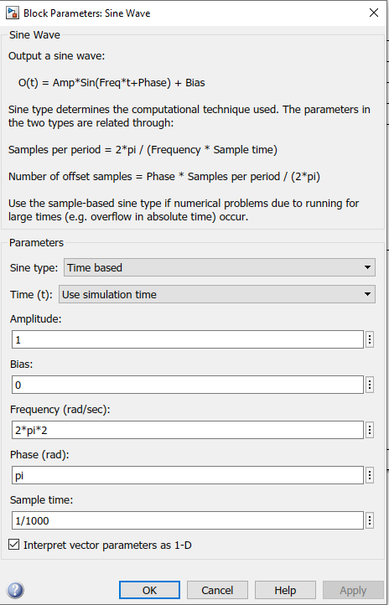
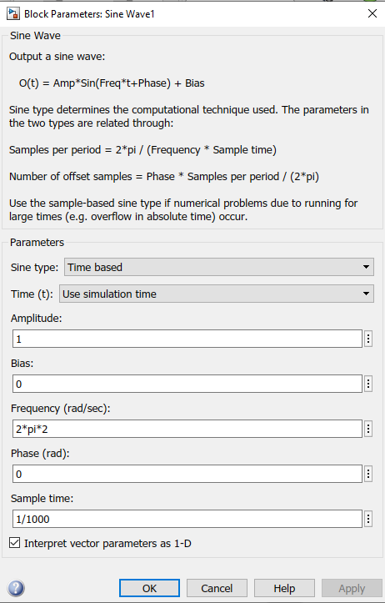
For the QAM and QPSK models the Bernoulli Binary Generator was changed slightly in order to get the models to function. These settings are shown in Figure 15.
Figure 13-PSK Sine Wave 2
Figure 14-PSK Sine Wave 1
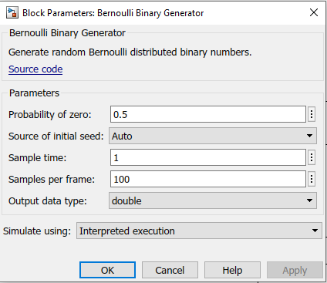
Figure 15-QPSK and QAM Bernoulli Settings
Although the amount of samples per frame has been significantly increased compared to the ASK and PSK models this shouldn’t have an effect on the results obtained from the QPSK and QAM models.
Once the models were complete the simulations were conducted. The Signal to Noise Ratio (SNR) was increased from +10dB so that the signal was clean and steadily reduced at a doubling rate each time until an SNR of -128dB was reached. Each simulation was run 10 times to obtain an average and the average Bit Error Rate was used to generate the graphical results. The BER Vs SNR graph for the ASK, PSK, QPSK and QAM models are shown in Figure 16 through Figure 19
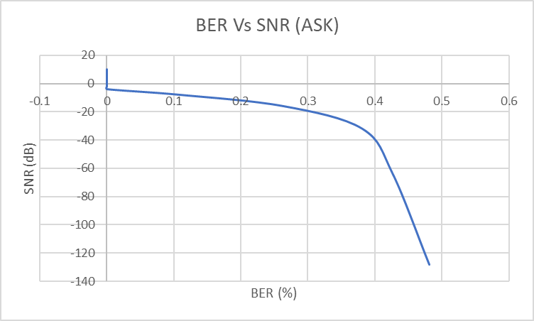
Figure 16-BER Vs SNR for ASK Model
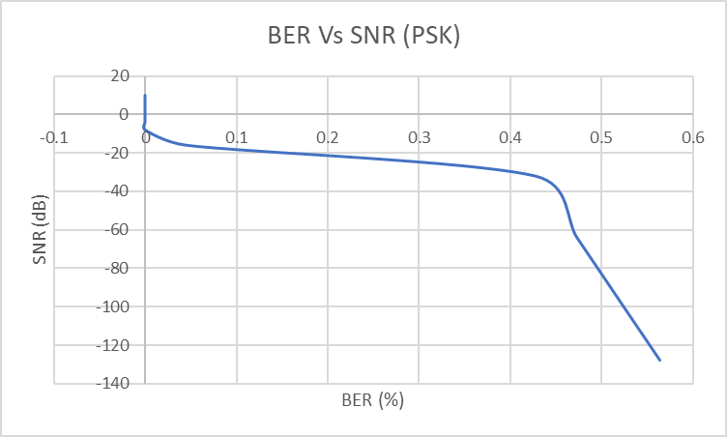
Figure 17-BER Vs SNR for PSK Model

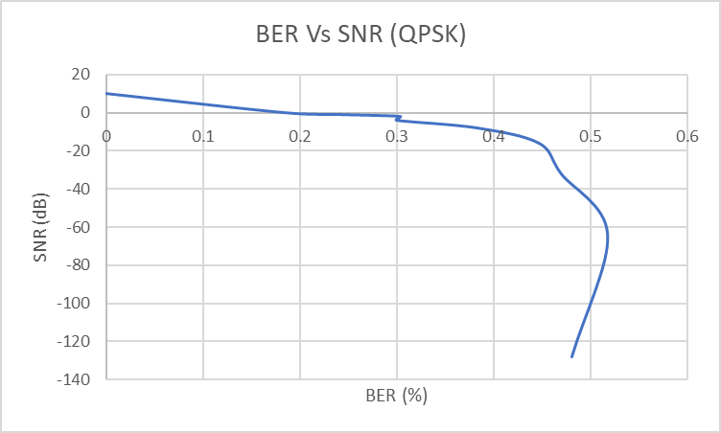
Figure 18-BER Vs SNR for QPSK Model
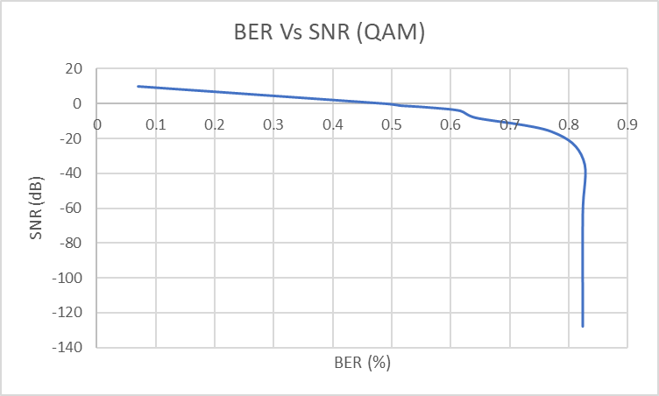
Figure 19-BER Vs SNR for QAM Model
In order to compare all the data a graph consisting of all the data was generated. This is shown in Figure 20.
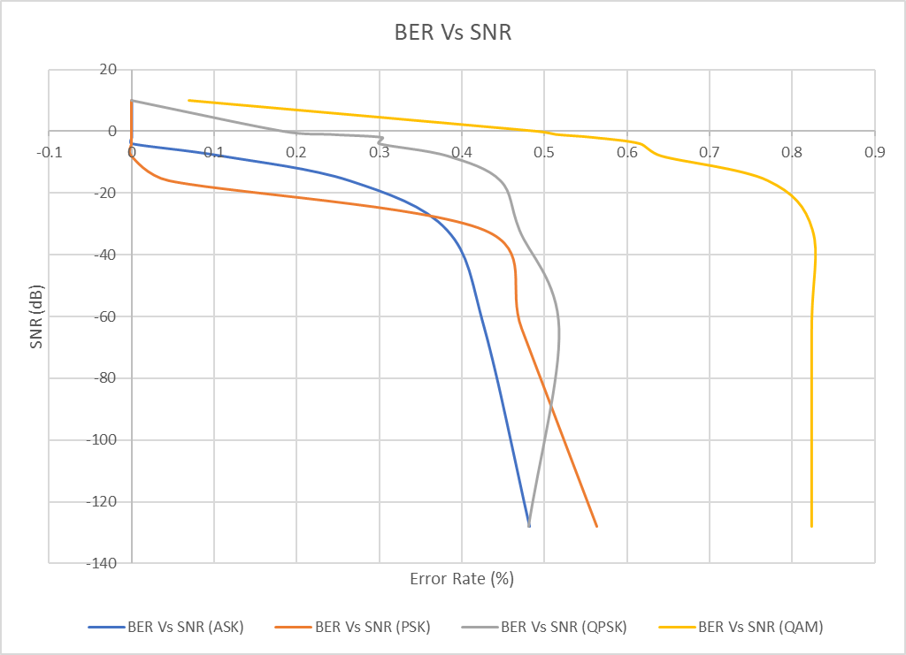
Figure 20-BER Vs SNR for all models

4.0-Discussion of Results
The data generated by the simulations has highlighted a number of areas of discussion regarding the simulations and a number of factors surrounding them. Directly from the graph in Figure 20 it can be seen that across all models as the Signal to Noise Ratio is modified so that more noise is introduced into the channel the Bit Error Rate increases. This means that as the environment that the signal is transmitted in has more noise present in it, there is a greater probability that the recipient of the signal will start seeing errors and may not receive the complete signal [8]. In terms of an OME environment this may mean that, for example, in a firing sequence the firing set may send a signal which could initiate the detonator un-intentionally or not send a correct signal to initiate the detonator when required. Because of this it is important that when designing OME articles that noise is considered and is part of acceptance tests for military equipment, In the UK one standard that covers this is DEFSTAN 59-411 Part 3 [9].
The graphs in Figure 20 also suggest that ASK and PSK techniques are more resilient than QAM and QPSK however the amount of data that QAM and QPSK is able to transmit efficiently is much greater than ASK and PSK [10]. All four techniques could find themselves being used in various OME applications. For example ASK and PSK could be utilised in the guidance of a wire guided system such as AT4 “SPIGOT”, shown in Figure 21. This is because of the signal sent to the missile from the command post through the wire is a simple on off command to move the control canards therefore the data that needs to be transmitted and received by the missile is very small. QAM and QPSK due to its ability to transmit a larger amount of data could be utilised in much more complex systems such as the Tomahawk Cruise Missile shown in Figure 22 [11].
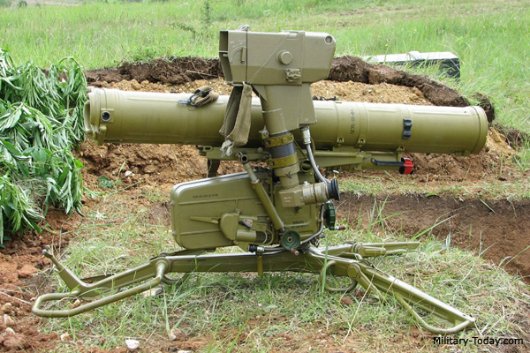
Figure 21-AT4 "SPIGOT"
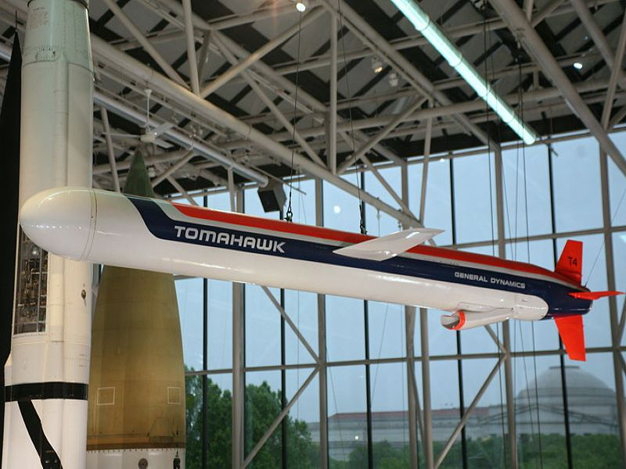
Figure 22-Tomahawk Cruise Missile
The Tomahawk uses a combination of Global Positioning System satellites as well as a satellite data link back to its command vehicle, be it a ship, submarine, land vehicle or aircraft. As well as using this for guidance the missile needs a number of onboard systems which keep the missile on path to its target [11], this capability comes at a cost and as such there must be a considerable effort to reduce the missiles susceptibility to external noise and interference within it’s communication and guidance systems as well as the digital systems onboard the missile, failure to ensure this may result in an erratic and uncontrollable flight, unintended initiation or even radio jamming.
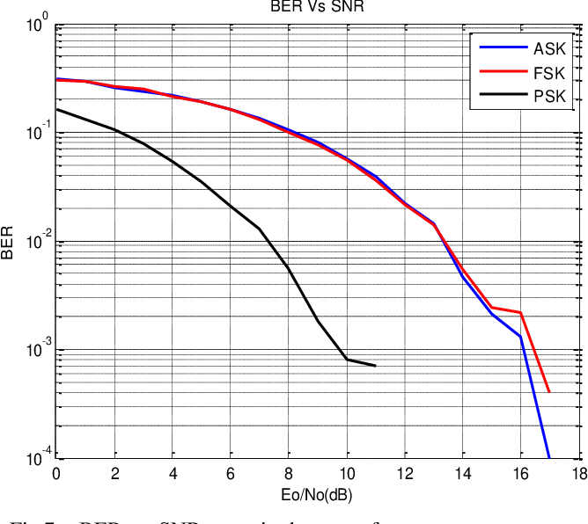
Figure 23-BER Vs SNR for ASK and PSK
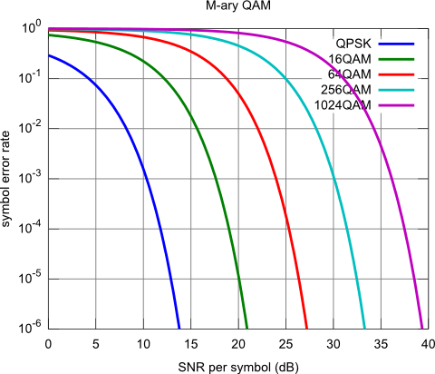
Figure 24-BER Vs SNR for QPSK and QAM
Figure 23 [12] and Figure 24 [13] show example BER Vs SNR results for the same types of techniques under analysis. This is confirmation that the behaviour observed in the analysis is similar to that observed in other studies. The data that was generated for the analysis however isn’t as smooth as that generated in the other studies, the reasons for this are varied. The Simulink models used in the analysis could have be different from the models or apparatus used in the other studies thus producing different results. The level of user familiarity with Simulink may also present an error in the results as models may have been modelled incorrectly or set up completely wrong for the analysis. The complexity of the ASK and PSK model when compared with the QPSK and QAM model may also present errors or may have enabled those techniques to perform better in these experiments. In order to determine where these errors occurred the models should be reconstructed and reassessed by a second party to determine if they are reflecting the conditions that should be observed.

4.0-Conclusion
From the experiments conducted using the simulation models that were constructed for them it is shown that as the Signal to Noise ratio a system experiences is increased and creates a weaker signal the Bit Error Rate of the system increases. The results also show that more simple techniques such as Amplitude Shift Keying and Phase Shift Keying are more resilient to the effects of noise than Quadrature Phase Shift Keying and Quadrature Amplitude Modulation, however the amount of data that can be transmitted by ASK and PSK is significantly less than QPSK and QAM which limits its use cases. The report has also discussed where certain techniques could be utilised in an Ordnance, Munitions and Explosive environment and why these techniques have an advantage over others for their respective applications. The report then discussed where potential errors may have occurred in the modelling and has suggested that the experiments be performed again by a second party to determine their validity.

References

[1] | S. W. Smith, “The Scientist and Engineer's Guide to Digital Signal Processing,” California Technical Publishing, 2011. [Online]. Available: http://www.dspguide.com/ch1/1.htm. [Accessed 11 12 2020].
[2] | M. Kurdziel, Cyber Threat Model for Tactical Radio Networks, 2014.
[3] | Military-Today, “Tor,” [Online]. Available: http://www.military-today.com/missiles/tor.htm. [Accessed 11 12 2020].
[4] | Britannica, “Tactical Guided Missiles,” [Online]. Available: https://www.britannica.com/technology/rocket-and-missile-system/Tactical-guided-missiles#ref57324. [Accessed 11 12 2020].
[5] | Britannica, “Amplitude Shift Keying,” [Online]. Available: https://www.britannica.com/technology/amplitude-shift-keying. [Accessed 13 12 2020].
[6] | All About Circuits, “Understanding Quadrature Phase Shift Keying,” 17 August 2016. [Online]. Available: https://www.allaboutcircuits.com/technical-articles/quadrature-phase-shift-keying-qpsk-modulation/. [Accessed 13 December 2020].
[7] | Electrical 4 U, “Quadrature Amplitude Modulation (QAM): What is it?,” 11 October 2020. [Online]. Available: https://www.electrical4u.com/quadrature-amplitude-modulation-qam/. [Accessed 13 December 2020].
[8] | CloudRF, “Modelling the Bit Error Rate (BER),” 20 December 2019. [Online]. Available: https://cloudrf.com/modelling-the-bit-error-rate-ber/#:~:text=A%20high%20SNR%20is%20required%20for%20a%20low%20BER.&text=Put%20simply%20a%20strong%20signal,unstable%20and%20unpredictable%20things%20become.. [Accessed 16 December 2020].
[9] | Ministry of Defence, “Defence Standard 59-411 Part 3: Electronmagnetic Compatibility: Test Methods and Limits for Equipment and Subsystems,” Ministry of Defence, London, 2007.
[10] | Open University, “1.7 Quadrature amplitude modulation (QAM),” [Online]. Available: https://www.open.edu/openlearn/science-maths-technology/exploring-communications-technology/content-section-1.7. [Accessed 16 December 2020].
[11] | Naval Technology, “Tomahawk Long-Range Cruise Missile,” [Online]. Available: https://www.naval-technology.com/projects/tomahawk-long-range-cruise-missile/. [Accessed 16 December 2020].
[12] | S. Bharati, M. A. Rahman and P. Podder, “Implementation of ASK, FSK, PASK with BER vs SNR comparison over AWGN channel,” ArXiv, vol. abs/2002.03601, 2020.
[13] | M. Nentwig, “Generate Ideal QPSK..64QAM Symbol Error Rates (Reference Result),” 21 October 2010. [Online]. Available: https://www.dsprelated.com/showcode/1.php. [Accessed 16 December 2020].

