

Programme: BA Business Management

  - Module: Introducing the Modern Workplace
  - Module code: LCBB4003
  - Module Lecturer: Winifred Soribe

Assignment Title: Assessment 1 Organisational Structure and Culture
Student Name: Boscanean Maria
Student ID: 2021937

Table of Contents

Executive Summary 4
Introduction 4
About Apple Inc 5
Analysis 5
Organisational structure 5
Organisational Culture 8
Influence of organisational structure 9
Influence of organizational culture 10
Factors which can influence on individual behaviour at work place 11
Recommendations 14
Conclusion 14
References: 16

Report on Organisational structure and culture

Apple Inc – Case Study

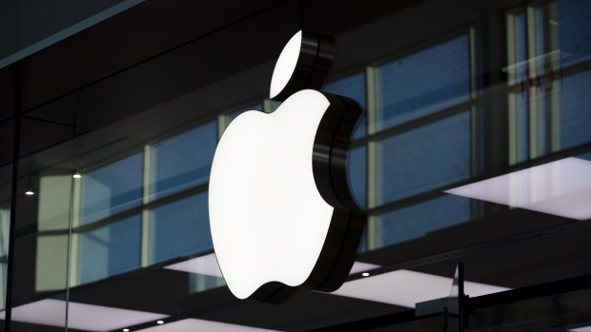

Introduction

According to Mintzberg (2003), structure of an organisation can be defined as a framework or system which sets the way how the activities are carried out and directed in order to meet the organisational goals. The activities include the individuals and employees’ roles and responsibilities alongside with the rules. Turner (1987) explained that while organisations have different types, they always set objectives. In order to achieve their objectives, it is essential to develop a structure. Sinding, Kreitner and Kinicki (2018) expressed the importance of the structure, as gives a clear overview and indication to both internal and external stakeholders of how the authority, power, responsibilities and information flow between the various levels within an organisation. Depending on the nature, size and type of the organisation, the different organisational structures may give advantages to a firm and may have drawbacks, too. For example, in a decentralized organisational structure, the authority to decide is distributed within the diverse levels, while in centralized structure, e.g.: hierarchical structure, the decision-making power is flowing from the top to the bottom.

About Apple Inc

Apple Inc is one of the leaders of the tech industry which was founded in 1976 in California by Steve Jobs, Steve Wozniak and Ronald Wayne. Apple Inc’s operates in both hardware and software industry and is considered as one of the most successful international firms. (Apple.com, 2021)
According to Meyer (2019) Apple Inc is famous from being ever innovative and committed to be pioneer of the computer industry. Upon developing new technologies, products, the firm encourages and open approach which contributes towards Apple is being one of the most well-known and popular smart gadgets’ manufacturer and is present in several segments of the tech industry, such as portable devices, personal computing, media players, mobile devices, smartphones, etc. This is mainly achieved through vertical integration. The firm has its own ecosystem, which gives the control and power of the entire process to the firm, starting from the product design to production, distribution chain, etc, including the excellent shopping and buying experience to its consumers via iTunes and Apple Store. (Apple.newsroom.com, 2021)

Analysis

Organisational structure

Stimpson (2011) stated that managements within an organisation are linked together. However, the ways of how organisations transmit the authorities are diverse. The way of transmitting the power and authority indicates the structure of an organisation, which is a formal business framework that explains the system of the hierarchy contributing towards the firm to achieve its goals by illustrating each job and their functions on the diverse levels. The most common type of the organisational structures:

- Hierarchical
- Functional
- Matrix
- Horizontal / Flat
- Divisional
- Network
- Team-based
(Csaszar, 2013)
According to Lehman and Haslam (2013) Apple’s structure had changed from a traditional to a unique structure which was designed on the informal relation style amongst the employees. In order to stimulate the effectiveness, productivity and most importantly the creativity of the employees. The unique organisational structure is based on a flat structure, reducing the long command of chain and reducing the levels of managements. The structure has undergone some changes in order to encourage the creativity and innovation at various levels, e.g.: decentralization of decision-making. (Fortune, 2011)
Microsoft’s had a functional organisational structure. According to Turner (1987) functional organisational structures have advantages for small firms who focus on a specific product or service and a rapid/quick change is not necessary. Functional organisational structure works well in stable environment, though it has disadvantages in a constantly changing environment. Therefore, Microsoft changed its structure to divisional, enabling each department to focus on a specific line of goods. The firms’ approach is different: Microsoft’s departments have larger collaboration between compartments of the same product. (Fortune, 2011)

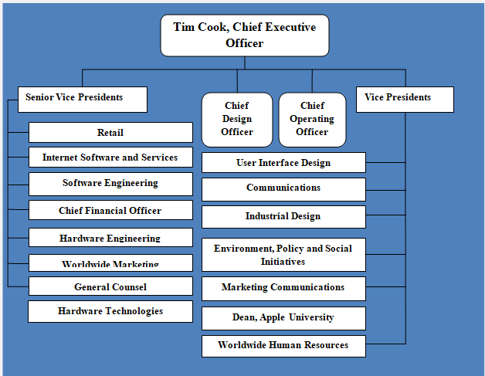
Figure 1: Apple’s organizational structure. (Dudovskiy, 2021)

Apple’s the organisational structure’s most important characteristics are as follows:
1. Spoke-and-wheel hierarchy- It is a spiral model’s version, which is designed to operate with smaller teams that scale up and create value quicker. While Jobs was the CEO, he checked everything and was responsible for the major decisions. Since Cook is the CEO, the firm’s organisational structure changed. The diverse departments’ collaboration has intensified. E.g.: presence of interaction between the software and hardware groups. Indeed, the vice presidents gained more autonomy, which was not enabled under Job’s management. (Dudovskiy, 2021)
2. Grouping by functions- Apple’s top-level is grouped by functions, which is a functional organisational structure’s element. Each Senior Vice President who reports to Cook holds a business position. For example: Apple there is a senior vice president for industrial design, for marketing, and another for retail. From this point of view of the organizational structure, the top leaders of Apple are enabled to express their business needs according to the operating area of which they are part of. (Fortune, 2011)
3. Product-based grouping- The lower levels of Apple are grouped by product-based point of view, which is a divisional organisational structure characteristic. Plenty vice presidents are responsible for diverse products under the subordination of SVP. For example, Apple has a VP for iOS applications, a VP for iPad, and another for consumer applications. This aspect of the organizational structure allows Apple to address types of product or their components. (Lee, 2014)

Organisational Culture

Ravasi and Schultz (2006) defined organizational culture as a system of values and concepts which are shared by an organisation’s all employees. The organisation’s culture governs their behaviour and the characteristics of the firm’s activities. Therefore, organisational culture significantly impacts on how team-members communicate with each other, with clients and stakeholders. Indeed, the culture of an organisation can also influence on how the employees identify with firm.
Apple was one of the first of the big firms who changed their organisational culture’s pattern, similarly to Microsoft and Southwest Airlines. The less formal culture was adapted, which led towards great success as talents were encouraged and motivated which is the major drive in technology industry. (Lee, 2014) Steve Jobs was famous from being informal and often walked barefoot in the office regardless the firm as in the top 500 companies on the world. Apple is famous from focusing on the user experience. This philosophy is shared by Nintendo. This attitude of Apple Inc’s explains the habit of changing the Mac computer from one architecture to another about every ten years, this change not representing a change in its main features.
Apple’s organisational culture’s most important characteristics are as follows:
1.Creativity- According to Tim Cook in Apple’s DNA there is creativity which is the base of the organisational culture. The firm’s success can be thanked to its constantly innovating products and services at the highest level which has been offered to its consumers.(Business insider, 2014).
2.Innovation- Both organisational structure and culture of Apple’s support the rapid innovation. The firm is well-know from its excellent creativity. The Business Week named Apple to be America's most creative company for consecutive seven years from 2005 to 2011. The firm endeavours for continuous improvement in areas such as health, environment’s safety and the quality of the products and services. Innovations of Apple: iPad, Apple watch (Heracleous, 2013).
3.Secrecy- Apple’s major principle is confidentiality. Regarding this cultural feature, the company set strict and structured rules, which ensure the minimization of theft of proprietary information or dissemination within the organisation. It is also a business strategy approach that helps Apple to retain its competitive success (Business insider, 2014).
4.Moderate combativeness- Apple’s organizational culture has moderate combativeness. Employees have an increased adaptation to innovation and change for the better.

Influence of organisational structure

According to George (2012) the structure of an organisation defines how job tasks are divided, grouped and coordinated within the firm. Apple’s organisational structure enables collaboration in a way. A collaborative organisational structure aims to keep together the employees together in a long-term relationship with a purpose of achieving a common goal. Within Apple, the environment is team-work based, which is predominating within the firm. George (2012) explained that team-work environment supports the team-members to work both individually and cooperatively. In a collaborative work environment, professionals work together to achieve goals regardless of their positions, so there is an effective collaboration between different talents. Apple’s with its structure ensured that the doors are always open for innovative and new ideas from the team-members. (apple.com, 2021)
Apple combines teamwork with individuality and integrates from the start of work all the necessary departments together, for example: design and marketing. According to business Insider (2014), the departments work closely and in line and collaborating. Apple shows a great example of how a company should be organized and managed to be successful in constantly changing and challenging environment.
According to Offermann & Spiros (2001), a structure of an organisation can significantly impact on the performance so it should be designed to help the divisions to adapt quicker to the changes and make decisions faster which can be enabled by collaboration. However, collaboration also has drawbacks. For example, when it comes to decisions-making where everyone wants to reach a consensus, it can lead to long delays.

Influence of organizational culture

Deal and Kennedy (2000) stated that for the members of an organisation, the organisational culture is a true "way of life". The organisational culture comprises basic assumptions, values, and beliefs of the individuals. Besides, once a culture is well established, it can persist despite staff variations and ensure social continuity. Internally, a culture can support innovation, risk-taking, or information secrecy. Externally, a culture can support the slogan "Customer first" or unethical behavior towards competitors. The performance of a firm and the team-members’ satisfaction can significantly influenced by the culture. Positive organisational culture can ensure the maintenance of good relations between the employees, enables the firm to keep the employees focused on continuous evolution, and good staff retention (Need, 2006).
According to Cook, "embedded values in the firm made it do unbelievably well''. (Earnings Hall, 2009). The organisational culture of Apple's organizational aims to increase the performance and sustain success. The idea behind Cook’s organizational culture was the belief that individuals with a high level of self-motivation would work harder if they had no manager to constantly monitor their activities. Cook’s theory and idea of a positive culture seemed to be a real success within the organization, as it is more flexible and has higher level of adaptation to change. (Business Insider, 2014) The adaptability of Apple was increased based on the fact that is easier to develop new projects if the number of people from whom the approval of its initiation must be received is low.(Apple.com, 2021)

Factors which can influence on individual behaviour at work place

Employees significantly contribute towards a firm’s success. Employees’ behaviour is impacted by the organisational structure and culture. The culture of the organisation is influenced by plenty factors and policies. (Armstrong, 2016) For example, dress-code policy. E.g.: flight attendants, with their neat appearance and impeccable uniform, inspire confidence in passengers. Indeed, the positive and respectful attitude is reflected in the way passengers perceive the company's image. Though this can be argued with the example of Apple, where Steve Jobs worked barefoot and encouraged his employees to do the same. (Apple.newsroom.com, 2021)
Furthermore, motivational level also impacts on the behaviour. Intrinsic and extrinsic motivational tools should be mixed by managers to maintain satisfactory motivational level amongst the team-members. For example, responsibilities, job title, fiscal compensation, etc. The job title and responsibilities that are held by an employee influences on the behaviour. (Armstrong, 2016)
Moreover, human behaviour is influenced by a series of needs, desires, and preferences, which determine the way they work. (Maslow, 1943) The most common motivating factors are workplace atmosphere, salary, promotion, integration of new employees, and others.
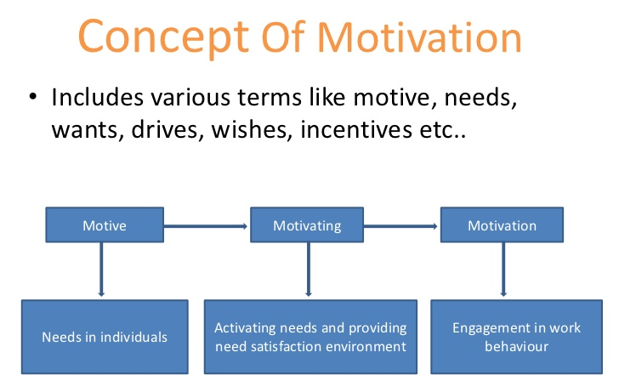
Figure 2: Concept of Motivation. (Dudovskiy, 2021)

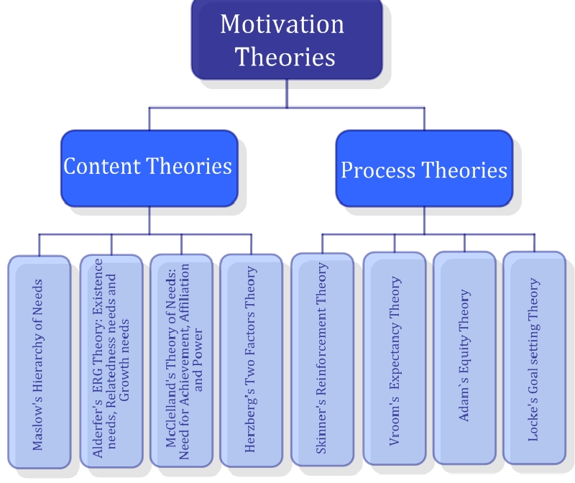
Figure 3: Motivation Theories. ( yourarticlelibary.com, 2021)
Maslow (1943) explained that if an individual’s needs are fulfilled in the right order, they eventually become self-actualized.
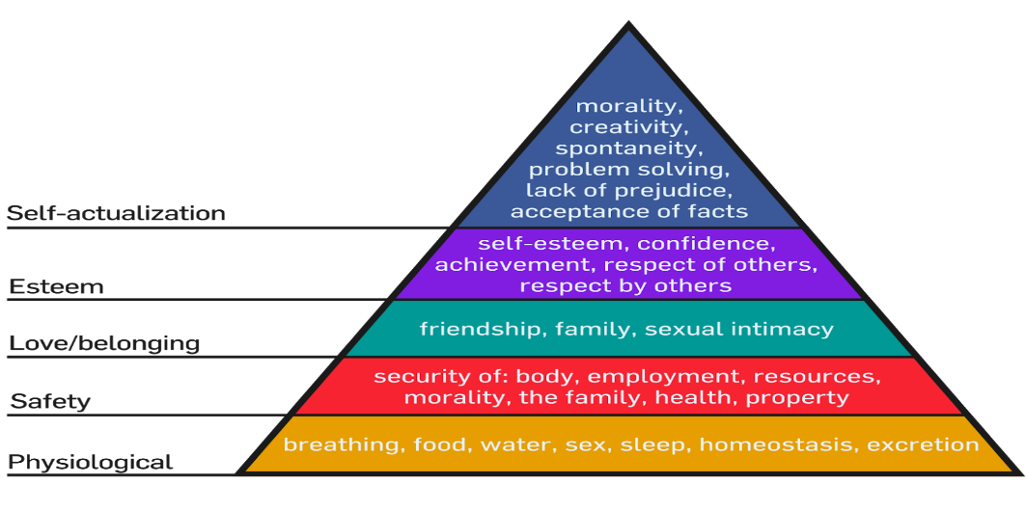
Figure 4: Maslow’s pyramid. (Mecleod, 2020)

Recommendations

Apple rather focuses on the individuals’ performance and expertise instead of the positions/roles. It emphasizes the employees’ hard-work. While Apple is a successful firm, adapting this culture has pros and cons, too. Emphasizing on hard-work and confidentiality reduces the risks of information leakage. However, less stringent information control may increase the motivational level of the employees and lower their stress level. E.g.: Strictly limited number of employees who has privilege to know about the new product launches. This may be very demotivating to an employee who works in an Apple store as a “genius”. Majority of the employees only find out about the new products/services after they were launched. This may lower the motivational and commitment level as it can be challenging to adapt to a unique culture like this.
Furthermore, flat organisational structure may limit the flexibility. Within large-sized flat organisations, the distribution of the hierarchy is limiting the lower level managements e.g.: a store manager to respond to the changing market demands. Flat organisational structure does not enable the firm to implement a rapid change. Collaboration within the diverse departments may be suggested.

Conclusion

Different organisational structures have both advantages and disadvantages. Apple may thank its success to flat organisational structure which positively impacts on the culture. Moreover, it enables the constant innovation and increases the employees’ motivational level, which is the biggest drive of the firm’s sustainability. The firm’s success is exemplary, the mission and vision support a positive organisational culture, maintains the brand image and loyal consumer base.
Schein (1999) stressed the importance of choosing the most appropriate organisational structure depending on the nature of the firm; which can significantly help and positively impact on the culture and brand image. Negative work culture may lead towards failure. Putting Schein’s theory in practice, Apple chose its organisational structure and management style appropriately which enables them to maintain excellent brand image and culture and contributes towards its organisational success.

References:

Apple.com, (2021). Newsroom. [online] Apple Newsroom (United Kingdom). Available at: <https://www.apple.com/uk/newsroom/> [Accessed 25 March 2021].
Csaszar, F. A. (2013). An efficient frontier in organization design: Organizational structure as a determinant of exploration and exploitation.
Dudovskiy, J., 2021. Apple Organizational Structure: a brief overview - Research-Methodology. [online] Research-Methodology. Available at: <https://research-methodology.net/apple-organizational-structure-a-hierarchical-structure-that-may-change-in-near-future/> [Accessed 25 March 2021].
Edwards, J . (2014). Apple employees confess all the worst things about working at apple. Business Insider.
Heracleous, L. (2013). Quantum Strategy at Apple Inc. Organizational Dynamics,42(2),92-99
HRD Connect, (2021). A guide to organisational management models and strategies - HRD. [online] HRD. Available at: <https://www.hrdconnect.com/2019/11/04/a-guide-to-organisational-management-models-and-strategies/> [Accessed 25 March 2021].
Lee, T., (2014). How Apple became the world's most valuable company. [online] Vox. Available at: <https://www.vox.com/2014/11/17/18076360/apple> [Accessed 25 March 2021].
Lehman, G., & Haslam, C. (2013). Accounting for the Apple Inc business model: Corporate value capture and dysfunctional economic and social consequences.
Levy, S., (2021). Apple Inc. | History, Products, Headquarters, & Facts. [online] Encyclopedia Britannica. Available at: <https://www.britannica.com/topic/Apple-Inc> [Accessed 25 March 2021].
Mcleod, S., 2020. Maslow's Hierarchical Theory of Needs. [online] Simplypsychology.org. Available at: <https://www.simplypsychology.org/maslow.html#gsc.tab=0> [Accessed 25 March 2021].
Meyer, P., (2019). Apple Inc.’s Organizational Structure & Its Characteristics (An Analysis) - Panmore Institute. [online] Panmore Institute. Available at: <http://panmore.com/apple-inc-organizational-structure-features-pros-cons> [Accessed 25 March 2021].
Mintzberg, H., (2003). The Strategy Process. Harlow: Financial Times Prentice Hall.

