Student name: Maura Pontes
Student Id number:1809187
Lecturer: Malani Guranatnam
Moodle title/code:Professional Career Development BMSW 4005

Personal and Professional
Student Reflective Report

Table of contents
Introduction 3
Reflection 4
Career Plans 7
What Employers Want 8
Self Motivation 11
Learning Styles ( VAK) 15
Personal Development 18
Employment Goals 19
Conclusion 20
References books 23
Websites 24

Introduction
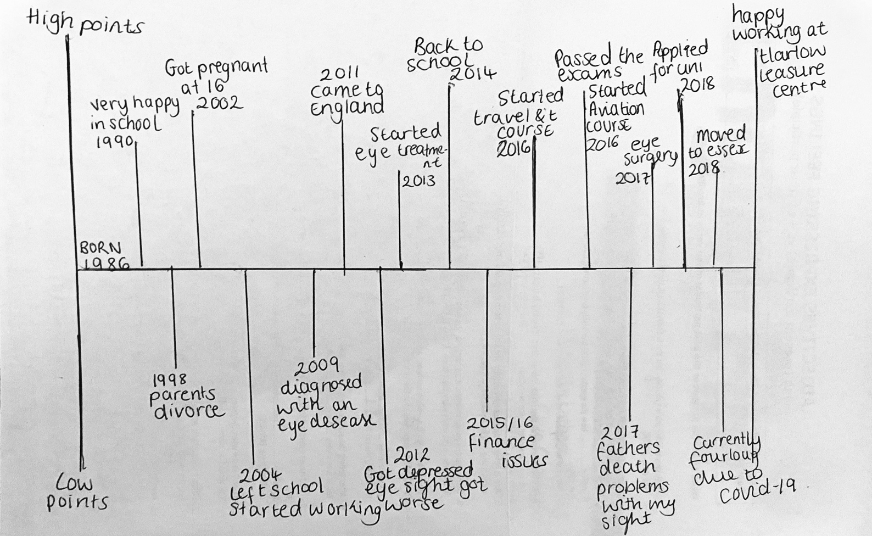
My name is Maura , one of the students of Professional Career Development subject from the course Certificate of Higher Education in Skills for the workplace. I am writing this personal report based on some research and online lessons learned to demonstrate some relevant concepts to succeed either personal and professional, also below I will draw my lifeline to identify the high and low key events since I was born till now.
Reflection
In order to develop this report,I had decided to apply the model of reflection called Kolb(1984).According to Kate Williams (2012,p.85)many thinkers and writers on the learning process view learning as a cycle:this contributes towards the next step of learning each moment learning happens and the cycle starts again.Trough this model ,Kolb demonstrates focus on an experience that motivates individuals to shape ideas on their experience and the ability to transfer from knowledge to experience. And there you pass along to the next step of consciously planning how to improve what you are doing next time , and the process begins afterwards.
Kolb also described different form of favoured research styles.By then,Kolb is theories and models created and modified by himself and other thinkers, including Honey and Mumford (Kate Williams p.87-88) and Gibbs (Kate Williams,p.90-102) .

Kolb is learning cycle
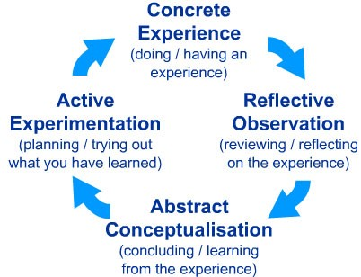

Example; on 12th of August I did a role play with one of my classmates online, was my first time and I realised video interviews can be difficult due to the difference among the audio and video monitors .when an individual would not pause till the other person involved talks before responding, it has the impact that people step on each other party is done speaking before reacting typically prevents this issue.Often, make sure that the scenery are appropriate and look look straight into the camera while speaking. Dress as though the interview were being done in person.
Overall the role I did with my classmate was not bad at all but after complete I notice that my classmate was inconvenient while I was interviewers him to say “you forgot one question”. I know was just a scenario and nothing real but if was me in different position like the interviewee person I would never behave like that interrupts the other person at the end and embarrassing the other person just because the other participant forgot to asked you one question.In addition as we are facing a global difficult situation (COVID-19)as I can seem that must of the interviews nowadays are online, even the lectures have been online as well means I need to start getting familiar with that .

Career Plans
We are currently facing some changes in the job market as a result of this global pandemic issues.During term 3 while I was studying the subject Professional Career Development which one is mean to help the students to understand their career options and starting to create their own PDP(personal development plan) in order to achieve their goals. I had chosen last year , once I finish the course Certificate of higher education in skills for the workplace, studying the course BA International Hotel Management and now I come to the conclusion that the hotel industry had some break down in the market as we known it is a very competitive area so instead of studying this course , I decide to continue the level 5BA Leadership and Management because this course is more advantageous in terms of job opportunities if I successfully complete my degree with merit , I would definitely find a Job straight way in management or an apprenticeship also I consider doing some voluntary work while I am in university, studying the course just to gain work experience. I am feeling more enthusiastic than before, I know that I still have to learn a lot to accomplish my goals, despite this thought time I am willing to sacrifice myself to being successful in my future career .

What Employers Want
Always demonstrate your value:Nowadays work recruitment method allows you to always to remain aware of particular issues that any company is attempting to address before filling the application.Then make sure that everyone who checks your resume understands that you have fixed this problem before and able to do it again.
Remember that I never said “whenever someone reads your curriculum “. Western-style teaching methods are not available in all cultures.However the methodology appears to be and you must show your abilities to the organisation.Even you do not have enough experience but can prove that you have the most necessary requirements for the job position. Hiring does not guarantee your job is safe; you still have huge advantage over competitors as you realise how the modern job market operates and how to improve things for you. Globalisation and technological changes have intensified the dependence on workers who can generate value regardless of where they are.
Strong market competitiveness necessities make businesses willing to recruit workers who will support them obtain the results. Job opportunities come and go in this world economy, and it is easier to learn how to navigate uncertainty than to search for contractors that do not outsource similarity, the internet has implemented near instant interaction around the world, lowering data storage and product delivery costs to close zero ; making market data openly for an infinite range of products and services, thus decreasing prices and profits margins; reducing barriers to entry for niche businesses; and generally growing global competition.
Jobs will now remain for their primary market, making them possible anywhere, products and services can be produced at the suitable price and quality.
Thought companies are reluctant to fire workers who increase profitability, the true purpose of developing value should not be the security one gets from termination through emphasising the production of value you generate value that is also attractive to others.
When you decide to build value in this sense , you can gain a deeper understanding of how the job is done.Works on the sector and how to handle it.

Self Motivation
Being honest I am not consider myself a hundred percent motivated person because I still have some doubts, sometimes my inner voice sabotage my self because my anxiety is so high means I need to believe in myself more , even if I fail in the first time there is always a solution not give up , keep moving forward next time could be better and sees the failure as a lesson learned.
According to self motivation quiz mindtools score interpretation says that I am doing good despite my score was 39.However I can achieve more than that to increase the motivation factors by following those suggested steps below:
1.Self-confidence and self-efficacy
“Score 16 out 20” means I still have to work on it.Feeling extremely self-assured implies you are setting yourself ambitious goals, this is also a resilience factor when you face obstacles.when you are do not trust in yourself enough, the first thing comes to you mind is”I knew I could not do that” instead of,”this one failure cannot stop me!”
A psychologist Albert Bandura from Stanford university, described self-efficacy as a confidence in our capacity to achieve and meet targets has yet stablished. Our own capacity can gives us the flexibility to mention the necessary strategies then find a solution to reach the objectives.
According to Bandura is research studies , high self-efficacy could be considered an ability for those sees any arduous objective as a challenge, even those with low self-efficacy which has different perceptions and experiences so they can successfully reach their goals. In addition depends on how motivated he or she is willing to overcome any obstacles during the process.Creating your own platform of self-confidence in yourself allows you to identify your abilities and how to apply them to accomplish your goals.
Once you achieve your goals ,you will starting feeling proud of yourself and gets the desire to transfer those skills to someone,who wants to accomplishes their goals . Remain the self-confidence period stablished is sometimes difficult to deal within. As you can see bellow there is some steps to follow:
.Think about the achievements in your life
.Examine your strengths and what you can build with
.Determine what other people see as your strengths
.Set achievable goals for yourself, work to achieve them, and enjoy that achievement
.Try to find someone qualified in model the competencies, skills, and attributes you desire
Once you realise how many goals accomplished by yourself, and recognise your value, you suddenly gain the ability to mention your goals and achieve any thing you want then see yourself as a winner because you are not the type of person who setback as soon you see any obstacle.
2.Always positive thinking
Positive thinking is kind similar to self-confidence as well considered a key point in self-motivation .However things seems different as planned and starting feeling there is no way to continue also if you keep thinking that you are not able to conquer the present issue, because only this thoughts suddenly happen in your head after that becomes reality because you start feeling dismotivated then transfer all the negative thoughts into anything.Imagine if you have to persuade someone to be you partner in any project ,you must be the one who always has the positive thinking even you achieve or fail ,challenging your negative thoughts, and replace them with positive ones.

3.Focus and strong goals
One of the most important point while you developing self-motivation is being specific related to your goals, may you can go beyond than your expectations and you can identity your self-confidence through your abilities.Determine time and how you are going to achieve your goals , also remain yourself there is always a plan B if any issue occurs in your path. Above of all a purpose must be in your mind to push your self to move forward.

4. Motivating environment
The final thing to focus on is surrounding yourself with people and resources that will remind you of your goals, and help you with your internal motivation.

Learning Styles (VAK)
In the 1920s a psychologists created the VAK Learning Styles model to describe the most common forms people learn.According to the model, most of us tend to learn in tree ways;visual, auditory or kinaesthetic (although, in reality , these three forms are usually “mix and matched”.)
“Picture below to describe the three models”

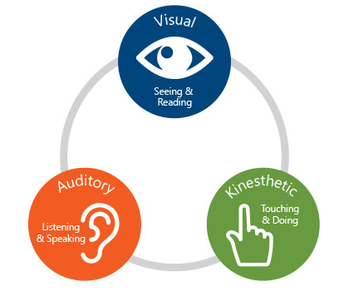

Example:my score results from mindtools identify me either visual and kinaesthetic learning . I know it is complex but I can assume that depends on the situation. However most of the time I am visual because in my workplace or university,I am the one who prefers talk less rather asking random questions by pay attention and taking some notes about other person trying to teach me then follow the instructions also I consider myself a kinaesthetic learner because sometimes I am good at problem solving if eventually any problem occur and nobody else are available to help me immediately I am the one who put hands on with attitude to solve the problem even without instructions.

Personal Development (swot analysis)

Strengths  Committed to activities  Good interpersonal skills ,flexibility  Strong work ethic, self discipline ,ability to work under pressure  Good attention to details | Weaknesses  Perfectionist  Time management  Get nervous in presenting ideas in public  Can appear shy in front of large groups
Opportunities  Have a place to apply my knowledge and gain work experience while studying voluntary work, work placement ,find a better job After successful complete my degree | Threats  Job market  Competitors with superior skills, experience,knowledge  Location

Employment Goals
As I mentioned in my career planning, my plans for the future are continue my studies in Leadership and Management course .
Studying Leadership and Management course, I will develop a range of analytical and problem-solving skills, the management of functions such as marketing,Human Resources and finance, and leading change also gain the ability to identify how business organisations are shaped and changed, and how stakeholders behaviours and management decision-making contribute to the various organisational functions.
In addition this degree in Leadership and Management it’s a great platform to gain the essential and practical skills in communication such as the use of IT, numerical interpretation ,collaborative working, and reflective thinking.
Overall I have been researching the career options available on the job market and I found out those career paths in marketing, business strategy and retailing, finance, entrepreneurship, inter-organisational collaboration or fundraising, I hope finish my degree with merit and pursue one of those career.

Conclusion
In conclusion I am sharing below my personal action plan to address my next steps

Target | Action to achieve | Evidence of completion | Target  date
Time management “keep up date with university work” | Allowing enough time for myself to the task in order to meet the deadline | Assignment work will be completed on time and to a good standard | Ongoing throughout  20/2021
Become more motivated to achieve good grades in my course | Attend all lectures motivate myself to complete work with good standard by learning more about the subject in my own | My overall grades in the course will have improved as a result all my work has been well presented with relevant information and recognise by lecturer with high mark | Ongoing  Throughout  2020/2021
Gain the confidence to speak in public | Understanding myself better to overcome my fear of public by find my voice and inspire the audience attend workshops or find a mentor to help me | Presenting my university work with confidence | August 2021
Develop the necessary skills set for my career | Read more books, articles  Online research Outside lecturer | Transfer those skills in my workplace after complete my degree | 2021 work placement

References
Books
Cottrell, S.(2010)Skills for Success: The Personal Development Planning Handbook.
( 2nd edition). Hampshire: Palgrave Macmillan
Maund, A. Schriek ,M. and Tinker, P.(2017).Certificate in Higher Education:Skills for the workplace Student Yearnook
Sage Publications.
Morgan, P.(2016).The Business Student’s Guide to Study and Employbility.
Sage Publications
McMillan,K. and Weyers,J.(2016) The Smarter Student : Skills and Strategies for Success at University, London:Prentice Hall.
Holland,R.Williams.(2012)Cracking the New Job Market: The 7 Rules for Getting Hired in any Economy .Printed in United States of America
Williams,K.Wolliams,M. and Spire,J.(2012)
Reflective writing: Palgrave Macmillan

Websites
https://www.prospects.ac.uk
www.mindtools.com
www.ey.com

