Comparing the work of Martin Stranka and Tommy Ingberg

In this essay I shall compare and contrast the work of two modern surrealist photographers; Martin Stranka and Tommy Ingberg. I shall discuss the surrealism briefly in order to better understand these artists’ styles and I will look at the surrealist artist, Magritte, who possibly influenced their work. I will look at the similarities and differences of two pieces of Ingberg and Stranka’s work. I will look at the artists’ background, their motivation, how they express themselves through their work, their composition, and how they have been influenced.
I will be looking at two particular works, Dreamers and Warriors by Martin Stranka (Fig 2) and Stone Part One by Tommy Ingberg (Fig 3).
Surrealism is a style of creativity that draws on the subconscious mind, dreams, fantasy, and deep hidden psychological issues. It was led by Andre Breton who wrote the surrealist manifesto in 1924 (Tate, 2021).
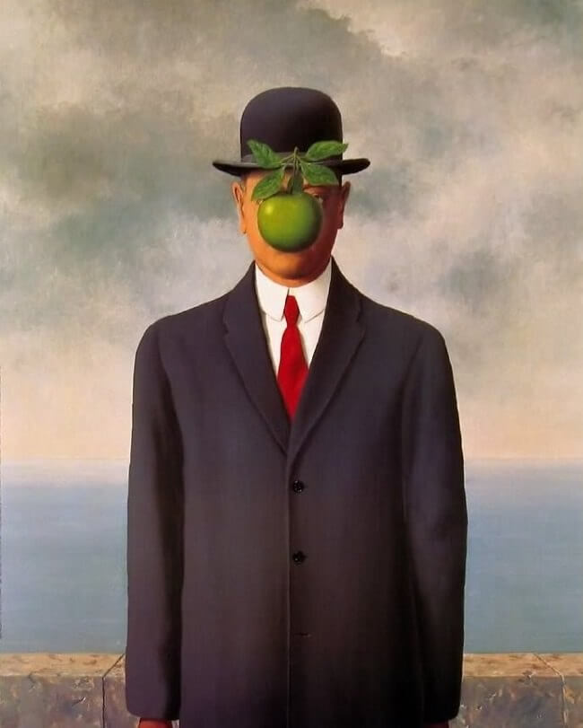
Surrealism can be seen as something that borders on reality and fantasy. It can be something fantastical and out of this world or something very realistic with a few thought provoking changes to express deep concealed messages here and there just to make the viewer think.
The surrealistic aspects in both Ingberg and Stranka's pieces are arguably influenced heavily by the work of Magritte and a common theme recognisable is identity and the viewer's perspective. One of his most well-known pieces is the Son of Man painted in 1946.

The son of man by Rene Magritte (fig 1) depicts a central figure of a man with a bowler hat with an apple covering his face, so that none of his features are visible. This is supposedly a self-portrait.
This figure could be interpreted that there are two faces. One you conceal from other people and another that you will show to the world. Magritte explains this in his quote: “the visible that is hidden and the visible that is present” (The Son of Man, 1946 by Rene Magritte, no date). Magritte is making a statement about humanity and the conflict that we feel when facing the world. Do we express ourselves openly, or do we hide behind a mask?
It seems likely that Magritte used his art as a therapy. His mother committed suicide and was found with her dress obscuring her face. Critics have suggested that this is why some of his paintings depict figures with veils or fabric over their faces (Rene Magritte Biography, no date).
Magritte’s figure is reflected in Martin Stranka’s Dreamers and Warriors. Both characters are anonymous and look forlorn, even though you can’t see their features. They both have a large expansive sky in the background, and both look completely isolated from the world due to the way they are masked. These views are subjective because any opinion on the characters is down to personal perspective. This is the nature of surrealism, the fine line between dream and reality.

Figure 1 The Son of Man, 1946 by Rene Magritte

Figure 1 The son of man, 1946 by Rene Magritte
(The Son of Man, 1946 by Rene Magritte, no date)
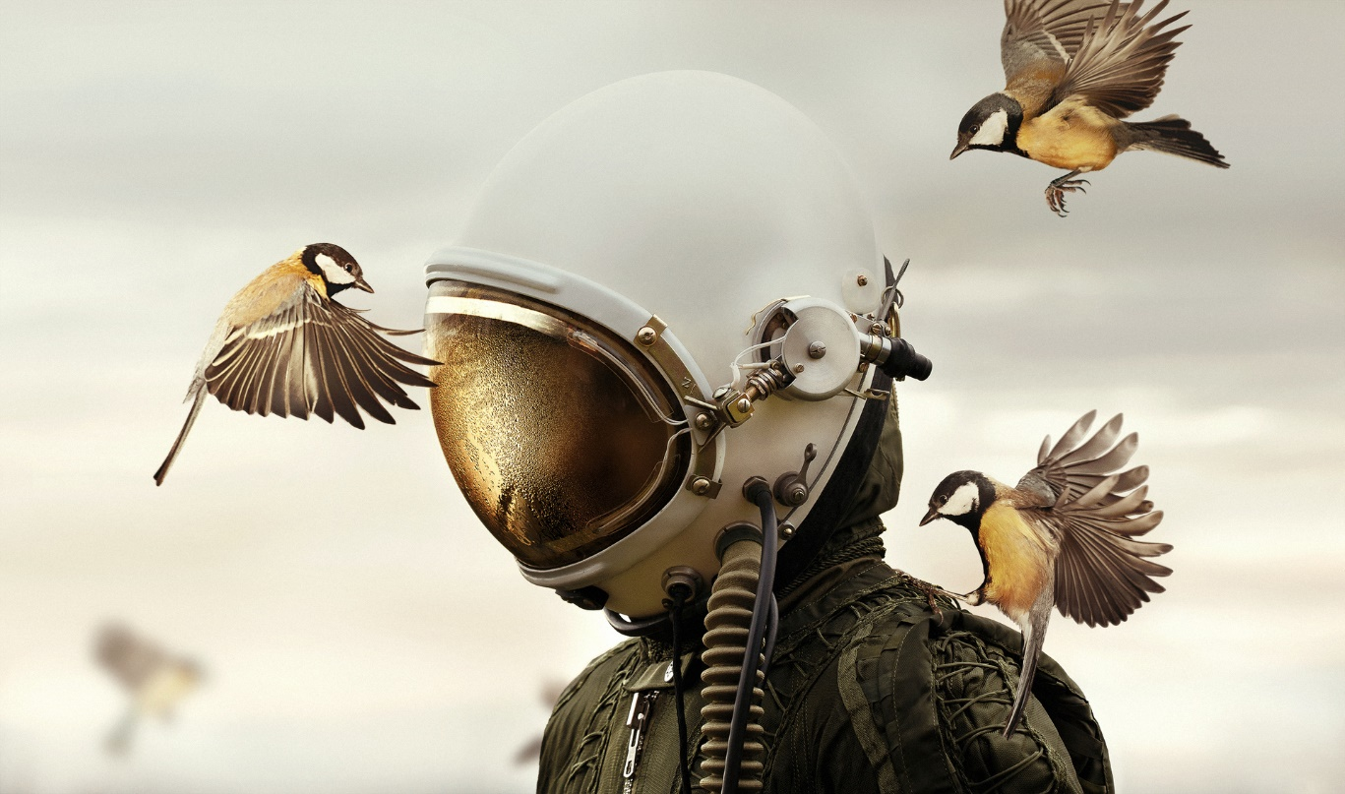
(martinstranka.com 2018)
Figure 2 Dreamers and Warriors by Martin Stranka
Martin Stranka was born on April 13th, 1984 in Czech Republic in Prague. He is a self-taught photographer and visual artist. Stranka did courses in business. The death of a close friend drove him to do photography as a sort of therapy. This hobby quickly turned into a passion and then a profession. On his website, he describes his vision as “etched as a unique space located in a balance and serenity” (martinstranka.com, 2021).
Figure one, Dreamers and Warriors by Martin Stranka, shows a person in a helmet
The scale of photo is determined by the central figure (pilot) who sits in the middle of the piece taking up a third of the overall space. The other main features of the image are the birds who are prominently placed in a triangle surrounding the helmet. The background is white with the top part of the helmet disappearing into it. This can be seen as a metaphorical depiction of the concept ‘head in the clouds’ when we are dreaming perhaps. His use of gold in the birds is reflected in the helmet. He uses a dark khaki green for the pilot’s uniform and a misty grey sky that fades into a light gold.
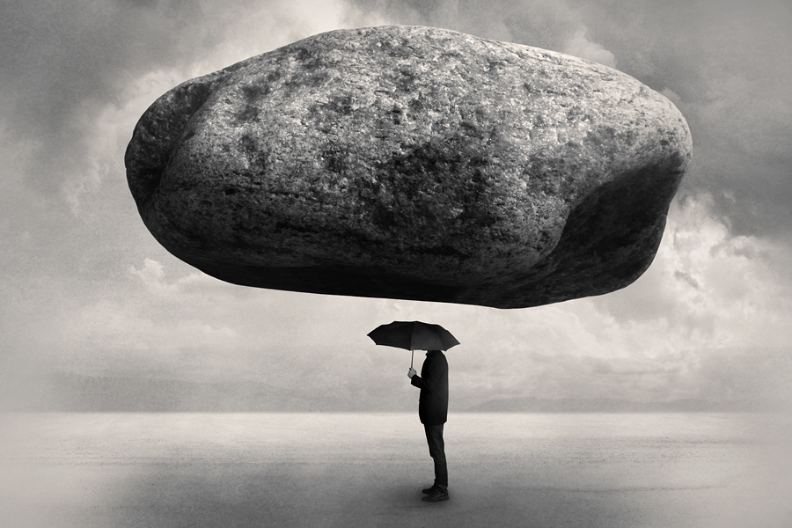
Minimal colours of the heavy pilot suit worn by the figure strike a contrast with the small, fluttery, golden birds (probably coal tits) It all comes together to bring a sweet image that Stranka says symbolises “our dreams and fighting against our fears” (Sophia Hawkes, 2019). Perhaps the Dreamers and Warriors series emphasises the inner self over our exterior form. His images work in subtle metaphors to show a psychological or spiritual world.
(Bogdan Florin, 2011)
Figure 3 Stone Part One by Tommy Ingberg
Tommy Ingberg’s piece ‘Stone Part 1’ reflects a similar style to Magritte’s, Son of Man. The man in the suit holds an umbrella to ‘protect’ him from the stone yet his face is obscured so it is impossible to be sure how he feels or the tone of the piece.
It is seeming likely that Ingberg was influenced by Magritte’s Son of Man. In both paintings, the figure has obscured his face from the viewer. They are both standing alone with a vast amount of sky behind them. They both have masculine physiques, wearing business suits.
It seems that Ingberg is also influenced by another one of Magritte’s paintings, which is called ‘Castle of the Pyrenees’. This depicts a big oval rock with a castle on it hovering in the sky over a large seascape. However, Ingberg goes a step further and by placing a man standing underneath with an umbrella that also obscures his face.
In the above photograph, ‘Stone part 1’, a solitary male figure stands in a desolate landscape with a large expanse of cloudy sky. There is a large rock hovering above his head taking up almost a third of the frame. The rock could be seen to represent the weight of society, his responsibilities or expectations weighing on his shoulders. The man holds an umbrella that conceals his head as if to protect him from the rock above. Whilst the rock seemingly hangs in place, the concept seems to imply it could fall at any time and the man will be unable to prevent it. It’s as though he is unable to stop the weight of the world falling on his shoulders. Whilst Ingberg himself states that his work is open to interpretation, it could be concluded that he is making a social statement about the state of society and the lack of individualism or creativity that exists.
Tommy Ingberg is also a self-taught photographer born in Sweden in 1980 (Tommy Ingberg Photographer | All About Photo, no date). His work is mostly in black and white with men in suits in various situations. They usually depict a man or group of men in business suits with the faces absent or replaced by some object such as hands, rocks, balloons. His faceless figures have a mundane quality, and they are uniform, blank, and grey. His businessmen seem to work for works sake with no creativity or love of life.
Similar to Stranka, Ingberg is trying to depict the inner reality using metaphors. Both use a strong central figure however Ingberg’s work is much darker than Stranka. Stranka’s figure looks over protected with a pilot suit and helmet, as though he is scared of the outer world. In contrast Ingberg’s figure despite having a boulder over him has just an umbrella to protect him. Whilst overly protected Stranka’s figure looks desolate with his helmet pointed downwards as if signalling unhappiness and a lack of connection to the world around him. The birds are trying to communicate with him however this seemingly is having no impact. Ingberg’s suited man, although facing impending doom seems calm and content as he looks forward, with only an umbrella to protect him yet his posture implies lack of worry or concern in comparison. Whilst both pictures could be described as dark and foreboding the man in the suit seems accepting to it as if it’s happened to him before whilst Stranka’s pilot looks forlorn and given up hope.
This essay has looked at two artists who have used surrealism as a way to express themselves and have arguably been influenced by the work of Magritte. Both Ingberg and Stranka used objects to obscure the face the same way Magritte does, making a statement on isolation and loneliness using ordinary items in strange context. The essay has also briefly explored the surrealist movement. I have compared the work of Martin Stranka and Tommy Ingberg and how their work relates to Magritte and conclude that art is often used as a way to express deep hidden subconscious ideas and has therapeutic value since both Stranka and Magritte used surrealist art therapeutically after a loved one died.

Bibliography
Bogdan Florin (2011) Reality Rearranged: Black and White Surrealist Photography by Tommy Ingberg, Photography Office. Available at: http://www.photographyoffice.com/blog/2011/10/reality-rearranged-black-and-white-surrealist-photography-by-tommy-ingberg (Accessed: 7 March 2021).
martinstranka.com (2021) BIOGRAPHY, Martin Stranka - Fine Art Photographer. Available at: https://www.martinstranka.com/biography (Accessed: 28 February 2021).
Rene Magritte Biography (no date). Available at: https://www.renemagritte.org/biography.jsp (Accessed: 23 March 2021).
Sophia Hawkes (2019) The quest for creativity, Capture. Available at: https://www.capturemag.com.au/advice/the-quest-for-creativity (Accessed: 5 March 2021).
Tate (2021) Surrealism – Art Term, Tate. Available at: https://www.tate.org.uk/art/art-terms/s/surrealism (Accessed: 14 March 2021).
The Son of Man, 1946 by Rene Magritte (no date). Available at: https://www.renemagritte.org/the-son-of-man.jsp (Accessed: 15 March 2021).
Tommy Ingberg Photographer | All About Photo (no date). Available at: https://www.all-about-photo.com/photographers/photographer/554/tommy-ingberg (Accessed: 7 March 2021).

