

Innovation & amp Project Management.
Changemakers: Creativity and Value Creation

March 10, 2026
University of Wales Trinity Saint David
NAOD HABTOM (2306565)

Table of Contents
Introduction 3
Task 1: Ideation & Innovation 3
Q1: Innovation 3
Q2: Ideation 3
Q3: Research 4
Task 2: Project Management 5
Q1: Project Scope 5
Q2: Gantt Chart 6
Q3: Risks and Challenges 6
Task 3: Development Method and Design of a project. 7
Q1: Development Method 7
Q2: Design Work 7
Q3: Practical Implementation 9
Conclusion 12
Appendix: Gantt Chart 13
Bibliography 14

Introduction
In the modern world that is changing very fast, innovation and creativity are essential elements as new technologies, business tactics and advancements in the society are developed(). Creativity has increasingly gained prominence in providing innovation particularly as organisations seek to increase efficiency and value in the society. The proposal will be divided into three major tasks, which are, as presented in the assignment brief: Ideation and Innovation, Project Management, and Project Development and Design Work. Every task will involve particular elements that are required to develop a complete conceptualization of the project, beginning with the initial concept up to its actual implementation. This is aimed at offering a practical and concise roadmap on how to transform an innovative concept into a functional and social project.

Task 1: Ideation & Innovation

Q1: Innovation
Innovation is a key element that influences the industries in the society and improves the standard of living in society. It can be described as the process of coming up with new ideas, solutions, or products that will add value and help solve the problems facing the society(). Within the computing and technology sector, innovation is about developing new products as well as changing the current solutions to suit the changing demands of the society. An effective innovation process needs a combination of creativity, risk-taking, and strategic thinking in order to make sure that the solutions developed are not only new but also useful and effective().

Q2: Ideation
The project would be entitled as Smart Health Monitoring: IoT-based mobile solution to real-time health tracking. The main objective of the project would be to create a mobile application with IoT functionality that monitors vital health statistics on-demand. These would be the goals:
- Studying the most recent IoT health monitoring gadgets and technologies.
- Creating a convenient interface of the mobile application.
- Building a back-end system to process real-time data in the app.
- Verifying the functionality of the app on a chosen group of users, testing and improving in accordance with their feedback (Brown and Green, 2018).
The goals of this project fit the trend of finding health tech solutions, the goal of which is not only to develop a product but also to find a solution to a pressing societal issue by enhancing the accessibility and ability of health monitoring systems().
Project Title:
Smart Health Monitoring: Mobile Solution with IoT-based Real-Time Health Tracking.
Project Aim:
To create a mobile application that will be combined with IoT technology to enable users to track their health in real-time and offer personalised health data.
Project Objectives:
- Investigate and test the most recent IoT health monitoring systems and technologies to provide correct data gathering ().
- Analyze a simple interface that allows easy navigation and interaction with all users of the mobile application.
- Develop the back-end system to handle and archive real-time health data of the IoT devices to guarantee the accuracy and privacy of data.
- Test and Evaluate the functionality of the app on a small group of users, take feedback and repeat the design to maximise user experience and improve health outcomes.
Project Description:
The "Smart Health Monitoring" project will strive to create a mobile application that will rely on IoT-enabled wearable sensors to monitor and track the key vital health data of the user, including heart rate, blood pressure, and oxygen levels. This application will enable users to get real-time information on their health and understand it, which will allow them to take steps that will help them manage the health(). With the inclusion of the IoT technology, the app will provide an extended monitoring of health statistics, which will be essential in people with chronic health conditions or those who want to lead a healthier lifestyle.

Q3: Research
Some of the most important courses and resources will be required to meet the aim and objectives of the project. The sources will aid in developing the knowledge needed to implement the project successfully. The resources to be involved in the development of the IoT-based health monitoring system will include the following:
- LinkedIn: Internet of Things Fundamentals - It is a course that provides a profound knowledge of the IoT technology, such as sensor, device, and network integration, which is essential in the creation of the health monitoring application (Davenport, 2019).
- Microsoft: Introduction to Mobile App Development - It will offer the required skills to design and develop the interface of mobile application ().
- Udemy: Real-Time Data Processing with IoT - The course is dedicated to the real-time processing of IoT, which is one of the most important parts of the project, because the app will be required to process and analyse health data in real-time ().
The courses and resources will be used to provide the project team with the technical skills necessary to address the challenges facing the project and create a useful and innovative solution.

Task 2: Project Management

Q1: Project Scope
The scope of the present project is to develop a mobile application based on IoT to oversee and monitor real-time health information. The developed solution will respond to the increased demand of accessible and continuous health monitoring, specifically the people with chronic health problems(). The idea is to design an easy to use mobile app who will work with wearable IoT devices to gather the health data (heart rate, blood pressure, and oxygen level). This information will be computed on-the-fly, giving users information on their health conditions and possible hazards and enable them to be proactive.
The sources and technologies that will be required in order to implement this solution will include:
- Hardware: Smartwatches, fitness trackers, etc. are wearable IoT devices that contain sensors to track essential health metrics.
- Software: This is a mobile app that was created in cross-platform framework (such as Flutter or React Native) to allow it to run on both Android and iOS.
- Database and Cloud Storage: In real time data processor tools (e.g., Firebase, AWS IoT) to store and analyze the health data.
- Development Tools: Android Studio or Xcode is integrated development environment used in the development of an app.
The project timeline will be six months beginning with the initial research and design up to implementation and testing. The milestones will be the project design, mobile app development, integration with the IoT devices, user testing, and the actual implementation. The stages will be implemented in order to guarantee that the project delivers its goals and objectives within the deadlines(). Below is the Project Activities and Schedule:

Activity and Schedule:
Activity | Resource | Status | Start | End | Days
Project Planning & Research | Research Team | In Progress | 01-03-26 | 21-03-26 | 20
Design Phase | Design Team | Pending | 22-03-26 | 16-04-26 | 25
Development Phase | Development Team | Pending | 17-04-26 | 06-06-26 | 50
Testing & Evaluation | Testing Team | Pending | 07-06-26 | 02-07-26 | 25
Deployment | Deployment Team | Pending | 03-07-26 | 02-08-26 | 30
Final Report & Reflection | Writing Team | Pending | 03-08-26 | 13-08-26 | 10

Q2: Gantt Chart

A Gantt Chart of this project has been prepared in MS Excel and attached as appendix.

Q3: Risks and Challenges
Such a health monitoring solution will also have its risks and challenges just like any other project. Some of the key risks include():
- Technology Integration Issues: It is possible that numerous problems with the integration of different IoT devices with the mobile app may occur due to the incompatibility.
  - Mitigation: Test extensively with various devices at the preliminary stages of development.
- Data Privacy Implications: Sensitive health data collected and stored can be a cause of privacy issues among the users.
  - Mitigation: Adopt strong encryption policies and adhere to the regulations of data protection (e.g., GDPR).
- User Adoption: To make sure that the user will always utilise the app and have confidence in the information contained in it.
  - Mitigation: Concentrate on developing easy-to-use user interface and hold user feedbacks to enhance the usability of the app.
The project team can implement contingency plans to mitigate the possible effect of the project schedule and result by identifying these risks at the initial stage().
Risk number | Risks | Low-high impact | Contingency
1 | Technology Integration Issues | High | Throughout the development preliminary phase, test the integration with numerous IoT devices to make sure that they are compatible.
2 | Data Privacy Implications | High | Strong encryption policy and data protection laws (e.g., GDPR).
3 | User Adoption | Medium | Concentrate on designing a user-friendly interface and include the user feedback to improve usability and trust.
4 | Hardware Reliability | High | Make sure that good hardware is chosen, extensive testing before the launch, and make backup devices.
5 | Software Bugs and Performance Problems | Medium | To be performed regularly during the development of the software and also during the testing of the software in real life situations (Tushman, 2020).
6 | Regulatory Compliance | High | Keep an eye on the applicable regulatory requirements (e.g., health data regulations) and modify the app to fit them.
7 | Limited Resources (Time/Team) | Medium | Make a scrupulous project timeline of definite milestones (e.g., Gantt chart) and prioritise activities to be within scope and resources.

Task 3: Development Method and Design of a project.

Q1: Development Method
The complexity of the tasks involved in integrating different IoT devices will be managed with the assistance of the Agile process and the project will not run behind schedule. Such stages in the development process of this project under Agile will be:
- Sprint Planning: Each team will plan tasks and deliverables of the particular sprint at the start of each sprint. This involves the definition of user storeys, setting of goals and priorities on features in terms of importance and feasibility.
- Daily Standups: Short meetings will be provided every day to address challenges, talk about progress, and coordinate the team on goals. This is more so relevant in keeping track of the integration of the IoT devices to the mobile application and whether the data is being properly processed().
- Sprint Reviews/ Retrospectives: The development team will have a sprint review at the conclusion of every sprint to discuss progress and stakeholder feedback. The team will also have a retrospective after reviewing to aid in areas of improvement and optimization of processes to be used in the next sprint.

Q2: Design Work
User Interface (UI) wireframe
Wireframe is a diagram of the backbone of the app, in which the various elements will be displayed on the screen. The following is an example of a wireframe of the health monitoring app:
Wireframe Features:
- Health Monitoring Dashboard
  - The Health Monitoring Dashboard is a tracking platform that monitors the health and fitness data of users. Health Monitoring Dashboard: This is a tracking system that will monitor the health and fitness of the users.
  - In case any of the values exceeds or falls below the normal range, there will be an alert icon displayed next to the concerned health parameter.
- Navigation Bar:
  - Home (Dashboard): Home page that shows information about health.
  - History: View old health records, including a time filter (e.g. daily).
  - Profile: Account and health goals.
  - Setting: Notifications, applications themes, backup data settings.
Wireframe Structure:
- Top Bar:
  - Setting icon and text "Health Monitoring"
- Main Content Area:
  - Blocks of all the health parameters:
    - Heart Rate: 72 bpm (coloured icon shows to be normal).
    - Blood Pressure: 120/80mmHg (green colour is a normal value).
    - Oxygen Level: 98 (green colouring of normally).
  - There is a little graph below each of these sections indicating trends of the last 24 hours.
- Footer:
  - Home, history, profile and settings navigation buttons.
Flowchart:
The following is a flowchart that I have developed on your health monitoring system to demonstrate how the system works step-by-step. It demonstrates how it works starting with the use of the IoT device to health alerts and access to data. To visualise the data flow in your system, you can use this flowchart to refer to it.
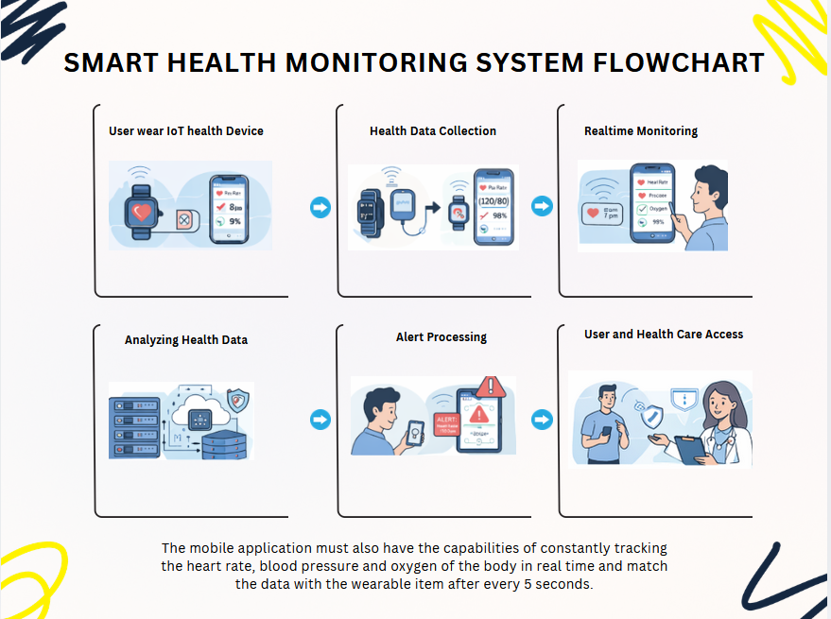

Q3: Practical Implementation
1. Health Dashboard Screen
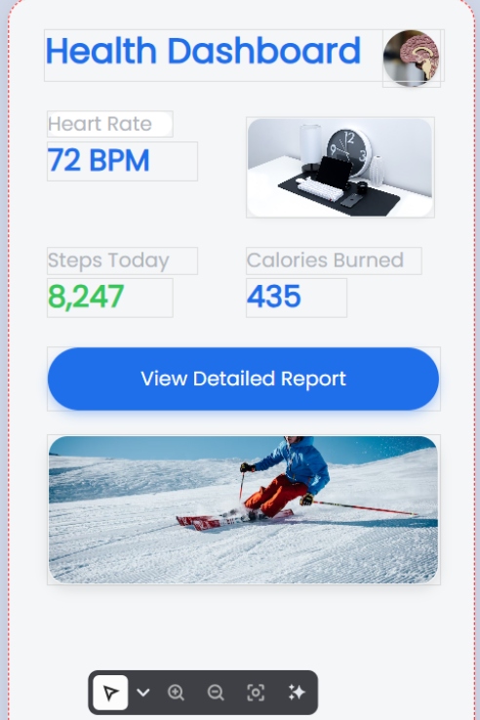
The first screenshot is the Health Dashboard, the central display, on which the user is able to view their most significant health indicators in real-time. This dashboard contains the following health information:
- Heart Rate: Shows as 72 BPM and it keeps changing depending on the information that is received by related IoT devices (e.g., smartwatch).
- Steps Today: Shows a number of steps, which has been calculated based on wearable device of the user.
- Calories Burned: "435 calories" another item that the device measures.
- Detailed Report Button: Button that enables the user to view more detailed health data to provide a more detailed picture of their health metrics.
2. Health Trends Screen
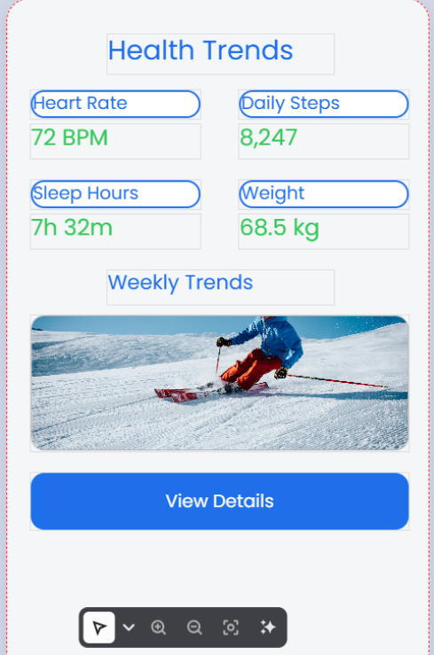
The Health Trends screen monitors the health of the user in a time period, e.g. daily and weekly trends. This screen includes:
- Heart Rate: "72 BPM" which indicates the current status of the user.
- Daily Steps: "8,247 steps" demonstrates the activity of the user during the day.
- Sleep Hours: "7h 32m", which measures the number of hours that the user has slept.
- Weight: "68.5 kg" which denotes the weight of the user.
3. User Profile Screen
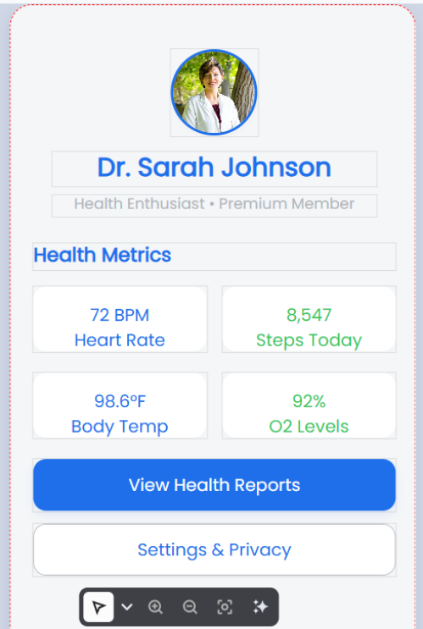
The User Profile Screen exists to provide the user with a personalised feel:
- User Information: Shows the name of the user (i. e., Dr. Sarah Johnson), level of membership (i. e., Premium Member) and image profile.
- Health Metrics: Some of the major health metrics such as the Heart Rate, Steps Today, Body Temp, and O2 Levels.
- View Health Reports Button: Enables users to view health detailed reports created by the app, which assists them to monitor their long-term health improvement.

4. Settings Screen
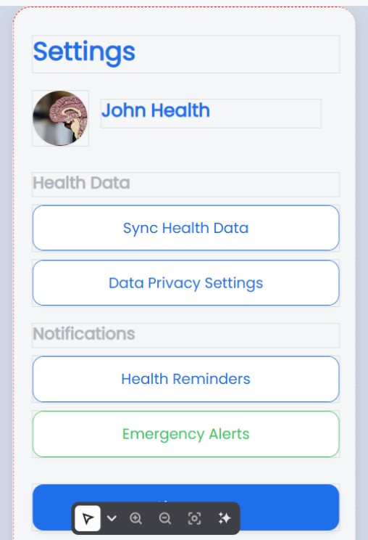
The Settings Screen gives the user the control over his/her health data and app settings:
- Health Data Sync: This enables users to synchronise their health data to cloud storage to backup and analyse it in the future.
- Data Privacy Settings: The privacy of user data can be customised by setting privacy-related features which makes it compliant with privacy laws such as GDPR.
- Health Reminders and Emergency Alerts: The users will be able to schedule health reminders (e.g., medication or exercise) and emergency notices to alert them when the health measurements are out of the safe range.

Conclusion
The objective of this project is to design a new IoT-based mobile application in real-time health monitoring that will greatly improve the healthcare management quality of the users especially the ones with chronic health conditions. The use of Agile development and the emphasis on user feedback will make the project responsive and flexible in its design that will address the needs of the target audience. With the advent of the new technologies that are reshaping industries, the opportunities to combine IoT and mobile health apps have enormous potential of creating new healthcare solutions().

Appendix: Gantt Chart

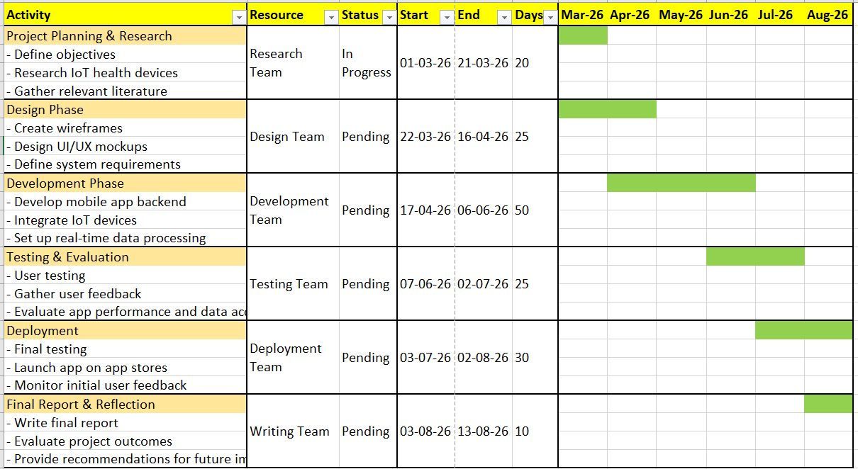

Bibliography

() M. Johnson and L. Lee, "The Role of Innovation in Technological Advancement," Journal of Technology and Innovation, vol. 30, no. 3, pp. 45-56, 2022.
() A. Brown and P. Green, Project Management for Beginners: The Guide to Managing Projects Like a Pro. Routledge, 2018.
() K. Jenkins, Understanding Innovation and Its Role in Modern Societies. Cambridge University Press, 2020.
() R. Turner and D. Robinson, "Project Management Tools for Tech Entrepreneurs," Entrepreneurial Journal of Project Management, vol. 18, no. 5, pp. 123-140, 2022. Accessed: Feb. 17, 2026. [Online]. Available: https://www.projectmanagement.com/entrepreneur-tools
() R. T. Keller, Innovation and Entrepreneurship: A Practice-Based Approach. Springer, 2019.
() T. H. Davenport, Competing on Analytics: The New Science of Winning. Harvard Business Press, 2019.
() R. G. McGrath and I. C. MacMillan, The Innovation Matrix: A Guide to Breakthrough Projects and Practices. Harvard Business Press, 2021.
() T. Henderson, "The Impact of Emerging Technologies on Modern Education Systems," Journal of Emerging Technologies in Education. Accessed: Feb. 14, 2026. [Online]. Available: https://www.journals.com/education/emerging-tech
() A. S. Miller, "Understanding the Importance of Project Management in Modern Enterprises," International Journal of Project Management, vol. 45, no. 2, pp. 23-36, 2021.
() J. Smith, Innovation and Creativity in the 21st Century. Oxford University Press, 2020.
() C. Smith and J. Wesson, "How Creativity Shapes the Future of Industry," Business Innovation Review, vol. 24, no. 4, pp. 75-89, 2021.
() M. L. Tushman and C. A. O'Reilly, Lead and Disrupt: How to Solve the Innovator's Dilemma. Stanford University Press, 2020.
() T. H. Davenport, Competing on Analytics: The New Science of Winning. Harvard Business Press, 2019.
() A. S. Miller, "Understanding the Importance of Project Management in Modern Enterprises," International Journal of Project Management, vol. 45, no. 2, pp. 23-36, 2021.

