Student Name – Mavis Addison
Student ID - 1713697

Professional Career Development

Table of Contents
Introduction 3
Using Self-Motivation 4
What is Learning Styles? 5
How I Learn? 7
Personal Development Planning 12
SWOT Analysis 12
Smart Objectives 14
Johari window 15
Review of the world of Employment 17
Career ambitions and aspirations 18
Personal Barriers 18
Suitable Career Goal 18
Personal Development Plan to enable me to achieve my ambitions 19
Assessment of the Effectiveness of PDP 20
Conclusions 21
References 22

Introduction
I have several professional experiences which let me chose my goal from my learnings. My previous job experiences have been managerial positions or being in contact with customers face to face. I was working in casinos for 6 six years which was enjoyable. But unfortunately, I had to leave the job for ethical issues. Then I started working at supermarkets for 2 years. My current position is a customer service assistant at Sainsbury's where I am working for 3 years. My professional life has always been helping out people, assisting them in getting things done the right way. In my background of work, I have to make sure that the customers are pleased and have had a positive experience shopping in the store. The primary goal is to be able to get a managerial role whereby, I can use my skills and knowledge that have learnt from being a customer service assistant. I would want the position of being able to act as a manager, during the shop and see what it entails. This will also give me the confidence that I need to move forward and expand myself. My future career goal is to become a manager of a company and for this position. This report is going to be the portfolio of evidence of how I gradually keep building up myself into the roles.

Using Self-Motivation
The level of one’s self-motivation determines the intellectual ability and spiritual power which enables him/her to decide the right job without external help. Self-motivation helps individual identifying an objective to take a challenge instead of giving up (Mindtools.com, 2019). I believe that the level of my self-motivations is good enough to take challenges which comes to my ambitions. I always find myself challenging and ready to provide extra efforts to accomplish my task which encourages me to achieve my ultimate future goals.
Self-motivation Quiz to find my level of motivation: I have participated in the self-motivation quiz developed by Mindtools (Mindtools.com, 2019) to know my self-motivation level. The score of my motivation from this quiz is presented below:
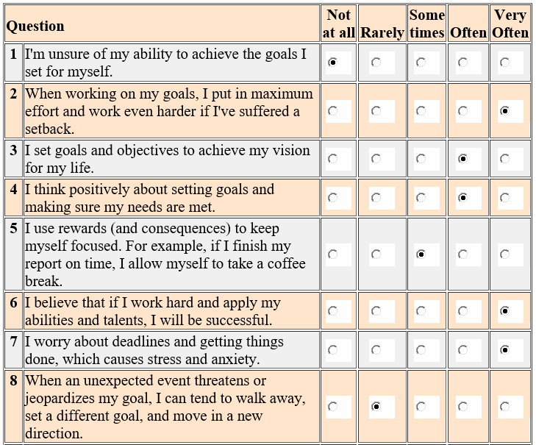
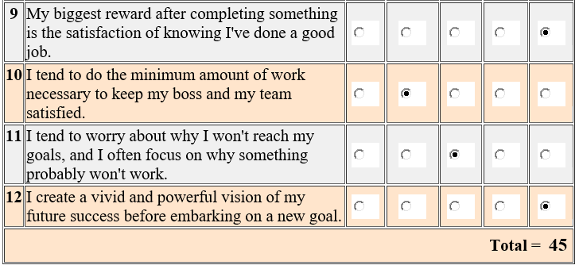
Source: Mindtools
I have scored 45 in this quiz of self-motivation which shows that I like to get things done without waiting for anyone’s help. I use to stay self-motivated with my continuous efforts and I spend enough time to set my goals and achieve them. I also like to inspire people with my success which motivates them. According to Mindtools (2019), I have enough self-motivation to accomplish my future goals with my continuous efforts on my job and this level of motivation is wonderful.

What is Learning Styles?
Learning is the process of gathering knowledge about the specific topic either by reading or from real-life experience. The impact of learnings and efficient usage of resources varies from person to person as the learning styles differ from individual to individual (Cottrell, 2015). Most of the people use different learning style to develop their professional skills from another person. There are various learning styles from where we select our own learning style by engaging ourselves while gathering knowledge about a specific topic. I will discuss the Honey and Mumford Learning style as well as VAK learning style to identify my own learning style.

Honey and Mumford Learning Style: There are mainly four learning categories in this learning style including Activists learning, Theorists learning, Pragmatists learning and Reflectors learning (Student Success Space, 2019). In the first category called Activist, people learn new skills from their activities in daily life. The second category is Theorists learning where everyone used to prepare their own models, ideas and goals for learning. The third category is known as Pragmatists learning where an individual applies ideas and theories in his to learn skills and knowledge based on different situations. In Reflectors category, people use observation and contemplation to learn a new skill.

VAK Learning Style: In 1920, some of the famous psychologists developed a VAK learning style while classifying various learning styles. It contains three subcategories of learning style such as Visual, Auditory and Kinesthetic learning style (McMillan, 2019). Different types of diagram, graphs, charts and pictures are used in VAK learning style to gather knowledge and information. When learners use different types of visual materials and objects for learning purpose is called Visual learning style which is the first category of VAK. Various tasks are being watched to learn by the individuals in this category. The second learning category of VAK is known as Auditory which uses audio media such as speaks, self-talks to provide information to the learners. On the other hand, Kinesthetic learners use physical objects and gestures to learn under VAK learning style.

Kolb Learning Style: In Kolb Learning Style, a learner goes through an experimental learning cycle of Kolb where there is no right or wrong way in the way of learning. Learners have their own way of learning and choosing their path in this learning style (Morgan, 2017). There are four categories in this learning style such as Accommodating Style (AE & CE), Diverging Style (CE&RO), Assimilating Style (AC &RO) and Converging Style (AC& AE) which are affected by the culture, attitude, education, career choice and job position of the learner.
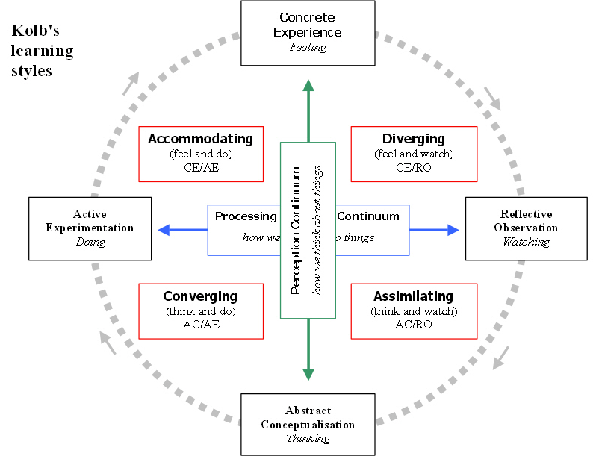
Figure: Kolb Learning Style (Morgan, 2017)

How I Learn?
I am going to use the Honey and Mumford Learning Style to determine my own learning style. For this, I used the quiz of Honey and Mumford Learning Styles Questionnaire to answer all the question to fund my category. After completing the self-assessment questionnaire, surprisingly I have found myself as Theorists Learners. I am presenting my answer for the self-assessment questionnaire under the Honey and Mumford Learning Style below:

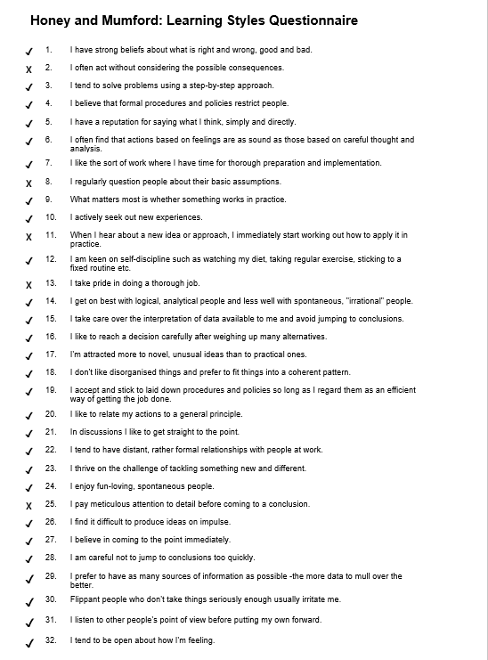
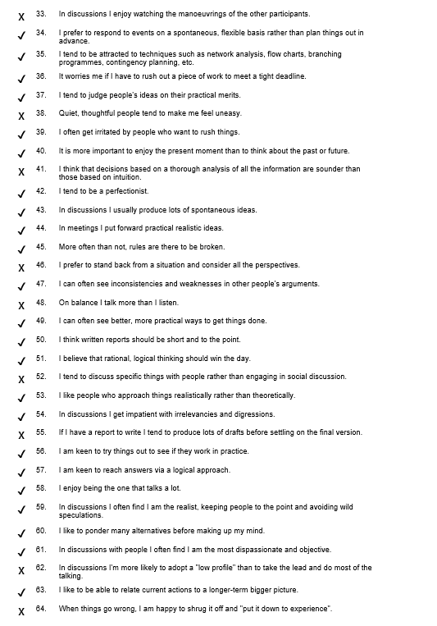

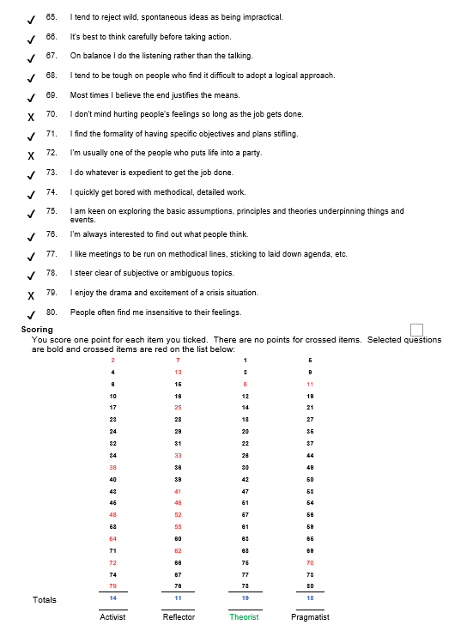
The above analysis of Honey and Mumford Learning Style shows that I got the highest scores for Theorists style learning. The score for this category is 19 out of 20. I also scored 18 in the Pragmatist learning style and 14 in the activist learning style. The lowest score is in the Reflector learning style which is 11. I am going to present my overall scores of Honey and Mumford Learning Style in the following pie charts.
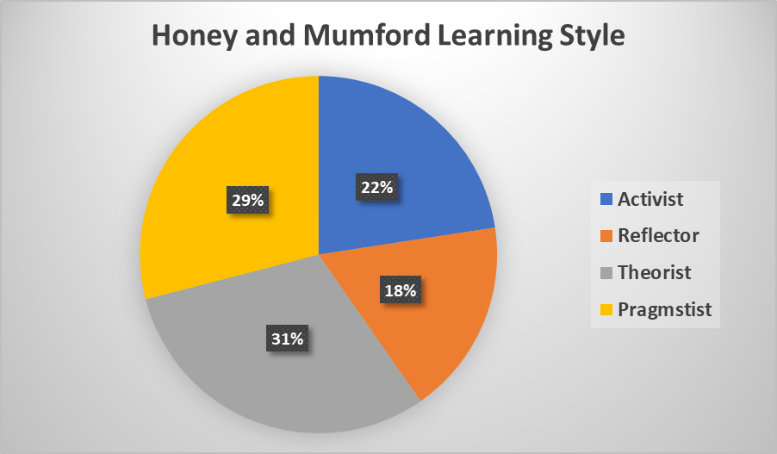

The above analysis of quiz data shows that I am Theorist learner in Honey and Mumford Learning style as I scored highest in this category which is 19. The reflection of my learning style covers 31% in this category. Besides, I scored 18 in Pragmatist category and 14 in the activist category. The lowest score is in Reflector category is covers 18% of my learning style.
As a Theorist learner, I analyse all problems with logic and consider the value of objectivity and rationality. I would like to organize the disparate fact to formulate into coherent theory while assessing the problems. I tend to be disciplined and I aim to sort things into rational order so that I can get things done in a neat and cleaner way. I also show my keen interest in basic assumptions rather than irrelevant objects. The basic principles and theories are valuable while applying any model in the system. I get these characteristics as a Theorist learner from Honey and Mumford learning style.

Personal Development Planning

SWOT Analysis
SWOT Analysis is an analytical tool used to analyse and present the strengths, weaknesses, opportunities and threats (Kreative Leadership, 2019). I have used this model to analyse my condition from the perspective of strengths, weaknesses, opportunities and threats.
Strength | Weakness
- I am good at public speaking.  - I am good at leading a team.  - I have a strong reference power.  - I have a working experience of more than 4 years as a management consultant in London.  - I have a strong academic background.  - I have decent networking in the consultancy industry specialized in hospitality businesses.  - A leader with strong reference power.  - A good public speaker | What do you need to improve?  - I need to improve my time management.  - I lose my focus on the core issue after some time.  - Sometimes I cannot take much stress.  - I have limited control over analytical problem-solving.  - My expertise in project management is still limited whereas people working in management have good control  - Hot-tempered  - Not efficient in managing stress
Opportunities | Threats
- The business world is becoming integrated day by day and as I have strong expertise in global trade and IT. So, it will open the window of opportunity for me.  - The business dynamics are changing and my skill of fast learner will give me the opportunity to adapt to a changing the environment.  - My expertise in leadership will help me shine in the management level in the service industry especially in the hospitality industry.  - My skill in fast learning will enable me to adapt to the changing dynamics of the business world. | - Innovation in Technology has been a threat to all business areas because a simple innovation can lead to a change.  - Increased globalisation seems to be a threat to me because the UK firms are taking service from low-wage countries in the world through freelancing. This may cause a decline in job creation in the UK.  - Change in the business dynamics might shift the management function to other countries by the virtue of IT and so my career objective might be at stake.  - Change in laws in the UK might include the provision to have a professional degree for working in the service industry.

The SWOT Analysis developed above has shown that I have strong expertise in public speaking and strong reference power. My strength in leadership is also mentionable. I have weaknesses in some areas such as I have to lack in proper time management and cannot manage stress much. There are some opportunities also in my career path and these are my expertise in global trade will help me exploit some opportunities created in globalisation and my fast learning skill will help become successful in any changed condition. There are also some threats that should be considered while designing a career path (Kreative Leadership, 2019). The first threat is the innovation in technology and this will take my career plan at stake because the change in technology might change whole industry dynamics. Another threat is increased focus on freelancing because if the UK based company starts freelancing the management functions to low-wage countries and this will reduce the employment.

Smart Objectives
Smart objective refers to the way of achieving a specific career objective which is measurable and restricts (Reflektive, 2019). It is the acronym of five key points including specific, measurable, achievable, relevant, and time frame which are the power to writing goal from an employee perspective for demonstrating their skills and knowledge. I am writing some of my SMART objectives which are related to my future aspirations in the table below:
Name of Skills | S | M | A | R | T
Name of Skills | Specific Goal | Is the goal Measurable | Is it Achievable? | Is it Realistic? | Time frame
Decision-making ability | I want to make the quick right decision in sudden issue so that I can be successful in my career as a manager. | This goal is measurable as I believe that I can improve my decision-making skill by 50% if I continue to experience this process. | I think it an achievable goal as I am already playing a role where the decision is dependent on my activity. | Yes, this is a realistic objective which I already have experienced. I have to improve it | Within the next 6 to 8 months, I will achieve this smart objective from my study and workplace experiences.
Supervision | I want to achieve the powerful supervising skill to supervise my people. | I think I should increase my supervision skill by 40% so that my employee and co-worker will be effective. | This goal is really achievable to me. I am experiencing this skill besides my studies. | This objective is realistic which can be improved from my present working sectors without any panic. | I believe I will achieve this skill within 1 year which will help me to supervise my people with good solutions.
Managing resources and overall operation | I want to manage the overall resources including human and financial resources along with the operation of a company. | My aim is to ensure maximum effort of human resources by motivating them in their work, Besides, I want to increase the turnover by 30% by expanding the operation. | I believe it can be achieved from the learning of the workplace and studying management. As I have already managed a super shop, I can manage a company if I try to improve my skill. | This objective is realistic which I have already experiencing and studies in this subject. I can achieve this goal. | I can achieve these management skills within the next 2 years as I am experiencing in this sector of managing resources.
I have given my smart objective based on my future ambition which becoming a manager of a company. Manager needs to improve his managerial skills, supervision and decision-making ability to manage the overall resources efficiently (Reflektive, 2019). All my smart objectives are achievable, measurable and realistic which can be achieved within the allocated time period. By achieving these goals, I can manage an office better way.

Johari window
The Johari Window, a model developed by Joseph Luft and Harrington Ingham, helps to understand and evaluate the relationship between an individual entity or person with other people. There are four segments in the model and every segment deal with a specific dimension (LEZakel, 2019). I have used this model to analyse myself below:
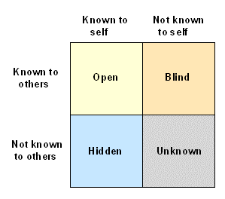
Figure: Johari Window (LEZakel, 2019)
Open Quadrant: This is the quadrant that deals with the skills and characteristics of individual those are known to that individual and the people as a whole. My leadership skill and public speaking skill fall under this category (LEZakel, 2019). Because the people who worked with me and under my supervision are known enough about my leadership skills. Moreover, I have been awarded the best presenter award for a couple of times in my student life and professional career.
Blind Quadrant: This quadrant deals with the skills, expertise and characteristics of individual those are known to other people but not by himself/herself (Maund, 2017). My reference power falls under this category because people around me have said it over and over that, I have the strong real problem-solving ability and so people find me having strong reference power.
Hidden Quadrant: This is the quadrant that deals with the skills and characteristics of the individual those are known to himself/herself but not the other people (LEZakel, 2019). This quadrant includes both sides of my characters such as people do not know about my networking skill and also most people around me do not know that I have limited expertise in project management.
Unknown Quadrant: This quadrant deals with the skills and weaknesses of myself those are unknown to me and unknown to other people (Cottrell, 2015). Especially I do not know much about my performance in the manufacturing industry because I worked there for very few times and so it was not possible to learn much. I think I should give more effort to discover this unknown quadrant and evaluate the characteristics.

Review of the world of Employment
My understanding and expectations from the world of employment are given below:
Management in CIPD Recruitment: I have read about the recruitment process of CIPD which explains that this process is central which makes it a complicated organisation process. The manager the company can handle this procedure if he/she belongs to the HRM depart. But my expectations are to make a common managerial process for some organisation where HRM is inactive (CIPD, 2019). Before hiring or recruiting employee, the manager has to analyse the skills and qualifications to assign the right job. Besides, the company have to determine the compensation and salary of the employee before joining him. There should not be any discriminations while recruiting the employee. By maintaining equality, the manager can manage them with less hassle as the employee won’t question him about discrimination. Besides, Local employee should get priority to reduce communication barriers with the local customer in case of a multinational company.
Employee management Acts: Every employer should develop their recruitment policy how will they recruit; how will they manage the employee inside their organisation. The employee should know details about the rules and policies of the company before joining in like position (Office of Administration - Human Resources, 2019). I have read the Equality Act 2010 which explains about the biases of the employers to specific gender age which needs to be eradicated. The company should provide equal privileges to all of its employees. The employer and higher authority should provide transparency in their activities toward the employee so that they can be helpful. The staffs should not be hired based on their religion, age gender or any ethnicity to reduce the discriminations.
Maintaining Dress Code: The dress code is selected based on the unique characteristics of the organization and it may vary organization to organization. Some organization may prefer a light dress code while some other organization may prefer dark dress code (Carry, 2019). The dress code also may vary based on the gender i.e. the dress code for a female can be different from that of a male. Here, the main objective of the organization is to make it attractive and comfortable so that it could create a positive impression on the mind of the customers.

Career ambitions and aspirations

Personal Barriers
The restrictions that might be a barrier in me reaching my goal and ambition is the geographic location. The location of a job might be a barrier due to the access to travelling as living in an area where the train runs at a certain time makes it difficult to get to a certain place. The location might be a barrier as travelling long distance might be an issue. But, with time managing I will be able to negotiate and see what the outcome.

Suitable Career Goal
My ambition is being able to progress in what I do. The goal is to be able to get a managerial role whereby, I can use my skills and knowledge that have learnt from being a customer service assistant. During my previous role of being a manager in a betting shop, it has enabled me to work hard and strive for more.
My short-term goal
My short-term goal is getting help from existing managers and supervisors. This will enable me to learn more from what they do, how they do it and how to solve an issue. With the skills and knowledge that I’ve gained from previous jobs, it will help me further my potential into being in a managerial position. Furthermore, the management in all departments will have to equip me with the right resources to push me further in this career path.
My mid-term goals
My mid-term goals with all the extra hours and skills learnt through this will help me with my mid-term goals. Also, by this stage, I will have had the opportunity to shadow the managers in the shop and see what they do from time to time. Being able to see how managers organize and set targets for the store is also important as this will come in handy.
My long-term goal
My long-term goal will consist of applying for roles within a managerial position. Also, as a long-term goal, I would want the position of being able to act as a manager, during the shop and see what it entails. This will also give me the confidence that I need to move forward and expand myself. E.g. being able to be in a manager position for a week and gradually keep building up myself into the role.

Personal Development Plan to enable me to achieve my ambitions
The personal development plan shows the future actions that an individual may follow in order to remain competitive in the market. The personal development plan is useful as it identifies the skill gaps an individual might need to expand his/her career (Scott Jeffrey, 2019). So, here I am providing my personal development plan:
A skill I need to achieve? | What do I need to do to achieve this skill? | What do I need to achieve this skill? | Success Criteria | Target dates for review
Managing office properly | There are some office management skills that I need to improve as it will increase my overall performance in the organization. | In order to achieve this objective, I need to work with the upper-level individuals so that I will get the office management skills from them. | If I could manage my assigned duties, then it will ensure that I got the proper office management skills and implemented in the organization properly. | It will take approximately two years to accomplish the objective. However, I will observe my improvement after six months.
Problem-solving ability | The objective can be achieved if I follow the organizational roles and policies and follow the procedures so that the overall activities of the organization can be performed properly. | In order to achieve this particular skill and knowledge, I think the best place is the University from where I could get the best guidance to improve my necessary skills. | The success criteria are the operational performance of the staffs because, if they play their roles and procedures properly it will indicate that the skills and knowledge are applied properly. | It will take approximately three years to accomplish the objective. However, I will observe my improvement after every one year.
Leadership and Supervising Skills | I need to assign tasks and follow the performance of my subordinate’s time to time. The more I will lead them, the more I will be able to supervise them properly. | I need to communicate with the subordinates and assign them tasks from time to time. And also, I need to take necessary actions when I will find that they aren’t following the direction properly. | I need to give them proper direction and support time to time so that they could accomplish their tasks perfectly. There should have a proper communication channel so that each and every direction is provided properly. | It will take approximately one year to accomplish this skill. However, I will observe my improvement after every six months.

Assessment of the Effectiveness of PDP
The personal development plan is effective because it provides the necessary directions to the individual so that he could develop his skill and performance continuously (Scott Jeffrey, 2019). From the usage of a personal development plan, I got to know that I have improved several skills that will help me to enrich my future professional career perfectly. Another positive side of the personal development plan is that the required objectives can be adjusted based on the current situation of the individuals. Moreover, I could adjust the timeframe for gathering the required skills and knowledge perfectly. The personal development plan will enable me to perform my organizational activity in the multinational company as there are lots of opportunities to enrich my skills and knowledge.

Conclusions
Professional career development is a continuous process of developing the required skills for the expected employer so that individual can lead the business to accomplish the objective. To develop our personal goal for our career, we need to identify our career ambitions so that the goal can be measured whether they are achievable or not (McMillan, 2019). I have explained my lifeline experiences and barriers to set my goals in this report. In addition, I have analysed my learning style and self-motivation level to determine how can I achieve my future goals. My professional life has always been helping out people, assisting them in getting things done the right way. Also, my professional life has also been dominated around bringing the best support and motivation into the company. So, all my self-evaluation and personal development plan are to make myself perfect for future ambitions which are to become a manager of the company.

References
- Carry, J. (2019). Professional Development Plan | Human Resources. [online] Hr.duke.edu. Available at: https://hr.duke.edu/managers/performance-management/professional-development-plan [Accessed 9 May 2019].
- CIPD. (2019). Recruitment Law Guidance | CIPD. [online] Available at: https://www.cipd.co.uk/knowledge/fundamentals/emp-law/recruitment [Accessed 9 May 2019].
- Cottrell, S. (2015). Skills for Success: The Personal Development Planning Handbook. 4th ed. London: Sage.
- Kreative Leadership (2019). eLeadership Personal SWOT Analysis | Personal Development | Kreative Leadership. [video] Available at: https://www.youtube.com/watch?v=9dlLw7_v_Do [Accessed 9 May 2019].
- LEZakel (2019). Johari Window in Interpersonal Communication. [video] Available at: https://www.youtube.com/watch?v=-7FhcvoVK8s [Accessed 9 May 2019].
- Maund, A. (2017). Certificate in Higher Education: Skills for the Workplace Student Yearbook.. 3rd ed. London: Sage Publications.
- McMillan, A. (2019). Learning Styles- VAK. [video] Available at: https://www.youtube.com/watch?v=0onG1OUTUWk [Accessed 9 May 2019].
- Mindtools.com. (2019). Self-Motivation Quiz. [online] Available at: https://www.mindtools.com/pages/article/newLDR_57.htm [Accessed 9 May 2019].
- Morgan, P. (2017). The business student's guide to study and employability. 4th ed. London: SAGE Publications.
- Office of Administration - Human Resources. (2019). Employee Relations Policies and Laws. [online] Available at: https://www.hrm.oa.pa.gov/employee-relations/policies-laws/Pages/default.aspx [Accessed 9 May 2019].
- Reflektive, T. (2019). SMART Goal Examples for Employees’ Success | Reflektive. [online] Reflektive. Available at: https://www.reflektive.com/blog/smart-goal-examples/ [Accessed 9 May 2019].
- Scott Jeffrey. (2019). Personal Development Plan: A Definitive Step-by-Step Process. [online] Available at: https://scottjeffrey.com/personal-development-plan/ [Accessed 9 May 2019].
- Student Success Space (2019). Honey-Mumford Learning Style. [video] Available at: https://www.youtube.com/watch?v=izMEy-UiRKM [Accessed 9 May 2019].

