(BMIH6003) Hotel Placement - Managing Guest Service Operations

Student Name: Nina Sokhan Kalashnikova
Student ID: 2234899

Lecturer name: Kathryn Roberts

Table of Contents
Introduction 3
Section 1: Role Reflection (Gibbs Reflective Model) 3
Section 2: Management Performance and Guest Service Analysis 4
Section 3: Guest Service Improvement Plan 5
Conclusion 6
Reference 8

Introduction
While at Novotel Liverpool Centre, I had the opportunity to observe a preparation of Meetings and Events. The department oversees all operations related to events, business meetings, conferences and large, or shorts bookings. They have flexible meeting plans, points for loyal guests and meals for people attending events. Members of the team coordinate a lot with both, with reception and restaurant for them meals. Its necessary to be very attentive to have enough food for all, and infill if its necessary with more, because many of events coincide in them break time. I mainly helped with organizing, preparing in advance their keys, dealing with guests and completing office tasks, prepared gift bags with some souvenirs from hotel. I wanted to achieve (1) supervising meetings and events together with colleagues at a hotel, (2) clearer teamwork and better communication skills and (3) faster responses to issues that come up during events.

Section 1: Role Reflection (Gibbs Reflective Model)
Description:
When working as a Hotel Associate, I prepped the meeting areas with juices and water, answered client demands, greeted business customers during check-in and also we cooperated with the reservations staff. I distributed the welcome packs, verified the equipment and timed food service.
Feelings:
I had to do every task promptly and with full attention. Still, as I worked alongside experts and stuck to a daily routine, my self-confidence increased. Working in a fast-paced place with changing routines each day was enjoyable for me.
Evaluation:
The team communicated perfectly between each other. Thanks to WhatsApp, colleagues being received live updates and it was simple to plan what needed to be done. A group of thirty guests once arrived for the meeting an hour before the appointed time. The manager told colleagues to handle setting up the space, early coffee, and to notify housekeeping to prioritize them rooms. Thanks to this deciding fast and instructing well, the guests all had a wonderful time.

Analysis:
I discovered from Management and Organizational Behavior that, to lead well, some leaders guide and inspire team members by setting common goals and providing support. Here, the leader aims to encourage open talks, appreciate valued input and include all staff members in making decisions (Slater, 2018). I noticed that key skills for supervisors included leadership, working as a team and making snap decisions. I was good at being flexible, paying attention and listening to others. Still, when things needed to be done quickly, I learned good abilities.
Conclusion:
I realized that successful events require strong teamwork and leadership. I learned to communicate well and got more confident whenever clients presented new challenges.
Action Plan:
- Enroll in a course that focuses on communication and leadership skills.
- Try delegating responsibilities during role-play practice.
- Regularly ask for advice from supervisors to boost my confidence when issuing instructions.

Section 2: Management Performance and Guest Service Analysis
Management Styles:
The department’s manager preferred to use a participative leadership approach. I found out from Management and Organizational Behavior (Level 5) that this method helps team members collaborate and improve their motivation. McGregor’s Theory Y confirms that workers work better when they are trusted and appreciated. The manager at Novotel worked with employees on planning, talked about enhancements in meetings and offered feedback. As a result, employees felt acknowledged and tried their best. Often, the team would meet to review what had already happened, plan for upcoming events and discuss their problems (Daskalaki, 2018). As a result, people were encouraged to look out for each other and avoid errors. As a result, the hotel ran smoothly and provided high levels of satisfaction for guests.

Health and Safety Compliance:
The rules for health and safety were followed in the spaces where guests are present. The fire exits in meeting rooms were easy to spot, fresh air could be found, and rooms were cleaned after every use. Extra sanitation measures and hand sanitizer were used. I also noticed that offices and break rooms did not get cleaned as often as one would expect. There was no wet cleaning in areas with communal use which made them hazardous. The Workplace (Health, Safety and Welfare) Regulations 1992 say that every workplace area, including those for employees, should be well-kept, properly ventilated and comfortable (Tan and Despotis, 2021). If this is not followed, employees may feel less motivated, and their health might suffer.
Culture and Teamwork:
The atmosphere in the hotel was accepting and encouraging. People from different departments commonly assisted one another. When the team was especially busy, the reception staff helped assemble meeting packs and help with the guest luggage’s (Vinod, 2022). As mentioned in Personnel Resourcing and Development (Level 5), an effective organizational culture often results in increased employee happiness and good service to clients. If employees receive support, they usually remain motivated and give great service.
Marketing and Guest Experience:
The team did everything they could to make sure the guests were pleased. They offered loyalty points, rooms set up in various ways, early check-ins and lunch boxes to take away. This placement helped me understand that improving service depends on recognizing what the target audience wants. Since the majority of guests were business travelers, the hotel made sure to provide them with prompt service and useful assistance (Vinod, 2018). Such actions are aligned with Hospitality and Guest Services by aiming to please each guest and handle their expectations.

Section 3: Guest Service Improvement Plan
Key Issue:
I noticed that wet cleaning was not done in the staff areas and offices. As a result, both company hygiene and employee motivation were damaged. Great aesthetics and safety at the workplace express respect for staff and encourage their productivity.
Justification:
Research indicates that employees’ well-being and the state of cleanliness at work are linked. They found that when work environments are kept hygienic, stress, illness and missed days due to sickness reduce (Murasiranwa, 2023). Employers must work to ensure a healthy environment for their staff, according to the Health and Safety Executive. Poor sanitation in areas others use often creates a hazard. In the hospitality field, if staff members are uninterested in their work, customers’ reviews and satisfaction might be impacted. A person who is tired or sick at work may serve customers more slowly and make additional errors.
Three-Step Improvement Plan:
Weekly Cleaning Rotation Among Departments: One employee from every department will be selected weekly to check the cleanliness of shared spaces and submit a report. By using a checklist, staff can easily highlight what needs to be cleaned (Slattery et al., 2021). As a result, everyone works together, and each department has important responsibilities.
Formal Proposal to the Director for Wet Cleaning: The manager of Meetings and Events should propose the use of wet cleaning services in the office by giving examples and analyzing the advantages and disadvantages. A cleaner office means fewer sick days for employees and better productivity (Mpofu, 2020).
Monthly Review with Feedback: It is important for department supervisors to look at cleanliness monthly but also ask employees for their opinions on the changes. This leads to a cyclical approach that ensures hygiene is always upheld (Vinod, 2022).
Expected Impact:
With this plan, the team will become healthier and more motivated. By feeling more at ease, employees can improve their cooperation and mood. If hotel employees are happy, they treat guests in an exceptional way, making individuals more devoted to the hotel (Tarrant, 2019). As a result, workers feel supported, and the quality of guest service improves.

Conclusion
My stay at Novotel Liverpool Centre gave me full experience in each of the three learning objectives. I became aware of the process for Meetings and Events, especially in a business hotel. Communication and problem-solving skills were improved, and I realized how people working as a team and as leaders directly impact those dining at the restaurant. I noticed that staff wellbeing can be improved, so I have created a plan to address these concerns. I got a better understanding of hospitality management by relating lessons in school to what I experienced at work. To be present on day of today on this tasks, helped me to prepare for a job in hotel management and guest services.

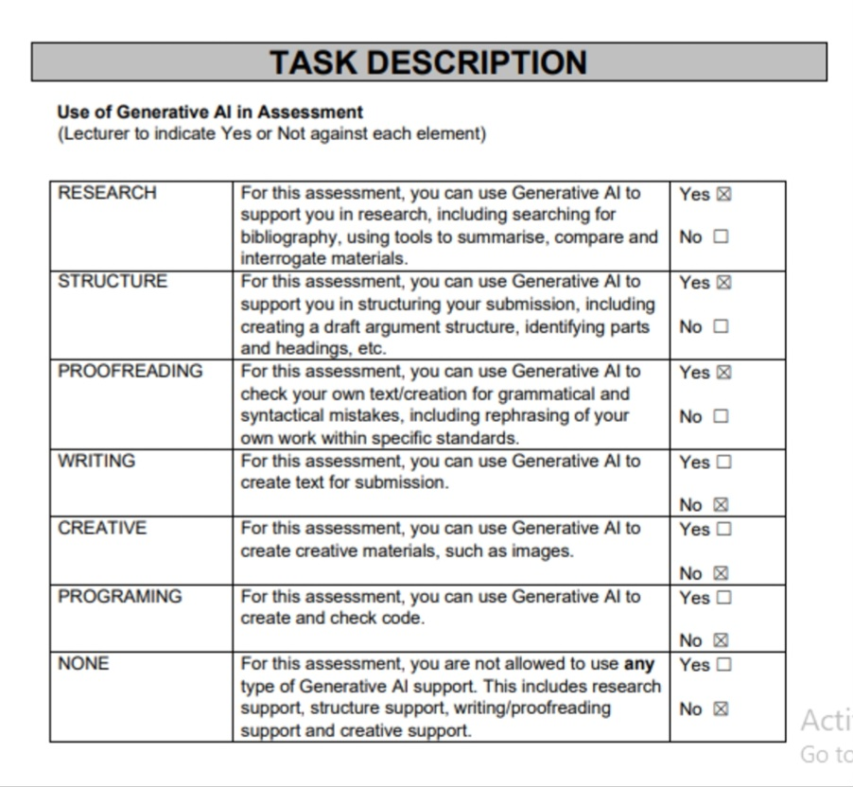

.

Reference
Slater, L., 2018. Pathways to building leadership capacity. Educational Management Administration & Leadership, 36(1), pp.55-69.
Daskalaki, E., 2018. Communication across cultures? An intercultural approach to customer service in the hotel industry: A study with globally branded hotels in the United Kingdom (Doctoral dissertation, University of Glasgow).
Tan, Y. and Despotis, D., 2021. Investigation of efficiency in the UK hotel industry: A network data envelopment analysis approach. International Journal of Contemporary Hospitality Management, 33(3), pp.1080-1104.
Vinod, B., 2022. Revenue management in the lodging industry: Origins to the last frontier. Springer Nature.
Vinod, B., 2018. Revenue Management in the Lodging Industry. Management for.
Murasiranwa, E.T., 2023. Service quality and business performance in branded UK budget hotels. Sheffield Hallam University (United Kingdom).
Slattery, P., Gamse, I. and Roper, A., 2021. The development of international hotel chains in Europe. In Handbook of hospitality strategic management (pp. 41-67). Routledge.
Mpofu, N., 2020. A37-Impact of Precarious Work on UK Hotel Employees' Well-being. In Research Student Conference Tuesday 16–Thursday 18 July 2024 (p. 159).
Vinod, B., 2022. Introduction to Hotel Revenue Management. In Revenue Management in the Lodging Industry: Origins to the Last Frontier (pp. 1-50). Cham: Springer International Publishing.
Tarrant, C., 2019. UK hotel industry—market restructuring and the need to respond to customer demands. Tourism Management, 10(3), pp.187-191.

