Sustainable Brand Extension Marketing Strategy for LUSH EcoRefill

STUDENT NAME: Shivans Bhimbha
STUDENT ID: 2514071

Table of Contents
Element 2: Segmentation, Targeting, Differentiation, and Positioning (STDP) Analysis 1
Introduction 1
Market Segmentation 1
Geographic Segmentation 1
Demographic Segmentation 2
Psychographic Segmentation 2
Behavioural Segmentation 2
Targeting Strategy 3
Differentiation Strategy 3
Positioning Strategy 3
Element 3: Marketing Mix (7Ps) 4
Introduction 4
Product 5
Price 5
Place 5
Promotion 6
People 6
Process 6
Physical Evidence 7
Conclusion 7
Element 4: Reflection 7
References: 10

Element 1: Poster Presentation

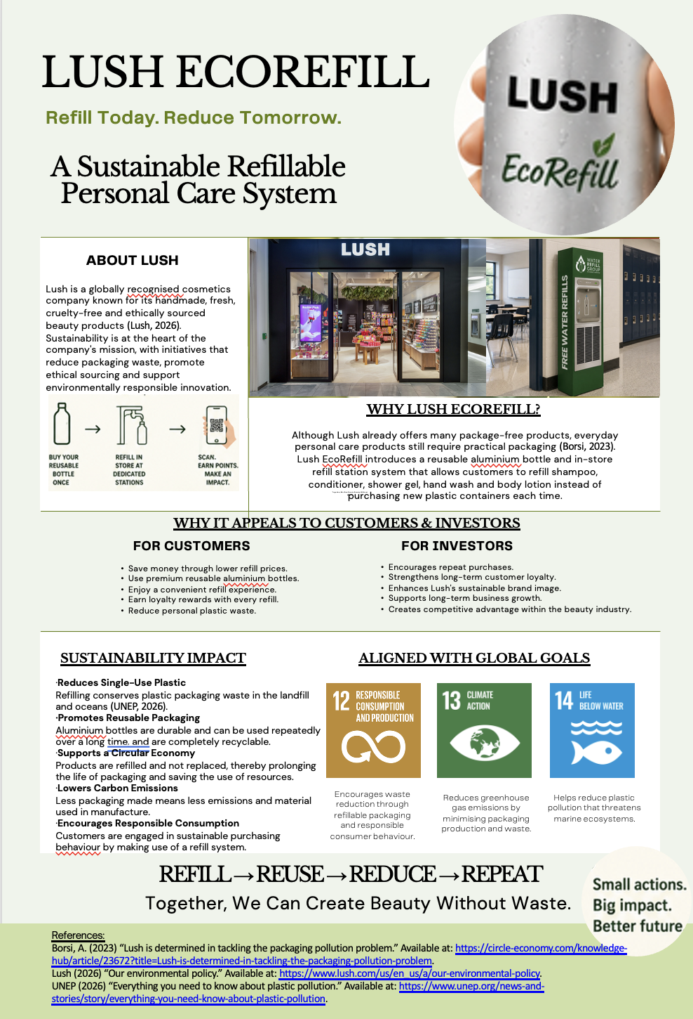

Element 2: Segmentation, Targeting, Differentiation, and Positioning (STDP) Analysis

Introduction
Segmentation, Targeting, Differentiation and Positioning (STDP) is a tool that can be used by organisations to find groups of customers that are attractive to them and form strategies that can provide them with a competitive advantage (Hanlon, 2024). LUSH EcoRefill's usage of STDP is vital for the product as it hinges on consumer values, purchasing habits and perceived value when applying it to personal care products. Hence this analysis aims to compare the most appropriate market segments and formulate an appropriate market positioning for the sustainable brand extension.
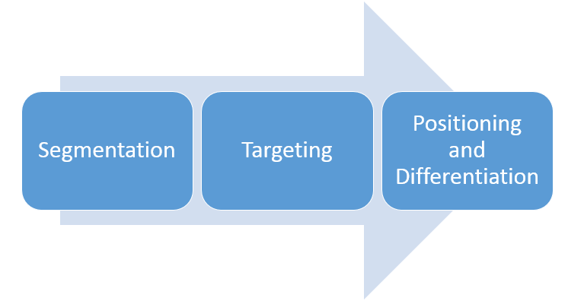
Figure 1: Marketing Segmentation

Market Segmentation
Using market segmentation, LUSH targets its resources to the consumers who will be most likely to purchase refillable personal care products, instead of the larger cosmetics industry.

Geographic Segmentation
LUSH EcoRefill should focus on cities and urban areas in the UK where LUSH has a proven presence, particularly London, Manchester, Birmingham and Bristol, where there is greater engagement with sustainable lifestyles in the city (Shahab and Webb, 2024). This strategy has significance because the convenience of accessing the physical location is important to participation in the refill systems. By targeting urban areas with high population densities, LUSH can also generate more refills and customer loyalty, allowing them to make improvements before branching to more remote areas (Tan, 2025).

Demographic Segmentation
Demographically, LUSH EcoRefill should aim to appeal to the 20-40-year-old Millennials and Generation Z age groups, mainly those living in urban settings and who are professionals and have an average and high disposable income. The segment is a mix of purchasing power and growing environmental consciousness, which is ideally positioned for high-quality sustainable personal care products (Veas-González et al., 2026). But, just the demographics are not enough to explain sustainable purchasing behavior (Fisher, Bashyal and Bachman, 2012). Hence, to know consumers who are most likely to be interested in refill systems and remain loyal, LUSH should incorporate demographic insights along with psychographic and behavioural aspects.

Psychographic Segmentation
The psychographic basis is the most important basis for targeting LUSH EcoRefill products, since the adoption of refills is largely related to consumer values and lifestyles (Allen et al., 2025). The brand should target those who pay attention to environmental responsibility and ethical sourcing, cruelty-free cosmetics and waste minimization (Theocharis and Tsekouropoulos, 2025). These consumers see the refills as a valuable part of their sustainable lifestyle, not just a way to save money. By aligning EcoRefill to these values, emotional brand attachment is bolstered, repeat purchases are driven and LUSH is maintained as a purpose driven cosmetics brand (Xue and Tian, 2025).

Behavioural Segmentation
By segmenting consumers based on their purchasing, brand loyalty, and willingness to adopt sustainable practices, LUSH can gain insight into their buying habits and preferences (Agarwal et al., 2025). The first category is made up of LUSH customers who have a habit of buying ethically-made cosmetics and are willing to try environmentally-friendly innovations. They know the brand, and this eases adoption risk and boosts the chance of repeat refills. These customers are encouraged to use refill stations in place of single-use packaging, which increases their lifetime value, builds long-term loyalty, and works towards LUSH's circular consumption goals (Coelho et al., 2020).

Targeting Strategy
LUSH EcoRefill needs to take a differentiated approach in targeting customers and focus on environmentally conscious Millennials and Generation Z consumers who are in the age range of 20-40 years and make frequent purchases of premium ethical personal care products (Filip et al., 2025). This segment is particularly appealing as it offers high purchasing power and high environmental awareness, which translates to its receptivity for product-refill systems that deliver product quality while minimizing plastic waste. A secondary target market will be the environmentally conscious families and working professionals looking for practical solutions to minimize household waste without sacrificing convenience (Nguyen et al., 2025). By targeting these customer segments, LUSH can ensure the maximization of customer lifetime value, improving repeat purchase rates and bolstering its sustainability-focused brand image (Sah, Hong and Huang, 2025). Thus, a differentiated targeting strategy is more likely to be effective in the long term than a mass marketing strategy, which is consistent with consumers' expectations and that of the company's ethical positioning.

Differentiation Strategy
While some cosmetics companies have developed refill programs, like The Body Shop or Faith in Nature, LUSH EcoRefill sets itself apart with a circular consumption model that incorporates refill stations with reusable aluminium bottles, handmade products, cruelty-free production and ethically sourced ingredients (Martins, Silva and Marto, 2025). LUSH is not just a sustainability initiative, but part of its overall brand purpose, allowing the refill experience to integrate with other sustainability efforts. Such an integrated approach will be more challenging for the competitors to copy, resulting in better customer loyalty and reaffirming the unique ethical brand image of the company (Canta Honores and Barcellos-Paula, 2024).

Positioning Strategy
LUSH EcoRefill needs to be viewed as a high-quality personalized care product, which can help consumers mitigate the use of plastic without sacrificing quality, values, or overall shopping experience. The value proposition goes beyond the environment and is a combination of convenience, product performance, and responsible consumption in a trusted brand (Laukkanen and Tura, 2022). This results in a consumer image of EcoRefill as an easily accessible contribution to the circular economy with LUSH handmade, cruelty-free cosmetics (Martins and Marto, 2023). The placement builds brand value and will help to enable LUSH to maintain its sustainability leadership and competitive advantage in the long term.

Element 3: Marketing Mix (7Ps)

Introduction
The marketing mix can be used as an approach to develop the LUSH EcoRefill concept into a viable product and program for the market, which is sustainable in the long run. The 7Ps model would be suitable for EcoRefill because they are a mix of high quality personal care products and refilling service in store, rather than the 4Ps. The following analysis critically reviews the effect of each marketing mix element on the value to the customer, sustainability and long term business growth.
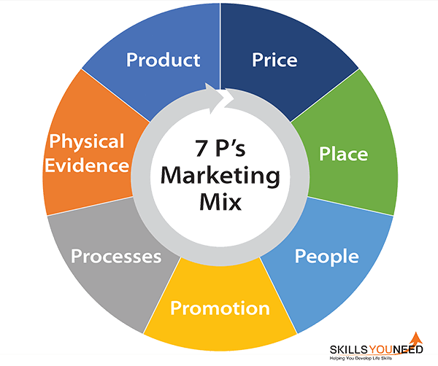
Figure 2: The 7 Ps of Marketing Mix

Product
LUSH EcoRefill's product strategy needs to reflect more than an eco-friendly refill, it needs to be a high quality personal care refill system. Both the product quality (shampoo, conditioner, shower gel, hand wash and body lotion) and the sustainable consumption (aluminium reusable bottles, dedicated in-store refill stations) are all adding value to the offering. This integrated solution aligns with the ethical approach of LUSH's brand, in line with the values already established, the method of production is cruelty free, formulations are handmade and ingredients are responsibly sourced (Figueiras, 2015). The reusable bottle is a long-term asset as opposed to a one-time-use package, going along with the concepts of the circular economy and eliminating single-use plastic containers (Kachook, 2022). Furthermore, the refill option encourages customers to return to the shop for more products, which increases the engagement and consequently raises customer lifetime value (Esmeli et al., 2026). LUSH EcoRefill products are environmentally friendly and of excellent quality; they feature a product that is difficult for competitors to duplicate and help to build brand equity and provide a competitive edge.

Price
The pricing of LUSH EcoRefill should be considered carefully to balance positioning and encourage repeat refillers. The first time a reusable aluminium bottle is used, it may cost more than the packaged bottle, however, the bot made reusable products should be cheaper than buying a new bottle containing packaged product. This is a cost-saving plan that encourages sustainable practices and reduces financial barriers to reordering (Tetteh, Osei-Kyei and Tam, 2025). Furthermore, customer loyalty programs that reward customers for making successive purchases could be used to promote loyalty and increase customer lifetime value. LUSH should not only differentiate on price, rather, it should differentiate on the value of premium quality, ethical production and environmental impact.

Place
The LUSH EcoRefill place strategy should involve both offline and online channels in order to make it convenient for the customer to refill. Users can find product information and store location online, and refilling in store remains to be refill stations (Defante et al., 2025). It enhances the ease of customer shopping experience, promotes re-entry to the store and allows for cross-selling of complementary products. LUSH stores also benefit from the availability of refill stations as a means to creating an efficient operation by using the existing retailing infrastructure. The place strategy, therefore, helps to impact commercial performance and sustainability by ensuring the refilling process is simple and smooth with a customer (Zhang et al., 2023).

Promotion
The rollout of LUSH EcoRefill should not only be about the products, but spreading education about the benefits of a refill system, including to the consumer and to the environment. Marketing communications need to convey that the system is convenient, cost-effective and environmentally friendly as refilling will effect behaviour change. By using integrated marketing communications – including social media marketing, influencing partner, email marketing, in-store demos, and user-generated content – LUSH can achieve this. Key components of sustainability storytelling are measurable plastic waste minimisation, highlighting the brand's ethical commitments and building consumer trust (Shruthi Priya and Sathish, 2026). Furthermore, customers who are frequently rewarded for their loyalty through loyalty programmes can be encouraged to stay loyal. Through educational and relationship-based promotion, LUSH reinforces the sustainable value proposition of EcoRefill and promotes long-term competitive advantage while building brand engagement.

People
The key to LUSH EcoRefill is the employee's ability to provide a uniform and interesting refill experience. Staff should therefore be given in-depth training about the refill process, about the product and its benefits for the environment to give accurate advice and promote customer involvement. Employees are not just salespeople; they are sustainability ambassadors, and educate customers and build trust in the brand. This service-oriented approach improves customer satisfaction, reaffirms LUSH's ethical outlook, fosters repeat customers, and places customers in a position of competitive advantage in the company's marketing plan.

Process
The process strategy should be simple, efficient, and convenient to promote long-term customer involvement in the EcoRefill system. As a first-time customer, you buy the reusable aluminium bottle, after which you can fill it with your favourite personal care products at special stations in the store (Hindsley and Morgan, 2026). The refill process is streamlined with a clear description, trained employees, and an embedded loyalty programme, which reduces customer effort and improves the overall shopping experience. This is because convenience is a strategic concern and consumers are likely to sustain their behaviours if they do not involve them in making much of an effort. In addition, the ability to gather refill purchase information allows LUSH to tailor promotions and enhance customer relationships by designing targeted marketing campaigns. Therefore, an efficient refill process can help to meet customer expectations, maintain customer interest in the product, and ensure the sustainability of the EcoRefill business model (Miao, Magnier and Mugge, 2023).

Physical Evidence
Physical evidence is essential to bolster the brand's sustainability commitments as they become part of the customer journey, from point of sale to in-store use (Anwar et al., 2025). There are dedicated refill stations, aluminium bottles to use again, sustainability labels and a more environmentally-friendly display in the store that are tangible proof of the brand's ethical values. These physical attributes help to diminish consumer scepticism when it comes to sustainability claims and improve perceptions of product quality and authenticity (Martínez et al., 2025). In developing an environment that always embodies its environmental commitment, LUSH builds customer trust, helps establish a brand identity and sets itself apart from the “personal care” products available to consumers.

Conclusion
The 7Ps marketing mix illustrates that LUSH EcoRefill is not just a sustainable product, but a business model. When they make every marketing decision based on the value the customer places on them and their commitment to sustainability, LUSH can reinforce their competitive advantage, build customer loyalty, and help them grow sustainably for long-term success.

Element 4: Reflection
Developing the LUSH EcoRefill brand extension was a great learning experience for me to help me understand that sustainability is not just a corporate social responsibility initiative, but also a strategic marketing initiative. In the early stages of this project, I considered sustainable marketing to be mainly concerned with the reduction of environmental impacts produced through the use of sustainable products. Yet, the idea of the LUSH EcoRefill reusable aluminium bottle and the refill system in stores proved that sustainability can also add value to the customer, boost brand equity, and help shape the future of the business. The STDP framework and the 7Ps marketing mix involved looking at consumer behaviour, market opportunities, and competitive positioning all at once rather than one concept at a time (CIM, 2025). The most difficult aspect was achieving sustainability goals while maintaining the viability of the business, since these sustainable efforts intended to provide benefits for the environment needed to provide convenience, profit, and satisfaction to the customers (Edith Ebele Agu et al., 2024). The challenge was to think strategically, and I was forced to back up each and every decision I made in marketing by applying academic theory and practical business concerns, instead of personal assumptions.
I extended my communication and presentation skills by creating and presenting a poster. Creating a single poster was an opportunity for me to explain some complex marketing concepts in a way that was concise, visually appealing, credible, and in a strategic way. It was more difficult than anticipated to prepare the information to include and exclude, as it needed to be analytical but not overwhelmingly complex visually. This experience gave them insight into the fact that it is not about how much information is being conveyed, but how effectively and logically they can convey the information to various target groups. It was also helpful to gain confidence in the presentation exercise to present my recommendations and answer questions within a time frame (Vogel and Viale, 2018). In a successful marketing presentation, these are the three critical factors—knowledge, preparation and audience interaction—that I saw.
In general, this assessment has contributed to my personal and professional growth in a positive manner, which has positively impacted my research, critical thinking, and strategic decision making skills. Independent research was used to evaluate the credibility of academic and industry sources and to be more practical in a real business environment with theoretical concepts. Comparing the marketing strategies also highlighted the need to make decisions based on the facts, as the marketing strategies have to cater to the changing consumer expectations, competition and sustainability issues (Nadeem, Ashraf and Kumar, 2025). In the future, I would like to be more comfortable in answering difficult questions and giving recommendations within a time frame. I will also aim to expand my knowledge of sustainable marketing, consumer behaviour and new trends within digital marketing through accessing and utilising the most up-to-date academic research and industry practice. The improvements will enable me to develop new and innovative and evidence based market strategies and to be a part of the decision making process for my organisation and its growth and sustainability.

References:
Agarwal, S. et al. (2025) “Redefining marketing strategies through sustainability: Influencing consumer behavior in the circular economy: A systematic review and future research roadmap,” Cleaner and Responsible Consumption, 18, p. 100298. Available at: https://www.sciencedirect.com/science/article/pii/S266678432500049X?via%3Dihub.
Allen, W. et al. (2025) “The Role of Demographics and Psychographics in Shaping Green Consumer Behavior.” Available at: https://www.researchgate.net/publication/395994701_The_Role_of_Demographics_and_Psychographics_in_Shaping_Green_Consumer_Behavior.
Anwar, R.S. et al. (2025) “Customer engagement, innovation, and sustainable consumption: Analyzing personalized, innovative, sustainable phygital products,” Journal of Innovation & Knowledge, 10(1), p. 100642. Available at: https://www.sciencedirect.com/science/article/pii/S2444569X24001811?via%3Dihub.
Canta Honores, J.L. and Barcellos-Paula, L. (2024) “Mediation of brand reputation and image in the relationship between perceived corporate social responsibility and brand equity and loyalty of technology companies among Generation Z: the moderating role of gender,” Cogent Business & Management, 11(1). Available at: https://www.tandfonline.com/doi/full/10.1080/23311975.2024.2424484.
CIM (2025) “The 7Ps of marketing.” Available at: https://www.cim.co.uk/content-insights/articles/the-7ps-of-marketing/.
Coelho, P.M. et al. (2020) “Sustainability of reusable packaging–Current situation and trends,” Resources, Conservation & Recycling: X, 6, p. 100037. Available at: https://www.sciencedirect.com/science/article/pii/S2590289X20300086?via%3Dihub.
Defante, D. et al. (2025) “Adoption of In-Store Refill Systems and Its Impact on Consumer Purchase Intention for Personal Care Products.” Available at: https://papers.ssrn.com/sol3/papers.cfm?abstract_id=5913463.
Edith Ebele Agu et al. (2024) “Exploring the relationship between sustainable business practices and increased brand loyalty,” International Journal of Management & Entrepreneurship Research, 6(8), pp. 2463–2475. Available at: https://www.researchgate.net/publication/382856036_Exploring_the_relationship_between_sustainable_business_practices_and_increased_brand_loyalty.
Esmeli, R. et al. (2026) “Understanding customer loyalty-aware recommender systems in E-commerce: an analytical perspective,” Electronic Commerce Research, 26(2), pp. 1581–1607. Available at: https://link.springer.com/article/10.1007/s10660-025-09954-6#citeas.
Figueiras, S. (2015) “Top 10 Reasons LUSH Fresh Handmade Cosmetics is a Great Green Brand.” Available at: https://www.greenqueen.com.hk/green-queen-living-top-10-reasons-lush-beauty-great-green-brand/.
Filip, A. et al. (2025) “Drivers of Purchase Intentions of Generation Z on Eco-Products,” Sustainability, 17(2), p. 629. Available at: https://www.mdpi.com/2071-1050/17/2/629.
Fisher, C., Bashyal, S. and Bachman, B. (2012) “Demographic impacts on environmentally friendly purchase behaviors,” Journal of Targeting, Measurement and Analysis for Marketing, 20(3–4), pp. 172–184. Available at: https://link.springer.com/article/10.1057/jt.2012.13#citeas.
Hanlon, A. (2024) “The segmentation, targeting, positioning (STP) marketing model.” Available at: https://www.smartinsights.com/digital-marketing-strategy/customer-segmentation-targeting/segmentation-targeting-and-positioning/.
Hindsley, P. and Morgan, O.A. (2026) “Consumer preferences and willingness to pay for the attributes of recyclable aluminum bottled water,” Environmental Development, 58, p. 101444. Available at: https://www.sciencedirect.com/science/article/pii/S2211464526000163?via%3Dihub.
Kachook, O. (2022) “Guidance for Reusable Packaging.” Available at: https://sustainablepackaging.org/wp-content/uploads/2022/04/Guidance-for-Reusable-Packaging.pdf.
Laukkanen, M. and Tura, N. (2022) “Sustainable value propositions and customer perceived value: Clothing library case,” Journal of Cleaner Production, 378, p. 134321. Available at: https://www.sciencedirect.com/science/article/pii/S0959652622038938?via%3Dihub.
Martínez, E.D. et al. (2025) “Genuine sustainability VS. Greenwashing: Consumer responses to environmental practices and biodegradable material in Colombian service firms,” Cleaner Environmental Systems, 19, p. 100375. Available at: https://www.sciencedirect.com/science/article/pii/S2666789425001217?via%3Dihub.
Martins, A.M. and Marto, J.M. (2023) “A sustainable life cycle for cosmetics: From design and development to post-use phase,” Sustainable Chemistry and Pharmacy, 35, p. 101178. Available at: https://www.sciencedirect.com/science/article/pii/S2352554123002127?via%3Dihub.
Martins, A.M., Silva, A.T. and Marto, J.M. (2025) “Advancing Cosmetic Sustainability: Upcycling for a Circular Product Life Cycle,” Sustainability, 17(13), p. 5738. Available at: https://www.mdpi.com/2071-1050/17/13/5738.
Miao, X., Magnier, L. and Mugge, R. (2023) “Switching to reuse? An exploration of consumers’ perceptions and behaviour towards reusable packaging systems,” Resources, Conservation and Recycling, 193, p. 106972. Available at: https://www.sciencedirect.com/science/article/pii/S0921344923001088?via%3Dihub.
Nadeem, W., Ashraf, A.R. and Kumar, V. (2025) “Fostering consumer engagement with sustainability marketing using augmented reality (SMART): A climate change response,” Journal of Business Research, 192, p. 115289. Available at: https://www.sciencedirect.com/science/article/pii/S0148296325001122?via%3Dihub.
Nguyen, T.T.T. et al. (2025) “Sustainable food consumption: Sustainability-conscious consumers do not reduce food waste but nutrition-conscious consumers do,” Resources, Conservation and Recycling, 219, p. 108296. Available at: https://www.sciencedirect.com/science/article/pii/S0921344925001752?via%3Dihub.
Sah, A.K., Hong, Y.-M. and Huang, K.-C. (2025) “Enhancing Brand Value Through Circular Economy Service Quality: The Mediating Roles of Customer Satisfaction, Brand Image, and Customer Loyalty,” Sustainability, 17(3), p. 1332. Available at: https://www.mdpi.com/2071-1050/17/3/1332.
Shahab, S. and Webb, B. (2024) “How are the UK Core Cities responding to retail-related challenges in city centres?,” Local Economy: The Journal of the Local Economy Policy Unit, 38(7), pp. 650–671. Available at: https://journals.sagepub.com/doi/10.1177/02690942241258138.
Shruthi Priya, G. and Sathish, A.S. (2026) “Exploring the impact of green brand storytelling on Indian consumers’ purchase intentions with the mediating roles of self-brand connection and brand trust,” Discover Sustainability, 7(1), p. 480. Available at: https://link.springer.com/article/10.1007/s43621-026-02681-4#citeas.
Tan, K.H. (2025) “International Marketing Strategy for Lush Ltd. in India.” Available at: https://www.researchgate.net/publication/391662254_International_Marketing_Strategy_for_Lush_Ltd_in_India.
Tetteh, P.A., Osei-Kyei, R. and Tam, V.W.Y. (2025) “Strategies for sustainable financing of circular infrastructure projects – a systematic review,” Construction Innovation, 25(7), pp. 235–267. Available at: https://www.emerald.com/ci/article/25/7/235/1267088/Strategies-for-sustainable-financing-of-circular.
Theocharis, D. and Tsekouropoulos, G. (2025) “Sustainable Consumption and Branding for Gen Z: How Brand Dimensions Influence Consumer Behavior and Adoption of Newly Launched Technological Products,” Sustainability, 17(9), p. 4124. Available at: https://www.mdpi.com/2071-1050/17/9/4124.
Veas-González, I. et al. (2026) “Determinant factors that influence purchase intentions for skin products with sustainable packaging,” Acta Psychologica, 266, p. 106759. Available at: https://www.sciencedirect.com/science/article/pii/S0001691826005603?via%3Dihub.
Vogel, W.H. and Viale, P.H. (2018) “Presenting With Confidence.” Available at: https://pmc.ncbi.nlm.nih.gov/articles/PMC6505544/.
Xue, X. and Tian, P. (2025) “Beyond ESG: Unpacking Brand Loyalty Through the Emotional Mechanisms Lenses of Attachment and Love—A Hierarchical Regression Study of Alibaba in China,” International Journal of Economic Sciences, 14(1), pp. 259–273. Available at: https://ijes-journal.org/journal/article/view/195/183.
Zhang, D. et al. (2023) “Strategies and practices to reduce the ecological impact of product returns: An environmental sustainability framework for multichannel retail,” Business Strategy and the Environment, 32(7), pp. 4636–4661. Available at: https://onlinelibrary.wiley.com/doi/10.1002/bse.3385.

