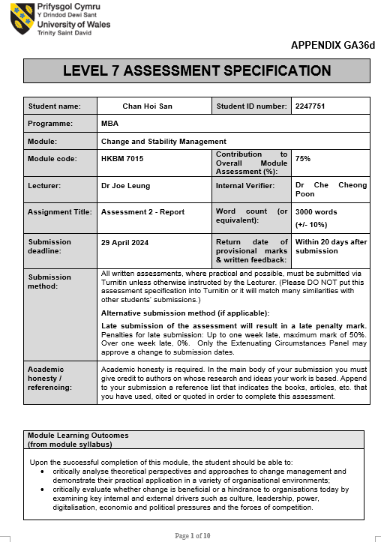



Change and Stability Management

Assignment Two: Analytical Report
“New Page for Tsui Wah” Proposal

Student Name | ： | Chan Hoi San
Student ID Number | ： | 2247751
Date of Submission | ： | 29 April 2024
Lecturer | ： | Dr. Joe Leung

Table of Content
 |  | Page
 | Introduction | 3
 | Background | 3
 | Force Field Analysis for the Organization Change | 5
 | Change Model Applying for Tsui Wah Situation | 6
 | New Page for Tsui Wah: Scheule for Unfreeze stage | 6
 | New Page for Tsui Wah: Scheule for Change stage | 8
 | New Page for Tsui Wah: Scheule for Freeze stage | 9
 | Right Leadership to Leading a Successful Change | 11
 | Managing the Resistance During the Change Process | 12
 | Conclusion and Recommendations | 13
References |  | 14

Introduction
The direction of this paper is to propose a change initiative – “New Page for Tsui Wah”, to conquer the downward movement of Tsui Wau in its sales amount since 2019. After the force field analysis, change may be the only way to conquer this ever-changing environment. After that, the environmental factors affecting the change will be studied, and recommendations will be made afterwards. The leadership style will be suggested for implementing a successful change and managing the resistance during the change process in the later part. To visualize the future picture of Tsui Wah after implementing the change, “New Page for Tsui Wah” will be assigned as the name of this one-year proposal.
Background
Founded in 1967, Tsui Wah Restaurant is one of the significant restaurants in Hong Kong. In its peak period, 2019, it employed 4227 staff to operate its business in Hong Kong, the Mainland, Macau, and Singapore. However, in recent years, due to the social incidents in 2019, the spread of COVID-19 from the end of 2019 to 2022, and new customer purchasing habits after the post-pandemic in 2023, Tsui Wah's profit has been seriously affected consecutively. Refer to Table 1, regarding the key financial figures, including Sales, Cost of Goods Sold, Net income after tax, inventory and cash; all recorded a closely straight downward movement from 2019 to 2023, about a 50% drop for the above areas. Furthermore, studying the sales per staff and restaurant, it appeared that the earning power of each restaurant decreased from HK$21,527,000 in 2019 to HK$9,947,000 in 2023. The earning power of each staff was also recorded to decrease from HK422,000 in 2019 to HK$306,000 in 2023. Based on the above financial figures, it can be assumed that Tsui Wah's business was reduced in size.

Table 1: Past Five Year’s Financial Situation
HK$’000 | 2019  (Tsui Wah, 2019) | 2020  (Tsui Wah, 2020) | 2021  (Tsui Wah, 2021) | 2022  (Tsui Wah, 2022) | 2023  (Tsui Wah, 2023)
Sales | $1,786,756 | $1,381,479 | $900,982* | $985,338* | $785,797*
Cost of Goods Sold | $497,497 | $402,376 | $285,362 | $282,116 | $230,825
Net Income after Tax | $4,709 | -$319,724 | -$126,994 | -$124,049 | $55,880
Inventory | $19,431 | $18,197 | $18,053 | $14,010 | $8,695
Cash | $424,480 | $237,392 | $167,198 | $103,261 | $186,395
Number of Restaurants | 83 | 83 | 79 | 85 | 79
Number of Staff | 4,227 | 3,039 | 2,953 | 2,448 | 2,565
Sales per Restaurant (HK$’000) | $21,527 | $16,644 | $11,405 | $11,592 | $9,947
Sales per Staff  (HK$’000) | $422 | $454 | $305 | $403 | $306
*Deducting the subsidies from the Employment Support Scheme
2021: HK$55,400,000
2022: HK$7,987,000
2023: HK$20,600,000
Source: Created by the Author
Referring to the Business Analysis from the 2023 Annual Report, Tsui Wah internally (Tsui Wah, 2023) also reviewed the current situation they faced, which may have caused them to remain in this difficult situation in 2023. Although the social distance policy was released in 2023, there is still a long way to go to restore the business environment before the pandemic. The main focus is to enhance the quality of service provided by the frontline staff and customer satisfaction with the food quality. Therefore, Tsui Wah definitely has its own direction for improving the business revenue. However, to strengthen the mindset of change for Tsui Wah, this proposal will comprehensively discuss the framework for implementing the change and how to manage the difficulties during the process.
Force Field Analysis for the Organization Change
To gain the recognition of the major colleagues in the change process, a significant analysis should be prepared for persuasion. Force Field Analysis, designed by Kurt Lewin, is one of the influential tools for studying the dynamic between the driving force and the restraining force when implementing a change in an organisation (Kurt, 1943). To adapt this model to Tsui Wah’s situation, the ultimate goal for the change should be clearly explained. Referring to the 2023 Tsui Wah Annual Report, it clearly mentioned that service quality and food quality should be the priorities to be enhanced in the future. Based on this goal, the driving force and the restraining force can be shown in diagram 1 below:
Diagram 1: Force Field Analysis for Tsui Wah
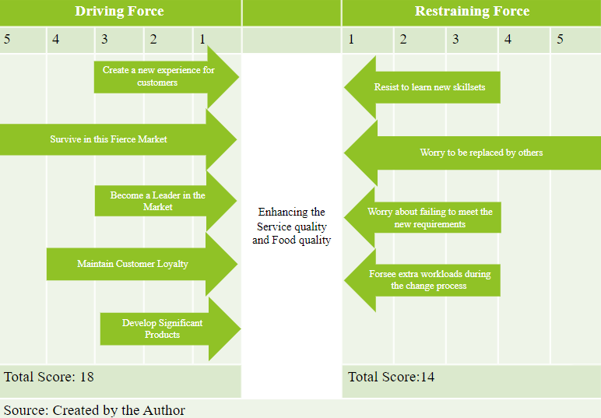
After listing out the possible driving force and the restraining force, the score of the driving force, 18, is higher than the restraining force, 14. How to Survive in this Fierce Market obtained the highest score, 5. The second highest score is maintaining customer loyalty. Both are responding to the Goal of change, enhancing the service and food quality. The other factors are creating a new experience for customers, becoming a leader in the market and developing significant products. Their purpose finally also addresses the issue of how to survive in this market. There is no doubt that change is the only way to improve the current situation. It is likely to build momentum for change.
However, the restraining forces can’t be neglected in change management. Almost all the restraining forces are coming to the worry of staff; for example, the highest one is worrying about being replaced by others, 5. The others are resisting learning new skills, failing to meet new requirements and having an extra workload during the process. The success of change depends on the participation of colleagues. Therefore, the change can be implemented without hearing the voices of colleagues. In the later part of this proposal, suggestions will be made to address colleagues' concerns.
Change Model Applying for Tsui Wah Situation
The 3-step change management model created by Kurt Lewin is one of the most commonly used change models in business settings (Kurt, 1947). The simple structure, including only the stages of unfreeze, change and freeze, and clear classifications of each step are its advantages compared to another change model. Therefore, it is widely used in business settings with single business and limited resources invested in the change process (Cummings, Bridgman & Brown, 2016). Also, the measurement of this model is relatively easy to follow. Due to the said advantages, this 3-step-change management model is recommended for Tsui Wah, which is a sole business in catering services. The change implementation plan will be explained below:
Stage of Unfreeze: The purpose of this stage is to ensure the purpose, readiness and commitment of colleagues to be involved in the change process. The following initiatives will be recommended;
- Chat with Management Team: It is necessary for management to ascertain the needs for changes with colleagues. A transparent communication platform should be arranged to reduce the worry of colleagues during and even after the change. The purpose of change should be clearly communicated to colleagues, who aim to survive in this fierce industry. So, the service quality and the food quality are waiting to be enhanced in the change process. Colleagues should participate in the process. They will not be rejected outside the door
- Slogan Creation Competition: To engage colleagues in the change process, their recognition is very vital because they are the drivers for every step. Slogan creation competitions can gain colleagues’ attention and reflect their expectations through slogans including “New Products, New Service” elements. Colleagues will be not only followers but also initiators in the change process.
- Vision Sharing session: To share common goals with all colleagues, management should share the vision for the future, which is to increase profit. Cutting costs is not the hidden agenda for the change's implementation. This action may help secure the stability of colleagues.
New Page for Tsui Wah: Scheule for Unfreeze stage
Time | Initiatives | Contents
May to June 2024 | Chat with the Management Team | The management team can visit the restaurants monthly to understand their current situation and promote how change can create another new page for Tsui Wah
June to July 2024 | Slogan Creation Competition | The competition should involve all colleagues to participate in. Three prizes, including champion, first-running up and second-running up can be selected during the competition. The selected slogan will be published in this project.
July 2024 | Vision Sharing Session | After selecting the slogan, Tsui Wah rides on this positive atmosphere. The management can share the whole framework, including the change of business strategies, training programmes, operational adjustment and indicators with all colleagues.

Stage of Change: The purpose of this stage is to implement the initiatives that match the goals agreed in the freeze stage. Enhancing the service quality and food quality is the ultimate goal, which can help Tsui Wah to survive in the market. Therefore, the below initiatives are suggested to respond to the above purpose.
- Reformation of the quality management team: To improve the service and food quality of Tsui Wah, the quality management team should be reformed to develop quality procedures and service standards to ensure the service is within the standards agreed upon. Also, the functions of the quality management team should monitor the daily operation of restaurants. Recommendations should be made after all investigations. Both internal assessor and secret customer schemes are proposed.
- One Significant Food from One Restaurant: This initiative can be arranged as a competition for every restaurant to promote the significance of products covering to the customer’s heart. Colleagues, especially cooks, should be highly involved in the initiative. The public vote can be the indicator of selecting a significant product for Tsui Wah and promoting it in corporate communication channels afterwards.
- Monthly Sale Growth Competition: Referring to the sale amount in 2023, HK$ 785,797 after deducting the employment support scheme. It decreased by about 50 % compared to the 2019 one, which was HK$1,786,756. The future target can be set for the coming year, for example, a 30% increase of sale for each restaurant compared to 2023. The finished restaurant can reward a certain amount of incentives from the profit, for example, 5 % of the net income. It can motivate them to fight for more of themselves and their company.
- Customer Feedback Mechanism on Service Quality: Customer feedback should be an important indicator to drive us in the right direction. Customer Mailbox can be established in every restaurant to collect feedback from customers. The quality management team should always check the message from it. Secret Customer can be another way to monitor each restaurant’s service quality.

New Page for Tsui Wah: Scheule for Change stage
Time | Initiatives | Contents
July 2024 | Reformation of the quality management team | The commitment should be formed by different positions, including frontline staff, supervisor and management staff. The voice can be more diverse about ensuring the quality provided at different levels.
September to October 2024 | One Significant Food from One Restaurant  Criteria:  - Different Country's styles  - Tasting  - Selling Points | Each restaurant can send a team to participate in this competition. It is valuable to develop a significant food ourselves, and it is also a cost-effective method of promoting Tsui Wah.
September to October 2024 | Monthly Sale Growth Competition | “Contribute more, Reward more” can be a slogan to engage colleagues in this change process. A tangible reward is one concrete recognition for colleagues involved in this process.
October 2024 | Customer Feedback Mechanism on Service Quality | This mechanism can help Tsui Wah to receive true feedback from customers. The one who provides constructive feedback may receive a coupon.

Stage of Freeze: This stage aims to sustain advantages after implementing the change. A celebration can be arranged to recognise a colleague’s effort in implementing the change. Of course, the initiatives with less effect should be reviewed, and adjustments should be made if necessary.
- Celebration Event: It is very important to share success with colleagues. Their contribution and effort should be appreciated by the management. Serval awards can be presented to the most committed colleague, team or department. Meanwhile, this is also an opportunity to reinforce the need for change, which is a correct action,
- Milestone Meeting: Not all change initiatives can be reformed successfully shortly. Regular updates are necessary to comfort the hearts of colleagues. The management can also share their feedback to the result of the change process. It can create a transparent atmosphere between colleagues and the management.
- Integration Process: All change initiatives are project-based tasks. It is important to embed them into daily operations, for example, how the marketing team turns the selected product of significant product competition into profit.
- Media Promotion: This initiative is to change the mindsets of customers to Tsui Wah, which rebuilds their confidence in Tsui Wah. Through media promotion, such as Facebook and Instagram, we can promote the “Chaa Cha Teng” culture to the new generation to expand to other generations, not just the mature-age group.
New Page for Tsui Wah: Scheule for Freeze stage
Time | Initiatives | Contents
Oct 2024 to Jan 2025 | Celebration Event | This event can be arranged at the finish stage of “New Page for Tsui Wah”. The purpose is to appreciate contributions paid by colleagues and the enhancement of the company.
Nov 2024 to Mar 2025 | Milestone Meeting | This meeting can be arranged quarterly. The management should share the progress and update the latest decisions of the management. Answering colleague’s questions is also necessary.
Mar 2025 to Apr 2025 | Integration Process | The change management team and the operation management team should consider how to implement change initiatives into the operation system.
Jan 2025 to Apr 2025 | Media Promotion | We may invite some young pop KOLs or artists, such as young singer from TVB, to promote Tsui Wah’s image of the change process.
The above suggestions should already cover the critical areas during the change process. However, to implement the plan effectively, leadership is highly affected by the result of the change movement. In the next stage, leadership style will be discussed to implement the plan while winning the heats of colleagues effectively.
Right Leadership to Leading a Successful Change
The right plan, with the right leadership, will accelerate the change movement’s effectiveness. Therefore, the management should deliberate on the leadership style during the change cycle because strong resistance may appear among colleagues. The management should always balance the voice between them and their colleagues. Therefore, to lead the change movement smoothly, the advantages of transformational leadership may be suitable for the Tsui Wah Style. The leader, in order to lead a change in an uncertain environment, should be able to motivate colleagues in different situations, including a smooth or difficult situation (Burn, 1978). The behaviours below are suggested for Tsui Wah’s management during the change process;
- Visiting Restaurant Monthly: The management should not wait for feedback passively. They should visit the restaurant frequently, for example, once per month, to listen to the voices of frontline staff (Sahay, 2023).
- Establishing Management Mail Box: Management should respond to colleagues immediately to eliminate negative emotions. This can create a colleague-first image in Tsui Wah.
- Lunch Sharing Session: Encouragement is a good motivator. Management should always find solutions for every problem and share their experience in every problem, not just query causes that lead to a problem.
- Be patient to unexpected situations: sometimes, the schedule may fall behind the plan. A transformative leader should understand the reason and make adjustments accurately.
- Accept all accident errors created by colleagues: Errors may also happen until the successful changes. Inclusiveness should be embedded in the leader’s heart.
Besides highlighting the importance of leadership, the next step for the leader is to consider how to lead the change in Tsui Wah, which should always be communicated with colleagues (Julie & Roger, 2011).
- Vision: During the unfreeze stage, the vision for change – Enhancing the service and food quality should always be reminded in different occasions. The purpose is to reinforce the readiness of change for every colleague. Team Building event can be a good opportunity to share the vision of change to colleagues.
- Purpose: The purpose of change should also be conveyed to colleagues clearly. The purpose is more down-to-earth, which is to survive in the market. If we fail to implement the change, all colleagues will lose their jobs immediately. Of course, Tsui Wah may be eliminated in the market. Through the above implementation plan, almost all colleagues should accept the purpose of change.
- Share value: Enhancing the service and food quality is the share value of this change movement. Through different communication channels, for example, posters posted in restaurants, to influence the mindsets of colleagues.
- Strategy: A clear strategy, Kurt Lewin’s 3 step of change mentioned above, is necessary. We should always monitor the effectiveness and modify if proper. Quarterly Review meetings can be formed to collect the voices of colleagues.
- Empowerment: Delegation is a practical way to involve colleagues in the decision-making process (Erstad,1997). Therefore, the quality management commitment team mentioned above should include different positions and colleagues.
- Engagement: Sufficient communication channels motivate colleagues in the change movement (Sonenshein & Dholakia, 2012).The Quality Management Team should always invite colleagues to participate in their meetings regularly to obtain feedback immediately through Email and cooperate communication channels.
Managing the Resistance During the Change Process
Although the strategy is prepared, we also estimate the resistance of the remaining colleagues. Referring to the force field analysis, the four restraining factors mentioned above can’t be neglected. We need to dwindle the spread of worry to other colleagues. Colleagues sometimes misunderstand and ignore the implications of change for their individual commitments to the company (Strebel,1996).
- Resist learning new things: A buffer period will be provided for them to understand the new initiatives and reduce their resistance to them. Job re-arrangement may be proposed if colleagues have tried their best but fail to follow the trend.
- Worry about being replaced by others: Training opportunities should be arranged for the new skillsets, for example, new cooking methods with different cultural styles. Sometimes, coaching and mentoring may be provided to colleagues who appear to be learning slowly.
- Worry about failing to meet the new requirements: The management's attitude is critical in this point. If the management can show their support and caring to the underperformer, they may be willing to try again and listen to your suggestions.
- Forsee the extra workload during the change process: Colleagues may be concerned about the extra workload adding on top of the current workload. They fail to balance their importance in time management and serving different supervisors. Conflict may appear in triangular relationships. Therefore, the work allocation should be stated clearly before starting new job duties. The management should endorse the proposed management. Sometimes, compensation events may be arranged to comfort the anxiety of colleagues.
Conclusion and Recommendations
“New Page for Tsui Wah” is not a 1-day project. The implementation preparation should be deliberate before acting out. “New Page for Tsui Wah” is a one-day project which includes all colleagues to motivate the change action for Tsui Wah. The difficulties may appear more than successful cases this year. Therefore, the company's change readiness should be communicated precisely during the unfreeze stage. If not, the period of unfreeze stage may be extended to match the colleague's pace. Here are some recommendations for promoting “New Page for Tsui Wah” positively.
- Training and Promotion: To diversify the styles of food and enhance the food quality, the company may consider sponsoring colleagues for external cooking classes, such as Eastern European and Russian Styles, to upskill their skills to suit future strategies. The company may consider developing a standard for colleagues to follow for service quality improvement.
- Support and Caring: The Human Resources Department (HR) may arrange some talks to debrief the management decision positively. If the colleagues fail to meet requirements, HK has arranged an improvement plan to catch up with the pace of change.
- Frontline participation for the Management: The active frontline participation of the management may motivate colleagues' emotions in the process (Klein,1996). They can find one day to work with colleagues in the restaurant. The purpose is to experience the difficulties of colleagues in daily operations. Colleagues may appreciate that the leader is walk-the-talk.
Through the above suggestion, the “New Page of Tsui Wah” may assist Tsui Wah Restaurant in achieving another milestone in the market.

References
Burn. J.M. (1978). Leadership. New York: Harper and Row
Erstad, M. (1997). Empowerment and Organizational Change. International Journal of Contemporary Hospitality Management, 9(7), 325-333.
Julie Hodger and Roger Gill (2011). Sustaining Change in Orginaisation, SAGE Publications.
Kurt. L (1943). ‘Defining the Field at a given Time’. Psychological Review. 50(3):292-310.
Kurt. L (1947). Field Theory in Social Science, New York:Harper & Row
Klein, S. M. (1996). ‘A management communication strategy for change’. Journal of organizational change management, 9(2), 32-46.
Sonenshein, S., & Dholakia, U. (2012). ‘Explaining employee engagement with strategic change implementation: A meaning-making approach’. Organization Science, 23(1), 1-23.
Strebel, P. (1996). ‘Why do employees resist change?’. Harvard business review, 74(3), 86.
Cummings, S., Bridgman, T., & Brown, K. G. (2016). ‘Unfreezing change as three steps: Rethinking Kurt Lewin’s legacy for change management’. Human relations, 69(1), 33-60.
Tsui Wah Holding Limited (2019). Annual Report (2019). Available at :https://www.tsuiwah.com/wp-content/uploads/2019/07/EW01314-AR.pdf (Accessed 5th April 2024)
Tsui Wah Holding Limited (2020). Annual Report (2019). Available at: https://www.tsuiwah.com/wp-content/uploads/2020/09/EW01314-ESG.pdf (Accessed 5th April 2024)
Tsui Wah Holding Limited (2021). Annual Report (2021). Available at: https://www.tsuiwah.com/wp-content/uploads/2021/07/E_Annual-report.pdf (Accessed 5th April 2024)
Tsui Wah Holding Limited (2022). Annual Report (2022). Available at: https://www.tsuiwah.com/wp-content/uploads/2022/07/2022070500863_e.pdf (Accessed 5th April 2024)
Tsui Wah Holding Limited (2022). Annual Report (2023). Available at: https://www.tsuiwah.com/wp-content/uploads/2023/07/2023072001087_e.pdf (Accessed 5th April 2024)
Sahay, S. (2023). Organizational listening during organizational change: Perspectives of employees and executives. International Journal of Listening, 37(1), 12-25.

