

BMIH5007
Financial Management for the Hotel
Industry
Assessment 1

Student name: Diana Vukov
Student Id: 2234549
Lecturer: Ernest Wavei

Table of Contents
Introduction ................................................................................................................................ 3
- Total Revenue Analysis: Shangri-La Hotels vs. Travelodge Hotels ...................................... 4
Shangri-La Hotels .................................................................................................................. 4
Travelodge Hotels .................................................................................................................. 5
- Market Position Analysis: Shangri-La Hotels vs. Travelodge Hotels.................................... 6
Shangri-La Hotels .................................................................................................................. 6
Travelodge Hotels .................................................................................................................. 7
Customer Demographics ........................................................................................................ 8
Brand Perception .................................................................................................................... 8
- Assessment of Growth Potential: Shangri-La Hotels vs. Travelodge Hotels......................... 9
Shangri-La Hotels .................................................................................................................. 9
Travelodge Hotels .................................................................................................................. 9
Potential Barriers to Growth ................................................................................................ 10
- Financial Commitment to CSR (Corporate Social Responsibility) ..................................... 10
Recommendations .................................................................................................................... 12
Conclusion ............................................................................................................................... 13
References ................................................................................................................................ 14
Table of Figures
Figure 1: Shangri-La hotels ....................................................................................................... 6
Figure 2: Travelodge Hotels....................................................................................................... 7

Introduction
The hospitality industry is a dynamic and, ever-changing, competitive sector whereby hospitality service providers, all unable some form of services, meet the traveller's needs by destination. In this report, we will conduct a thorough examination and comparison of two prominent entities in the hospitality industry: Two very different hotel brands: Shangri-La Hotels and Travelodge Hotels. The main goal of our study is a critical evaluation of the financial management strategies and activities which will help to provide us with assessments of the firms´ performance and sustainability.

1. Total Revenue Analysis: Shangri-La Hotels vs. Travelodge Hotels

Shangri-La Hotels
Shangri-La posted total revenue of USD 2,141.8 million last year on December 31, 2023, an important increase compared to the sum of USD 1,462.1 million it got in 2022 (Shangri-La Group 2024). At Shangri-La hotels, core resources of revenue are comprised of room bookings, food and beverage and other services which include event hosting and spas among others (Bilgihan and Ricci, 2024). Further to that, collaborations include popular chefs to tap into the modern market. Moreover, the integrated taxi services put in the guests for revenue growth.

Revenue Trends and Factors Driving Growth

Luxury Positioning
Shangri-La Hotels' product characterises luxury accommodation and professional services that puts the group in a different category from others, which in return makes them strive for the top price, attracting high-end clients who are willing to pay the luxury price (Jia, 2017). Such careful top-level point also characterises increases in revenue in good seasons and particularly in high-demand markets.

Diversified Revenue Streams
Besides the direct bookings of the rooms, Shangri-La Hotels boasts of various other revenue streams like food and beverage services, spa treatments, and event hosting for a variety of client groups. This diversification allows for reduced dependence on room revenues and improvement of total revenue robustness. Create an engaging and clear call to action that invites the viewer to take specific action in support of your cause.

Market Expansion
Facilitated by the strategic inroad into the fast-developing emerging markets Shangri-La Hotels can benefit from a new revenue channel and increase their customer shares. The company, which serves to inform travellers about high-quality experiences, can keep on living in its mind an illusion of prestige and at the same time adapt to new ways of travelling, thus, boosting its revenue.

Travelodge Hotels
Travelodge replaced an impressive total sum of GBP 1,800,000 in revenue from its last-year reporting period (Travelodge Reports, 2024) presenting a mark compared to the GBP 2,200,000 in 2022 and GBP 2,500,000 in 2021 (Travelodge Re The main source of income for Travelodge Hotels are room bookings and they target the budget conscious travellers by positioning their services as value for money.

Revenue Trends and Factors Driving Decline

Budget Segment Positioning
Travelodge Hotels, being a budget hotel brand, aims to offer the convenience of cost-effective options for travellers who want to be thrifty without sacrificing the amenities their stay should offer. As a result of this, the discounted rates are likely to drive middle-class tourists to the resort. However, the average room rates may not be high and may not be comparable to Shangri-La, another luxury chain that offers renovated, new, and improved resort features, leading to a revenue loss for the resort.

Economic Sensitivity
Travelodge Hotels' revenue trends may be more susceptible to macroeconomic variables, foreign exchange rates, and grades of spending by consumers. Slowdowns in the economy might give an impression of reduced travel and cause lower rates of occupancy leading to a decreased income generation.

Limited Ancillary Services
In contrast to the luxury chains, Travelodge Hotels provides a minimal range of services like food or vehicle parking but it offers free internet connection, room service and optional checkouts which are a must for any economy and business travellers. The ghost hotel syndrome may arise due to dependence on room bookings as the primary source of income. This reduces these incomes a lot during a travel activity decline or struggle for market share.

Financial Analysis and Comparison
The broadening of Shangri-La Hotel's sources of income, luxury market placement, and operating intelligence about the market assist in potentially maintaining revenue growth, thereby becoming verified by the 2022-2023 total revenue figures.
Nevertheless, Travelodge Hotels experienced a sales downturn, consistent with a deficiency in budget segment position and dependence on room booking, which caught up with the recessionary mood.

2. Market Position Analysis: Shangri-La Hotels vs. Travelodge Hotels
The market positioning of Shangri-La Hotels and Travelodge Hotels represents them as players who are targeting their specific customer groups, operating with certain brand identities, and using different competitive strategies towards the hospitality industry. By carrying out the mentioned comparison, we learn how each of the brands positions itself to capture the audiences of various consumer segments and communicate its specific value proposition to them.

Shangri-La Hotels
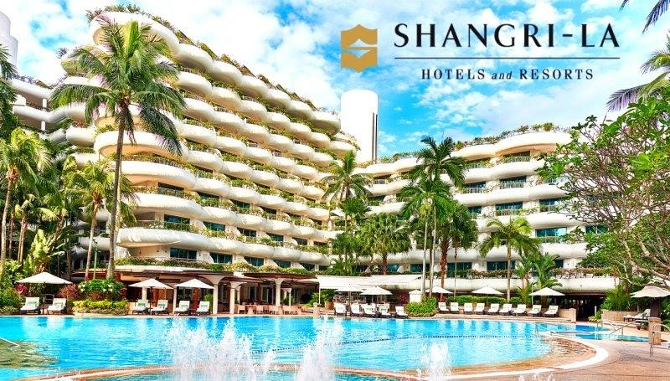
Figure 1: Shangri-La hotels
Source: https://www.marketing-interactive.com/shangri-la-hotels-and-resorts-marks-50th-birthday-with-sleek-new-brandlogo
Shangri-La Hotels is the embodiment of superior hospitality for the smart set globally, representing a premium provider of the classiest hospitality brands, that value privacy and service quality above all else. The brand's market positioning is characterised by: The brand's market positioning is characterised by:
The Shangri-La Hotels group apart from the luxurious staying and exquisite design construct of the hotel, is also a name of perfection and opulence that needs to be repeated by the visitors (Sadhale, 2023). Shangri-la is directed towards affluent people, corporate customers, and leisure travellers who spend their holidays in first-class comforts and personal service. ShangriLa's brand identity encapsulates ultra-luxury, specialness, and exceptional hospitality enveloped within its global positioning placing it as the leader in the industry, with recognition awards and ratings to show for it. SHTG's share of the market is slightly smaller compared to the market share of 'mass' brands. Still, it holds a giant stake in the luxury hospitality sector, yielding people with demands for luxury holidays who are willing to pay premium prices for them.

Travelodge Hotels
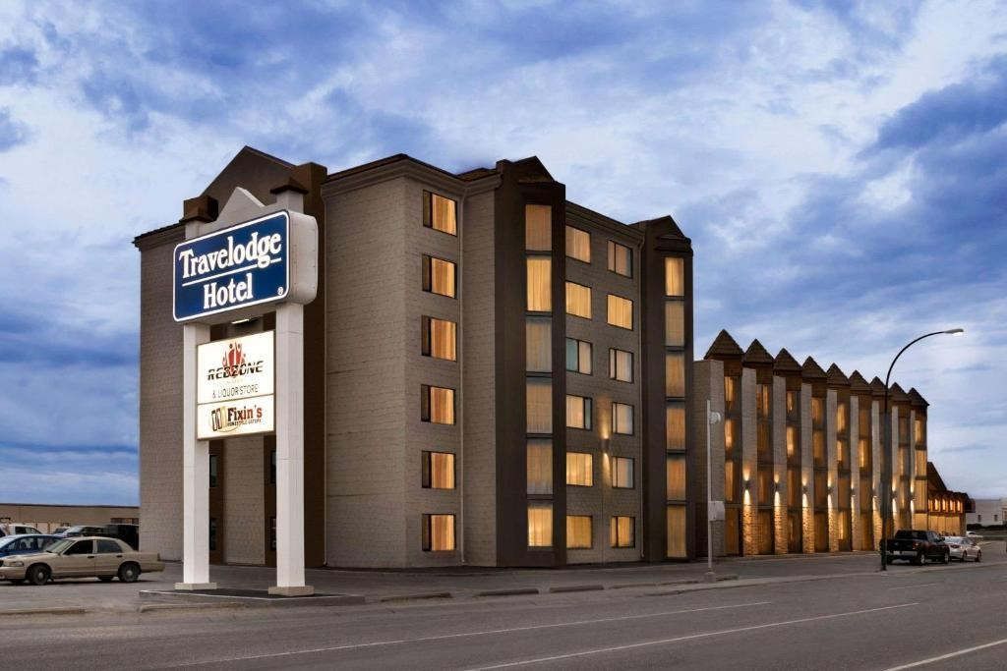
Figure 2: Travelodge Hotels
Source: https://www.booking.com/hotel/ca/travelodge-
saskatoon.html?auth_success=1&account_created=1&activeTab=photosGallery
Travelodge takes value as one of its assurances for budget travellers who want to Identify themselves with the offer of convenience, affordability and reliability. The brand's market positioning is characterised by: The brand's market positioning is characterised by:
Travelodge Hotels is a choice for people who desire practical lodging at an affordable price, a hotel that is appropriate for those price-sensitive consumers seeking more economical accommodation but not giving off quality and comfort (Aroul et al., 2023). Travelodge is geared towards a broad range of clients including frugal travellers, families, and those using hotels for either business or leisure travels who wish for accommodation that is lower priced and within proximity.
Travelodge is not a luxury brand per se, but the emphasis on reliability and consistency in delivering the value proposition for value-for-money customers assists the brand to be seen positively among price-conscious travellers (Górska-Warsewicz and Kulykovets, 2020).
Travelodge market share is broader but fragmented and less specific compared to the brand Shangri-La which targets specific customers and connects with the high-income class.

Customer Demographics
The customer demographics for Shangri-La Hotels and Travelodge Hotels vary significantly based on their market positioning: The customer demographics for Shangri-La Hotels and Travelodge Hotels vary significantly based on their market positioning:

Shangri-La Hotels
They will focus on the wealthy class of consumers, corporate clients and amorous travellers who are looking for an exclusive and special service and facilities.

Travelodge Hotels
Blackness the spectrum of the market's high profitability and expands the range of services to a greater number of clients: budget travellers, families or single men in the quest for cheaper accommodation without the sacrifice of quality and comfort.

Brand Perception
Brand perception plays a crucial role in influencing consumer preferences and loyalty within the hospitality industry: Brand perception plays a crucial role in influencing consumer preferences and loyalty within the hospitality industry:

Shangri-La Hotels
Reward yourself with a superior product range, bearing the name of your company and being closely associated with luxury, uniqueness, and outstanding standards in providing service, the tradition of excellence, public recognition, and customers’ commendations will remain forever.

Travelodge Hotels
However, Travelodge is not poised as a luxury brand, but on quality, continuity, and suitibility which help the budget-conscious crowd to have a satisfying travel experience and the company to maintain its positive brand perception.

3. Assessment of Growth Potential: Shangri-La Hotels vs. Travelodge Hotels
Shangri-La Hotel and Travelodge Hotels delegate their diverse strategies of expansion showing their positions within the hospitality industry in two parts with different target consuming segments.

Shangri-La Hotels
Shangri-La follows a reserved allocation strategy, focusing on dominating strategic locations in luxury recreational places, business hubs, and emerging markets that have huge tourism potential. Through careful selection of locations, brands cannot only align with their brand positioning, but they are in high demand by their target customers. This helps in capturing these lucrative segments and in return drive revenue growth (Supapipatpong, 2018). Through its well-known brand image and proficiency in operations, Shangri-La enjoys being exceptional in competitive markets, thus the company gains the advantage of premium experience and outstanding service from its excellence.

Travelodge Hotels
On the contrary, Travelodge is an active company that launches an expansion strategy both in national and international markets to take advantage of the growth in demand for cheap stayovers (Husa, 2020). Embracing both a franchise business model, asset-light choices, and strategic alliances as its rapid growth tools helps Travelodge to conveniently tap into new markets, seizing any emerging business opportunities without taking on too many investment risks. Travelodge cuts its costs and market prices and concentrates as much as possible, on brand visibility and market penetration, to ensure premium value for budget hospitality. As well, Travelodge is driven to innovate and distinguish itself from its competitors by introducing new services, amenities, and digital experiences as consumer preferences and market trends change.

Potential Barriers to Growth
Both Shangri-La Hotels and Travelodge Hotels face potential barriers to growth, including:
A company such as Shangri-La Hotels may face difficulties in penetrating another market since stricter regulation and regulation compliance exist. Travelodge too suffers from regulatory restrictions, more specifically in the international markets, which are very complicated about the legality and licensing of businesses.
The group of Shangri-La hotels could be facing the problem of the down industry not being able to discover the open market and its growth opportunities in mature markets that are already dominated by some of the established contenders. Apart from the Travelodge hotel may as well still get saturated with the very competitive markets hence the need to differentiate and innovate to give the growth momentum a boost.
Both companies are exposed not only to economic downturns but also to shifts in consumer choices or foreign currency exchange rates that bring a raft of geopolitical risks. Trends in the national economy or any sensational crisis may affect the hotel’s profits and revenue growth when the traveller demands are low and the travel spending is not done with discretion.

4. Financial Commitment to CSR (Corporate Social Responsibility)
In 2023, Shangri-La Hotels gained USD 1,462.1 million achieved in 2022, and this reflects an impressive spike in the revenue level of 46.5% which was USD 2,141.8 million. Hence, the inflow of funds that could result in the event gives hope to this, since a part of the additional profit can be used for sponsoring CSR projects. Moreover, gross profit was $686.5 million in 2022 and leapt to $1,166.7 million during 2023, which is clear evidence of improved gross operational efficiency and which in turn boosts capital of the company to direct towards CSR activities. Environmental and community projects receive considerable support from the company in terms of service costs as the operating expenditures jumped from USD 527.1 million to USD 650.4 million this year. Shangri-La spent USD 40 million in the 2023 financial year but still achieved an operating profit of USD 214.7 million in that year. Thus, the decline from a loss of USD 4.3 million in 2022 to a gain of USD 210 million in 2023 is an indication of reasonably satisfactory operating performance as well as higher financial flexibility
Furthermore, the net finance was USD 291.8 million in 2023 compared to that of USD 238.6 million seen in 2022 but one has to look into whether any of the expenses associated with net finance were for CSR activities. In other words, Shangri-La’s consistent profitability and revenue growth suggest that the business is in a position to provide increased financial resources for corporate social responsibility efforts, which serves the purpose of commitment to corporate social responsibility.

Travelodge hotels
The financial performance of Travelodge Hotel is based on the financial report for the year 2023 (Travelodge Reports, 2024).
During the year 2023 Travelodge Hotels reported amazing financial results such as reaching an EBITDA record and substantial revenue growth, the organisation has created a support and base that would allow it to consider the possibility of making a financial contribution to CSR. Despite the tough circumstances that arose from the pandemic, the company's full-year 2020 underlying revenue hit £909.9 million (+£182.0 million versus 2019) with a record adjusted EBITDA of £212.9 million, showing more positive signs on the financial statements. Furthermore, this income from free cash flow amounts to £167.8 million and the possibility be used for investment in such areas as CSR facilities. Inflation is a negative influence on Travelodge via increasing cost and therefore Focuses on controlled expenditures, and resources can be diverted such as CSR initiatives. While the statements do not provide financial details regarding what percentage of the budget goes into CSR, Travelodge's impressive financial status means that it can fund sustainability, community engagement, and employee welfare programs so they might come up with a CSR strategy that supports the wider Corporate Responsibility goals. The detailed form of business in this case is company would add more to the understanding of CSR undertaking and pledges that they have made to their customers.

Recommendations

Shangri-La Hotels
Recommendation: Strategic Market Expansion
Shangri-La Hotels should prioritise strategic market expansion into fast-growing emerging markets (Sadhale, 2023). By leveraging its reputation for high-quality service and luxury experiences, Shangri-La can capture market share in regions with increasing demand for hospitality services. This expansion strategy aligns with evolving consumer travel behaviour and allows Shangri-La to diversify its revenue streams while maintaining its brand prestige. Additionally, entering emerging markets provides opportunities for long-term growth and mitigates risks associated with over-reliance on mature markets (Surdu and Narula, 2021).

Travelodge Hotels
Recommendation: Sustainable Growth Practices
Travelodge Hotels should focus on developing sustainable practices across their operations, supply chain, and guest services. Embracing environmental stewardship not only aligns with growing consumer preferences for eco-friendly accommodations but also presents opportunities for cost savings and operational efficiency improvements (Kholijah, 2024). By integrating sustainable practices into its business model, Travelodge can differentiate itself from competitors and appeal to environmentally conscious travellers (Thorsson, 2018). This strategic approach not only supports long-term growth but also contributes to positive brand perception and enhances guest loyalty.

Conclusion
The comparative examination of the Shangri-La Hotels and Travelodge Hotels shows that such hotels have different approaches to financial management (strategies that they engage in for effective management of their organisation's financial resources), market positioning (the strategies used to make their hotels recognisable to consumers against competitors), growth potential (the plans they engage in for growth of the organisation), and CSR commitment (the activities their establishments do towards community Whilst Shangri-la Hotels succeeds in luxury hospitality field where the brand emphasises premium experiences and sustainable practices, Travelodge Hotels is this business’s unique part due to its focus on a more budget oriented approach and scalable business model that meet the travellers who watch their wallet.

References
ANNUAL REPORT 2023 (2024). Luxury escape at the best rate. Available at: https://www.shangri-la.com/group/investors/public-disclosures (Accessed: 06 May 2024).
Aroul, R.R., Hodari, D., Bianchi, G. and Martignoni, G., (2023). The impact of brand affiliation on asset values: the case of UK hotels. Journal of property research, 40(2), pp.157-187.
Bilgihan, A. and Ricci, P., (2024). The new era of hotel marketing: integrating cutting-edge technologies with core marketing principles. Journal of Hospitality and Tourism Technology, 15(1), pp.123-137.
Górska-Warsewicz, H. and Kulykovets, O., (2020). Hotel brand loyalty—A systematic literature review. Sustainability, 12(12), p.4810.
Husa, A., (2020). Population Sustainability in Rural Nebraska Towns (Doctoral dissertation, The University of Nebraska-Lincoln).
Jia, H., (2017). Luxury fashion brands: how brand personality, mediated by perceived brand luxury, and moderated by brand experience, contributes to brand equity (Doctoral dissertation, University of Alabama Libraries).
Kholijah, S., (2024). Analysis of Economic and Environmental Benefits of Green Business Practices in the Hospitality and Tourism Sector. Involvement International Journal of Business, 1(1), pp.60-74.
Ntacho, G.A. and Muba, S., (2021). COVID 19 The pandemic and Price Volatility: An Analysis of Hospitality Industry in Emerging Market Economy-Case Study of Tanzania. East African Journal of Business and Economics, 4(1), pp.34-45.
Sadhale, M.V., (2023). A study of customer engagement as a business strategy with reference to five star hotels in pune city (Doctoral dissertation, Tilak Maharashtra Vidyapeeth).
Sadhale, M.V., (2023). A study of customer engagement as a business strategy with reference to five star hotels in pune city (Doctoral dissertation, Tilak Maharashtra Vidyapeeth).
Shangri-La Group (2024). Luxury Escape at Best Rate. Available at: https://www.shangrila.com/group/media/media_post?post=Shangri-
La+Group+Releases+2023+Full+Year+Results (Accessed: 06 May 2024).
Surdu, I. and Narula, R., (2021). Organizational learning, unlearning and reinternationalization timing: Differences between emerging-versus developed-market MNEs. Journal of International Management, 27(3), p.100784.
Thorsson, M., (2018). Investigating consumer motivations for sustainable hotel practices and the effect on satisfaction and attitudinal loyalty (Doctoral dissertation, Iowa State University).
Travelodge (2024). Sustainability, Travelodge Corporate Website. Available at: http://www.travelodgesustainability.co.uk/ (Accessed: 22 April 2024).
Travelodge Reports (2024). Travelodge. Available at:
https://www.travelodge.co.uk/blog/news/travelodge-trading-record-results-2022-2023/ (Accessed: 06 May 2024).
Zanetti, B., Verrascina, M., Licciardo, F. and Gargano, G., (2022). Agritourism and farms diversification in Italy: what have we learnt from COVID-19?. Land, 11(8), p.1215.

