
Daily tools identification for home service robot

Student name: Xinzhe Lyu
Student code: 2214776
Programme: MSc Software Engineering and AI
Moudle: Research Methods and Professional Development
Moudle code: ACCA7004
Lecturer: Terry Walcott

Abstract
With the rapid development of the field of artificial intelligence, many prototypes of service robots have entered people's lives, such as: Sweeping robots, robots that pay attention to children's education, interactive robots that are popular in shopping malls, robots that carry goods in logistics centres, these have been integrated into our lives, but they are not very comprehensive, in order to solve some complex problems we encounter in family and daily life. Home service robots, as well as the RoboCup Home Group roll-out, will be tested to evaluate robot capabilities and performance in realistic, non-standardized home environments. The focus is on, but is not limited to, the following areas: human-robot interaction and cooperation, navigation and mapping in dynamic environments, computer vision and object recognition in natural light conditions, object manipulation, adaptive behavior, behavior integration, ambient intelligence, normalization, and system integration.

Introduction
This research is mainly through the vision-based deep neural network algorithm, and image processing algorithm, after continuous training and correction, the model of the recognition tool is obtained, the model is uploaded to the home service robot platform, and then the adjustment of the recognition posture is carried out, and finally the optimal effect is obtained, so as to obtain a model that ADAPTS to the computing power and storage space of the robot platform. The robot's tool identification and speech broadcast are better combined, which improves the robot's tool identification rate and increases the fitness and robustness of the model to the robot platform.

Literature review
​ ​In the field of robotics, results from human cognitive science are constantly introduced to improve the level of machine intelligence. Currently, home service robots are able to mimic human perception well, but there is still a gap compared to the expectations of robots entering everyday homes to naturally interact with people and provide pleasant services. The important reason is that their understanding of tools is not comprehensive and deep enough. The research on tool cognition of service robots has gone through two stages, namely perception stage (oriented to recognition and localization) and cognition stage (oriented to natural interaction). In the sensing phase, tool representations are mainly based on low-level apparent features such as color, texture, and depth, which are suitable for tool detection and localization. However, since the semantics of objects and scenes are not considered, the robot cannot recognize the service environment in the same or similar way as a human, which makes it difficult to form natural interactions with humans and achieve human-like service. In the cognitive stage, the middle and high level semantic information of items is paid attention to, and by adding these semantic information to the traditional perception information, the tool description compatible with human cognition is attempted to establish, aiming at improving the pleasant service ability of robots in the human-robot integration environment. In recent years, the application of deep network-based vision to robotics and robotic processing algorithms for other mobile devices has become a research problem that has attracted a lot of attention. To address the limited storage space and long prediction time, the proposed algorithm has low object detection performance and weak computational power for mobile devices such as home service robots. A classification detection model based on common household tools is designed for MobileNet, a lightweight convolutional neural network. First, MobileNet is chosen for feature extraction. By decomposing the standard convolution into deep convolution and pointwise convolution, the multiscale prediction part is preserved and the parameters are effectively reduced. Then, a fully connected network of layers and the use of a Softmax classifier enable the identification of common household tools for classification. Compared with common classification algorithms, the proposed network algorithm has high prediction accuracy, small network model, and good results. Thus, it is more suitable for applications in home service robots.
After consulting papers and academic reports, the current phase of research on home service robots involves theoretical studies. For example, Wu Peiliang et al. [1][2][3] studied a detection algorithm of functional parts of daily household tools based on joint learning, a classification of daily household tools based on functional semantic combination of components, and a classification of daily household tools based on functional semantic combination of components. Classification of household service daily tools based on spatial pyramid pooling features; Chen Weizhao et al. [4] studied the detection and recognition system of daily tools for home services based on home service robots. The direction of these studies is to classify the everyday tools of domestic service on the web for domestic service robots, without rising to the level of practical applications. Inspired by Chen Weizhao's paper, this paper will use MobileNetV3 network to train the model of the identification of daily tools of home service, load the model into the home service robot, and complete the development of the environment cognitive platform of the home service robot, so as to realize the autonomous identification of the robot and return the name of the tool report. Let it rise from the level of theoretical study to the level of practical application.

The algorithm using MobileNetV2 is mentioned in the paper, but after 2 years of updating iterations, MobileNet has been upgraded to v3. In this study, the algorithm of MobileNetV3 will be used to train the model, obtain a model with better accuracy, and port it to a robot equipped with ROS platform. The identification of the tool is completed and the identification results are broadcast.

Methods
1 Preliminary plan
Existing deep learning-based methods for object recognition and detection have been systematically studied and summarized. Based on the computing power and storage capacity of the home service robot platform, we design a network model based on deep learning to build the most appropriate model for the home service robot platform. The designed model is loaded into the platform of the home service robot, then the identified pose is adjusted, and the accuracy and stability are improved by constantly debugging the tool acquisition method. Finally, the algorithm is combined with the hardware to complete the specified action.

2 Implement methods
Knowledge from machine learning and artificial intelligence is used to build a model based on the UMD Part Affordance dataset produced by the University of Maryland, which is then ported to the Home Service Robotics platform. The RGB-D camera of the KinectV2 on the machine is also used for recognition and finally the recognition tool is broadcast in the form of a speech broadcast.
The overall process of this study is shown in Figure 1 below.
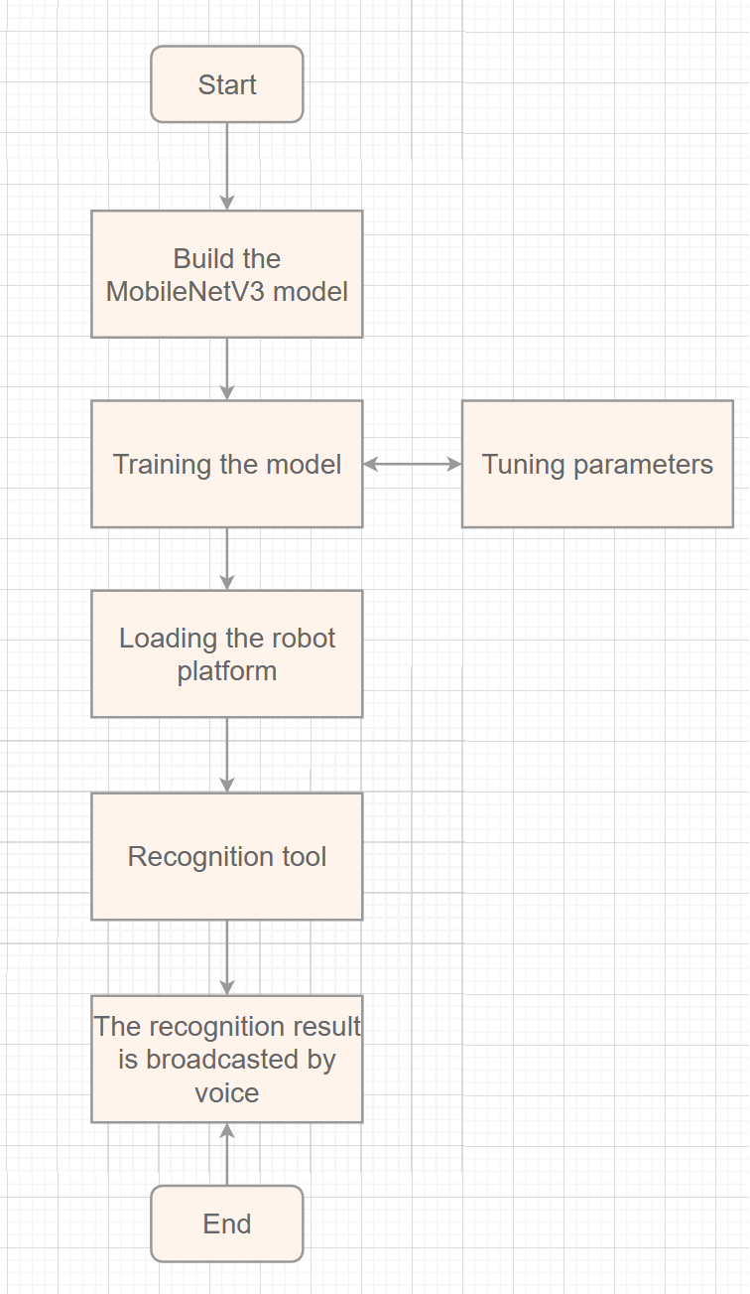
Figure 1 Flow chart of the study
3 Related technologies
3.1 Lidar-based Slam Mapping
Lidar is a commonly used sensor for ground mobile robots, and its working principle is to use a high-speed rotating laser ranging probe to measure the surrounding 360° distribution of obstacles, as shown in Figure 2.





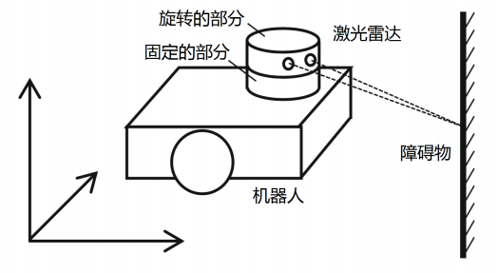
Figure 2 Schematic diagram of the lidar structure
The rotating part of the LIDAR is equipped with a laser ranging probe, which measures the distance at every certain Angle during the rotation. When it rotates one circle, it can just get a top-down two-dimensional dot matrix map of the contour of the surrounding obstacles, and this dot matrix is the output value of the LIDAR, as shown in Figure 3.
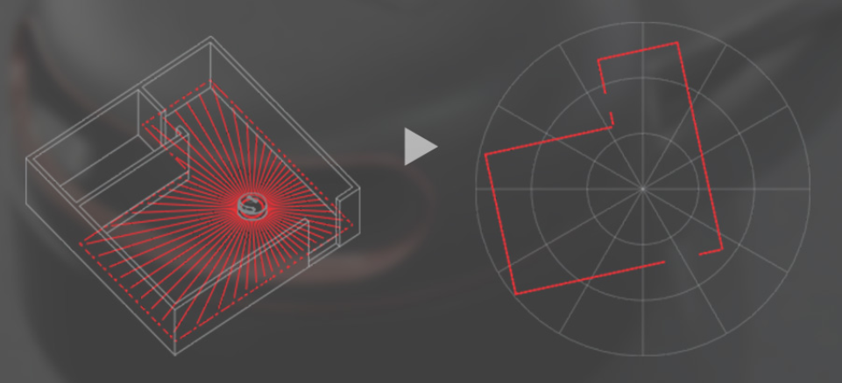
Figure 3 generates the contour map by 360° scanning
The home service robot carries the RPLIDAR A2 lidar, which is mounted above the robot's rounded chassis and protected from damage by a carrier bracket. The rotation frequency of the RPLIDAR A2 lidar is 10 Hz, which is 10 revolutions per second. The scanning Angle is 0° to 360°, and the scanning resolution is 1°, that is, a distance value is measured every 1°, and 360 distance values can be obtained by rotating one week.

3.2 Principle of SLAM
The full name of SLAM in English is "Simultaneous Localization And Mapping", which translates to "real-time positioning and map construction". SLAM was first proposed by Smith, Self and Cheeseman in 1988. Because of its important theoretical and application value, it is considered by many scholars to be the key to realize truly autonomous mobile robots. To understand SLAM, it is necessary to understand the characteristics of lidar data. The scanning data of lidar can be understood as a section diagram of the obstacle distribution, which reflects the edge shape and distribution position of the obstacle facing the radar at a specific height. The principle is shown in FIGURE 4.
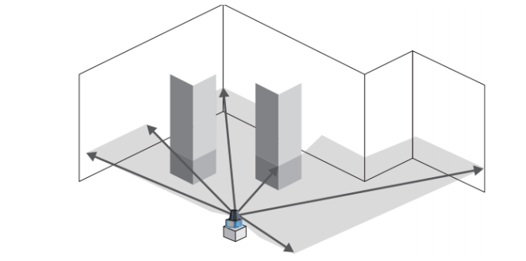
FIGURE 4 Schematic diagram of SLAM mapping
Therefore, when the robot carrying lidar moves in the environment, it can only get the partial contour of the obstacles in a limited range and their relative positions in the robot body coordinate system at a certain time. For example, the following figure reflects the contour of obstacles scanned by LIDAR of A robot at three adjacent positions A, B and C, as shown in Figure 5.
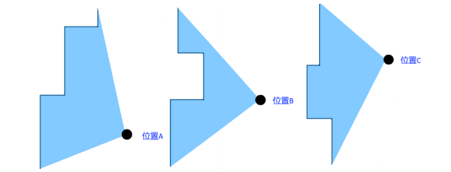
Figure 5 Obstacle contours scanned by lidar at three positions A, B, and C
Although the relationship between positions A, B and C is not known at this time, as shown in Figure 2.11, it can be found that some parts of the obstacle contours scanned at the three positions A, B and C can be matched and overlapped by careful observation. Since these three positions are relatively close, it is assumed that the similar part of the scanned obstacle contour is the same obstacle, so that the obstacle contour of the similar part can be superimposed and overlapped to obtain a larger obstacle contour pattern. For example, the obstacle contours of position A and position B are superimposed as shown in Figure 6:
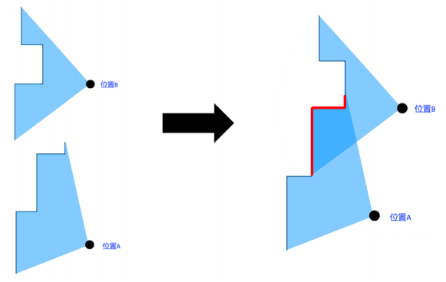
Figure 6 overlays the A and B figures
For another example, the obstacle contours at positions B and C are superimposed as shown in Figure 7:
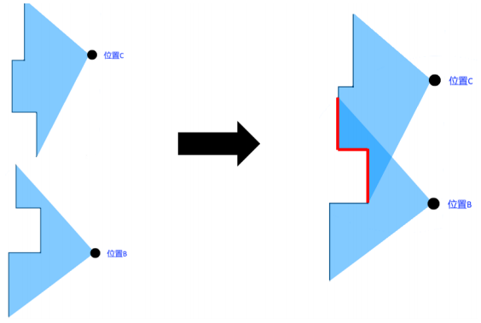
Figure 7 overlays the B and C graphs
According to the above method, a relatively complete planar map can be formed by stitched together the obstacle contours of consecutive multiple positions of lidar scans. This map is a two-dimensional map, which reflects the outline and distribution of obstacles in the whole environment on the scanning surface of the lidar. In the process of building the map, the relationship between the positions that the robot has walked and the position of the robot in the map can also be deduced according to the coincidence relationship of the contour of the obstacles, which completes the two functions of map construction and real-time positioning of the robot. This is where the full name "SLAM" comes from, "Simultaneous Localization And Mapping". Similarly, take the three locations A, B, and C as an example, by stitching the lidar scan contours of the three locations together, A relatively complete planar map can be obtained, and the position of the three locations in this map can also be obtained, as shown in Figure 8.
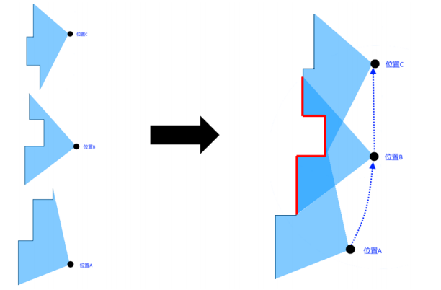
Figure 8 Results after stacking the three positions
ROS supports a variety of SLAM algorithms, the mainstream of which are Hector SLAM and Gmapping. Hector SLAM can work only by relying on lidar, and its principle is similar to the method described previously. On the basis of the above methods, Gmapping also incorporates information such as motor code plate odometry, and its mapping stability is higher than that of Hector SLAM. Therefore, we use Gmapping method for mapping in the subsequent research.

3.3 Autonomous navigation and obstacle avoidance
Motion control and the use of radar to obtain ranging information have been studied in the early stage. The two can be combined to achieve an obstacle avoidance movement based on lidar ranging information. The program logic designed is shown in Figure 9:
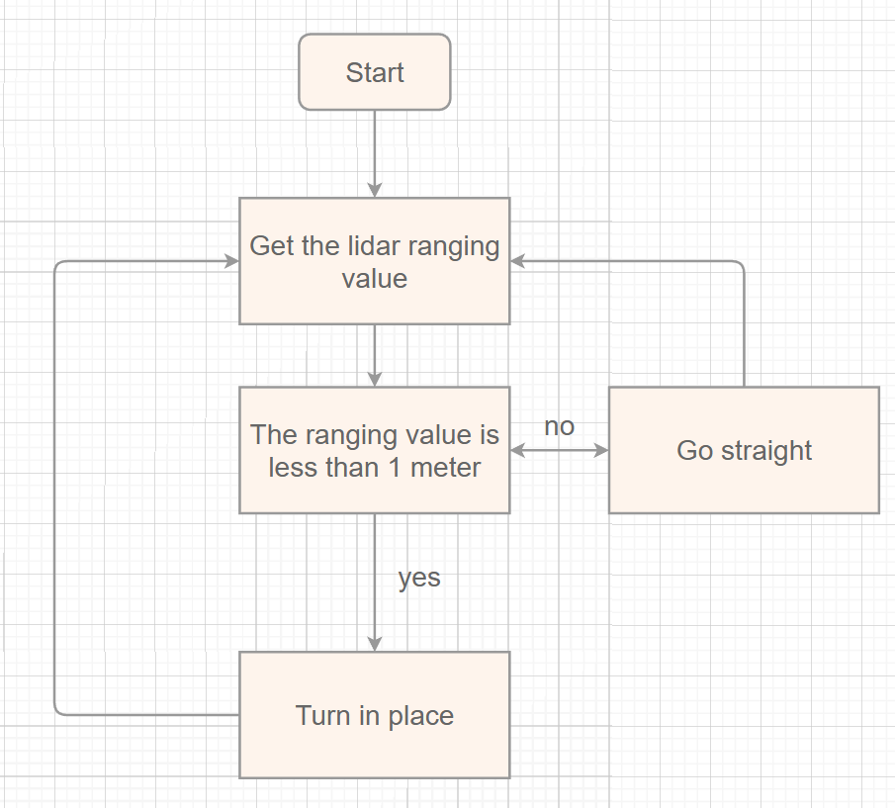
Figure 9 Logic diagram of radar obstacle avoidance
According to this idea, after obtaining the lidar ranging information, the distance value of the obstacle in front of the robot becomes the judgment basis for the robot to move. If the distance value of the obstacle directly in front of the robot is less than 1 meter, the robot will turn in place to try to avoid the obstacle until the distance value of the obstacle directly in front of the robot is greater than 1 meter, the robot stops rotating and moves forward in a straight line. The distance value of the obstacle directly in front of the robot, and the ranging Angle of the RPLIDAR carried by the home service robot are shown in Figure 10:
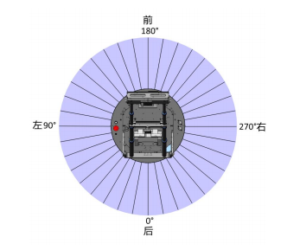
Figure 10 Schematic diagram of the radar operation
The scanning Angle range of a lidar rotation is 0° to 360°, and the laser ray Angle directly in front of the robot is the middle value of the scanning Angle range, that is, half of 360° is 180°. When the program is implemented, it is only necessary to use the lidar ranging value in the 180° direction as the judgment basis to control the robot to rotate and go straight.
The map established by lidar SLAM in this study is a grid map, which is a common map format for indoor mobile robots to navigate. It is a map form that describes the distribution of obstacles in two-dimensional space. The grid map divides the whole environment into a small grid space arranged horizontally and vertically in a section, and each small space is marked with a different color to mark the situation of this space. As shown in Figure 2-17, the left figure shows the two-dimensional planar map established by the SLAM algorithm of ROS in Rviz. If you zoom in, the details of the two-dimensional map are as shown in the right figure, which is composed of square grids. White indicates that there are no obstacles in the grid space and the robot can pass through it. Black indicates that there is an obstacle in the grid space and the robot cannot pass through it. Gray indicates that the raster space has not been explored and the passable condition is unknown, as shown in Figure 11.
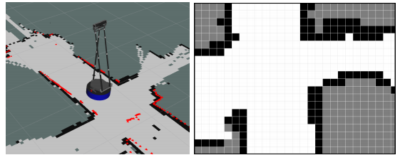
Figure 11 Two-dimensional map
With the grid map, the map navigation problem of robot becomes to find the space area that the robot can pass in the grid map and drive the robot to move from the starting point to the end point, which contains two parts of the task: robot localization. The robot needs to know its current position on the map in order to determine where to start its navigation. In the process of moving, the robot also needs to determine whether its position fits the planned path. Path planning and navigation. The path planning algorithm looks for a passable path in the grid map, that is, a continuous passable grid, extending from the current position of the robot to the destination of the navigation.
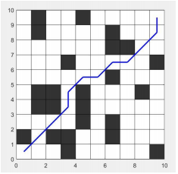
Figure 12 Schematic diagram of path planning
In the actual robot path planning, in addition to considering the connectivity of the white traversable grid, it is also necessary to consider the space occupied by the volume of the robot itself. Only when the white traversable grid space is larger than the diameter of the robot chassis, the robot can safely pass. Therefore, a collision safety boundary is usually expanded in the black obstacle domain, and the width of this boundary is the radius length of the robot chassis. Its meaning is: the robot will collide with the obstacle when it is located in this safety boundary. Finally, the traversable path of the robot will avoid this safety boundary and plan in the remaining traversable area. In ROS, when the Navigation system is activated, Rviz shows a light blue safety perimeter around the obstacle grid. The path planning of the robot will avoid the black obstacle grid and the light blue safety boundary, and find a shortest path in the remaining white passable area. The purple curve in Figure 13 is the Navigation path planned by the navigation system.
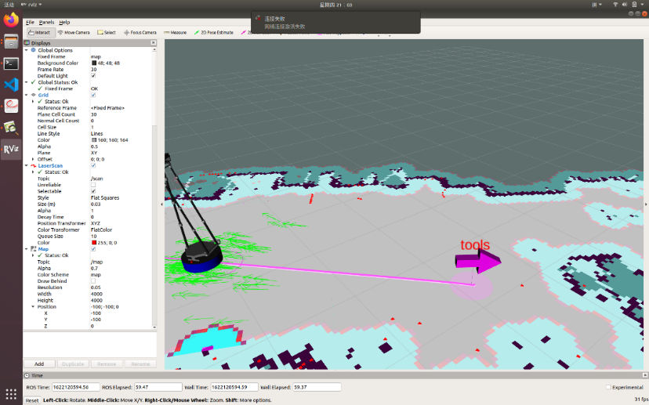
Figure 13 Path planning for the laboratory

3.4 Rviz
ROS provides users with rviz, a 3D visualization platform for displaying a variety of data to meet the visualization requirements of robotic systems.
Rviz is a 3D visualization tool based on the ROS software framework that is compatible with a variety of robotic platforms. In rviz, any real object, such as a robot and surrounding objects, can be described in XML in terms of size, mass, position, material, joints and other properties, and presented in the interface. At the same time, the rviz can display the information of the robot's sensors, the robot's motion state, and the changes in the surrounding environment in real-time through graphical means.
In summary, rviz allows developers to visualize all the information that can be monitored, as well as control the robot's behavior via buttons, sliders, and values in the control interface of rviz.

3.5 Lightweight neural network
3.5.1 Problems with large networks
Storage issues: Hundreds of layers of networks have a large number of weight parameters, and storing a large number of weight parameters requires a lot of memory on the device.
Speed issues: In practical applications, it is often millisecond level, in order to achieve practical application standards, either improve processor performance, or reduce the amount of calculation, large network computation, processing tasks slow.
A lightweight neural network is a lightweight model that has the same performance as a heavier model, so as to achieve a hardware-friendly neural network. Heavy and light here usually refers to the size/number of parameters of the model. Commonly used techniques for lightweight neural networks are: distillation, pruning, quantization, weight sharing, low-rank decomposition, attention module lightweight, dynamic network architecture/training, lighter network architecture design, NAS (neural Architecture Search), hardware support, etc. Each of these techniques is a huge field, and in recent years there have been a lot of sophisticated designs to make neural networks lightweight.

3.5.2 MobileNet series
3.5.2.1 mobilenetv1
Core idea:
MobileNet was proposed by the team at Google and presented at CVPR-2017. The main idea of MobileNet is depth wise separable convolution to replace the standard convolution and reduce the number of parameters. Let's see how depth wise separable convolution works and reduce the number of parameters. The core idea of depth wise separable convolution is:
1. I first do a per-channel convolution (DW convolution), what does that mean? That is, I group the input feature map by channel, and use as many convolution kernels as there are channels (so the number of convolution kernel channels here is 1), convolver with the feature map of a single channel, for example, I input the feature map with the number of channels is 3. I want to have 256 channels in the output feature map after depth wise separable convolution, so I should use 3 Dk*Dk*1 kernels for the per-channel convolution step (DK=3 is usually used more often), each convoluted on one channel in the input feature map.
2. After the per-channel convolution, then use the 1x1 convolution (PW convolution) to string all the channels of the above feature map after convolution. What does that mean? Using a 1x1 convolution kernel (the number of convolution kernel channels is the number of channels in the input feature map, the number depends on the number of channels you want to get out of the output feature map, the number of channels is what, then you use a few convolution kernels) or following the above example, the number of input feature map channels is 3, I think the number of output feature map channels after the depth wise separable convolution is 256, After the channel-wise convolution above, I still have 3 channels (because the number of kernels is 3), so for the point convolution in the second step, I convoluted with 256 1x1x3 kernels with the channel-wise convolution feature map. Here's an illustration of depth wise separable convolution to make it easier to understand:
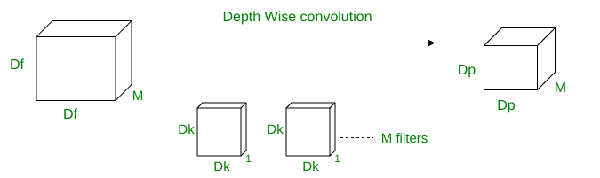
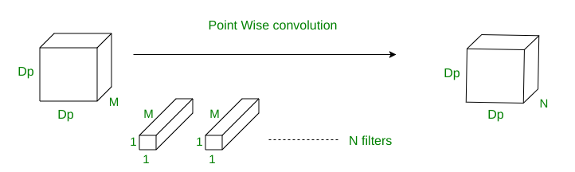
Figure 14 Depth Wise Convolution and Point Weise Convolution
As shown in the figure above, let DK be the standard convolution kernel size, M be the number of input feature map channels, N be the number of output feature map channels, and DF be the input feature map size.
Number of depth wise separable convolution parameters=DK*DK*1*M+1*1*M*N=DK*DK*M+M*N

3.5.2.2 MobileNetV2
Improvements:
MobileNetV2 mainly makes two improvements on the basis of MobileNetV1, one is the inverted residual structure, the other is the linear bottleneck layer structure.
The Linear Bottleneck layer
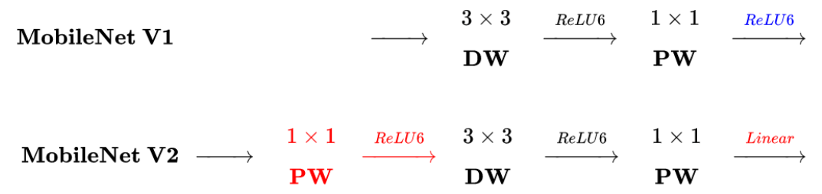
Figure 15 Structure of MobileNet V1 and MobileNet V2
Similar point: both use depth wise separable convolution
Differences: First, before the depth wise separable convolution, a 1x1 convolution is used to increase the dimensionality. This allows DW convolution to extract features in high dimensional space better than in low dimensional space. (High-dimensional space contains more abundant semantic information); Secondly, the nonlinear activation function was changed to a linear activation function after the second PW convolution. The authors of mobilenetv2 believe that the nonlinear activation function can effectively increase the nonlinearity of the network in the high-dimensional space, but it will destroy the features in the low-dimensional space. So it is not appropriate to use ReLU6 after the second PW convolution. The authors call this structure a Linear Bottleneck.
(2) inverted residual structure
It is so called because its structure is in reverse order of dimensionality increase and dimensionality reduction of a ResNet. To explain, let's compare the network:
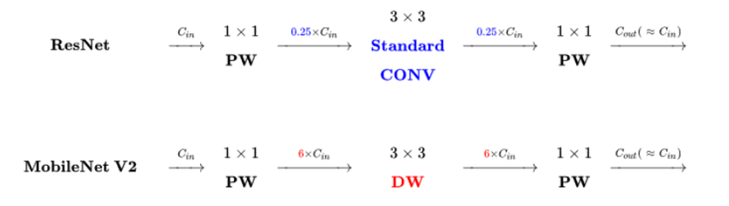 Figure 16 Structure of ResNet and MobileNet V2
Similarities:
1. Both used 1x1,3x3, 1x1 convolutions
2. MobileNetV2 adds the input and output (not shown), borrowing the shortcut idea from ResNet.
The differences:
1. MobileNetV2 uses DW convolution (deep convolution, channel by channel convolution above) to extract features, while ResNet uses standard convolution to extract features.
2.Resnet dimensionality reduction (0.25 times), then convolution, and then dimensionality increase; MobileNetV2, on the other hand, first increases the dimension (6x), followed by DW convolution, and then reduces the dimension. The authors hope that DW convolution can extract features in high dimensional space.

3.5.2.3 MobileNetV3
MobileNetV3 does not introduce new blocks, and the title "Searching" describes the design philosophy of the network: Neural Architecture Search (NAS).
Efficient network building blocks
As mentioned earlier, MobileNetV3 is the result of the neural architecture search, and its internal modules are inherited from:
1.depth wise separable convolutions introduced by MobileNetV1;
2.the inverted residual with linear bottleneck introduced by MobileNetV2 model; 2.
3. Lightweight attention model based on squeeze and excitation structure introduced by MnasNet model.
These proven building blocks for mobile network design are the building blocks of MobileNetV3.
Complementary search
In the network structure search, the authors combine two techniques: Resource-constrained NAS (platform-aware NAS) and NetAdapt. The former is used to Search each module of the network under the condition of limited calculation and parameter, so it is called Block-wise search. The former is equivalent to global structure search, while the latter is equivalent to local search, and they complement each other.

4. Development environment
1.Software environment for training the model: python3.10, PyTorch on Windows11
2.Hardware environment for training the model: Intel i7-12700KF, Colorful 3080 (12G), 32G memory
3.Hardware environment: home service robot equipped with ROS system.

5. Design focus and emphasis
In view of the limited computing power and the limited storage resources of the home service robot platform, it is necessary to design a relatively small model to adapt to its environment, so to find a network model that can not only have high accuracy, but also need to be relatively small. And in order to ensure the accuracy of recognition, the model used needs high accuracy, good robustness, portability, and to be able to adapt to object recognition in various environments.

6. Specific arrangements for the schedule
Week 1-2: Get familiar with the subject, understand and master the overall design requirements.
Week 3-4 : Collect relevant materials for the project, investigate and research, and complete the proposal report.
Week 5-8: Configure the environment and design the network model for detection and identification.
Week 9-11: The trained model is loaded into the platform for debugging of the physical machine.
Week 12-14: Debug the solid machine and prepare the first draft of the graduation thesis.
Week 15-17: summarize and finish, complete relevant documents, and complete the graduation thesis.

Results
Through a year of systematic study, I have learned a lot. After referring to some literature, combined with my previous learning experience, I used MobileNetV3 algorithm in lightweight neural network to train the UMD Part Affordance dataset produced by the University of Maryland. After a lot of debugging and optimization, a daily tool recognition model with good accuracy and small network model is obtained. Then it is transplanted to the home service robot platform and debug the physical machine. Finally, the tool recognition is successfully realized, and the tool recognition and voice broadcast are realized.

Evaluation
I think I am very confident to complete the subject after reading the materials in the early stage and studying in the school for one year. In the undergraduate stage, I have a strong interest in machine learning, and achieved excellent results in the courses of artificial intelligence and image recognition. I have rich experience in the principle and call mode of KinectV2, as well as path planning. However, in the aspect of lidar, some work needs to be done to continue to study the working principle and the use of Rivz 3D visualization platform.
Reference
- 吴培良,隰晓珺,杨霄,孔令富,侯增广.一种基于联合学习的家庭日常工具功用性部件检测算法[J].自动化学报,2019,45(05):985-992.
- 吴培良,何犇,孔令富.一种基于部件功用性语义组合的家庭日常工具分类方法[J].机器人,2017,39(06):786-794.
- 吴培良,何犇,侯增广.基于空间金字塔池化特征的日常工具分类识别[J].控制与决策,2019,34(7):1481-1486.
- Weizhao Chen, Wenbai Chen, Chao He. Research on Classification and Detection System of Common Household Tools for Home Service Robot[C]. ICSSE 2020: 1-5

