
(Robinson & Garton, 2007)

Academic and Employability Skills

MODULE LECTURER´S NAME: SYLVIA HOFFMANN
STUDENT NAME: IRENA LONCAR
STUDENT IDENTITY NUMBER: 1917107

Table of Contents
Introduction 2
Summarizing 2
Paraphrasing 3
Referencing 3
Academic writing 4
Models of reflection 5
Conclusion 7
References 8
Appendix 9

Introduction
Reflective writing skills come useful in both academic and professional sectors and in this section I would like to present my own journey about gaining knowledge through module classes. I have attended some important classes of Prof. Lloyd and then took online classes with Prof. Alfred Mensah and Sylvia Hoffmann, who have enlightened us with some fascinating knowledge regarding some academic and employability skills that are useful in carrying out various academic and professional presentation. They did a great effort to make the classes interesting and I have enjoyed the classes both for their enthusiastic style, clarity on the subject and fluency as well as understanding the importance of the module. This module was designed to make academic writing style more authentic in nature.

Summarizing
In our class we learned about summarizing which is the art of making brief statement about the important points out of a narrative thing (Khosravi and Taheri, 2018). Any text which is long and descriptive could be shortened with this process and without changing the final deliverables, the techniques makes it crisp and takes less time for the reader to get into point. We tried to summarize various text in our own style and this increased our capability for doing so. I think it was a good idea to practice with a real piece of example as it gave us a chance to try our hands in this subject. I also think that people can feel that summarizing a piece of text is not so important but, in the class, I understood that we actually practice it in daily basis for carrying out many mundane actions. As for example, during the class we take running notes by focusing on the main points of a lecture, which we can later write down. Also, while have to make any power point presentation, after reading the subject in details we are meant to put just the brief outcome of the matter in the slides. In academic and professional life there will come many instances where we will need to express a detailed thing in a short and crisp manner which is the art of summarizing. There were loads of useful information, depiction of understanding the important points in a text, right way of summarizing them using many examples, assessments etc. which improved my knowledge on this subject. The knowledge made us to be confident and capable of making summary by ourselves and so he put so many efforts in the class. At the end of the module, I find myself quite able to make summary out of a detailed text. The session was enjoyable as learning new things are always a favorite to me and this subject was not a new one but the approach, I found very attractive. I was eager to apply them in my own work and tried at home for practicing the same. I can now summaries a piece of text confidently and I think that is the change, the module has made in me.

Paraphrasing
There was another important academic aspect called paraphrasing. This helps to make greater clarity of a text or speech by using different words while keeping the meaning same. The information related to this subject was particularly interesting as unknowingly we try to do it many times. For example, during writing any assessment, we have to go for researches both online and offline. We find many texts or useful piece of information. In order to present that in our work, we all need to write it down in our own words. This is actually paraphrasing. In examinations also, we first understand a subject, read it over and over to understand it and then write in our own words. I personally felt quite informed and educated related to this topic and felt very happy while practicing it. In works related with paraphrasing, I used to take much interest and used online software to check the percentage of similarity of my writing with the original one. I feel that for writing a good paraphrased text, it is important to understand the main text first. This is the most crucial aspect of a good paraphrasing. Until and unless we understand a text clearly, it will be hard to make a paraphrasing which can deliver the reader the same meaning. The module was interesting as there were information, activities and interactive sessions which has helped the students a lot. The information was impactful and helped all to put those information in real work in order to make it more authentic. I feel that we all need to do paraphrase in many aspects and this module will help us in our professional careers also. I have enjoyed learning the new tricks that has helped me to paraphrase any text such as pointing down the main facts and after understanding them presenting it with own language. I can now make paraphrased content with ease.

Referencing
As we all are still students and to complete our various assignments, it is very important to know about the importance of referencing which tells about the use of citations of the source of information from which we gather knowledge (Rahman, 2016). At the beginning of this module, professor made it clear to the class that this is very important to make our own research authentic and requested our undivided attention. Clear points were made that while we try to find information from books, journals or internet sources and try to put them in our own work for making it more informative we need to acknowledge the source. It is important to mention the authors or sources of any information so that their authenticity could be cross- checked. We came to know that there are particular styles of referencing namely Harvard, APA, MLA, Vancouver etc. Also, they have distinguished style of representation both in the referencing section as well as while mentioning them in the text section. I felt that we were unaware about these various styles which is important to learn the subject deeply. This was a whole new experience for me and others and helped all of us to get a good grip over all the styles. I also noticed that there are different patterns of using comma, full stop and use of “and” while mentioning about the authors. Not only in the reference section but these styles are quite obvious in the “text” section also. The differences of these styles were studied with real examples so that we all can understand them and use them in real sense. We worked with every style of referencing so that we do understand them and be ready to use it without making any error. The subject was a bit difficult than other as there were so many types of referencing styling but due to repeated attempts, I can now use them all in my own writings.
In this case, I have also learned about making Cover letter and CV in our second term with Sylvia Hoffmann, which was my favorite topic of our second term, Sylvia was very engaging, checking and correcting our CVs. Before the class, I along with my classmates have the idea that writing our degree is enough for a CV which we were proved wrong in the class. It was fascinating to know that a cv along with the educational details includes personal details, details of any extra-curricular activities, any important achievement of life, hobbies, professional experiences and other many important information that could be useful for the company records. A cover letter represent my profile in more appealing way as all necessary information about my educational details, professional achievements and goals, job interests, various skills I have received over the years and personal background are briefly acknowledged, so that the recruiter cannot overlook my eligibility for the opening and this also makes me the most deserving candidate.

Academic writing
There are different writing styles and one of them is academic writing. This is a special style of formal writing that presents a clear, structured, focused and evidence- based text that helps readers to understand the deliverables. The language remains simple and discourages long complex sentences or complicated vocabulary. The information of this module was interesting and took longer sessions than other. It is important to know about the structure of an academic writing, how can we add the formal tone in it, the process of focusing on the main point and making it relevant to the subject. I felt that the previous knowledges of summarizing, paraphrasing and referencing were the basic steps for reaching this final stage. All these information seemed helpful in this context of writing some academic text finally. As this information came to us after all the above- mentioned academic pieces, it was easier for us to understand and represent our writing in a comparatively efficient manner. We could now understand the effectiveness of the whole module. In this stage, therefore, I understood that if not known to the art of making the summarizing, paraphrasing and referencing beforehand, it would have become a nightmare for all students. We, the students felt a little competition among us in order to present the best academic writing and reflecting the knowledge of us. This practice of academic writing will help us to write professional writing as we all have strong bases for this and are eager to exhibit through assessment.

Models of reflection
There are two reflective models through which I can express my journey. The first one is Gibbs model of reflection and the second is Kolb’s model of reflection.
Gibbs model of reflection is based on six cyclic steps of a reflective pathway (Wareing, 2017). It starts with description phase and I related that in this phase I came across the module and to understand the subject in private, wrote down the notes. I and my team mates were doing the same thing though our notes were similar and dissimilar at times. This phase made a clear note about the reading material, the tutor, and the occurrence of the class and made it clear to myself that for what reason I was taking the class with interest. I realized that understanding these information are going to help me in future increased my intentions to take those classes. In the second stage of feelings, I explored my own so far gathered knowledge and tried to understand that weather I am satisfied or not by the knowledge, what is my position before and after gaining it. In the third phase of evaluation I was pointing out the understandable parts of the lesson and the parts which still have some questions or difficulties in mind so that I can clear themselves. To present them to my professor, I needed to note it down and I did exactly. This phase was also important to go to the next phase of analysis which gave me a scope of think more deeply on it and improvise on the process of understanding. From this I came to conclusion phase, where I understood the whole learning process and tried to think about overcoming the difficulties as well as finding out alternative ways. In the last phase of action plan making, I devised my own plan for future to face the similar situations.
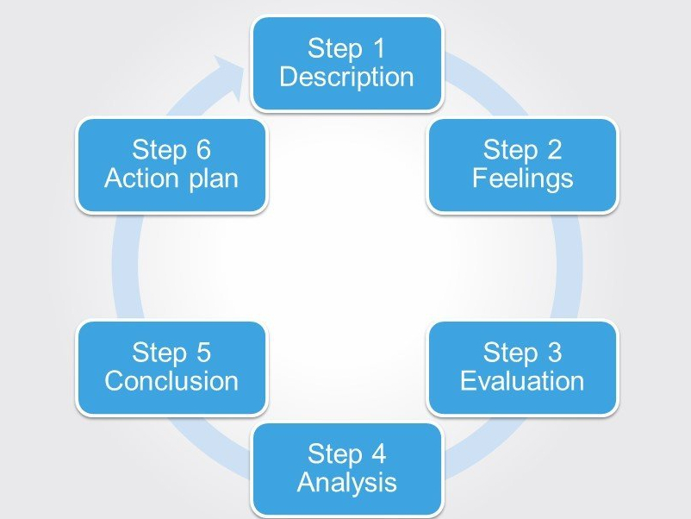
Figure 1: Gibbs model of reflection
(Source: Wareing, 2017)
Kolb’s model of reflection also helped me to understand the various steps of learning in a reflective way through four steps (Morris, 2019). This model of experimental learning started with concrete experience making which focused on the physical presence of a situation and in my case the accumulation of the knowledge by me. Without it, I was not able to gather the required knowledge. My personal experience helped me to get notes, understand the subject through interactive sessions and understand something new to me. The step of reflective observation helped me to have deep insights about my learnings, the positive and negative sides of it, my success and failure regarding it so that I can improve in future. The third stage is abstract conceptualization in which I was looking for the better and alternative ways to overcome my failure and make more success. In the final stage of active experimentation, my newly acquired theoretical knowledge was expected to give me fruitful experience in my next venture.
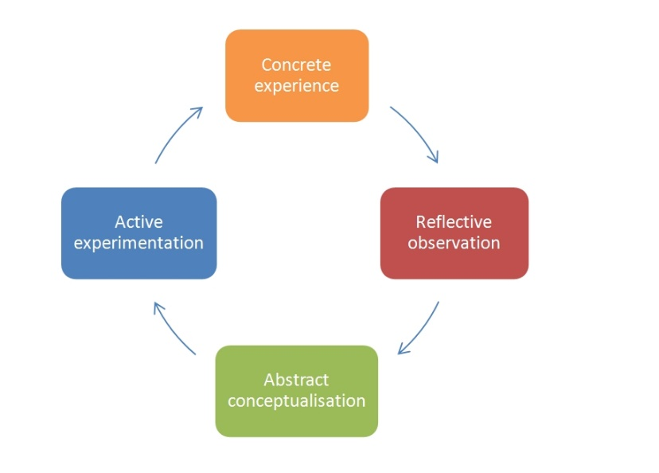
Figure 2: Kolb’s model of reflection
(Source: Morris, 2019)

Conclusion
In conclusion it could be said that I feel myself fortunate to have attended such wonderful and informative module that has increased my knowledge about many academic concepts. I have felt that in order to present professional writing in our own respective career, it is very important to know the writing style in a formal way. The information have so far enriched me with knowledge and now I can efficiently write. I have also reviewed my own journey of knowledge earning through the use of established reflective models which have cleared my views about learning process.

References
Khosravi, S. and Taheri, P., 2018. Investigating the effectiveness of summarizing, note-taking, and outlining on lexical and grammatical writing accuracy of upper elementary efl learners. QUID: Investigación, Ciencia y Tecnología, (30), pp.41-48.
Morris, T.H., 2019. Experiential learning–a systematic review and revision of Kolb’s model. Interactive Learning Environments, pp.1-14.
Rahman, M.R., 2016. Referencing an Academic Obligation. Delta Medical College Journal, 4(2), pp.52-54.
Wareing, M., 2017. Me, my, more, must: a values-based model of reflection. Reflective Practice, 18(2), pp.268-279.

Appendix:
Cover letter
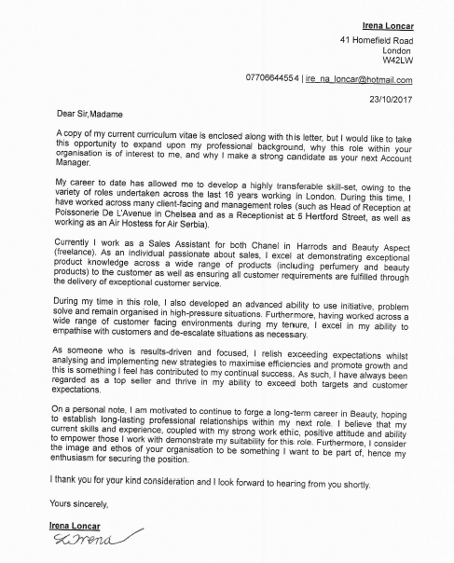

CV
Irena Loncar
Professional Profile:
A highly resourceful, efficient and customer focused Account Manager. Demonstrating considerable experience maximizing the awareness, sales and profitability of recognizable luxury brands. Excel at communicating with both colleagues and clients, resulting in forging excellent relationships across organisational boundaries. Communicative and dedicated in all pursuits, now seeking a new and challenging professional opportunity to demonstrate proven and measurable knowledge as well as enhance existing skills further. Certain to add immeasurable value to any company.
Core Competencies:
- Advanced communication and organisational planning skills.
- Compliant and objection handling.
- Demonstrating vast experience in the fashion and beauty industry.
- Brand management: building reputation to secure repeat business and referrals.
- Quality focused with the ability to prioritise complex and varied workloads.
- Pragmatic, focused and innovative member of staff.
- Client relationship management: skilled at interacting, empathising and understanding a wide variety of individuals.
- Working in rapidly changing and challenging environments, effectively managing and de-escalating difficult situations.
- Adept at working to constantly meet and exceed all clearly defined targets.
- Multi-lingual.

Education and Qualifications:
Helena Rubenstein | Beautician Qualification
Air Hostess full licence | Cabin Attendant's License Boeing 737.
- Six week course covering all practical aspects of airline stewardship.
Employment Overview:
November 2017 – Present: Beauty Aspect, Account Manager
Working on this independent site to sell and promote 40 different perfumes.
July 2016 – October 2016: Chanel, Make Up Artist
- Working closely with clients involving: gathering their bespoke requirements and delivering a variety of make-up techniques.
- Developing an excellent rapport with all clients and ensuring all client requirements are understood and fulfilled.
- Assessing what products are advisable for each client and up selling as required.
- Demonstrating an excellent knowledge of the Chanel brand and its products.
December 2015 – June 2016: Travelling
September 2015 – December 2015: Hertford Street, Private Member Club, Receptionist
- Placing reservations and handling complaints.
- Exercising a high level of diligence and discretion.
- Demonstrating an excellent knowledge of the brand and ensuring this was communicated effectively.
- Maintaining an excellent level of customer service at all times.
- Meeting / greeting customers.
April 2005 – May 2015: Poissonerie De L’Avenue, Chelsea, PA / Front of House
- Taking phone calls, placing reservations and handling complaints, exercising a high level of diligence and discretion.
- Performing a wide variety of administrative tasks including customer management.
- Arranging meetings and diary management for the restaurant owner.
- Maintaining an optimal standard of customer service at all times.
- Ordering of supplies when appropriate, and processing invoices.
- Banking and cashier responsibilities; exhibiting reliability.
- Greeting customers, and allocating tables.
2003 – 2005: Beauty Base, Assistant Manager
Representing and selling a vast range of brands including; Christian Dior, Lancôme, YSL, Sisley and Guerlian.
- Taking incoming telephone calls, providing customer service in addition to advice and information based on identified requirements.
- Demonstrating an exceptional knowledge of the Beauty Base brand and its products.
- Ensuring the effective execution and delivery of strategies in order to meet all short, mid and long term commercial targets.
- Developing and implementing key strategies to promote business growth and profitability.
- Proactively responding to customer complaints and ensuring the delivery of exceptional customer service.
2000 – 2003: Emmanuel Ungaro, Senior Sales Assistant
1999 – 2000: L.K. Bennett, Sales Assistant
Ladies shoes, clothing, and accessories.
Hobbies and Interests:
I enjoy a wide range of recreational activities including, but not limited to, a dedication towards personal fitness; performing Pilates, ballet bar method, and swimming. I am also keen on travel; learning about foreign cultures and food.

