Harry Byrne
P133366

Internet Technology and Security (ACCA4018)

HTML & CSS Web Development

Contents

Abstract Page 1

Requirements Page 2

Implementation & Validation Page 3- 8

Evaluation Page 8

References Page 9

Abstract

The assignment was to build a website with a minimum of 5 pages for a relevant activity to the writer. It was chosen to build one for a local archery club. After the build, the website was tested for functionality where small errors were found in the HTML but the CSS passed with no errors. The accessibility evaluation brought more errors to the authors attention. Whilst the website functioned, it would require more graphics and images to interest the passing user. Also, the site navigation would benefit upgrading.

Requirements

The ‘Bowmen of Gower’ are a Swansea based archery club dating back to the 1950’s in various iterations. While they have a regular membership who shoot regularly, it’s felt that the club needs to attract more members from all walks of life as most members now have joined via family and friend recommendations.

The wish is to build a website to allow new potential members to see the various styles of archery, as well as detailing other archery information such as scoring for new club members. At a future point extra information will be available to members who are signed into the website to access scores, fees due and upcoming events or cancellations that are only relevant to active club members, this however will not be tackled in the initial build, but upon trials after seeing the hit count to the page, this information is currently put onto the closed Facebook group only which is not useful for members who do not use social media. The website is to be built using HTML and CSS.

HTML is the standard markup language for creating Web pages.
- HTML stands for Hyper Text Markup Language
- HTML describes the structure of Web pages using markup.
- HTML elements are the building blocks of HTML pages.
- HTML elements are represented by tags.
- HTML tags label pieces of content such as "heading", "paragraph", "table", and so on.
- Browsers do not display the HTML tags, but use them to render the content of the page.[1]
CSS is a language that describes the style of an HTML document. It describes how HTML elements should be displayed.[2]

Implementation

The following screenshots are all from taken using Internet Explorer.

This page is The Homepage

This page summarizes the history of the club. The HTML layout follows basically links to Bootstrap and CSS to set design for the page. Bootstrap was only used due to the brief requiring it and only used at the top section. Following the title and greyed box is a form asking for username and password for login details. Whilst the form is unused in the current website, it was added for future use, should the archery club wish to give members private page access to information only relating to them.
Following the login form are hoverover links to the other pages of the website titled relevantly. A brief history of the club is placed within standard HTML paragraphs. In retrospect, this information should be placed on its own page with possibly animation and pictures used more on the homepage to grab the attention of passing viewers. The website footer is a copyright symbol along with the authors name.
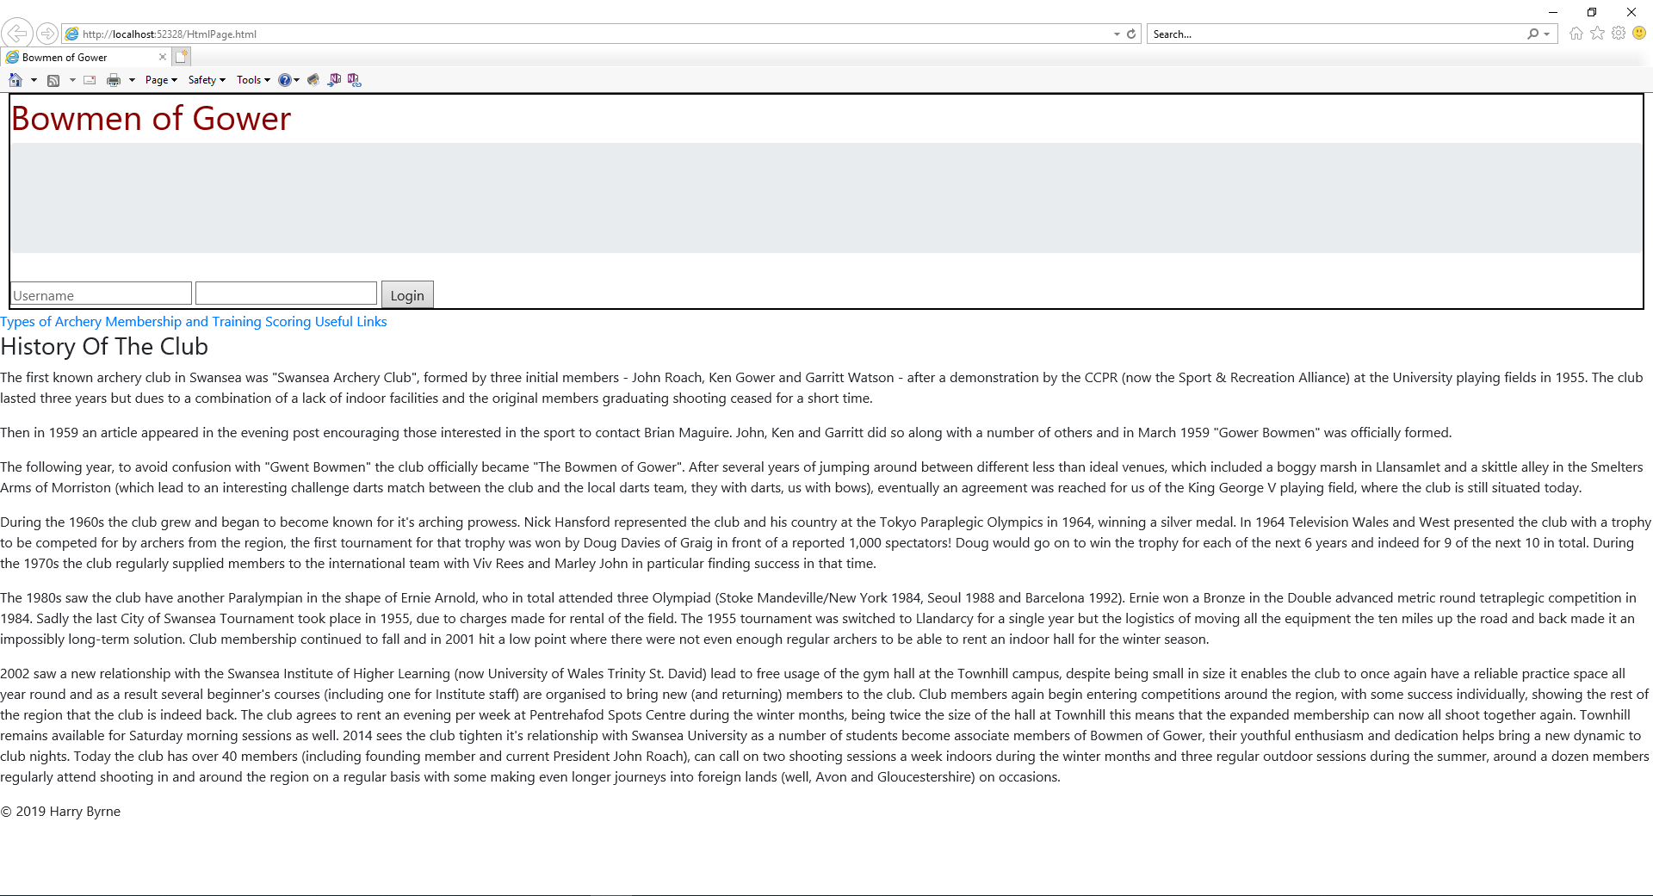

This is the Types of Archery Page

This page shows the user various different types of archery. The Header follows the form of the homepage with Bowmen of Gower title, Login form and hoverover links to the other pages of the website. Included are descriptions of various forms of archery and images with height and width set in the HTML page. The Compoud archery was styled with a dashed border in CSS while Barebow was styled in CSS to have text and border in indigo. Due to text alignment issues, a few paragraphs were given inherited padding in CSS which appeared to resolve the issue. The website footer is a copyright symbol along with the authors name.
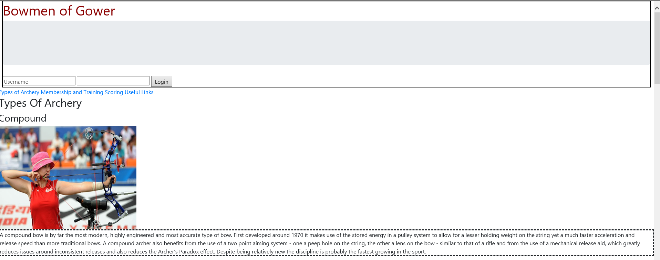
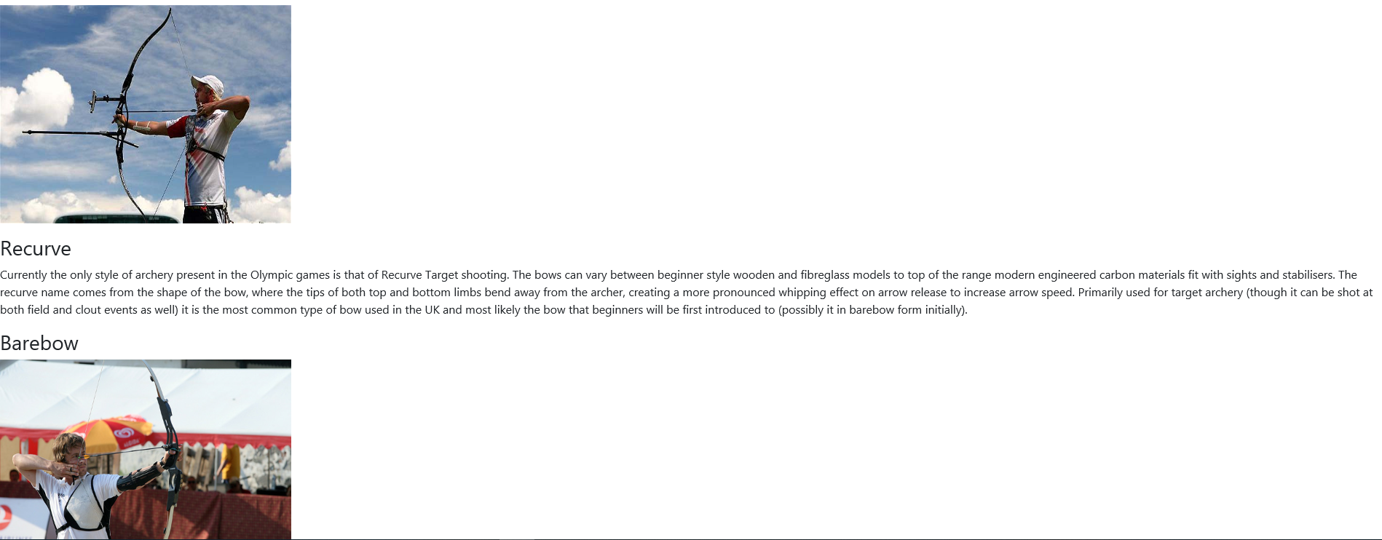
The page does continue further beyond this point.

This is the Membership Page

This page briefly describes courses to join the club. The Header follows the form of the homepage with Bowmen of Gower title, Login form and hoverover links to the other pages of the website. It has a simple format of paragraphs in HTML with no CSS beyond the previously mentioned bit on the homepage. The website footer is a copyright symbol along with the authors name.
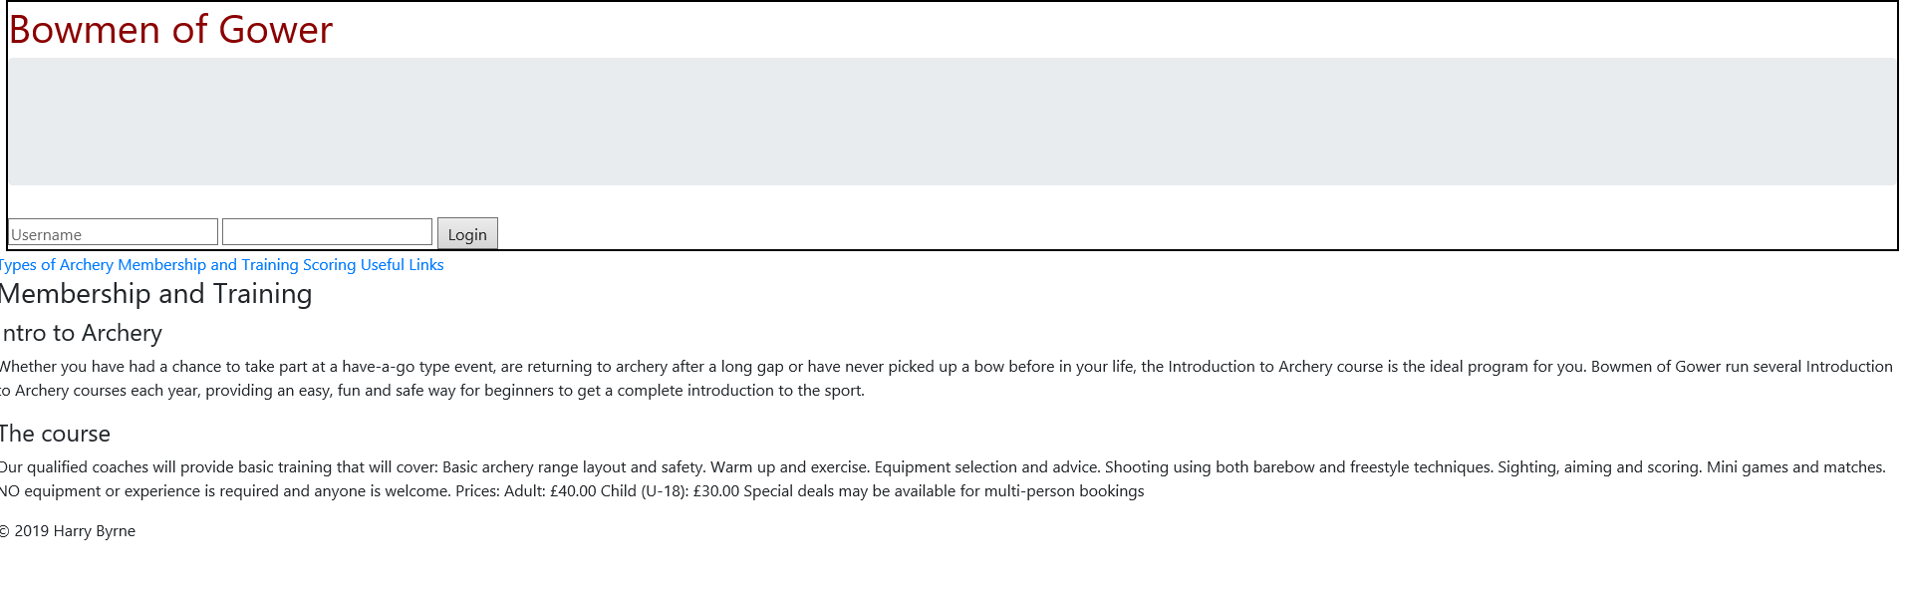

This is the Scoring Page

This page describes some of the many scoring ways used in archery. The Header follows the form of the homepage with Bowmen of Gower title, Login form and hoverover links to the other pages of the website. It follows a basic paragraph image format. The website footer is a copyright symbol along with the authors name.
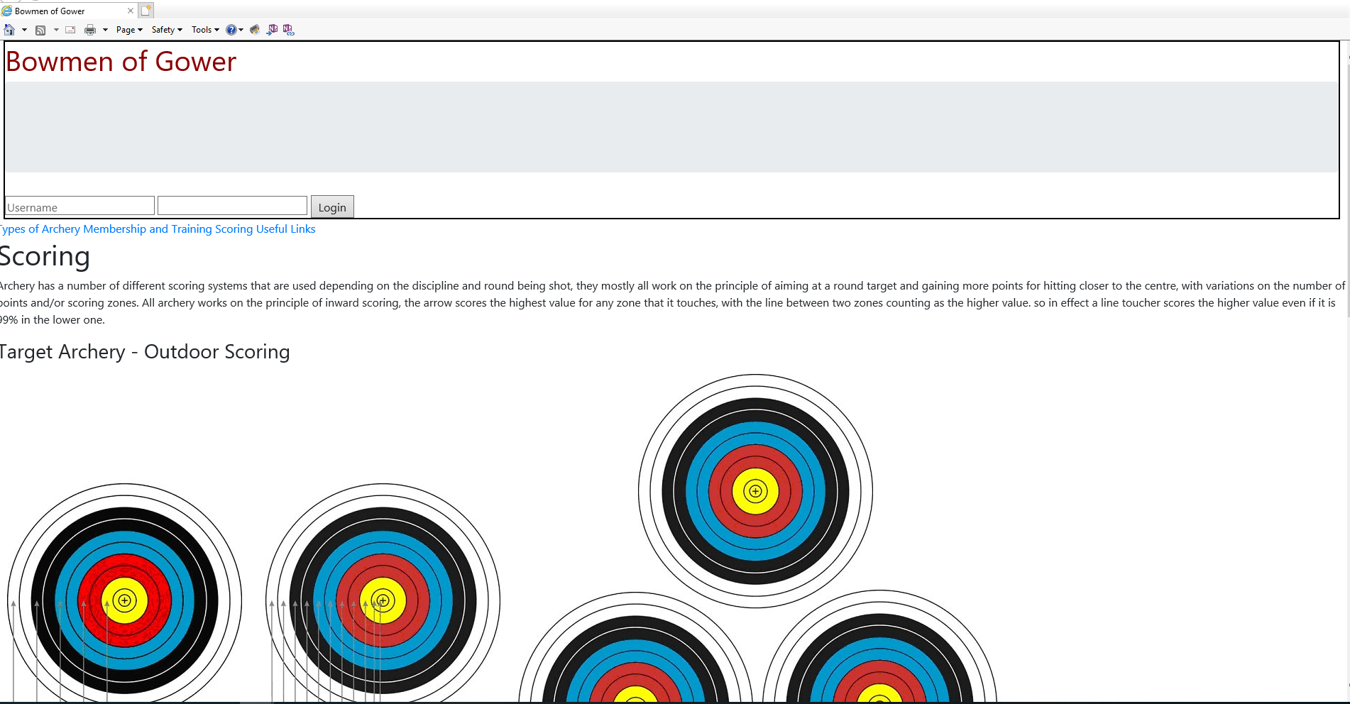
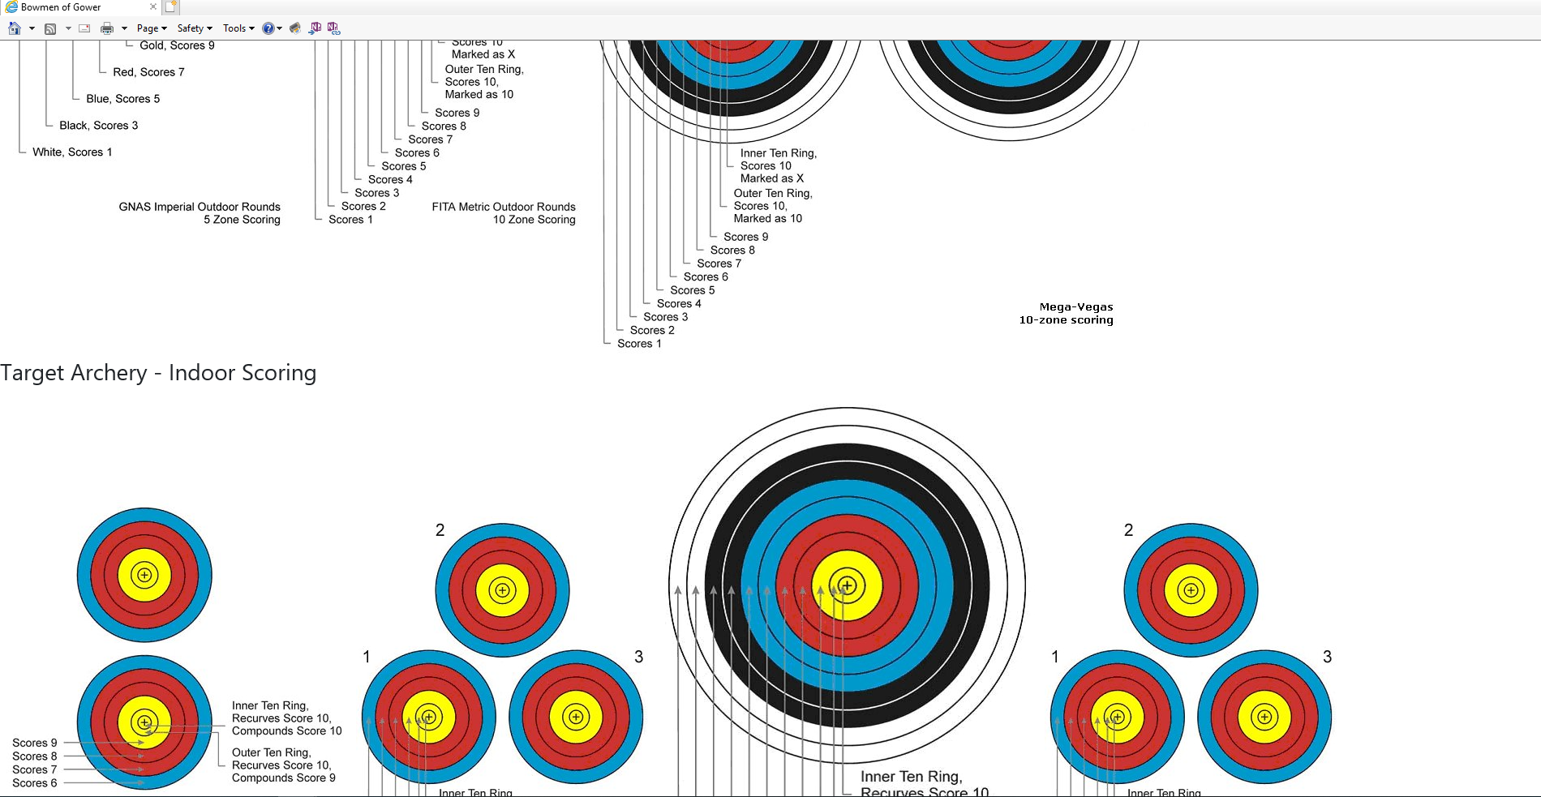
The page continues beyond this point.

This is the Useful Links Page

This page shows links to affiliated clubs of the Bowmen of Gower, along with the main ruling body in the UK. The Header follows the form of the homepage with Bowmen of Gower title, Login form and hoverover links to the other pages of the website. Whilst div classes were set on the HTML page ready to go to CSS sadly the author ran out fo time, hence there is a poor layout to this page. The website footer is a copyright symbol along with the authors name.
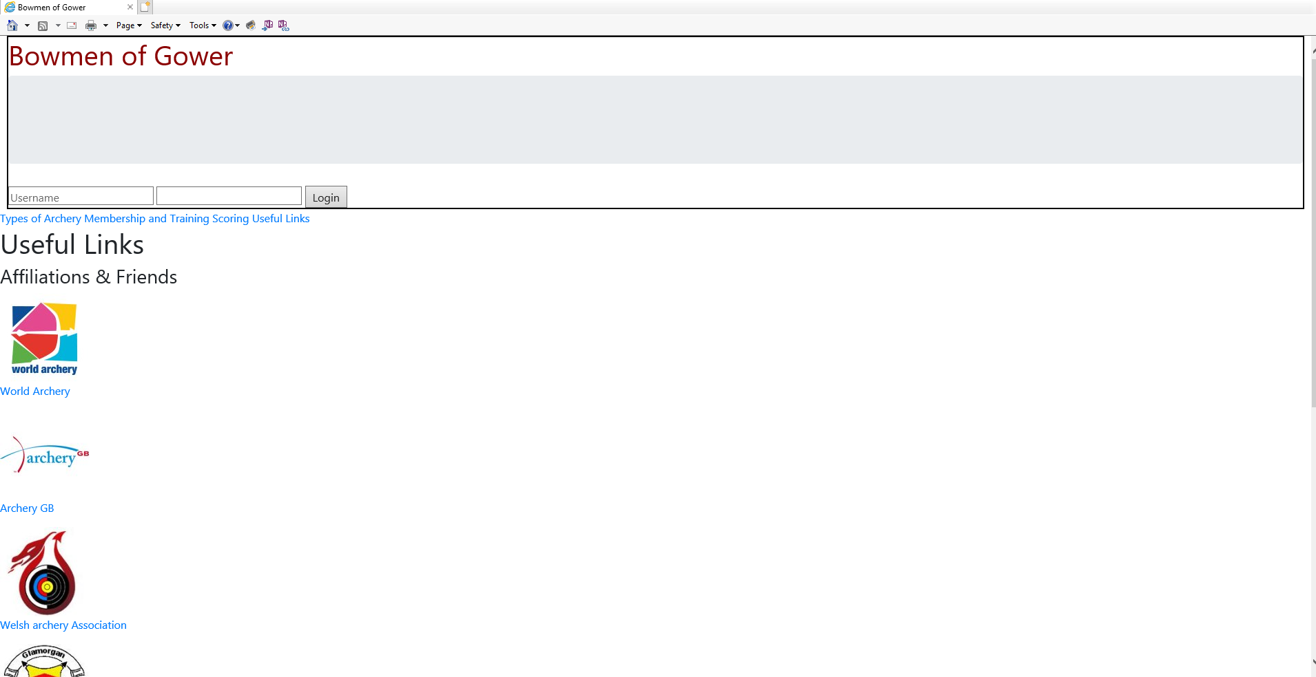
This page also continues beyond this point, whilst some of the hyperlinks do work, some were made up for the purpose of demonstration.

Validation

Using the validation tool for HTML on the website http://validator.w3.org, the homepage code was entered. Follows is a screenshot of the results.
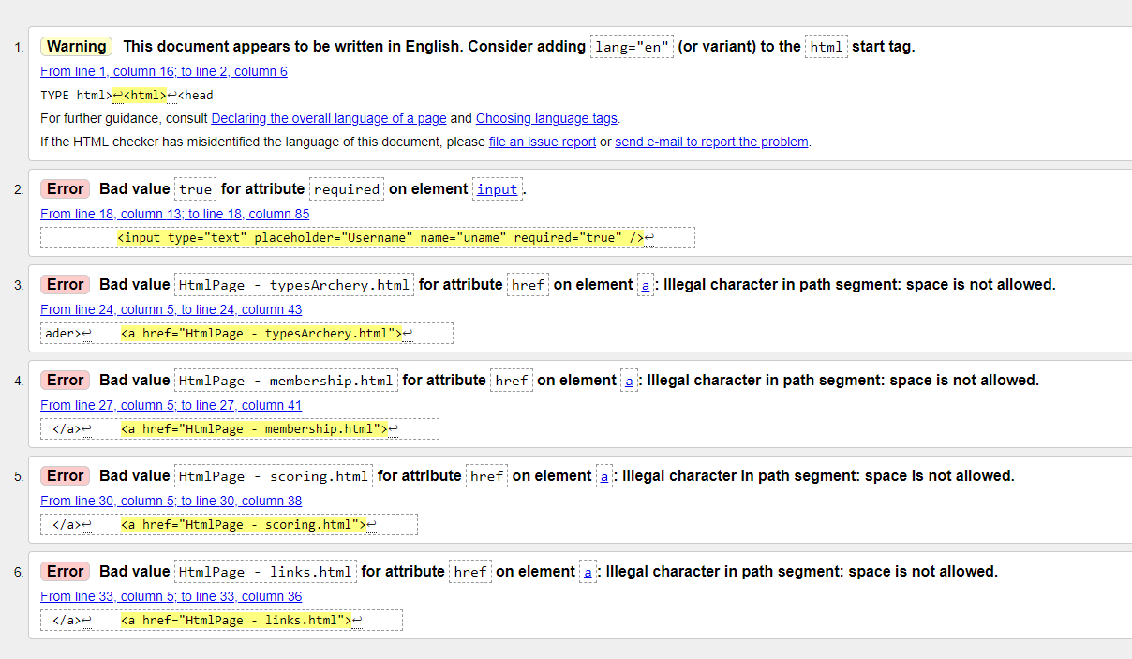
The first error refers to value true on line 18 of the homepage. Due to an age related error of taught slides relating to an older version of HTML the author assumed that the code should set required to true, but in HTML 5 it is now no longer set, with the login form appearing on every page of the website. This error was repeated throughout. A simple correction of deleting ‘=”true” on that line of each page would correct the error.
There is one main recurring error of putting spaces into the various links to other pages. This would be easily rectified but simply removing the spaces or inserting other non-defined characters to ease page naming. Whilst it did not effect the way the website worked on Internet Explorer, to adhere to standards, each link name should be changed to follow the correct naming as other browsers may be effected by it.
The other points highlighted are to define the language as English.

The CSS was validated on the website http://jigsaw.ws.org/css-validator/. As can be seen from the screenshot below no errors were found.
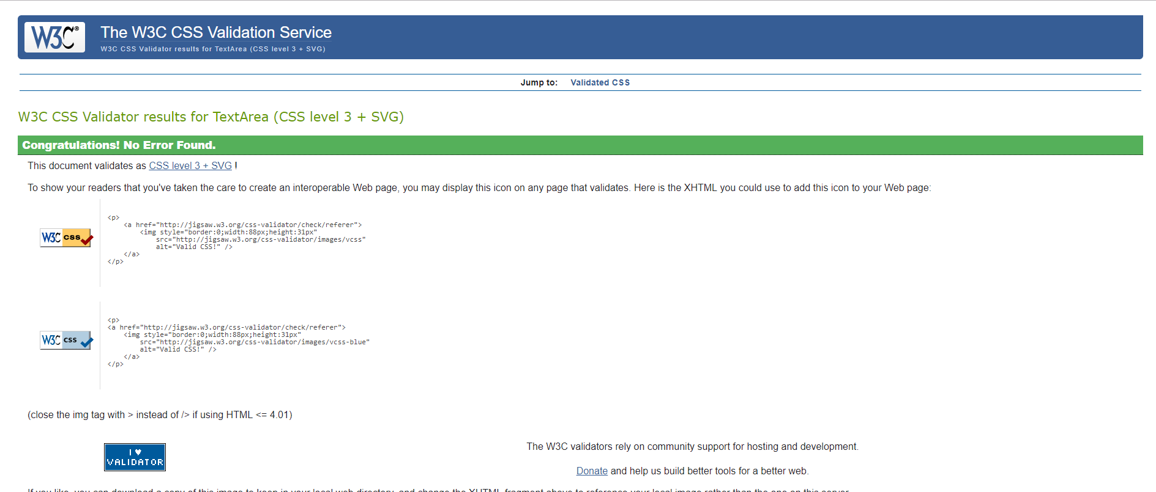

Evaluation

Accessibility Evaluation of the Website
This was tested on the Visual Studio software. Below are the test results from the Homepage.
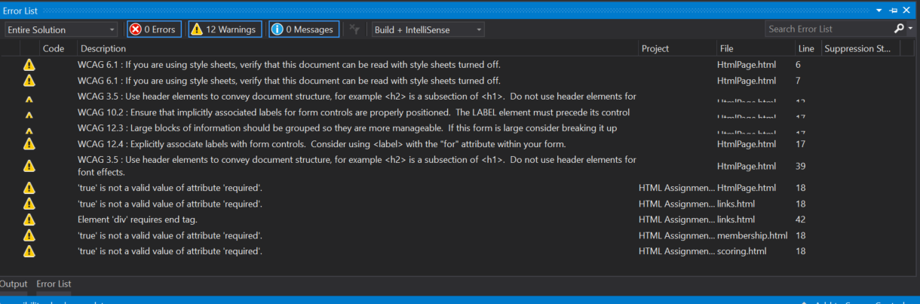

The first 2 points regarding making sure the website could be read were disregarded as this project specified using CSS along with Bootstrap. The next point shows poor practice where the writer used header elements for font effects as apposed to showing the HTML document structure. The next few points refer to the structure of the form writing, specifically in using the LABEL element. The <label> element does not render as anything special for the user. However, it provides a usability improvement for mouse users, because if the user clicks on the text within the <label> element, it toggles the control[3]. This would be a quick fix. Next again on line 39 the writer is picked up on poor practice of using different header elements for font effects instead of the correct use in document structure.
The True attribute issues on line 18 refer to the issue of the login form which was described in the validation, with a tested and functioning resolution shown.
The only other issue shown on the accessibility test in Visual Studio was a Div element not being closed. This was easily found and by simply adding </div>, the problem was resolved.

General Evaluation
Whilst the site is functional on Internet Explorer, it proved to have issues opening on other browsers, it is assumed by the author that this is due to issues loading the style sheets.
In General, the homepage is lacking anything to draw the users interest with it being all text. It could be improved with graphics, images and animations. Putting the history of the club on a new page while keeping the homepage of a more general idea would be of more interest to the user.
Adding a form to the membership page to allow users to express an interest would be of benefit as currently there is no means of potential new members contacting the club.
On the links page, arranging the links and images in set block and inline elements on the page would stop the user having to scroll as much to access the links at the bottom of the page.
The recurring errors found of using different level of heading tags simply as for font effects throughout the website is poor writing and could be rectified easily.

References

[1] “Introduction to HTML.” [Online]. Available: https://www.w3schools.com/html/html_intro.asp. [Accessed: 11-May-2019].
[2] “CSS Introduction.” [Online]. Available: https://www.w3schools.com/css/css_intro.asp. [Accessed: 11-May-2019].
[3] “HTML label tag.” [Online]. Available: https://www.w3schools.com/tags/tag_label.asp. [Accessed: 24-May-2019].

