BRIDGET RILEY INSPIRED PATTERN WORKSHOP

Create numerous designs; stripes, checks and spots…

You can use Photoshop or Illustrator do this.

File > New > 10cm x 10cm @300dpi

View > New Guide > 50%

View > SHOW > GRID

Use the rectangular marquee tool to fill areas; monochrome first – save a version BLACK & WHITE

Then apply colour; use the Bridget Riley inspired images over leaf for colour reference please.

Use the Picker colour tool & Paint Bucket tool to

Select > All
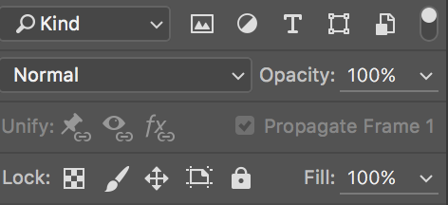
Edit > Define Pattern
New > Fill Layer > Pattern > Change scale etc.

You can also adjust the canvas size – Image > Canvas size
- if you want to adjust the files size of the tile…

PLAY & STACK LAYERS

- Use the opacity within the layers and adjustments panel to have elements coming through each other
- Use your layers palette
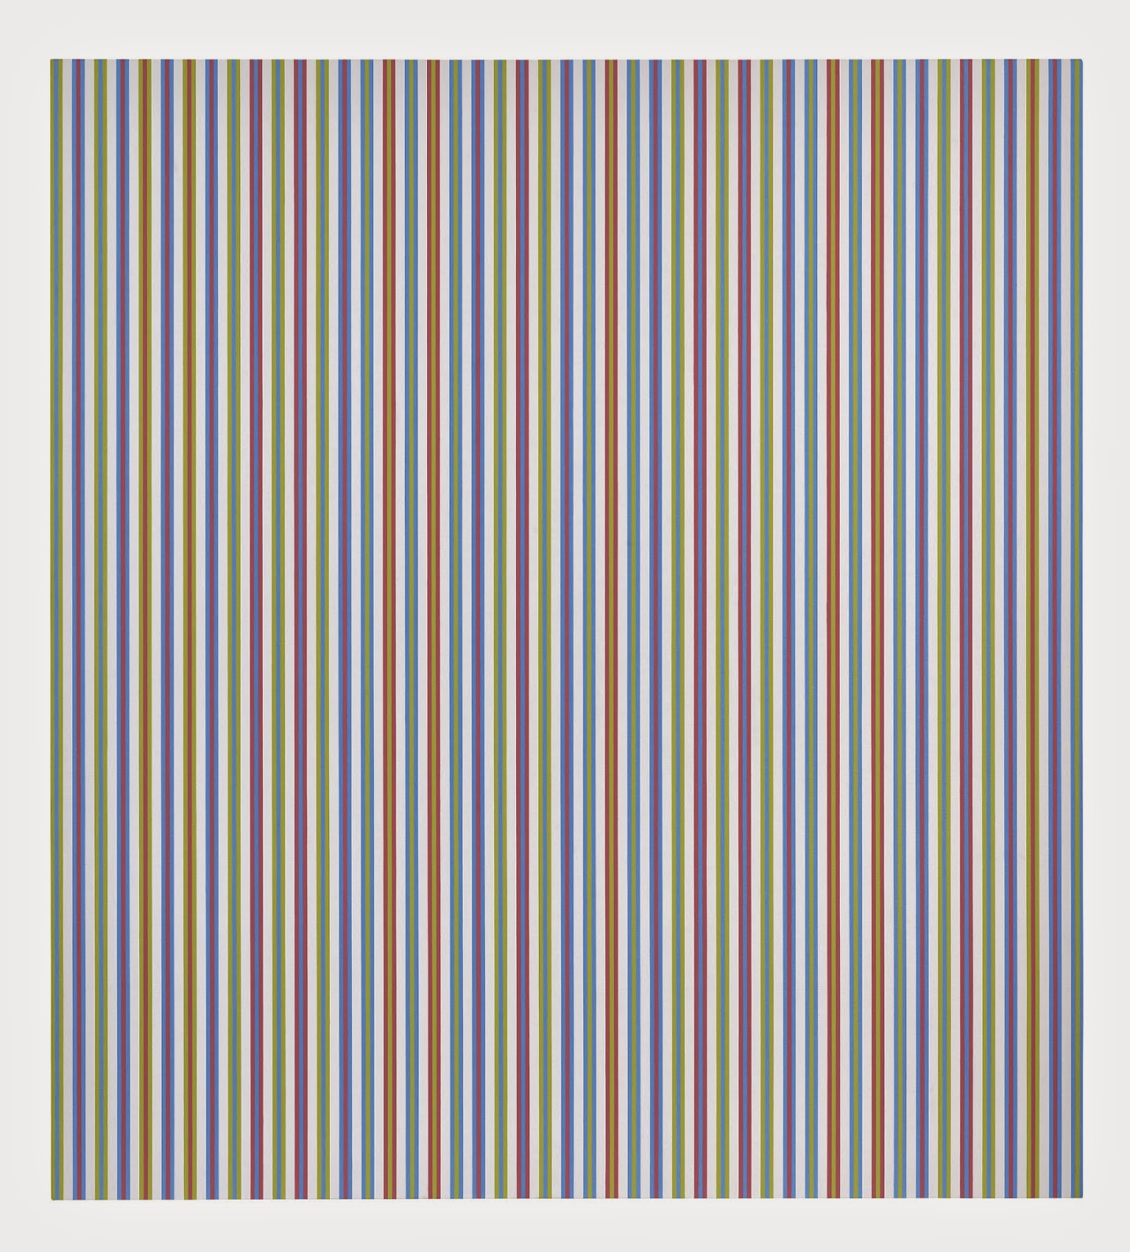
- USE – FILTERS to adjust the stripes into WAVES – FITLERS > DISTOT >WAVE


