
Haruna Kolley 2539053
Task 1 – Reading Task Template the main map
Upload your photo of your A3 in-class notes here:
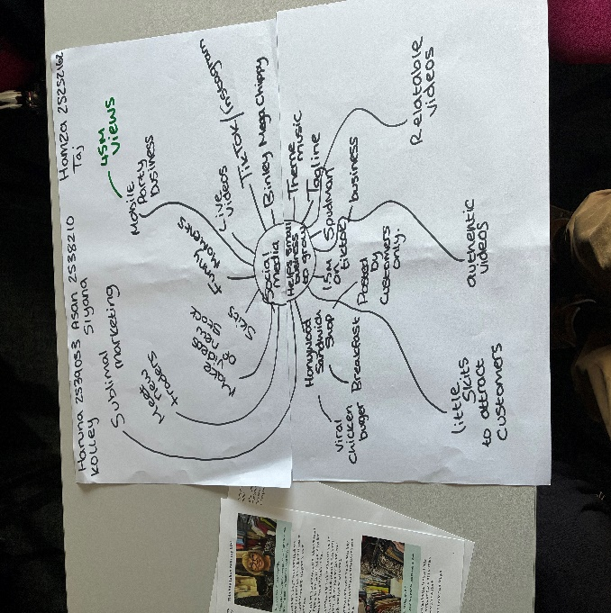

1. Answer these questions using the sentence starters below
a. What is the main idea of the text?
The main idea is that social media help small businesses grow

b. What are two key points?
One key point is the main idea is key detail andignore less important
Another key point is the key details
c. What part of the text did you find most important? Why?
The most important part is the map to structure ideas using key words
d. Was anything unclear or difficult to understand?
I was not sure about well understanding
e. How did your group help you understand the text better?
My group helped me by understanding the main map and text
3. One sentence reflection
Question: What did you find challenging about this task?

