I confirm that I have not used any AI tools in the research and creation of this assignment. I confirm that I have not presented any AI generated materials as my own work. I confirm I have copies of my drafts, notes, and other resources I used, which I may be asked to provide in evidence.

Contents Page
- Reflective Piece
- Reference List
- Mission and Values
- Supervision/Debrief Sessions
- Minutes
- Appendices
a. Placement Application
b. Emails to Placement
c. Approval of Placement from University
d. Placement Information Form
e. Placement Hours

1000 Word Reflective Piece
Gibbs’ Reflective Cycle
Description
I have been volunteering with a service that supports individuals with a history of sexual offence as they reintegrate safely into the community. The model is based on Circles of Support and Accountability (CoSA), which brings together trained volunteers to provide structured support and relational accountability (Almond, Bates and Wilson, 2015). CoSA positions volunteers as part of the deliberative public, helping bridge the gap between the client and the wider community while contributing to risk reduction. Research has shown that this model can reduce recidivism and support safer reintegration (Duwe, n.d.).
My role has involved attending weekly meetings as part of a group, contributing to discussions about the client’s progress, and helping to identify areas where the client may need encouragement, boundaries or additional support. Alongside this, we collaborate with professional services such as probation, who offer guidance and oversight to ensure that both the client and volunteers are supported appropriately.
Feelings
Before starting the role, I did not feel apprehensive about working with someone with a sexual offence history, as I had supported similar client groups before. What felt unfamiliar was doing this work as a volunteer rather than as a professional. CoSA’s deliberately collaborative structure (Almond et al., 2015) required me to adjust to a different sense of identity and responsibility.
I also felt some discomfort when volunteers with no prior experience expressed preconceptions in front of the core member. This contrasted with the non‑judgemental, person‑centred values that support engagement and psychological safety (Joseph, 2025) and with the autonomy‑supportive stance central to Motivational Interviewing (Hohman, 2024). At times the atmosphere felt tense, and I worried about how this might affect the core member’s trust. Discussing these concerns with the coordinator helped me process the emotional impact, reflecting the role of supervision in supporting reflective and ethical practice (Hawkins et al., 2012).
As the circle progressed, the structure and support from the coordinator and probation services helped me settle into the role and I became more confident navigating the peer‑based nature of the work.
Evaluation
Evaluating the experience, the shift from professional to volunteer required meaningful adjustment. Drawing on wider CoSA research, the collaborative structure prompted me to reconsider how support, authority and boundary’s function when work is shared between volunteers and professionals. This helped me reconsider how support can be offered in a community‑based rather than professionally led context.
The presence of volunteers with limited experience highlighted the importance of shared values within the circle. Moments where judgement was expressed risked undermining the relational conditions that support engagement, such as empathy and acceptance (Joseph, 2025) and conflicted with the non‑judgemental stance emphasised in Motivational Interviewing (Hohman, 2024). Bordin’s framework helped me understand how sensitive the working alliance can be to relational tension, which I noticed during points where the group dynamic felt unsettled.
Supervision played a key role in helping me evaluate these challenges. Hawkins et al. (2012) describe supervision as a space for containment and ethical reflection and addressing concerns there helped maintain the integrity of the circle. Overall, the experience strengthened my confidence and highlighted the value of reflective practice in managing complex interpersonal dynamics.
Analysis
Reflecting on the experience, I recognised how the circle structure creates a space where support and accountability operate together. The involvement of volunteers offers the core member consistent pro‑social contact, helping reduce isolation which is a factor linked to increased risk of reoffending in CoSA research (Wilson et al., 2009). This relational focus aligns with counselling approaches that emphasise containment and the development of healthier interpersonal patterns and echoes ideas within group and relational work (Yalom and Crouch, 1990).
My reflections also highlighted how wider societal stigma surrounding sexual offences can shape volunteer attitudes. Although I was familiar with this client group, I observed how some volunteers’ preconceived views influenced their interactions. This reinforced the importance of self‑awareness and ethical sensitivity, as personal biases can interfere with the purpose of the intervention. Thompson and Thompson (2023) emphasise that critically reflective practitioners must examine the assumptions they bring into their work and this became evident within the circle.
The discomfort I experienced when navigating differing perspectives or discussing risk made more sense when viewed within the emotionally complex nature of high‑risk environments. Rather than signalling inadequacy, these reactions reflected the challenge of balancing empathy, boundaries and accountability which are core elements of effective relational practice (Joseph, 2025 and Hohman, 2024). Over time, I became more confident contributing to discussions as I learned to trust both the structure of the circle and my developing counselling skills.
The involvement of probation services provided essential oversight and ensured that volunteers were not left to manage complex situations alone. This highlighted the importance of recognising the limits of one’s competence which is a key ethical requirement in counselling and demonstrated the value of collaborative multi‑agency working in supporting safe reintegration (Hawkins et al., 2012).
Conclusion
In conclusion, this volunteering experience has been both professionally and personally meaningful. It enabled me to apply and further develop core counselling skills such as active listening, empathy and maintaining appropriate boundaries within a sensitive and complex context. Working within the circle reinforced the importance of creating a supportive non‑judgemental environment while still holding space for accountability and risk awareness. It also highlighted the need to recognise the limits of my role as a volunteer and to rely on the expertise of the coordinator and probation services when situations extended beyond my competence.
The challenges that emerged, particularly around differing volunteer perspectives and the emotional demands of the work, emphasised the value of ongoing self-reflection and supervision. These experiences strengthened my understanding of ethical practice, the impact of stigma and the importance of collaborative multi‑agency working in supporting individuals with complex needs. Overall, the placement has contributed significantly to my learning and enhanced my self-awareness, professional judgement and confidence in applying counselling related skills in real world settings.
Action Plan
Going forward, I plan to continue developing my counselling skills through regular reflective practice, paying particular attention to my emotional responses, use of empathy and ability to maintain a non‑judgemental position. I intend to pursue further training in areas such as trauma‑informed practice and risk awareness to strengthen my confidence when working with sensitive or complex material.
I will also make consistent use of supervision and the guidance of coordinators and professionals, recognising the limits of my role and the importance of seeking support when situations extend beyond my competence. In addition, I aim to set ongoing personal development goals focused on enhancing my communication skills, managing differing perspectives within group settings and building the professional self-awareness required for future counselling practice.

Reference List
Almond, P., Bates, A., & Wilson, C. (2015). Circles of support and accountability: Criminal justice volunteers as the 'deliberative public'. British Journal of Community Justice, 13(1), 25.
Bordin, E. S. (1979). The generalizability of the psychoanalytic concept of the working alliance. Psychotherapy (Chicago, Ill.), 16(3), 252–260. 10.1037/h0085885
Duwe, G.Promise and potential of circles of support and accountability: A SEX OFFENDER REENTRY PROGRAM. American Enterprise Institute.
Hawkins, P., Shohet, R., Ryde, J., & Wilmot, J. (2012). Supervision in the helping professions. McGraw-Hill.
Hohman, M. (2024). Motivational interviewing: Helping people change and grow (4th edition). william R. miller and stephen rollnick. Oxford University Press. 10.1093/sw/swae040
Joseph, S. (2025). The humanistic psychology of carl rogers : Understanding the person-centered approach (1st ed.). Oxford University Press. 10.1093/9780197790632.001.0001
Thompson, S., & Thompson, N. (2023). The critically reflective practitioner. Bloomsbury Academic.
Wilson, R. J., Cortoni, F., & McWhinnie, A. J. (2009). Circles of support & accountability: A canadian national replication of outcome findings. Sexual Abuse, 21(4), 412–430. 10.1177/1079063209347724
Yalom, I. D., & Crouch, E. C. (1990). The theory and practice of group psychotherapy. British Journal of Psychiatry, 157(2), 304–306. 10.1192/S0007125000062723

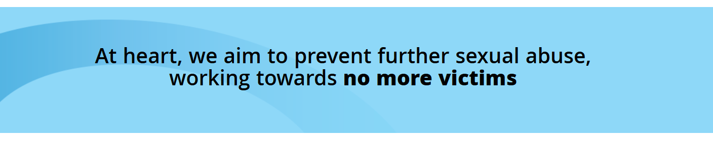
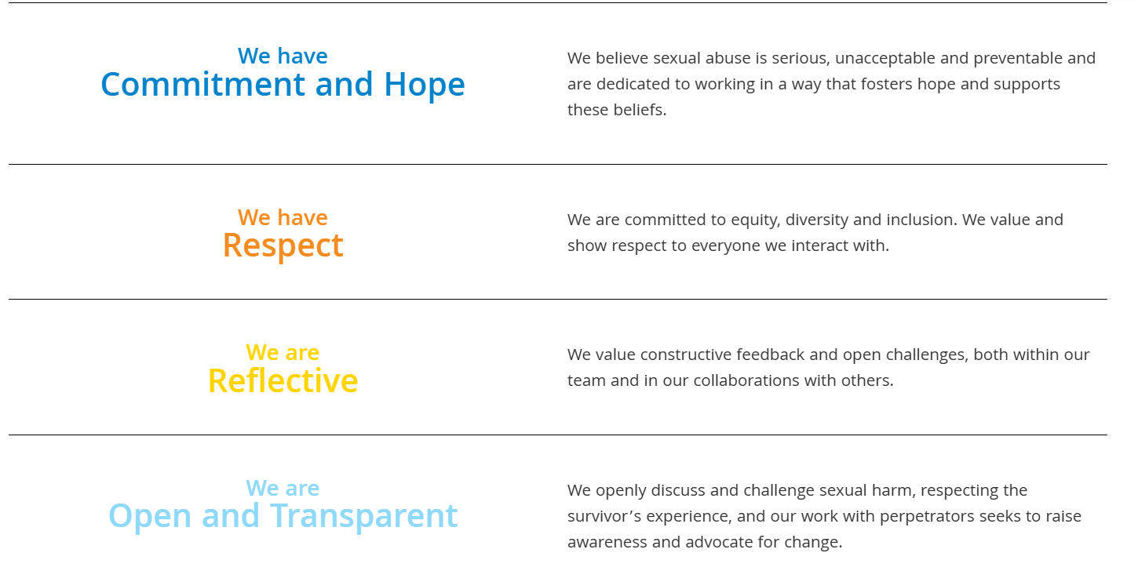
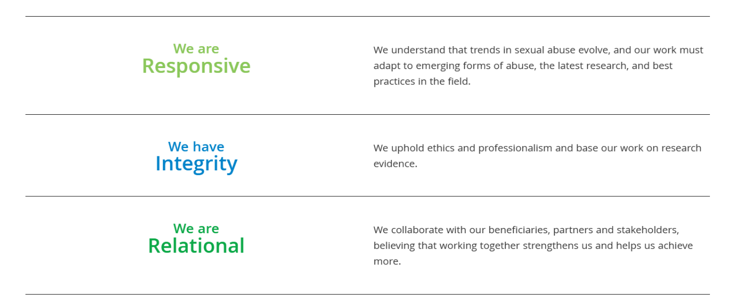
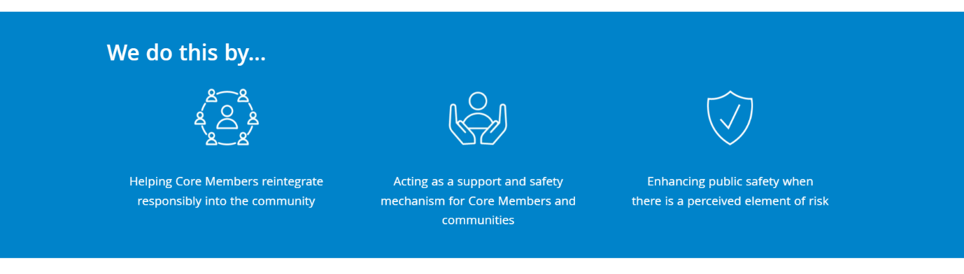
Circles UK – Aims and Values
Taken from circles-uk.org.uk
Circles of Support and Accountability are described by Circles UK as a community-based initiative that works with people who have committed sexual offences to help them live safe, productive, and accountable lives in the community. The model brings together trained volunteers who meet regularly with a core member to offer support, challenge, and consistent contact. Circles UK emphasises that this work is carried out in partnership with statutory agencies, including probation, police, and safeguarding teams, and that volunteers play a central role in offering both support and accountability.
Circles UK highlights that Circles help reduce the risk of sexual harm by addressing factors such as isolation, emotional wellbeing, stability, and engagement with services. They also emphasise the importance of community involvement in reducing harm and improving public safety. Their approach is based on creating safe, structured relationships in which core members can be open about challenges, discuss risks, and work towards safer behaviour, supported by volunteers who are trained to notice concerns and communicate them appropriately.
From a counselling perspective, many aspects of the Circles model align with core therapeutic principles, even though Circles is not a counselling service. The work relies on building safe, respectful, and non-judgemental relationships, and volunteers use interpersonal skills such as active listening, empathy, and clear communication. These skills help create an environment where core members can reflect on their behaviour, explore risk factors, and develop greater self-awareness. The emphasis on accountability also mirrors psychological approaches that encourage individuals to recognise the impact of their actions and take responsibility for change. In this way, Circles draw on relational and reflective practices that are central to counselling and psychological support, while maintaining clear boundaries and a focus on community safety.
In Wales, Circles are delivered by Adferiad and St Giles Trust, who work together to provide the service across Wales. Adferiad is a Welsh organisation that supports people and families affected by mental health issues, substance use, and other complex needs, offering integrated, person-centred services across communities in Wales. St Giles Trust is a charity in the UK that helps people facing poverty, exploitation, abuse, and involvement in the criminal justice system, providing practical support and opportunities to build positive futures. Together, Adferiad and St Giles recruit and support volunteers, coordinate Circles in line with Circles UK quality standards, and work in partnership with probation, police, and safeguarding teams to ensure that each Circle operates safely and effectively. Their collaboration ensures that Circles in Wales are delivered consistently with the national model and remain accessible to core members across the region.

Supervision/Debriefs
At the end of each circle meeting, there was an informal 30-minute supervision/debrief with the circle’s coordinator. This space allowed us to check in on our emotional responses, ensure volunteers felt safe and supported, and confirm that the core member had left the area before discussing anything sensitive. These regular debriefs provided a consistent opportunity to reflect on the session, raise concerns, and think through how to approach issues in future meetings. Over time, this structure strengthened my confidence in using supervision as a reflective tool and deepened my understanding of how to work safely and ethically within my volunteer role.
Session 1
In the first debrief, my focus was on settling into the volunteer role and understanding how the circle operated. I spent much of the session observing the group dynamic, noticing how the core member engaged, and asking questions about boundaries and expectations. This early clarification helped me understand the limits of my role and supported my ability to use counselling-related skills, such as active listening and attentive observation without stepping outside my remit.
Session 2
By the second week, I had noticed emerging patterns in the group dynamic, including moments where comments from volunteers felt slightly judgemental. I raised this privately with the coordinator rather than in the group, as it felt more appropriate. As a group, we also reflected that we were beginning to gain a clearer sense of how isolated the core member might be, although we were still gathering information. The supervision discussion helped us think about how to continue building rapport while maintaining a non-judgemental stance. This strengthened my ethical sensitivity and reinforced the importance of respectful communication in creating a safe and supportive environment which was crucial to keep the core member engaged with circle support.
Session 3
In the third debrief, we collectively reflected that the core member appeared quite isolated and might benefit from more structured social contact. Although everyone recognised the issue, there was understandable hesitation about who felt comfortable to raise it, given its sensitivity. When the coordinator suggested that someone could introduce the topic gently, I offered to do so as I felt able to approach it in a supportive way. Together, we discussed how to frame the conversation so it conveyed care rather than criticism. This planning process strengthened my ability to communicate difficult topics with empathy and clarity while remaining firmly within my volunteer boundaries.
Session 4
During this session, it was already previously agreed as a group that it was an appropriate moment to share our collective concern about isolation with the core member. As volunteers, we discussed how to approach the topic sensitively in the previous supervision, and I offered to raise it as I felt able to do so in a calm and supportive manner. I explained to the core member that the volunteers had noticed they might be feeling quite isolated and gently explored possible ways of increasing appropriate social connection. I aimed to balance encouragement with clarity about the importance of maintaining engagement with others, while ensuring the conversation remained respectful and non-judgemental. In the debrief afterwards, both the coordinator and the group felt the discussion had been handled constructively and that the concern had been communicated in a helpful way. This feedback strengthened my confidence in using counselling-related skills such as empathic communication, active listening, and sensitive boundary-keeping, and reinforced the value of collaborative decision making when addressing sensitive topics.
Session 5
In the fifth debrief, we reflected on how the core member had responded to the previous conversation about isolation. I shared that they seemed to have taken the feedback on board and had been more open during the session, including talking more freely about their week and the steps they had taken to increase their social contact. As volunteers, we considered how to sustain this positive engagement while remaining mindful of their pace, comfort, and any appropriate risks, taking a person-centred approach to ensure our support aligned with the core member’s readiness. As a group, we felt confident that the balanced approach we had used so far remained suitable. This discussion strengthened my understanding of the importance of pacing, sensitivity, and active listening in group work, and enhanced my ability to adapt my communication to the core member’s needs. It also reinforced how counselling-related skills, such as empathic listening, non-judgement, risk awareness and clear boundary-keeping can support engagement and encourage meaningful progress within a non-therapeutic volunteer role.

Session 6
The circle meetings had been cancelled for a couple of weeks due to the core member not attending. A few weeks after the fifth session, I received a phone call from the coordinator informing me that the core member had chosen not to continue with the circle. I was told that he felt he no longer needed the support, and as the service is voluntary, he had the right to withdraw at any time. The call provided space to process my feelings about the unexpected ending and reflect on the work we had done as a group. We discussed the progress the core member had made, the supportive role we had played, and how to make sense of endings that happen suddenly in this type of work. This final conversation helped me consolidate my learning from the placement. The experience deepened my understanding of endings in support work and reinforced the importance of supervision in managing emotional responses and maintaining professional boundaries. It also strengthened my awareness of the need for flexibility, resilience, and reflective practice when working in settings where engagement can change quickly.

Circle Minutes
Please do not use any identifying information in this document.
Refer to the CM as simply ‘CM’ and to the volunteers by first names only.
Do not give venue information.
(To be completed by a volunteer after each meeting)
CORE MEMBER ID:

RESTRICTED

Date of Meeting: | 21/11/25 | Circle Code: |  | Minutes completed by: | Emily
Record of any contact since last meeting:
Circles Members present: | Emily, Kelly, Claire
What was discussed at this meeting: | CM has attended Men’s Shed this week and the local community centre where he has been socialising and making positive relationships with peers. Says the building he lives in has been quieter recently (there has been previous issues with noise disturbance) which is positive and his window has been replaced.  CM continues to keep himself busy when at home with hobbies and walking the dog.  Encouraged by the group to meet with his mother as he hasn’t seen her for a couple of weeks and CM says their relationship is positive and supportive.  CM says his sleep is still poor and is currently experiencing night terrors, however says he is managing this.
Positive  Developments: | CM has attended Men’s Shed again and the local community centre for lunches and socialising this week which is a positive development.
High Level Outcomes  (Not all high-level outcomes will be achieved in one session) | - Develop improved self-efficacy, resilience, and ability to recognise and manage triggers to worsening well-being.  - Have an increased ability to build and maintain appropriate social interactions.  - Have an increased ability to engage with and access support services.  - Making effective transitions from the structured prison environment to the community (where appropriate).  - Support early post-release engagement with community-based services where appropriate.  - Develop and sustain social networks to reduce social isolation.  - Develop an improved pro-social self-identity and ability to access community-based support networks. ·  - Sustain engagement in pro-social leisure interests and purposeful activities.  - Risk to be managed effectively by identification of potentially risky behaviour/lifestyle deterioration, and appropriate action to be taken.
Risk Issues/ Areas of Concern: | CM is experiencing night terrors which is resulting in poor sleep currently. CM advised to monitor this and access support if continues.
Any new/ significant information: | None
Actions arising: (including details of who is responsible & timescale) | CM to bring logbook next week.
Date of next meeting | 28/11/25

For Co-Ordinator use only
Who has been informed of Risk Issues/ Areas of Concern:
Outcome:

Appendices

https://adferiad.org/
VOLUNTEER APPLICATION FORM
This form is confidential
Name: Emily Lewis-Richards

Address: 1 Club Row, Clydach, Monmouthshire, NP70NE

Email Address: elewisrichards@aol.co.uk

Phone Number: 07413011020

Current occupation/Volunteering role

Full time Student at University of Wales Trinity Saint David.

Hobbies/Interests

Walking with my dog George, live music, reading, spending time with my friends and their children

Why do you want to volunteer with Adferiad?

As part of a Level 5 module in university, I am required to undertake a volunteering role. I have learned about the work that Circles provide and would like the opportunity to take part.

What skills/qualities/experience could you bring to Adferiad?

I spent years working in a forensic mental health hospital before moving to community support working with women in the criminal justice system. My most recent job before starting university was working with men in the criminal justice system with wellbeing support.

I am currently studying Psychology and Counselling. I have a passion for mental health and working with people and hope to qualify as counsellor in my career.

Have you attended any training courses that could assist you in your volunteering role?

I have an up-to-date certificate in mental health first aid

How many hours and what days would you like to volunteer in a week?

Will depend on university hours, I will not receive my timetable until at least September 22^{nd.} I am expected to carry out 60 hours of volunteering.

Which area would you like to volunteer? (Admin, gardening, fundraising, etc)
Circles

Are there any health issues we need to be aware of?
I have Endometriosis, on occasion I may have painful days that may prevent me from attending.
Are you a current or ex Substance/Alcohol user?
No.

Knowledge of Welsh/English
English speaking
Do you hold a clean driving licence? Yes ☒ No ☐

Are you happy to drive as part of the volunteering role? Yes ☒ No ☐ N/A ☐

Have you ever been convicted of a Criminal Offence? Yes ☐ No ☒

How did you hear about us?
I have referred clients to Circles in previous roles.

Names and addresses of two referees (they should not be a relative, or a person with whom you live or share a house. They should be someone who can tell us about you as a person, e.g. your tutor, current or previous employer, a member of staff where you have volunteered, your neighbour, etc.)

Reference 1
Name: Jason Coombes
Address: The Cambrian Inn, Clydach, Monmouthshire, NP7 0LY
Phone Number: 07983532601
Email address: b20jlc@sky.com
How long have you known this person, and how? 3 years, my neighbour and I work in his pub sometimes to help out.
Reference 2
Name: Katie Chambers
Address: 33 De Winton Terrace, Llanbradach, Caerphilly, CF83 3JX
Phone Number: 07731510264
Email address:
How long have you known this person, and how? 5/6 years, we previously worked together in the same mental health hospital, Katie is now a qualified nurse and we remain friends.

Signature. E.Richards
Date. 27/08/2025

Please return the form to:
Volunteering Department, Station Court,
41 and 43 Station Road, Colwyn Bay, LL29 8BP.
Or email it to volunteering@adferiad.org

Email Correspondence
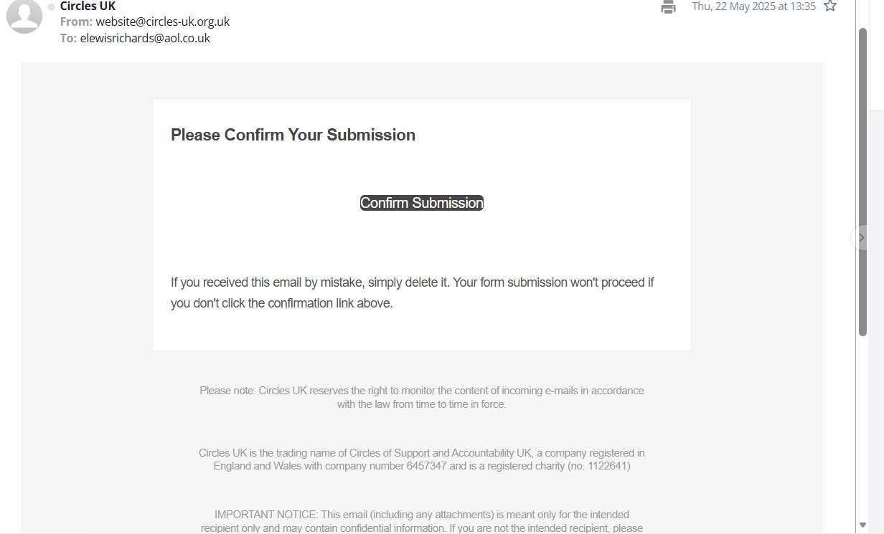

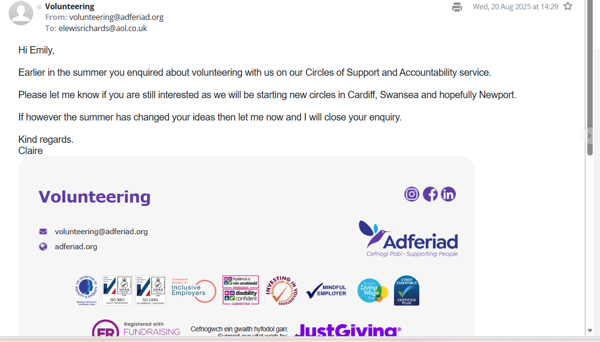
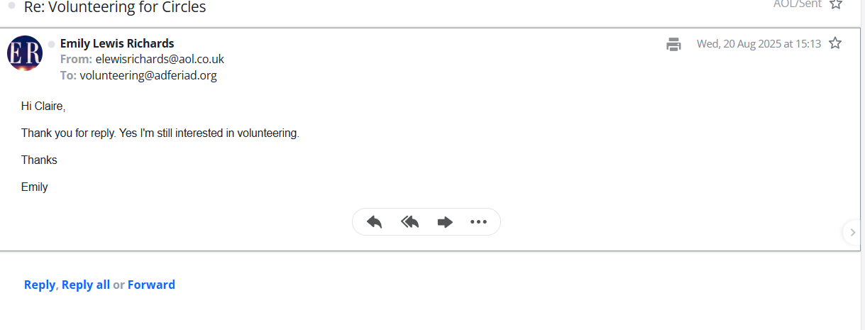
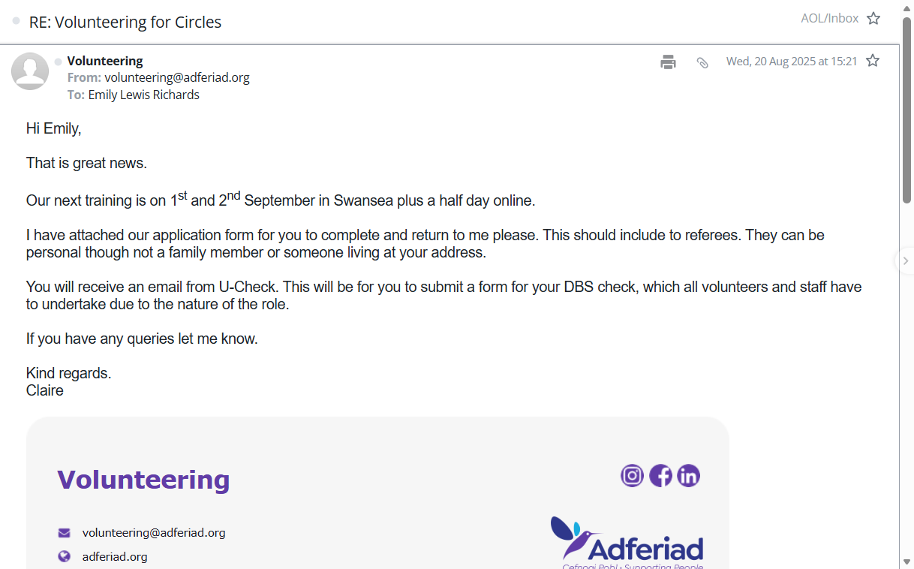
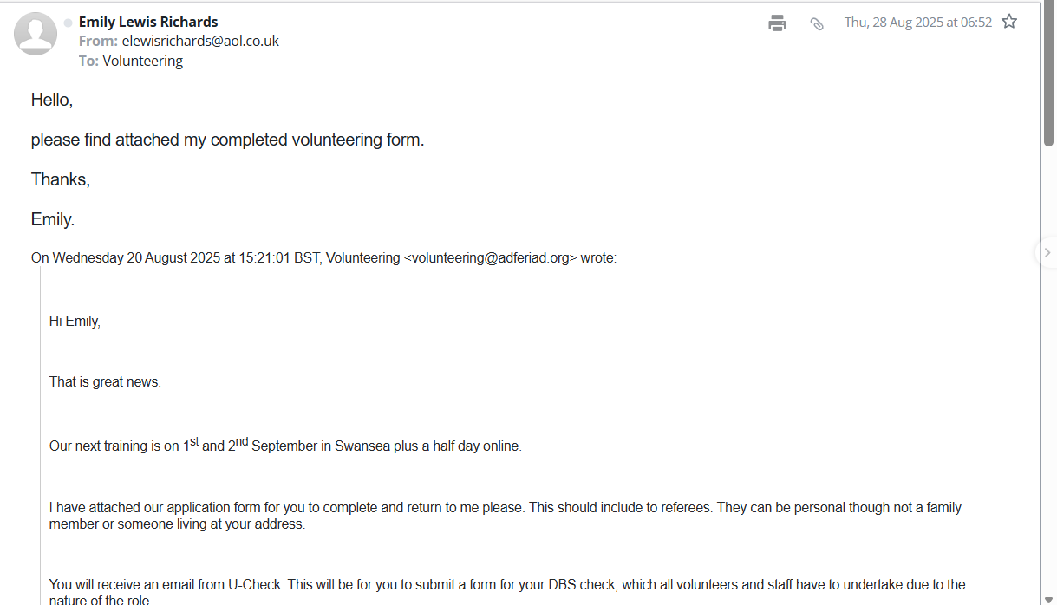

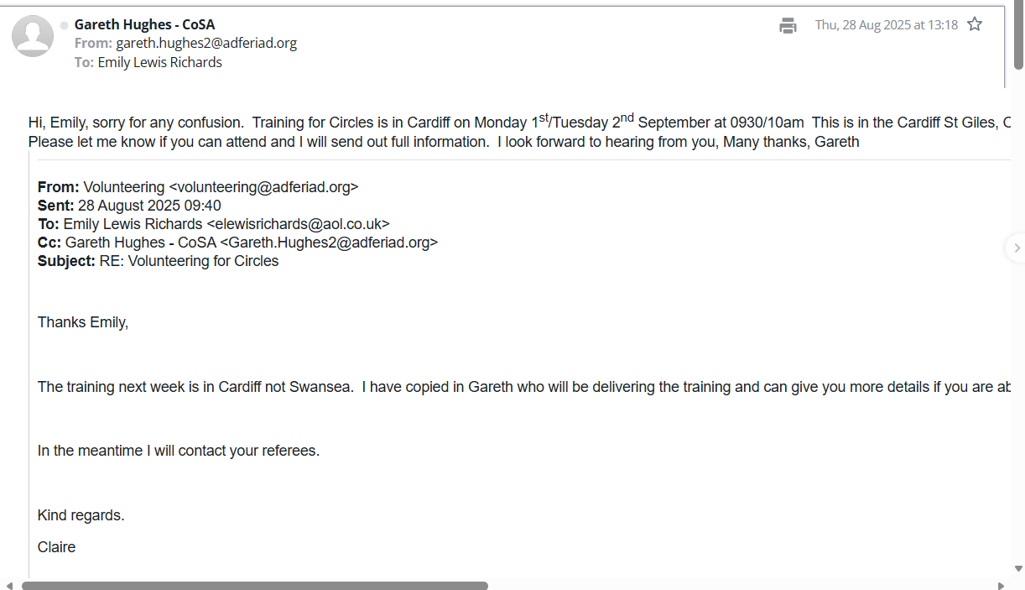
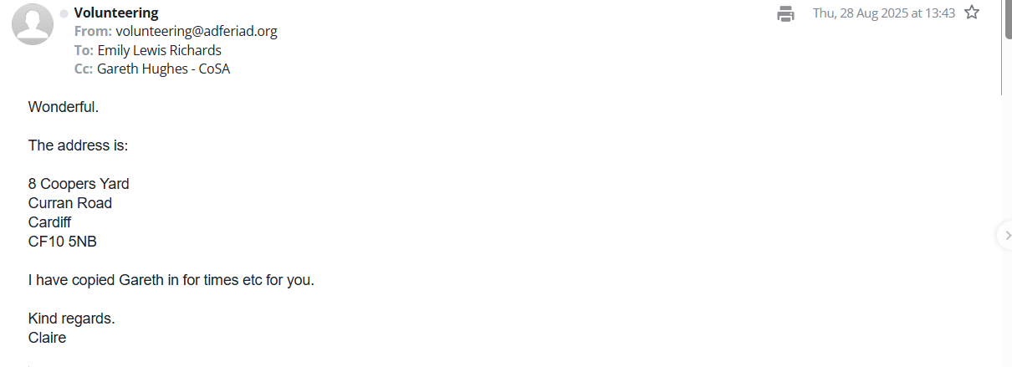

Placement Confirmation from University
Although I did not receive a written response, the confirmation of my placement hours was provided verbally.
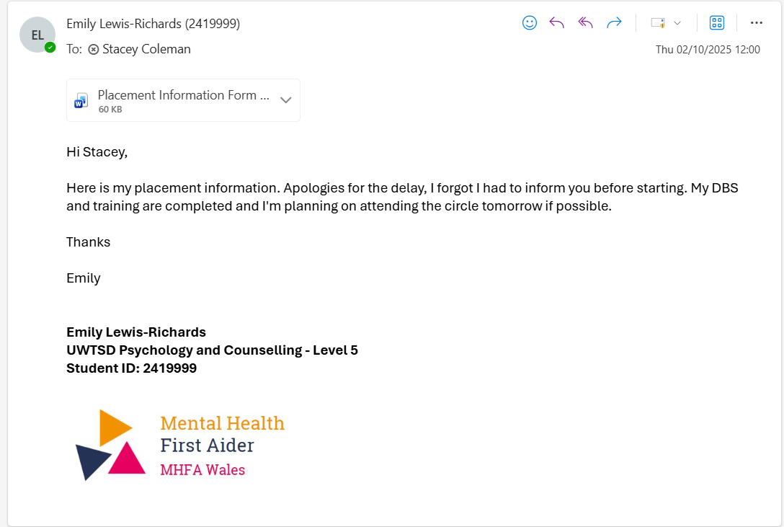
Placement Information Form
Name of student: | Emily Lewis-Richards
Proposed placement setting and address: | Circles  St Giles Trust, Cardiff
Proposed dates of placement: | Every Friday
Name and position of contact: | Gareth Hughes – Circles Coordinator
Contact email address: | gareth.hughes2@adferiad.org
Contact telephone number: | 07471992519
Is a DBS required for you to attend this placement? | - Yes  - No  If Yes, have you applied for this?  - Yes applied on 02/09/25  - No
Explain how your role in this organisation/on this placement meets the criteria for the assessment for the module  (e.g., what duties/tasks will you be undertaking that are relevant for the module assessment) | I will take part in a group of volunteers working with a core member that has been involved in the criminal justice system for sex offences. We will work as a group to integrate the core member back into society to support rehabilitation.


ALL information must be provided. Incomplete forms will be returned to the student.
Please return this form to Stacey Coleman (stacey.coleman@uwtsd.ac.uk) by no later than 12pm on Monday 1st July.

Proof of Hours
After my final contact with Circles, I experienced a delay in receiving confirmation of my completed hours. I followed up several times but did not receive a response until shortly before my submission deadline, when the coordinator provided the necessary sign-off in an email. Although the situation was resolved, it emphasised the importance of managing administrative uncertainties, maintaining professionalism, and planning for potential delays when working with voluntary sector organisations.



