University of Wales Trinity Saint David
Wales Institute of Science & Art



Improvement of cycle time and tool life for Xtrutech liners
Quality & Business Improvement (ACMA4004)

Liam Jones
2418894
September 2025

Content Table
Content Table 1
Figure Table 2
1. Abstract 3
2. Introduction 3
2.1 The effect of the issue 3
2.2 Aims and Goals 3
3. Root Cause Analysis 3
3.1 Fishbone Diagram 4
3.1.1 What is a Fishbone Diagram and why was it used? 4
3.1.2 Analysis of the Fishbone Diagram 4
3.2 Failure Mode and Effect Analysis 5
3.2.1 Developing a plan using the Failure Mode and Effect Analysis 5
4. Results from the testing 5
4.1 Check sheets 6
4.2 Data showing when each insert broke for each test 6
4.2.1 Turning the data into a clustered column 6
4.2.2 Analyzing the clustered column 7
4.3 How were the new feeds and speeds calculated? 8
5. Discussion 8
5.1 Were the goals of this report met? 8
5.2 What did the result mean? 9
5.3 What were the issues or errors in the report 9
5.4 Five Why analysis 9
6. Conclusion 10
7. References 10

Figure Table
Figure 1 – Fishbone Diagram for tool life and cycle time (Xtrutech) at FSG Tool & Die ...... 5
Figure 2 – Failure mode and Effects Analysis (Xtrutech) at FSG Tool & Die ...................... 6
Figure 3 – Check Sheet (Xtrutech) at FSG Tool & Die ...................................................... 7
Figure 4 – Multiple Tables showing when each insert broke (Xtrutech) at FSG Tool & Die . 7
Figure 5 – Multiple Charts showing when each insert broke (Xtrutech) at FSG Tool & Die . 8
Figure 6 – Table showing the increase on tool life per change (Xtrutech) at FSG Tool & Die 8
Figure 7 – Time taken per part and increase of production (Xtrutech) at FSG Tool & Die ... 9
Figure 8 - Selection Reference Table (Mitsubishi Material, 2022) .................................... 9

Abstract
This report examines the efficiency challenges in CNC machining at FSG Tool & Die, specifically in the roughing process for Xtrutech liners made from Clamax, a hard and sticky stainless steel that accelerates tool wear. The primary objective was to reduce cycle times and extend tool life, thereby increasing profitability and productivity. A fishbone diagram and Failure Mode and Effect Analysis (FMEA) were used to identify key issues, including incorrect tool selection, inefficient tool paths, and improper feeds and speeds. Experimental testing demonstrated that optimizing feeds and speeds increased tool life by 104%, while refining tool paths reduced cycle time by 50%. The combined changes led to a 100% increase in overall productivity. Despite minor inconsistencies, such as variations in stock size, the findings provide a reliable basis for improving CNC efficiency.

Introduction
In the world CNC manufacturing, the time spent roughing out material is often considered wasted, as it does not affect the final dimensions or appearance of the fished part. Therefore, removing material as quickly as possible is the most effective way to increase profit and production by reducing cycle times. This report will cover the manufacturing issue at FSG Tool & Die, in their milling section, however, with a twist. The material machined at FSG, Clamax, is exceptionally hard and sticky, leading to accelerated tool wear and frequent tip breakage.

2.1 The effect of the issue
This issue is somewhat of a major problem at FSG as the parts being made are liners for Xtrutech, which come in as mass orders sometimes between 25-50 which slows down the rate of production of other parts as there is not enough machines to run them alongside the Xtrutech.

2.2 Aims and Goals
The aim and goals of this report are to decrease the cycle time of the Xtrutech liners and to increase the tool life of the tips. Both will increase the profitability of the Xtrutech liners, by decreasing the amount of machine time spent, time spent changing tips and the cost of tooling.

3. Root Cause Analysis

3.1 Fishbone Diagram
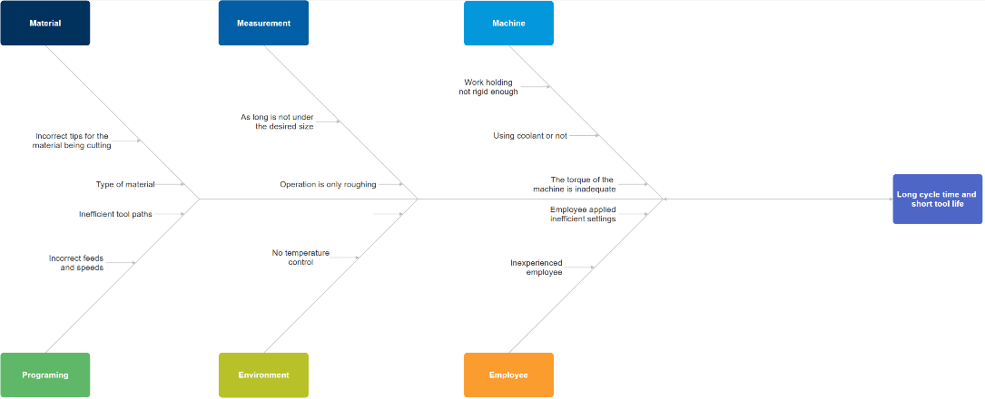
Figure 1 – Fishbone Diagram for tool life and cycle time (Xtrutech) at FSG Tool & Die (Jones, 2025)

3.1.1 What is a Fishbone Diagram and why was it used?
“A fishbone diagram, sometimes referred to as a cause-and-effect diagram or an Ishikawa diagram, is a quality tool that helps users identify the many possible causes for a problem by sorting ideas into useful categories.” ASQ (2024). It was used to quickly identify problems with the process of machining the liners.

3.1.2 Analysis of the Fishbone Diagram
The fishbone diagram identified several key areas for improvement in the machining process, including:
- Incorrect tips
- Inefficient tool paths
- Incorrect feeds and speeds
- Work holding not rigid enough
- The torque of the spindle
- No temperature control
Each of these factors impacts cycle time and tool life. Industry professionals also emphasize their importance:
- “Choosing the right cutting insert is crucial for optimal CNC machining performance” (Sacher CNC, 2023).
- “To reduce cycle time is to optimize the cutting parameters, such as the feed rate, spindle speed, depth of cut, and tool path.” (Farhat, Aggarwal and PMP, 2025).
After identifying the factors with the most significant impact on cycle time and tool life, a Failure Mode and Effect Analysis (FMEA) was conducted for further investigation.

3.2 Failure Mode and Effect Analysis
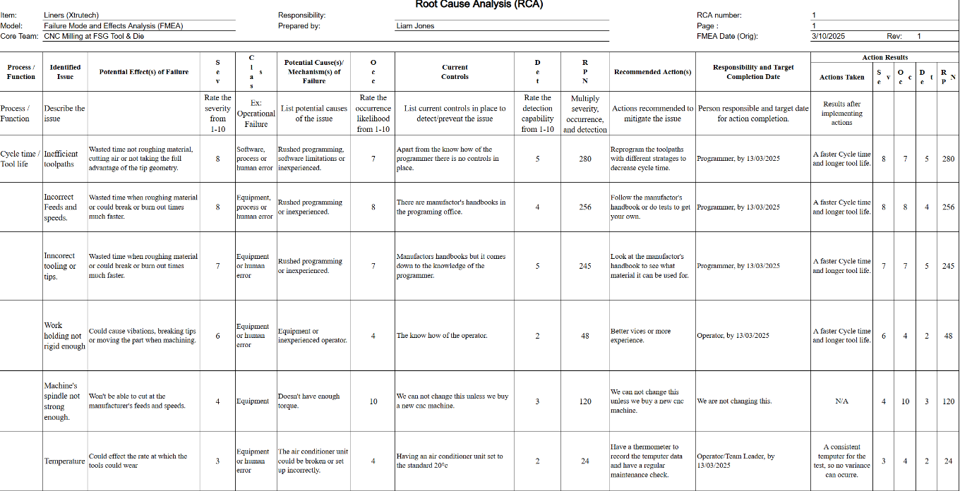 Figure 2 – Failure mode and Effects Analysis (Xtrutech) at FSG Tool & Die (Jones, 2025)

3.2.1 Developing a plan using the Failure Mode and Effect Analysis
The Failure Mode and Effect Analysis helped narrow down which elements to test, each to keep consistent and some that are unable to change. The elements to test are toolpaths and feeds & speeds the reason being, they both scored the highest Risk Priority Number meaning they are most likely to have the biggest effect on tool life and cycle time. After evaluating the tooling and inserts, it was determined that they were the most cost-effective for the material and did not require changes. This can also apply to work holding and temperature control. The torque of the spindle is impossible to change without purchasing a new machine, which is out of the scope of this report however keeping the same machine will ensure that the tests are consistent.

4. Results from the testing

4.1 Check sheets
Before testing, a check sheet was completed to minimize potential errors, such as:
- Inserts already warn or damaged
- Incorrect type of inserts
- Temperature
- Incorrect program (Tool paths or feeds and speeds)
- If the machine being used is the same as the rest of the tests
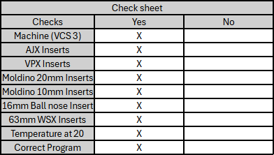
Figure 3 – Check Sheet (Xtrutech) at FSG Tool & Die (Jones, 2025)

4.2 Data showing when each insert broke for each test
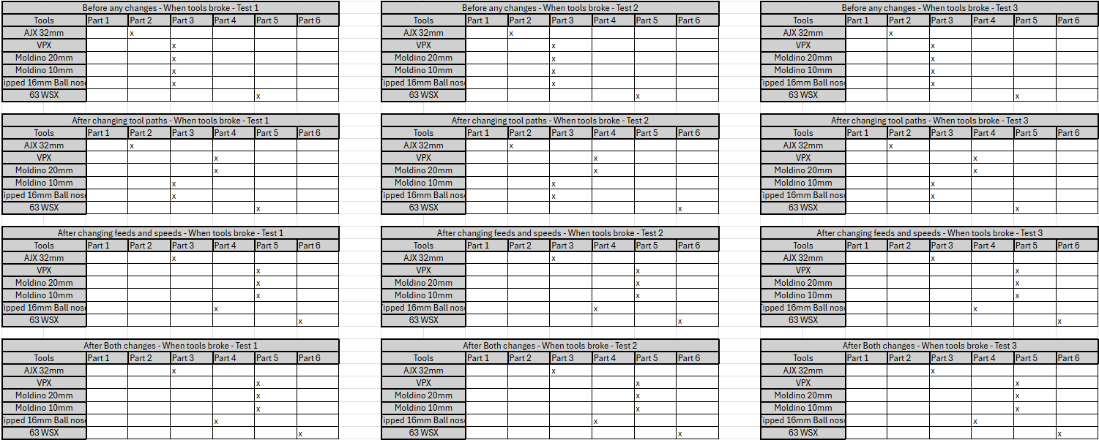
Figure 4 – Multiple Tables showing when each insert broke (Xtrutech) at FSG Tool & Die (Jones, 2025)
The large volume of data in Figure 4 is difficult to interpret for correlations, trends, or outliers. Converting it into a clustered column chart for each tool will help analyze test consistency and identify patterns or trends

4.2.1 Turning the data into a clustered column
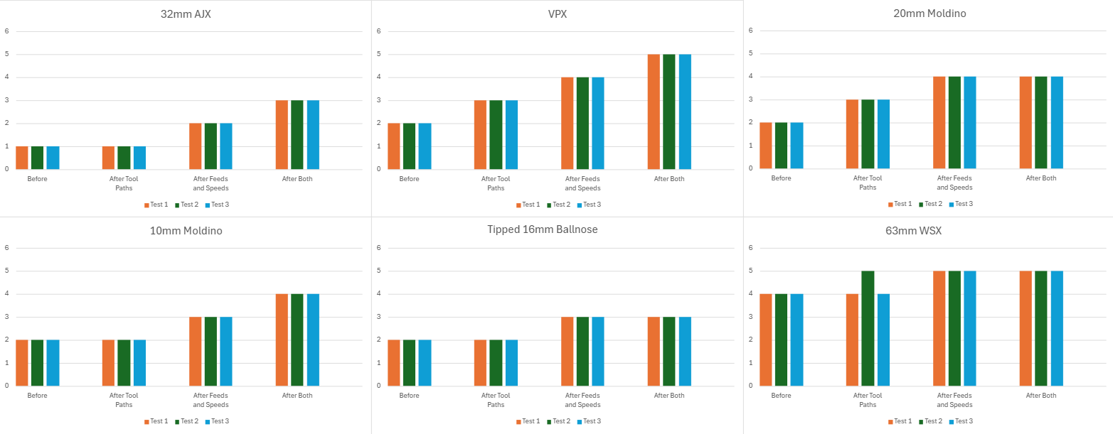
Figure 5 – Multiple Charts showing when each insert broke (Xtrutech) at FSG Tool & Die (Jones, 2025)

4.2.2 Analyzing the clustered column
Figure 5 shows that the testing was consistent throughout each change apart from one anomaly in the 63mm WSX, after tool paths changes, Test 2. It completed one more part than the other two tests. However, with the testing system used, a triple modular redundancy can be used to ignore the outlier, giving four parts completed. The difference could be explained by the different starting thickness of the stock as the 63mm WSX is used to remove the excess material.
After finding the number of parts produced before a breakage occurs for each change, the percentage can be calculated to show the increase of the productivity of that tool.
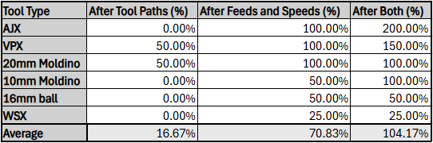
Figure 6 – Table showing the increase on tool life per change (Xtrutech) at FSG Tool & Die (Jones, 2025)
Figure 6 also shows that feeds and speeds have the most significant change on tool life with figure 7 showing the increase of the tool life in a percentage. New feeds and speeds increase the tool life by 70.83% and the tool path only increases it by 16.67% on average. This shows that having the correct feeds and speeds are important for tool life.

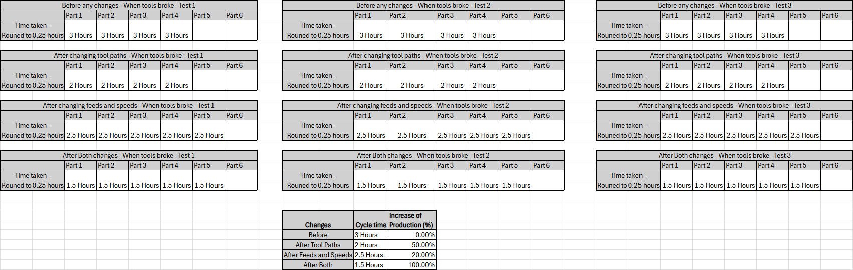
Figure 7 – Time taken per part and increase of production (Xtrutech) at FSG Tool & Die (Jones, 2025)
However, the opposite happens when looking at cycle time, figure 7. Where feed and speed increase the production by 20%, however the new tool paths increase it by 50% and both increase it by 100%. It shows that a shorter distance traveled faster has a huge effect on decreases cycle time, however only doing one doesn’t have such a huge effect compared to doing both. This can also be proven by:
“High-feed milling is particularly adept at roughing large workpieces and deep pockets where cycle times can be cut in half compared to conventional milling. Moreover, the process works especially well in difficult materials, from tool steels to aerospace alloys.” (MMS Editorial Team, 2019)
Their statement that “cycle times can be cut in half” holds true when looking at the data in figure 7, showing that high-feed milling can half cycle time.

4.3 How were the new feeds and speeds calculated?
All the feeds and speeds were pulled from the manufacturer’s website or handbook. Here is the reference table that Mitsubishi Materials provided for the AJX:
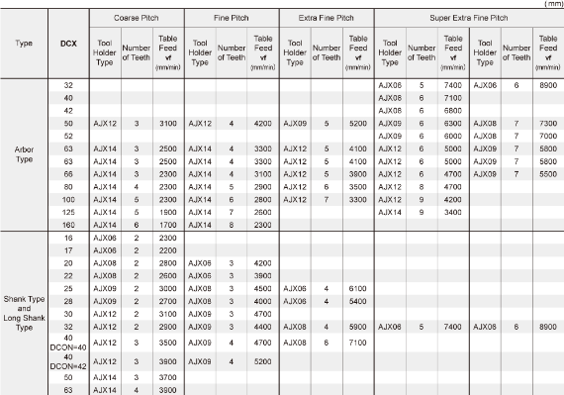
Figure 8 - Selection Reference Table (Mitsubishi Material, 2022)

5. Discussion

5.1 Were the goals of this report met?
The primary goals were to reduce the cycle time of Xtrutech liners and extend insert tool life. Achieving these improvements resulted in a more efficient and streamlined process, ultimately increasing profitability. The goals were met as the tool life increased 104% on average and the cycle time decreased by half resulting in a 100% increase in the productivity of the Xtrutech liners. Meaning the new program can produce twice as much as the old program in the same amount of time.

5.2 What did the result mean?
These results show that insert consumption will be reduced by half, and production time will also be doubled. This is a huge improvement over the last process and will increase overall profitability for the Xtrutech liners and will allow FSG Tool & Die to take on more customers because of the increase in production.

5.3 What were the issues or errors in the report
The issues were as follows:
- Temperature
- Torque of the spindle
- Different sized stock
The temperature was solved by machining in an air control room so that any errors or anomalies could not occur and that the tests were all done in the same environment.
The torque of the spindle was not solved however the same machine was used throughout the testing resulting in consistent and accurate data. It still influenced the feeds and speeds as it could not run at the manufacturer’s stated feeds and speeds however 80% of that feed and speed was possible.
Stock size variation was overlooked in the fishbone diagram, leading to the anomaly in Figure 5. However, since stock size variation is common in FSG’s production, the results remain relevant.

5.4 Five Why analysis
- Why was the cycle time so long?
Because the program wasn’t optimized and the cutting inserts break frequently, requiring frequent tool changes.
- Why do the cutting inserts break frequently?
Because Clamax, the material being machined, is exceptionally hard and sticky, which increases tool wear.
- Why does machining Clamax cause accelerated tool wear?
Because the incorrect feeds and speeds were being used, leading to inefficient cutting conditions.
- Why were the incorrect feeds, speeds, and tool paths being used?
Because the default machining parameters were not optimized for this material, and previous processes had not been adjusted based on empirical data.
- Why were the machining parameters not optimized earlier?
Because there was no systematic testing or application of quality improvement tools (like FMEA and Fishbone Diagrams) to analyze and refine the process.

6. Conclusion
In conclusion, the goals of this report were to decrease the cycle time of the Xtrutech liners and to increase the tool life of the inserts. This was successfully achieved with a doubling in tool life and production of parts. The tests were all done in a controlled environment, with the same temperature, machine and tools; however, the thickness of the stock varied, which did result in an anomaly. The results are valid for real-world manufacturing, where stock size variation is common. However, future improvements could enhance data accuracy.

7. References
ASQ (2024). What Is a Fishbone diagram? Ishikawa Cause & Effect Diagram. Available at: https://asq.org/quality-resources/fishbone.
(Accessed: 20 March 2025).
Farhat, Y., Aggarwal, N. and PMP, S.G. (2025). How can you reduce machining operation cycle time? Available at: https://www.linkedin.com/advice/3/how-can-you-reduce-machining-operation-bomwe
(Accessed 20 Mar. 2025).
Mitsubishi Material (2022) Selection Reference Table. Available at: https://www.mmc-carbide.com/in/products/rotating_tools/face_mills/ajx#:~:text=Employing%20a%20two%2Dstep%20straight,ultimate%20efficiency%20in%20rough%20machining.
(Accessed: 20 March 2025).
MMS Editorial Team (2019) High Feed Milling Can Reduce Cycle Times 50 Percent. Available at: https://www.mmsonline.com/articles/high-feed-milling-can-reduce-cycle-times-50-percent
(Accessed: 20 March 2025).
Sacher CNC (2023) Cutting inserts - types, designations, purpose, colors, grades, and selection of cutting inserts. Available at: https://sacher-cnc.com/en/cutting-inserts-types-designations-purpose-colors-grades-and-selection-cutting-inserts
(Accessed: 20 March 2025).

