During this piece of writing I will be discussing the ideas that I have, in which, I can explore more in depth with regards the use of art within our health care system.
I will achieve this by researching into different aspects of our care system that include art as a whole, but ultimately I will narrow down the research that I have already completed, to three keywords that I feel summarise the parts of the field that I would like to further research and study. To do this, I will also be discussing artists that have used these treatments themselves or enjoy working with patients to allow them a way to express themselves, I will also be using some extracts from essays and case studies that I have found during my research to further help emphasis the research within the topic that I have chosen.
My first point of discussion will be to look at the ‘Creative arts’ which has been defined as the theory and physical expression of creativity found in human society and culture, which is to say that it is something that we use to express ourselves and our views. Since the creative arts alone is such a broad topic I have narrowed it down to specifically the visual arts, which focuses more towards the forms of art that are appreciated mainly through sight such as painting, sculpture and film.
In this section of writing I am going to be focusing on the artist Jean Dubbet and how his work developed through out his career. Born July 1985 he is best remembered for founding the movement of Art Brut or ‘Outsider Art’, which I will speak of a little more as we continue to explore what led him to create the movement. Dubbet was not a fan of authority, even at an early age, and would often use his work to ‘attack’ the mainstream and conformed culture, even going as far as to call it ‘asphyxiating’. A good example of this post war Paris; when the public would flock to galleries after the horrors conflict, hoping to view images of beauty, redemption and old values, they would instead view the childlike images of Dubbet, which he created to challenge the conventional idea of high art, focusing more on textures and drab colours over the aesthetic of the image. The use of texture has been interpreted to appeal to the viewer to acknowledge the failings of humanity and to instead begin again from the ground up. 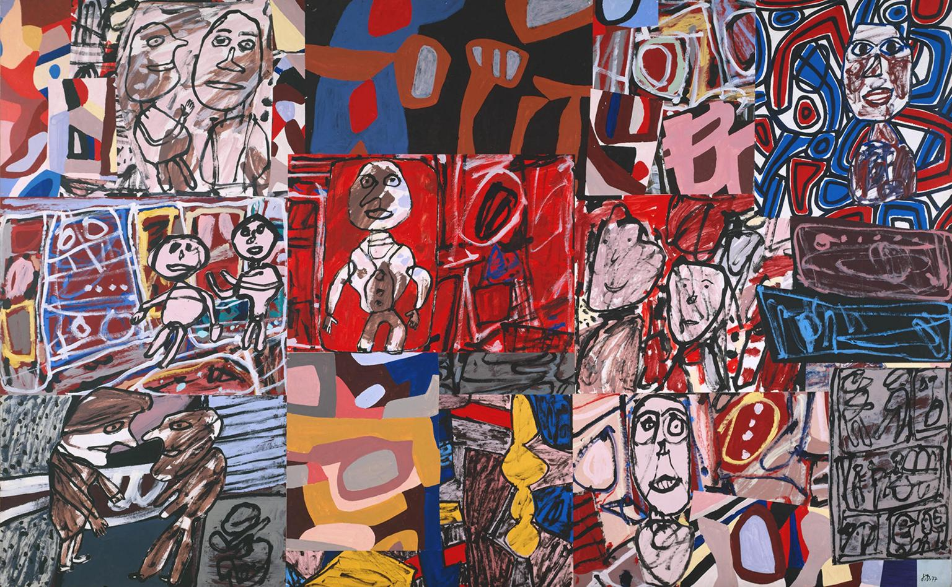
It was 1942 that Dubbet made the decision to return to painting, after previously withdrawing from the Académie Julian, that he truly began to explore and develop his technique as he worked to show his fondness for the simplistic life and importance of human emotion. Becoming more and more frustrated by the ‘intelligent’ approach to art, that he began to recreate the uninhibited style of the art created by children and asylum inmates, that he so admired throughout his life time, in order to achieve this, he would work in seclusion so that he could freely explore new methods and concepts, away from the criticism of new trends and theory. His work though ‘primitive’, is a perfect summery of the artist beliefs as he did not believe in the separation of beauty and ugly, creating the works as a declaration that ugliness simply does not exist. It was during 1948 that Dubbet teamed up with Andre Breton and Charles Ralton to establish Art Brut, a primitive and childlike approach to art that is different to the conventional aesthetic of the art world. In his later career that he began to move toward the common tools used by man such as pens and sticks, which he used as he explored surrealist ideas which allowed him to access his unconscious, which he believe produced art in its truest form. It is due to this development of childlike figures and bold palette that his ideas have become instrumental in modern psychology and mental development studies.
My next topic of discussion is the idea of ‘Care’ which holds so many different connotations, such as vulnerability and need as well as support and emotion, however in the instance of this paper I will be discussing the medical aspect of care, more specifically the mental aspect.
To do this will mainly be looking at the ideas and theories of Sigmund Freud before moving on to briefly question the idea of universal care.
Sigmund Freud was an Austrian Neurologist and the founder of psychoanalysis, which he developed to better understand the human personality and how it functions. To begin with the development of his research Freud would analysis himself to prove his theory of the unconscious, which he published in 1900, and later developed into the three major parts of the human psyche. These three structures being the ID (primitive and childlike), the Ego (reality and planning) and the Superego (morality and ideal self), it is these three key components that create our personality and what is used in order to analyse a person psyche.
However an argument could be made that every person is different and so should not be treated with what is known as ‘universal care’; which is the idea that because a treatment has worked for one person then it should have the same effects on others within society however Freud himself conformed to this suggestion and yet didn’t.
In one of my research readings I can across a study of Dora (a patient of Freud’s), whom was displaying symptoms of hysteria which was quickly dismissed to the idea that she was instead struggling to acknowledge and process what she wanted. It was here that his therapeutic role became more urgent and forceful, without taking away the voice of the patient. It is using his depictions of the case that we can see how the patient resists his interpretations and even goes as far as to accuse her of ‘playing secrets’ dismissing claims of what Freud thought she desired; yet through all of this never once did he take away her voice or silence her. There was clearly the understanding of ‘the doctor knows best’, but by never taking away or disregarding her voice Freud allowed the patient to remain an active member of her treatment which is something that I wish to further explore in the coming months, and how the way that ‘universal care’ is received by people affects them in various way.
My final keyword of exploration is Isolation and how it affects those receiving ‘care’. The concept of isolation is to keep one separate from someone or something, and is often used in the medical field as a quarantine, way of containing and stopping the spread of illnesses such as disease, however in the case of this paper I will be discussing emotional isolation. This is when someone who is part of function society or a social network feel disconnected and is unable to relate or engage with others; this can be caused by many things but due to the nature of my research I will be focusing on isolation because of illness and/ or injury and how the treatment is affecting the patient. The best example that I can provide of an artist feeling isolated due to an experience that she had when she was a young child is Yagoi Kusama, also known as the Princess of Polka Dots, who is a prime example of how the experience has continued to affect her life through adulthood and into her senior years. When she was a child she suffered from an hallucination of a field of flowers, of which all looked like dots and went on for as far as her eye could see, making her feel as though she was disappearing and almost being consumed by the field of endless dots (flowers) herself. It is due to this experience that she uses dots within all of her work as she wishes to make herself and her audience apart of the bigger universe, often going as far as to state “Our Earth is only one polka dot among the million stars in the cosmos. Polka dots are a way to infinity when we obliterate nature and our bodies with dots, we become part of the unity of our environment.” 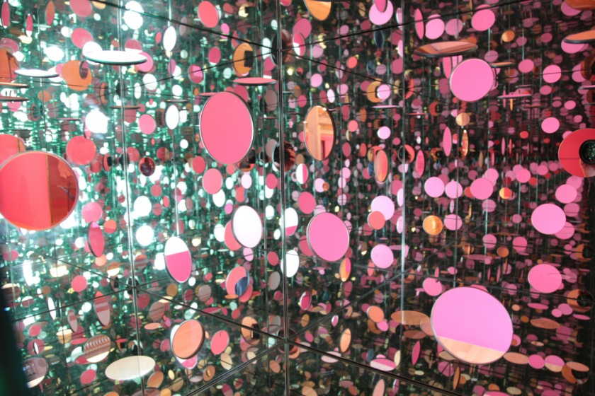
Her work centres around making the viewer become immersed within the work using dots, mirrors and lights, making it so that the viewer cannot tell where they end, and the piece begins; these piece of work she calls her ‘infinity rooms’.
Kusama works with her identity as an outsider in many ways the most noticeable being that she has voluntarily lived within a psychiatric institution since 1977 and as such, much of her work has been described as obsessive and displaying an attempt to escape her psychological trauma.
Another great opportunity to discuss cases of isolation within the universal care ideology is the Prinzhorn Collection, made up exclusively with work that has been created by people who are suffering due to mental illness, ‘like windows into the psyche of the mentally ill patients’ if you will. The collection itself is named after the historian Hans Prinzhorn, who was formally educated in medical science during the First World War, however after the war he was given the task of expanding the arts program in place to help people who were suffering mentally and so began to look for ways to combine the two. 1922 he published a book in which he begins to analyse and study the works and what they could possibly symbolise for the creator, thus giving an idea of what was happening within their minds, however where the art world celebrated this study the psychiatric community found it lacking and did not put much faith in the study.
A much worse critic appeared as the world entered the Second Great War, of which the Nazis who were steadily taking power sought to cleanse any art that they considered to be ‘un-German’, and did not promote their ideas and propaganda. As such the abstract works of therapy art were certainly included within the ‘tainted’ art and had to go. Thankfully a huge collection of these works had previously been hidden away within the storage of the university and so were able to escape the censorship fires of the Nazis and can still be viewed today by any one who wishes to engage with the work of those who are mentally ill and desperately trying to find an outlet in which they can better express themselves, to those who are willing to listen.
By focusing on these fields within my chosen areas of the keywords of Creative Arts, Care and Isolation I have found that there are many fields in which I would like to explore and further research to expand my field of knowledge, the most prevalent one being the effects that the creative arts have on those whom are isolated through medicine and mental illness.
And so I would like to further study the cases of which visual arts has helped the patient that is felling isolated express themselves in the various forms offered to them and what benefits such a practise has granted.

Books Reference and Bibliography
Holmes, J. 2001, ideas in psychoanalysis narcissism
Borossa, J. 2001, Ideas in psychoanalysis hysteria
Serpentine galleries. 2013, Art and care: a future
Case, C and Dalley, T. 2003, Working with children in art therapy
Connell, C. 1998, something understood art therapy in cancer care.
website and images bibliography
20/04/2018

http://www.creativetherapies.co.uk/
http://www.creativetherapy.org.uk/creative.html
https://www.mind.org.uk/information-support/drugs-and-treatments/arts-therapies/#.WtnRJojwbIU
https://www.cambridge.org/core/journals/public-health-nutrition/article/influence-of-physical-activity-on-mental-wellbeing/3C363AEECE5C8CAC490A585BA29E6BF8
https://www.surgeongeneral.gov/priorities/prevention/strategy/mental-and-emotional-well-being.html
https://www.prospects.ac.uk/jobs-and-work-experience/job-sectors/creative-arts-and-design/overview-of-the-creative-arts-sector-in-the-uk
https://www.thoughtco.com/what-are-the-visual-arts-182706

03/05/2018
http://www.bbc.co.uk/history/historic_figures/freud_sigmund.shtml
http://www.theartstory.org/artist-dubuffet-jean.htm
http://www.tate.org.uk/art/artists/jean-dubuffet-1035
http://www.tate.org.uk/art/artists/louise-bourgeois-2351
http://www.tate.org.uk/whats-on/tate-modern/exhibition/yayoi-kusama
https://www.simplypsychology.org/psyche.html
http://www.spiegel.de/international/zeitgeist/masterpieces-from-the-prinzhorn-collection-by-psychiatric-patients-a-936148.html
https://www.atlasobscura.com/places/the-prinzhorn-collection
http://www.isendyouthis.com/galleries.aspx?id=370626
http://www.tate.org.uk/art/art-terms/a/art-brut
https://www.guggenheim.org/artwork/movement/art-brut

