Student Name
Saira Zaeed
Student Number
2332216
Module Code
BMHP5014
Module Title
Changemaker: in Creativity and Value Creation
Lecturer Name
Precious Igbinigie
Assignment Title
Component two; Written Assignment (Report)

- Poster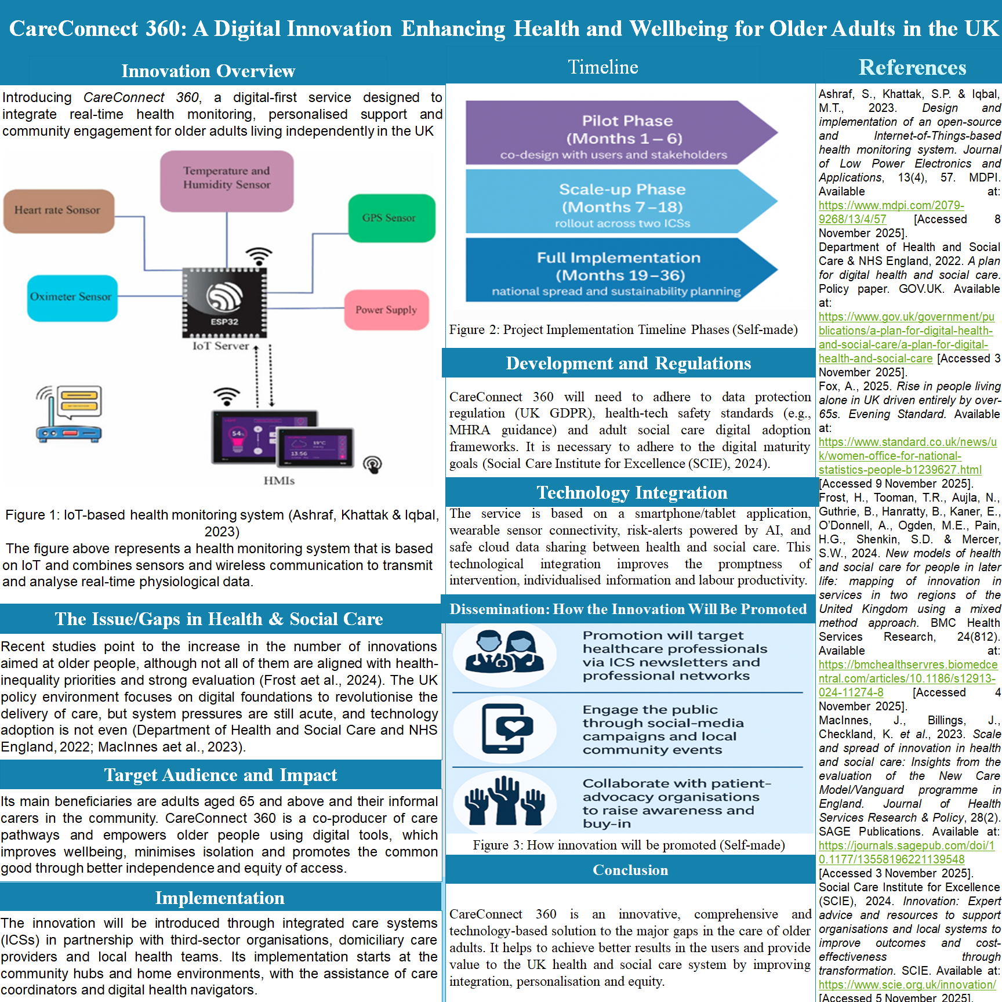
- Pitch
Introduction
Care Connect 360 is a disruptive, IoT-based digital service that aims to combine real-time health monitoring, personalised support and community engagement of older adults living independently in the UK. It is an expansion of the digital transformation agenda of the NHS (Department of Health and Social Care and NHS England, 2022) and provides a model of initiative-taking care and early intervention that can be expanded to scale. The system links wearable gadgets, sensors, and medical practitioners to create a single platform that enhances patient and provider experience.
Innovation Overview
The solution will use heart rate, oximetry, temperature and humidity, and GPS sensors based on IoT (Figure 1). These sensors send data through an ESP32 microcontroller to an IoT server, allowing to monitor continuously and send alerts automatically. Wearable sensors and data analytics can be used to facilitate personalised care planning, which helps to reduce hospital admissions and enhance the independence of older adults (Ashraf, Khattak & Iqbal, 2023).
Figure 1: Health monitoring system using IoT (Ashraf, Khattak and Iqbal, 2023).
The Issue/Gaps in Health & Social Care
Although the UK is a healthcare innovation leader, there are still gaps in the provision of inequality among ageing populations. As Frost aet al. (2024) emphasise, numerous older-adult innovations do not correspond to the priorities of health-inequality. According to the A Plan for Digital Health and Social Care (2022) by the Department of Health and Social Care, digital integration is a necessity, but the barriers to adoption and the lack of resources are still important. care Connect 360 is a direct response to these gaps, in that it fosters inclusivity, user co-design and data-driven care pathways.
Target Audience and Impact
The project serves the adults aged 65 years and above, as well as their informal carers. Fox (2025) indicates that the number of people aged 65 years and above living alone in the UK has been increasing since 2004 (Figure 2) which illustrates the increasing demands of technology-based independent living.
Figure 2: Age-related people living alone in the UK (Fox, 2025)
care Connect 360 improves wellbeing through reassurance, interventions, and linkage to professional and community support in a timely manner. It fosters the common good through lessening social isolation, empowerment of users and enhancing intergenerational care networks.
Implementation
This will be implemented in collaboration with Integrated Care Systems (ICSs), domiciliary care providers, local councils, and voluntary organisations. The project is based on a three-stage model (Figure 3):
Figure 3: Implementation Timeline of the project (Self-made)
Pilot Phase (Months 1-6): Co-design with older adults, carers, and stakeholders to improve features.
Scale-up Phase (Months 718): Scale-up to two ICSs to assess the effects, data quality and user satisfaction.
Full Implementation (Months 1936): National expansion and sustainability and training strategies.
This participatory practise guarantees ethical, inclusive, and practical integration in different care settings.
Development and Regulations
Legal and professional standards should be adhered to. CA reconnect 360 is subject to the UK GDPR (2018) on data privacy, MHRA regulations on medical devices and adult social care digital adoption frameworks (Social Care Institute for Excellence [SCIE], 2024). Compliance with regulations protects patient safety, data integrity and professional responsibility. Furthermore, the correspondence to A Plan for Digital Health and Social Care (Department of Health and Social Care and NHS England, 2022) supports the validity of care Connect 360 and its scalability in the national policies.
Technology Integration is an app-based service that can communicate with wearable devices through Bluetooth and Wi-Fi to monitor physiological parameters and relay them to an IoT server. The algorithms of artificial intelligence identify abnormalities and alert healthcare providers in real-time, which guarantees initiative-taking actions (Ashraf aet al., 2023). Such integration promotes the sharing of data across sectors, which allows greater coordination of NHS Trusts, GPs, and community services (MacInnes aet al., 2024). The secure cloud infrastructure also increases productivity through minimising duplication and enhancing efficiency in decision-making.
Dissemination: How the Innovation Will Be Promoted
care Connect 360 will use a multi-channel dissemination strategy as shown in Figure 4.
Figure 4: The Promotion of the Innovation (Self-made).
Professional Networks: ICS newsletters, NHS digital transformation bulletins and professional forums will be used to promote the adoption of the initiative among clinicians and managers.
Public Engagement: Awareness among families and carers will be created with specific social-media campaigns on Facebook, X (previously Twitter) and YouTube. Live demonstrations of the technology will be done through local community events, which will tackle the issue of digital literacy.
Advocacy Partnerships: Age UK and Carers UK will be collaborated with to increase credibility and reach. The involvement of advocacy groups creates a sense of trust and makes sure that the voices of older adults influence the ongoing improvement.
This three-level strategy promotes active civic engagement, professional support, and policy advocacy of sustainable scale-up.
Policy, Legislation and Professional Services Alignment
care Connect 360 is aligned to the NHS Long Term Plan (2019) that focuses on preventative and personalised care. Integration of health and social care systems is required by the Health and Care Act (2022), and the Digital Health and Care Plan (Department of Health and Social Care and NHS England, 2022) provides frameworks of digital adoption. Practically, the cooperation between NHS Trusts, ICSs, general practitioners, occupational therapists, and domiciliary care providers makes sure that the solution is used to complement the current services and make them efficient.
As a professional, it is consistent with the principles of SCIE (2024) of dignity, safety and co-production, and the standards of Care Quality Commission that focus on transparency and evidence-based improvement. The frameworks will ensure that care Connect 360 is ethically sound and operationally sound.
Community Engagement and Public Involvement
The success of care Connect 360 is based on public involvement. During the pilot stage, usability features will be co-designed with older adults and carers through feedback. Skill development will be facilitated through open digital-literacy workshops that will be inclusive and empowering. The project encourages university students, social enterprises, and local governments to become so-called Digital Health Ambassadors and promote intergenerational learning. Engaging the population enhances social unity and shared property needed to achieve sustainable health outcomes (Guthrie aet al., 2024).
Conclusion
care Connect 360 is a technology-enhanced visionary solution to a pressing societal issue: to assist the ageing population and relieve health and social care systems. The innovation can promote independence, safety, and wellbeing of older adults by incorporating IoT monitoring, AI-powered analytics, and human-centred design. In line with the existing UK laws and NHS digital policies, it will fill the gap between innovation and inclusivity, providing value to the professionals and the population. care Connect 360 is creative and entrepreneurial in the common good through its model of collaboration, regulation, and community driven.
References
- Ashraf, S., Khattak, S.P. & Iqbal, M.T., 2023. Design and implementation of an open-source and Internet-of-Things-based health monitoring system. Journal of Low Power Electronics and Applications, 13(4), 57. MDPI. Available at: https://www.mdpi.com/2079-9268/13/4/57 [Accessed 8 November 2025].
- Department of Health and Social Care & NHS England, 2022. A plan for digital health and social care. Policy paper. GOV.UK. Available at: https://www.gov.uk/government/publications/a-plan-for-digital-health-and-social-care/a-plan-for-digital-health-and-social-care [Accessed 3 November 2025].
- Fox, A., 2025. Rise in people living alone in UK driven entirely by over-sixty-fives. Evening Standard. Available at: https://www.standard.co.uk/news/uk/women-office-for-national-statistics-people-b1239627.html [Accessed 9 November 2025].
- Frost, H., Tooman, T.R., Aujla, N., Guthrie, B., Hanratty, B., Kaner, E., O’Donnell, A., Ogden, M.E., Pain, H.G., Shenkin, S.D. & Mercer, S.W., 2024. New models of health and social care for people in later life: mapping of innovation in services in two regions of the United Kingdom using a mixed method approach. BMC Health Services Research, 24(812). Available at: https://bmchealthservres.biomedcentral.com/articles/10.1186/s12913-024-11274-8 [Accessed 4 November 2025].
- MacInnes, J., Billings, J., Checkland, K. et al., 2023. Scale and spread of innovation in health and social care: Insights from the evaluation of the New Care Model/Vanguard programme in England. Journal of Health Services Research & Policy, 28(2). SAGE Publications. Available at: https://journals.sagepub.com/doi/10.1177/13558196221139548 [Accessed 3 November 2025].
- Social Care Institute for Excellence (SCIE), 2024. Innovation: Expert advice and resources to support organisations and local systems to improve outcomes and cost-effectiveness through transformation. SCIE. Available at: https://www.scie.org.uk/innovation/ [Accessed 5 November 2025].

