Business Plan

Graceful Living Care Home Ltd
Residential Nursing Care for the Elderly in Uganda

Programme of Study: Business Skills for the Workplace
Name: Pamela Keijema
Student No: 2440400
Lecturer: Andry Rakotovololona

Executive Summary
Graceful Living Care Home Ltd is the proposed residential nursing care home that will be located in Kampala, Uganda, which offers professional elderly care services to the increasing number of ageing population in the country in addition to underdeveloped formal service of care infrastructure. The Uganda Bureau of Statistics says that the population aged 60 years and more takes an estimated 5 percent of the population, estimated to be 2.3 million people, with many people not receiving adequate support. It will provide 24-hour residential nursing services, physiotherapy, medication administration, as well as social activities in a safe and specially designed establishment in Muyenga. The service will also be provided under three care packages, which include Standard Residential Care, Enhanced Medical Care and Specialist Nursing Care to individuals with complicated health conditions. The main market segment is the middle- and high-income families in Kampala and the Ugandian diaspora, who want to find quality services to care of the aged relatives. The marketing approaches will involve collaborating with hospitals, church networks, social media marketing, and involvement with communities. The business has objectives of admitting 12 residents in the initial year and attaining the status of operational stability and regulatory acceptance by the Ministry of Health. The long term strategies are to grow to 40 residents, start home based care services to the elderly, development of a care worker training academy. By meeting the increasing needs of professional elderly care, Graceful Living Care Home Ltd will aim to enhance the quality of life and wellbeing of aged patients in Uganda and establish a sustainable and socially relevant healthcare organization.

Contents
Executive Summary 2
1 Business Concept 5
1.1 Business Description 5
1.2 Product Description 5
2 Business Objectives (SMART Objectives) 5
2.1 Short-Term Objectives (Less Than a Year) 5
2.2 Long-Term Objectives (More Than a Year) 5
3 Market Analysis and Marketing Plan 5
3.1 Market Analysis (Competitors, Customers, Target Groups) 5
3.2 Marketing Approach: Segmentation, Targeting, and Positioning 6
3.2.1 Market Segmentation 6
3.2.2 Targeting 6
3.2.3 Positioning 6
3.2.4 Connecting with Your Audience. 6
4 PESTEL Analysis 6
5 SWOT Analysis 7
6 Marketing Mix (4Ps) 7
7 Management Team 8
7.1 Management Team and Their Background 8
7.2 Organisational Chart 8
7.3 Key Milestones 8
8 Financial Plan (One Year) 9
8.1 Sources of Finance 9
8.2 Sales Forecast 9
8.3 Cost of Production Forecast 9
8.4 Cash Flow Forecast 9
8.5 Break-Even Analysis 9
9 Operations and Management Plan 10
9.1 Production of Goods and Services. 10
9.2 Technology Plan 10
9.3 Human Resource Plan 10
9.4 Expansion Plan 11
10 Reference List 12

Business Concept

Business Description
Graceful Living Care Home Ltd will be a limited company, a residential elderly care facility, which will be set in Kampala, Uganda. The census of 2024 shows that individuals over 60 years old and older comprise approximately 5 percent of the population, or 2.3 million people, and 86 percent of them are not taken care of or supported. Moreover, not more than 5% of the ageing population is pensioned (Nawagi et al., 2023). The nursing care, physiotherapy, medicine management, and social activities services will be 24-hour care to the elderly in the care home. The services will be provided in a well-equipped and secure facility in Muyenga as the aim is to enhance the quality of life and wellbeing of the older adults.

Product Description
The service delivery will consist of three packages, specifically a Standard Residential Package covering accommodation, meals and activities; Enhanced Care Package that includes medical monitoring and physiotherapy; and Specialist Nursing Package that consists of intensive twenty four-hour care of chronic illnesses. They all have family counselling and visitor programmes which are vital to wellbeing (Gumikiriza-Onoria et al., 2023).

Business Objectives (SMART Objectives)

Short-Term Objectives (Less Than a Year)
In the first year, the business hopes to fully construct the business, hire three nurses and four care assistants as well as have twelve residents after 9 months. By the sixth month, the ministry of health approval will be obtained and two hospital referral partnerships are going to be secured (Burns, 2022).

Long-Term Objectives (More Than a Year)
In three to five years, the business will grow to forty residents, introduce home-based care to the neighbouring districts, and generate over four hundred million UGX revenue annually and build a care worker training academy (Lewrick, 2022).

Market Analysis and Marketing Plan

Market Analysis (Competitors, Customers, Target Groups)
Uganda’s elderly care sector remains critically underserved despite demographic change. Life expectancy has increased to 68.5 years (UBOS, 2024), while Africa’s population aged over sixty is projected to double by 2050 (WHO, 2023). However, formal care infrastructure remains extremely limited. Existing providers such as Golden Age Elderly Homes and Tick Bedside Nursing Care collectively accommodate fewer than 200 residents in Kampala, highlighting a significant service gap. This shortage indicates unmet demand among middle- to upper-income families seeking reliable elderly care, suggesting strong market potential but also exposing systemic neglect of ageing populations.

Marketing Approach: Segmentation, Targeting, and Positioning

Market Segmentation
The segments of the market include the income level, the dependency of the care and the location. The main one is high-income urban families, then there are middle-income families, diaspora Ugandans, and corporate retirement clients (Kotler and Keller, 2021).

Targeting
The main focus is the upper-middle-income families of Kampala and Wakiso whose aged members require medical attention on daily basis. The urban population is estimated to overcome rural population in Uganda by 2060, which will raise the demand of formal care (World Bank, 2024).

Positioning
The first purpose-built, medically supervised residential elderly care home in Uganda, Graceful Living, distinguishes itself by its twenty-four-hours of nursing, systematic physiotherapy, and activities that are sensitive to culture (Karakolias, 2024).

Connecting with Your Audience.
Hospital collaborations, church networks, retirement benefit plans, Facebook, WhatsApp, healthcare conferences, and the engagement of the diaspora via the Uganda Retirement Benefits Regulatory Authority form part of outreach (Chaffey and Ellis- Chadwick, 2019).

PESTEL Analysis

Factor | Analysis
Political | The National Policy for Older Persons acknowledges elderly welfare needs, and the Social Assistance Grants programme reaches over 300,000 seniors, signalling growing political attention (Ministry of Gender, Labour and Social Development, 2024).
Economic | GDP growth averaged 5.3% between 2020 and 2024 with a rising middle class. Only five per cent of older persons receive a pension, creating demand for care alternatives (World Bank, 2024).
Social | Urbanisation and changing family structures weaken traditional elderly care. The 2024 census shows 86% of elderly persons experience neglect, driving demand for professional care (UBOS, 2024).
Technological | Telemedicine and electronic health records enable remote specialist consultations and improved care quality (Kiberu et al., 2019).
Environmental | Uganda’s tropical climate requires careful facility design for elderly comfort, with ventilation and water harvesting reducing costs and environmental impact (Hopkinson et al., 2022).
Legal | Uganda lacks a dedicated nursing home regulatory framework, creating opportunity for early entrants but risk of future changes. Compliance with the Public Health Act and Data Protection Act 2019 is mandatory (Government of Uganda, 2019).

SWOT Analysis

Factor | Analysis
Strengths | Twelve years of healthcare administration experience including patient pathway coordination across NHS settings. Purpose-built facility and medically supervised care offer quality advantage over informal competitors (Barney and Hesterly, 2019).
Weaknesses | Cultural resistance to institutional elderly care, high capital requirements for construction, and limited geriatric-trained nurses in Uganda present start-up challenges (Nawagi et al., 2023).
Opportunities | Rising life expectancy, rapid urbanisation, and weakening family care structures create unprecedented demand. Absence of dominant competitors and growing diaspora remittances offer strong market entry potential (United Nations, 2023).
Threats | Cultural stigma, economic downturns affecting disposable income, and potential new regulations could impact operations. Competition from charitable homes offering free care also poses a risk (Skjold et al., 2020).

Marketing Mix (4Ps)

4Ps | Description
Product | Three-tiered residential care packages from standard accommodation with meals to specialist twenty-four-hour nursing care with physiotherapy and family counselling (Kotler and Keller, 2021).
Price | Monthly fees: Standard at UGX 800,000; Enhanced Care at UGX 1,200,000; Specialist Nursing at UGX 1,800,000, offering savings compared with private hospital or full-time home nursing at UGX 3,000,000 plus (Scarborough, 2019).
Place | Purpose-built facility in Muyenga, Kampala, selected for accessibility, proximity to hospitals, and appeal to target demographic (Hollensen, 2020).
Promotion | Hospital referral networks, church partnerships, Facebook and WhatsApp campaigns, diaspora-targeted marketing, and open day events to overcome cultural hesitancy (Chaffey and Ellis-Chadwick, 2019).

Management Team

Management Team and Their Background
Founder and Managing Director Pamela Keijema has twelve years of experience in the UK healthcare administration in cancer services, occupational health and mental health environments. Three months of recruitment will be performed to hire a Head of Nursing, Operations Manager, and Finance Officer (Burns, 2022).

Organisational Chart
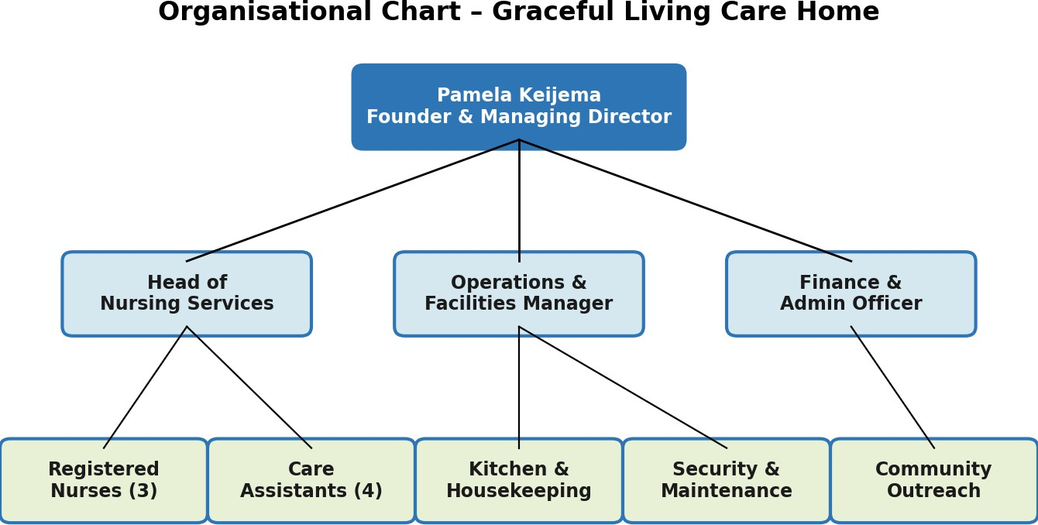

Key Milestones

Timeline | Milestone | Outcome
Month 1–3 | Land acquisition, facility design, licensing | Regulatory readiness
Month 4–6 | Construction completion, staff recruitment | Operational capacity
Month 7–8 | Soft launch, admit first 8 residents | Revenue generation begins
Month 9–10 | Hospital referral partnerships established | Steady client pipeline
Month 11–12 | Reach 15 residents, full operations | Break-even targeted
Year 2–3 | Expand to 30 beds, launch home care | Scalable growth

Financial Plan (One Year)

Sources of Finance
One hundred and fifty million UGX (sixty million in personal savings, seventy million in Uganda Development Bank loan at twelve per cent and twenty million in diaspora angel investor) is used to balance between debt exposure and construction costs (Scarborough, 2019).

Sales Forecast

Quarter | Q1 | Q2 | Q3 | Q4
Avg Residents | 4 | 8 | 12 | 15
Quarterly Revenue (UGX M) | 14.4 | 28.8 | 43.2 | 54.0

Cost of Production Forecast

Expense Category | Monthly (UGX)
Staff salaries (nurses, care assistants, support) | 4,500,000
Food and nutrition supplies | 1,200,000
Medical supplies and pharmaceuticals | 800,000
Utilities (electricity, water, internet) | 600,000
Maintenance, insurance & loan repayment | 900,000
Marketing and outreach | 500,000
Total Fixed Costs | 8,500,000

Cash Flow Forecast

Item (UGX M) | Q1 | Q2 | Q3 | Q4
Opening Balance | 150.0 | 131.1 | 121.0 | 122.3
Total Inflows | 14.4 | 28.8 | 43.2 | 54.0
Total Outflows | 33.3 | 38.9 | 41.9 | 44.1
Closing Balance | 131.1 | 121.0 | 122.3 | 132.2

Break-Even Analysis
The break-even point is twelve residents per month with fixed costs of eight million five hundred thousand UGX a month, average fee of one million two hundred thousand UGX per resident, and variable costs of four hundred and fifty thousand UGX projected twelve residents per month in month nine.

Component | Value
Monthly Fixed Costs | UGX 8,500,000
Average Fee per Resident | UGX 1,200,000
Variable Cost per Resident | UGX 450,000
Contribution per Resident | UGX 750,000
Break-Even Point | 12 residents/month

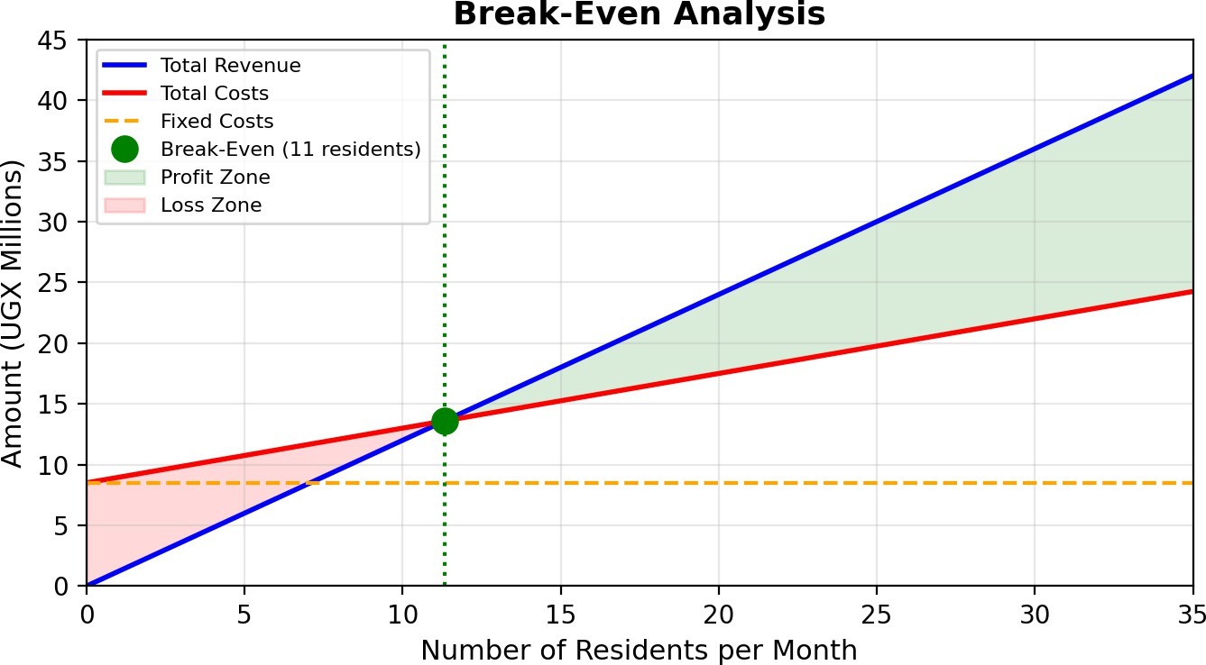

Operations and Management Plan

Production of Goods and Services.
Every resident is assessed in terms of health and also has a personalised care plan. There are standardised medication rounds, meals, physiotherapy and activities, and weekly review and monthly family feedback (Slack, Brandon-Jones and Johnston, 2022).

Technology Plan
The infrastructure consists of electronic health records and pharmacy management that can be used to track medicine, telemedicine to enable remote specialist consultations, and CCTV with biometric access to provide the safety of the residents (Singh et al., 2022).

Human Resource Plan
The focus of recruitment is on nurses with geriatric experience and in-house geriatric care assistants, responding to the severe geriatric workforce issue in Uganda (Nawagi et al., 2023). Continuous training in elderly care and dementia management, competitive salaries, and accommodation benefits support retention.

Expansion Plan
Phase one establishes twenty beds in Kampala. Phase two expands to forty beds and launches home-based care in Wakiso and Mukono. Phase three develops a training academy and explores franchising in secondary cities (Whittington et al., 2019).

Reference List
Barney, J.B. and Hesterly, W.S. (2019) Strategic Management and Competitive Advantage: Concepts and Cases. 6th edn. London: Pearson Education.
Bloom, P., Bloom, H., Moses, I., Stephens, J., Owembabazi, I., Sam, M. and Paccione, G., 2024. Community-oriented primary care to improve health in older adults of rural Uganda: A feasibility study. Global Health Economics and Sustainability, 2(2), p.3000.
Burns, P., 2022. Entrepreneurship and small business. Bloomsbury Publishing.
Chaffey, D. and Ellis-Chadwick, F. (2019) Digital Marketing: Strategy, Implementation and Practice. 7th edn. Harlow: Pearson Education.
Government of Uganda (2019) Data Protection and Privacy Act, 2019. Kampala: Parliament of Uganda.https://bills.parliament.ug/attachments/Data%20Protection%20and%20Privacy%20Act%202019.pdf
Gumikiriza-Onoria, J.L., Nakigudde, J., Mukasa, M.K., Tibasiima, I., Mayega, R. and Nakasujja, N., 2023. Reflections of ageing among older adults in a Ugandan community: a qualitative analysis into the benefits and pains of ageing. Journal of mental health and aging, 7(6), p.171.
Hollensen, S. (2020) Global Marketing. 8th edn. Harlow: Pearson Education.
Hopkinson, P., Charnley, F., Pencheon, D., Dawson, T., Eatherley, D., Burton, K. and Gopfert, A., 2022. Accelerating the transition towards a net zero NHS: Delivering a sustainable and resilient UK healthcare sector.
https://socialprotection.go.ug/wp-content/uploads/mdocs/State%20of%20Social%20Protection%20Report.pdf
Karakolias, S., 2024. Outsourcing non-core services in healthcare: A cost-benefit analysis. Valley International Journal Digital Library, pp.1177-1195.
Kiberu, V.M., Scott, R.E. and Mars, M., 2019. Assessing core, e-learning, clinical and technology readiness to integrate telemedicine at public health facilities in Uganda: a health facility–based survey. BMC Health Services Research, 19(1), p.266.
Kotler, P. and Keller, K.L. (2021) Marketing Management. 16th Global edn. Harlow: Pearson Education.
Laudon, K.C. and Laudon, J.P. (2022) Management Information Systems: Managing the Digital Firm. 17th edn. Harlow: Pearson Education.
Lewrick, M., 2022. Design thinking for business growth: how to design and scale business models and business ecosystems. John Wiley & Sons.
Ministry of Gender, Labour and Social Development (2024) Annual Report on the State of Social Protection in Uganda. Kampala: MGLSD.
Nawagi, F., Najjuma, J.N., Mukisa, J. and C.Nabirye, R. (2023). Barriers and Opportunities for Elderly Nursing Care in Uganda: A Descriptive Qualitative Study. Annals of Nursing and Practice, [online] 10(1), pp.1–7. doi:https://doi.org/10.47739/2379-9501/1131.
‌Scarborough, N.M. (2019) Essentials of Entrepreneurship and Small Business Management. 9th edn. Harlow: Pearson Education.
Singh, S., Kumar, P., Rehman, F. and Vashishta, P., 2022. Telemedicine, telehealth, and e-health: a digital transfiguration of standard healthcare system. In Cloud IoT (pp. 143-161). Chapman and Hall/CRC.
Skjold, E., Nosch, M.L., Malcolm-Davies, J. and Bang, A.L., 2020. THREADs that Connect: Social Innovation through Textiles. Centre for Textile Research.
Slack, N., Brandon-Jones, A. and Johnston, R. (2022) Operations Management. 10th edn. Harlow: Pearson Education.
Uganda Bureau of Statistics (2024) National Population and Housing Census 2024: Main Report. Kampala: UBOS.https://www.ubos.org/wp-content/uploads/2024/12/National-Population-and-Housing-Census-2024-Final-Report-Volume-1-Main.pdf
United Nations (2023) World Population Prospects 2022: Summary of Results. New York: United Nations Department of Economic and Social Affairs.https://www.un.org/development/desa/pd/content/World-Population-Prospects-2022
Whittington, R., Regnér, P., Johnson, G., Angwin, D. and Scholes, K. (2019) Exploring Strategy: Text and Cases. 12th edn. Harlow: Pearson Education.https://books.google.com.pk/books/about/Exploring_Strategy_Text_and_Cases_12th_E.html?id=GeksEAAAQBAJ&redir_esc=y
World Bank (2024) ‘The demographic boom: an explainer on Uganda’s population trends’, Africa Can End Poverty Blog. Washington, DC: World Bank Group.
World Health Organization (2023) World Health Statistics 2023. Geneva: WHO.https://www.who.int/publications/b/69040

