Amina Meah (2237650)
Data and information systems
Learning in the Digital Era (Computing & Electronics)
Assignment 1: E-Portfolio.

Contents
e-Portfolio. 2
Link for e-Portfolio. 2
Evidence 3
Task 1 -Written summary 3
Task 2-Academic poster 4
Task 3-Automatic referencing tool 5
Task 4-e-Portfolio creation and review 6

e-Portfolio.

Link for e-Portfolio.
https://sites.google.com/view/aminameahlearningjourney/home
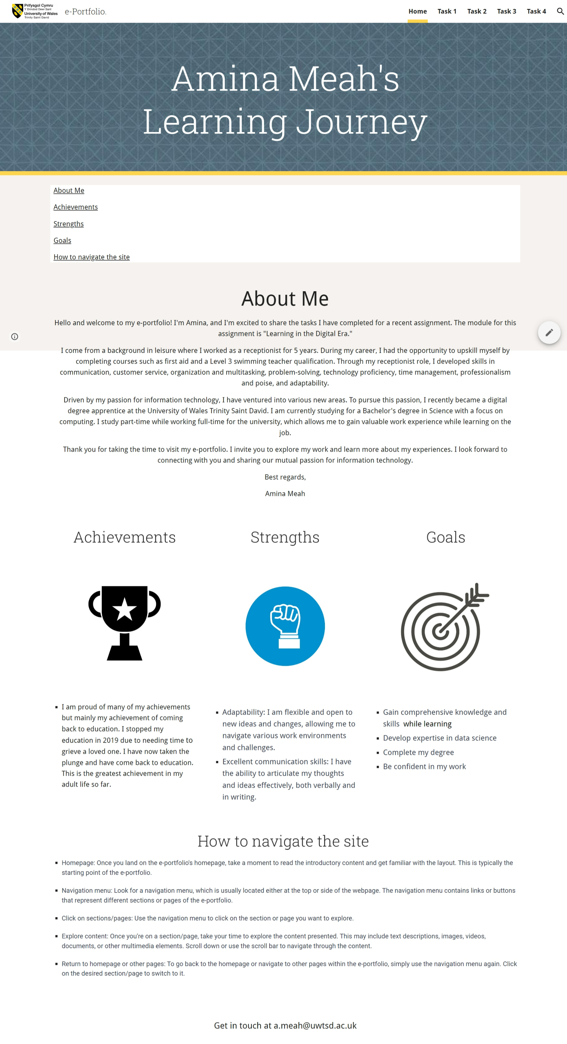

Evidence

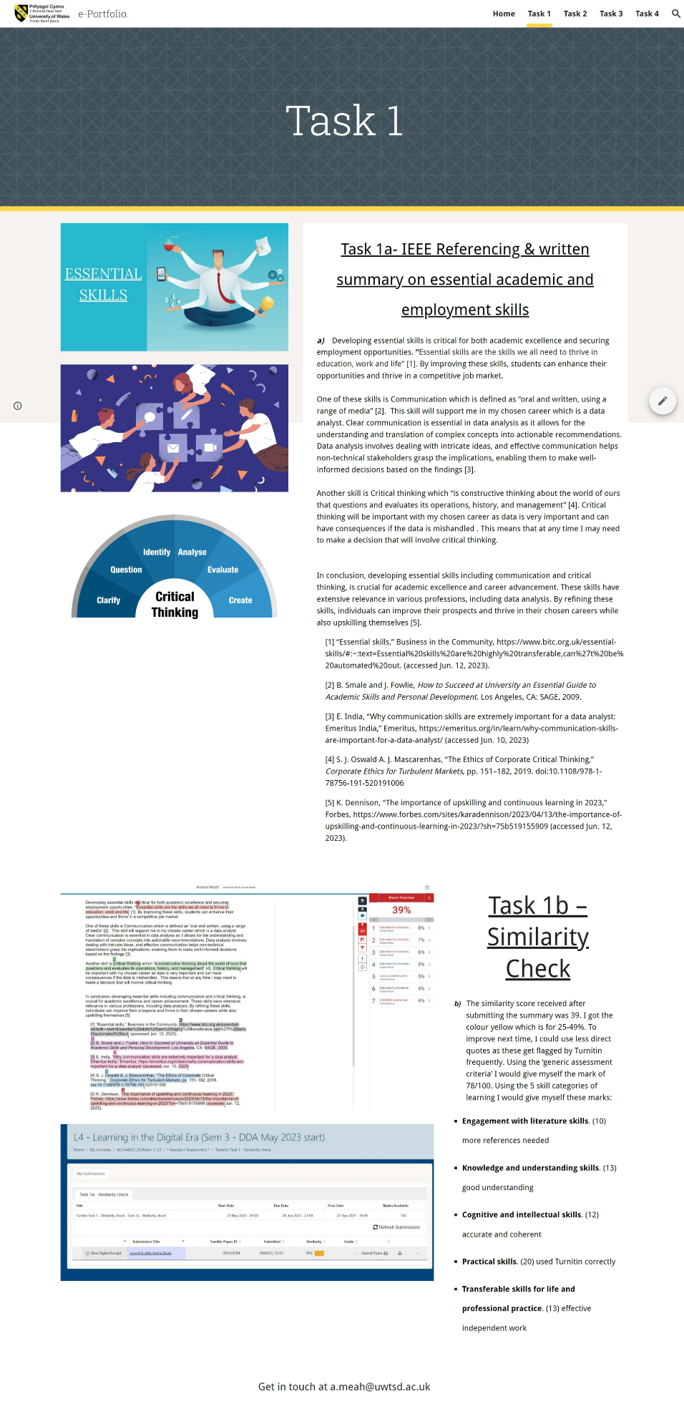
Task 1 -Written summary

Task 2-Academic poster
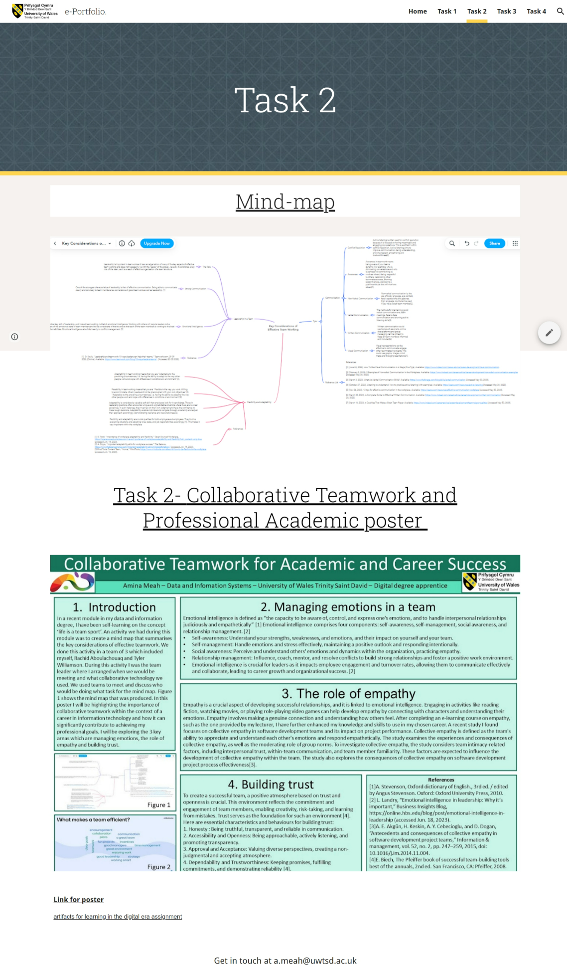
Link for poster - artifacts for learning in the digital era assignment

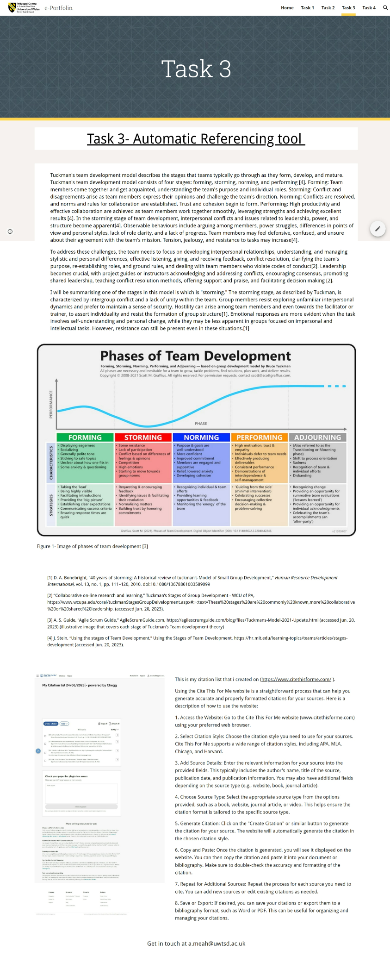
Task 3-Automatic referencing tool

Task 4-e-Portfolio creation and review


