Reflective journal
Giulia Olivotto (2115346)
UWTSD
Academic and employability skills
Lecturer: Lizeta Dimetriou
Table of Contents
Introduction 2
Time management 2
Academic writing 3
Summarising 4
Public speaking 5
PowerPoint presentation 6
Conclusion 6
References 7
Appendix 8

Introduction
This year I have decided to going back to study. After living in London for six years I have decided that it was time for me to improve some of the skills I have learnt in these years. And also refine my English, which is a language I have only learnt by speaking with people in London. I have joined this course in order to achieve all of this as well as continue my study and graduate in business and events management.
In the first term of this level 4 course, I feel like the class that has thought me the most and has helped me to set my mind back into study is academic and employability skills. I would say that the thematic seen and discussed in class are the foundation of any future course or jobs, especially for my intended career as Personal Assistant. I have found every topic of this course really stimulating and inspiring.

The topics I will focus on and discuss in this essay are:
- Time management
- Academic writing
- Summarising and,
- Public speaking
      - PowerPoint presentation

Time management

Time management is something that has always fascinating me. The idea of someone being able to precisely organise time and tasks in order to achieve goals in an almost effortless way amaze me.
In the past I have always tried to keep track of the activities and appointments daily schedule with agendas. I found out pretty soon that it was a perfectly fine method to me.
In order to use time efficiently you must to start from the very beginning. Lizeta gave us a proper explanation on how we should do it, organising a daily list of our obligations, or the things we want to achieve, and then give them a sort of ranking of importance, so prioritize. I have read and checked few websites, MindTools (N.d) and The balance careers (2021) and they both gave me an insight of the complexity behind time management. It comprehends a sphere of different organisational skills so we need to take in consideration different things like for example prioritize, problem solving, multitasking (the balance careers, 2021) and so on. It Is also important to find what works best for you. With Lizeta exercises and this type of thinking, I found out that the best way to organise my time is giving me little goal through each day. I wake up and I think about my day ahead and I write down (usually on my phone, but sometimes also on a little agenda) all the things I need to do for the day and I do that for my personal life and then, once I get to work, I would also do it for my work day. Having a list with tasks helps me to maintain calm under pressure and to follow a pattern in order to perform my duties. Working full time and studying can be very tricky that is why it is extremely important manage time appropriately. During this first term I set some goals for my assignments. Each day I would give myself 2 hours and sometimes also 3, at the end of my work day, to study. Working in an office give me the possibility to use quiet spaces to do it. When I am studying, I need my environment to be tidy and as quite as possible and also, studying in public places like libraries or quiet coffee and my office, really helps my mind to stay focus at the end of a day, when if I was just going home, I would lose myself and ended up wasting time. My recreation moment happens in the same moment I am done with whatever I had planned for the day. Once I get home I like to relax.
So, with an understanding of how important time management is, and having had the opportunity to find out what works best for me in this class, I am confident I will be able to achieve anything I set my mind to with practice and constancy.

Academic writing

Another topic we spoke about in class is academic writing. The importance of a good writing. I very enjoyed this class because I have always enjoyed writing, I kept diary since I was a kid and I am used to write letters for the people I love, and I don’t think I have ever struggled find a way to express myself. But academic writing is a completely different thematic. The use of a proper structure behind every sentence and clause is it something I hope I will constantly improve.
As for many of my colleagues, English it is not my first language, so to explain myself I would have to avoid translations, which I have been told by Lizeta is something we should always avoid when we want to write an essay, for example. Understanding better how to build a sentence and how many different words are there to be used really opened up a different world to me.
As mentioned in the booklet How to improve your academic writing (2008), within reasoning, academic writing is one of the most important skills in order to succeed in a good education.
In class we discussed different part of academic writing, we spoke about grammar, building sentences and also summarising. I think it was very important for me to participate to these lessons, in particular because knowing how to write in a certain way it is very crucial. I sometimes find myself re-reading an email over and over because I am not quite sure if my grammar is correct or if the way I construct a sentence is the most appropriate one. Practicing, reading and studying are the ways how I will improve and how I am improving already regarding this topic.

Summarising

We have also spoke about summarising. We did exercises about it, and there I have realised how much I was missing on that, being familiar with the right words to say can help minimize what I thought was a difficult task, if you are confident and have a good knowledge of different synonymous it can be easy to explain in your own words something you have studied. I think that I should really practicing more and constantly on this topic because most of the time I find myself struggling in completing this task.
Reading around about this topic I have learnt that there are some essential steps in order to summarise adequately. Akrani (2010) was a good reading to understand better each step of summarization techniques.
Select the main idea, some key words and sentences and then rejection, reject all the unnecessary and finally substitution. To replace and use your own words to build your summary. Akrani (2010)
For our PowerPoint presentation I have tried to applied what I have learnt and I have summarised as much as possible. I made every slide simple and condense, I have avoided to write down many words and long sentences, I have used key words to remind me of the speech I had prepared to discuss in front of the class and overall, I consider myself happy of the final result.

Public speaking
Another topic we spoke about in class is public speaking. I have found this topic very interesting considering I am terrible at it. As an anxious person myself I have had many adversities in the past, and still do. I understand the importance of being good at public speaking because it is a great skill to have and it applies to many different environments. In life, no matter what, knowing how to handle a speech in the right way in front of an audient will always be useful. Not only for personal reason but specially for any career path.
Public speaking has been a discussed topic for decades, as mentioned from Nikitina (2011) the first findings on this topic can be traced back to 2000 years ago. Aristotele elaborated some rules that are still the elements at the base for a successful public speech. Which are:
- Ethos = Credibility
- Logos = Logic
- Pathos = Emotion. Nikitina (2011)
The speaker should have a knowledge of the chosen topic, should know how to talk the audience through and how to explain it in the most accurate way and lastly, the speaker should be able to engage the public.
In the past being a good public speaker was something that interested just few selected people, nowadays it is a skill taught to everyone. In any circumstance being able to talk in public can really make an impact on the first impression you give. Not only it can have personal benefits but it can improve work performances.
In class we’ve seen a video of Barak Obama, which is a really great example of being good at public speaking. One of the first thing we’ve noticed is that is really confident and whenever he speaks about something you can just tell he transmit a sense of trust for the way he has to communicate. So Self- confidence is probably one of the first benefits of being good on this matter and definitely something I should work on and keep practicing as I have done with our PowerPoint presentation in class. Having had to talk about my intended career in front of the whole class was indeed good exercise.
I truly believe that constant practice it is what can help to improve, there is no other way to master public speaking. Reading and do research on the topics, in order to build the right confidence and knowledge, that is about it.

PowerPoint presentation

Considering public speaking is it not one of my best skills I have found this assignment quite difficult. Moreover, it was the first time I had to speak in front of the class in this term.
For my presentation I have tried focusing on just few words and make a very simple but effective dialogue explaining what are the criteria for being a good personal assistant. I did my research and read different articles, websites and even watched a video about it, in order to expand my knowledge but mostly in order to find the right way to explain to others about this career. The presentation went fairly well, mistakes were address. This exercise brought me more confident in public speaking and that made me feel satisfied of myself, which is another personal benefit of delivering a speech in front of a public. SAGE flex for public speaking (N.d)

Conclusion

In conclusion, this first term has given me a proper introduction back to school. I was very happy to see how every useful arguments has been covered in the classes. I thought it would have been more difficult after so many years because I was afraid we would have start from a more advanced level, along with the fact I am trying to take a degree in a different language but so far, I have enjoyed very much. Obviously, I have also found it challenging and there are many points where I should really improve, for example as mentioned already, I should spend more time working on my oration but I really believe that with the right dedication and with constant practice I will successfully achieve my goal.

References

Akrani, G. (2010) How to summarize a passage? Summarization skills techniques. Available at: https://kalyan-city.blogspot.com/2010/09/how-to-summarize-passage-summarization.html (Accessed on: 17 December 2021)

Doyle, A. (2021) The balance careers. Available at: https://www.thebalancecareers.com/time-management-skills-2063776 (Accessed on: 11 December 2021)

Mind tools content team (N.d) Mind tools. Available at: https://www.mindtools.com/pages/article/newHTE_00.htm (Accessed on: 11 December 2021)

Nikitina, A. (2011) Successful public speaking. Available at: https://www.isbtweb.org/fileadmin/user_upload/successful-public-speaking.pdf (Accessed on: 17 December 2021)

SAGE Flex for public speaking. Available at: https://edge.sagepub.com/sites/default/files/elements_section_02_module01.pdf (Accessed on: 17 December 2021)

University of Essex (2008) How to improve your academic writing. Available at: https://www.york.ac.uk/media/schools-and-colleges/sixth-form-resources/how-to-improve-your-academic-writing.pdf (Accessed on: 12 December 2021)

Appendix:
PERSONAL ASSISTANT

Giulia Olivotto

2115346

Accademicand employability skills (BMSW4001)

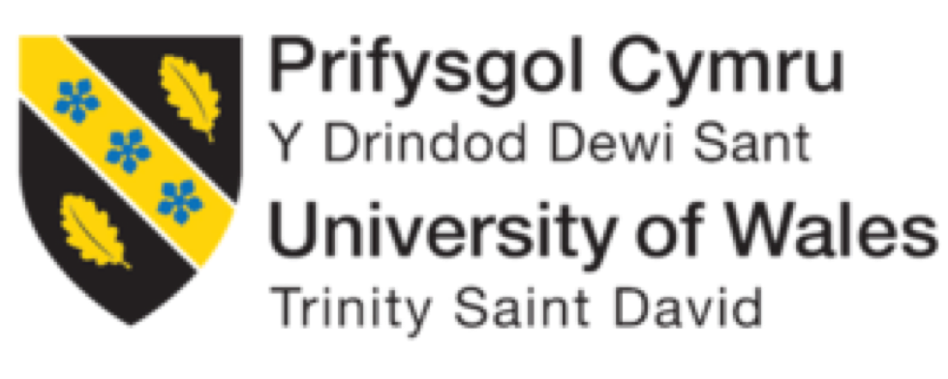 LizetaDemetriou
Overview

ØPersonal Assistant description

ØSkills required

ØOpportunities

ØThreats
Personal Assistant

 A personal assistant works as the right-hand ofa CEO or a high profile individual. The

main scope of a personal assistant It is to organise someone else agenda, to help

managing their time. (Totaljobs, 2021).

Therefore, undertaking a range of administrative tasks and not, it is the key of the job.

The responsibilities may vary depending on the individual or the office for whom you

work. (Prospects, 2021)

“PAs are the heart of organizations, working side by side with chief executives and

leaders, playing a key role in supporting decision.” (Sims, 2013)

However, the skills behind this profession are always the same.

Image: https://medium.com/@pelumiwrites/the-personal-assistant-the-slave-8e9676036b83
Skills needed to be a good PA

Organizational

skills

Social and

Technical

interpersonal

skills

skills
Organizational skills

Organization skills are essential for multitasking and keeping a business running

smoothly and successfully. (The balance career, 2021)

Time management is critical, being able to managing the time accurately and respect

deadlines, understanding how to prioritize as well as being able to multitasking, to

maintain calm under pressure. (Prospects, 2020)

In addition showing initiative. (Prospects, 2020)
Social and interpersonal skills

Social skills are important to communicate more effectively and efficiently and also to

help you build, maintain and grow relationships with colleagues, clients and new

contacts. (Indeed, 2021)

Strong communicational skills, in order to be able to write and talk in the appropriate

way in every circumstance, along with being confidentso as to achieve and gain the

trust necessary for this role and to deal with public speaking. (Indeed, 2021)
Technical Skills

Computer literacy, a knowledge of basic software packaging.

Speaking different languages. (Target jobs, 2021)
Opportunities

It is a very adaptable job

■Celebrity personal assistant

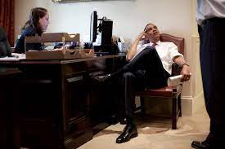 ■Executive personal assistant

■Wealthy families and so on…

(Target jobs, 2021)

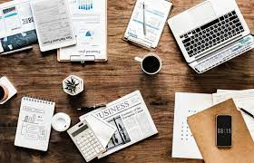Images: https://en.wikipedia.org/wiki/Personal_assistanthttps://19london.com/qualities-of-a-top-personal-assistant/
Threat

■Being reliable 24/7

■Passing on information, being able to understand the request by knowing very less

details. (Linkedin, 2021)
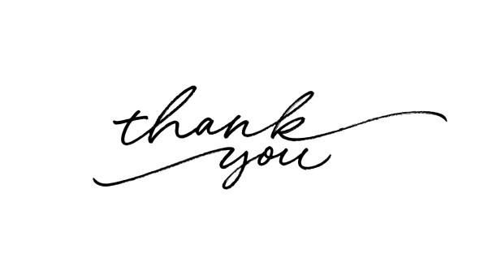 Questions?
References

19 London (2020) [Online] Available at: https://19london.com/qualities-of-a-top-personal-assistant/(Accessed: 9 December 2021)

AGCAS (2020) Prospects. [Online] Available at: https://www.prospects.ac.uk/job-profiles/personal-assistant -skills

(Accessed: 27 December 2021)

Doyle (2021) The balance career. [Online] Available at: https://www.thebalancecareers.com/organizational-skills-list-2063762

(Accessed: 20 December 2021)

Indeed Editorial Team (2021) Indeed. [Online] Available at: https://www.indeed.com/career-advice/career-development/social-skills

(Accessed: 20 December 2021)

Istock(2021) Thank you. [Online] Available at: https://www.istockphoto.com/photos/thank-you(Accessed: 27 December)

Sims (2013) ‘Being a personal assistant isn't just about diary management’ The guardian, 30thAugust. [Online] Available at:
https://www.theguardian.com/careers/personal-assistant-diary-management

(Accessed: 20 December 2021)

Target jobs (2021) Personal assistant: job description.[Online] Available at: https://targetjobs.co.uk/careers-advice/job-descriptions/personal-assistant-job-
description

(Accessed: 9 December 2021)

Totaljobs (2020)Personal Assistant job description. [Online] Available at:://www.totaljobs.com/advice/personal-assistant-job-description

(Accessed: 27 December 2021)

Wikipedia (2011) Personal Assistant. [Online] Available at: https://en.wikipedia.org/wiki/Personal_assistant(Accessed: 9 December 2021)

