NOTE TO TUTOR:This is a VERY rough draft. Text highlighted in red is not set in stone, neither is the rest of the text. Ultimately I am unsure of how to direct this essay. should this cover my major project and surrounding ideas and theories, or should it encompass an overview of explorative research? Am I writing too descriptively? I plan to discuss process and use of materials in more depth.

A HUMAN:NATURE Relationship
Rewilding the psyche
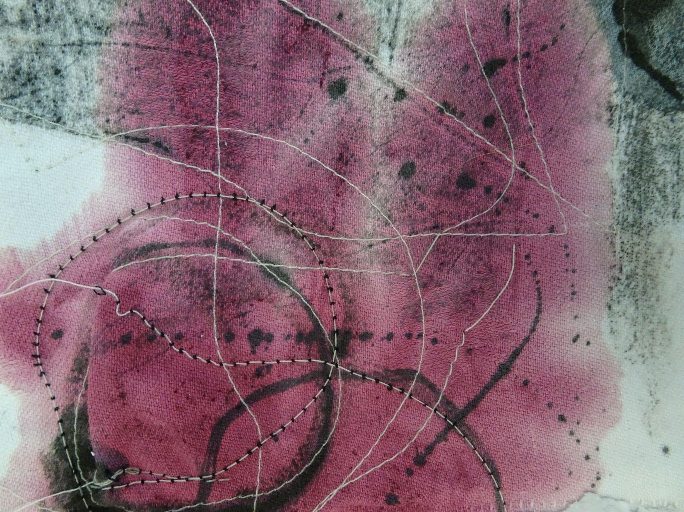
Hazel Maria Foy
Confirmative Praxis Report
2022 - 2023

‘Our identities are so intricately intertwined with our surroundings that the subtle yet powerful inﬂuences of place, which mold us, often go unrecognized. And place not only shapes us, we shape place .’ (CFHN,22)

Human connection with nature is an exceptional bond, crucial to our ability to survive as a species just as is the role that oxygen and water play in supporting life. It is a sacred bond. As described in James Lovelock’s ‘Gaia Hypothesis’, our planet acts as a self-sustaining system - a living, breathing organ that functions on a regulated system influenced by the interaction of different organisms and their surrounding environments.(Lovelock, J.2006) Having a healthy, thriving environment rich in biodiversity and wildlife ensures a safe and hospitable place for us to not only survive, but thrive. Yet despite having survived for millions of years, our planet now faces a dark and dystopian future. A fate too dark to face is cemented in my psyche and has been a driving force for much of my work, both in a theoretical and conceptual sense. Lovelock’s documentation(analysis?) of ecological hypotheses, particularly ‘The Gaia Hypothesis’, has become a deep-rooted connection to the theoretical studies integrated in my praxis. Working as a physical scientist in training for NASA in the 1950’s, James Lovelock produced what is known as the ‘Electron Capture Detector’, a highly analytical process which allowed toxic chemical substances to be detected in small, trace amounts. The use of this technology enabled scientists to discover that highly toxic residues such as pesticides were present in vast variations of ecological life. From creatures in the Arctic such as penguins to the breast milk of human mothers; for the first time hard physical evidence could be brought to light that Humans had begun to change the biological composition of the planet. Scientific discoveries such as these were what inspired Rachel Carson to write ‘Silent Spring’ in 1962, one of the many publications I used to formulate my dissertation earlier this year. (Odum, p. E. 1993 )
This sudden change in ecology is currently being discussed as a new geological epoch, known as the ‘Anthropocene’. The term was first made popular by Dutch chemist Paul.J Crutzen in an article published in 2002, referring to this term in relation to biospheric research, making its way into several scientific studies and reports. Described in Heather Davis and Etienne Turpin’s ‘Art in the Anthropocene’ as a ‘collective assemblage of scientific enunciation’, they convey its conceptual barriers, being an ‘inherently political concept, albeit one that many critics have suggested remains inadequate for describing the present situation’. Anthropocene is an emphasis of desperation, and urgency of human impact calling for attention to re-evaluate political economic logics and the future. (D, Heather.T, Ettienne. 2015)
Natasha Myers is an artist that I first drew inspiration from, and has remained a key part of my research throughout my praxis. Myers’ composition of video, sound and artifact are one installation of many spread out across her exhibition, ‘Edenic Apocalypse’. Davis and Turpin describe her works as ‘a dramatic climate-change data-visualization room’ which incorporates modern technology in order to portray scientific analysis of human impact. It is her use of information in conceptual artworks that resonates with my own work and the intentions surrounding my process.
The monitors read:
“ + 0.7 Degrees: Hot, dry areas get hotter and dryer. There are more wildfires.
+1.1 Degrees: Small mountain glaciers disappear. Threatening water supplies for 15 million people.
+1.5 Degrees: Malnutrition, malaria, and other diseases continue to increase.
+1.8 Degrees: All coral reefs are bleached.
+2.7 Degrees: The last polar bear dies.
+2.9 Degrees: Half of all species are doomed to extinction. +3.9 Degrees: 1 in every 5 plants is critically endangered or extinct.
+4.3 Degrees: 50 % decrease in fresh water availability.
+5.0 Degrees: And so we reach 2100, it is 5 degrees warmer, the earth is a dry rock dying in space. ”
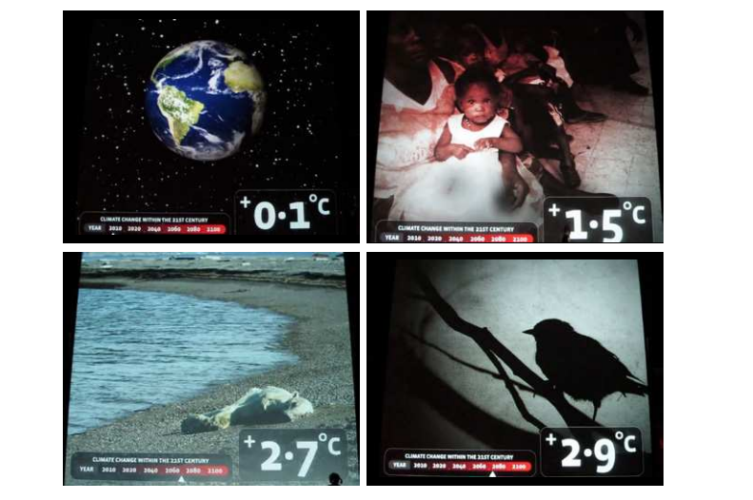
Natasha Myers, ‘Earth Check’, ‘Edenic Apocalypse’.

The June–August 2022 global surface temperature was 0.89°C (1.60°F) above the 20th-century average of 15.6°C (60.1°F)(quote)

WHY IS EVERYONE NOT FREAKING OUT?

It is with this information that the notion of self in relation to being an artist in this current climate has led me to incorporate such narrative in my practice. As noted in ‘Art in the Anthropocene’, from the words of Henri Cartier-Bresson; ‘The world is going to pieces and people like Adams and Weston are photographing rocks!’, reflects on current ecological and political economic realities in relation to the present art world. It is explained that Henri Cartier-Bresson argued for a ‘more socially engaged art practice’. I cannot help but think, ‘how can I possibly make art that does not reflect the times in which I live?’ For it is the most urgent crisis of all, one that shapes our current shifting reality and threatens the world we live in.
‘It is remarkable that in less than a century we should find the terms of this debate uncannily entangled: what does it mean for art to encounter the Anthropocene? If art is now a practice condemned to a homolithic-earth …how can aesthetic practices address the social and political spheres that are being set in stone? Becoming-geological undoes aesthetic sensibilities and ungrounds political commitments.’ (Davis, H & Turpin, E. 2015)

…researching artists such as ‘....’ has contextualized my creative journey, inspiring much of my practise. It has led me to believe that there are other artists out there, speaking the same conversation. And that there is hope in the human race.

In reflection, my praxis grew from seed into an organic extension of the( my)self, in relation to place, space and environment. It has become a personal reflection of the state of the world through anxious eyes, seeking solace and escape in the hope of returning to the brave, wild inner child and animal. A hope that someday soon our diminishing bond with nature shall return. My body of work reflects an intrinsic relationship between earth and self, showing an understanding of how this connection has played a key role in molding my identity; both as an artist and a human in this contemporary world. (HAVE I SAID THIS ALREADY?) Environmental affairs such as climate change have been a driving force for much of my work, having always had an affinity with the natural world, and a devotion for portraying the destruction caused by humankind. Through a derridian sense of deconstruction, I investigate the relationship between identity and the environment, creatively approaching my own personal identity in relation to the strong symbiosis of self and ecology whilst taking apart archetypal structures within the material world. The artifacts, text and imagery that I will discuss throughout this report aim to create dialogue between human and non-human entities, aiming to question the archetypal regime of tradition and to question our place on earth and what future we choose. We wait at a crossroads with two choices of direction - one in harmony with nature, and one that fails to recognise the current situation and to continue destroying the planet .Whether we decide to live a slower life-style, in rhythm with nature - or continue into a synthetically manufactured future where planetary systems break down and climate disaster becomes even more frequent. I explore organic materials as an action of slowness, observing and collecting and making. I pay attention to the forgotten, broken fragments of what we used to be. (extend this?)

Identity and environment: Ecological Identity
What role do I play in the Anthropocene?

Research into the Anthropocene drove me to continue using ephemeral materials, reflecting the theme of ‘impermanence’ and the fragile state of our planet. Writings of James Lovelock and Julia Zylinska became fundamental research. I became interested in works of art that would not last forever. Research into Anna Gallaccio and Richard long informed me in this process.

(QUESTION FOR DRAFT REVIEW: DO I NEED TO INCLUDE RESEARCH AND INVESTIGATION FROM EXPLORATIVE, OR FOCUS THIS ESSAY SOLELY ON THIS ‘MAJOR PROJECT’ / BODY OF WORK- AND EXHIBITION?)
During the early stages of my praxis I discovered a collection of old photographs,
portraying a different place in time. I became interested in the nostalgia surrounding these images, and the ancestral connection between my own identity and the environment in which I relate to. In a sense, I became intoxicated by the phenomenon of identity represented in each of the photographs. The indexical materiality of the images I held in my hand seemed a great contrast to the technologically advanced neon age we appear to be living in now.
My initial aim was to investigate the link between identity and environment, through interpretation of these photographs and research into contemporary artists and writers that support these proposed ideas. Somewhere between the internal plane……and the external view of the world lay the answers to my questions. My father has always felt drawn to the wilderness, as has my nana and inherently so have I.
(CAPTION)
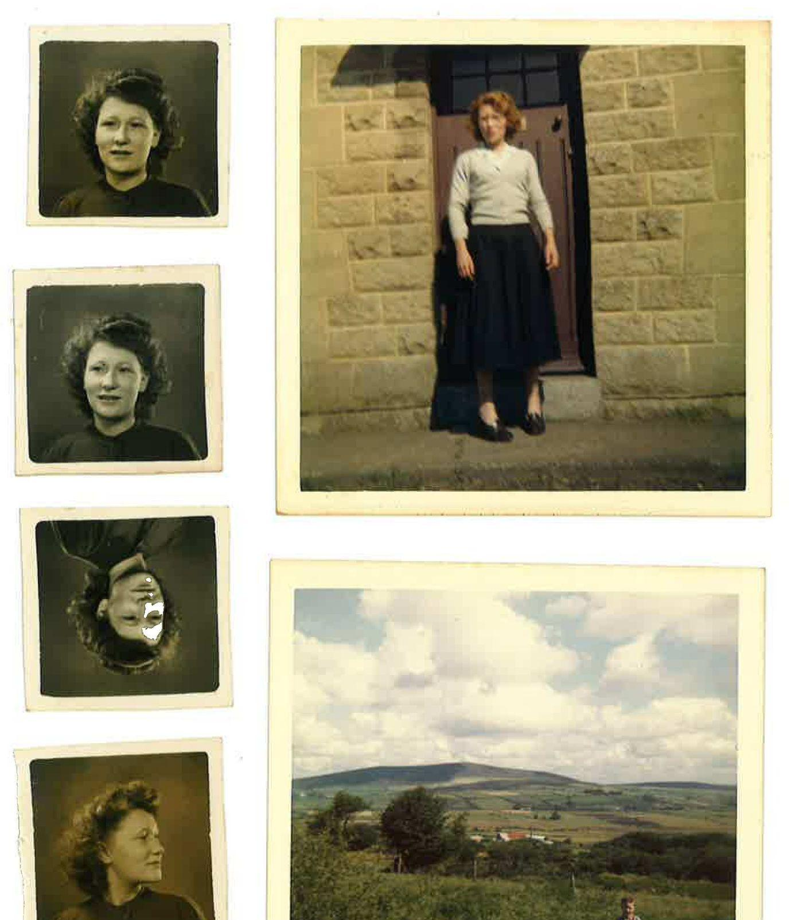
I often wonder if my affinity with the natural world is hereditary, or if it stems from early stages of nourishing connection with nature and being within it. Research into the writings of Richard Louv influenced me to explore themes of Identity and childhood in connection with these physical photographs. Author of ‘Last Child In The Woods’, published in 2005, Louv coined the term Nature Deficit Disorder, ‘a description of the human costs of alienation from nature’ (Louv, R. 2005). Through Environmental Philosophy, these ideas surrounding a nature and child connection created the basis of my praxis. (ADD WRITING BY LIUVRE)

layered tonal compositions, creating further dialogue between each article.

Theoretical research has allowed me to contextualise my practise, and engage with philosophical language in order to ….?
I wanted to evaluate the materials and process involved in traditional photography - the notion that photography captured ‘self’, felt ironically contradictory since most analogue processes contribute to environmental harm (dev//plastic paper//toxic chemicals). It made me think of the notion of ‘human exceptionalism’ that Melanie Challenger discusses in ‘How to be more animal’ …analugue photography is ‘fixed’ with chemicals - in a conceptual light one might consider these means as ‘permanent’ - we want our image to last forever. Yet this very phenomenon contradicts who we really are as a species - our organic selves. And may lead us to understand why the world is in such a state as it is now. Human’s want to live forever, in essence or in the physical sense.
(QUOTE BY MELANIE CHALLENGER - HUMAN EXCEPTIONALISM)

‘ The myth of human exceptionalism is as unsettling as it is irrational. The idea of our superiority runs with mercenary and sometimes aggressive features of our psychology.’ (Challenger, M. 2021)

If the nature of photography allows us to capture memory, then it is permanence we seek within parameters of ‘human exceptionalism’. We deny our true selves by believing in something ‘bigger’ than organic selves. We ignore the ‘animal’ within us, creating a barrier within our psyche between us and the natural world. (QUOTE MELANIE CHLLENEGR )

Roland Barthes’ Camera Lucida ‘It was not she, and yet it was no one else’.Roland Barthes, Part 2, Chapters 27–28
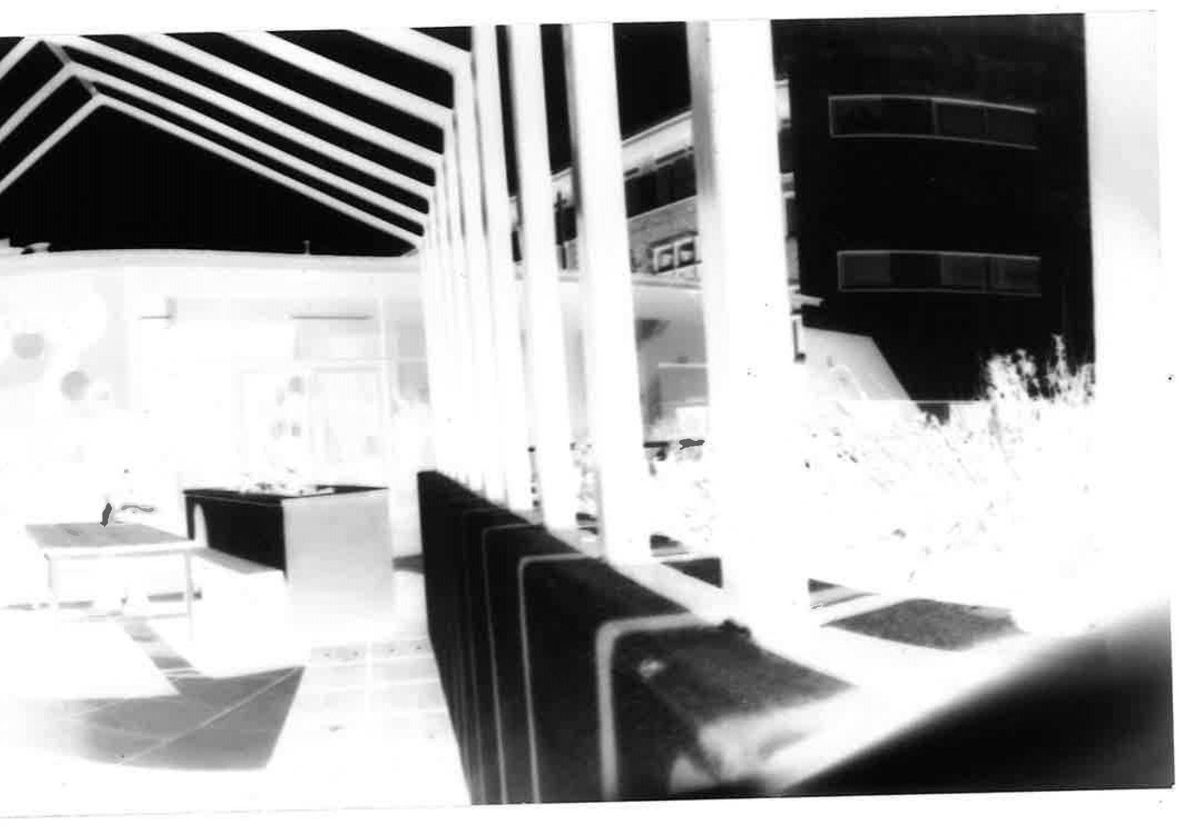
Roland Barthes searches for his deceased mother's essence in photographs. Going through many pictures of her, she is undoubtedly present in the photographs and yet they fail to illustrate her true being, her essence, her soul.
PIN HOLE CAMERA

Using photography to conceptually explore ideas
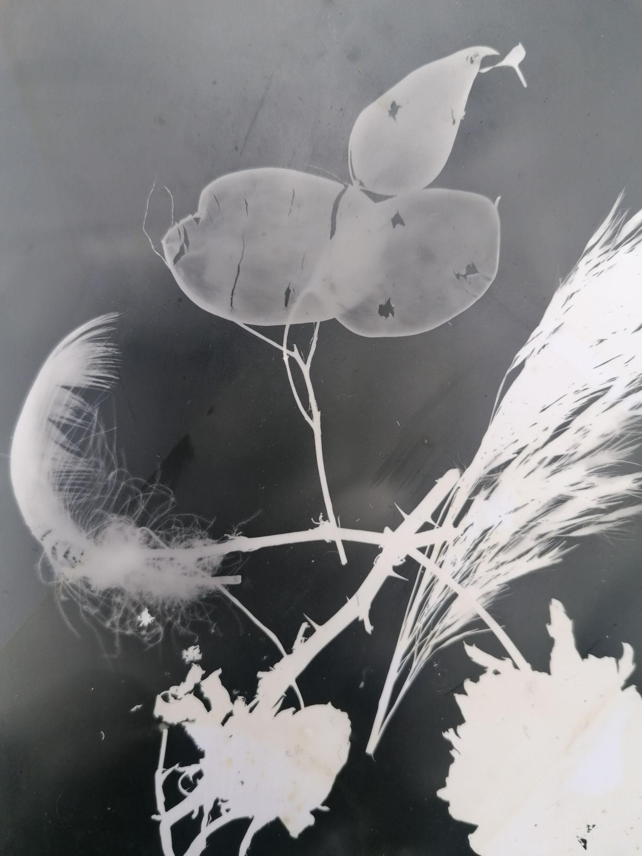
Photogram, Found Objects. (Foy, H. 2022)

I responded to these images through analogue photography, using the dark room to alchemise a relationship between subject and material. Through deconstruction of contemporary ideals, I experimented with natural materials which removed destructive consequences from their environmental impact. While seeking for a representation of my own identity within these photographs, these figures naturally transitioned to a dialogic motif within experimentation of artistic process. Organic processes became just as crucial in significance as the subject matter itself. Caffenol-C replaced developer and salt water replaced fixative. (FIND NAMES OF FIXATIVE CHEMICALS). The methodology behind this organic process were influenced by artist and (..?) Melanie King, as well as the ‘Caffenol cook book & Bible’ (QUOTE)
(Melanie King - QUOTE//RESEARCH)

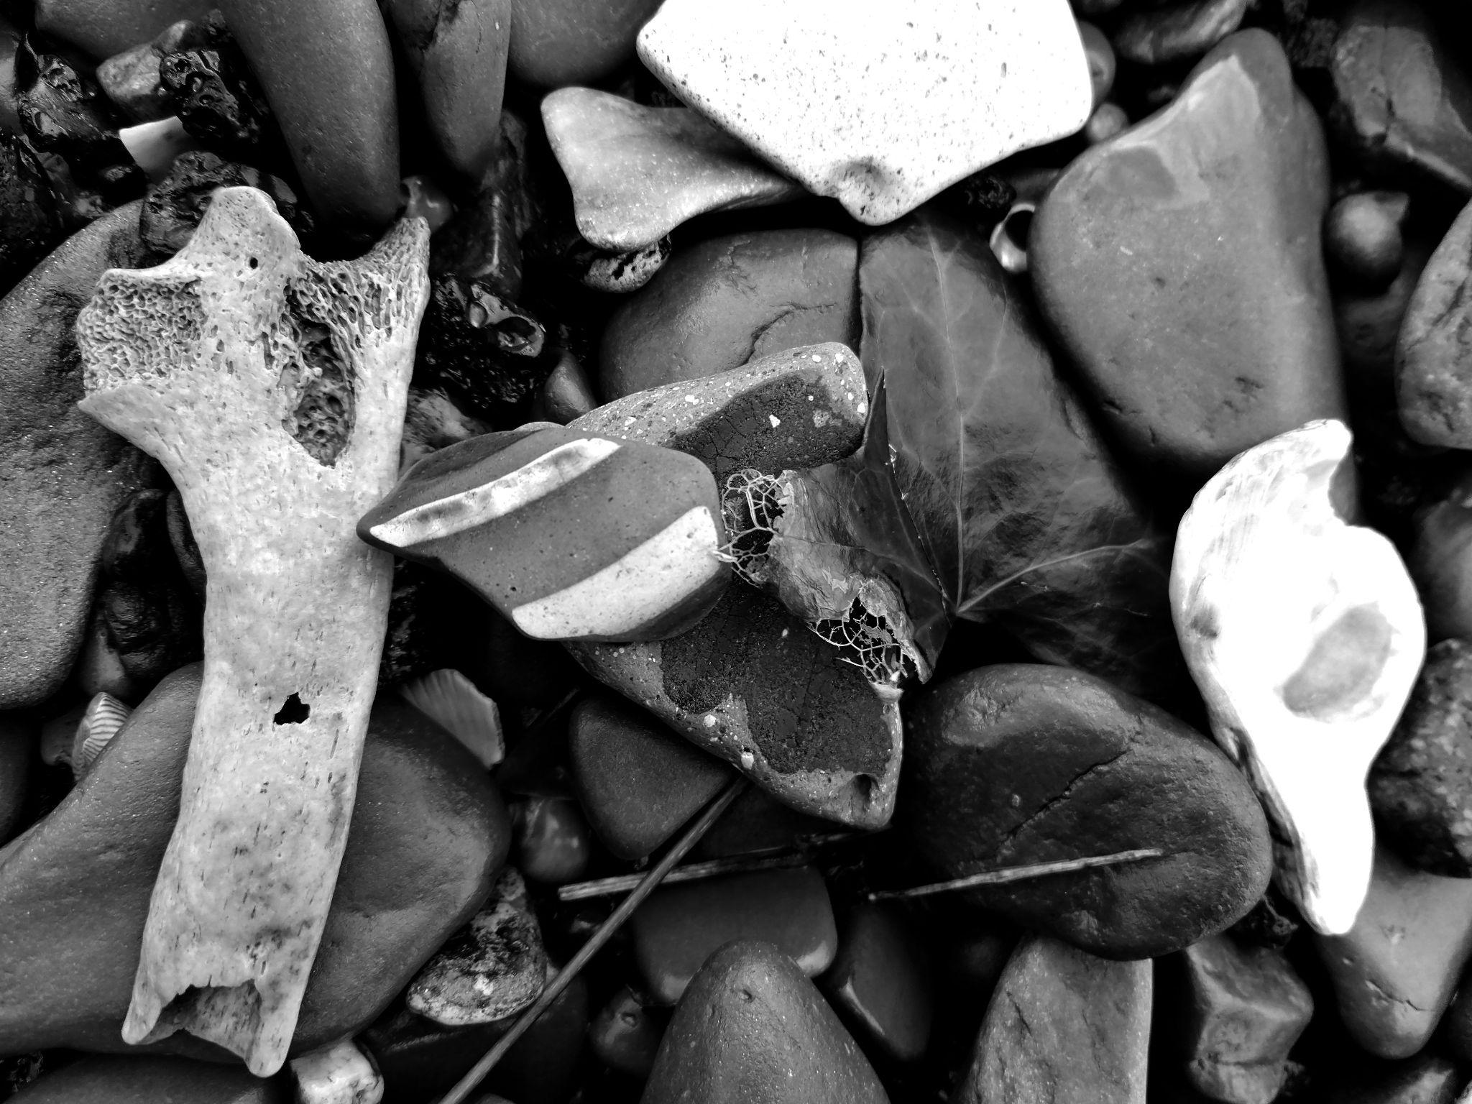

IDENTIY - SOPHIE CALLE/

Does place, shape space; shape self?
Collecting objects - traces - walking - footprints - observer’s eye - texture/form/prganic
Post-humann - anthropocene -
Philosophy
ENVIRONMENTAL IDENTITY
ARTISTS - SESEE DENEO BOPAPE FROM ARTES MUNDI

CYANOTYPE - moving to more natural materials - the role of self in current social times - anthropocene.
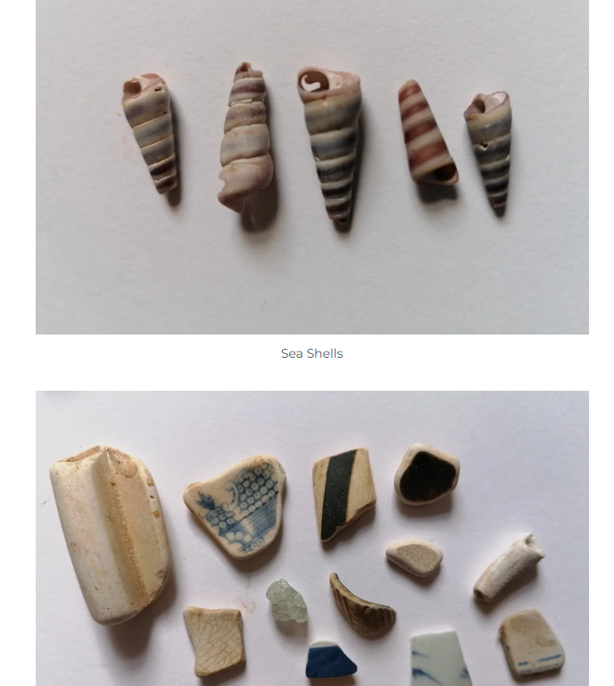
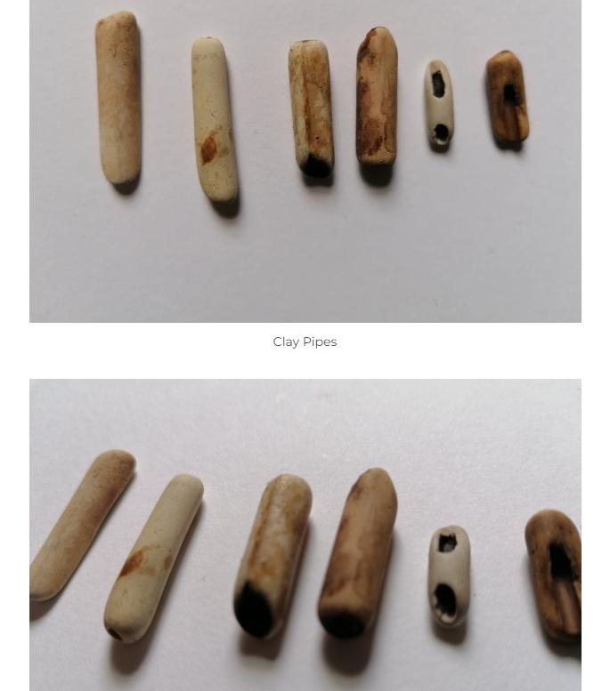
Cameraless photo
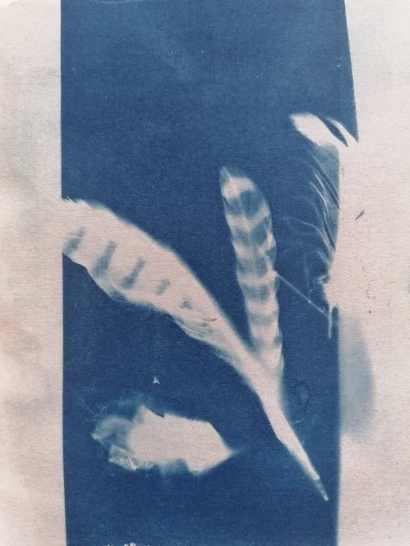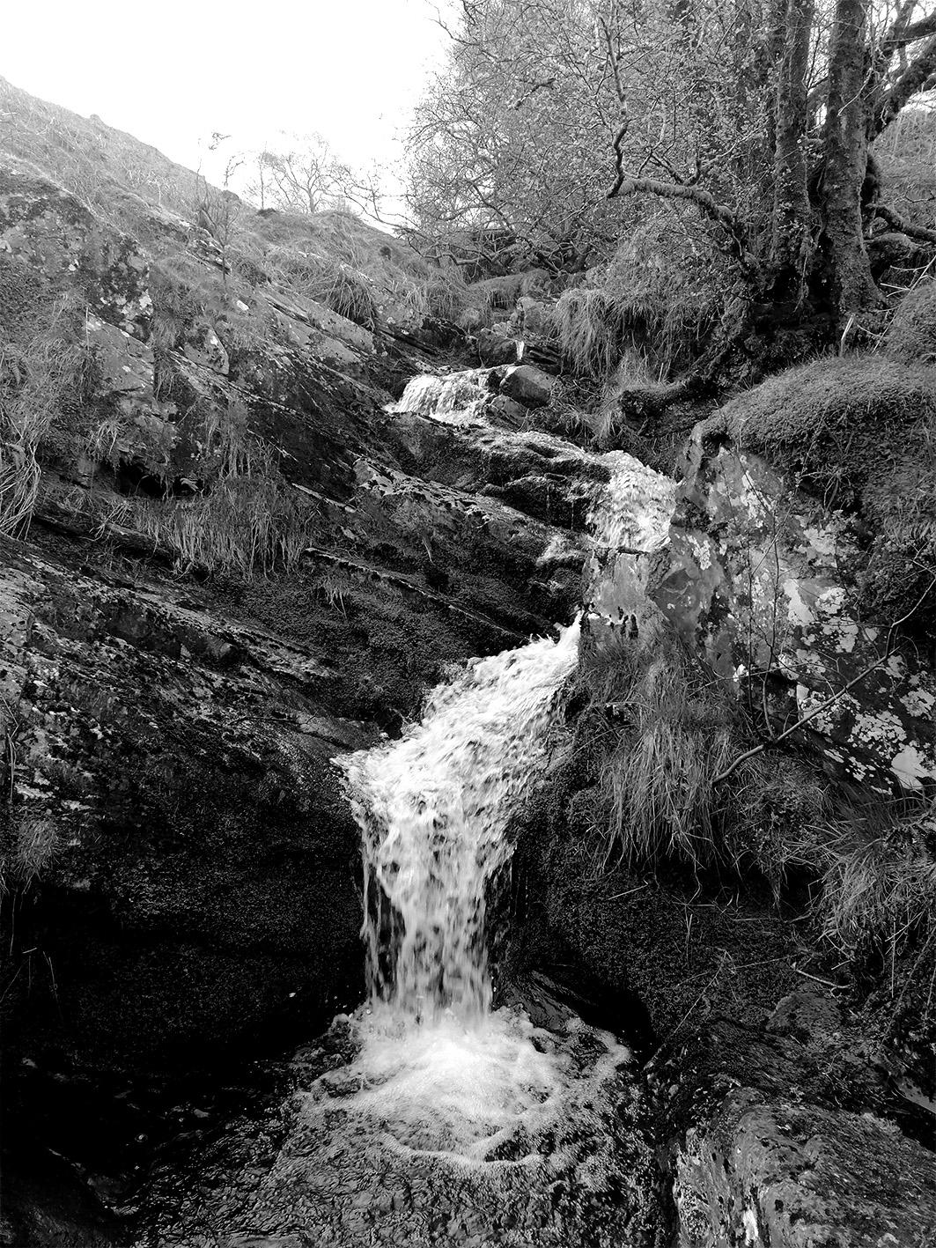
My praxis became a conversation between subject and material. The material and process that I used became just as important as the research and conceptual ideology. The slow characteristics of using natural materials naturally reflected the conceptual structures.

Does space, shape place; shape self?

Bibliography

‘The Revenge Of Gaia’ (Lovelock, J. 2006.)
https://www.ncei.noaa.gov/access/monitoring/monthly-report/global/202208
Art In The Anthropocene: Encounters Among Aesthetics, Politics, Environment and Epistemologies. Davis,H. Turpin, E.

Last Child In The Woods: Saving Our Children From Nature-Deficit Disorder, 2009.
Louv, R.

https://www.melaniek.co.uk/ancient-light

Fritsch, M., Lynes, P., & Wood, D. (Eds.). (2018). Eco-Deconstruction: Derrida and Environmental Philosophy (1st ed.). Fordham University Press.

https://doi.org/10.2307/j.ctt201mp8w

https://lab.cccb.org/en/joanna-zylinska-we-need-a-new-way-of-seeing-the-anthropocene/

