

Module Title: Hotel Placement Research Project
Module code: BMIH6008
Level 6

Topic: Role of AI in personalised customer service in the tourism and hospitality industry: A case study on The Crown Bawtry, Rossington Hall
Lecturer: Ben Ka Po Chong

Student Name: Flavia Nanu
Student ID: 2239004

Declaration
I am immensely writing to affirm that this research study is a personal original piece and has never been presented before in any academic qualification. The sources used have all been mentioned accordingly and cited. The work is in line with the academic integrity and ethical provisions of the University.
Acknowledgement
I would like to say my genuine thanks to my academic supervisor, who helped me and provided positive feedback during the fulfilment of the following Hotel Placement Research Project. I am also grateful of the management and staff of The Crown Hotel Bawtry and Rossington Hall to give me their experience that was practical in my study. Lastly, I am grateful to have support of my family and fellow students in the process of the research.
Abstract
This research discusses the use of artificial intelligence in providing customer service in the tourism and hospitality sector in offering personalised customer service based on a two-site study (The Crown Hotel Bawtry and Rossington Hall). The research addresses the increasing challenge to hospitality organisations to deliver very personalised guest experiences and be able to offer operational efficiency and control costs. As stress-free and personalised service, customer satisfaction, service performance and long-term relationships become more closely connected with the fast rates of AI technologies up taking (chatbots, recommendation systems, CRM-based personalisation, data analytics, etc.), this study investigates the relationship between this type of tool and customer satisfaction, service efficiency, and long-term relationship formation in boutique and luxury hospitality environments. The main objective of the study was to examine how AI can be used in the chosen hotels to facilitate the customised customer service and recognise the benefits, obstacles, and aspects of strategic implementation. To do so, I have decided to use a quantitative research design with a deductive approach and positivist philosophy. A structured questionnaire that was administered on 100 individuals, who had stayed recently at The Crown Bawtry and Rossington Hall with convenience sampling, was used to gather data. Frequency analysis was used to analyse the findings to put forward overriding trends in customer perceptions. The findings indicate the mainly positive effect of AI based personalisation on the customer experience and service performance. One of the major portions of the respondents affirmed that AI enhanced the speed, consistency and responsiveness of the service especially in things like reservations, information provision, and personalised recommendations. The guests found AI-driven services to be efficient, modern, and valued, and these led to the increased levels of satisfaction and the enhanced perceptions of the service quality. The research also suggests that digital assistance based on AI has led to greater customer loyalty as personalised communication occurs and preferences of the guest are identified in the long term.
Nonetheless, some specific challenges are also mentioned in the research. An issue of data privacy turned out to be a key impediment to the entire adoption of AI-driven services, with numerous respondents being concerned about data security and system reliability. Besides, on the one hand, automation enhanced the effectiveness of operations; on the other hand, it had a less significant effect on relationships and emotions. It indicates that AI will never solve the human factor that is at the centre of hospitality service excellence. The results prove the criticality of staff training and organisational preparedness because the implementation of AI systems proves to be the most effective when they are applied to complement, and not to replace human contact. According to the results, the study suggests that The Crown Bawtry and Rossington Hall should introduce a hybrid model of service that will incorporate AI technologies and excellent human service provision. Effective data governance policies, open communication with visitors and consistent employee education should be implemented to ensure the maximum of trust and efficiency. Comprehensively, throughout the research results indicate that AI is a strategic pertinent to improving individual customer service under ethical application and in accordance with central hospitality principles.

Table of Contents
Chapter 1 Introduction 9
1.1 Research background 9
1.2 Aim 9
1.3 Objectives 9
1.4 Problem statement 10
1.5 Vision 10
Chapter 2 Literature Review 11
2.1 Introduction 11
2.2 Use of artificial intelligence in hospitality customer care 11
2.3 Personalised technologies to improve tourist experience and satisfaction 12
2.4 Advantages of artificial intelligence-based service delivery in hotels 12
2.5 Difficulties and moral problems of AI hospitality deployments 13
2.6 Theoretical Underpinning 13
2.7 Literature Gap 14
2.8 Conceptual Framework 14
2.9 Summary 15
Chapter 3 Methods 16
3.1 Research Philosophy 16
3.2 Research Approach 16
3.3 Research Strategy and Design 16
3.4 Sampling Technique 17
3.5 Data Collection Method 17
3.6 Data Analysis Technique 17
3.7 Ethical Considerations 18
Chapter 4 Findings and Discussion 19
4.1 Introduction 19
4.2 Findings 19
4.3 Discussion 29
4.4 Limitations 33
4.5 Future research and development 33
4.6 Summary 33
Chapter 5 Conclusion and Recommendations 35
5.1 Conclusion 35
5.2 Recommendation 37
Reference List 41
Appendices 51
Appendix 1: Survey Questionnaire 51
Appendix 2: Ethics form 55

List of Figures
Figure 2.1: Conceptual Framework 15
Figure 4.1: Survey Response for Q1 19
Figure 4.2: Survey Response for Q2 20
Figure 4.3: Survey Response for Q3 21
Figure 4.4: Survey Response for Q4 22
Figure 4.5: Survey Response for Q5 22
Figure 4.6: Survey Response for Q6 23
Figure 4.7: Survey Response for Q7 24
Figure 4.8: Survey Response for Q8 24
Figure 4.9: Survey Response for Q9 25
Figure 4.10: Survey Response for Q10 26
Figure 4.11: Survey Response for Q11 26
Figure 4.12: Survey Response for Q12 27
Figure 4.13: Survey Response for Q13 28
Figure 4.14: Survey Response for Q14 28
Figure 4.15: Survey Response for Q15 29

Chapter 1 Introduction

1.1 Research background
This study analyses the applicability of AI in personalised customer service by conducting a two-site case study of The Crown Hotel Bawtry and Rossington Hall (Rossington Hall, 2026). The Crown is a four stars town hotel; Rossington Hall is a Victorian stately-home events venue with approximately 21 bedrooms both offer Doncaster-area leisure and business to their guests (Tripadvisor, 2026). The study posits the question of the impact of AI services (chatbots, recommendation engines, CRM-based offers and in-room personalisation) on guest satisfaction, upselling, and operational efficiency. The adoption of generative AI is fast in the industry, approximately 65% of organisations utilise it (Craig, 2024). Approximately 80% of the hotels process or intend to make use of AI/data analytics in making personalised offers (Schwarz, 2024). The market of AI-in-hospitality is developing very rapidly. The use of hospitality AI will expand at a high rate (CAGR ≈25%), thus maintaining importance of strategic relevance among small operators (Research and Markets, 2024). Smaller operators claim prevalent AI testing, implying that the application was practised in the case locations.
1.2 Aim
The aim of this research is to analyse the role of AI in personalised customer service in the tourism and hospitality industry: A case study on The Crown Bawtry and Rossington Hall by identifying challenges and the strategic implementation process.
1.3 Objectives
To identify different functions of AI for personalised hospitality service in The Crown Bawtry and Rossington Hall in the tourism industry
● To assess the advantages of AI for the personalised hospitality service of The Crown Bawtry and Rossington Hall in the tourism industry
● To analyse current challenges in using AI for the imprecation of customer service of The Crown Bawtry and Rossington Hall in the hospitality and tourism industry
● To provide strategic solutions for reducing issues in AI implication in customer service of The Crown Bawtry and Rossington Hall in the hospitality and tourism industry.

1.5 Hypothesis development
Based on the findings and the literature, the study puts the following hypotheses.
- H0: There will be no impact of the AI-enhanced personalised services on the guest satisfaction, perceived value of service or operational performance of The Crown Bawtry and Rossington Hall.
- H1: AI-based personalised services do greatly improve guest satisfaction, perceived service value, and operational efficiency, whereas privacy concerns, the reliability of the system, and employee competence to cut the performances of AI-based interactions relate to such a promotion.

1.6 Problem statement
The hospitality and tourism sector has struggled to promote a high level of personalised customer experiences at scale and operate at a cost (Šakytė-Statnickė and Budrytė-Ausiejienė, 2025). The conventional service models cannot cope with an increase of customer demands connected with immediate tailored communication at various touchpoints (Sousa, Cardoso and Dias, 2024). Although AI can be used in a manner that improves service personalisation, barriers to implementation such as technological integration, staff resistance, and lack of certain ROI remain an issue in the hospitality sector (Żyminkowska and Zachurzok-Srebrny, 2025). This study will determine how The Crown Bawtry and Rossington Hall can use AI technologies to overcome these obstacles and provide customers with personalised customer service.

1.7 Vision
This research discusses the concept of AI changing customer service personalisation in the hospitality and tourism sector, using two examples of The Crown Bawtry and Rossington Hall. It explores autonomous AI-based systems of recommendations, chatbots, and predictive analytics that can help in improving the experiences of guests by providing personalised services (To and Billy, 2025). The study deals with the issue of implementation, staff adjustment and guest satisfaction indicators (Alhelal, Alshiha and Al-Romeedy, 2025). Through the study of practical applications, this case study will add value to the concept of AI being a strategic value in generating competitive advantages and sustainable personalisation systems within hospitality environments.

Chapter 2 Literature Review

2.1 Introduction
This respective chapter conducts a literature review of the available literature on artificial intelligence in personalised hospitality services. It critically reflects on the adoption of AI, personalisation technologies, operational advantages and also issues with the implementation of AI that sets up a theoretical background to analyse AI-based customer service in the tourism and hospitality sector.

2.2 Use of artificial intelligence in hospitality customer care
The utilisation of chatbots, virtual concierge systems, and automated reservations has made artificial intelligence become a bigger part of hospitality service delivery. AI improves the speed and efficiency with which customers respond to and the efficiency with which hospitality operations are conducted (Milton, 2024; Awasthi, 2022). The technologies provide the hotels with the ability to handle large numbers of guest contacts in the same orderly manner, especially when guests are at their peak (Das, 2023; Jawabreh et al. 2022). Meanwhile, excess focus on automation undermines the interpersonal aspect which is traditional to hospitality service (Huang and Liao, 2026). The mediation of the interaction with the customers by AI entirely is under a threat of seeming transactional as opposed to relational, which leads to a lack of emotional involvement (He et al. 2025; Han et al. 2023). The acquisition is also higher in different organisations depending on financial capability, digital infrastructure and leader buy-in. Big and luxurious hotels can implement AI much more successfully, and smaller hotels face the problem of high costs and lack of skills. The critical role of training and organisational culture is then influential to the outcomes of adoption (Tripathi and Kalia, 2024). Such opposite trends show that the implementation of AI in the hospitality industry is more than just a matter of technological preparation. It also justifies that the implementation should be accompanied by the organisation of interdependence of service philosophy, staff training, and guest anticipations.

2.3 Personalised technologies to improve tourist experience and satisfaction
Personalisation on top of AI can allow those in the hospitality industry to customise services based on customer-related information, tastes, and behavioural patterns to improve the perception of relevance and convenience. Individualised room environments, personalised suggestions, and individualised communication are leading to a better client satisfaction and loyalty rate (Rane et al. 2023; Maghembe and Magasi, 2024). These personalised experiences are able to enhance emotional attachment and brand positioning. Simultaneously, algorithmically inspired personalisation can decrease spontaneity and decrease genuine service experiences (Shin, 2023; Hardcastle et al. 2025). There exists a risk to privacy in case of the intensive data collection and in this case, the guests are not aware how their data are being processed. The accuracy of personalisation may also be biased particularly in case of new or frequent visitors whose data profiles are constrained (Jansen et al. 2024; Rafieian and Yoganarasimhan, 2023). Excessive dependence on past information has the potential to empower the same whereas new experiences should be promoted. The credibility of personalised systems is supported by transparency, ethical data handling and control by guests on information sharing (Yallop et al. 2023; Olateju et al. 2024). These discrepancies reveal that AI-based personalisation improves tourist experience provided that technological accuracy is spread equally between privacy and human services design.

2.4 Advantages of artificial intelligence-based service delivery in hotels
Hotels benefit with AI-driven service delivery, which streamlines operations and removes manual labour as well as enhancing service touchpoints uniformity. Automation of check-in, smart scheduling, and predictive analytics allow serving faster and with increased efficiency (Kaul, 2023; Negoita et al. 2023). These efficiencies enable the personnel to shift the focus to guest involvement. The technology of standardised AI procedures may decrease the flexibility and prevent one-of-a-kind responsiveness to special demands of guests (Cole and Eda, 2024; Zhang et al. 2022). Hospitality business is usually dependent on emotional sensitivity and improvisation, which AI capabilities are yet to achieve (Zahidi et al. 2024; Hasanein et al. 2026). Monetary gains also are not even because initial implementation and maintenance cost can counteract the short-term gains in efficiency (França et al. 2023; Kayani et al. 2024). Strategic combination is hence important in long-term value, as opposed to complete automation. Such opposing results provide a reason to believe that AI can provide operational benefits, yet the role in enhancing service can only be fulfilled through complementation, rather than replacement, of human judgement and hospitality values.

2.5 Difficulties and moral problems of AI hospitality deployments
The application of AI in the mentioned industry has made the introduction of ethical and operational issues associated with data security, the effect on the workforce, and transparency of decisions. AI functions require the collection of customer data, which predisposes them to privacy risks and cyber-attacks (Radanliev et al. 2024; Ijaiya, 2024). Regardless of the presence of regulatory protection, it does not fail to undermine trust and damage brand reputation. The issue of workforce also arises with automation as it transforms the duties of workers and creates doubt and opposition towards work (Howcroft and Taylor, 2023; Almatrodi et al. 2023). Reskilling programs provide incomplete solutions but are not equally available and effective (Li, 2024; Olaniyi et al. 2023). Algorithms bias also makes it more difficult to implement as poor datasets may lead to poor service experiences. Lack of transparency in AI decision-making makes guests less confident, especially in cases where automated systems are used to change the price or one of the services prioritised (Kovari, 2024; Booyse and Scheepers, 2024). Such obstacles denote that the efficient implementation of AI needs accountable leadership and ethical supervision along with non-selective staffing and approaches instead of a strictly technological focus.

2.6 Theoretical Underpinning
The Technology Acceptance Model and Service-Dominant Logic are used to support this research. Technology Acceptance Model is a model of understanding acceptance in terms of perceived usefulness and ease of use (Ibrahim and Shiring, 2022). The theory underpins the assessment of AI uptake by the employees and customers (Hasija and Esper, 2022). It also helps in the analysis of the results in terms of operational efficacy and performance of services. The Service-Dominant Logic concentrates on value creation by the means of interaction service. It focuses on technology, employee, and customer cooperation (Yuliana et al. 2024). The given view is in line with the customised service provision in hospitality environments. It promotes the comprehension behind how AI can beautify experiences and not humiliate human interaction (Kabra and Singh, 2025). The Technology Acceptance Model is used in the current research to understand the way employees and guests of The Crown Bawtry think about AI-driven personalised services being useful and easy to use. Service-Dominant Logic is adopted to explain AI as a value co-creation process that presupposes the presence of personnel, technology, and customers. Collectively, the frameworks aid the study of AI integration into hospitality in its service efficiency, personalisation, and ethics.

2.7 Literature Gap
The discussion in this literature review highlights several gaps. Huang and Liao (2026) point to the absence of emotional involvement but do not analyse the results of long-term loyalty of the guests. Rafieian and Yoganarasimhan (2023) reveal the problem of data in personalisation but do not consider mitigation strategies on the side of managers. Franca et al. (2023) address the challenges of costs without assessing the value of the investment in the long run. Kovari (2024) presents the issue of lack of transparency but does not give empirical data on the perceptions related to guest trust.

2.8 Conceptual Framework
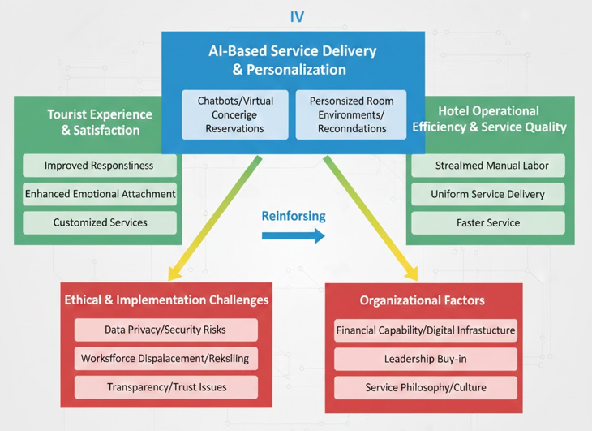

Figure 2.1: Conceptual Framework

2.9 Summary
This chapter is a synthesis of the literature on the importance of AI in personalised customer service in hospitality. It reveals opposite points of view on the existence of acquisition, gain, and ethical dilemmas, which offer a critical knowledge foundation to inform the analysis of the case study and to assist in the attainment of the research goals.

Chapter 3 Methods

3.1 Research Philosophy
The research is based on the positivism research philosophy according to which, reality is objective and can be quantified by observable and quantifiable data. Positivism also advocates the application of numerical evidence in order to determine the patterns, relationships, or a cause-effect relationship, which would be appropriate to determine customer perceptions towards the utilisation of AI-driven personalised services. Positivist philosophy, especially, can be applied to quantitative studies in which the researcher aims to test hypotheses and project conclusions based on the structured data (as Ghanad, 2023, points out).

3.2 Research Approach
This study has used a deductive research approach. Adopting the deductive approach will enable the researcher to experiment on the existing concepts and theoretical assumptions associated with the issue of AI-driven personalisation and customer satisfaction in a genuine hospitality setting. Instead of developing new theory, the research analyses the applicability of the already available notions on AI-enhanced service delivery to The Crown Bawtry and Rossington Hall. The chosen method fits the quantitative research design in which the hypothesis is tested on the basis of the empirical material (Ghanad, 2023). The hypotheses represent the deductive approach in which the current theory regarding AI personalisation and quality of services is put to test with survey data to establish the expected correlation between AI usage and customer outcomes.

3.3 Research Strategy and Design
The researcher adopts the descriptive research design because the research aims at describing and quantifying the experiences, perceptions as well as satisfaction rate of customers with AI-based personalised services. The descriptive research allows presenting the associations between the variables and determining the trend without altering the research setting. The present strategy would be appropriate to hospitality research, where it is important to learn customer reaction at a given time (Slater and Hasson, 2024).
Despite the fact that mixed methods are extensively covered in the modern research, both qualitative or mixed methods are deliberately avoided in the current study because both are time-consuming and complex in interpretation. According to Creswell and Inoue (2024), mixed methods are useful in case the depth is needed whereas quantitative-only strategies should be used to accomplish prediction, measurement, and generalisation.

3.4 Sampling Technique
The study employs non-probability convenience sampling method where its target sample consists of customers who have used the services of The Crown Bawtry and Rossington Hall recently and are ready to respond to the questionnaire. This sampling technique is suitable because of the availability, time limitation and the interest in compiling the real time perceptions of customers. In hospitality studies, convenient sampling is often employed when the participants are picked on the basis of their availability and applicability to the situation of the research.

3.5 Data Collection Method
The survey has employed a structured questionnaire survey based on 15 objective-sensitive closed-ended questions to be filled in by 100 participants, with the help of social media platform. The survey will be structured to meet the perception of the Customers to The Crown Bawtry si Rossington Hall of AI functions, benefits, challenges, and general satisfaction of personalised services. Standardisation in data collection is possible through quantitative surveys, and the researcher bias is minimised and makes quantitative surveys adequate in facilitating a data collection on a larger sample. Maida et al. (2022) and Zhang (2021) suggest that one of the most efficient data collection methods to use when studying customer-reported experiences is survey-based data collections.

3.6 Data Analysis Technique
Frequency analysis is used to analyse obtained data allowing to identify common pattern of responses and compare customer opinions with each other according to various variables. This is specifically the method to be used in descriptive studies using quantitative research methods where the researcher wishes to make predictions by taking a majority vote on the issue. Kotronoulas (2023) points out that frequency-based analysis increases the degree of clarity, reliability, and interpretation of quantitative results.
More refined methodologies of qualitative analysis like thematic analysis are not used since the research focuses more on number rather than reflection. The decision is in line with the positivist and deductive orientation of the study (Wallwey and Kajfez, 2023).

3.7 Ethical Considerations
The research is conducted in line with the Data Protection Act, which ensures confidentiality, anonymity and safe manipulation of data of the participants. This is purely voluntary, and informed consent is made with all the respondents before the data is collected. The respondents are well informed of the purpose of the study, their ability to withdraw at any point and, the fact that personal identifiers will not be released. Slater and Hasson (2024) emphasise that distinctions between ethical compliance and data protection are the key factors in achieving trustworthiness and credibility in quantitative studies.

Chapter 4 Findings and Discussion

4.1 Introduction
The findings and discussion segment will critically evaluate the contribution of AI technology in personalising consumer services in The Crown Bawtry si Rossington Hall by focusing on analysis of finding section. Throughout the research, 100 responses from guests of the mentioned hospitality organisations have been evaluated. Based on this evaluation, it is disclosed that integration of AI tool has significantly refined consumer experiences of The Crown Bawtry and Rossington Hall. In this discussion segment, a comparison between information in the findings section and existing literature will be evaluated. Limitations of the present research related to findings section will also be demonstrated in this chapter.

4.2 Findings
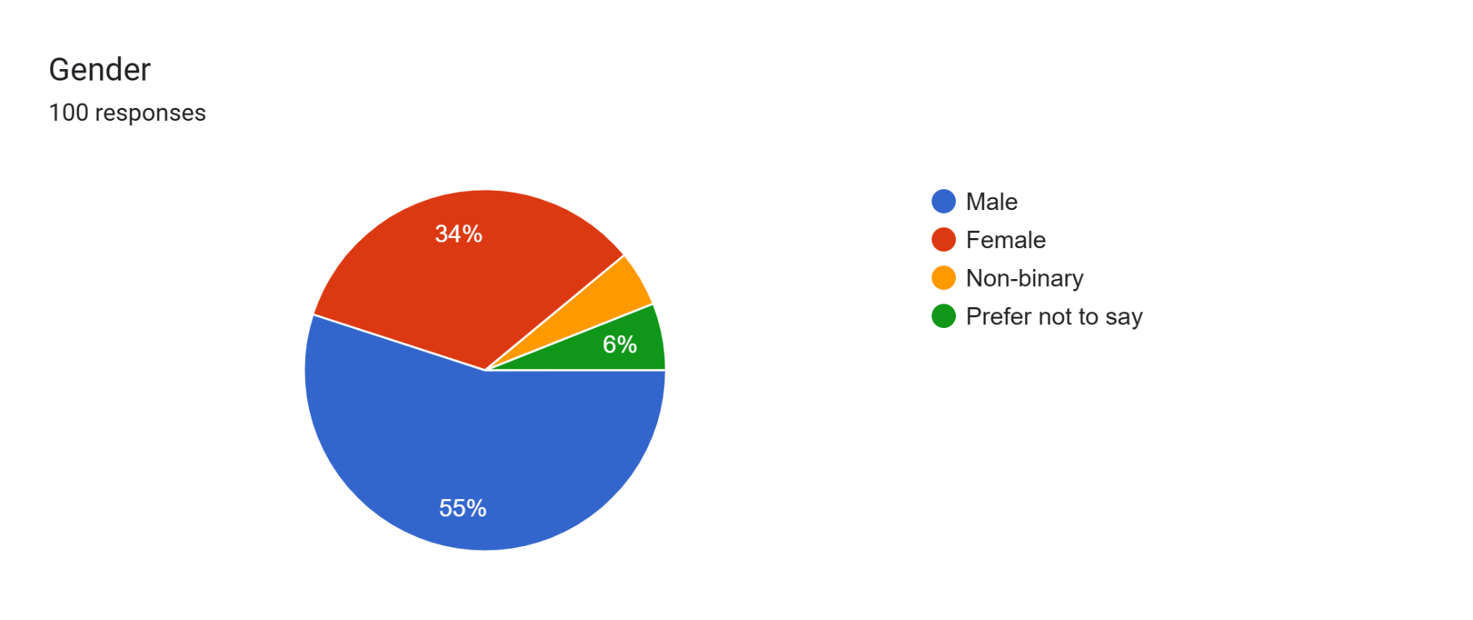

Figure 4.1: Survey Response for Q1
The demographic data of the participants reveal that the sample is gender-balanced, with 55% of the respondents representing the male group and 34% representing the female group. Such an imbalance says that the experiences and expectations of male respondents may be a bigger determinant of the perceptions of AI-enabled personalised services at The Crown Bawtry si Rossington Hall. Although this does not nullify the results, it brings on a possible bias in the response that must be considered when generalising results. The differences in technology acceptance and service expectations that are based on gender have been identified in previous research studies on hospitality, which suggests that future research can involve a more balanced sample of respondents to facilitate the capture of a wide range of different experiences.
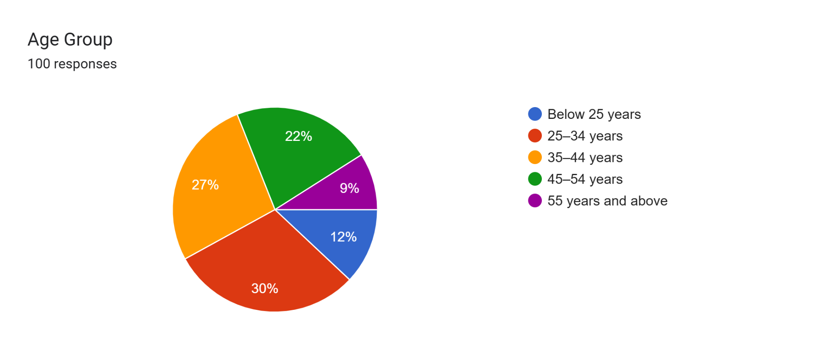

Figure 4.2: Survey Response for Q2
The survey responses were higher in terms of age group between 25-34 years (30%) and 35-44 years (27%) brackets. Such a level of concentration represents a technologically fluent and economically engaged population, which will have a greater tendency to engage and critically assess AI-based services. The good representation of these age categories makes the findings more relevant, since these groups are usually frequent users of hospitality services and are more accepting of digital personalisation. Nevertheless, the relative lack of older age groups may restrict the information on resistance, trust-related issues, or the lack of adaptability to AI adoption among less digitally savvy customers.
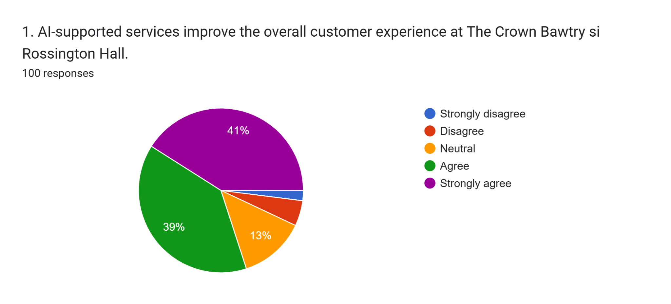

Figure 4.3: Survey Response for Q3
An important percentage of the respondents (41) strongly believed that service improvement, which is facilitated by AI, helps improve overall customer experience in The Crown Bawtry and Rossington Hall. This result indicates that AI plays a significant role in the dependent variable, efficacy of personalised customer service, by enhancing the level of perception that the guest may have towards the various interactions they have in the course of service. Analytically, it helps to argue that AI is an experience enhancer, not an operational utility, which strengthens experiential value creation, which is the main pillar of competitiveness in the hospitality industry.
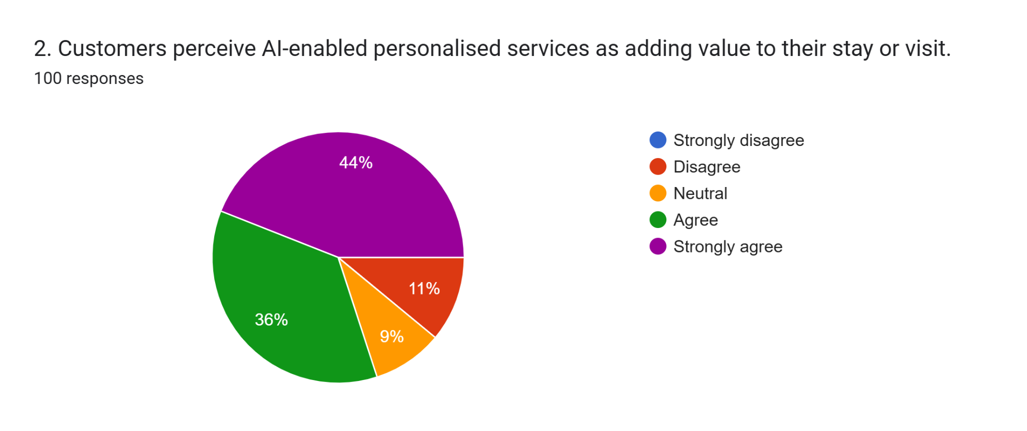

Figure 4.4: Survey Response for Q4
In close connection with this, 44% of the respondents strongly agreed that AI-enabled personalised services provide value when customers visit and stay in the premises. It means that the AI-driven personalisation is not viewed as a shallow form of automation, but rather as a legitimate improvement of the quality of the service. The capability of AI systems to personalise offers to preferences seems to have a beneficial effect on the perceived value, which is in line with the relationship marketing theory, which underlines the importance of personalised interactions as a factor of customer loyalty and satisfaction.
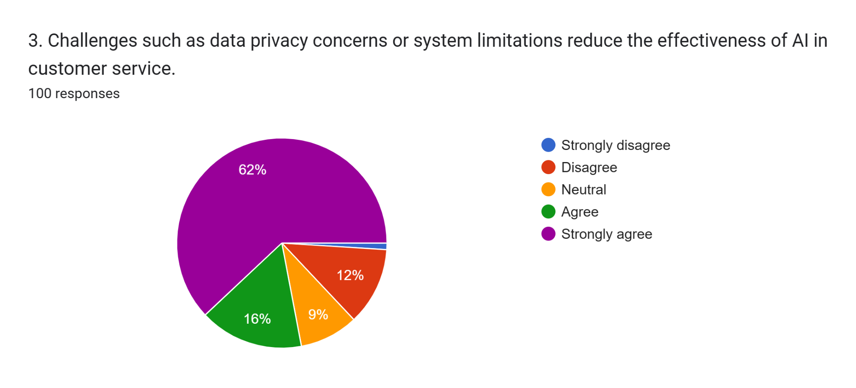

Figure 4.5: Survey Response for Q5
Nevertheless, in spite of these benefits, some challenges are imminent. The high percentage of 62% of the respondents, who strongly agreed on the topic of data privacy concerns and system constraints, diminishes the performance of AI in customer services. This is a crucial discovery, which brings to the fore a major limitation to the potential impact of AI. Although AI systems improve efficiency and personalisation, a lack of trust in terms of data security and system reliability can erode the effectiveness of the system, which can eradicate customer acceptance. This conflict highlights the necessity of ethical AI regulation, excellent cybersecurity, and a clear data use policy in hospitality settings.
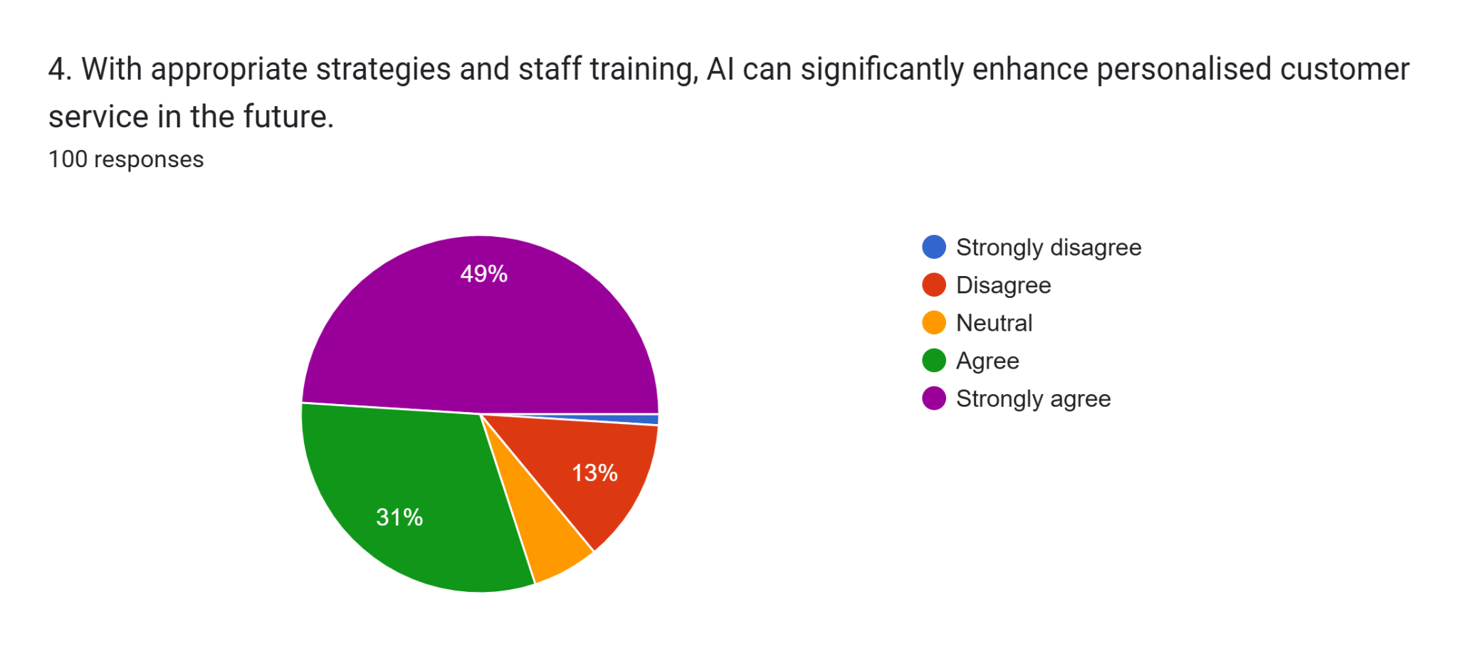

Figure 4.6: Survey Response for Q6
The importance of human capital as a strategic aspect is highly highlighted by the result that 49% of the people surveyed agreed that correct staff training and AI-oriented strategies in the future can be used to a great extent to improve personalised services. This implies that AI performance is also dependent on technological advancement, but also on the ability and organisational preparedness of employees. Instead of substituting human interaction, AI is seen as a supplementary resource, which needs trained personnel to achieve its potential, which supports the socio-technical perspective of system views on service innovation literature.
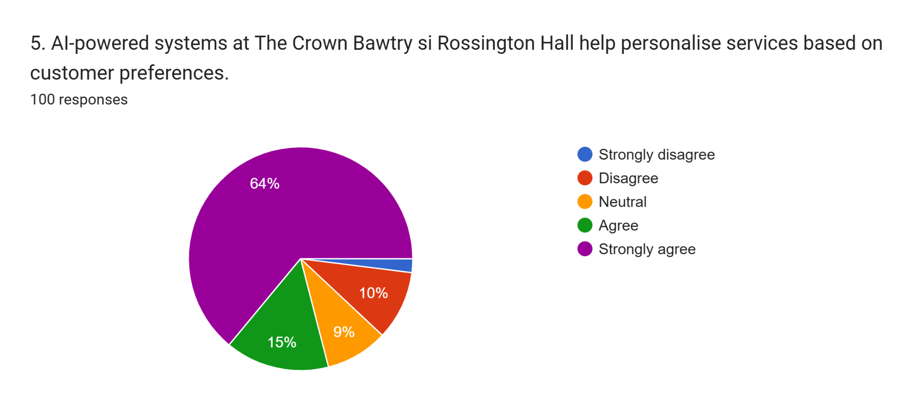

Figure 4.7: Survey Response for Q7
Regarding the functional capabilities of AI, 64% of the respondents were firmly in agreement that AI-enabled systems have a high ability to customise services using customer preferences. This overwhelming approval proves that the main, functional purpose of AI, the data-driven personalisation, is known and valued by the customers. It confirms the first independent variable as well since it proves that the AI capabilities are at the core of service differentiation at The Crown Bawtry si Rossington Hall.
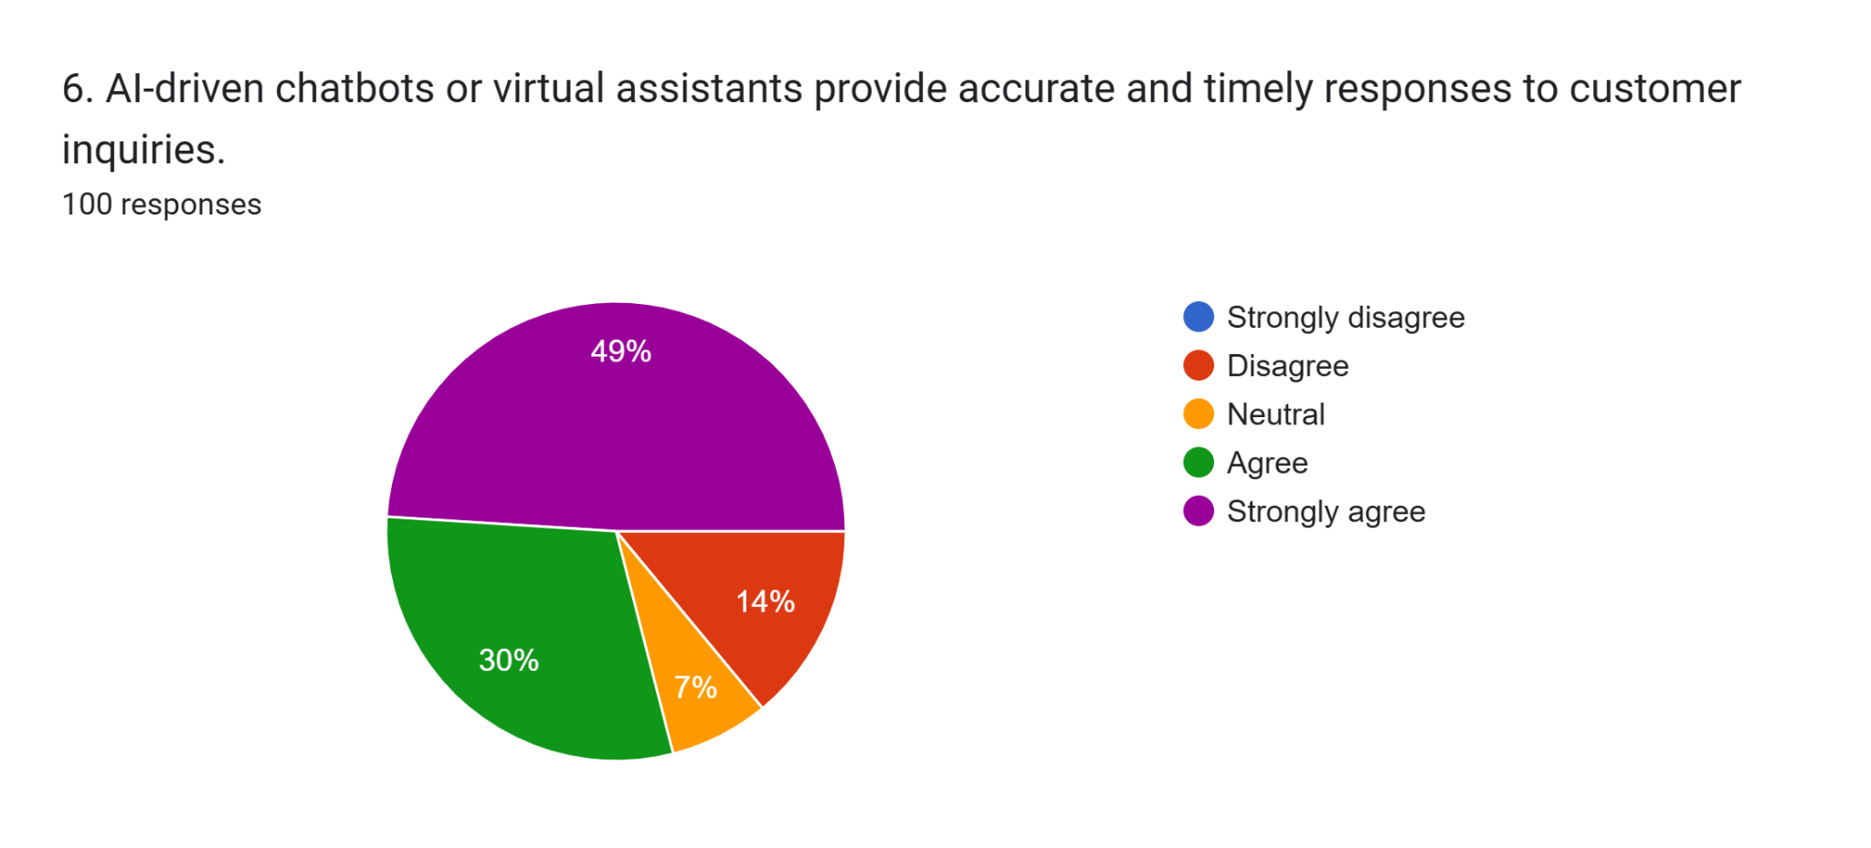

Figure 4.8: Survey Response for Q8
Likewise, the application of AI-based chatbots and virtual helpers was also highly approved, as 49% of the participants strongly agreed that the software delivers timely and accurate answers. This number is relatively low compared to other AI functions, which indicates a possibility that conversational AI needs to be improved when it comes to addressing complex or emotionally sensitive queries. This discovery implies that automation is a technique that is better applied with human intervention to prevent dissatisfaction with services.
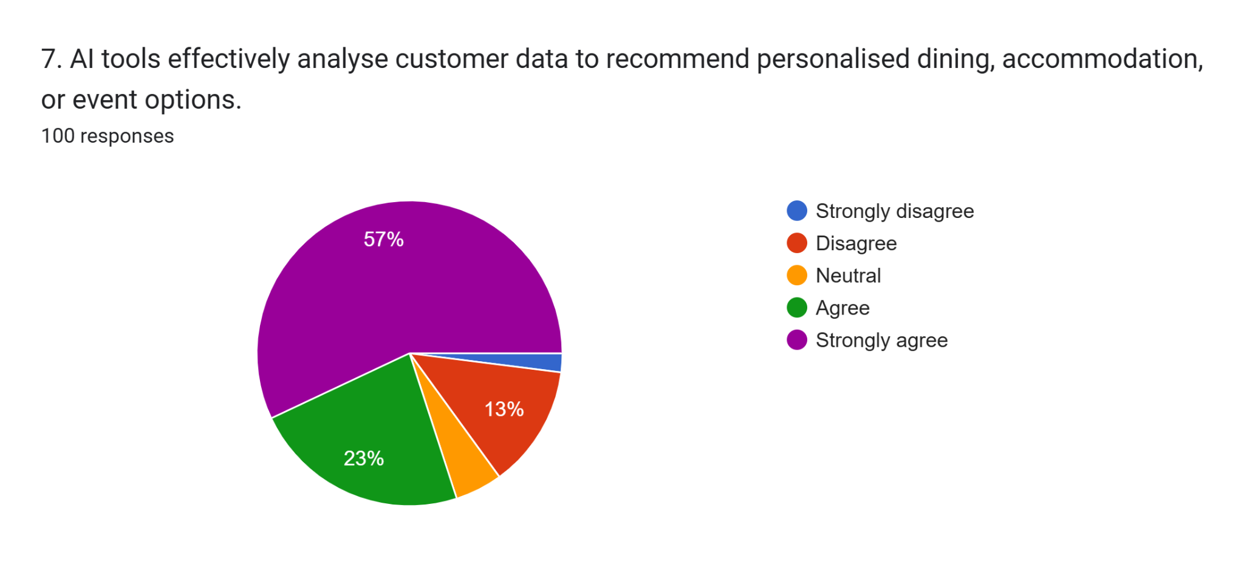

Figure 4.9: Survey Response for Q9
The analytical AI capability is also emphasised by the 57% high rate of agreement when it comes to effective customer data analysis, resulting in personalised events, accommodation, and dining recommendations. This is indicative of the ability of AI to convert raw information into actionable results, which can be used to support operational effectiveness and experiential personalisation. These features can be especially useful in the environment of a boutique hospitality where the personalised service can greatly benefit the sense of exclusivity and interactions between the customers.
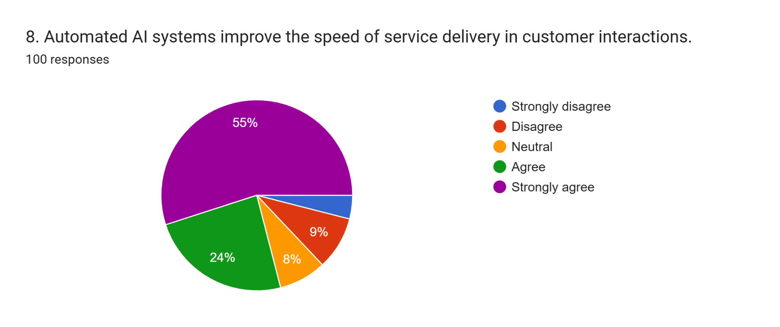

Figure 4.10: Survey Response for Q10
The operational performance improvements are reflected, as 55% of the respondents are in strong agreement that automated AI systems enhance the speed of service delivery. This implies that AI has a positive effect on service responsiveness, making waiting periods shorter and the process smoother. Moreover, half of them highly concurred that AI improves service uniformity in various touchpoints, which shows that AI helps in the standardisation of services without necessarily reducing personalisation.
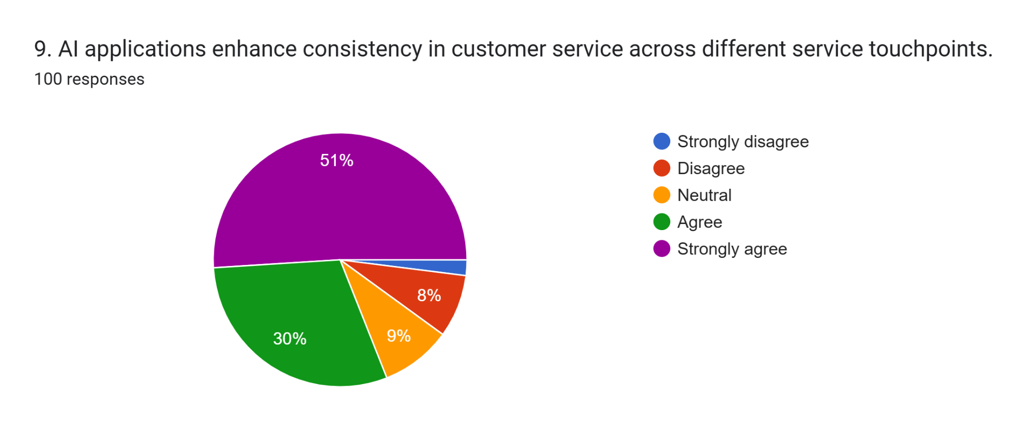

Figure 4.11: Survey Response for Q11
According to the survey outcomes, half of the participants strongly concurred that AI applications made service delivery more consistent in the various customer touchpoints within The Crown Bawtry si Rossington Hall. This observation implies that AI is a stabilising force in the standardisation of service provision, whereby similar quality is guaranteed despite the medium of interaction. Analytically, consistency is one of the key factors that define service reliability within hospitality, and AI-oriented systems seem to decrease variation brought about by human error or operational demands. Nonetheless, the excessive standardisation can lead to a danger of losing the personal and emotional aspects of the hospitality industry when it is not properly balanced with a human factor.
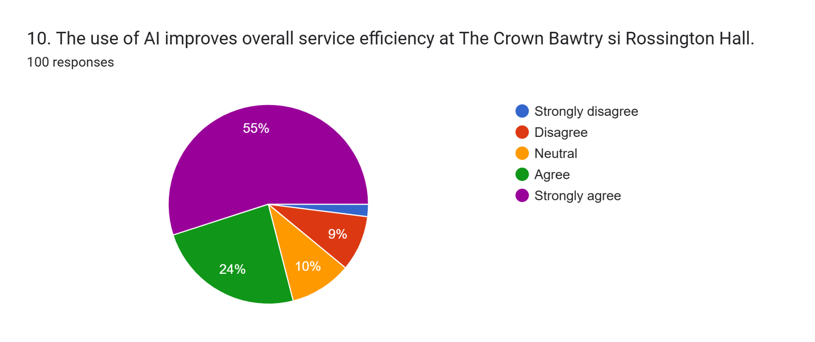

Figure 4.12: Survey Response for Q12
The use of AI as an improvement to service efficiency was highly supported among 55% of the survey population, suggesting that automation and data-driven processes are useful towards optimisation of operations. The given enhancement echoes the ability of AI to automate the workflow, decrease response time, and optimise the use of resources. However, the increase in efficiency alone is not enough to ensure an excellent customer experience, which is why it is necessary to interconnect the efficiency-oriented AI-based tools with experiential service design.
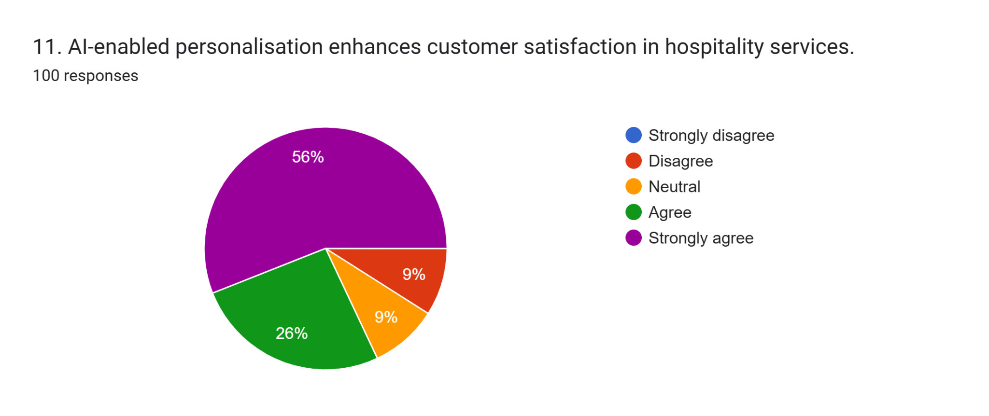

Figure 4.13: Survey Response for Q13
The dependent variable of personalised service effectiveness was also strengthened by a strong agreement among 56% of the respondents regarding the AI-enabled personalisation as a means of enhancing customer satisfaction. This indicates that the use of AI in the customisation process is consistent with the expectations of customers.
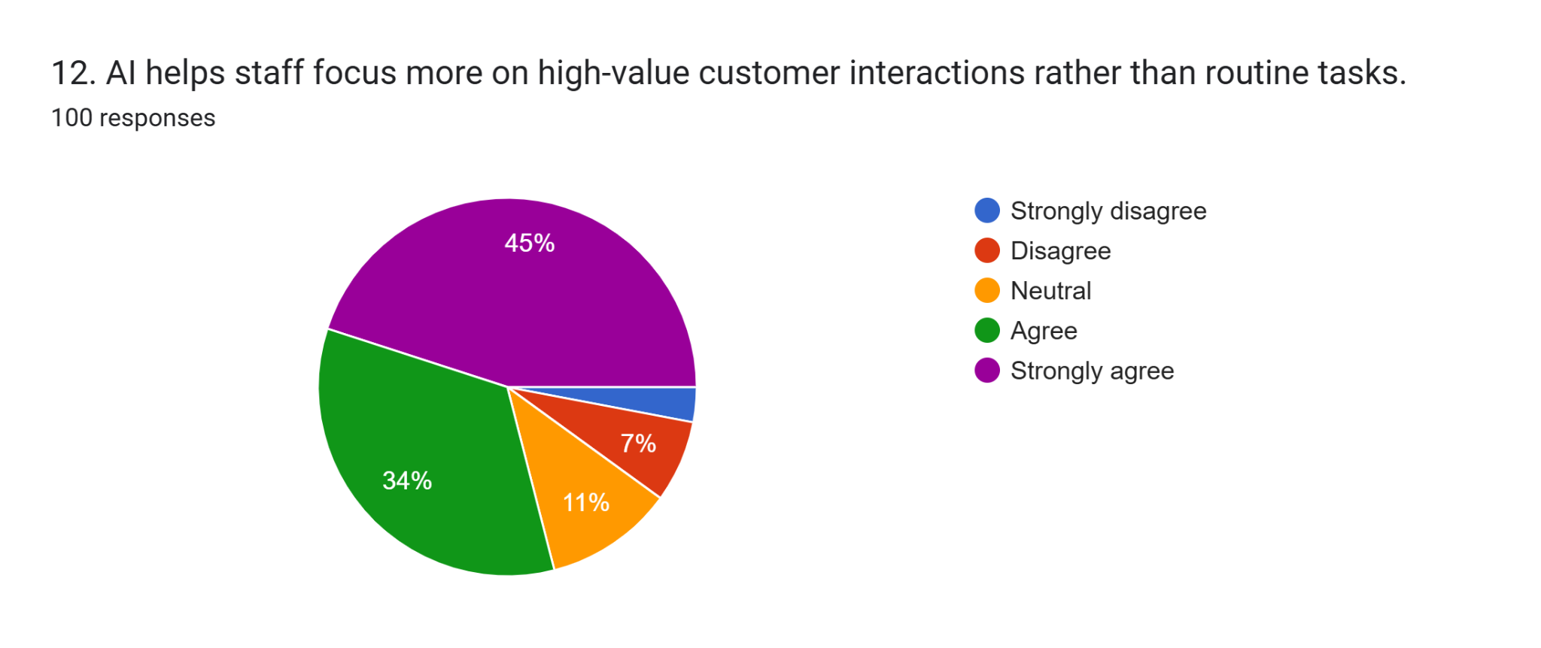

Figure 4.14: Survey Response for Q14
Nevertheless, the percentage of respondents who strongly agreed with the fact that AI provides the staff with the opportunities to pay more attention to high-value interactions and facilitates the process of establishing long-term customer relationships is 45. This comparatively less support means that even though AI enhances transactional areas of service, its strategic relational effect can be very much dependent on complementary human interaction, staff education, and trust-creating mechanisms.
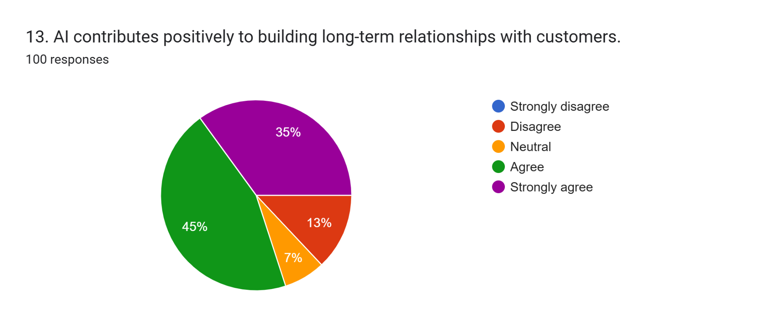

Figure 4.15: Survey Response for Q15
45% of positive support has been accumulated regarding the maintenance of customer relationships at a long-term level, with the positive building of it with the contribution of AI.
Altogether, the results indicate that although AI can greatly improve the phenomenon of personalised customer service in The Crown Bawtry si Rossington Hall, its success is regulated by the issues concerning data privacy, system constraints, and the development of human capabilities. This subtle effect shows that a balanced approach to AI implementation is necessary, which would harmonise technology, humanity, and ethics.

4.3 Discussion
In aiming to achieve the research aim that prioritises functions of AI technology in promoting personalised services among guests in The Crown Bawtry and Rossington Hall, updated and relevant information need to be collected. Owing to this, 100 respondents were selected who provided unfiltered responses regarding personalised customer services in the mentioned hotel and marriage hall after integrating AI software. After analysing the answers of the first two questions, it is found that compared to women and other persons who did not want to specify their genders, men exhibited more willingness to share their experiences pertaining to AI services in the hall and luxurious hotel. After analysing responses on age group, it can be stated that the presented democracy supports high digital literacy, from familiarity with AI services and economic activity. After comparing this information with the existing literature, it is disclosed that middle-aged and younger individuals have exhibited strong acceptance toward personalised systems and digital disruptions (Rane et al. 2023, Hasija and Esper, 2022). This has occurred because of perceived convenience along with growing exposure to advanced technology such as AI. This information has supported demographic information in the findings section which highlights the growing engagement between younger consumers with advanced software. However, the low responses from older consumers have showcased potential resistance toward the pigmentation of AI-enabled personalised services in hotels and restaurants. This information is further elaborated in existing literature which focuses on age-related differences in the digitalised era (Shin, 2023). Therefore, it can be deduced that to cater a broad range of guest profiles, both Rossington Hall and The Crown Bawtry integrate diverse service designs that can be made possible through AI tool.
As per figure 4.3 in findings section, AI-enabled services have significantly improved overall consumer experiences. This information conspicuously supports AI software as an experiential enhancer instead of an operational tool. Existing studies also support this information by highlighting contributions of AI technology in mentioned sector. According to Inavolu (2024); Chen et al. (2023), AI tools have remarkably upgraded service quality by promoting fast responses and enhancing accuracy of service providers. The theoretical perspective in the literature review section also emphasises seamless interaction between consumers and service providers through AI technology. In the context of The Crown Bawtry and Rossington Hall, technology has accelerated experiential values by refining how guests accept identities and service responsiveness. This clearly indicates strategic significance of AI tool within hospitality environment where guest experience is considered a cornerstone in improving business performance.
The analysis of 4.4 suggests that 44% of survey participants supported contribution of AI-enabled personalised services in introducing meaningful values within the hospitality sector. The existing literature also supports this information by focusing on relationship marketing where personalisation is regarded as a key factor in improving emotional engagement, loyalty and satisfaction among existing and new customers (Okeke et al. 2024; Ifekanandu et al. 2023). Talukder et al. (2025) and Nira (2025) also supported the positive impact of AI tool by indicating tailored offerings from hotels that included dining suggestions, communication styles and room preferences through AI-driven personalisation. Nevertheless, Hardcastle et al. (2025) contradicted the opinion by disclosing that algorithmic personalisation might affect authenticity and spontaneity of standard hotel services. Although maximum respondents supported AI personalisation yet, it is crucial for The Crown Bawtry and Rossington Hall management to consider flexible AI-enabled recommendations. In terms of maintaining unique nature in each service, the hotel and hall authorities need to give authorisation to staff for complementing AI-driven recommendations.
The above discussion has clearly shown the positive aspects of AI-driven personalisation in hospitality sector. However, figure 4.5 indicates data privacy concerns about 62% of participants. According to those respondents, system limitations along with privacy issues have created a negative impact on AI performance. This information from findings section is also found in existing literature where absence of transparency, cybersecurity threats and growing privacy risks have been considered as the primary barriers to integrated AI tool in the mentioned sector (Du et al. 2025; Fornells Herrera et al. 2024). The technology acceptance model also highlights negative consequences including reduction of perceived usefulness due to the mentioned drawbacks of the AI tool. In the Rossington Hall and The Crown Bawtry, trust remains an operational issue as AI personalisation heavily depends on consumer data. As per the findings and existing literature, it is essential to maintain two-way communication on data utilisation and ethical safeguards in the concerned hotel and marriage hall. Without this, service effectiveness might be affected. However, before integrating AI-driven personalisation, it is essential for every organisation to provide adequate training to employees so that they can effectively utilise the new technology.
Figure 4.6 in the findings section also supports this information by revealing that 49% of survey participants agreed on the necessity of AI-focused tactics and staff training in refining personalised services within hotels and restaurants. This information strongly highlights updated technical perspectives in hospitality innovation where skilled individuals have succeeded in delivering excellent services after using advanced tools (Lukanova and Ilieva, 2019; Gupta et al. 2022). Instead of replacing employees, AI tools should be considered as a complementary resource for surging workers' capacity. In the Crown Bawtry and Rossington Hall, high investment in change management, AI awareness and staff training should be followed to ensure that AI-enabled personalisation can be used ethically and appropriately.
The analysis of figure 4.7 suggests that the AI system has successfully customised services, based on guest preferences. This supports the first research objective that demonstrates data driven personalisation and the core factor at The Crown Bawtry and Rossington Hall. After assessing existing literature, it is also found that AI has played an important role in creating targeted recommendations (Bilgihan and Ricci, 2024; Bhuiyan, 2024). This information also supports the essence of the 4.7 figure. Though the feedback on the importance of virtual assistants and AI chatbots was positive in survey responses (4.8). However, the agreement was lower compared to other functions of AI tools. After comparing this information with existing literature, it is disclosed that excessive automation might affect service interaction (Janssen et al. 2019; Mandić et al. 2023). This indicates that chatbots fail to resolve emotionally sensitive and complex queries despite showing high accuracy and efficiency. The described limitation showcases high implication in The Crown Bawtry and Rossington Hall as guest expectations in those places require personal attention and emotional sensitivity.
In this study, the Technology Acceptance Model is also critically used since it indicates both positive and negative views of AI as people indicated a strong level of acceptance of AI in terms of efficiency of services provided, personalisation, and fast services, but at the same time, the issues of data protection and limitation of system functions are expressed to a significant extent. Whereas the perceived usefulness had a positive impact on AI acceptance, lower trust had a negative influence on perceived ease of use. Service-Dominant Logic, in turn, changes the emphasis on efficiency to value co-creation, which is consistent with results showing that AI can only improve experience through staff training and human interaction. In this way, TAM describes why people adopt and SDL describes the causes of the lack of analytics and experience in the form of relational and experience constraints, which are balanced as a comprehensive analytical perspective.
The survey respondents also highlighted the improvement of service speed and efficiency of staff owing to the integration of AI tool in the mentioned marriage hall and hotel, which satisfied the alternative hypothesis. The positive aspects of AI technology are also found in the existing literature where operational advantages such as workflow optimisation and automation have been achieved by hospitality organisations through AI tools (Milton, 2024; Shaik, 2020). The descriptions in the literature and findings support the research objective which analyses advantages of AI in refining guest interactions. However, the existing literature also showcases the negative impact of excessive standardisation through AI technology in eradicating interpersonal and emotional elements in hospitality services (Huang and Liao, 2026). The low responses (45%) on the contribution of AI technology in creating long term consumer relationships in the survey has raised concern over the effectiveness of the mentioned tool in the hospitality sector. This concern is also supported by the present literature which showcases the undermined relational aspects of guest services due to AI integration. As per the statement, AI technology needs to complement human interaction instead of eradicating human intervention. Overall, it can be stated that AI has succeeded in operational performance and improving effectiveness of personalised services. Nonetheless, success of AI solely depends on strategies on staff capability and management of ethical data.

4.4 Limitations
Despite showing relevant information on AI technology, the discussion section has shown multiple limitations such as serving formation which might promote response bias. Only a hotel and a marriage hall and limited sample size have also affected generalisability. Moreover, absence of adequate responses from elder respondents have also restricted perspectives into white consumer acceptance patterns toward AI technology in the hospitality industry.

4.5 Future research and development
The future research paper on similar research topic might explore the longitudinal effect of AI technology on revenue performance and consumer loyalty in hotels and restaurants. A comparative analysis between large hotel chains and boutique hotels might offer valuable information on effectiveness of AI-driven personalisation.

4.6 Summary
Throughout the section, a comparison between existing literature and research findings in assessing improvement of personalised consumer services through AI technology in the hospitality sector. The section has successfully achieved research objectives and aim by offering meaningful insights regarding AI tool that include refining of personalisation and efficiency and data privacy issues.

Chapter 5 Conclusion and Recommendations

5.1 Conclusion
This respective study has discussed how artificial intelligence would be used to provide th personalised consumer service in the hospitality and tourism sector and The Crown Bawtry and Rossington Hall were used as case study settings to explore this issue. The main aim was to learn to find out how AI-based personalisation affects service performances and customer experience in luxury hospitality environments. These findings give considerable support to the idea that AI can no longer be regarded as an additional tool but a strategy mechanism that determines the performance of the organisation and interaction with guests and service delivery. The findings prove that AI-based personalised customer service can be regarded as a primary force affecting various outcomes regarding customers. Among the most important findings, customer satisfaction is mentioned. Use of AI chatbots, automated reservation and personalised recommendations improved satisfaction because AI technology provided quicker response times, delivered precise information and customised service interactions. The AI was highly appreciated by guests in terms of its efficiency and convenience when it comes to pre-arrival and on-site service interactions. But it also comes out that the optimal results were achieved when AI served to enhance human interaction and not annul it.
Another important result that was highly affected by AI personalisation was service efficiency. The results show that AI applications minimised the time and frequency of operations, minimised human error, and enhanced service touchpoints coordination, accomplishing the alternative hypothesis. Reservation management, guest request, and feedback were automated to provide the staff with time to concentrate on high-value activities. The efficiency enhanced easy service delivery and minimised guest waiting time, which strengthened the service perceptions. However, the conclusions indicate that the training of staff is instrumental since the ineffective application of AI systems may ruin such advantages. The personalisation that is facilitated by AI was also observed to have a positive influence on customer loyalty. The efficiency of recording preference of the guests, predicting the needs, and providing uniform personalised services enhanced repeat visitation intentions. The customised communication and personalised offers were seen by the guests as a sign of special treatment and care especially in a luxurious hospitality setting.
Nevertheless, the results also indicate that loyalty is also based on the degree to which technological personalisation is genuine but also on the manner it is integrated into service experience. In cases where personalisation seemed to be generic or too automated, its effects on loyalty were reduced. Another important outcome that is influenced by the acquisition of AI is perceived service quality. The results show that the use of AI enhanced the perceived reliability, responsiveness and consistency of service. Guests linked AI-based systems to professionalism and modernity, which supported the end of the premium positioning of the hotels under consideration. Simultaneously, the results indicate that there is a subtle connection between AI and service quality. On the one hand, the technical quality increased, but on the other hand, the functional quality, especially, the emotional warmth, and the connection with the person, occasionally worsened, when AI substituted face-to-face interaction. This points to one of the major contradictions of efficiency-inspired innovation and experience authenticity in terms of innovative efforts in hospitality services.
The research also highlights the strategic significance of AI as a support system, not as a replacement of human workers. The application of AI as an employee performance enhancement tool was most successful with the provision of real-time data, guest data, and operational support. The hybrid service model enhanced a better embracement of guests and also did not compromise on the productivity of the staff. On the other hand, isolated operating environments of AI ran the risk of dehumanising the personalised and relationship-based hospitality excellence. The implications of the findings have a lot of value to hospitality managers in a practical sense. The tangible benefits of investment in AI technologies may appear in satisfaction, efficiency, loyalty, and service quality when the implementation process occurs in a strategically identified relationship with service values. To maximise the use of AI, managers need to put a high value on the staff training, ethical use of data, and transparency of the data to customers. Notably, the results warn against the over-computerisation and accentuate that human touch is the core focus of the luxurious hospitality experiences.
This research has its limitations, even despite its contribution to the academic and practical nurse practitioner experiences. A case study design used in the study in the case of The Crown Bawtry and Rossington Hall restricts the research in the context of the hospitality and tourism sector at large. The findings are mostly based on the operational setups, service quality, as well as expectations of the guest in the luxury hospitality environments, which could be a vast dissimilarity compared to the budget or mid-scale environment. Also, contextual variables, including brand reputation, service environment, and previous expectations, affected the view of AI-driven personalised service by the guest and could have predisposed the more positive reactions.
The given dissertation proves the fact that personalised customer service, based on AI, is one of the critical aspects affecting modern hospitality experiences. Its results have shown that AI is useful in increasing the service performance with a proper mix of human touch, which serves to reinforce customer experience, business effectiveness, client loyalty and service quality perceptions. Instead of substituting people workers, AI is more effective as synergistic devices, which improve the service delivery and the decision-making. Sustainable competitive advantage in the context of the hospitality business is attainability of balance between the technological savvy and emotional involvement and experience provision, which, as opposed to undercutting the gist of personalised hospitality, contributes to it.

5.2 Recommendation
Embrace an AI and Hybrid Service Model
The hybrid service model enables organisations to consider technological effectiveness and human sensitivity. Although AI enhances speed, consistency, and accuracy in routine services, human interaction is critical to emotional connection, building of trust, and solving complicated problems (Inavolu, 2024). The integration of the two guarantees a lack of depersonalisation when it comes to service quality. In line with Crown Bawtry si Rossington Hall, the results indicated that AI enhanced responsiveness at high rates and diminished emotional engagement at the cost of over-utilisation. A hybrid approach, including AI handling booking, frequently asked questions and small-time tasks, will result in the hotel retaining the warm side of the service and gaining the benefit of operational efficiency.
Increase the use of AI and Digital Competence among the staff
The key to successful AI implementation is employee knowledge and confidence. Adequate training enhances digital ability and lessens change resistance, in addition to allowing employees to apply AI in a constructive manner alongside emotional intelligence (Singh and Chouhan, 2023; Bukartaite and Hooper, 2023). Professional employees will be able to offer uniform and individualised service. The results showed that staff preparedness for AI tools differed. The systematic training sessions related to the use of AI, data interpretation, and online interactions with customers will help the employees to incorporate technology into everyday tasks without fear and with a sense of competence, thereby improving the services they provide to customers as well as the efficiency of their work.
Enhance Data privacy, security and transparency
Effective data protection measures increase customer confidence and behavioural norms to protect regulation and minimise the number of ethical risks of AI-based services. Data usage and collection transparency give customers confidence and make them accept digital systems (Brennig and Müller, 2023). Secure systems also safeguard the reputation of the organisation as well as its sustainability in the long-term (Yan et al. 2022). The findings of the placement hotel have revealed the concern by the guests regarding the privacy of their data. Increasing the level of cybersecurity, presenting the policies of using the information clearly and introducing the transparent system of consent will not only enable the guests to gain trust but also contribute to the new implementation of AI morally and reinforce the reputation of the hotel in the changing technological world of services.
Based on the findings of the research, the results of this research as well as the experience of working at the Crown Bawtry and Rossington Hall allow formulating some useful recommendations that could assist The Crown in maximising its use of AI in customer-centred service and ensure that the fundamental principles of hospitality remain intact.
Implementing hybrid service model
The hotels are to implement a hybrid service model, i.e., AI will complement, but not cover, human communication. Artificial intelligence-based sources like chatbots, recommendation engines based on CRM, and even automated reservation systems must be listed as frontline efficiency providers whereas the staff should continue to deal with emotionally compelling or challenging guest interactions. As evidenced by Abufawr et al. (2024), AI provides a competitive advantage only in certain cases where it establishes complementary support based on personalised human service, but not lessening the level of emotional engagement.
Special staff training and change management programmes
The results point to the fact that the perceptions of AI in guests involve a person being largely determined by the extent of confidence and competence of employees utilising the systems. Organised AI literacy training and ethical data management, and service integration would decrease resistance and positively influence service outcomes, which are also supported by Rakhmatullaev Botir et al. (2025). Giving employees the power to make inferences on AI could make them personalise interactions in a more authentic way.
Data transparency and privacy assurance procedures
The hotels are to be more prolific in their data transparency and privacy assurance procedures. According to Nugroho et al. (2024), trust is a prime facilitator of effective AI-(personalisation) based, especially among small-scale hospitality establishments and boutiques because of the boutique, luxury hospitality industries. Guest confidence would be enhanced by the presence of visible privacy policies and option-on personalisation features.
Personalisation services
AI systems need to be enhanced to provide personalisation, which is contextually sensitive and dynamic instead of following history-recommended, historical-based advice. Excessive use of previous information may impropriate experiences by turning them into generic ones. The use of real-time behavioural data and guest reviews is in line with the disruptive, yet adaptive AI approaches mentioned by Lazarillo Florido-Benítez and Alcazar (2024) and will make the services dynamic and experiential.
Continuous performance monitoring
Lastly, the management should adopt the continuous performance monitoring of AI investments, according to which the use of AI is tied to indicators that can be measured: satisfaction scales, repeat visitation and upsell metrics. Magano et al. (2025) prove that the effectiveness of AI in different age groups and expectations is not consistent, so it is important to assess them almost on a regular basis.

Reference List
Abufawr, M., Alawami, A., Attar, M., Obaid, A.G., Alharbi, M., Alawami, M., Alawami, H., Eddine, B.B., Lamine, B.M., Alzoori, H., Abosaif, S., Bahir, G. and Alfahke, H. (2024). Evaluation of the Role of Artificial Intelligence on Customer Satisfaction as a Competitive Advantage in the Hospitality Industry in the United States. Technology and Investment, 15(3), pp.135–144.
Alhelal, A.A., Alshiha, A.A. and Al-Romeedy, B.S. (2025). AI-Driven Sustainable Competitive Advantage in Tourism and Hospitality: Mediating Roles of Digital Culture and Skills. Sustainability, 17(19), p.8903.
Al-Hyari, H.S.A., Al-Smadi, H.M. and Weshah, S.R., (2023). The impact of artificial intelligence (AI) on guest satisfaction in hotel management: An empirical study of luxury hotels. Geo Journal of Tourism and Geosites, 48, pp.810-819.
Almatrodi, I., Li, F. and Alojail, M. (2023). Organizational resistance to automation success: how status quo bias influences organizational resistance to an automated workflow system in a public organization. Systems, 11(4), 191.
Awasthi, P. (2022). Revolutionizing the Hospitality and Tourism Industry through AI-Powered personalization: A Comprehensive Review of AI Integration, Impact on Customer Experience. International Journal of Leading Research Publication, 3(1), 1-12.
Bhuiyan, M.S., (2024). The role of AI-Enhanced personalization in customer experiences. Journal of Computer Science and Technology Studies, 6(1), pp.162-169.
Bilgihan, A. and Ricci, P., (2024). The new era of hotel marketing: integrating cutting-edge technologies with core marketing principles. Journal of Hospitality and Tourism Technology, 15(1), pp.123-137.
Booyse, D. and Scheepers, C. B. (2024). Barriers to adopting automated organisational decision-making through the use of artificial intelligence. Management Research Review, 47(1), 64-85.
Brennig, K. and Müller, O. (2023, January). More Isn't Always Better-Measuring Customers' Preferences for Digital Process Transparency. In HICSS (pp. 1043-1052).
Bukartaite, R. and Hooper, D. (2023). Automation, artificial intelligence and future skills needs: an Irish perspective. European Journal of Training and Development, 47(10), 163-185.
Chen, Q., Lu, Y., Gong, Y. and Xiong, J., (2023). Can AI chatbots help retain customers? Impact of AI service quality on customer loyalty. Internet Research, 33(6), pp.2205-2243.
Cole, S. and Eda, K. (2024). What is artificial intelligence (AI). Consulté le, 11(03), 2024.
Craig, D. (2024). Key Stats on Artificial Intelligence in 2024 – and What They Mean for Hotels, Available at: https://www.hospitalitynet.org/opinion/4122564.html (Accessed 4th February 2026).
Creswell, J.W. and Inoue, M. (2024). A Process for Conducting Mixed Methods Data Analysis. Journal of General and Family Medicine, 26(1).
Das, M. P. (2023). Technology and Guest experience: innovations reshaping hotel management. International Journal for Multidimensional Research Perspectives, 1(3), 76-95.
Du, H., Li, J., So, K.K.F. and King, C., (2025). Artificial intelligence in hospitality services: examining consumers’ receptivity to unmanned smart hotels. Journal of Hospitality and Tourism Insights, 8(11), pp.55-78.
Fornells Herrera, A., Paradela Morgan, A. and Ficapal Mestres, J., (2024). Navigating the Technological Landscape in Hospitality: Added Values and Entry Barriers of Technologies 4.0. SAGE Open, 14(4), p.21582440241296237.
França, A., López‐Manuel, L., Sartal, A. and Vázquez, X. H. (2023). Adapting corporations to climate change: How decarbonization impacts the business strategy–performance nexus. Business Strategy and the Environment, 32(8), 5615-5632.
Ghanad, A. (2023). An Overview of Quantitative Research Methods, Available at: https://www.researchgate.net/publication/373370007_An_Overview_of_Quantitative_Research_Methods (Accessed 4th February 2026).
Gupta, S., Modgil, S., Lee, C.K., Cho, M. and Park, Y., (2022). Artificial intelligence enabled robots for stay experience in the hospitality industry in a smart city. Industrial Management & Data Systems, 122(10), pp.2331-2350.
Han, E., Yin, D. and Zhang, H. (2023). Bots with feelings: should AI agents express positive emotion in customer service?. Information Systems Research, 34(3), 1296-1311.
Hardcastle, K., Vorster, L. and Brown, D. M. (2025). Understanding customer responses to AI-Driven personalized journeys: impacts on the customer experience. Journal of Advertising, 54(2), 176-195.
Hasanein, A. M., Khairy, H. A., Al-Romeedy, B. S. and Albarq, A. N. (2026). Working Smarter with AI in Hotel Industry: How Awareness Fuels Eustress, Task Crafting, and Adaptation. Societies, 16(1), 36.
Hasija, A. and Esper, T. L. (2022). In artificial intelligence (AI) we trust: A qualitative investigation of AI technology acceptance. Journal of Business Logistics, 43(3), 388-412.
He, C., Xiong, H., Cai, W. and Song, J. (2025). How does AI awareness affect employees’ voice behavior in the service industry? A transactional theory of stress perspective. International Journal of Contemporary Hospitality Management, 37(5), 1662-1680.
Howcroft, D. and Taylor, P. (2023). Automation and the future of work: A social shaping of technology approach. New Technology, Work and Employment, 38(2), 351-370.
Huang, J. and Liao, J. (2026). The more, the worse? Exploring the negative influence of robot replicates on human-robot rapport in the tourism and hospitality sector. Journal of Hospitality Marketing & Management, 1-25.
Ibrahim, A. and Shiring, E. (2022). The Relationship between Educators' Attitudes, Perceived Usefulness, and Perceived Ease of Use of Instructional and Web-Based Technologies: Implications from Technology Acceptance Model (TAM). International Journal of Technology in Education, 5(4), 535-551.
Ifekanandu, C.C., Anene, J.N., Iloka, C.B. and Ewuzie, C.O., (2023). Influence of artificial intelligence (AI) on customer experience and loyalty: Mediating role of personalization. Journal of Data Acquisition and Processing, 38(3), p.1936.
Ijaiya, H. (2024). Harnessing AI for data privacy: Examining risks, opportunities and strategic future directions. Int. J. Sci. Res. Arch, 13, 2878-2892.
Inavolu, S. M. (2024). Exploring AI-driven customer service: Evolution, architectures, opportunities, challenges and future directions. International Journal of Engineering and Advanced Technology, 13(3), 156-163.
Inavolu, S.M., (2024). Exploring AI-driven customer service: Evolution, architectures, opportunities, challenges and future directions. International Journal of Engineering and Advanced Technology, 13(3), pp.156-163.
Jansen, B. J., Jung, S. G. and Salminen, J. (2024). Finetuning analytics information systems for a better understanding of users: evidence of personification bias on multiple digital channels. Information Systems Frontiers, 26(2), 775-798.
Janssen, C.P., Donker, S.F., Brumby, D.P. and Kun, A.L., (2019). History and future of human-automation interaction. International journal of human-computer studies, 131, pp.99-107.
Jawabreh, O., Al Fayoumi, T. and Bareya, A. (2022). Customer satisfaction towards communication skills of front office staff at the hotel (case study five stars Hotels in Aqaba). Geo Journal of Tourism and Geosites, 44(4), 1312-1318.
Kabra, S. and Singh, P. (2025). Envisaging creative tourism through boutique hotels: An integrated framework of transformative experience. Tourism Recreation Research, 50(1), 161-177.
Kaul, D. (2023). Ai-driven real-time inventory management in hotel reservation systems: Predictive analytics, dynamic pricing, and integration for operational efficiency. Emerging Trends in Machine Intelligence and Big Data, 15(10), 66-80.
Kayani, U. N., Gan, C., Rabbani, M. R. and Trichilli, Y. (2024). Is short-term firm performance an indicator of a sustainable financial performance? Empirical evidence. Studies in Economics and Finance, 41(3), 619-637.
Kotronoulas, G. (2023). An Overview of the Fundamentals of Data management, analysis, and Interpretation in Quantitative Research. Seminars in Oncology Nursing, 39(2), p.151398.
Kovari, A. (2024). AI for decision support: Balancing accuracy, transparency, and trust across sectors. Information, 15(11), 725.
Lázaro Florido-Benítez and Alcázar, del (2024). The Disruptive Use of Artificial Intelligence (AI) Will Considerably Enhance the Tourism and Air Transport Industries. Electronics, 14(1), pp.16–16.
Li, L. (2024). Reskilling and upskilling the future-ready workforce for industry 4.0 and beyond. Information Systems Frontiers, 26(5), 1697-1712.
Lukanova, G. and Ilieva, G., (2019). Robots, artificial intelligence, and service automation in hotels. In Robots, artificial intelligence, and service automation in travel, tourism and hospitality (pp. 157-183). Emerald Publishing Limited.
Magano, J., Quintela, J.A. and Banerjee, N. (2025). Driving Consumer Engagement Through AI Chatbot Experience: The Mediating Role of Satisfaction Across Generational Cohorts and Gender in Travel Tourism. Sustainability, 17(17), pp.7673–7673.
Maghembe, M. and Magasi, C. (2024). The Role of Customer Perceived Value, Brand Trust and Service Personalization in Shaping Customer Loyalty. International Journal of Management, Accounting & Economics, 11(9).
Maida, C.A., Xiong, D., Marcus, M., Zhou, L., Huang, Y., Lyu, Y., Shen, J., Garcia, A.O. and Liu, H. (2022). Quantitative data collection approaches in subject-reported oral health research: a scoping review. BMC Oral Health, 22(1).
Mandić, D., Panić, A. and Šain, M.Č., (2023, December). Automated service delivery in hotels: balancing efficiency and human interaction for optimal guest satisfaction. In International Scientific Conference on Economy, Management and Information Technologies (Vol. 1, No. 1, pp. 167-174).
Milton, T. (2024). Exploring the synergy of artificial intelligence and financial management in the hotel industry: A critical review of innovations, challenges, and strategic implications for enhancing operational efficiency and competitive advantage. International Journal for Multidimensional Research Perspectives, 2(2), 79-95.
Milton, T., (2024). Exploring the synergy of artificial intelligence and financial management in the hotel industry: A critical review of innovations, challenges, and strategic implications for enhancing operational efficiency and competitive advantage. International Journal for Multidimensional Research Perspectives, 2(2), pp.79-95.
Negoita, R. F., Borangiu, T. and Raileanu, S. (2023). Prediction-based Optimization of Service Capacity with Robotic Process Automation. Journal of Control Engineering and Applied Informatics, 25(2), 83-92.
Nira, R.A., (2025). AI-Driven Hyper-Personalization in Hospitality: Application, Present and Future Opportunities, Challenges, and Guest Trust Issues. International Journal of Research and Innovation in Social Science, 9(4), pp.5562-5573.
Nugroho, I.S., Priyanto, D. and Purnama, Y. (2024). Exploring the Role of Artificial Intelligence (AI) in Designing and Optimizing Personalization Strategies to Enhance Customer Experience in the Tourism Industry. Technology and Society Perspectives (TACIT), 2(3), pp.292–298292–298.
Okeke, N.I., Alabi, O.A., Igwe, A.N., Ofodile, O.C. and Ewim, C.P.M., (2024). AI-driven personalization framework for SMEs: Revolutionizing customer engagement and retention. Journal name needed for completion.
Olaniyi, O. O., Ezeugwa, F. A., Okatta, C., Arigbabu, A. S. and Joeaneke, P. (2024). Dynamics of the digital workforce: Assessing the interplay and impact of AI, automation, and employment policies. Automation, and Employment Policies (April 24, 2024).
Olateju, O., Okon, S. U., Olaniyi, O. O., Samuel-Okon, A. D. and Asonze, C. U. (2024). Exploring the concept of explainable AI and developing information governance standards for enhancing trust and transparency in handling customer data. Available at SSRN.
Radanliev, P., De Roure, D., Maple, C., Nurse, J. R., Nicolescu, R. and Ani, U. (2024). AI security and cyber risk in IoT systems. Frontiers in Big Data, 7, 1402745.
Rafieian, O. and Yoganarasimhan, H. (2023). AI and personalization. Artificial intelligence in marketing, 77-102.
Rakhmatullaev Botir, Suyunov Alijon and Mukhammad Kurbonov (2025). The Role of AI and Automation in the Hospitality Industry: Balancing Technology with Personalized Service. American Journal of Economics and Business Management, 8(2), pp.909–913.
Rane, N., Choudhary, S. and Rane, J. (2023). Hyper-personalization for enhancing customer loyalty and satisfaction in Customer Relationship Management (CRM) systems. Available at SSRN 4641044.
Research and Markets (2024). Artificial Intelligence In Hospitality Global Market Size, Available at: https://www.researchandmarkets.com/report/global-artificial-intelligence-in-hospitality-market?srsltid=AfmBOoqDHoH_WSN0gDcR3WrmNQsGoZB9_Lxy_Rns_pfLNITqCH_o4-tY (Accessed 4th February 2026).
Rossington Hall (2026). Rossington Hall - Luxury Wedding Venue, Dining & Accommodation Doncaster, Available at: https://rossingtonhall.co.uk/ (Accessed 4th February 2026).
Šakytė-Statnickė, G. and Budrytė-Ausiejienė, L. (2025). Application of Artificial Intelligence in the Tourism Sector: Benefits and Challenges of AI-Based Digital Tools in Tourism Organizations of Lithuania, Latvia, and Sweden. Tourism and Hospitality, 6(2), p.67.
Schwarz, L. (2024). AI in Hospitality: Advantages & Use Cases, Available at: https://www.netsuite.com/portal/resource/articles/business-strategy/ai-hospitality.shtml (Accessed 4th February 2026).
Shaik, M., (2020). Streamlining Hospitality Operations with Intelligent Automation. International Journal of Innovative Research in Engineering & Multidisciplinary Physical Sciences, 8(1), pp.1-9.
Shin, D. D. (2023). Algorithms, humans, and interactions: How do algorithms interact with people? Designing meaningful AI experiences. Taylor & Francis.
Singh, A. and Chouhan, T. (2023). Artificial intelligence in HRM: role of emotional–social intelligence and future work skill. In The adoption and effect of artificial intelligence on human resources management, part A (pp. 175-196). Emerald Publishing Limited.
Slater, P. and Hasson, F. (2024). Quantitative Data Quality Assurance, Analysis and Presentation. Journal of psychiatric and mental health nursing, 32(3), p.10.1111/jpm.13143.
Sousa, A.E., Cardoso, P. and Dias, F. (2024). The Use of Artificial Intelligence Systems in Tourism and Hospitality: The Tourists’ Perspective. Administrative Sciences, 14(8), pp.165–165.
Talukder, M.B., Kabir, F. and Jibon, F.A., (2025). AI-Driven personalized room management in the modern hotel industry. In AI technologies for personalized and sustainable tourism (pp. 59-82). IGI Global.
To, W.M. and Billy, Y. (2025). Artificial Intelligence Research in Tourism and Hospitality Journals: Trends, Emerging Themes, and the Rise of Generative AI. Tourism and Hospitality, 6(2), p.63.
Tripadvisor (2026). Rossington Hall, Available at: https://www.tripadvisor.in/Hotel_Review-g4597293-d4593802-Reviews-Rossington_Hall-Rossington_Doncaster_South_Yorkshire_England.html (Accessed 4th February 2026).
Tripathi, A. and Kalia, P. (2024). Examining the effects of supportive work environment and organisational learning culture on organisational performance in information technology companies: The mediating role of learning agility and organisational innovation. Innovation, 26(2), 257-277.
Vashishth, T.K., Sharma, V., Sharma, K.K., Kumar, B., Kumar, A. and Panwar, R., (2024). Artificial intelligence (AI)–powered chatbots: Providing instant support and personalized recommendations to guests 24/7. In Technology and Luxury Hospitality (pp. 211-236). Routledge.
Wallwey, C. and Kajfez, R. (2023). Quantitative research artifacts as qualitative data collection techniques in a mixed methods research study. Methods in Psychology, 8(1), p.100115.
Yallop, A. C., Gică, O. A., Moisescu, O. I., Coroș, M. M. and Séraphin, H. (2023). The digital traveller: implications for data ethics and data governance in tourism and hospitality. Journal of Consumer Marketing, 40(2), 155-170.
Yan, X., Espinosa-Cristia, J. F., Kumari, K. and Cioca, L. I. (2022). Relationship between corporate social responsibility, organizational trust, and corporate reputation for sustainable performance. Sustainability, 14(14), 8737.
Yuliana, E., Putro, U. S., Hermawan, P. and Ghina, A. (2024). Service-dominant logic perspective on technology-based business incubator. Cogent Business & Management, 11(1), 2320996.
Zahidi, F., Kaluvilla, B. B. and Mulla, T. (2024). Embracing the new era: Artificial intelligence and its multifaceted impact on the hospitality industry. Journal of Open Innovation: Technology, Market, and Complexity, 10(4), 100390.
Zhang, X., Balaji, M. S. and Jiang, Y. (2022). Robots at your service: value facilitation and value co-creation in restaurants. International Journal of Contemporary Hospitality Management, 34(5), 2004-2025.
Zhang, Y. (2021). Book Review: Data Collection Research Methods in Applied Linguistics. Frontiers in Psychology, 12(15).
Żyminkowska, K. and Zachurzok-Srebrny, E. (2025). The Role of Artificial Intelligence in Customer Engagement and Social Media Marketing—Implications from a Systematic Review for the Tourism and Hospitality Sectors. Journal of Theoretical and Applied Electronic Commerce Research, [online] 20(3), p.184.

Appendices

Appendix 1: Survey Questionnaire
Demographic Information
Gender
- Male
- Female
- Non-binary
- Prefer not to say
Age Group
- Below 25 years
- 25–34 years
- 35–44 years
- 45–54 years
- 55 years and above
Survey Questions
Dependent Variable: Effectiveness of Personalised Customer Service
AI-supported services improve the overall customer experience at The Crown Bawtry and Rossington Hall.
- Strongly disagree
- Disagree
- Neutral
- Agree
- Strongly agree
Customers perceive AI-enabled personalised services as adding value to their stay or visit.
- Strongly disagree
- Disagree
- Neutral
- Agree
- Strongly agree
Challenges such as data privacy concerns or system limitations reduce the effectiveness of AI in customer service.
- Strongly disagree
- Disagree
- Neutral
- Agree
- Strongly agree
With appropriate strategies and staff training, AI can significantly enhance personalised customer service in the future.
- Strongly disagree
- Disagree
- Neutral
- Agree
- Strongly agree
Independent Variable 1: AI Functional Capabilities
AI-powered systems at The Crown Bawtry si Rossington Hall help personalise services based on customer preferences.
- Strongly disagree
- Disagree
- Neutral
- Agree
- Strongly agree
AI-driven chatbots or virtual assistants provide accurate and timely responses to customer inquiries.
- Strongly disagree
- Disagree
- Neutral
- Agree
- Strongly agree
AI tools effectively analyse customer data to recommend personalised dining, accommodation, or event options.
- Strongly disagree
- Disagree
- Neutral
- Agree
- Strongly agree
Automated AI systems improve the speed of service delivery in customer interactions.
- Strongly disagree
- Disagree
- Neutral
- Agree
- Strongly agree
AI applications enhance consistency in customer service across different service touchpoints.
- Strongly disagree
- Disagree
- Neutral
- Agree
- Strongly agree
Independent Variable 2: Perceived Advantages of AI
The use of AI improves overall service efficiency at The Crown Bawtry si Rossington Hall.
- Strongly disagree
- Disagree
- Neutral
- Agree
- Strongly agree
AI-enabled personalisation enhances customer satisfaction in hospitality services.
- Strongly disagree
- Disagree
- Neutral
- Agree
- Strongly agree
AI helps staff focus more on high-value customer interactions rather than routine tasks.
- Strongly disagree
- Disagree
- Neutral
- Agree
- Strongly agree
AI contributes positively to building long-term relationships with customers.
- Strongly disagree
- Disagree
- Neutral
- Agree
- Strongly agree

