An exploration of the artist’s studio as an active archival space

P145093

BA Fine Art: Studio Site and Context

Word count: 5,380

Gwenllian Beynon and Marilyn Allen

M6X01791

“Among art’s most significant developments worldwide since the 1960s has been a turn to the archive…” (Merewether, 2006 : back of book)

This discourse will explore the phenomenon of the artist’s studio as an active archival space. A succinct historical context will be established in relation to the artist’s studio in order to establish its purpose and function. The concept of the studio as a space of both power and possibility will also be discussed as a means to propose the studio as a living, active entity. This dissertation will include references to artists’ studios that appear to act as archival spaces. In addition, I will evaluate my studio and question whether this space performs the function of a living, evolving archive.

The Oxford Dictionary states that a studio is the “Working-room of [a] painter, sculptor, photographer, etc.” (Fowler et al, 1951 : 1258). Other nouns describe the studio as a “workshop”, “workroom” and “atelier”. (Waite, 2008 : 807). Jens Hoffmann (2012 : 12) expatiates on this, stating that, “Traditionally, the studio has been considered the working space of artists, a place where artworks […] are created.”

In order to provide a context for the discourse which follows, I will briefly look at the history of the artist’s studio. Ian Wallace (2017) suggests that the modern studio can be traced back to the Renaissance where private patrons replaced the centralized structure of the Church in the control and creation of art in the Middle Ages, when artists were based in monastries and other religious establishments. He further suggests that during this new period, artists created close and continuing relationships with patrons – creating commissioned work for them over many years, including portraits, murals and altarpieces. The livelihood of the artist came to depend on the good will of these patrons and the reputation of the artist was interwoven with the relationship they held with them. The work of the artist was produced in the ‘bottega’ rather than the ‘studiolo’ – a room with the sense of a study, a room for reflection.

Our cultural understanding of the artist’s studio has arguably been influenced by the traditional representation of a room where an artist is seated next to an easel, holding a palette and paint brush, therefore inferring that the studio is essential for the production of an artwork. However, to many contemporary artists, such as Chantal Joffe, Jenny Saville and Antony Gormley, it is more than a room, it has been described as an “oasis” (Joffe, 2012 : 174), a “safe haven” (Saville, 2012 : 517), an “asylum” (Gormley, 2012 : 178). Rachel Kneebone (2012 : 167) refers to her studio as an “anchor”, suggesting that the studio is a shelter and refuge in the artist’s troubled world. I can relate to these descriptions of the studio, as my studio often serves as a retreat, a sanctuary, a way of escaping and shutting out the world in order to make sense of it through the process of making. To me, it is where I try to comprehend things. It has been a means of responding to events, feelings, inspirations and uncertainties, leading to unexpected work emerging. At times, simply sitting in the studio has been sufficient – even if nothing is accomplished. “Sometimes even if you don’t physically make work, it’s very important that you feel comfortable…” there. (Schoorel, 2012 : 153 and 155).
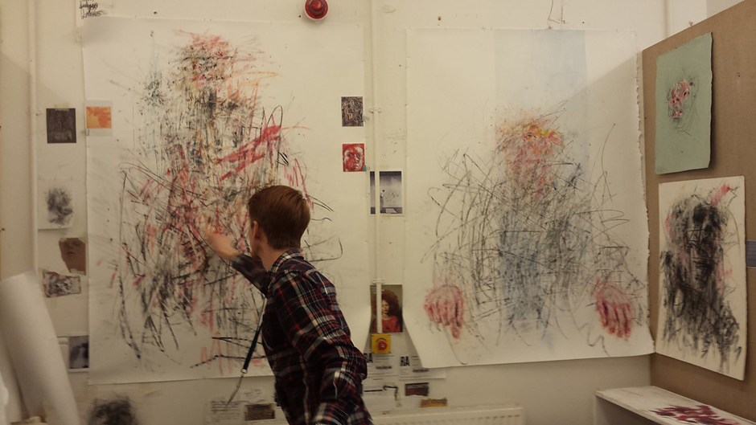
Sparnon (2016) In the studio

There are also romantic assumptions made about the artist’s studio with ideas and work being produced effortlessly. Howard Hodgkin (Lemmon, 2014) however contradicts this idea by describing his studio as an “utterly lonely” place, suggesting it as a place of struggle and isolation. This again has been true of my studio space when creativity seems to elude me. In a period of political and cultural complexity the ambiguous condition of creativity can be elusive and during these periods the studio “can be somewhere you don’t want to go because the work’s not going right”. (Saville, 2002 : 517). However, at times like this, I take comfort from the words of Christian Boltanksi (2002) who states that “The big problem when you’re an artist is that the times of creation don’t come often.” As a young artist, hearing these declarations provides reassurance, knowing that the studio, at times, can be an arduous place.

Much of the research relating to Frank Auerbach’s work suggests that the studio is indispensable to his mode and method of practice. It is said that “He remains dependant on the Mornington Cresent studio, sensing that if he lost it he would be ‘like a snail without a shell.’” (Lampert, 2015 : 181). This is a significant metaphor in that a snail cannot function without its shell – it is protection, armour and comfort. This therefore implies that Auerbach cannot function without his studio.

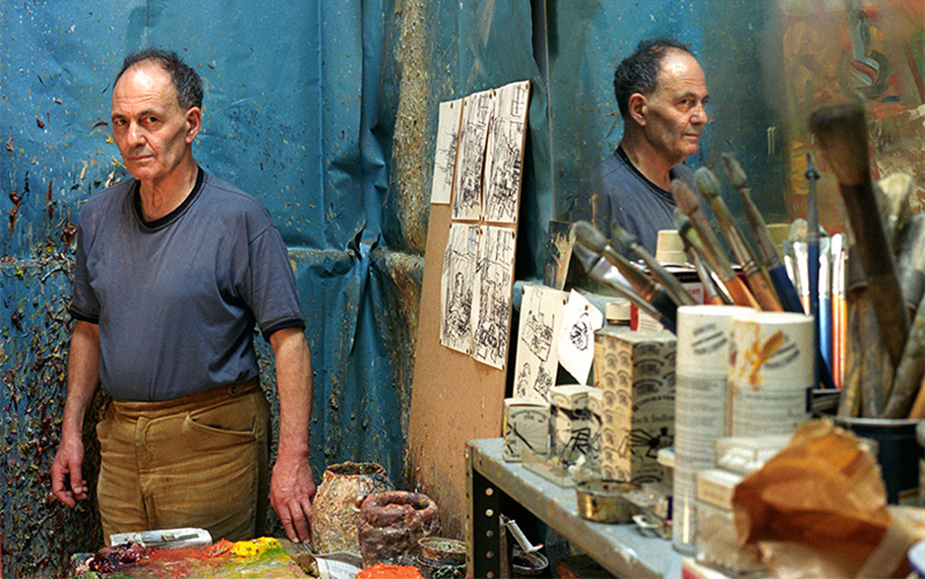
Getty Images (Date unknown) Frank Auerbach in his studio

Auerbach’s dependence on the studio is in stark contrast to those artists for whom the studio is of no importance. Pablo Bronstein (2012 : 280) clearly sees no purpose to the studio, stating “I loathe studios. I think they are scams”. How can such differing opinions of the studio exist? From where do these artists gain refuge and shelter? From where does their inspiration come? Christian Boltanski (2002) also appears to gain very little from the studio, stating, “I come to my studio every day at 10:30, and I stay and do nothing. […] The only useful thing about the studio is that after some time you can imagine something”. Even Chantal Joffe (2012 : 174) seems to suggest a lack of respect for the studio when she describes it as a “filthy, messy space”.

This introduction has provided some prevalent perceptions of the artist’s studio and has proposed this space as a site where ideas and objects converge. This discourse will attempt to make connections between the artist’s studio and the theory and function of the archive.

An archive is described in The Oxford Dictionary (Fowler et al, 1951 : 59) as a “place in which public records are kept” and in The Penguin Encyclopedia (2002 : 82) as “A place where historical records and other important documents are preserved.”

Many theorists have written about the concept of the archive, most notably Jacques Derrida and Michel Foucault. Derrida’s Archive Fever is a “…study on the power and politics of the archive” where Derrida describes the archive “as an illness that strives to reconcile the will to safeguard significant documents in human history with the wish to share those documents with others.” (IVC Editorial Board et al, 2008). Derrida’s writing on the archive centres primarily on a psychoanalytical perspective relating to Freudian theory’ however, he notes that archive fever “is not the question of a concept dealing with the past that might already be at our disposal […] It is a question of the future, the question of the future itself, the question of a response, of a promise and of a responsibility for tomorrow.” (Derrida 1996 : 36). Derrida’s inference that the archive can impact upon future possibilities provides an effective link to a discourse proposing the studio as an ‘active archive’. Foucault suggests that “The description of the archive deploys its possibilities (and the mastery of its possibilities)” (Foucault 2002 : 147). Foucault’s use of the term mastery affirms the concept of power associated with the archive and provides a context for the power of the artist’s studio as an active archive.

Archives may be described as the treasure houses of our past. They may tell us who we are or where we have come from. Archives are a space to deposit the material components of our shared heritage – be that art, language, music, literature – contributing to a definition of who we are. A positive view of the archive may be that which gives us a good foundation to move forward, building on what we have with confidence. Dr Hywel Francis (The National Archives UK, 2013) states “It’s inconceivable that we should have a society that does not recognise the importance of archives”. It is also said that “Archives are important because they provide evidence of activities and tell us more about individuals and institutions.” (King’s College, 2017). Without such archives, there would be no record of events or actions. Neither would there be documentation of different cultures and the development of humanity. Archives are arguably needed to understand ourselves in the context of events past and future possibilities.

It is difficult to read the above statements without associating them with the artist’s studio: the preservation of historical records and other important documents, evidence of activities, individuals and institutions. Alongside creating artwork, the purpose of most artists’ studios is the storage of work. In housing a practitioner’s work in one space it becomes an archive – a record of work, a record of actions and of development, a record of significant milestones and achievements and a way of learning about the artist and their relationship to society. There are several references to artists destroying their work – perhaps early works that show little skill in their opinion, works that give them no satisfaction, works that fail to stir emotion, or that depict a period in their life or a specific style of work that is no longer coherent with their artist identity.

It is said that chance played an important part in the art work of Francis Bacon. However, he was not undisciplined and was ruthless in terms of what worked artistically. “If a painting went too far or just did not work, he destroyed it, seldom with any regret.” (Daniels, 2008). Boltanski (2002) states that he too destroys his work, “something like 60 per cent of my work is destroyed after every show.” In destroying these works however, they eliminate a part of their practice that cannot be replaced, and deny those records to others. Without these records, we see only a glimpse of the artist’s life, an incomplete picture rather than a whole narrative. Without this evidence, we arguably cannot delve into the artist’s creative development and fully understand thoughts, struggles and methodologies. Without these records, we may struggle to understand their practice in the broader context of human experience.

The temptation to destroy work has been very real to me in the past, after feeling the despair of being unsatisfied with my work. I have come close to putting a canvas in the bin on several occasions and it is only through reading quotations such as the following by Celia Paul, I have come to accept that this is one of the consequences of working in the studio: “I think the main thing is not to be afraid to spoil something. I think actually, the best thing for me, I mean, it’s very, very painful – you get an image you’re pleased with but you somehow have to go further and the only way to do that is to destroy it and rework it.” (The Last Art Film, 2012). This perspective may superficially appear to run counter to the ideology of the archive which centres on preservation; however, memories is arguably one of the words most associated with the concept of the archive. It could be argued that memories and the archive are linked since archiving could be seen as the ordering of memories. Adrian Glew (Tate, 2015) states “Archives to me are really where memories are stored…” This suggests the archive as a place of nostalgia, of comfort and of looking back at the past with longing and fondness – all the feelings that ignite memories. Memories remind us of who we are and perhaps what we have achieved. Nostalgia may arguably be seen as characteristic of the artist’s studio: the preservation of working materials and other creative catalysts in the studio is an example.

Many artists house particular objects in their studio as a source of inspiration and possibly as a reminder of previous narratives. Henri Matisse is an example, and visitors to his studio stated that “Everywhere around them they saw objects – furniture, textiles, sculptures, vases and more.” (Gallery Guide, 2017, Royal Academy of Arts). When visiting the exhibition ‘Matisse in the Studio’ at the Royal Academy of Arts (2017), I was struck at how an unexpected object in his studio, or one that could be considered ordinary to some people, could have such a profound influence on him and his work. Ordinary things found in my studio, such as a chocolate wrapper, a piece of cardboard or a tiny staple, have often ignited ideas and have led to the creation of something new.

Matthew Teitelbaum and Christopher Le Brun describe the artist’s studio as “…a world self-created with objects, memories, and visual clues gathered for inspiration and comfort.” (Burnham et al, 2017). This is arguably true of many artists whose studios seem to contain objects with the aim of stimulating them. A studio that comes to my mind is that of Sir Peter Blake, which is described as “crammed” with things collected by him over the years. (Cook, 2017). William Cook (2017) states, “Blake’s studio isn’t like most artists’ studios. It’s more like a museum – a colossal cabinet of curiosities.” This statement also draws a comparison with the archive and the idea of preservation. Indeed, his studio is described by Robin Brown (2017) as “…an archive that he works within.” Cook (2017) elaborates by saying “Every aspect of his life is secreted here – his inspirations, his obsessions. It’s like walking into one of his artworks. It’s like stepping inside his head.” This suggests that the studio reveals everything about Blake – his life, his feelings, his thoughts – nothing is hidden. Whether it is possible to know everything about a person through their objects and the spaces they inhabit is, I would argue, uncertain, yet there are insights that may be gleaned about working practices and processes.

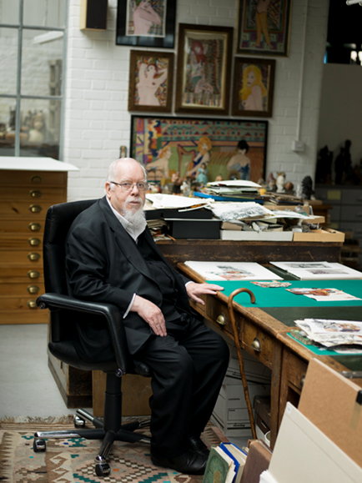
Hansen (2012) Sir Peter Blake

Objects can arguably conjure memories. One of the results of having memories is the reliving of stories, and it may be suggested that this is true of the archive. Indeed, it is said, “They [archives] tell stories”, suggesting that the archive speaks, tells tales and reveals secrets. (King’s College, 2017). In the same way, it may be proposed that the artist’s studio, conceived as an active archive, also has the capacity to speak about the artist, give an account of their lives – the happy and the sad, inspiration and struggle. Does not the studio reveal the artist’s thoughts, feelings and emotions? Much can be said about the artist through the studio and its contents.

Revisiting earlier works in an artist’s oeuvre is considered beneficial, indeed necessary to some artists. It can be a vital reminder of a time, and a style of work which has passed or developed. An archive of artistic practice can be a catalyst for new ideas and a source of inspiration. Rachel Harrison (2010 : 217) states, “I have a hard time throwing things away, as I never know if they might inspire thought or reflection.” This again suggests a condition of nostalgia, the unwillingness or inability to let something go. As an art student whose studio is comprised of a multiple narrative I can relate to this statement. I find it hard to part with anything in my studio – a scrap of paper, a used tissue, the remnants of an eraser – all these things are records of an event or moment and somehow feed into my practice. They are treasures in my archive and removing them makes that archive incomplete. More specifically, I find it difficult to part with my work as I feel as though I am parting with a part of myself. Even if a work is incomplete and does not reach my subjective approval or is not intended to be shown to anyone, it is still a record, evidence of what I have created and part of my personal archive that could be used again in the future. Rachel Harrison (2010 : 217) suggests similar feelings stating “I will never show these abandoned pieces in public, but I can’t throw them away (just yet) as I might actually learn from them. Or maybe the work that went into the piece leads me into something better.” At times I feel the need to revisit old art works that lie in the studio and this process of reflection frequently leads to the creation of new work.

Referring to the archive, Professor Joanna Bourke (The National Archives UK, 2013) states, “Without archives, we’d only have the stories of the winners in history, we wouldn’t know what ordinary people were feeling, thinking and doing”. This must surely be true of the artist’s studio? Without an archive of work, how would we see the ‘failed’ works as well as the ‘successful’ ones? Would we only see those works the artist would choose to display? How would we see the struggle as well as the ease? Surely this is essential at times to give encouragement and reassurance, to know that those artists too faced failures as well as success. The artist Bob and Roberta Smith (Tate, 2015) states that the archive records “How things were done badly or how things were done really well”. Without an artist’s records how would we see the development of artist’s work and their evolving style? Without the artist’s archival inclination, we would not have had access to Pablo Picasso’s early works, which are so different from his later ones. These hidden works are arguably as important as public ones. We often get a better understanding of an artist’s working process through looking at their unseen works. Francis Bacon denied he ever made drawings, yet drawings were found in his studio after his death and these reveal ‘secrets’ and private thoughts which somehow appear in his work.

Paddy Ashtown (The National Archives UK, 2013) notes that “The reason why archives are so important is [be]cause history is so important. Here you can find the real evidence”. History is also essential in the artist’s life and it is in the studio that this history is arguably found. It is in the studio that evidence is found – evidence of work and its meaning and evidence of the artist’s identity. Sjöholm describes the studio as “a physical space filled with “evidence”. (Bastian, 2016 : 10).

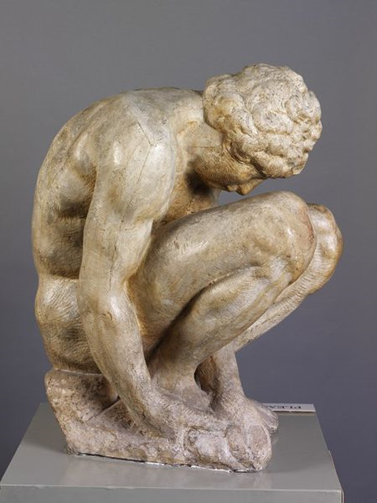
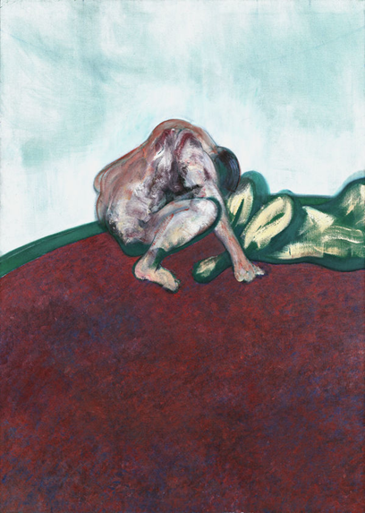
Historical narratives may also be present in the artist’s studio in that many contemporary artists gain their inspiration from traditional practices and referents, such as The Old Masters. Francis Bacon frequently described his admiration of the works of Michelangelo, Rembrandt and Velázquez. When referring to Michelangelo’s drawings, Bacon stated, “I think they are the greatest drawings that exist.” (theartroom1, 2010). The influence of Michelangelo’s work on Bacon can arguably be seen in paintings such as ‘Two Figures in a Room’, 1955, where the figure in Bacon’s painting “strikingly emulates the pose of Michelangelo’s boy.” (Mills, 2014).

Two Figures in a Room (Bacon, 1959). Crouching boy (Michelangelo, 1524 – sculpted, 1884 – cast).

Auerbach is another contemporary artist who refers to his admiration for Old Masters such as Rembrandt and Rubens. Not only does he acknowledge the historical importance of painting but also the intimacy of the subjects of Old Masters. (Tate, 2017).

The question arises therefore, without archives, how would these contemporary artists have discovered the works of The Old Masters? There would be no Rembrandt to study, no Michelangelo to admire, no da Vinci to inspire. I also rely on works from history, using them as a catalyst for my own working practice. In my studio, I have reproductions of works from the early Renaissance by artists such as Sandro Botticelli and the Old Masters Raphael and Rembrandt, these are strategically placed on the studio walls. I look at them, not only for inspiration but for ‘comfort’. Lynn Lester Hershman (2010 : 219) states; she places relics of other artists in her studio and that they “serve as a continual inspiration of courage, flexibility, spirit, bravery, and audacity.” These descriptions suggest a relationship with the past for both guidance and an indication of where to go next. This scenario became a reality for me recently when I produced a series of work under the heading, ‘A search for a contemporary figure’. At the time, I was struggling to create something ‘new’ in my drawings. I realised that in order to find a contemporary figure, I needed to comprehend and utilise historical representations. Through texts, images and information from the archives, I gained new ideas, channels and directions.

The above citations imply that the archive is a vital source of information, documentation and evidence relating to people and society. In doing so, it indicates the archive’s importance and suggests it is a place of power. Jeannette A. Bastian (2016 : 9) also states: “The ‘archive’ is also always a deliberate site of power.” The concept of power in both the archive and the studio suggests that certain objects and ideas have been preserved and therefore privileged in the system of knowledge. Archival objects hold the power to determine how a culture or time period is defined and therefore has the capacity to influence future projects.

Dr Gus Casely-Hayford (The National Archives UK, 2013) goes further, stating that “The world without archives is us without any sense of orientation, any sense of who we are, any sense of locality.” Without this orientation, we would not know anything about where we have come from, nothing of our past and arguably have no bearings. This in turn affects our future direction. There is perhaps nothing more dislocating than one who has lost his or her memory. The archive has been lost and he or she cannot apply anything to the future: there is no sense of orientation. The archive provides an assurance and the power to go forward. Casely-Hayford (The National Archives UK, 2013) goes on to say, “Archives are vital as much for our past as for our future”. Similarly, perhaps the studio also gives a sense of orientation for the artist – who he or she is and from where he or she has come. It may make the artist question their purpose and consider their future direction. My studio space gives me the opportunity to meditate on who I am and question my place in the world, and the work that formulates in the studio is a result of this process. Lisa Wainwright (2010 : ix) suggests something similar in saying that the studio is a space and a condition wherein creative play and progressive thinking yield propositions for reflection on who we are – individually and collectively – and where we might go next.

It is possible that we would not associate the word ‘power’ immediately with the archive, because as Joan M. Schwartz et al (2002 : 1) asks: “what have old, dusty archives, stored away in secure vaults, got to do with power?” However, ‘power’ suggests something that is strong and active in its external appearance and has the capacity to influence. What authority or influence may the archive hold? Can anything be gained from them? We can equally ask what an old, dishevelled, cluttered artist studio has to do with power? Yet, these are adjectives that come to mind when thinking of the studio of Francis Bacon – a studio that is now a physical archive which reveals moments of his life, inspiration, thoughts and working method. His studio however, contradicts our traditional perception of the archive as a clean and “…ordered system of documents and records…” (Merewether, 2006 : 10).

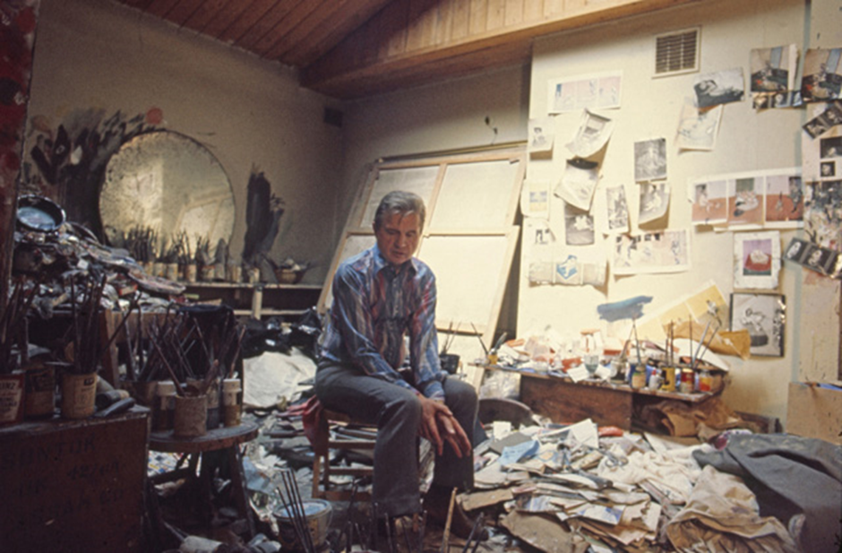
Holtz (1974) Francis Bacon in his studio in London in 1974

It is also in stark contrast to the studio of Sir Peter Blake, whose table area is described as an “incredibly ordered little surface with used paint brushes in pots, arranged in a spiral, and all his clippings and fragments arranged.” (Brown, 2017). Bacon also kept used paint brushes in pots; however, these were scattered across the studio, often in heaps on the floor, arguably in an unordered manner. Yet despite this messy, unkempt and disordered appearance, Bacon’s studio was clearly an active archive as he “…used the piles of photographs and newspaper clippings scattered throughout his studio as an ever-evolving image bank.” (Getsy, 2010 : 99). Furthermore, the ‘chaos’ of this archival studio space appeared to inspire him, aiding his creativity, with comments such as “I work much better in chaos. I couldn’t work if it was a beautifully tidy studio, it would be absolutely impossible for me… chaos for me breeds images.” (xenbay, 2010). Bacon was in control of his studio, behaving in the way he wanted and not according to the expectations of others. He had power over the narratives he constructed and how that space operated. He had authority over what left the studio and what remained, and even though he is no longer there, his studio will still be “crucial in critical analysis of Bacon’s work”. (Sharrock, 2011). The studio spaces of prolific artists shift from being active archival spaces to a static preservation of an artist’s activity after their death.

According to Joan M. Schwartz et al (2002 : 3), “…archives, ever since the mnemons of ancient Greece, have been about power – about maintaining power, about the power of the present to control what is, and will be, known about the past, about the power of remembering over forgetting.” In a similar way, this is characteristic of the artist who, in their studio, creates work in response to events as a way of recording and not forgetting them. This in turn demonstrates power.

The painting ‘Guernica’ by Pablo Picasso is one that comes to mind when thinking of work made in response to an event. The painting was produced by him as a result of hearing the news of the bombing of Guernica, a town in Northern Spain. Picasso depicts the “pure terrorism” of the attack through his use of darkness and light and through the horror on the faces of the figures. (Warncke, 2006 : 145). It could be argued that the power of the painting is evident in as much that it has been referred to as “the best-known 20th century work of art”. (Warncke, 2006 : 145).

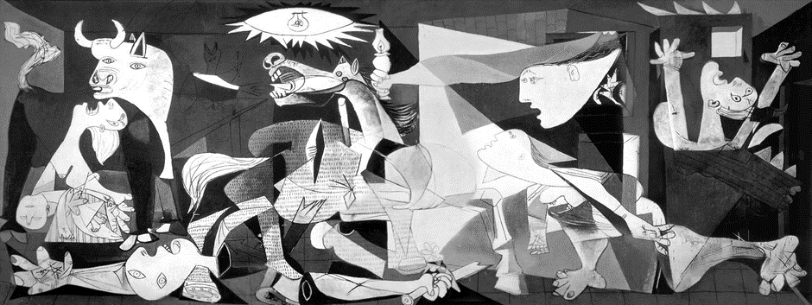
Guernica (Picasso, 1937).

When studying Art at A level, I made a series of ten oil paintings on old school desks in response to a school bombing in Gaza, Palestine. This was my way of responding to the event and creating a record of the pain, sadness and horror of it.

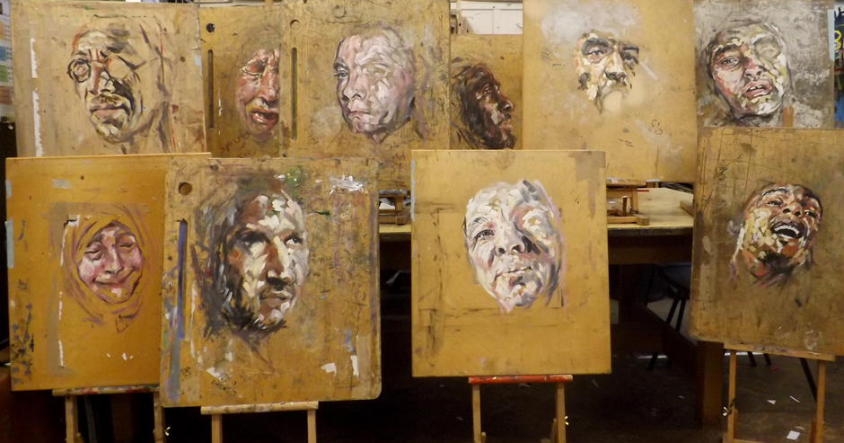
Bombing in Gaza (Sparnon, 2015).

The studio gives me the power and confidence to express my feelings and voice my opinions. To me, it is a type of ammunition. I feel powerful in the studio as I’m the one in control of everything that happens there. Auerbach states, “One has little power over the crises in life, or in friends’ lives. One cannot control wealth or poverty, happiness or misery.” (Lampert, 2015 : 162). However, he goes on to say “I am only in control when I am in the studio.” (Lampert, 2015 : 162). This summarises my experience of the studio too.

It may be argued that more can be revealed about the artist through looking at his or her studio than by looking at a finished, refined work exhibited in a gallery space. We see things that are not meant for public viewing – possibly pain, stress, laughter, fun, release, relief and pride – all the stages an artist arguably goes through. We also gain “a visual insight into their process and thus (we think) their mindset.” (Beaven1, 2017). This could arguably be seen as another example of the power of the studio. Studying an image of the studio of Alberto Giacometti, I see the struggle, the failures as well as the successes of an ‘ordinary’ man. The scratched walls and furniture suggest strain, frustration and a battle in the studio which are not in my opinion as evident in his polished, perfected bronze sculptures. Hidden, unexpected surprises come to light. Michael Peppiatt (2010 : 7) notes that Giacometti’s work, personality and life was crystallized in a single compact space. He also described a sense of struggle, stating, “Within those walls and bearing all its diverse traces, a struggle to express a very specific vision of man had taken place over forty years’ relentless labour. In the end, the studio came closer than an exhibition or book. The studio was both the theatre and the archive, a stage for sublime achievement and even more interestingly a repository of repeated failure.” (Peppiatt, 2010 : 7).

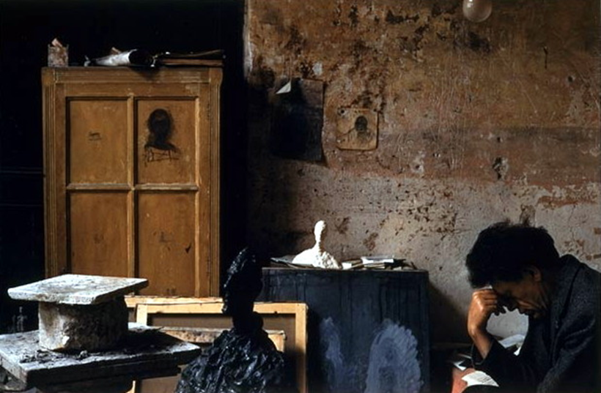
Photographer unknown (Date unknown) Alberto Giacometti in his studio

Similarly, Tom Buchanan (Tate, 2015) argues that we gain a fuller and better understanding of a story through the archive, “I think the importance of archives [studios] is that it can take us much deeper into the story than reading a book based on some sort of secondary account of what happened”.

In concluding this discourse, we can deduce that a number of concepts have been established regarding the archive and the artist’s studio. There are distinct similarities between the culture of the archive and the culture of the studio. Perhaps one of the primary connections between the archive and the studio is the construction of a space which acts as a site of convergence for multiple objects and ideas. This environment serves as an active catalyst for narrative connections, whether between the artist and the studio or the audience and the archive and these spaces arguably possess the power of influence. It has also been proposed that the archive and the artist’s studio store a wealth of historical and valuable information which provides insight on individuals and society. It has also been suggested that both the archive and the artist’s studio may be considered places of nostalgia that ignite memories.

The citations included in this dissertation imply that the archive is a vital source of information, documentation and evidence relating to people and society and that this is also the case with the artist’s studio.

In addition to the many conclusions drawn about the similarities in the way the studio and the archive operate, this discourse has also established differences that may be considered to exist. The fundamental difference may be that traditionally, we tend to think of the archive as static – a place to preserve things, a space where nothing is created. It is “a place of stasis”, whereas the studio operates as a space of fluctuation – it is continually changing, evolving and full of potential. (Derrida 1996 : inside front flap). While the noun ‘stasis’ may at times be true of the archive, in the context of the artist’s studio, it is not inactive, stationary or motionless, but rather a growing and progressive place.

The archive is arguably ordered, methodical, neat and tidy and while this is sometimes true of the artist’s studio, it is often not the case. This text has concluded that the studio of Francis Bacon was anything but ordered. Yet, despite its chaos, his studio operated as an active archive.

Without a doubt, my studio space contains elements of memories, nostalgia and a narrative which affects the way I operate within it. The reproduction of a late self-portrait by Rembrandt on the wall of my studio not only influences the artwork I make, it ignites memories. In particular, it reminds me of a visit to London and seeing the work of Rembrandt for the first time. I am reminded of the feeling of humility and being in awe of his strength in difficult times, together with his ability to capture humanity. This in turn leads to feelings of nostalgia, and to memories of creating work in response to the visit. It is a positive reminder of the failures as well as the successes of works made. The historical artefacts within in my studio function as archival material and play a pivotal role in my art practice and process. I gain help and guidance from the past, which ignites new ideas and a new direction for the future. The studio provides me with a sense of power as an art student to continue experimenting, to construct and author the narratives within this space, thus enabling my personal archive to evolve.

Bibliography

Books:

Crystal, D. (ed.) (2002) The Penguin Encyclopedia. London: the Penguin Group.

Derrida, J. (1996) Archive Fever. University of Chicago Press.

Foucault, M. (2002) The Archaeology of Knowledge. Routledge.

Fowler, H. W., and Fowler, F. G. (ed.) (1951) The Concise Oxford Dictionary of Current English. Fourth Edition. London: Oxford University Press.

Hoffmann, J. (ed.) (2012) The studio. London and Cambridge: Whitechapel Gallery and The MIT Press.

Lampert, C. (2015) Frank Auerbach: Speaking and Painting. London: Thames & Hudson Ltd.

Merewether, C. (ed.) (2006) The archive. London and Cambridge: Whitechapel Gallery and The MIT Press.

Peppiatt, M. (2010) In Giacometti's Studio. London: Yale University Press.

Waite, M. (ed.) (2008) Compact Oxford Thesaurus. Third edition (revised). Oxford: Oxford University Press.

Warncke, C-Peter. (2006) Picasso. 1997. Cologne: TASCHEN.

Chapters in edited books:

Bastian, J. A. (2016) ‘Moving the margins to the middle: reconciling ‘the archive’ with the archives’, in Foscarini, F., MacNeil, H., Mak, B. and Oliver, G. (ed) Engaging with Records and Archives: Histories and theories. London: Facet Publishing : 9-10

Bronstein, P. (2012) 'Pablo Bronstein', in H. Amirsadeghi (ed) Sanctuary: Britain's Artists and their Studios. London: First published by Thames & Hudson in association with TransGlobe Publishing Limited : 280

Getsy, D. J., (2010) ‘David J. Getsy, The Reconstruction of the Francis Bacon Studio in Dublin’, in Jane Jacob, M. (ed) and Grabner, M. (ed) The studio reader: on the space of artists. Chicago and London: The University of Chicago Press, Ltd : 99

Gormley, A. (2012) 'Antony Gormley', in H. Amirsadeghi (ed) Sanctuary: Britain's Artists and their Studios. London: First published by Thames & Hudson in association with TransGlobe Publishing Limited : 178

Harrison, R. (2010) 'Rachel Harrison', in Jane Jacob, M. (ed) and Grabner, M. (ed) The studio reader: on the space of artists. Chicago and London: The University of Chicago Press, Ltd : 217

Hershman, L. L. (2010) 'Lynn Lester Hershman, The Studio Present', in Jane Jacob, M. (ed) and Grabner, M. (ed) The studio reader: on the space of artists. Chicago and London: The University of Chicago Press, Ltd : 219

Joffe, C. (2012) 'Chantal Joffe', in H. Amirsadeghi (ed) Sanctuary: Britain's Artists and their Studios. London: First published by Thames & Hudson in association with TransGlobe Publishing Limited : 174

Kneebone, R. (2012) 'Rachel Kneebone', in H. Amirsadeghi (ed) Sanctuary: Britain's Artists and their Studios. London: First published by Thames & Hudson in association with TransGlobe Publishing Limited : 167

Saville, J. (2012) 'Jenny Saville', in H. Amirsadeghi (ed) Sanctuary: Britain's Artists and their Studios. London: First published by Thames & Hudson in association with TransGlobe Publishing Limited : 517

Schoorel, M. (2012) 'Maaike Schoorel', in H. Amirsadeghi (ed) Sanctuary: Britain's Artists and their Studios. London: First published by Thames & Hudson in association with TransGlobe Publishing Limited : 153 and 155

Wainwright, L. (2010) ‘Foreword by Lisa Wainwright’, in Jane Jacob, M. (ed) and Grabner, M. (ed) The studio reader: on the space of artists. Chicago and London: The University of Chicago Press, Ltd : ix

Films:

The Last Art Film (2012) Jake Auerbach. London.

YouTube:

Lemmon, P. (2014) Howard Hodgkin on being in the studio. Available at: https://www.youtube.com/watch?v=j8zVZaJseNc (Accessed: 24 August 2017).

Tate. (2015) What are Archives? | Animating the Archives. Available at: https://www.youtube.com/watch?v=QNN2LFe_iD8 (Accessed: 7 December 2017).

theartroom1. (2010) francis bacon documentary part 4.mov. Available at: https://www.youtube.com/watch?v=iS3FRUkoniY (Accessed: 12 December 2017).

The National Archives UK. (2013) What would the world look like without archives? Available at: https://www.youtube.com/watch?v=Rbs5UnzDQdY (Accessed: 4 December 2017).

xenbay. (2010) The South Bank Show: Francis Bacon 2/6. Available at: https://www.youtube.com/watch?v=VfTgEKQj0Dk (Accessed: 10 December 2017).

Websites:

Beaven1, K. (2017) Tate. Available at: http://www.tate.org.uk/context-comment/blogs/tate-debate-how-much-your-work-influenced-space-you-work (Accessed: 7 December 2017).

Burnham H., Dumas A. and McBreen E. (2017) Exhibition Catalogue Matisse in the Studio. London: Royal Academy of Arts. Available at: https://shop.royalacademy.org.uk/softback-matisse-in-the-studio-exhibition-catalogue.html (Accessed: 12 December 2017).

King’s College. (2017) King’s College Cambridge. Available at: http://www.kings.cam.ac.uk/archive-centre/introduction-archives/definition/why-important.html (Accessed: 7 December 2017).

Sharrock, D. (2011) Francis Bacon studio recreated in Dublin. Available at: http://www.telegraph.co.uk/news/worldnews/europe/ireland/1331346/Francis-Bacon-studio-recreated-in-Dublin.html (Accessed: 12 December 2017).

Tate, (2017) Tate. Available at: http://www.tate.org.uk/whats-on/tate-britain/exhibition/frank-auerbach/auerbach-introduction (Accessed: 9 December 2017).

Wallace, I. (2017) Artspace. Available at: https://www.artspace.com/magazine/art_101/art_market/the-evolution-of-the-artists-studio-52374 (Accessed: 7 December 2017).

Articles in online collections:

Boltanski, C. (2002) 'Studio: Christian Boltanski', Tate Magazine issue 2, [Online]. Available at: http://www.tate.org.uk/context-comment/articles/studio-christian-boltanski (Accessed: 8 December 2017).

Brown, R. (2017) ‘An Archive of Inspiration’, Frieze, [Online]. Available at: https://frieze.com/article/archive-inspiration (Accessed: 18 October 2017).

Cook, W. (2017) ‘A Colossal Cabinet of Curiosities: Inside Peter Blake’s Studio’, BBC Arts, [Online]. Available at: http://www.bbc.co.uk/programmes/articles/1ZyhBKkC2d40nvgVVkClZXv/a-colossal-cabinet-of-curiosities-inside-peter-blakes-studio (Accessed: 18 October 2017).

Daniels, R. (2008) ‘Francis Bacon: Behind the Myth’, The Telegraph, [Online]. Available at: http://www.telegraph.co.uk/culture/art/3558531/Francis-Bacon-behind-the-myth.html (Accessed: 7 December 2017).

IVC Editorial Board., Anable, A., Dove-Viebahn, A., and Miller, A. (2008) ‘The Archive of the Future / The Future of the Archive: Introduction’, InVisible Culture: An Electronic Journal for Visual Culture, Issue 12, [Online]. Available at: https://ivc.lib.rochester.edu/the-archive-of-the-future-the-future-of-the-archive-introduction/ (Accessed: 9 December 2017).

Mills, E. (2014) ‘Francis Bacon and the Art of the Past at the Hermitage’, The Royal Academy of Arts, [Online]. Available at: https://www.royalacademy.org.uk/article/francis-bacon-and-the-art-of-the (Accessed: 9 December 2017).

Schwartz, J. M., and Cook, T. (2002) ‘Archives, Records, and Power: The Making of Modern Memory’, Archival Science, 2(1-2) : 1-3, [Online]. Available at: http://www.nyu.edu/classes/bkg/methods/schwartz.pdf (Accessed: 9 December 2017).

Gallery Guide:

Gallery Guide, (2017) Introduction: Matisse in the Studio, Sackler Wing of Galleries, Royal Academy of Arts.

Image sources:

Bacon, F. (1959) Two Figures in a Room [Oil and sand on canvas]. Sainsbury Centre for Visual Arts, Norwich. [Online]. Available at: https://d1e2kq1i6pwuuf.cloudfront.net/production/4/6/4607-842.jpg (Accessed: 10 December 2017).

Getty Images. Frank Auerbach in his studio [Online]. Available at: http://www.christies.com/media-library/images/features/articles/2015/07/13/frank-auerbach/mainimage.jpg (Accessed: 10 December 2017).

Hansen, P. (2012) Sir Peter Blake [Online]. Available at: http://palhansen.com/content/images/stories/sir_peter_blake-6551599.jpg (Accessed: 10 December 2017).

Holtz, M. (1974) Francis Bacon in his studio in London in 1974 [Online]. Available at: http://studiointernational.com/index.php/francis-bacon-invisible-rooms-review-tate-liverpool (Accessed: 10 December 2017).

Michelangelo. (1524 – sculpted), (1884 – cast) Crouching boy [Sculpture]. V&A, London. [Online]. Available at: http://collections.vam.ac.uk/item/O41524/crouching-boy-plaster-cast-michelangelo/ (Accessed: 11 December 2017).

Photographer unknown. Alberto Giacometti in his studio [Online]. Available at: https://i.pinimg.com/originals/46/92/e4/4692e413d892eaf93e2aee52d3fc88a3.jpg (Accessed: 10 December 2017).

Picasso, P. (1937) Guernica [Oil on canvas]. Museo on Reina Sofia, Madrid. [Online]. Available at: https://artsintherightplace.files.wordpress.com/2011/01/guernica.jpg (Accessed: 11 December 2017).

Sparnon, T. (2015) Bombing in Gaza [Oil on old school desks]. Personal collection. [Online]. Available at: http://www.saatchigallery.com/portfolio_images/thumbnail.php/fg7pm2201529084829pupil_art.jpg (Accessed: 11 December 2017).

Sparnon, T. (2016) In the studio [Online]. Available at: https://static.wixstatic.com/media/d59c87_a0d63ea2b98a47b78860eba0dd7d65a1~mv2.jpg/v1/fill/w_1216,h_684,al_c,q_90,usm_0.66_1.00_0.01/d59c87_a0d63ea2b98a47b78860eba0dd7d65a1~mv2.jpg (Accessed: 11 December 2017).

