
Management, Innovation and Sustainability
Approaches.to Innovation.and Organisational Change

April 28, 2025
University of Wales Trinity Saint David

Executive Summary
The impact of the change begun as a positive change for the employees but later turned into a negative one. The main reason behind the negative turn, is the method of how management rolled the change out. The employees wanted an input into the change, whether that’s correcting the skill matrix or allowing management to understand prospects within the company. Instead, the management decided to keep employees in the dark and prevent them from accessing the skill matrix to ensure it is correct. This became an issue when employees begun speaking about their new tiers and increased pay, some felt as though they were undervalued in the skill matrix and believed that some employees who were above them, should be below. There is growing frustration within the employees how the change leaves them in the dark. The management should create an open line of communication within the employees, allowed the employees to have a voice and accurately created a skill matrix. This will allow the management to have better reasoning to why the employee is in a certain tier. By having an open approach, it makes the employees voice valued, and they will be more open for the change. The skill matrix change is a positive one. It was meant to improve the morale in the workforce and create pathways into future roles in a fast-growing company.

With time, the skill matrix can be communicated to the employees in a preferred method. Allowing the employees to feel heard and involved with their skill level, will help them understand where they can go within the company. They can possibly have role changes and specialise in a certain department, they could be an engineer, team lead or even manager. Creating an ambitious workforce who are ready to develop themselves. This will then have a huge impact on the production efficiency, create a happier workplace and create more opportunities.

Table of Contents
Executive Summary 1
Introduction 4
Main Findings 5
Driving forces for change 6
Evaluate Forces 7
Conclusion 7
References 9

Introduction
In this report I will be identifying a change for the business to improve it. I have worked in this company for 2 years and have a great relationship with the production and engineering departments. My role in the company is currently split between engineering and production, half a week in each area. For production side, I am the most experienced on the section and in some ways, lead the team. My role is solely rework and repair on composite structures, I am also the sign off for the area.
The company has seen tremendous growth over the previous year with more projects and success to come. The workforce is currently around 100 members of staff in production and engineering, with more operators to come. With the uplift in contracts the company has on the horizon, it is important that the experience and knowledge gets passed through production to ensure the highest level of operators. The McGregor theory suggests that there are two types of management skills for the employees in the workplace, theory X and Y (Prottas, 2018). The unambitious employees who are happy in their role and do not wish to progress further, even when opportunities present themselves. These employees must be controlled by the management team. Theory Y is where the employees are trusted in their role, pro active and ambitious within the company. Both management skills currently being used in the company for different employees. The theory Y employees should not be paid the same as the theory X employees, but they do. There needs to be a change in the company to enable the theory y employees to progress in the company whilst encouraging theory x to enable the y theory approach.
The management do need to be made aware of the employee’s skills and intentions whilst working for the company. This would enable the management team to create pathways for the theory y employees, enabling the theory x and most importantly, developing the company for a busy successful future on the horizon.
We must aim for a change which will inspire the workforce and motivate them to improve their skillset. The change will be an incentive with possibility of a pay rise, extra responsibility and a new role within the company. This will allow employees to vision a future within the company and perhaps increase their longevity in the company. It will also help the company sustain the skillsets from elder, more experienced employees who can mentor the younger employees. This is critical for a business to achieve to allow the wide range of skillset remain in the company when more experienced employees retire or leave.

Main Findings
The change made to the workplace was creating a skill matrix for the employees to understand the skills and intentions of the employees within the company. With each skill being scored 0-5, with the highest score being.
There is a morale issue within the workplace due to some employees being more efficient, higher skilled, but the pay remains the same for all. With this change, the less skilled employees will have a pathway given from management on how to develop the skillset to become a higher tier in the company wants to hold on to experienced and skilful employees and prevent them from leaving and working for the competition. matrix, and the higher skilled can potentially move into different departments depending on what their intentions are within the company. Creating personalised pathways for the employees allows management to understand their intentions within the business. This can motivate the employees to achieve higher roles within the company, increased pay, better benefits and possibly new responsibilities. Creating a drive within the workforce can lead to increased production efficiency and better engagement through out the business. This allowing the possibility of more work in the future.
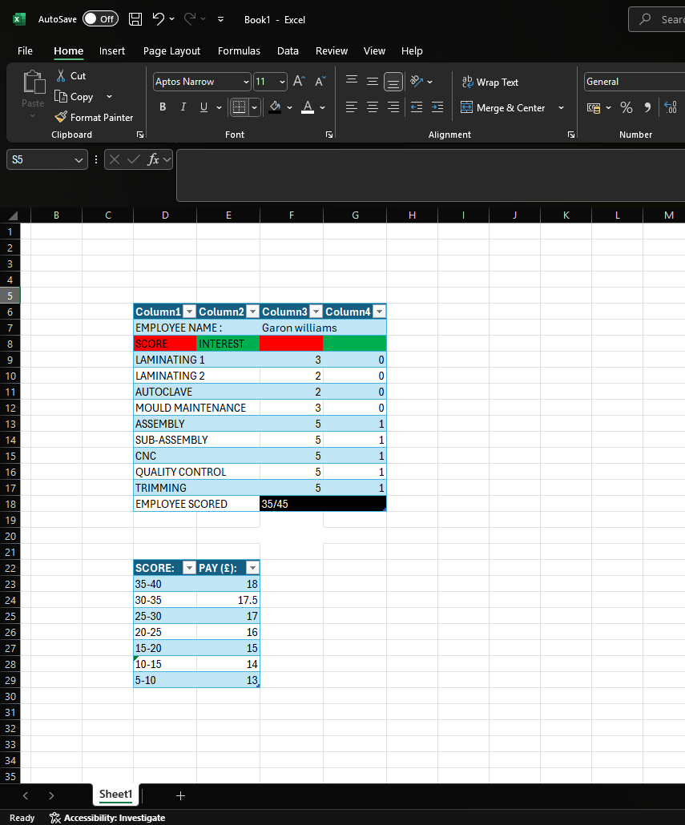
Figure 2: Pay Matrix
Figure 1:Skill Matrix Example
The example given above has an example skillset in the company. You can see from the example that the employee score will have a predetermined by the pay matrix. The employees will have the option to see their skill matrix to understand what they’ve scored and, in some cases, give their opinion why they believe they should be higher. With the employees understanding the areas of the company they have scored low scores, they can ask for the manager to allow them time in these areas for the development of the skill. The idea of the skill matrix will help the management system workout which employees are able to complete some tasks if certain individuals are off. It also allows them to cross train several employees. This allows a very flexible workforce whilst also increasing the engagement with other employees. This will lead to a high morale within the team.
In theory, this skill matrix should inspire employees to develop their skills and knowledge. However, there are different work ethics within the company, some prefer doing less for the pay they are on. In the 1960s Douglas McGregor had two contrasting opinions on how managers motivate their employees. This is known as the X and Y theory. Theory x suggests that managers assume that employees are naturally unmotivated and dislike work. Though theory y suggests that when the managers enable the employees with a voice and responsibility, it has a positive effect on their role Kurt, Dr.S. (2022). Some of the employees within the company are theory x and majority is theory y. The skill matrix, if implemented correctly, can motivate the theory x employees whilst also inspiring the theory y to improve their tiers.
As with any change, there are employees who are happy to embrace the change and some whom are against the change, this is commonly known as Lewin’s Force Field Analysis. Lewin’s Force Field Analysis is a well-established model used to analyse a situation and identify the forces that drive and resist change. (Tahir, 2019). The most important thing for management, is to create an open communication with the employees, allow their voice to be heard, and explain the matrix thoroughly when completed.

Driving forces for change
We can understand the driving force for this change.is low morale throughout the employees, some feel they are higher skilled and work harder than others, therefore deserving higher pay and better opportunities. There are however other driving forces which the business itself will come across, such as, new leadership, increased demand in production, incentives and competition (Tahir, 2019). The employees need to understand what pathway they’re on. The change will enable employees to learn new skills, develop their knowledge and potentially be given a new role within the company. The employees will understand that they can learn skills within the business to increase their tier. With the employees knowing this, it creates a desire to improve their role and potentially an increased salary.

Restraining forces to change
There is an uncertainty with change which can make people wary of it, can even put some people off before the change has even occurred. This can restrain due to old habits of the employees which they’ve done for most of their career. The longer serving employees, it may even scare them because previous managers have tried to change some processes which have failed. These are all uncertainties when trying to develop the business.
When this change occurred, there was mostly driving forces from the production employees. The management did not roll the change out well, they tried preventing the employees from speaking with one another. This caused frustration within the employees due to it starting some kind of rumour regarding each other’s pay. Some felt they deserved more money than others, whether that’s because of the time spent in the company or skills not being accounted for. The tipping point for this change, I believe, is the fact management wouldn’t show what your personal skill matrix included. This immediately turned the change negative for the employees, they couldn’t check to see if their score was correct, people who aren’t as skilled are being paid more. The concept of the skill matrix was not the issue, the method on how it was delivered is the issue.

Evaluate Forces
The company wants to hold on to experienced and skilful employees and prevent them from leaving and potentially, working for the competition. Ensuring the morale within the employees remains high is key for businesses. This change has many driving forces which typically came from the employee’s dissatisfaction. This is a change is good, it acknowledges some of the employees concerns regarding their pay, skills and work ethic, which can increase morale. The restraining forces were also from the employees, though I don’t believe it was the change that caused this. I believe it was the method of how management rolled this change out with. Keeping the matrix in secrecy within the workforce, not showing the skill matrix with the employees. They needed to create an open communication with the employees prior to rolling out. Create forms of where the employees believed they are, what career pathways they want, collect data from HR or other managers on some skills some employees may have. This will allow management to explore all data, tier employees accurately but mainly, allow the employees to have a say. This will make them feel included with the change, which makes them open to it. Creating an open environment for the employees is a crucial skill that managers and leaders must have. A survey was completed and found that 86% respondents blame the lack of communication for any changes and failures. Without clear communication, employees lack direction, positivity and lack of engagement Miller, H.L. (2022).
If the communication was open and transparent, the employees would have been more open about the change and perhaps they would have adapted better to it. Allowing for a positive effect on the workforce and production.

Conclusion
The change was negative in some aspect for certain employees, I do believe, however there was a small success within the workplace, this is mainly because the hardest workers were all rewarded as expected. I believe it could’ve been significantly better, I believe they should’ve been open and honest regarding people’s salary. This can cause conflict, but it would mainly create an incentive for the employees, a target in some ways. This will help the knowledge and skills flow through the company whilst also developing the new starters into the lower tier, lower into the higher tier. This way, the company will always maintain the knowledge and skills in the company. Whilst constantly developing future employees.
The change is Creating an open and honest line of communication with the employees is a major factor in why the change had a negative impact. I also believe management should’ve ask all employees to fill in a skill matrix template, this will give the management an idea of where the employees believe they are, compared to where they truly are. This way, the manager is prepared when the employees are asking why others are being paid more. When these employees understand why they haven’t been awarded a higher tier, which will kickstart incentive for the employee to work harder, learn new skills to potentially earn a larger pay or create new job opportunity within the company.

References
Prottas, D. &. N. M., 2018. Mgregors Theory X & Y, s.l.: The Health Care Manager .
Tahir, U., 2019. Lewin's Force Field Analysis, s.l.: Change Management Insight .
Miller, H.L. (2022) The value of open communication in the Workplace, Leaders.com. Available at: https://leaders.com/articles/company-culture/open-communication/ (Accessed: 10 May 2025).
Kurt, Dr.S. (2022) Theory X and theory Y, Douglas McGregor, Education Library. Available at: https://educationlibrary.org/theory-x-and-theory-y-douglas-mcgregor/ (Accessed: 10 May 2025).

