Article review on “Youth Justice: Past, Present and Future”
“Youth Justice: Past, Present and Future” is an article published within the British Journal of Community Justice in 2015. The Article was created with the aim to provide a comprehensive exploration of the ‘highly political’ context of youth justice. The Article begins with discussion of the emphasis on the “offence and offender” focused approaches, rather than the promotion of positive outcomes coming from within legislation (Case et al 2015). Case et al (2015) suggest that, historically, within youth criminal justice, children are often “doubly punished”, in that children are punished for their poor circumstances and furthermore for the criminal act. The added factor of poor circumstance “inevitably” led to a disproportionate sentence for the juvenile involved. The unintended consequences for the crimes and harsher punishment is suggested by Case (2015) to cause ‘more harm than good’ in relation to the life of the child.
Case et al (2015) highlight the legislation from the 1990s, adding evidence of a historical context in which there was a turn from welfare and towards ‘just deserts’. The article underlines the concern the public had at the time with car crime such as ‘joy riding’ which was hitting news headlines more frequently and, in order to combat this, there became a political ‘arms race’ in order to show the public which party was tougher on crimes. This practical application within the article provides a real-life example in which there was a clear push with harsher sentences in relation to certain crimes. Newburn (2007) supports the argument that there was a greater push from political figures on the increase of car crime in order to tackle the issue. This then extended to a political race in order to show the public which political party would be tougher on the people committing these crimes which statistically as highlighted by Case et al (2015) was young persons. The article then states that legislation such as the Criminal Justice Act 1993 and the Public Order Act 1994 was introduced through the conservative party in their ‘no more excuses’ agenda that claimed to bring forth a ‘new youth justice’.
Case et al (2015) state that they support Smiths (2006) argument in which it is argued that politicians and professionals should use informed ideas and methods that have been tested and proven to be effective rather than using guess work and using punishment to receive public approval. The article continues to state that there was clear success in forms of Youth Justice in which the main aim was to rehabilitate the child and the consequences for a crime should be less severe, highlighting the statistical success since 2007/2008 in reducing numbers of children arrested and the number being entered into the Youth Justice System. Case et al (2015) cite Fionda (1998) in highlighting that even with the statistical support of lesser aggressive forms of punishments for young offenders, there is a tendency within the Youth Justice System to become more ‘controlling’ than ‘caring’, and they have become ‘stubbornly blind’ when it comes to the child’s welfare and age. The article is missing alternative opinions, highlighting ‘political arms races’ and suggesting little has been done in the form of rehabilitation and care for children within the system. This could be a concern as it offers a biased and one-sided perspective, using evidence that only support their argument without providing an alternative perspective on the topic of the Youth Justice system and the punishments it uses. The Ministry of Justice (2010) provides a fitting counter argument stating that while there may be statistical support for the rehabilitation and ‘softer’ punishment, there is a growing concern with allowing the young offenders to remain in the public, as without containment there could be more victims. The Ministry of Justice (2010) states that often incarceration within a young person’s unit, can be the most effective way to remove troubled offenders from chaotic families and offer them structure, education and a future. Case (2015) highlighted the ‘controlling’ way the Youth Justice System can be, yet the Ministry of Justice (2010) suggests that young persons sometimes need to be controlled, there often needs to be firm structure and strict rules in order to develop them into a rule abiding citizens. An example of this is given by the BBC (2018) in which they describe Robert Thomson, originally ten years old when introduced to the Youth Justice System. Thomson as outlined by the BBC (2018) states that his imprisonment has made him a better person, gave him opportunity to learn and also removed him from his Chaotic family. This would suggest that whilst Case et al (2015) can provide evidence of children receiving harsh punishments and several political races involving imprisonment. There is a lack of evidence from other sources that could support the current Youth Justice System.
The argument is consistent, a push on evidence that backs a political arms race that can be detrimental to the young offenders. The Article is clear, using evidence from second-hand sources with several citations citing themselves from other articles, which could suggest some first-hand knowledge - albeit without things such as surveys, interviews and questionnaires. Using the evidence provided in the article it is clear that there is support to their claims and this is used in a persuasive manner which enforces their beliefs. The final conclusions drawn by Case et al (2015) are the need for improvements within the Youth Justice system, with the inclusion of suggested methods for improvement for care and welfare for the offenders within the system. Hinnigan (2015), chief of the youth justice board, supports this claims stating a need for reform within the system, calling for a drive towards ensuring preventative methods and a child supportive approach, with the ideals of every child being able to live free from the impact of crime – whether victim or perpetrator. Case et al (2015) refers to the notion of progressive diversion, consisting of constructive interventions that promote success, achievement and support services. The article contains the recommendations to improve the issues they perceive within the Youth Justice System, which is a positive means to finish the article, as opposed to focusing entirely on negative facets. This ensures the readers understand and ha access to the evidence behind the final recommendations and can furthermore see how the system could be further improved.
Reference list for academic article review
Bateman, T (2014), A timeline of youth justice legislation, policy and practice available at: http://www.beyondyouthcustody.net/a-timeline-of-youth-justice-legislation-policy-and-practice/ accessed on the 12th May 2020.
Bateman, T. (2012) 'Who pulled the plug? Towards an explanation of the fall in child imprisonment'. Youth Justice issue 12. Article 1. Pages 36-52
BBC (2018) Bulger killer had better life after toddler murder. [online] available at https://www.bbc.co.uk/news/uk-england-merseyside-46209074 accessed on the 12th of May 2020.
Case, S. Creaney, S. Deakin, J and Haines, K (2015) Youth Justice: Past, Present and Future. British Journal of Community of Justice. Volume 13. Article 2. Pages 99-110.
Case, S. P. and Haines, K. R. (2009) Understanding Youth Offending: Risk Factor Research,
Case, S. P., Clutton, S. and Haines, K. R. (2005) Extending Entitlement: A Welsh policy for children. Wales Journal of Law and Policy, issue 4. Article 2. Pages 187-202.
Creaney, S. (2014) 'The benefits of participation for young offenders'. Safer Communities, Vol 13. Issue: 3. Pp. 126-132.
Fionda, J. (1998) 'The Age of Innocence - the Concept of Childhood and the Punishment of Young Offenders', Child and Family Law Quarterly. Article 10. Issue 1. Pages 77-8
Hinnigan, L (2015) Strategic Plan. Youth Justice Board. London.
Hough, M and Roberts, J (2009) Youth Crime and Youth Justice; Public opinion in England and Wales. The policy Press. Bristol.
Ministry of Justice (2010) Breaking the Cycle. Home office. London.
Newburn, T (2007) ‘Tough on Crime’. Crime and justice. Volume 36. Article 1.
Newburn, T (2007) ‘Tough on crime” penal policy in England and wales. Crime and Justice. Volume 36. Number 1. Pages 425-470.
Policy and Practice. Cullompton: Willan Publishing
Troyna, G (2011) Unforgiven: The Boys who Murdered. Documentary. [online] available at https://www.youtube.com/watch?v=TrkQe4tyJnQ accessed on 12th of May 2020.

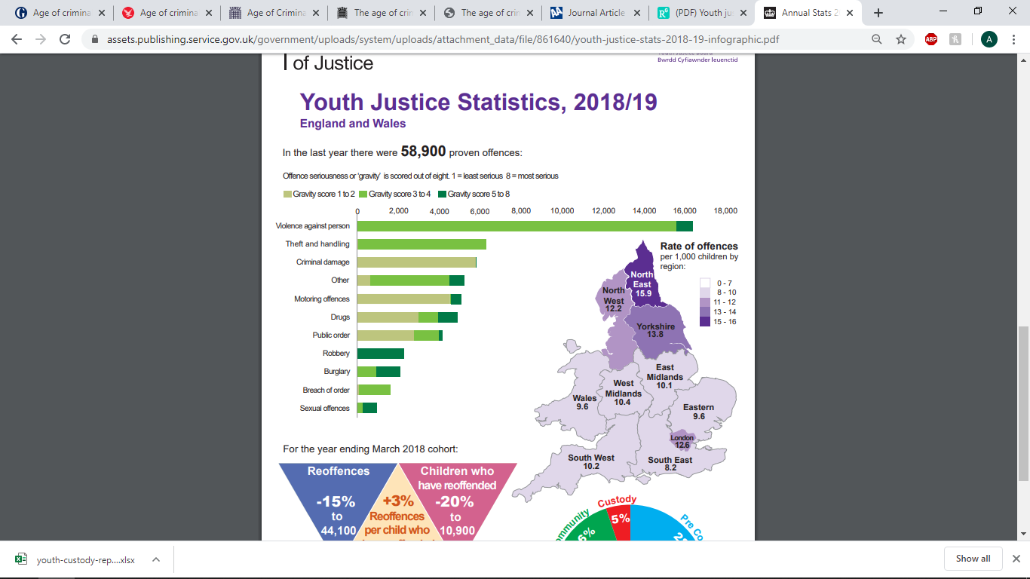
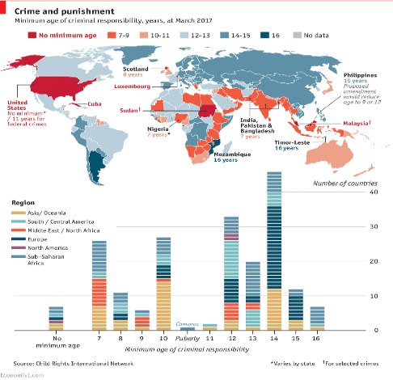
Age of criminal responsibility
Children under 10 within England and Wales are treated differently from adults that commit an offence. Whilst those under 10 cannot be charged, they can be given;
Local child curfew – Preventative method that restricts the young person going to a public place between 9pm to 6am. This can last up to 90 days.
Child Safety Order – if an offence is committed or the local curfew order is broken it leads to the child safety order in which they are placed under the supervision of a youth offending team.
The image on the right provided by the Economist (2017) shows the ACR across the globe. In the USA there is no minimum age of ARC outlining that a person of any age will be held accountable for their actions, apart from those that commit federal crimes in which the ACR is at 11 years of age. Whereas Mozambique and Timor-Leste have a minimum ages of 16 years. The UK has one of the lowest age within Europe with Scotland having an ACR of 8 years old.
26,700 children and young people were caution or sentenced within England and wales in the years 2017-2018. Although the number of offenders who received a caution or sentence has fallen by 82% over the previous ten years. 14,400 young persons were entered into the Youth Justice System (YJS) for the first time over 2017/18 yet this statistic is 14% lower than March 2017.
The Age of Criminality (ACR) provides the minimum age that a child can be prosecuted and punished for an offence (Brown and Bunn, 2018). The ACR within England and Wales is currently at 10 years old. This suggests that if there is a child under 10, they are unable to be arrested or prosecuted for any form of crime.
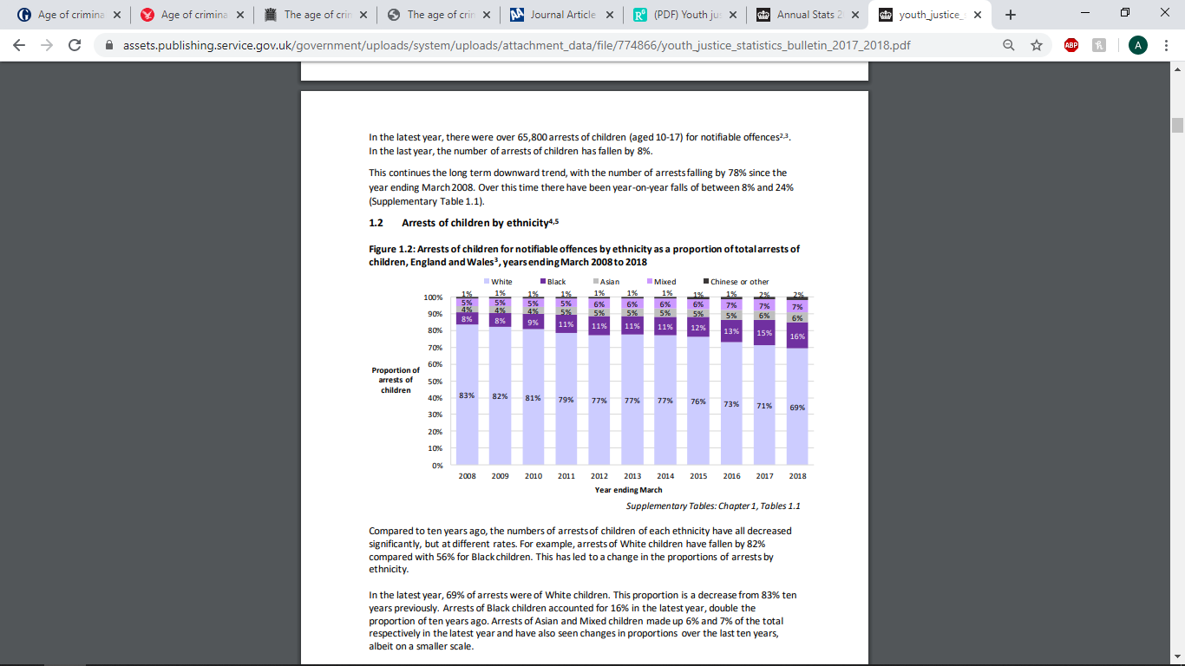
The table on the left provided by the Ministry of Justice (2019) shows the that the proportions of youth cautions given have changed for white and black children over the last ten years. The statistics show an increase of 4% for black youths from 2015/18 creating a total of 11% overall. Whereas there has been a decrease in the youth cautions given to white youths within 2015/18 reducing it by 8%. Whereas the statistics for Asian youths receiving a caution has remained steady throughout the last decade increasing only by 1% creating the overall total in 2018 to 5%.
The image above provided by the Ministry of Justice (2019) shows the offences committed by young offenders and the seriousness and the number of the crimes committed. Violence against a person is one of the highest crimes committed with statistics showing around 16,000 incidences in 2018/19. The different green shades show the severity of the crime committed, with the majority having a score of 3 to 4 and the most serious, a dark green shade, with a gravity score of 5 to 8. The most serious of the crimes being robbery with over 2,000 committed within England and Wales.

The Economist (2017) [image] Crime and punishment [online] available at: https://www.economist.com/graphic-detail/2017/03/15/the-minimum-age-of-criminal-responsibility-continues-to-divide-opinion accessed on the 15th of May 2020. / Bulman, M (2019) Age of Criminal; responsibility in England and Wales. The Independent [online] available at https://www.independent.co.uk/news/uk/home-news/age-of-criminal-responsibility-child-crime-england-wales-a8898121.html accessed on the 15th of May 2020. /Brown, P and Bunn, S (2018) Age of Criminal Responsibility. Parliamentary Office of Science and Technology. London. /Cipriani, D (2016) Children’s rights and the minimum age of criminal responsibility. Ashgate Publishing. New York. / Pidd, H. Halliday, J. Wolfe-Robinson, M and Parveen, N (2019) Age of Criminal Responsibility must be raised. The Guardian [online] available at https://www.theguardian.com/society/2019/nov/04/age-of-criminal-responsibility-must-be-raised-say-experts accessed on 15th of May 2020. / Bateman, T (2013) ‘keeping up appearances. Criminal Justice Matters. Issue 92. /McGuinness, T (2016) The age of criminal responsibility. House of Commons. London ./ Goldson, B. (2013) Unsafe, unjust and harmful to wider society: grounds for raising the age of criminal responsibility in England and Wales. Youth Justice, 13 (2) 111-130 / Bateman, T. (2014) Catching them young- some reflections on the meaning of the age of criminal responsibility in England and Wales. Safer Communities, 13 (3) pp 133-142 4 / Ministry of justice (2019) [image] Youth justice. Youth justice board. London. / Youth Justice Board (2018) (image) Youth Justice Statics. Available at: https://assets.publishing.service.gov.uk/government/uploads/system/uploads/attachment_data/file/774866/youth_justice_statistics_bulletin_2017_2018.pdf accessed on 16th of May.

The Criminal Courts in England and Wales; A reflective report
During my studies on the Criminal justice system, youth justice and prison systems, I have learned a great deal about a variety of interesting and fulfilling topics. However, for the purpose of this assignment I have opted to discuss my experience with the criminal Courts in England and Wales focusing in on Magistrates court. The moment that piqued my interest came from a case study of something that was seemingly simple yet turned out to have more of an implication and a complex idea than I had originally perceived. This case study was on a Mars Bar; provided by The Secret Barrister (2018) and explained to us within class. According to The Secret Barrister (2018) on the 6th of August 2015, Louisa Sewell appeared in court having been accused of stealing a pack of Mars Bars, valued at 75p. Sewell pleaded guilty, with the explanation that due to her benefits being sanctioned, Sewell could not afford food and had stolen “the cheapest item in the shop” to feed herself. The chairman proceeding over the court hearing stated “we do not readily accept you go into a shop to steal just for being hungry” the overall punishment decided by the proceeding magistrate was a total of £328.75 to be paid by Sewell for the offence, which can be broken down as; £150 for a criminal courts charge which they were obligated to apply, £73 as the discretionary punishment decided by the magistrates, £85 for the prosecution costs and £20 for the victim surcharge and 75P to compensate the shop. The idea of this to me was unpleasant, I began thinking about the level of disassociation the proceeding magistrate had to the situation; It seemed to me that they lacked understanding and seemingly some compassion, fining far beyond the price of the Mars Bar to someone that could not afford that in the first place. Mortimer (2015) proceeds to imply, that the causes could be in part due to the changes to the courts system that brought about the charges; with £150 initially being attributed to the criminal court appearance charge, and the lack of education for magistrates, with regard to the application of fines in proportion to the crime committed.
Gaps within my knowledge
Having learned the case study within class about the court proceeding that charged a disproportionate amount for the theft of a Mars Bar, I realised there was large gap in my knowledge when it came to the Magistrate’s court. Whilst I understood the purpose of it, I had not realised the lack of understanding within the system. In order to improve my knowledge on the system I revisited the taught material from our lectures. The Magistrates’ court is the main court that hears cases from both the criminal and family court as outlined by the Ministry of Justice (2020), continuing to highlight that all magistrates are volunteers. In class there was an open discussion about the possibility of corruption within the system, and that the volunteers could potentially have bias. There is also concern over the lack of knowledge within the justice system. For example, due to the importance and frequency of the majority of rulings being made through these courts, it could be seen as a concern when they rely on a legal advisor for advice on law. The class discussion was very enjoyable and informative, and I felt that every member contributed effectively to my new understanding on the topic. Due to the lack of knowledge I previously had on the topic, I was very limited in the contribution I could make. In light of this, I decided to go more in depth, with the idea to use this as a base for my first assignment.
All criminal cases begin in the Magistrates’ court, who pass the more serious crimes onto the crown court; examples of these are rape, murder and robbery. Lemme (2017) states that statistically 90% of criminal court cases are dealt with in the Magistrates court. They do not require legal training or qualifications, but they are understood to be the ‘representatives of the people’. Lemme (2017) states that courts are where some of the most life changing decisions are made and I agree within this statement. Courts arguably have the ability to alter lives beyond any other public service. This imposes the idea that this sector is exceptionally important and those they chose to chair the hearing are significant in altering the lives of the people on trial. In my personal opinion, I am unsure about the idea of someone untrained and unqualified making a decision that affects someone’s life so greatly. Education in my opinion is important, this for example could teach about previous cases and social cultural differences, and could improve the Magistrate’s perceptions and understanding of the different lives people may live within the same society. Due to my interest in the subject, I also delved into the psychological theories and explanations governing such behaviours and decisions in cases such as the 75p Mars Bar, as I was intrigued as to the cognitive mechanisms involved in people deciding the fate of others. An example of this is known as the “halo effect”, whereby individuals are more likely to act favourably towards others with factors in common with themselves as Forgas and Laham (2007) explains, such as those hailing from the same economic class, ethnicity or appearance. In contrast, as evident in many Magistrate cases the opposite effect may be said for those of opposing traits and characteristics, which may assist in explaining the Sweller case. Lemme (2017) states that there needs to be a consideration of the risks involved when sentencing, and not solely the punishment that is “deserved”.
Scholarly development
The research into this topic gave me the required knowledge and understanding of the court system to effectively complete my first assignment on the prison crisis. Learning elements to this subject is critical if I decide to pursue any field within the public sector. This has developed my knowledge of the court systems and more, even incorporating elements of psychology into decision making and ideas on how the systems could potentially be improved for the benefit of the volunteers and those undergoing court hearings. The relevant lecture posed questions on moral arguments about the justice system which I had previously not considered, such as the implication of prison time on a single parent. Whilst personally I am under the Impression that if one commits a crime, there should be equal consequence for all - as most understand the implications of a crime before committing it, excluding those with learning difficulties, people of a young age and other contributing factors in which making a life altering decision is not fully understood - the argument did raise the idea of that there would be further consequence on the children of the single parent whom are innocent, as to where they would go, and their life being uprooted. This is an area that I found challenging as, whilst I had considered this before, there was an element of uncertainty for the children involved and the impact crime has on their life. Whilst the adult is in the position to understand before they commit the crime, the child may struggle to understand as to what is happening and why they are being moved from their living situation.
Overall, the resources, material and debates have been helpful in my progress on the course and has provided an in depth look at the workings of the criminal justice system. They have challenging my ideas and urged me to expand my knowledge on the subject, leading me to do further reading into the subject and reasons behind why things such as the 75p Mars Bar case take place. I found several areas difficult such as finding resources, arguments and hearing unpleasant stories from the criminal justice system. The lectures were challenging, creating argument for and against certain situations and ensuring questions were posed to the current justice system and if there are ways in order for it to improve. I have had many ideas stemmed from researching and undergoing lectures on the justice system and ways in which it could be improved, such as the fact that it may be beneficial for Magistrates to undergo training and education to understand those from different lives. I also believe it would be beneficial for the role as magistrate to change from a volunteer role to a paid role, as my research suggests that many volunteers feel undervalued and aren’t paid to do the role they have been given, even with the court dealing with 90% of cases. There should be a drive to show the volunteers that they are needed within the system and create a more inclusive base of Magistrates from all backgrounds.

Reference List for Reflective Report
Forgas, J and Laham, S (2007) Halo Effect. Encyclopaedia of Social Psychology. Volume 1. Pages 410-410.
Lammy, D (2017) Lammy Review. Home Office. London.
Ministry of Justice (2020) Become a magistrate. Home office. London.
Mortimer, C (2015) Fundraising appeal for woman fined £330 for stealing a 75p Mars Bar. Independent [online] available at: https://www.independent.co.uk/news/uk/home-news/fundraising-appeal-for-woman-fined-330-for-stealing-75p-mars-bar-reaches-nearly-14k-10459372.html accessed on the 17th of May 2020.
Secret Barrister (2018) Stories of the law and how it’s broken. Macmillan. London.

