

Programme: Master of Business Administration
Module: Marketing Management
Module code: CMB7024
Assessment component 2: Marketing Portfolio

Student Name: Vijay Kumar
Student ID: 2433812

Submission Date: 17/12/25
Word Count: 2495

Table of Contents
ELEMENT 1: STDP ANALYSIS 3
Introduction to the Company and Concept 3
Appeal to Current Market Trends and Consumer Behaviour 4
Segmentation 4
Targeting 5
Differentiation 5
Positioning 6
ELEMENT 2: MARKETING MIX (4Ps) 6
1. Product 6
2. Price 7
3. Place 8
4. Promotion 9
Conclusion 10
ELEMENT 3: MARKETING STRATEGY PITCH – Coca-Cola Vital+ 11
ELEMENT 4: REFLECTION 13
Reference list 15

ELEMENT 1: STDP ANALYSIS
New Brand Concept: Coca-Cola Vital+

Introduction to the Company and Concept
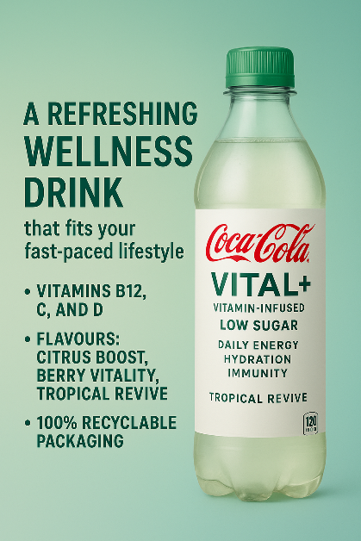
Coca-Cola is a well-known brand of beverage in the world, and the product has a long history of innovation and product diversification to suit the changing demands of consumers. Though it is still associated with carbonated soft drinks, Coca-Cola has been diversifying into waters, sports drinks, teas, coffees and energy drinks (Coca-Cola, 2024). The report is responsive to major changes in consumer behaviour relating to health, wellbeing and functional beverages through the introduction of a new brand concept, Coca-Cola Vital+. The product is a functional beverage that contains all the vitamins and has low sugar content with a plan towards serving the health-conscious consumers seeking convenient, refreshing and nutritionally supplemented drinks (Dini, 2019).

Appeal to Current Market Trends and Consumer Behaviour
In recent years, consumers—especially young adults— have been very attracted to beverages with health advantages that will go beyond mere hydration. The wellness lifestyles, concerned health management and the need for natural functional ingredients represent trends that have enhanced the popularity of vitamin waters and performance drinks (Sethna, 2023). Meanwhile, the issue of the consumption of sugars also provoked increased interest among the population in drinking healthier copies in place of classic soft drinks. Coca-Cola Vital+ is a direct reaction to these trends, offering a lightly flavoured non-sugary drink fortified with important vitamins (B12, C, and D) and promoted as a convenient daily wellness-enhancing drink. The brand is also capitalising on the emerging functional beverage market by appealing to consumers who are interested in the product and do not have to sacrifice their health objectives because of the flavour and health benefits it offers (Bagozzi et al., 2021).

Segmentation
The key market segments for Coca-Cola Vital+ can be identified using demographic, psychographic, and behavioural variables.

Segmentation Type | Description | Relevance to Coca-Cola Vital+
Demographic Segmentation | Focuses on young adults aged 18–35, including university students and early-career professionals. | This group prioritises health, often seeks convenient nutrition, and has higher interest in functional beverages (Kotler and Keller, 2016).
Psychographic Segmentation | Targets individuals with wellness-oriented lifestyles, including interests in fitness, mindfulness, self-care, and healthy eating. | These consumers are motivated by wellbeing and are more likely to choose vitamin-infused, low-sugar drinks that align with their values.
Behavioural Segmentation | Includes consumers who actively look for functional benefits, prefer low-sugar beverages, purchase drinks on the go, and value convenience. | These buyers seek products that provide energy, hydration, and daily nutritional support, aligning directly with the purpose of Vital+ (Tireki, 2021).

Targeting
Coca-Cola Vital+ is going to be targeting the health-conscious youth group of 18-35 years of age, who are employed in cities, and lead busy lives of great intensity. This market usually buys drinks on their way to and away, to and out of the gym, or during their school or work time (Cording, 2025). They are more susceptible to nutrition information and like trying out new products which fit in with their values of balance, wellness and vitality. The target market is also digital, using social media influencers, fitness trends, and lifestyle-related content, and that is why it is easier to reach them through targeted digital campaigns (Kotler and Armstrong, 2018). Secondary audiences can also comprise professionals in the 35-45 age bracket who would want to find convenient methods of sustaining energy and wellness throughout the day.

Differentiation
Various strategic factors will make Coca-Cola Vital+ stand out in the marketplace, competing with other functional drinks, like Vitaminwater, Lucozade Sport and flavoured waters. To begin with, it incorporates low-sugar and clean formulation, which would be appealing to consumers who do not consume artificial additives (Hang, 2018). Second, Vital+ will focus on balanced vitamin blends that do not overdo the stimulant and caffeine jolt and assist in immunity, energy and hydration. Third, the brand will take advantage of the distribution network of Coca-Cola, which will be available in extensive quantities in convenience stores, supermarkets, gyms, and vending machines (Food Navigator, 2025). Lastly, Vital+ will use minimalist, modern packaging that conveys a definite health-related message, as that will allow it to be more noticeable and convey itself as useful at first glance.

Positioning
The positioning of Coca-Cola Vital+ will be an exclusive but affordable healthy drink that will help to enhance daily energy with the necessary vitamins and light refreshing flavours. The product will be positioned as an easy and fun method of remaining active and healthy, particularly for individuals with hectic schedules (Kotler and Keller, 2016). The essence positioning statement can be:
“For active, health-minded individuals, Coca-Cola Vital+ is a vitamin-enriched functional beverage that allows refreshing its drink and delivering wellness support in a day, making it a healthier choice compared to the sugar-containing soft drinks.
This approach sets Vital+ apart from regular soft drinks and also when compared to more powerful, high-energy drinks, since the product will provide a functional beverage that is naturally oriented with a well-known brand that Coca-Cola has built over the years.

ELEMENT 2: MARKETING MIX (4Ps)
Brand: Coca-Cola Vital+ (Vitamin-Infused Functional Beverage)
The Marketing Mix is critical in converting the brand strategy of Coca-Cola Vital+ to a working plan. As Vital+ is a product-oriented product, 4Ps analysis is implemented to make sure that the brand can bring value matching consumer requirements and overall Coca-Cola business objectives (Iacobucci, 2022).
- Product
Coca-Cola Vital+ will be a pure yet affordable, high-quality vitamin-fortified functional beverage, which is aimed at supporting health in everyday life. It is designed in consideration of growing consumer preference for beverages which are nutritious, low in sugar content and convenient (Giri, Sakhale and Nirmal, 2023).
Key Product Features
Feature Category | Details | Strategic Purpose
Core Benefits | Hydration, vitamin boost (B12, C, D), energy support | Meets consumer demand for functional, health-enhancing drinks
Design & Flavours | Citrus Boost, Berry Vitality, Tropical Revive | Appeals to diverse taste preferences while maintaining low-sugar profiles
Ingredients | Reduced sugar, no artificial colours/flavours, natural extracts | Reinforces the brand’s health-oriented positioning
Packaging | Minimalist design, transparent bottle, pastel accents | Communicates purity, modernity, and wellness; attracts young adults
Sustainability | 100% recyclable bottle, eco-friendly labels | Appeals to environmentally-conscious consumers (Giri, Sakhale and Nirmal, 2023).

In the design of its product, there is a promise of wellbeing, candour, and naturalness. The plain visual image allows distinguishing Vital+ among sweeter soft drinks in the market, whereas the health-conscious labelling (including Daily Immunity Support or Natural Energy) allows consumers to realise the presence of functional benefits much faster (Food Navigator, 2025). This conforms well to the positioning of the core brand: a refreshing wellness drink which fits the busy lifestyle.
- Price
A very clear pricing policy will be vital in positioning Vital+ in the functional drink market. The Coca-Cola Vital+ will carry a value pricing strategy when it represents inherent nutritional value in addition to the willingness of the customers to spend on functional health products (Sudarman and Lailla, 2023).
Proposed Pricing Structure
Product Type | Pack Size |  | Suggested Retail Price (SRP) | Rationale
Single Bottle | 500 ml |  | £1.60 | Competitive with Vitaminwater and Lucozade Zero; still premium compared to regular soft drinks
Multi-Pack | 4 × 500 ml |  | £5.00 | Encourages repeat purchases and household consumption
Gym/Health Store Exclusive | 750 ml |  | £2.20 | Premium option targeting fitness-oriented consumers

Through this price model, Coca-Cola Vital+ will lie between mass-market soft drinks and high-end wellness drinks. The pricing has been done to attain three objectives:
- Affordability: It can be used frequently by young adults who have a low amount of disposable income (Tireki, 2021).
- Value of Money: Added Vitamins and functional reinforcements: Consumers feel the added value of the goods is worth the increase in price slightly.
- Market Penetration: It will be competitive on pricing, which helps in the early adoption of the product in a market where the Vitaminwater, Boost, Prime and electrolyte drinks are the dominant producers (Food Navigator, 2025).
Vital+ can also be supported by a small price advantage that will further distinguish it among the traditional carbonated beverages offered by Coca-Cola as a health-enhancing beverage.
- Place
Vital+ depends on functionality and accessibility, which is the core of the success of the distribution of the functional beverage. Coca-Cola has a large distribution network throughout the global markets, and this gives it a good base for penetrating the market easily (Fifield, 2024).
Distribution Strategy
Channel | Examples | Strategic Role
Retail Stores | Tesco, Sainsbury’s, ASDA | Ensures mass availability to mainstream shoppers
Convenience Stores | Co-op, Londis, corner shops | Targets on-the-go consumers who buy drinks impulsively
Fitness & Wellness Venues | Gyms, yoga studios, sports centres | Reaches health-conscious audiences in relevant contexts
Foodservice Outlets | Cafés, university canteens, workplace vending | Supports frequent daily consumption
Online Platforms | Amazon, Tesco Online, Coca-Cola Direct | Appeals to digital-first consumers; enables bulk purchasing

The distribution approach will target the youthful consumer lifestyle of young adults. Having Vital+ in various touchpoints, particularly gyms, colleges, and convenience stores, reaffirms that Vital+ is a daily wellness companion. There are also minimal market entry barriers encouraged by current relationships that Coca-Cola has with its retailers, and facilitating the quick rollout of the brand (Cording, 2025).
- Promotion
The objective of the promotional strategy is to create awareness, explain the practical benefits and make Vital+ seem an important component of a balanced and healthy lifestyle. The combination of digital interaction, collaboration with influencers, and experience-based marketing will be used as promotion (Bagozzi et al., 2021).
Promotional Mix Overview
Promotional Tool | Execution Plan | Strategic Purpose
Digital & Social Media Marketing | Instagram, TikTok, YouTube campaigns; wellness content | Targets digitally active young adults; boosts brand visibility.
Influencer Partnerships | Fitness influencers, nutritionists, lifestyle bloggers | Builds trust and credibility by using role models.
Experiential Marketing | Sampling events at gyms, campuses, marathons | Allows consumers to taste the product and build emotional connections (Kotler and Armstrong, 2018).
Outdoor Advertising | Billboards near universities, transport hubs | Reinforces brand presence in high-traffic youth areas
Promotional Offers | Introductory discounts, bundle deals | Encourages trial and repeat purchases.

The communication of the promotion will be health-based, full of life, convenient and well. Taglines such as “Boost Your Day, Naturally” or “Stay Energised, Stay Vital+” emphasise the product’s functional positioning. The campaign via social media will also promote user-generated content, and one will be able to generate engagement about the brand in the community.

Conclusion
The 4P approach to Coca-Cola Vital+ has been devised with the right perspective to underpin the right promise of the brand, which is a refreshing, low-sugar functional drink that improves everyday wellbeing.
The product differentiation, pricing strategy, distribution, and promotion strategies co-exist to satisfy the health-conscious young adults and to advance the Coca-Cola innovativeness and wellness stance.

ELEMENT 3: MARKETING STRATEGY PITCH – Coca-Cola Vital+
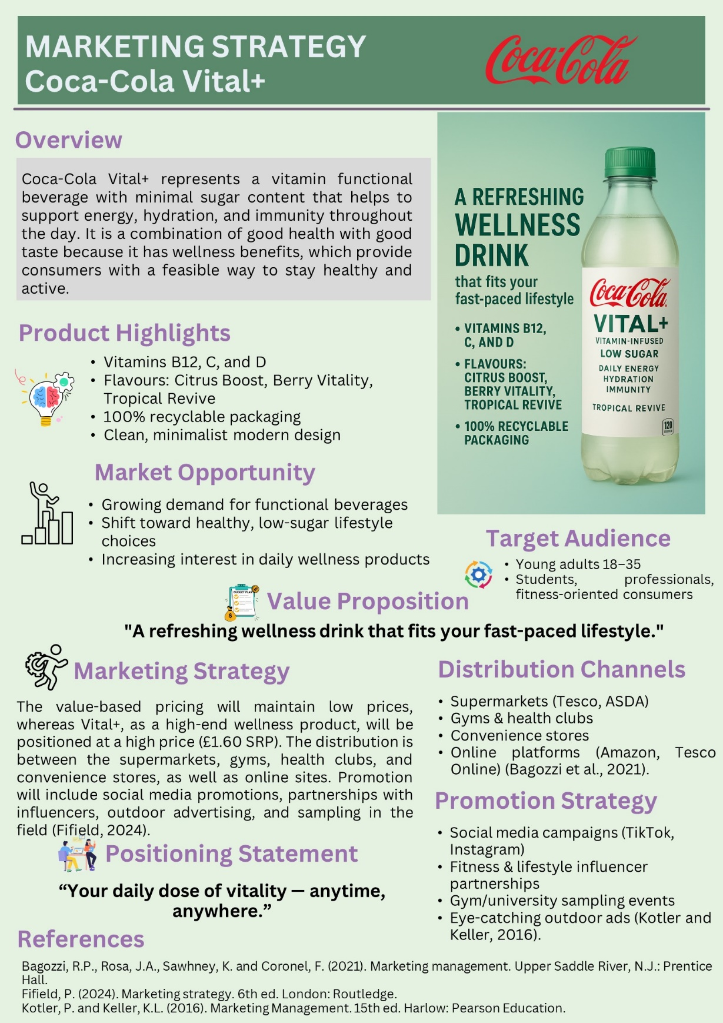
Coca-Cola Vital+ has been positioned as a high-end functional drink that easily combines health and convenience to the new generation consumer. Catering to the needs of young adults between 18 and 35, like students, early professionals, and fitness-loving people, the brand taps into the system of increasing demand for products that enable them to maintain daily wellness and be health-conscious without being dependent on high-sugar diets (Sudarman and Lailla, 2023). Its distinct value proposition, A refreshing wellness drink that fits your busy life, focuses not only on the functional and operational advantages, in other words, on the presence of vitamins B12, C, and D as a source of energy, immunity, and extra hydration, but also on the pleasant taste experience. Its modern and responsible brand image is also supported by the fact that the packaging of the product is simple and easily recyclable (Tireki, 2021). Coca-Cola Vital+ will be priced on the value of attracting a wide range of consumers, but with a premium image of 1.60 SRP. The selection of distribution includes supermarkets, gyms, convenience stores, and the internet, with social media marketing, influencer placement, sampling, and outdoor advertising being presented as the supplements, making Vital+ the drink of choice to stay energised at all times and everywhere (Kotler and Keller, 2016).

ELEMENT 4: REFLECTION
Description
In this assignment, I created a new brand proposal for the Coca-Cola company, which was referred to as the Coca-Cola Vital+, a low-sugar functional drink enriched with vitamins aimed at the young adults who can easily be influenced to buy this product. The task also entailed the development of a Segmentation, Targeting, Differentiation, and Positioning (STDP) analysis, developing a marketing mix based on the 4Ps model, developing a marketing strategy pitch, and reflecting on the learning process. I was also required to take into consideration the existing consumer trends, the market requirements of the functional beverages and also the brand equity of Coca-Cola.
Feelings
First, I was eager to have the chance to develop a product that complies with the new health trends, and also a bit confused about the necessity to design a blend of strategic analysis, innovative thinking, and academic research. Therefore, with the continued advancement, I became more confident in organising the STDP analysis, the development of the marketing mix, and the visualisation of the brand positioning. It was also an interesting process since I had the opportunity to put theory into a convincing setting to investors and consumers during the preparation of the pitch.
Evaluation
The incorporation of the market research findings in the development of the brand was one of the positive factors of the project. It was satisfying to identify important segments and develop a product that fulfils the functional and emotional needs of the consumers. Moreover, using tables to divide the segments and the marketing mix was useful to structure information that is simple to understand. Conversely, it was difficult to condense a detailed analysis into 35 minutes in a pitch, and information prioritisation and correct language were needed.
Analysis
The project made me understand the need to have strategic alignment of STDP with the marketing mix. As an illustration, the choice of flavours, vitamin levels and the packaging needed to be based on the target audience and their lifestyle. Moreover, the exercise demonstrated the importance of promoting and distributing strategies as part of a process of affecting brand adoption and visibility. Being able to relate the theory of consumer behaviour to a real-life brand choice empowered my competence to transfer some academic knowledge into practice in marketing.
Conclusion
All in all, the assignment contributed to my knowledge of the development of brand, market segmentation and strategic marketing. My analytical, creative, and presentation capabilities were also enhanced, especially in the process of summarising complex information in a brief and convincing output. I also got to know how customer insight can be used to determine a new product idea that is also relevant and competitive.
Action Plan
As an achievable future, I want to make it better and use primary research using surveys, focus groups, or other means to confirm assumptions about the target audience. I will also enhance my presentation and visual communication so that I can be more comfortable presenting marketing pitches. Lastly, I will discover new avenues of combining sustainability and digital marketing in brand efforts, as well as make sure that upcoming projects are progressive and in line with market trends.

Reference list
Bagozzi, R.P., Rosa, J.A., Sawhney, K. and Coronel, F. (2021). Marketing management. Upper Saddle River, N.J.: Prentice Hall.
Coca-Cola (2024). The Coca-Cola Company. [online] The Coca-Cola Company. Available at: https://www.coca-colacompany.com/ [Accessed 30 Nov. 2025].
Cording, J. (2025). The Rise Of Functional Beverages Among Millennials And Gen Z. [online] Forbes. Available at: https://www.forbes.com/sites/jesscording/2025/04/13/the-rise-of-functional-beverages-among-millennials-and-gen-z/ [Accessed 30 Nov. 2025].
Dini, I. (2019). 1 - An Overview of Functional Beverages. [online] ScienceDirect. Available at: https://www.sciencedirect.com/science/article/pii/B9780128163979000017 [Accessed 30 Nov. 2025].
Fifield, P. (2024). Marketing strategy. 6th ed. London: Routledge.
Food Navigator (2025). Functional beverage market to hit $250bn by 2030: Key trends driving growth. [online] FoodNavigator.com. Available at: https://www.foodnavigator.com/Article/2025/10/02/functional-drinks-market-to-hit-248bn-by-2030/ [Accessed 30 Nov. 2025].
Giri, N.A., Sakhale, B.K. and Nirmal, N.P. (2023). Chapter 8 - Functional beverages: an emerging trend in beverage world. [online] ScienceDirect. Available at: https://www.sciencedirect.com/science/article/pii/B9780443191435000025 [Accessed 30 Nov. 2025].
Grand view research (2019). Functional Drinks Market Worth $93.68 Billion by 2019 | CAGR: 6.1%. [online] Grandviewresearch.com. Available at: https://www.grandviewresearch.com/press-release/global-functional-drinks-market [Accessed 30 Nov. 2025].
Hang, B. (2018). Marketing strategies and factors influencing young people’s decisions when buying alcohol beverages. [online] www.theseus.fi. Available at: https://www.theseus.fi/handle/10024/156847 [Accessed 30 Nov. 2025].
Iacobucci, D. (2022). Marketing Management. 6th ed. Boston, Ma: Cengage Learning.
Kotler, P. and Armstrong, G. (2018). Principles of marketing. 17th ed. Hoboken: Pearson Higher Education.
Kotler, P. and Keller, K.L. (2016). Marketing Management. 15th ed. Harlow: Pearson Education.
Sethna, Z. (2023). Consumer Behaviour. 5th ed. SAGE.
Sudarman, D. and Lailla, N. (2023). The Influence of Marketing Strategy and Marketing Mix on Marketing Performance of Ready to Drink Beverages Through Brand Image. International Journal of Professional Business Review: Int. J. Prof.Bus. Rev., [online] 8(9), p.11. Available at: https://dialnet.unirioja.es/servlet/articulo?codigo=9070094 [Accessed 30 Nov. 2025].
Tireki, S. (2021). A review on packed non-alcoholic beverages: Ingredients, production, trends and future opportunities for functional product development. Trends in Food Science & Technology, 112(112), pp.442–454. doi:https://doi.org/10.1016/j.tifs.2021.03.058.

