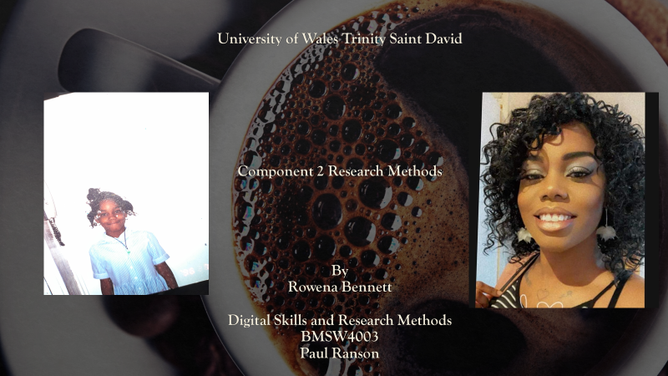
My name is Rowena Bennett, and this is my first year of the programme. Certificate of Higher Education in Skills for the Workplace. Title Page containing: University name: Assignment title, Student name, my student number is 2029311, module name, module code and Tutor name Paul Ranson.
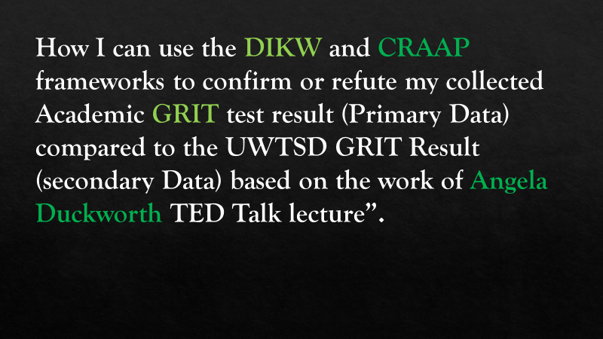
As an assignment, I am to write a paper and show my digital skills by evaluating and using technology to improve workplace efficiency and employability using the DIKW and the CRAAP framework and how I’ve transformed either qualitative or quantitative data, as well as how this data can be incorporated in Angela Duckworth’s life's work. essentially, qualitative data is information that can be arranged in categories based on physical features, gender, colours, or anything that does not have a number attached to it, and quantitative data is information that is gathered by surveying, polling, and posing questionnaires to a group of people the approach I'll be using is based on Angela Duckworth's work, which is known as the Grit test. Grit is defined as tenacity and passion in the face of hurdles and diversions. It's a technique she developed to better understand kids and youngsters, as well as to determine who is successful and why. Grit, she claimed, was one of the primary characteristics that kept coming up. Grit is what puts you back on the horse after you've been booted off. Grit allows a person to self-regulate and delay the need for positive reinforcement while showing their value. (Kollar et al., 2021). This paper will be showing how Angela Duckworth Passes the CRAAP test. I will be using methods from the DIKW (Ackoff 1989) and CRAAP test to confirm whether I believe her theory is true. Angela specifically states that her grit test is the best, so I will be testing this out.

CRAAP stands for Currency, Relevance, Authority, Accuracy, and Purpose. There is no easy way to determine whether a source can be used for research or not. California University, Chico Professor Sarah Blakeslee has developed the CRAAP Test with her team. Resources must pass the five steps of verification. (The CRAAP Test « Evaluating Sources Easily, 2021). Angela Duckworth is the founder and CEO of Character Lab, a non-profit whose mission is to advance scientific insights that help children thrive. She is also a professor of psychology at the University of Pennsylvania and in 2013 was named a MacArthur Fellow. Prior to her career in research, she was a math and science teacher at public schools in New York City, San Francisco, and Philadelphia. In her late 20s, Angela Lee Duckworth left a demanding job as a management consultant at McKinsey to teach math in public schools in San Francisco, Philadelphia, and New York. After five years of teaching seventh graders, she went back to grad school to complete her Ph.D. in psychology at the University of Pennsylvania, her research subjects include students, West Point cadets, and corporate salespeople, all of whom she studies to determine how "grit" is a better indicator of success than factors such as IQ or family income. She also has a bestselling New York times book named Grit: the power of passion and perseverance. Angela states that by using grit you can conclude a sustained application of effort towards long term goals and predict lifelong achievements. (Duckworth, 2021) by this I will be doing an experiment to see if I think she passes my Craap test.
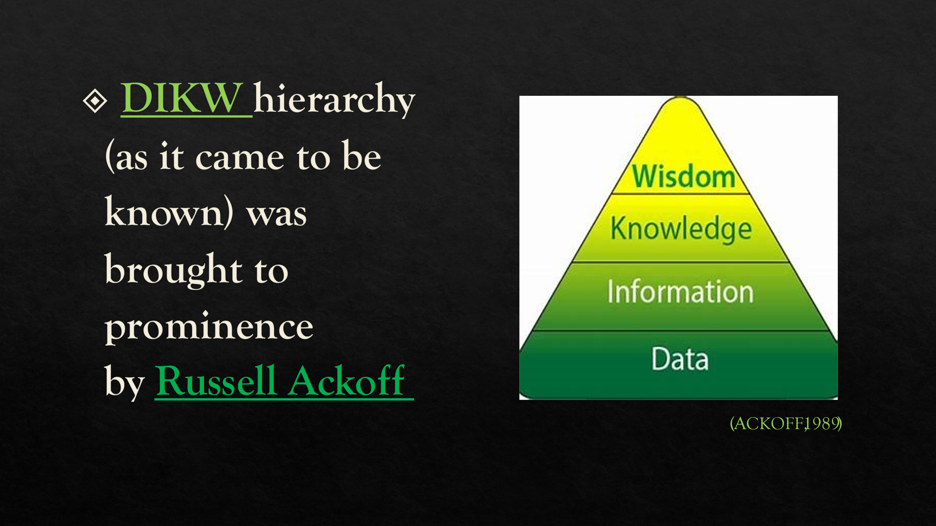
Known as DIKW pyramids or DIKW models, these models explain how we move from data (the “D”) to information (the “I”), the knowledge (the “K”), the wisdom (the “W”) through actions and decisions. But the person to first to put all the terms into single formula was Russell Lincoln Ackoff, in 1989. Ackoff posited a hierarchy at the top of which lay wisdom, and below that understanding, knowledge, information, and data, in that order. Furthermore, he wrote that “each of these includes the categories that fall below it,” and estimated that “on average about forty percent of the human mind consists of data, thirty percent information, twenty percent knowledge, ten percent understanding, and virtually no wisdom” (Ackoff, 1989) (2021) Ackoff was raised in Philadelphia during the Great Depression. He enrolled at the University of Pennsylvania in 1937 and graduated with a bachelor’s degree in architecture. His graduate studies in philosophy were interrupted by the Second World War, during which he served in the Fourth Armored Division prior to moving on to Officer Candidate School. (Ackoff, Russell L., 2021)

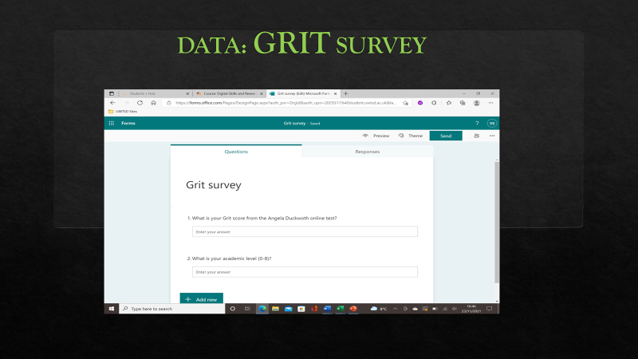
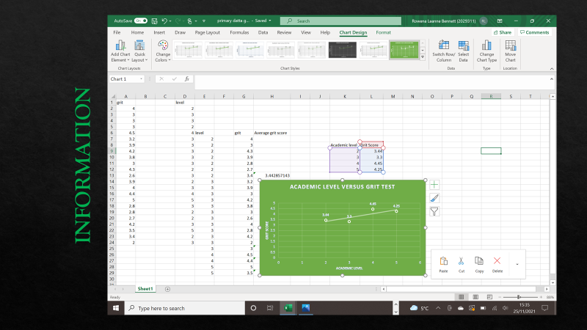
I have used the Duckworth Grit scale found at https://angeladuckworth.com/grit-scale. According to a recent study, 20% of American adults take an average test of 3:00 (Angela Duckworth, 2021) to determine their grit. From this I have formulated my own short questionnaire survey using Microsoft Forms off the UWTSD office365. there is also other means to download or transfer information, this was using a QR code or using URL address supplied from our lecturer Everyone in my class had to take this test online to find out their grit score. Microsoft forms helped me produce results into quantitative data. I also asked my peers once they had completed their grits scale results to also tell me what their academic level was. This number would only be between 0 and 8 this helped me formulate data which I would go on to use to test and produce my own charts. We would then go on to screenshotting a version of this to add onto Microsoft PowerPoint slide merge my results onto Microsoft Excel.

There are approximately 24 students in my class, so this is the amount that had been used precisely in the survey from the Microsoft Forms. So, from that, the answers were then put into quantitative data chart. On the image above I had created a separate table to work out the average grits score for each academic level. (See chart) created using this formula:
=AVERAGE (highlight cell number) ENTER
Once that step was complete, I then converted the data form the average grit score results into a graph. the graph that I had identified to used that had relevance to what we were looking for was a Scatter chart. I’ve also included a trendline which is commonly used to plot measurements that increase at a certain rate. Using a scatter diagram was the best way to demonstrate this.
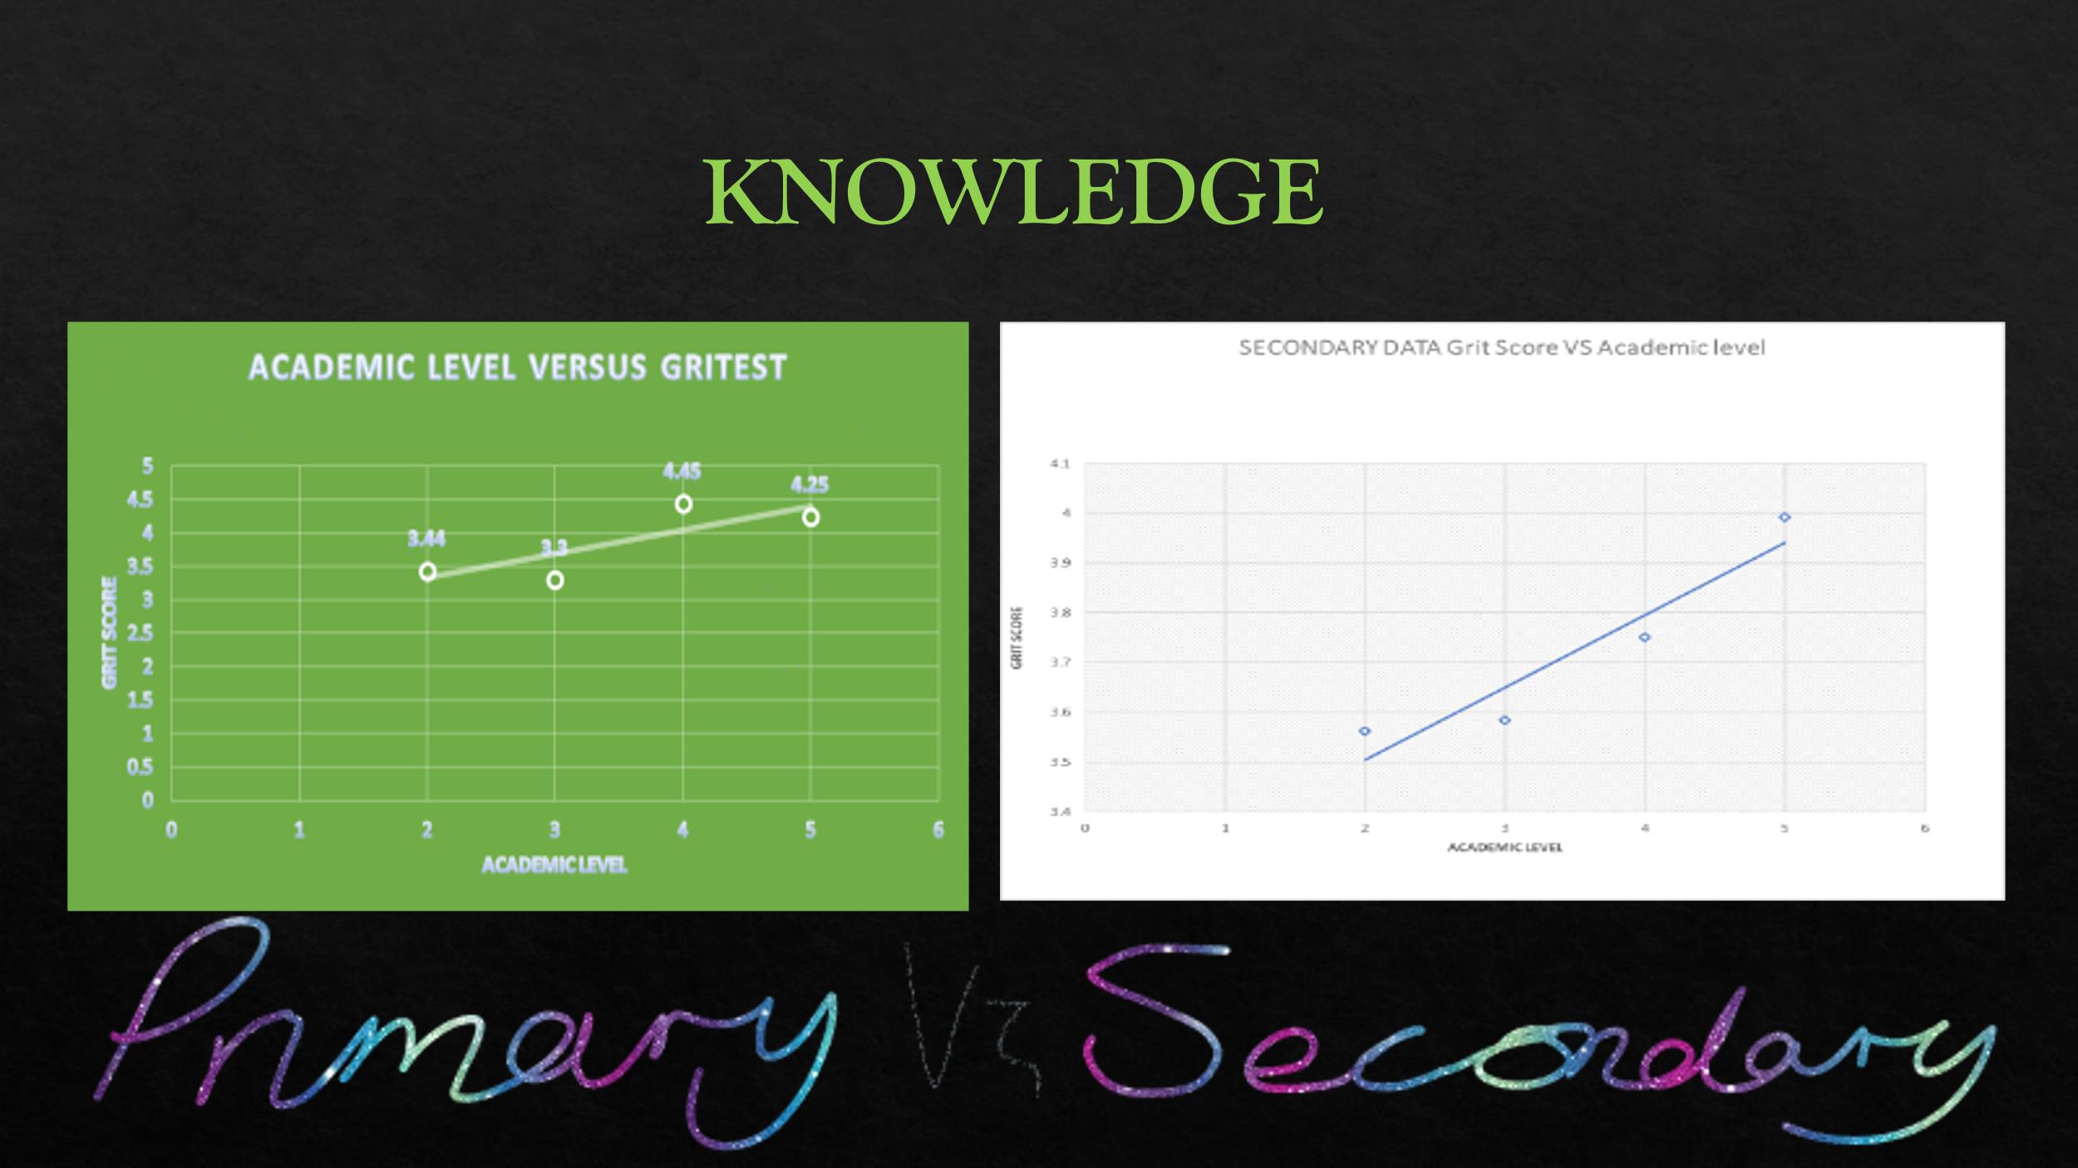
Angela mentioned that the higher your grits score, the higher your chances of success. As a result, I was even more determined to incorporate the DIKW stage into my assignment. I needed to turn my information into knowledge to prove her theory, so I took my own data from primary sources, as shown on the left, and formulated another chart on the right based on school-collected data. It is the secondary data I am using for my analysis. In the left axis, the axes tiles are labelled as grit scores, whereas the bottom axis is titled Academic Level. From what I can see, there are a few similarities between the two charts. By using these charts, you can easily determine that trendlines show an inclination. This is the type of evidence I am seeking. Academic achievement increases as grit increases. On my primary chart, my results do suggest that Angela's theory might not be entirely accurate since the Academic level score does appear to drop to 4.25 form 4.45 so that would show as a slight decline. But as I had mentioned in my attempts of collecting the information for this I had asked a lot less people that she did for her several thousands for the use of her work.
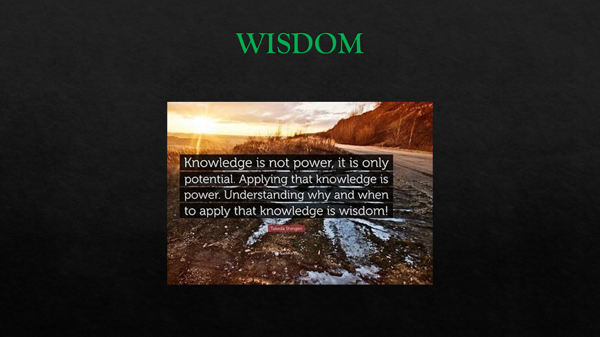
By using DIKW theory I have concluded that Angela’s does pass the CRAAP test because She is credible as she has Millions of views by people on her Ted Talks lecture and her book has been published many times, her work is relevant and up to date as people can still use her grit survey online. She has authorities that have printed her information as she is a psychologist. I wouldn’t say that her work is 100 accurate as I have ended up with a default on results. On my primary chart, my results do suggest that Angela's theory might not be entirely accurate since the Academic level score does appear to drop to 4.25 form 4.45 so that would show as a slight decline. But as I had mentioned in my attempts of collecting the information for this, I had asked a lot less people than she did for her several thousand for the use of her work. I didn’t think the Purpose of her work was to gain anything although she has best seller books, she still shares her research worldwide. Her thesis of her work does somewhat deem as accurate, but I do know from trying my own experiments, from my class to the previous year work is there was at least 100 people more asked to participate. This can throw off results. so, it’s just a trial and error. Angela mentioned that she doesn’t know how to fully build grit, but she claims that the best idea she has heard about building grit is by a lady named Carol Dweck.
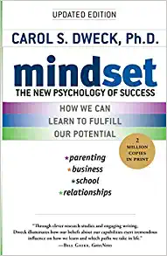
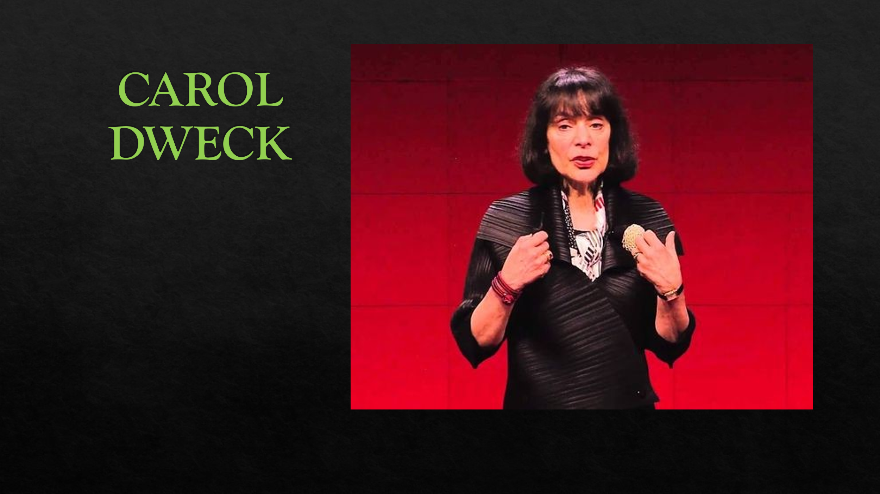
Carol Dweck from Stanford University, studies more on the mindset and attitude about failure. She loved the phrase “not yet” which I had thought that was fantastic. You think, I'm nothing, I'm nowhere, if you get a failing grade. Then you realize that you are on a learning curve if you get a grade of "Not Yet.". Getting a Not Yet gives you a direction to follow. (Dweck, 2021) Dweck's theory of Mindset Carol Dweck offers a theory of Mindset. People can be classified into either Fixed or Growth Mindset states. People that possess a growth Mindset rise to challenges and learn from feedback on their mistakes. People's Mindsets can be changed, and it is possible to support people in the transition to a growth Mindset. Dweck’s research has allowed her to distinguish two perspectives that people hold about their abilities (with approximately 15% undecided). Different mindsets can be applied to different aspects of our lives. For example, we can have a fixed mindset with respect to our ability to do maths, but a growth mindset with respect to our ability to play tennis. A fixed mindset intelligence is a fixed mindset so, in summary, challenges are avoided because failure suggests that they are lacking in intelligence. When people don't understand, they are led to believe that effort is pointless. It is frustrating to receive negative feedback when you do things wrong. However, growth mindset intelligence can be developed. It is believed that challenges will help to improve performance. Effort therefore is seen as worthwhile- a path to mastery. Getting things wrong and receiving feedback is positive- it guides further improvement (Dweck's theory of Mindset, 2021)
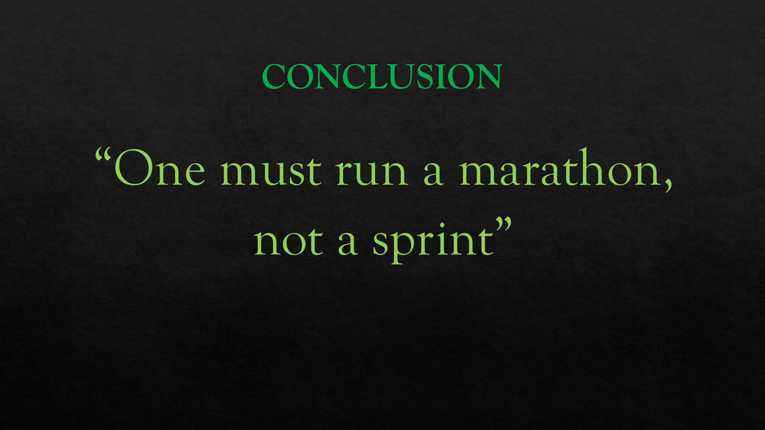
One must run a marathon, not a sprint, in order to reach one's full potential. I've gone from knowing nothing to ending up finding this experiment quite interesting. I had some experience using Microsoft Excel. I knew how to create charts and use formulas, but I was unclear about how to change numbers around so easily. Angela Duckworth's theory was such a great opportunity for me, and I look forward to using it in the future. As a measure of our work towards becoming grittier, I think this is a good measure to anticipate or test. We could make grit better by praising the process of learning, and according to Dweck, when we push people outside of their comfort zone, the neurons in their brain form stronger connections. This is helpful and true, and I believe it to be the case. Due to this, I believe people should be encouraged to apply grit to their studies as well as to their everyday lives to avoid giving up. I have learned what Angela did, which was to investigate people as well as companies for more information about grit. I feel I have become very familiar with Angela now.


CRAAP Test. 2021. The CRAAP Test « Evaluating Sources Easily. [online] Available at: <https://craaptest.net/> [Accessed 1 December 2021].
Duckworth, A., 2021. Angela Lee Duckworth | Speaker | TED. [online] Ted.com. Available at: <https://www.ted.com/speakers/angela_lee_duckworth> [Accessed 1 December 2021].
Dweck, C., 2021. Transcript of "The power of believing that you can improve". [online] Ted.com. Available at: <https://www.ted.com/talks/carol_dweck_the_power_of_believing_that_you_can_improve/transcript> [Accessed 5 December 2021].
INFORMS. 2021. Ackoff, Russell L. [online] Available at: <https://www.informs.org/Explore/History-of-O.R.-Excellence/Biographical-Profiles/Ackoff-Russell-L> [Accessed 5 December 2021].
Journals.lib.washington.edu. 2021. [online] Available at: <https://journals.lib.washington.edu/index.php/nasko/article/viewFile/12806/11288#:~:text=Ackoff%20was%20a%20management%20consultant%20and%20former%20professor,short%29%20was%20first%20given%20in%201988%20as%20a> [Accessed 2 December 2021
Kollar, c., Mbense, Z., Bentley, R., patel, S., avery, A., Long, C., Winthorpe, g., Solomon, k., Debi, N., Debi, N., Singleton, V., Toplikar, D., Foshee, S., ugwu, c. and Zen, M., 2021. What is Grit? [online] GoStrengths! Available at: <https://gostrengths.com/what-is-grit/> [Accessed 1 December 2021]
Teachit.so. 2021. Dweck's theory of Mindset. [online] Available at: <https://teachit.so/mindset.htm#:~:text=Dweck%27s%20theory%20of%20Mindset%20Carol%20Dweck%20offers%20a,people%20in%20the%20transition%20to%20a%20growth%20Mindset.> [Accessed 5 December 2021].

