

Project Management and Research Methods

Managing a Hardware/Software Project Integrated with Enterprise and Innovation Group Project

Elliot Barnett
1801749
BSc Computer Networks and Security

Table of contents

Contents
1. Background 3
2. Objectives 3
3. Scope 3
4. Constraints 4
5. Authority 4
5.1. Project Sponsor 4
5.2. Project Manager 4
5.3. Project Organization Structure 6
6. Resources 6
References 7

Background
My group and I came up with the idea of enhancing the current ‘Medical Wristband’. The current wristband only contains key information engraved on a piece of metal on the inside of the wristband. With technology advancing, we are able to give the wristband more features and potentially remaking it into a digital wristband. In this project initiation document, I will include all the features that are going to be added to the wristband to make it easier to use and efficient.

Objectives
The overall objective of this project is to create a smart medical wristband that would aid people within the community. Below are objectives that lead to the overall objective:
- Re-design the bracelet to the user's preference (colours).
- Add chip into the bracelet that stores further information on the person wearing the wristband.
- Have a symbol that can be recognisable as a medical band.
- Make sure that the wristband is made from a durable material.

Scope
- The wristband will have a chip that stores critical data on the user.
- The chip must be readable by a chip reader.
- There will not be a visual interface on the wristband.
- The wristband will be designed to be durable and comfortable on the wrist.
- The GPS system will be implemented later down the line and will be a future feature on the wristband.

Constraints
There are a couple of constraints that we will need to take into consideration, these include.
- The time that it takes to build a prototype might be affected due to the lack of knowledge in certain areas.
- The budget might also be affected by the type of battery power that is used.
- The risk of not completing the product on time will affect the relationships we would have with customers and external stakeholders [1].
- External constraints need to be managed. We would manage these constraints by creating a "PEST" analysis. This would cover Political factors, Economic Factors, Social Factors, and Technological factors. [2].
- Lastly, the use of a feasibility study will help gather more information on different external variables that need to be managed and not controlled. This would help the project not be at much of a risk when the product enters the market [3].

Authority

Project Sponsor
The main project sponsor for the project is the people running the project. These people will have the authority to change and control different aspects of the project, they would also have control of all the internal and external components of the project [4].

Project Manager
The Project Manager is Kaylie Shoulder, she would be responsible for planning different meetings and group talks. She would set up meetings with any external stakeholders that may support the project. Kaylie Organises the team’s different roles and makes sure that the team is motivated to do the work ahead. Kaylie would also work closely with the marketing department (Elliot Barnett) on making amendments and estimations of finances within the project. Kaylie would also make sure that everyone is sticking to a timetable or Gantt chart, this would prevent any delays within the project because of certain tasks depending on other tasks being completed. Kaylie would lastly make sure that the customer feels supported and happy with our project and would amend and inform the team of any unsatisfactory reviews for the team to work on [5].
Below is a screenshot of the current Gannt chart and Network Diagram:
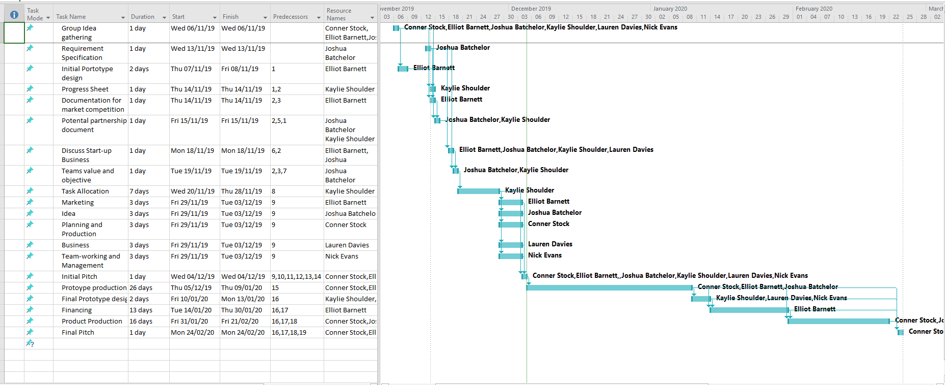
The Gannt chart above shows all current tasks that are completed and need to be completed. All tasks depend on at least one other task to be completed.
Below is a network diagram. The tasks that are coloured in red show the critical path. The diagram shows an in-depth analysis on what tasks depend on the other tasks.
Part 1
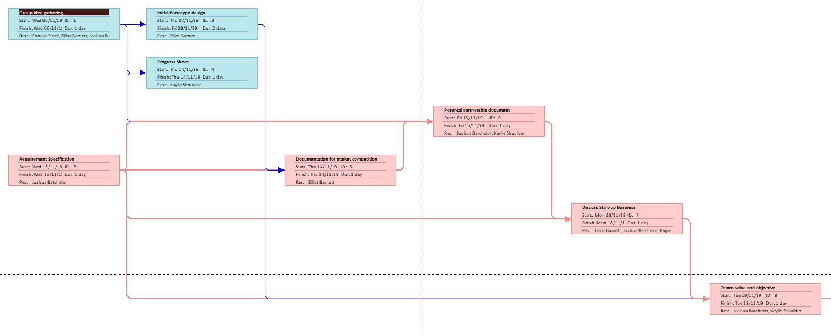

Part 2
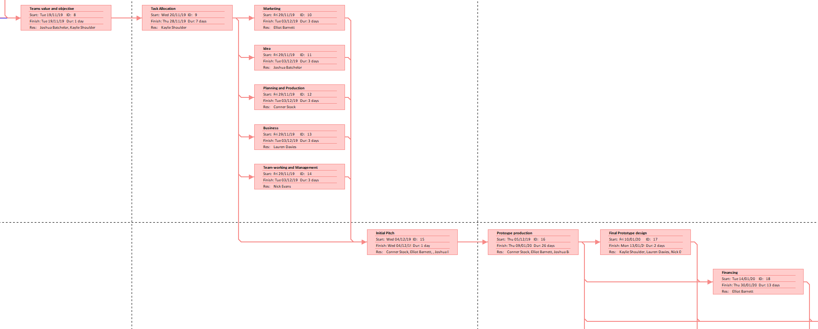
Part 3
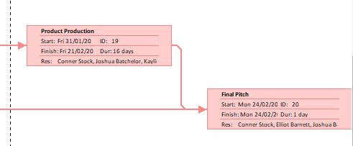

Project Organization Structure
Below is a structured chart showing the different lines of authority:
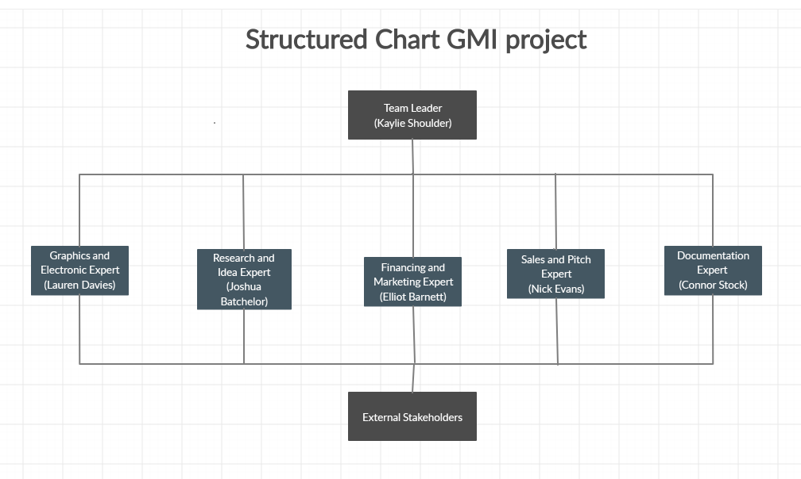

Resources
Resources required are listed below:
- Project stakeholders include all the team running the project. The team is Kaylie (Team Leader), Lauren (Graphics and electronics), Elliot (Finance and Marketing), Nick (Sales and pitch), Joshua (Research and idea) and Connor (Documentation).
- Equipment needed includes a Programmable chip, Wristband made from durable materials and a label to go on the wristband.
- Software needed: - Visual Studio.

References

[1] | M. Benz, “Project Manager,” 5 July 2018. [Online]. Available: https://www.projectmanager.com/blog/10-project-constraints-that-endanger-your-projects-success.
[2] | “Visual Paradigm,” [Online]. Available: https://www.visual-paradigm.com/guide/strategic-analysis/what-is-pest-analysis/.
[3] | W. Kenton, “Feasibility Study,” Investopeida, 11 August 2019. [Online]. Available: https://www.investopedia.com/terms/f/feasibility-study.asp.
[4] | W. Malsam, “What Is a Project Sponsor?,” Project Manager, 27 August 2019. [Online]. Available: https://www.projectmanager.com/blog/what-is-a-project-sponsor.
[5] | M. Mrsic, “Project manager roles and responsibilities,” ActiveCollab, 2017.

