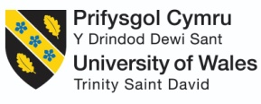

ASSESSMENT 2 (LCMB7000)

HUMAN RESOURCE MANAGEMENT

Programme name: MBA (Master of Business Administration)
Lecturer name: Dr. Gladius Kulothungan
Student name: Ghanchi Kinjal Arjunkumar
Student id: 2124033
Executive Summary
This report is based on different strategies of human resource management and their advantages and benefits. This report has not only provided benefits of different strategies but also provided theoretical underpinning. Existing human resource theories have helped organisations to achieve their mission and goal and with the help of these theories organisational behaviour and organisational structure can be created. Microsoft is a global company that deals with different technological products and due to this, the company needs to adopt different human resource policies such as change management, leadership development and HR effectiveness measurement to understand the efficiency of their HR department. It has also been observed that to boost the revenue of a company, companies need to adopt measures related to human resources.

Table of Contents
Introduction 4
1. Outline detailed and appropriate Human Resource Strategies you would develop and deploy in any three areas out of seven listed below 4
Change management 4
HR effectiveness measurement 5
Leadership development 6
2. Demonstrate how your chosen strategies will make your team members valued, appreciated, and develop a sense of belonging to your organisation. 7
Change management 7
HR effectiveness measurement 8
Leadership development 9
3. Your discussion must demonstrate a critical appreciation of principles, models and concepts of current HRM and IHRM theories. This will be demonstrated through significant use of academic references from appropriate sources 9
Conclusion 11
References 12
Appendix: Role of HRM 14

Introduction
Human resource management is a department of an organisation that regulates, controls, and handles all particulars of employees. It has different functions in an organisation such as recruitment procedure, resource planning, compensating, training, orienting, retaining and many more. In matters of competence and commitment, human resource management has transferred the organisational structure of an organisation. In this report, the human resource management of "Microsoft '' will be discussed and it will focus on change management, leadership development and human resource effectiveness management. Apart from this, in this report, different benefits and advantages of HRM have been constructed and different theories and models have been observed for critical understanding.

1. Outline detailed and appropriate Human Resource Strategies you would develop and deploy in any three areas out of seven listed below

Change management
Change management is a process in which the business environment of an organisation can be changed. It can be possible with help of resources, application of change and tools and in this regard, human resource teams have adopted different corporate strategies, technologies and procedures to regulate the external conditions of an organisation. As per the research paper of Jayatilleke and Lai, (2018), change management in matters of technology and software development, is the management of maintenance process, engineering process and system development. Different factors must be implemented in an organisation to provide a better organisational structure. In the case of Microsoft, different areas have been observed that need to be changed by human resource management. First, change in the “external market” and in case any uncertain event has taken place in the field of stakeholders such as customers, competitors, government bodies and other shareholders, then human resource management needs to focus on different areas to manage its organisation. In the matter of Microsoft, change in consumers' needs with the development of technology and an unstable market are key areas that must be focused on by the organisational team.
On the other hand, a change in “requirement specification” in matters of any unnatural events of an organisation needs to be improved for the betterment of the organisation. Misunderstanding and miscommunication must be reduced in internal and external matters of the company and a change in understanding of consumer behaviour needs to be adopted by HRM also. Apart from this change in “Solution” is also required and a solution in consumer's requirements and change in techniques can remove redundancy in the organisation. A company needs to focus on design improvement and the introduction of new technology and tools.
With the help of the “agile method”, change management of an organisation can be possible and change management requires different particulars such as face to face communication, code factoring, requirement prioritisation, customer involvement and interaction. With help of these particulars and the agile model, software development of Microsoft can be possible.

HR effectiveness measurement
As per the research paper of Boon et al. (2019), human resource effectiveness is a process of measurement and it is a measurement of organisational development and different activities of the human resource department. Different methods can help to improve human resource effectiveness and the first method is organisational communication. Human resource teams need to focus on organisational communication and the "waterfall approach" can be used by organisational senior management to make the effective communication.
On the other hand, as per the opinion of Madhani, (2020), the six-sigma model can help the human resource teams to monitor organisational performance and by measuring performance, different problems of the organisation can be removed. In the six-sigma model, control is the most important thing and, in this regard, the HR department can control human resources and with the help of a plan, action plan and document, different organisational procedures can be managed by the department.
Apart from this, the next rule is to measure and, in this aspect, the HR department can measure the current capabilities of the organisation and this department can measure costs, services, and efficiency. With the help of another method, HR effectiveness can be improved and that is providing and getting regular feedback. Feedback is the process in which both the employees and the HR department can be motivated and feedback helps an employee to increase their performance. On the other hand, feedback helps the HR department to boost its effectiveness. There are different ways that the HR department can get feedback from their employees and senior managers such as surveys, face to face interviews, team meetings and focus groups.
As per the research paper of AlZgoolet al. (2020), in the era of modernisation, organisations face different pressures and difficulties while managing their structural development and for that, an organisation needs to focus on HR effectiveness. Without the appropriate effectiveness of the HR department, an organisation cannot manage its employee's performance and the HR department must focus on the effectiveness of employees via providing different rewards and benefits that can help employees to boost their performance. On the other hand, another method is data analysis can help HR depart to improve their effectiveness. In the matter of Microsoft, the HR department has adopted these techniques to improve its effectiveness. Data analysis is a process in which the HR department needs to construct a user matrix and to find out different problems in the organisation with this technique, this department can manage their performance and regulate employee culture.

Leadership development
Leadership development is another strategy of human resource management and with the help of a leadership development organisation, performance can be increased. Leadership is a process in which individuals provide direction, influence groups or society and help to achieve any goal or mission. In the matter of an organisation, leadership development is required and that can promote organisational structure in a significant way. Leadership developed in the human resource department helps the department to motivate or influence organisations or employees. It helps the department to work with integrity and honesty and due to this organisational growth can be possible adequately.
As per the opinion of Edmonstoneet al. (2019), some different challenges and difficulties have been observed while adapting leadership skills in an organisation and these challenges are creating obstacles to reaching their goals. Lack of resources is the first challenge while developing leadership and it includes time and funding. Without appropriate time and funding an organisation cannot develop a leadership style however, in the case of Microsoft, these problems have not created any obstacles. Microsoft is a multinational technology company and due to this, this company has adequate resources to use in leadership development in this matter with appropriate training and education, leadership development of this company can be possible.
In this report, the leadership development of Microsoft can be possible with the help of top management support. This is another challenge of leadership development; top management has not provided any support to inhuman resource management to adopt any strategy to develop leadership skills. On the other hand, the administrative system and lack of learning have created another obstacle and, in this matter, Microsoft needs to focus on learning and education by providing this organisational performance can also be increased.
Change management | “External market”  “Requirement specification”  “Solution”  “Agile method”,
HR effectiveness measurement | "Waterfall approach" and “Six-sigma model’
Leadership development | Organisational development  Company’s mission and vision  Direction and influence group
Table 1: Human resource strategies
(Source: Self-developed)

2. Demonstrate how your chosen strategies will make your team members valued, appreciated, and develop a sense of belonging to your organisation.
In this report, three strategies have been chosen to provide a better understanding of human resource strategies and in this part, these strategies have helped the team members to increase their performance.

Figure 1: Human resources
(Source: Marketing91.com, 2022)

Change management
Change management is a human resource strategy and, in this matter, this strategy has helped team members to feel valued and appreciated. In Microsoft Company, change management has helped in a significant way to boost organisational performance and change management also focuses on employees' beliefs and values. In this way, this strategy can provide a better workplace environment and motivation to the employees of Microsoft. Change management in the matter of solution has provided another motivation to their employees and employees can use new technologies and development and this can help them to become more innovative and productive.
The main mission of this company is to empower others and with this initiative, Microsoft can develop different particulars to motivate their employees and the company with the help of change management can focus on the project vision (Microsoft.com, 2022). In project vision, the company has always focused on opportunities and challenges while regulating their business in the market and the product of the company has always focused on the customer's segment. Due to this approach, Microsoft has given the freedom to their employees and no complaints have been registered in the matter of workplace pressure or misbehaviour. For this, the company has adopted different measurements and all of these measurements have been adopted appropriately.

HR effectiveness measurement
This human resource strategy has helped team members or workers of Microsoft in different ways. HR effectiveness measurement is a process of measuring the performance of the HR department through different kinds of procedures. The first method is conducting a meeting or interview to provide feedback about their effectiveness and in this regard, the employees can provide feedback about the performance of their HR and this can help the employees and the HR department to communicate properly. Another approach that has been adopted in this regard is measuring and control of HR effectiveness. Measurement is how the HR department can measure different things that are related to employee's performance and different data of the organisation and with the help of this approach employee can be motivated about their work and the reason behind this is that employee's performance and rating of their work can be provided to them.
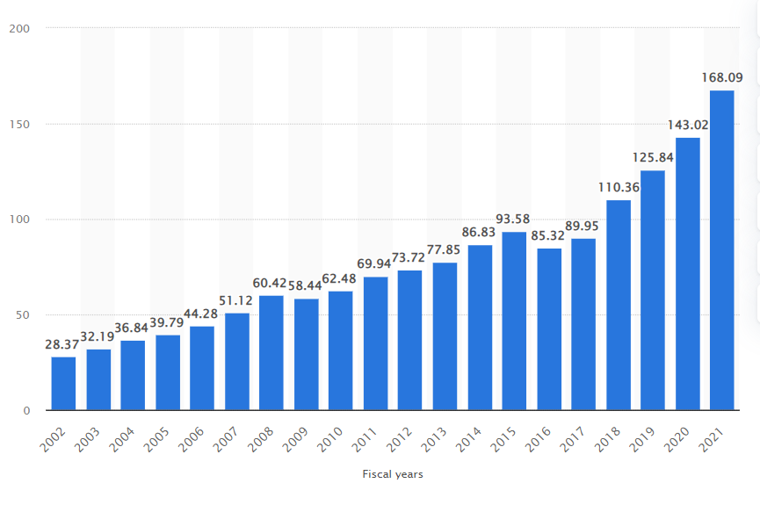
Figure 2: Microsoft's annual revenue worldwide from FY 2002 to FY 2021
(Source: Statista.com, 2022)
Figure 1 shows the annual revenue of this company and it shows that the revenue has been increasing day by day (Statista.com, 2022). This can be possible with the appropriate effectiveness of the HR department and the organisational performance. The company has done measurements of HR effectiveness and due to this; employees of the company are performing well and without any difficulties.

Leadership development
It is another strategy that has helped employees of an organisation to work with motivation and efficiency. In this report, leadership development in the organisation has helped in developing organisational structure. As per the research paper of Paais and Pattiruhu, (2020), appropriate leadership skills can help employees to work with motivation and with self-efficacy and in this regard, freedom and autonomy to their employees can also boost organisational performance.
In this report, the leadership development and communication with their employees have provided more value to their employees and for this approach, the organisational goal and mission can be achieved adequately. On the other hand, job satisfaction is an important part of the employees and in this respect, leadership skills and techniques can provide job satisfaction to their employees. In this regard, without job satisfaction, employees cannot work properly and the reason behind this improper workplace environment and misbehaviour on the behalf of the top management department. However, in the case of Microsoft, job satisfaction is higher than in other organisations and this can be possible with appropriate leadership quality.
On the other hand, as per the research paper of Han et al. (2019), responsible leadership in an organisation can help the employees to engage in organisational behaviour. The author has also created a relationship between external motivation and responsible leadership. Responsible leadership not only provides internal motivation but also provides external motivation. External motivation means employee behaviour outside the workplace and the actions that the individual must take to boat organisational structure.

3. Your discussion must demonstrate a critical appreciation of principles, models and concepts of current HRM and IHRM theories. This will be demonstrated through significant use of academic references from appropriate sources
Some different theories and models have helped human resource management to deliver positive outcomes. As per the research paper of Mayrhofer et al. (2019), there are two different types of theories that are incorporating human resource management and the theories are “cultural theory” and “Institutional theory”. In cultural theory, human resource management needs to focus on the cultural differences that must be removed from the organisation and this can be possible with effective communication. On the other hand, in “Institutional theory”, HR must recruit those candidates who do not have any cultural differences and laws and regulations that come under this theory have been implemented for control of employees.
In the opinion of Guest et al. (2021), “Signalling theory” is an approach that has helped in the matter of human resource management process and with the help of theory; the HR department can identify its strengths and weaknesses. In this theory, signallers are the initial management of an organisation that are executives and managers and signals are the information that has been observed in the organisation. In the critical analysis of this theory, it has been observed that in management research, this theory has helped in a significant way. In contrast to institutional theory, signalling theory is slightly different and in this regard, the institutional theory reduces the gap between employers and employees and also between workers and in signalling theory organisational strengths and weaknesses have been observed.
As per the research paper of Hewett et al. (2018), “attribution theory” helps the organisation to understand human behaviour and this can help in boosting organisational performance. Attribution theory has three procedures in the first stage, the behaviour of an individual must be observed and in the second stage, measurement of the behaviour must be considered. On the other hand, in the third stage, the observer must categorise such behaviour as external and internal affairs.
On the other hand, in the opinion of Soltis et al. (2018), “social network theory” is helpful for an organisation and it includes organisational behaviour, integration, organisational theory and strategic management. In contrast to attribution theory, this theory is different in this theory; employees' competencies have been included. However, in attribution theory, overall organisational performance has included and included managemental research.
As per the research paper of Harney and Alkhalaf, (2021), in the matter of organisational consistency “contingency theory” has helped HR departments to become consistent in organisational aspects and external aspects. In contrast to that “Organisational theory” has helped in the process of HRM activities and in this regard, the behaviour of the individual is an important aspect and due to these organisational goals can be achieved adequately.
[Refer to appendix]

Figure 3: Critical analysis of theories
(Source: Self-developed)

Conclusion
In conclusion, it can be stated that human resource management is a process in that organisational behaviour can be boosted and an appropriate organisational structure can be created. In this report, three HRM strategies have been observed that have helped the organisation in the matter of enhancing the performance of the employees. On the other hand, in the technological industry, a company needs to adopt a change management strategy that can help them to boost employee performance and to identify consumers' interests. Change management, leadership development and HR effectiveness measurement have helped workers and team members to work efficiently and with motivation. Along with this, strategies have helped employees to achieve self-motivation and self-efficacy. Apart from these different theories such as organisational theory, signalling theory, and social network theory have helped the HRM department and organisation to build the organisational structure. From this report, it has been observed that different theories can be beneficial for an organisation and an organisation needs to adopt different theories in its work to achieve its mission and goal adequately.

References
AlZgool, M.R.H., Ahmed, U., Shah, S.A., AlMaamary, Q. and AlMahmoud, N., 2020. EXAMINING THE INTERPLAY OF HR INITIATIVES, KNOWLEDGE MANAGEMENT, TECHNOLOGICAL CAPABILITIES AND PRODUCT INNOVATION. Journal of Security & Sustainability Issues, 10(2).
Boon, C., Den Hartog, D.N. and Lepak, D.P., 2019. A systematic review of human resource management systems and their measurement. Journal of management, 45(6), pp.2498-2537.
Edmonstone, J., Lawless, A. and Pedler, M., 2019. Leadership development, wicked problems and action learning: provocations to a debate. Action Learning: research and practice, 16(1), pp.37-51.
Guest, D.E., Sanders, K., Rodrigues, R. and Oliveira, T., 2021. Signalling theory as a framework for analysing human resource management processes and integrating human resource attribution theories: A conceptual analysis and empirical exploration. Human Resource Management Journal, 31(3), pp.796-818.
Han, Z., Wang, Q. and Yan, X., 2019. How responsible leadership motivates employees to engage in organizational citizenship behavior for the environment: A double-mediation model. Sustainability, 11(3), p.605.
Harney, B. and Alkhalaf, H., 2021. A quarter‐century review of HRM in small and medium‐sized enterprises: Capturing what we know, exploring where we need to go. Human Resource Management, 60(1), pp.5-29.
Hewett, R., Shantz, A., Mundy, J. and Alfes, K., 2018. Attribution theories in human resource management research: A review and research agenda. The International Journal of Human Resource Management, 29(1), pp.87-126.
Jayatilleke, S. and Lai, R., 2018. A systematic review of requirements change management. Information and Software Technology, 93, pp.163-185.
Madhani, P.M., 2020. Enhancing HR competitiveness: a Six Sigma approach. WorldatWork Journal, 27(2), pp.30-37.
Mayrhofer, W., Gooderham, P.N. and Brewster, C., 2019. Context and HRM: theory, evidence, and proposals. International Studies of Management & Organization, 49(4), pp.355-371.
Microsoft.com (2022). Empowering others. Available from https://www.microsoft.com/en-us/about. Accessed on 07.04.2022.
Paais, M. and Pattiruhu, J.R., 2020. Effect of motivation, leadership, and organizational culture on satisfaction and employee performance. The Journal of Asian Finance, Economics, and Business, 7(8), pp.577-588.
Soltis, S.M., Brass, D.J. and Lepak, D.P., 2018. Social resource management: Integrating social network theory and human resource management. Academy of Management Annals, 12(2), pp.537-573.
Statista.com (2022). Microsoft's annual revenue worldwide from FY 2002 to FY 2021. Available from https://www.statista.com/statistics/267805/microsofts-global-revenue-since-2002/. Accessed on 07.04.2022.

Appendix: Role of HRM
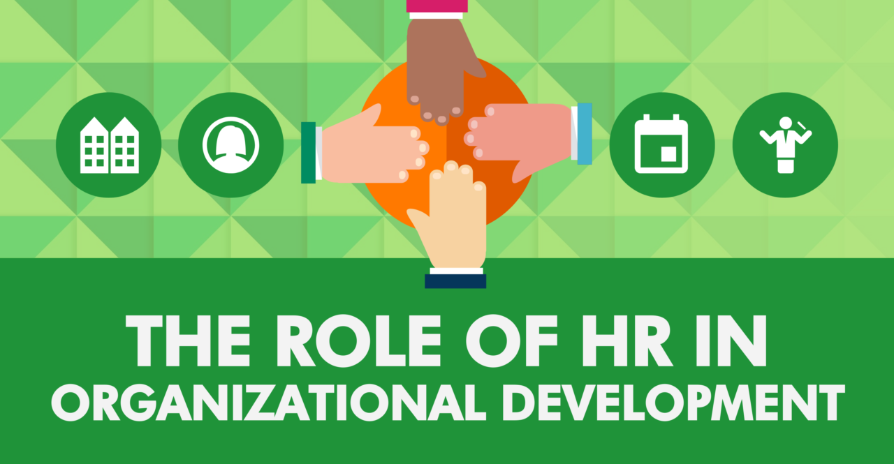
(Source: Sprigghr.com, 2019)

