
INTRODUCTION TO HEALTH AND SOCIALCARE
LCHS4003

Tutor: Mumtaz Goolam
20 feburary2026
Amina HASHMI 2508599

RESIDENTIAL CARE HOME
WHAT IS THE SERVICE.

Britian’s society has always worked on the mental, physical and social wellbeing of its citizens.
People have always looked out for each other with specific needs especially the vulnerable which include elderly and sick people.
No date Family Home Care www.familyinhomecare.com (date assessed 19 Feb2026)

Care homes provide great facilities for elderly, disabled and depending on adults who do not have the family support to look after them. Healthcare professionals including doctors, nurses and trained carers are working tirelessly to provide their best service to patients. This service has been established a long time ago.
The History of Care Homes in Britain
In early times the churches used to run alms houses. Some records show the first one was built in York in 936AD. Monastries also provided homes for elderly and sick people. But conditions were not that great then. During the early 20th century there was evidence that conditions were not great and changes needed to be made. In the end of World War 2 a lot of British veterans returned with physical and psychological disabilities. This led to the creation of NHS in 1948 redefining the state’s role in supporting vulnerable citizens.

Today’s care system has its roots in Britain’s social, political and economic history, dating back to the 10th century. The system evolved over hundreds of years, until sweeping changes occurred in the 18th and 19th centuries: new laws were introduced that paved the way for redefining elderly care in the 20th century. (23june2023) The History of Care Homes in Britain

history of the service

c.

  - FUNCTIONS OF THE SERVICE.
A great number of care homes have been established all over the country in public and private sector to provide facilities of elderly.
Social care is developing at a fast pace these days. How elderly people are looked after shows how our society is functioning. No date Care homes for the elderly: where are we now? care-homes-for-the-elderly-brochure-2025.pdf ( Date assessed 19Feb2026)
(Data from before the pandemic shows that:

• Less than 5% of care homes had more than 90% of residents being funded by councils.

Recent studies have shown that there is an increasing number of care homes in the United Kingdom. As of the week ending 14 July 2025, there were 350,077 residents in the 91.6% of total care home providers that responded. This included:
- 323,069 residents in the 91.5% of older adult care home providers that responded
- 27,008 residents in the 92.1% of younger adult care home providers that responded.
- Published 7Aug 2025 (Adult social care in England, monthly statistics: August 2025 - GOV.UK) Adult social care in England, monthly statistics: August 2025 - GOV.UK)

Unfortunately care homes are facing a lot of challenges. There is staff shortages and a lot of financial pressure on he admin staff of the care homes. Recruiting and training skilled staff members has been a long-term issue faced by the authorities.
Etelka Froymovich, RN, MHA April24,2023 Home Care Differences between Grooming and Hygiene Home Care Differences Between Grooming and Hygiene - Home Health Care Indianapolis by Home Services Unlimited assessed 19 Feb26 Indianapolis by Home Services Unlimited

In an executive summary carried out by Skills for Care, in 2024 the turnover rate of employed staff in the care sector was 24.2%, which equates to around 350,000 people leaving their roles. July 10,2025.
To resolve this issue the authorities should improve training strategies and improve career opportunities so that the staff feels more appreciated and acknowledged.
In addition to this care homes can liaise with other care home organizations or do partnership with them to develop their facilities for the elderly. July 10 2025 Top Challenges For Care homes That Aren’t Going Away. Top Challenges for Care Homes that Aren't Going Away | PKF SCS (date assessed 19Feb2026)
CHALLENGES
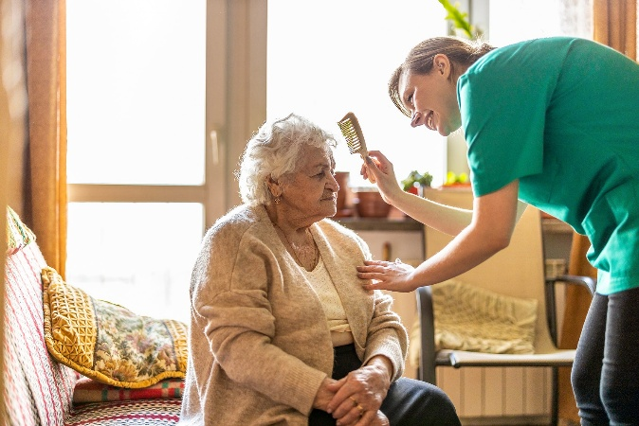

There are a lot of financial costs also involved to make improvements in the care home sector.
As compared to last year there is an extra cost of £3.4billion on the care business. Due to this a lot of care homes are under the pressure of closing or downsizing.
- 12June 2025 Local Government Spending Review Spending Review 2025: Briefing 12 June 2025 | Local Government Association (assessed 19Feb26)
- 

Part 2 Essay LHSC4003
Ambulance Service
Emergency Services in the United Kingdom provide urgent health care to patients who have an acute illness or injury. Emergency care includes Ambulance and Emergency department which is free to everyone for the time being. In an emergency patients call 999and ask for ambulance. In a non-emergency situation such as planned appointment and matters which do not need urgent care people are expected to make their own way to the emergency services. Some people who have mobility disabilities can apply for non-emergency patient transport services (PTS). These services provide free transport to and from hospital for people including:
- those whose condition means they need additional medical support during their journey
- those who find it difficult to walk
- parents or guardians of children who are being transported.15 May 2023 How to organise transport to and from hospital https://www.nhs.uk/How to organise transport to and from hospital - NHS (assessed:19Feb2026)

In 2017 the NHS developed a new system or a plan to provide high quality services to the most vulnerable patients. No date. NHS England » Ambulance available at NHS England » Ambulance (date assessed 19Feb2026)
The ambulance service is effective and works its best to give priority to people who need it the most according to their symptoms and the nature of emergency.
The ambulance service is a first point of contact for people in dire emergency. People depend on dialling 999 and expect a response from the paramedics to those patients who have a life-threatening emergency and respond to major incidents.2026/27 ambulance emergency and urgent care service specification available at PRN02107-26-27-ambulance-emergency-and-urgent-care-service-specification.docx (date assessed 19 Feb2026)
Paramedics are trained and skilled to primarily give advice over the phone or treat patients in
2026 Speak Up Review of Ambulance Trusts in England National Guardian’s Office report from February 2023 (date assessed 19Feb 2026) states that ambulance services face a lot of challenges in providing services. The paramedics are trained to act sympathetically and skilfully when dealing with people of different cultures. They have to consider the diversity and bear in mind that some things are considered offensive in some ethnicities while they are taken normal by others.
The ambulance service has improved a lot in recent years. Care Quality Commission (CQC) reports have reported empathy and consideration taken by the ambulance staff. Published 15Feb 2024 updated 16 June 2025 Culture review of ambulance trusts. NHS England » Culture review of ambulance trusts. (date assessed 19Feb 2026)
However, there is an increased number of challenges faced by the ambulance services. There are staffing issues, less funding and less workforce. The response time of the ambulance has also decreased. Statistics show that the ambulance service really struggled in winter times.
(In December, 35% of patients waited more than the 4-hour target in Accident and Emergency (A&E) departments, whilst 54,532 people waited longer than 12 hours, triple the operational standard, up 44% compared to November).( Fryer and Palazuelos May 2023) Urgent and emergency care and the threat to ambulance service Ambulance-Piece-vF-1.pdf (date assessed 19Feb2026)
There is an increase in sickness absence also, there should be enough workforce employed to cover for illnesses.
The West Midland Emergency Services play a vital role in community work.
There is around 7,500 staff members who are working tirelessly day and night to provide the best of their services to the vast community of West Midlands.
West Midlands Ambulance Service (WMAS) and the University of Staffordshire have strengthened a long-standing partnership reflecting a shared commitment to innovation, education and workforce development
All their efforts to continue with the collaboration of University of Wolverhampton have been very successful to enable WMAS to continue as university ambulance service.
Arrowsmith 28Jan26.WMAS and University of Staffordshire strengthen long -standing partnership .WMAS and University of Staffordshire strengthen partnership (date assessed 19 Feb 2026)

To conclude I would like to say that Ambulance services are avital part of our healthcare system. Their services are of great value to our community and people and members of our society should really appreciate their tireless efforts.

References
Arrowsmith 28Jan26.WMAS and University of Staffordshire strengthen long -standing partnership .WMAS and University of Staffordshire strengthen partnership (date assessed 19 Feb 2026)
Froymovich, RN, MHA Home Care Differences between Grooming and Hygiene,April24,2023 Home Care Differences Between Grooming and Hygiene - Home Health Care Indianapolis by Home Services Unlimited (assessed 19 Feb26 )Indianapolis by Home Services Unlimited
Fryer and Palazuelos May 2023) Urgent and emergency care and the threat to ambulance service Ambulance-Piece-vF-1.pdf (date assessed 19Feb2026)
Grant Thornton (2026) Care homes for elderly: where are we now? care-homes-for-the-elderly-brochure-2025.pdf
No date Family Home Care www.familyinhomecare.com(date assessed 19 Feb2026)
No date. NHS England » Ambulance available at NHS England » Ambulance (date assessed 19Feb2026)
Published 15Feb 2024 updated 16 June 2025 Culture review of ambulance trusts. NHS England » Culture review of ambulance trusts. (date assessed 19Feb 2026)
The History of Care Homes in Britain(23/06/23) https://www.gloveman.co.uk/news/the-historry-of-care-homes-in-britaindate( assessed 19 Feb26)
15 May 2023 How to organise transport to and from hospital https://www.nhs.uk/How to organise transport to and from hospital - NHS (assessed:19Feb2026)
12 June 2025 Local Government Assossication.Spending Review2025. :Spending Review 2025: Briefing 12 June 2025 | Local Government Association (assessed 19Feb2026)
July 10, 2025, Top Challenges For Care Homes That Aren’t Going Away. Top Challenges for Care Homes that Aren't Going Away | PKF SCS (date assessed 19Feb2026)
Aug2025 Adult social care in England, monthly statistics: August 2025 - GOV.UK

2026/27 ambulance emergency and urgent care service specification available at PRN02107-26-27-ambulance-emergency-and-urgent-care-service-specification.docx(date assessed 19 Feb2026)
2026 Speak Up Review of Ambulance Trusts in England National Guardian’s Office report from February 2023 (date assessed 19Feb 2026)

