Introduction to Web and Database Concepts – Database Analysis and Design

Author: Liam Aaron Jarvis (2000388)
Introduction to Web and Database Concepts (ACCA4023)
School of Applied Computing
Wales Institute of Science and ART
Date of Submission:

Table of Contents
Page
Introduction 3
Celtic Caterers 4
Context Diagram 5
Level 0 DFD 6
Documentation 7
Tables 7
User Guide and Forms 15
Queries 29
ERD (Entity Relationship Diagram) 32
Conclusion 34

Introduction
The aim of this report is to show my database design and analytic skills by creating a suitable database for Celtic Caterers, ensuring it meets the user requirements laid out in the specification. On top of this, I will also create both a context diagram and Level 0 DFD outlining data flow and processes the system will carry out and help with.

Celtic Caterers
Celtic Caterers are a successful catering business located in central Swansea. The supply catering services to local businesses/organisations. They have recently expanded and opened stores in Neath, Port Talbot, Llanelli, and Carmarthen. The business uses handwritten diaries to ensure delivery is coordinated correctly to events that they cater for, and accounts work through paper receipts to keep track of work in progress. This is a problem, as keeping on top of orders increases in difficulty as they become bigger in size. To solve this problem, Celtic Caterers want to upgrade their data processing provision and implement a database system. The user requirements of this database system are below:
- The user would like a system that will provide them with a designed invoice that they can view on screen or send to print.
- When purchases are made from the supplier, they would like to see a record of transactions recorded.
- When a catering event has been booked, they would like to be able to query information about it.

Context Diagram
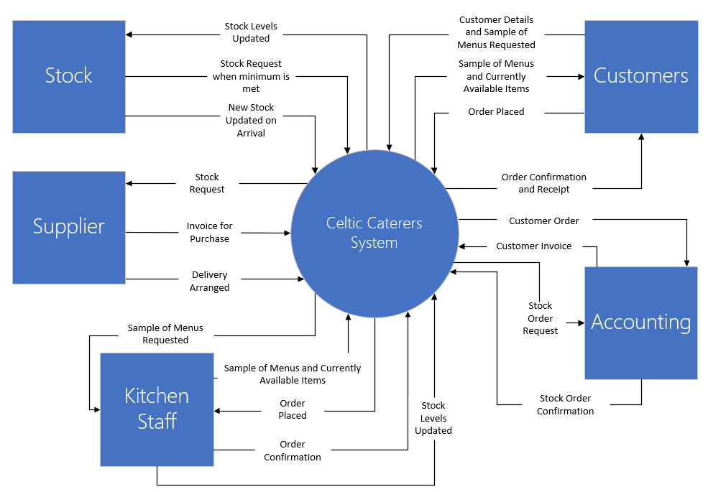
Context Diagrams are used “ to define and clarify the boundaries of the software system. It identifies the flows of information between the system and external entities. The entire software system is shown as a single process.” [1]. Below is the context diagram for the system I am implementing for Celtic Caterers:

Level 0 DFD
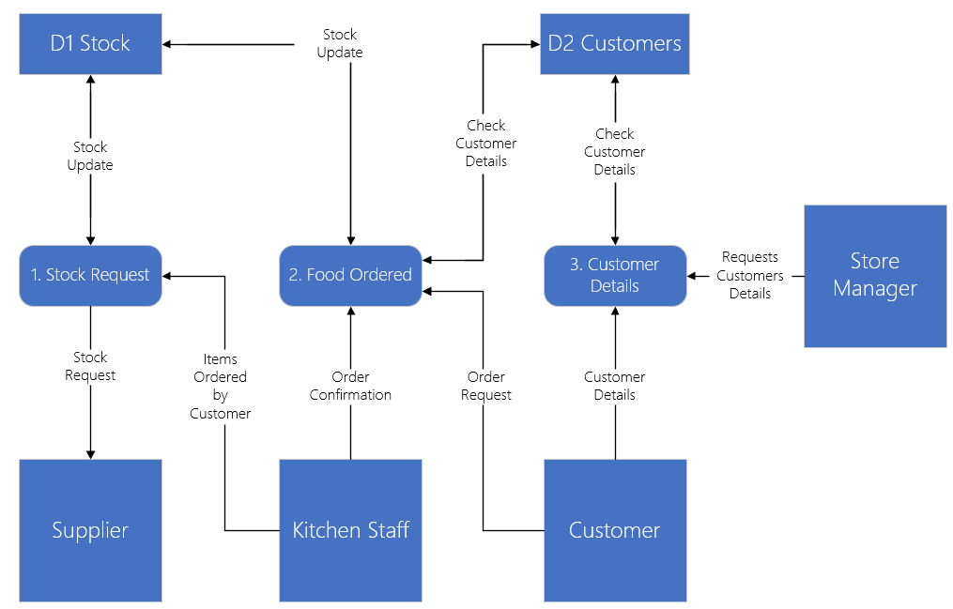
Context Diagrams and Level 0 DFDs in some literatures are used interchangeably, however in this circumstance a Level 0 DFD is diagram that shows multiple numbered processes symbolised with rounded rectangles, rather than the entire system being shown as a single process like a context diagram. Below is my Level 0 DFD for Celtic Caterers system:

Documentation

Tables
Firstly, I created the tables for the system. I made 7 tables for storing details for Customers, Staff, Orders, Bookings, Stock, Products and Supply. Below are each of them:
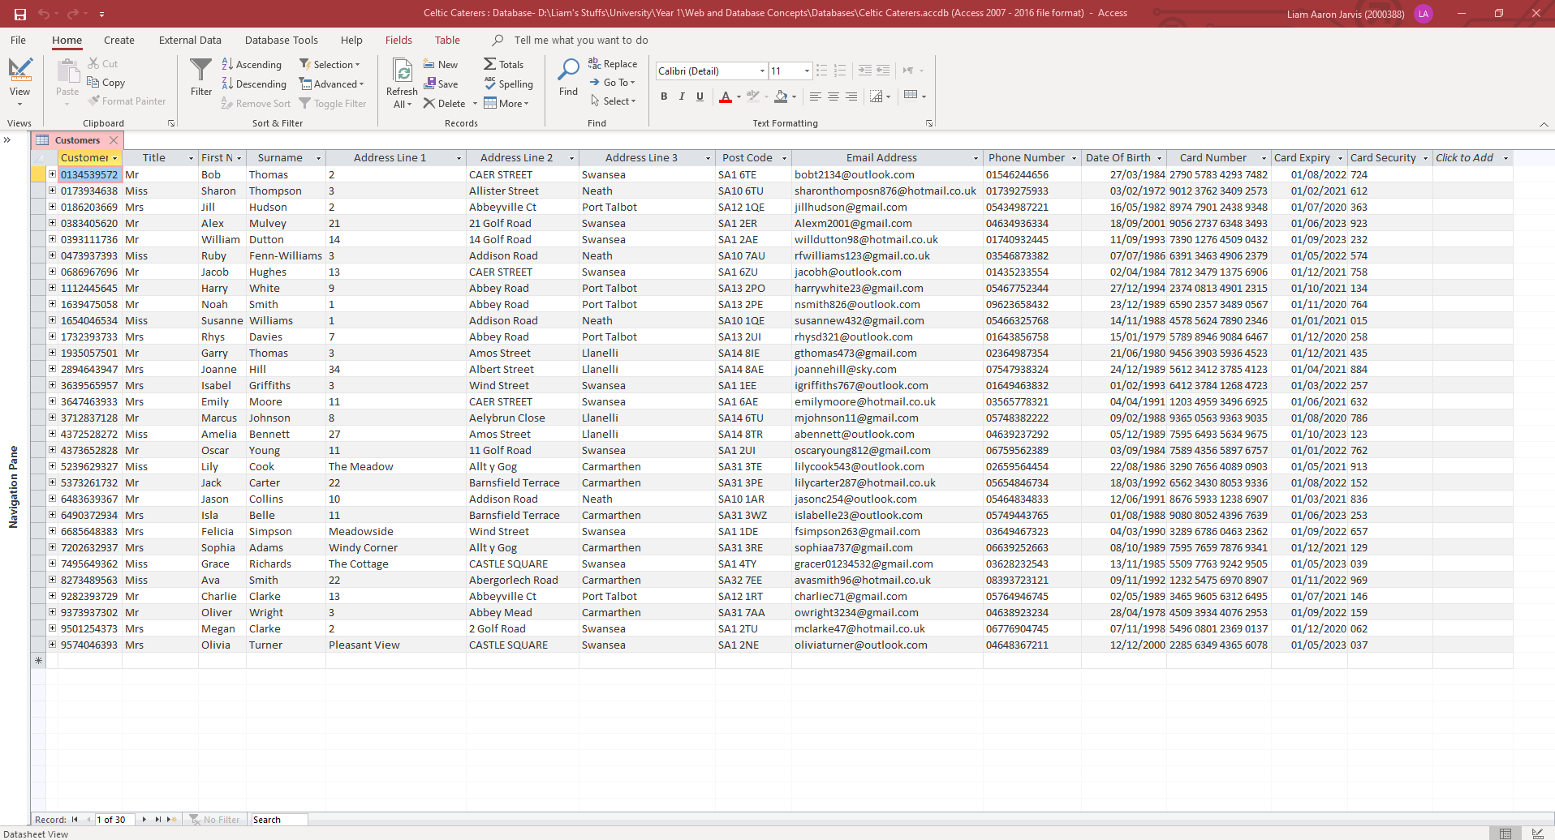
Customers Table:

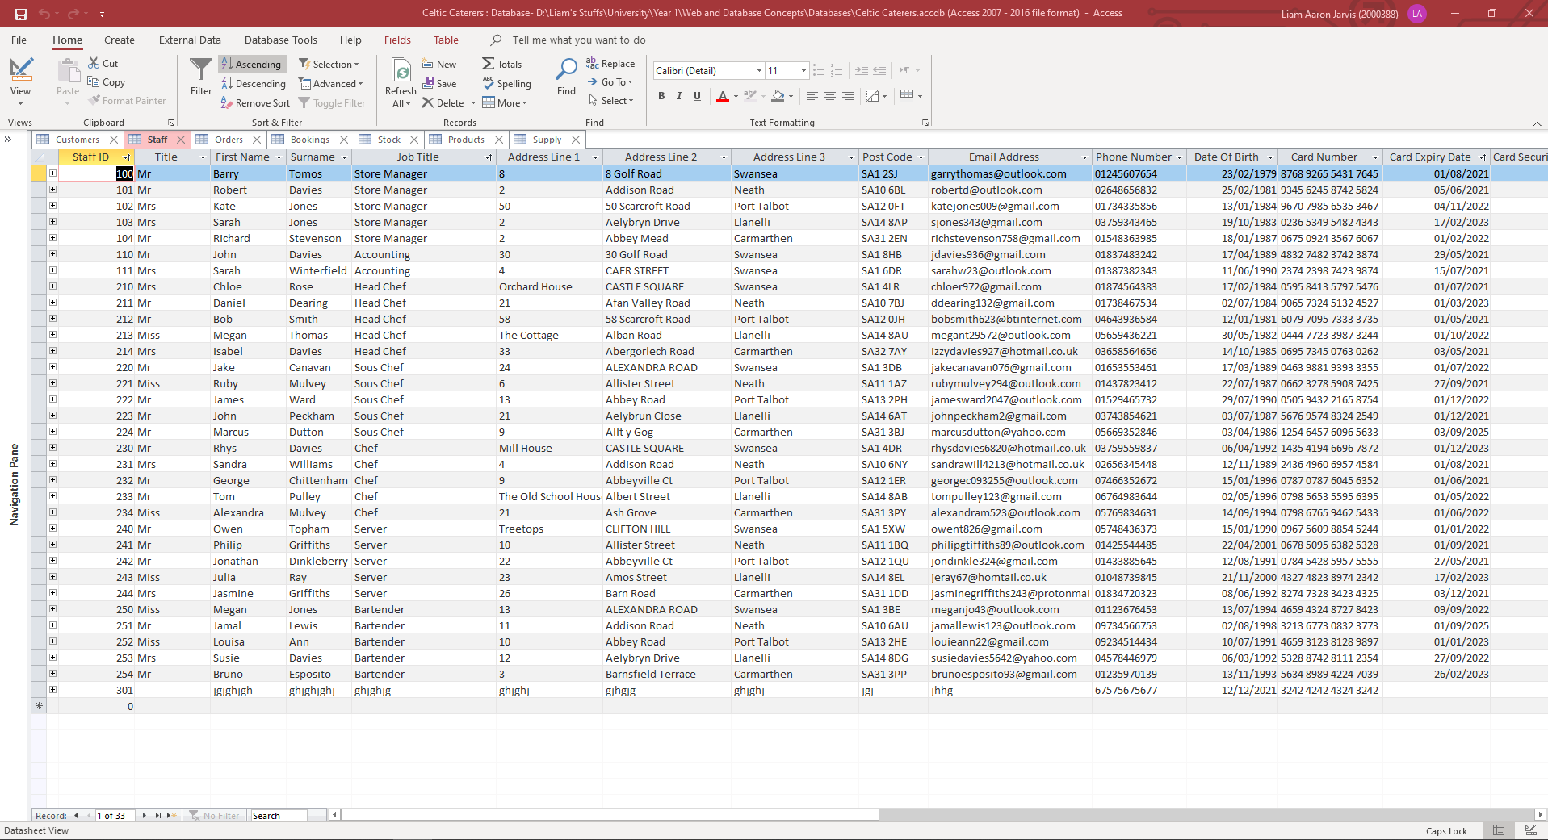
Staff Table:

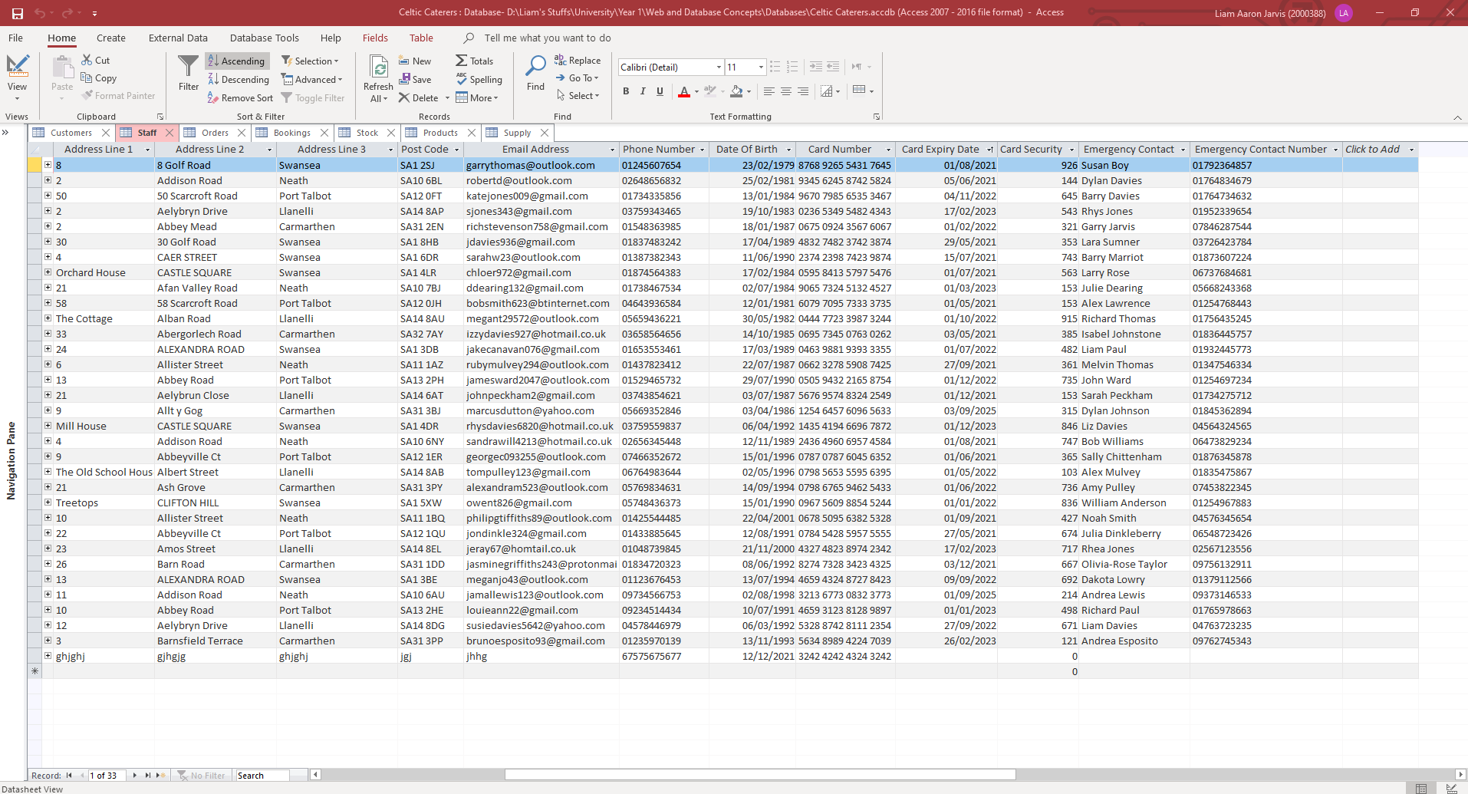
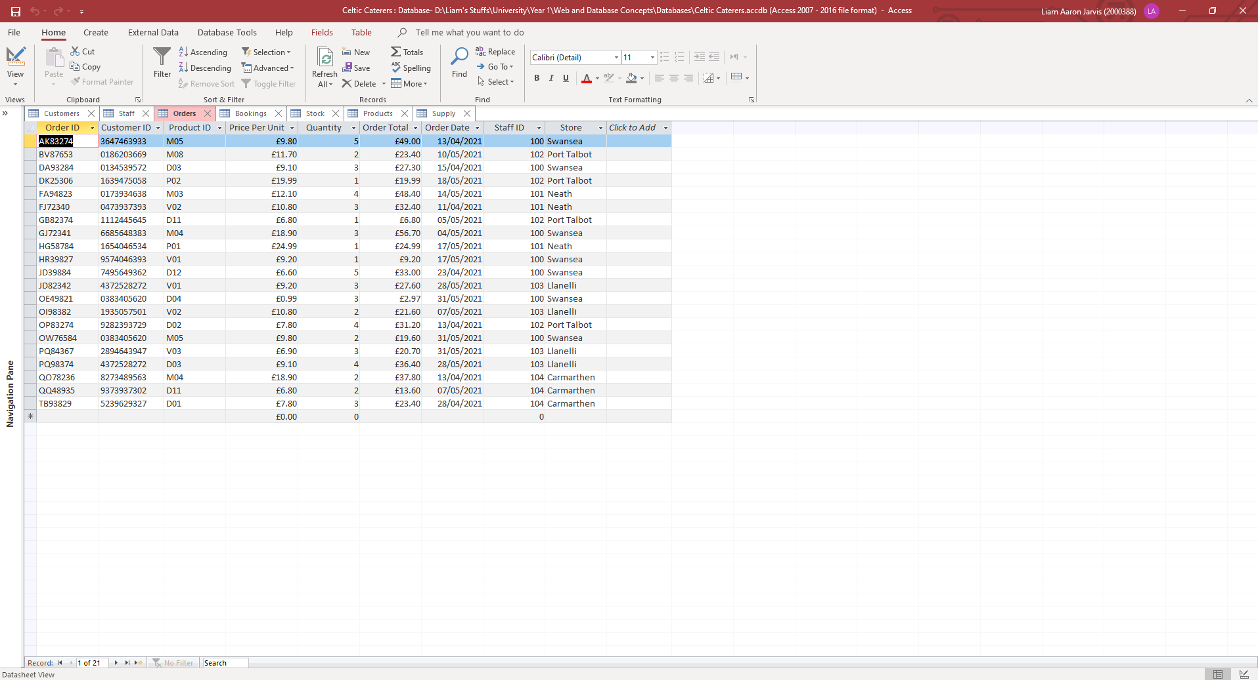
Orders Table:

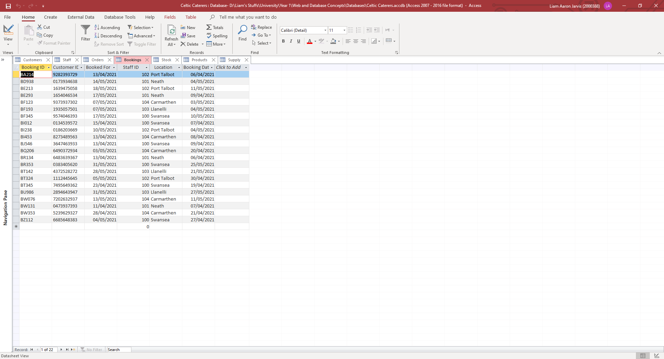
Bookings Table:
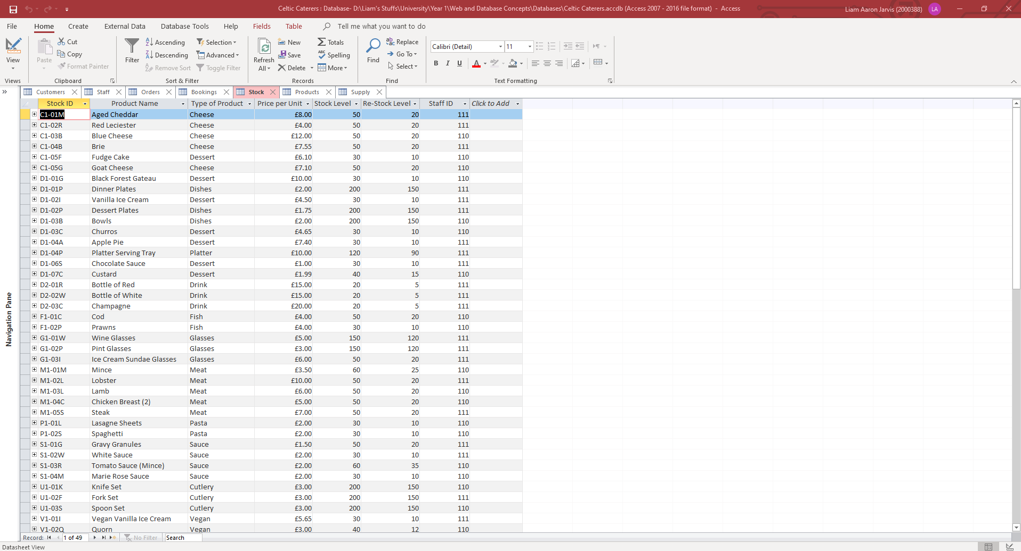
Stock Table:
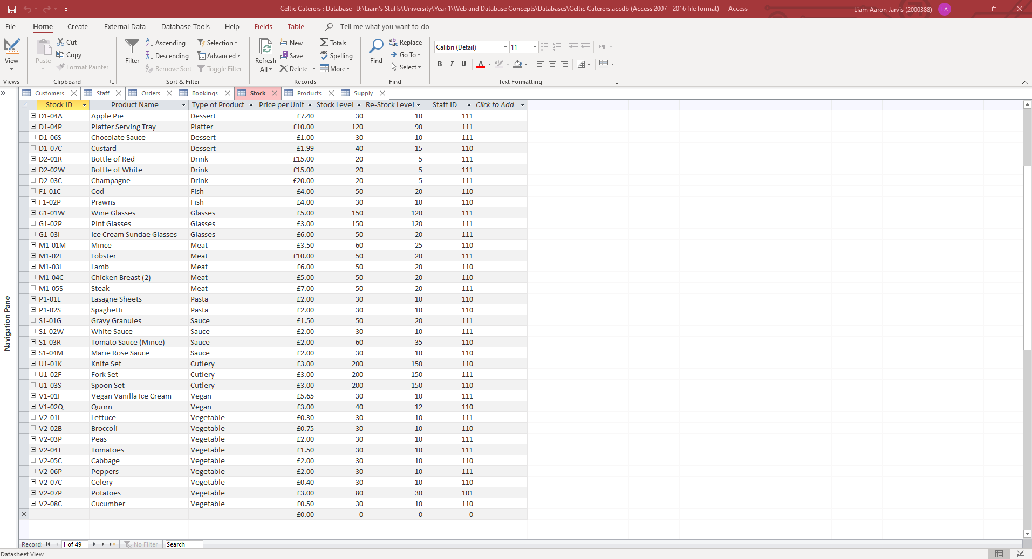
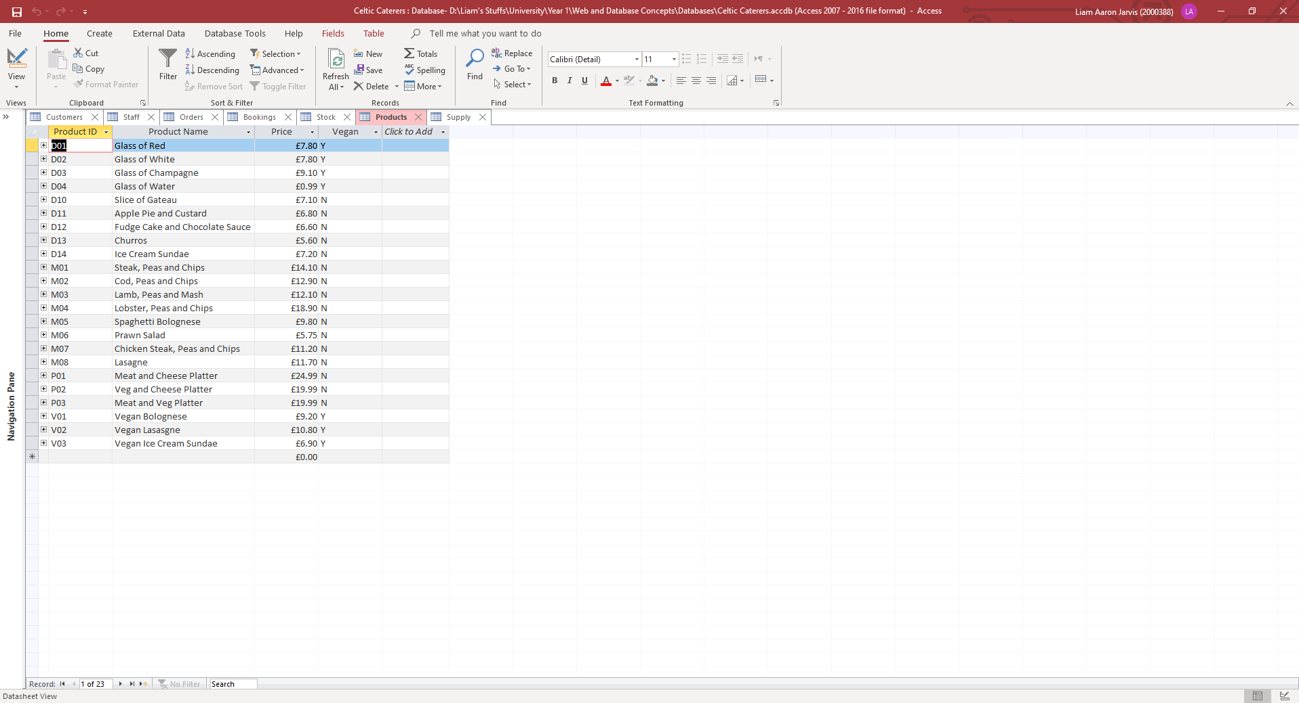
Products Table:

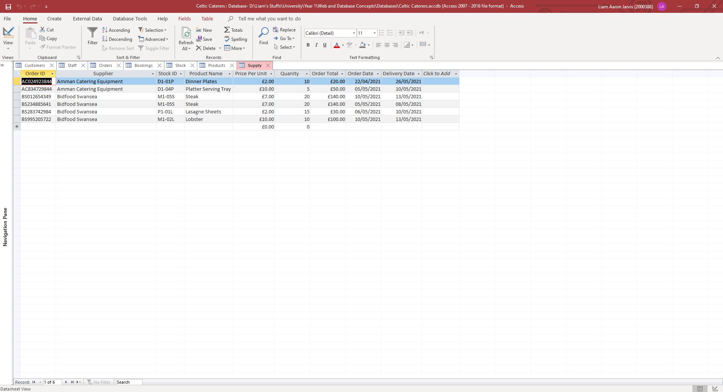
Supply Table:
To minimise data entry errors, I used input masks, validation rules, data types and field sizes. Firstly, the data type “determines the kind of the values that users can store in any given field.” [2]. For example, in my orders table, I have Order ID as “Short text” that allows the user to type both letters and numbers into the field. I also have Price per Unit set as Currency, so the user can only enter numbers into this field. I also have Date/Time for order date that allows the user to either type or select the date from a calendar within access.
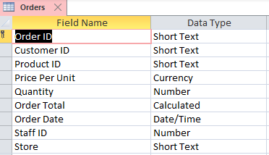

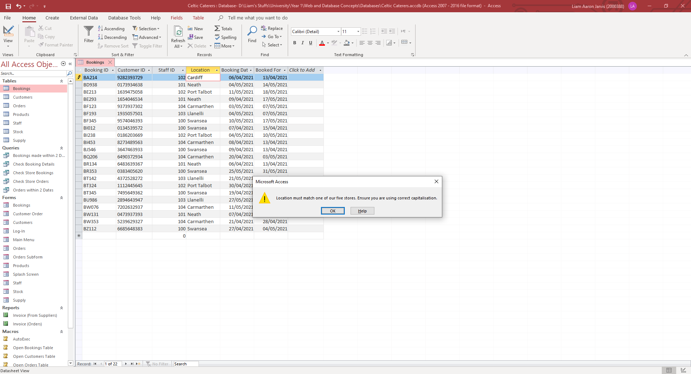
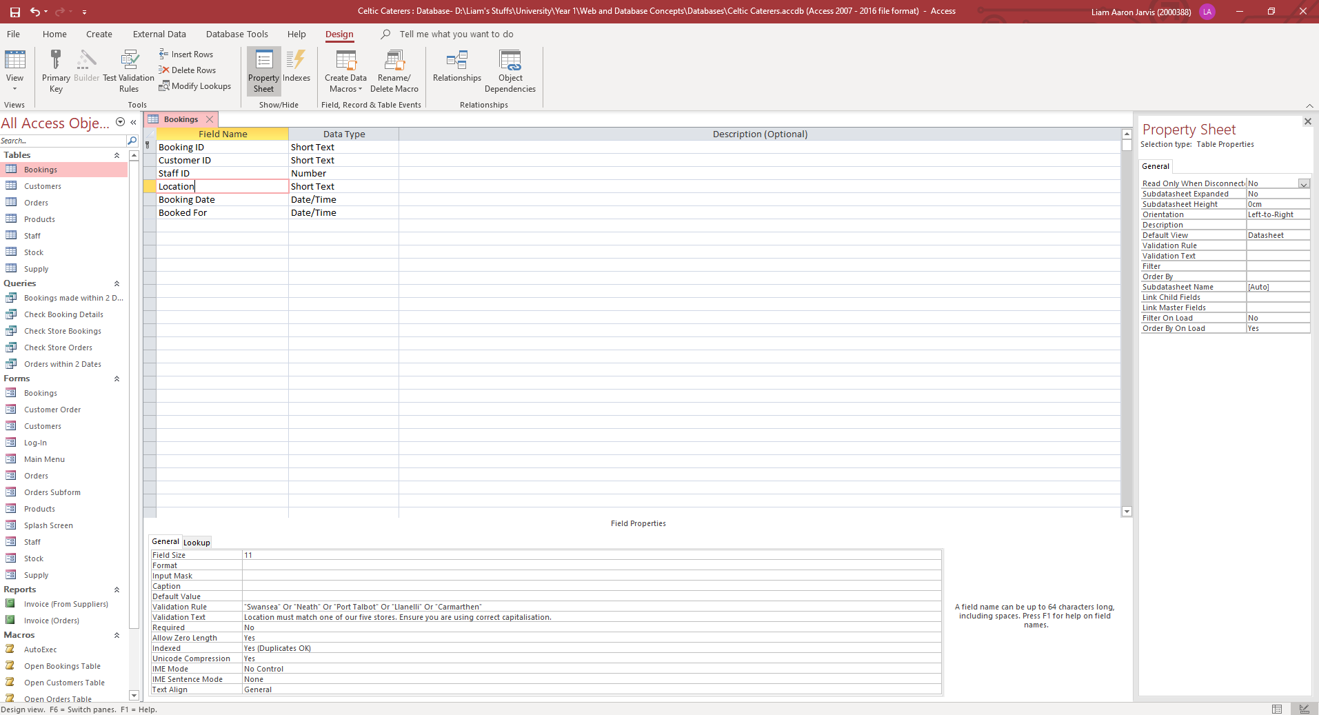
Field sizes simply allow the user to select the size of the field. For example, I set the “Location” field in the Bookings table to 11, as the maximum character length of a location is eleven, this being “Port Talbot”. I also used a validation rule for this field. “A validation rule is a rule that dictates which information can be entered into a field. When a validation rule is in place, it is impossible for a user to enter data that violates the rule.” [3] I used the validation rule "Swansea" Or "Neath" Or "Port Talbot" Or "Llanelli" Or "Carmarthen" for the “Location” field, as this means the user can only enter these 5 locations, which are the 5 store locations for Celtic Caterers. You can also add a validation text that displays when the user enters an incorrect value into the field and is mean to indicate what they have done wrong. Below is the field size and validation rule for the “Location” field, along with the validation text when the user enters data that does not pass the validation rule:
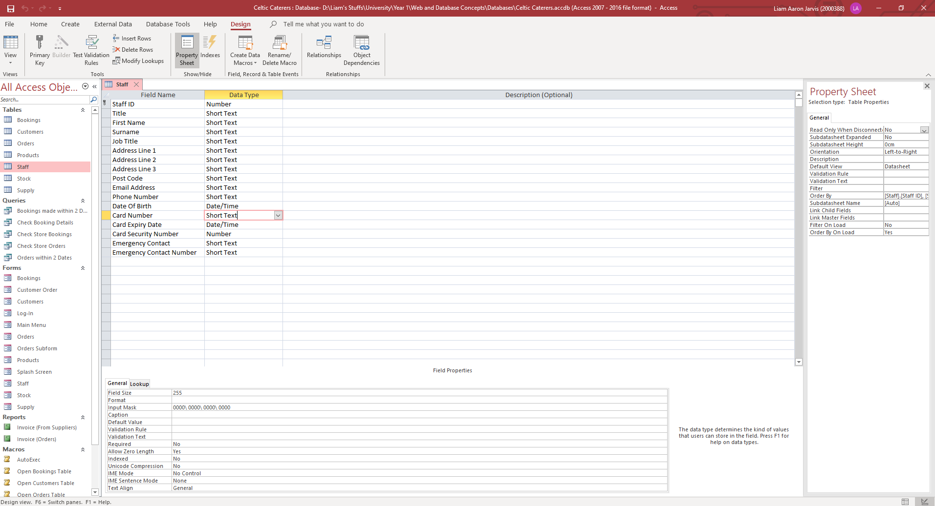
Lastly, an input mask is a way of ensuring “people enter data correctly into your Access desktop database by providing input masks for fields that contain data that is always formatted a certain way. For example, you can use an input mask to make sure that people enter correctly formatted phone numbers into a phone number field. An input mask only affects whether Access accepts the data – the mask does not change how the data is stored, which is controlled by the field’s data type and other properties.” [4]. One example of an input mask is for the field “Card Number” for both the Staff and Customers tables. I used the input mask “0000\ 0000\ 0000\ 0000” which forces the user to enter the card number as a 16-digit number separated in sets of four like and actual card number.

User Guide and Forms
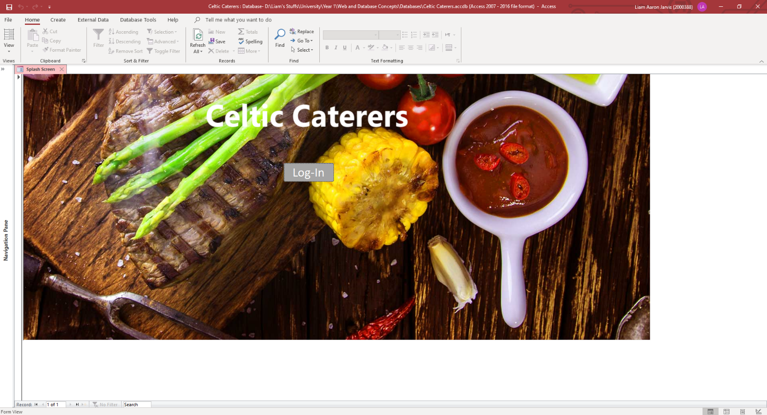
To allow the users to navigate through the database efficiently, I created forms that would allow the user to navigate through the systems tables, forms, queries, and reports. Firstly, I created a splash page for the system:
This form houses the button that takes the user to the Log-In page and is a nice visual to open to. As this was the splash page, I wanted to make sure this opens on start-up when the user opens the database. To do this, I created a macro that opens this form, shown below:

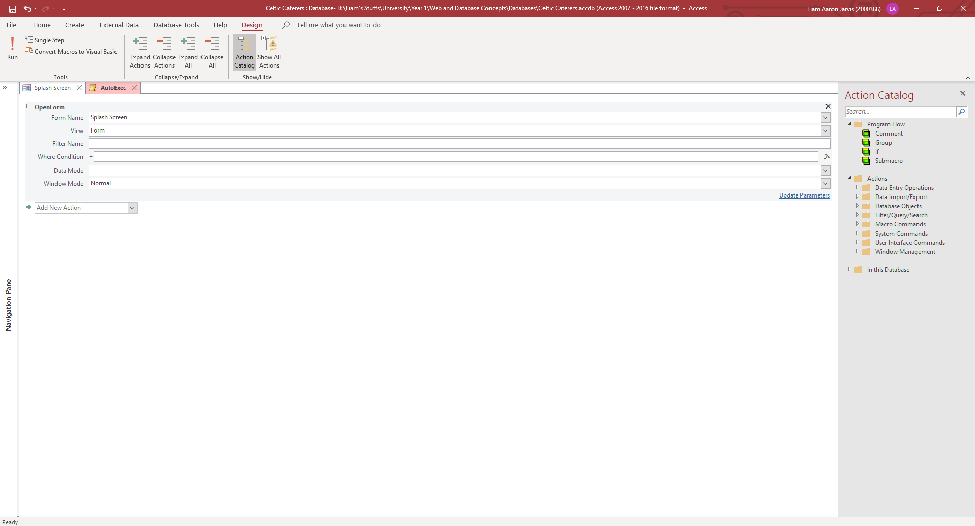
I then needed to make this macro run on start-up when the database is opened. To do this, I simply named the macro “AutoExec” which tells the database to run this macro when the database is opened.
Once the user starts the database, they can navigate to the main menu by first logging in on the Log-In form. To do this, they need to select the button labelled “Log-in” on the Splash Screen. This button opens the form “Log-In”.

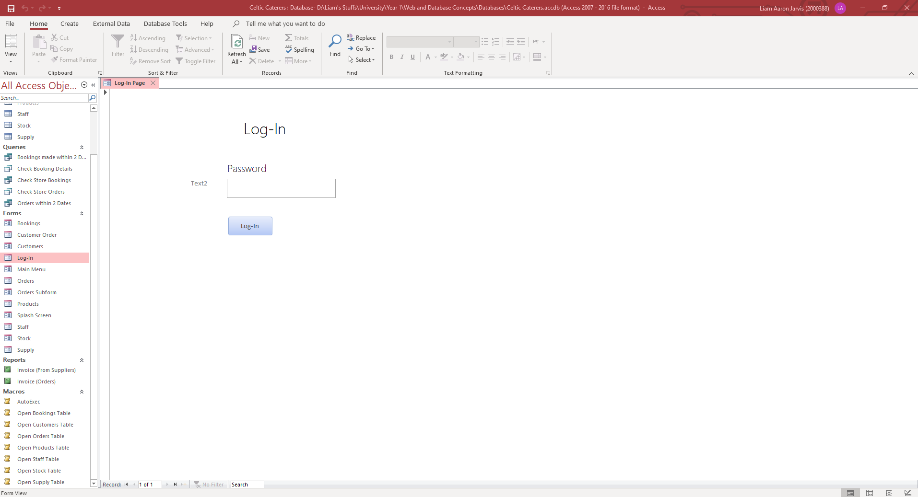
Log-In Form:
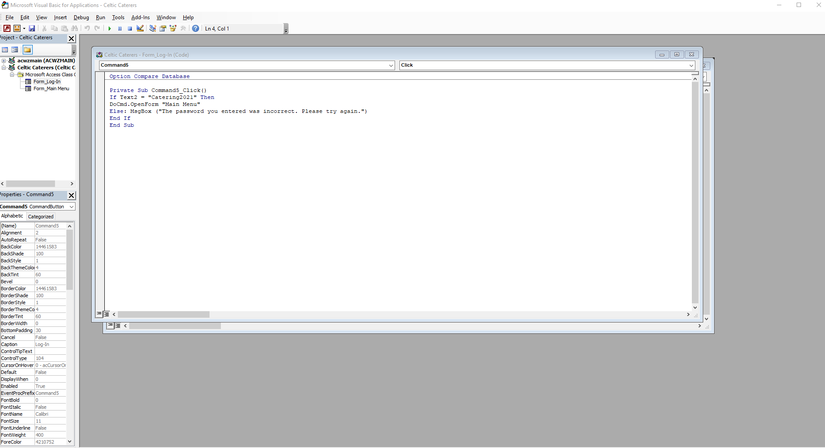
The Log-In page simply requires the user to enter the password for the database correctly, and then select the button labelled “Log-In”. This button checks if the textbox “Text2” equals “Catering2021” which is the password for the database. This is an easy way to stop users from accessing the database without permission to do so, as the password can be given out to those that are trusted. Below is the Visual Basic code for this button:
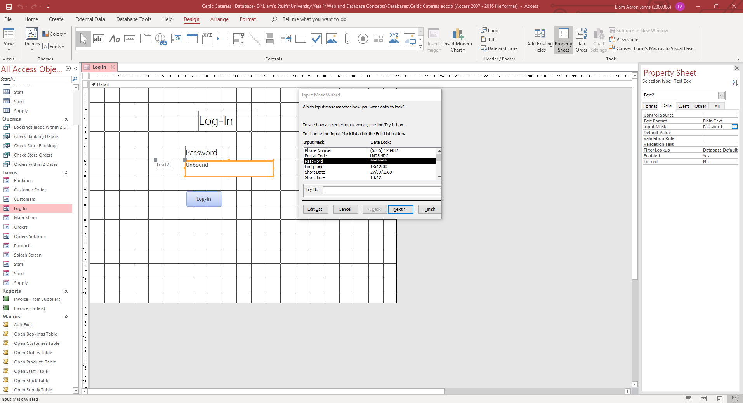
I also added an input mask for this text box that hides the text from users so people can’t simply see someone enter the password on screen and then use that to enter the database unwarranted.
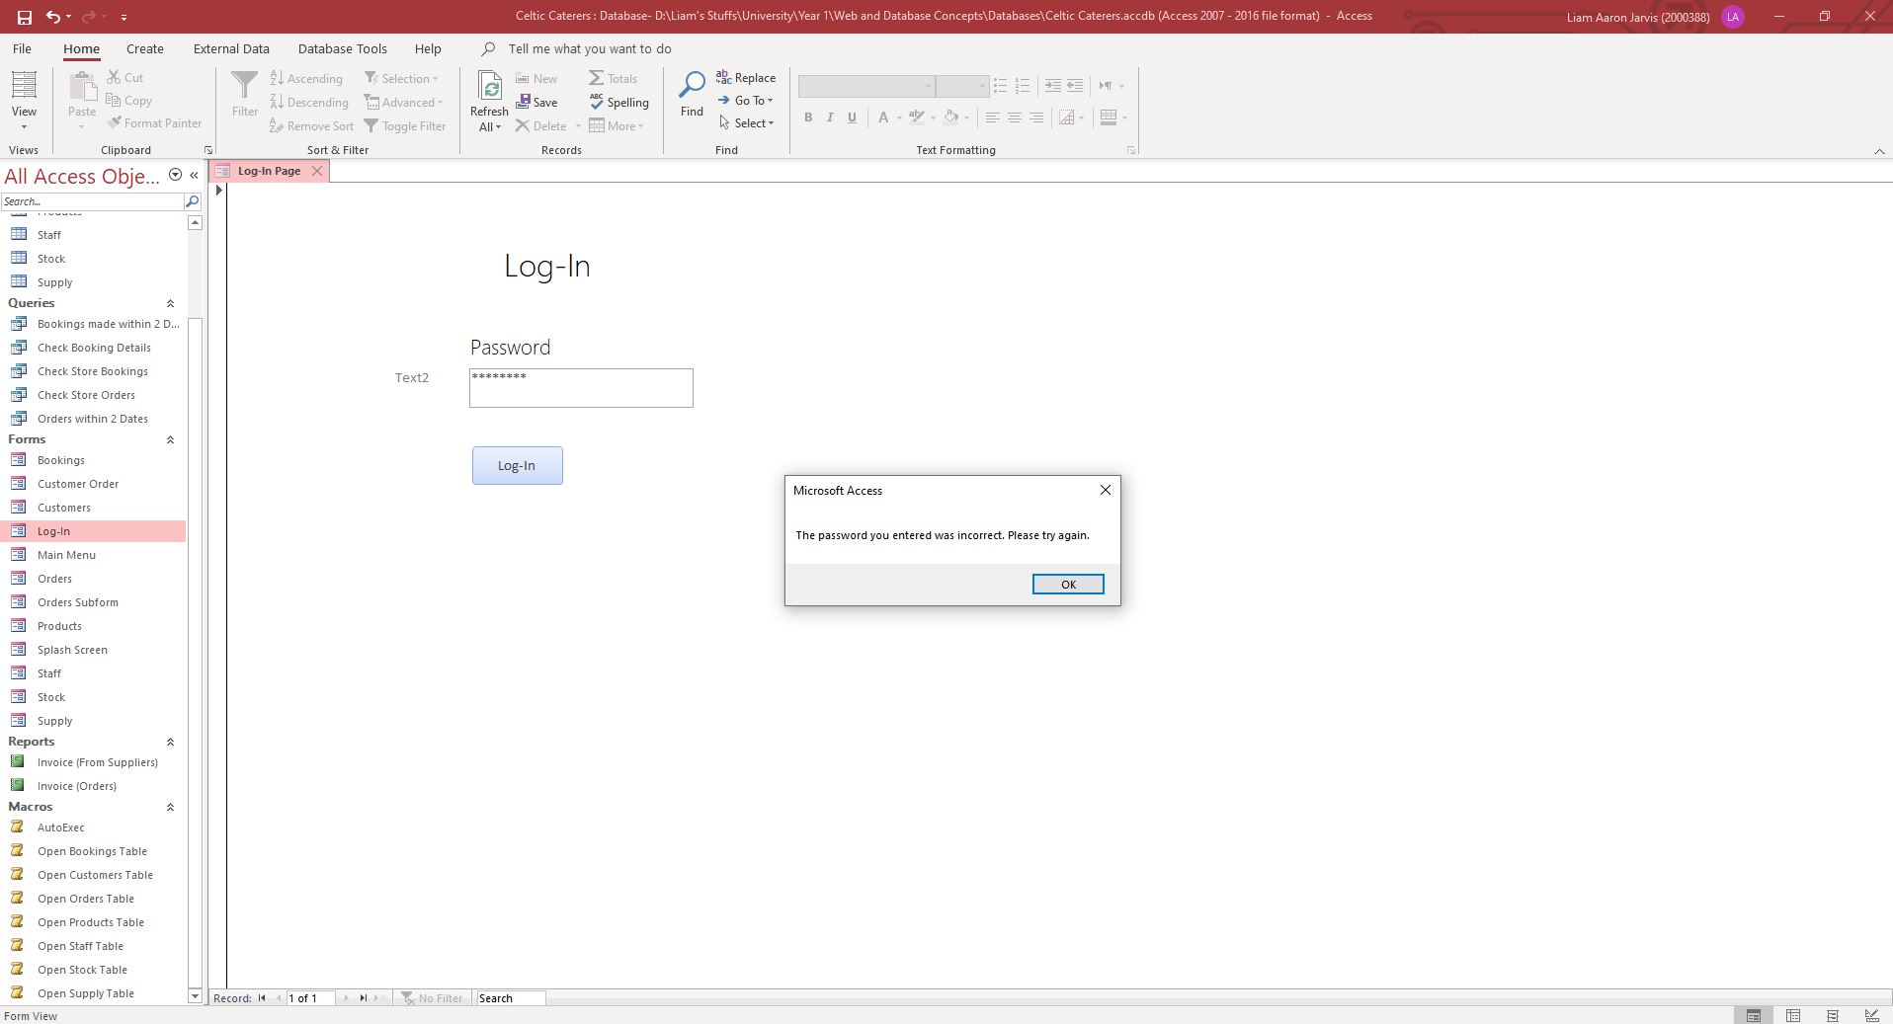
If the user enters the wrong password, they are given this error message:

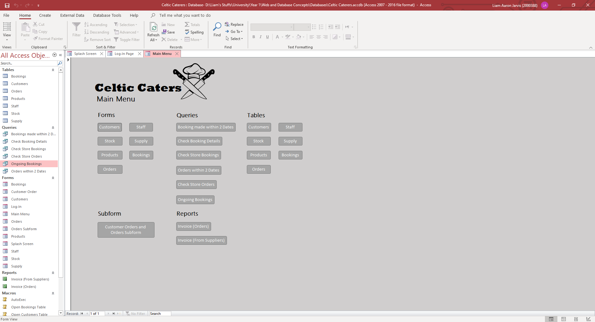
But if they enter it correctly, they will be taken to the Main Menu form.
From here, the user can use the many buttons to access the different parts of the database. The buttons are categorised under the headings “Forms”, “Queries”, “Tables”, “Subform”, and “Reports”. All buttons bar the “Tables” were created by selecting Design > Controls and selecting the button. After this, I made the “Forms” and “Subforms” buttons open their corresponding form using the Open Form action in the Form operations category. For the Queries I selected the Run Query actions from the Miscellaneous category, and for the Reports I used the Open Report action from the Report Operations category. Tables cannot be opened using the actions from the Command Button Wizard like the other buttons I created. To get around this, I made 7 macros that each open their own table, and then assigned these macros to their corresponding button. An example of an OpenTable macro can be found below:

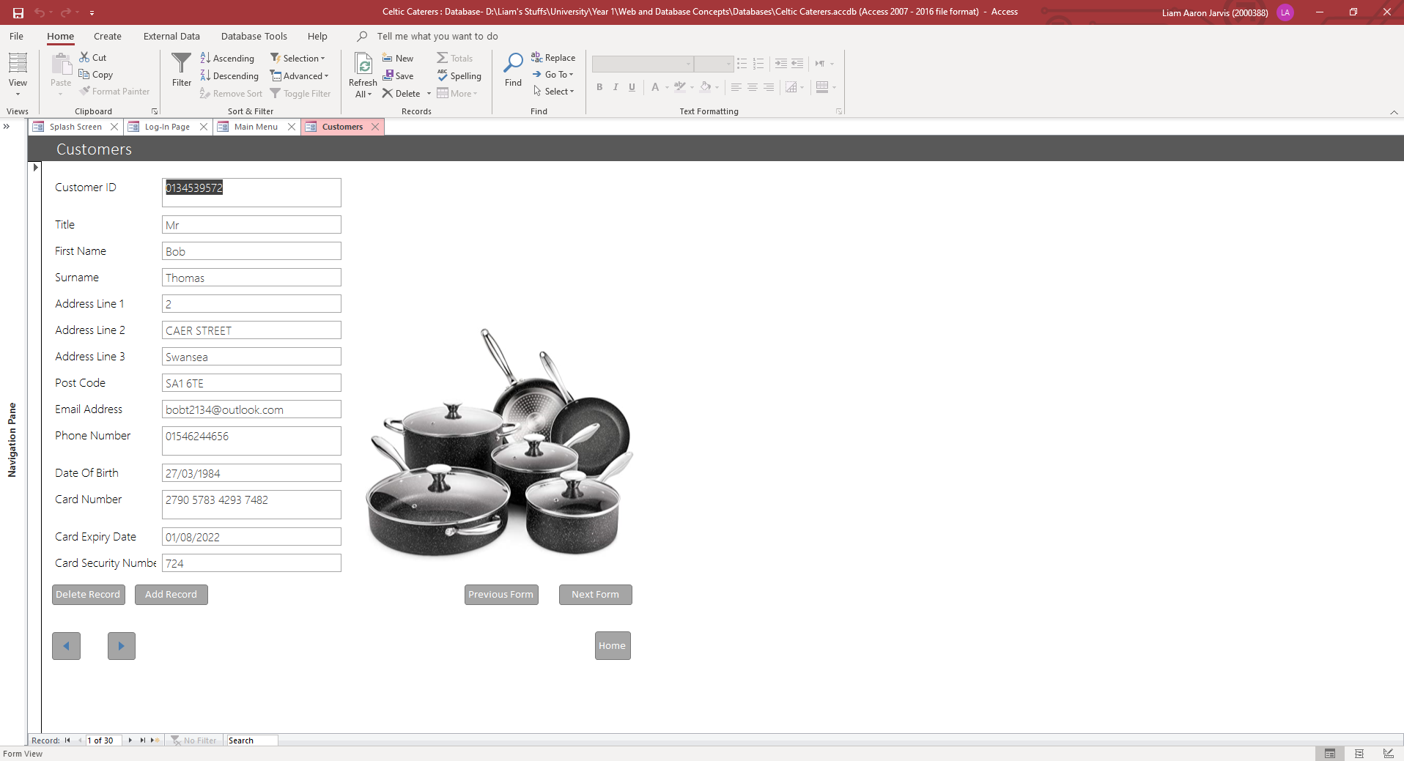
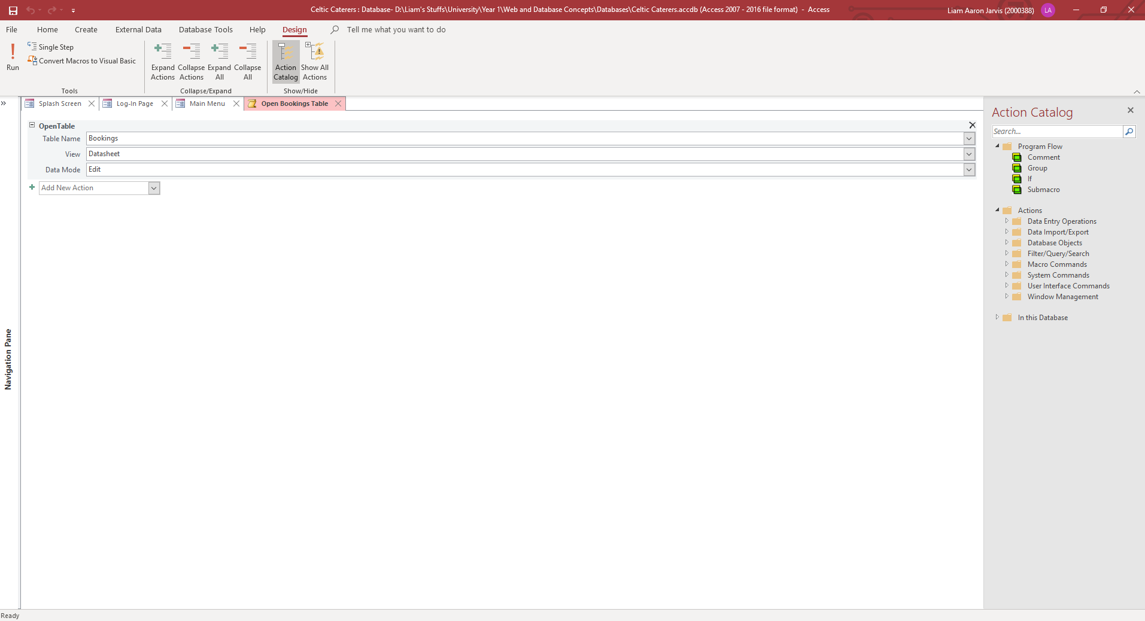
Customers Form:

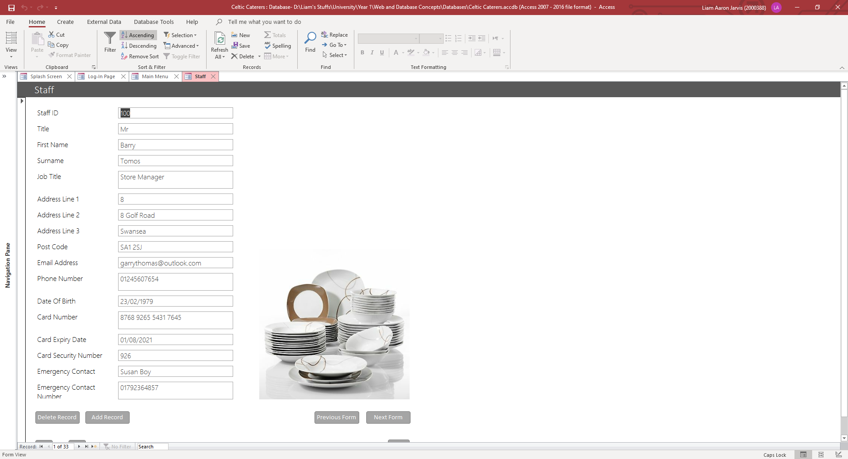
Staff Form:
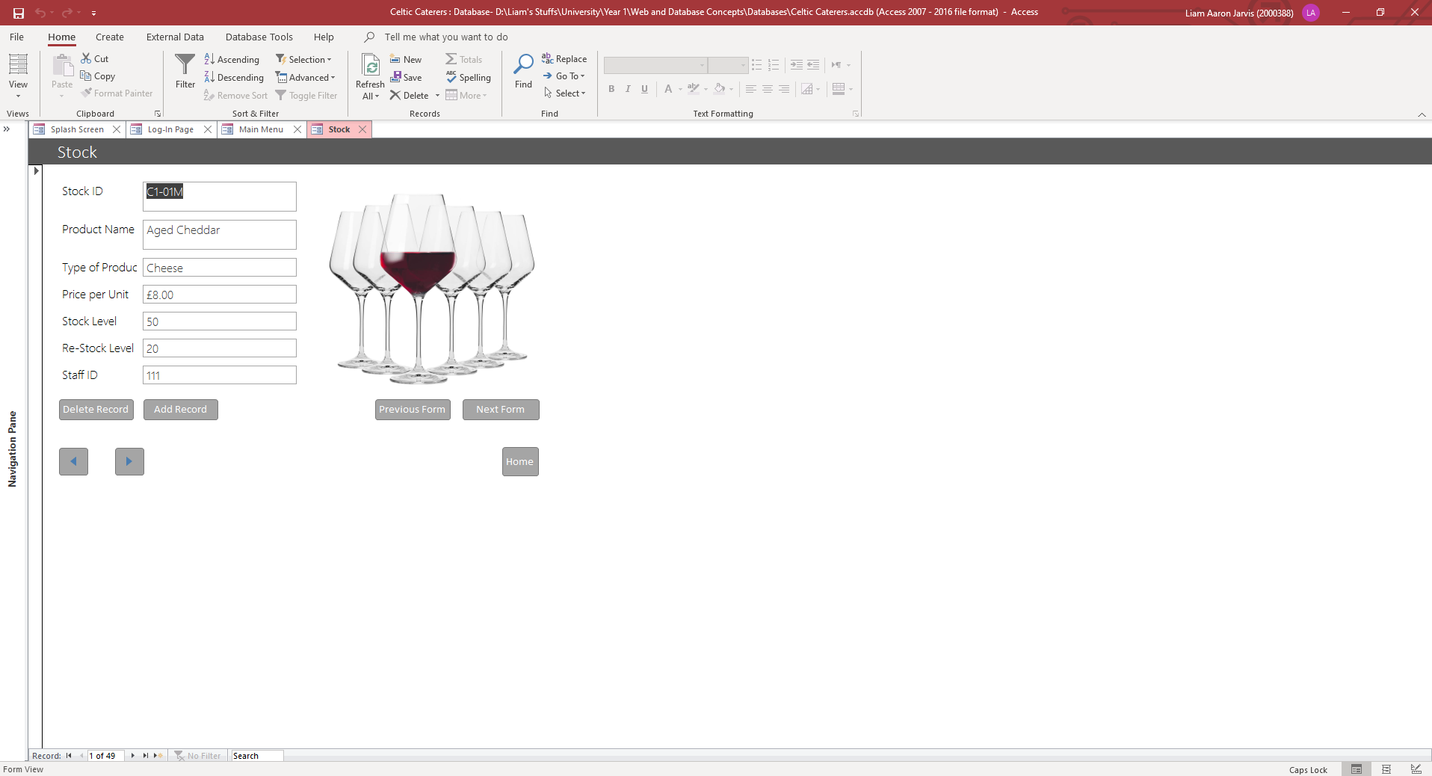
Stock Form:

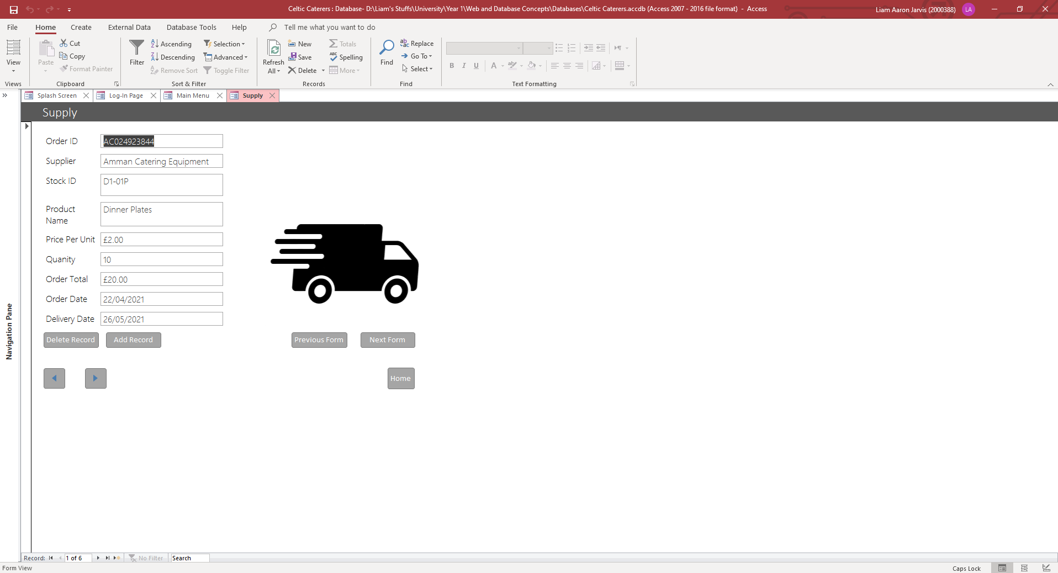
Supply Form:
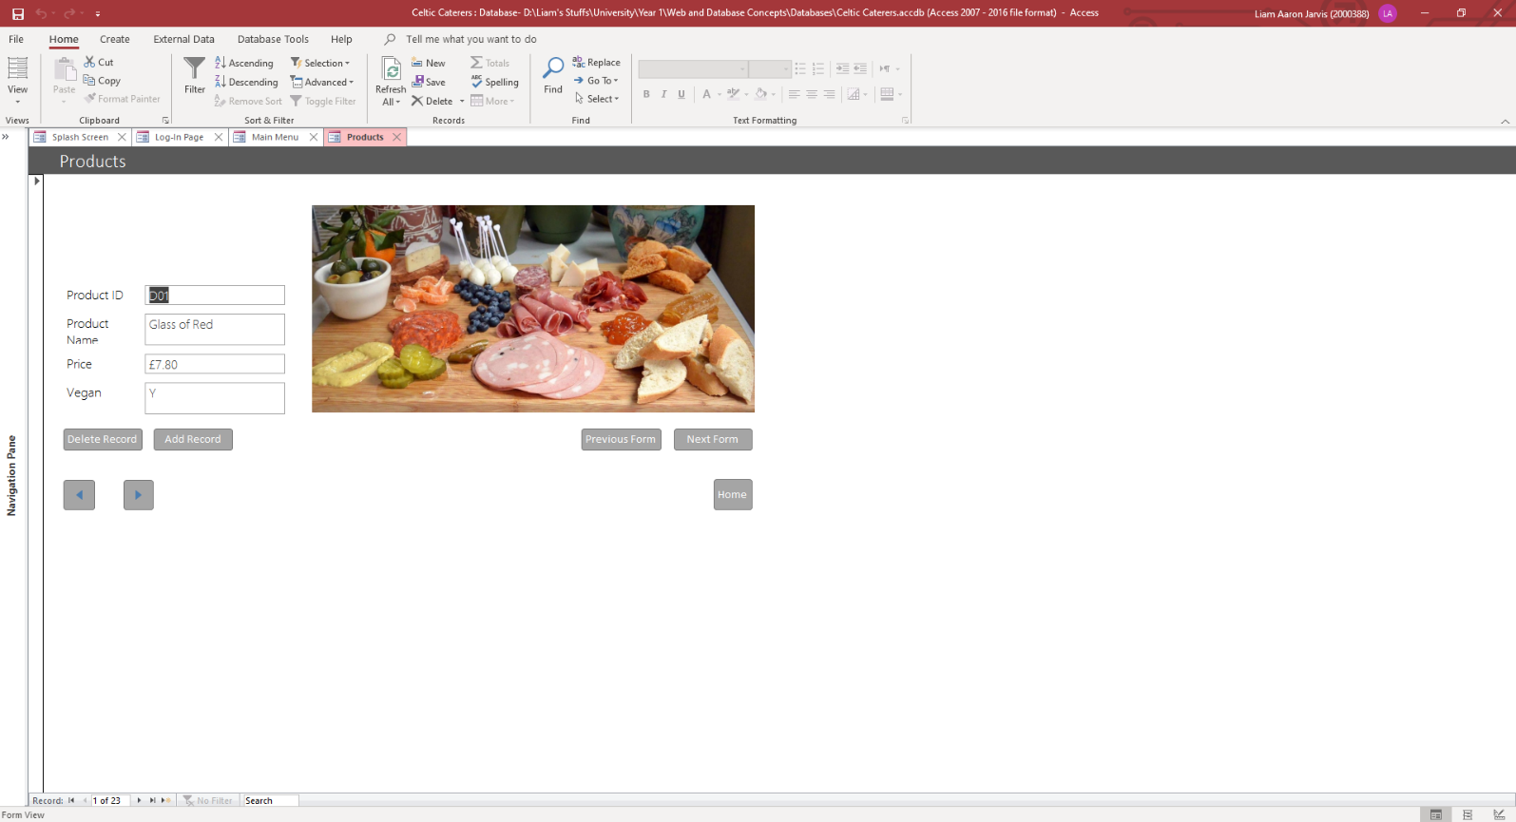
Products Form:

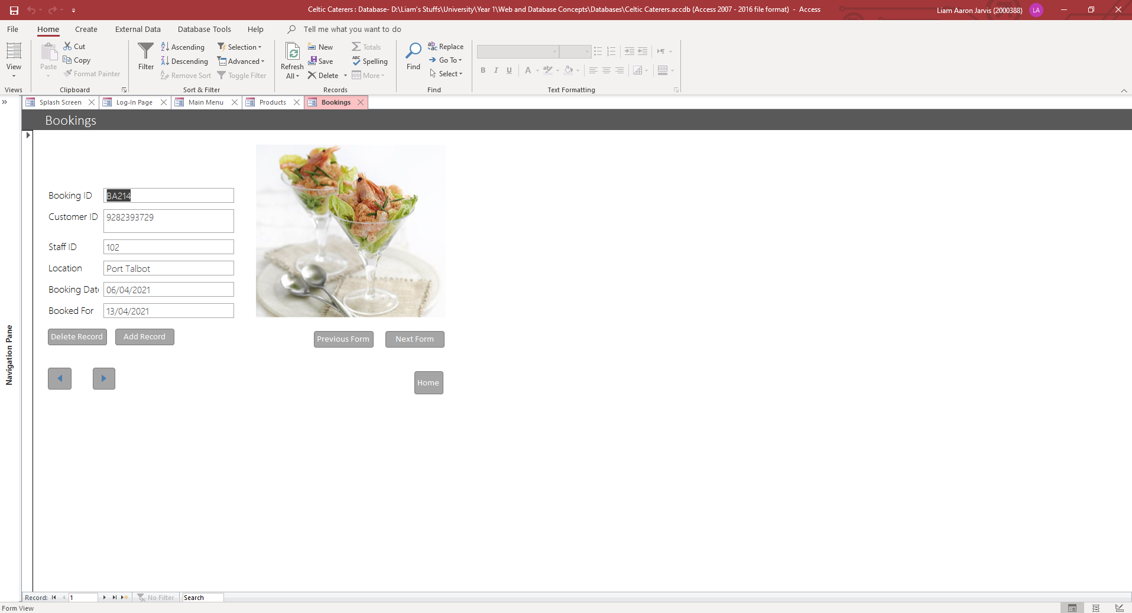
Bookings Form:
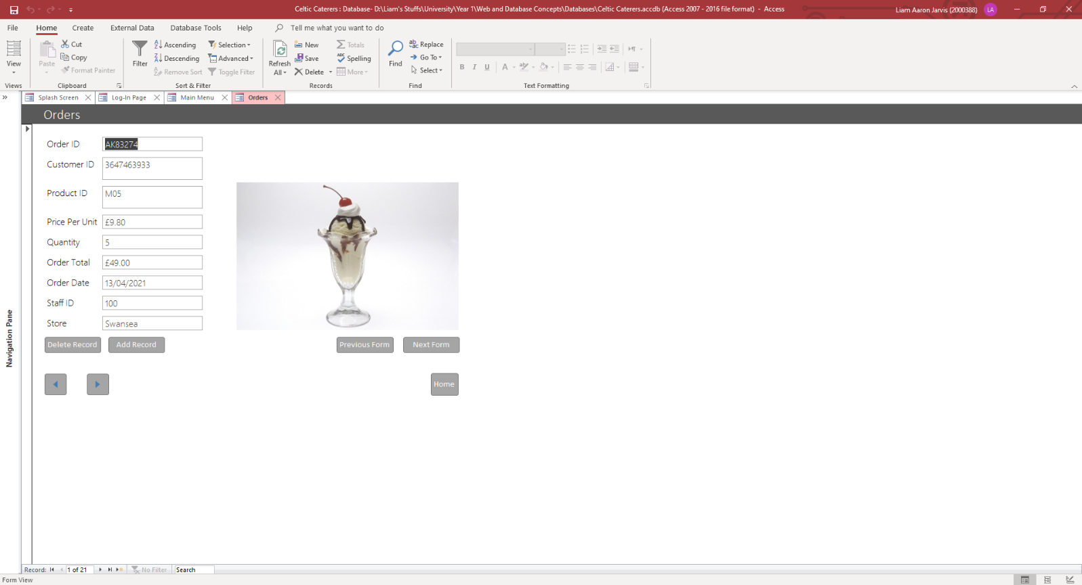
Orders Form:

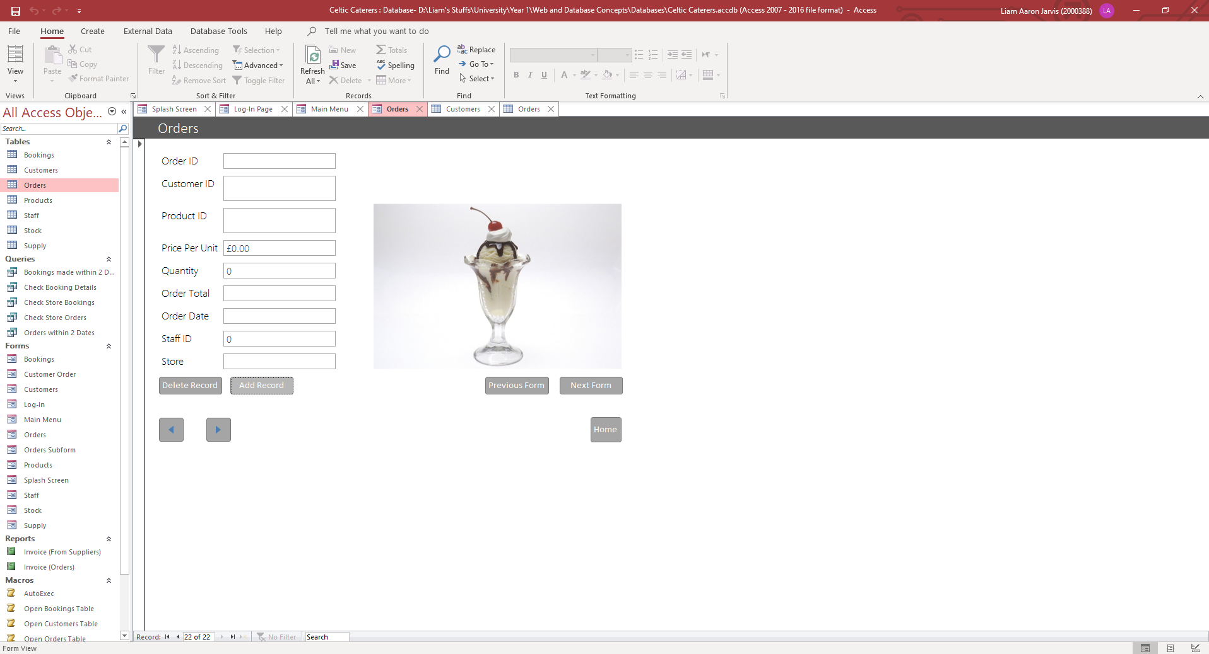
As shown, I have included further navigation buttons within each of the forms. Firstly, the arrows allow the user to cycle through each record of the table the form is made fore. The “Add Record” button takes the user to a blank record that allows the user to enter data into. This means the user can enter new records into the corresponding table from the form, rather than from the table itself. To do this, the user simply needs to select “Add Record” which takes them to a blank record, and then enter the data, as shown below:
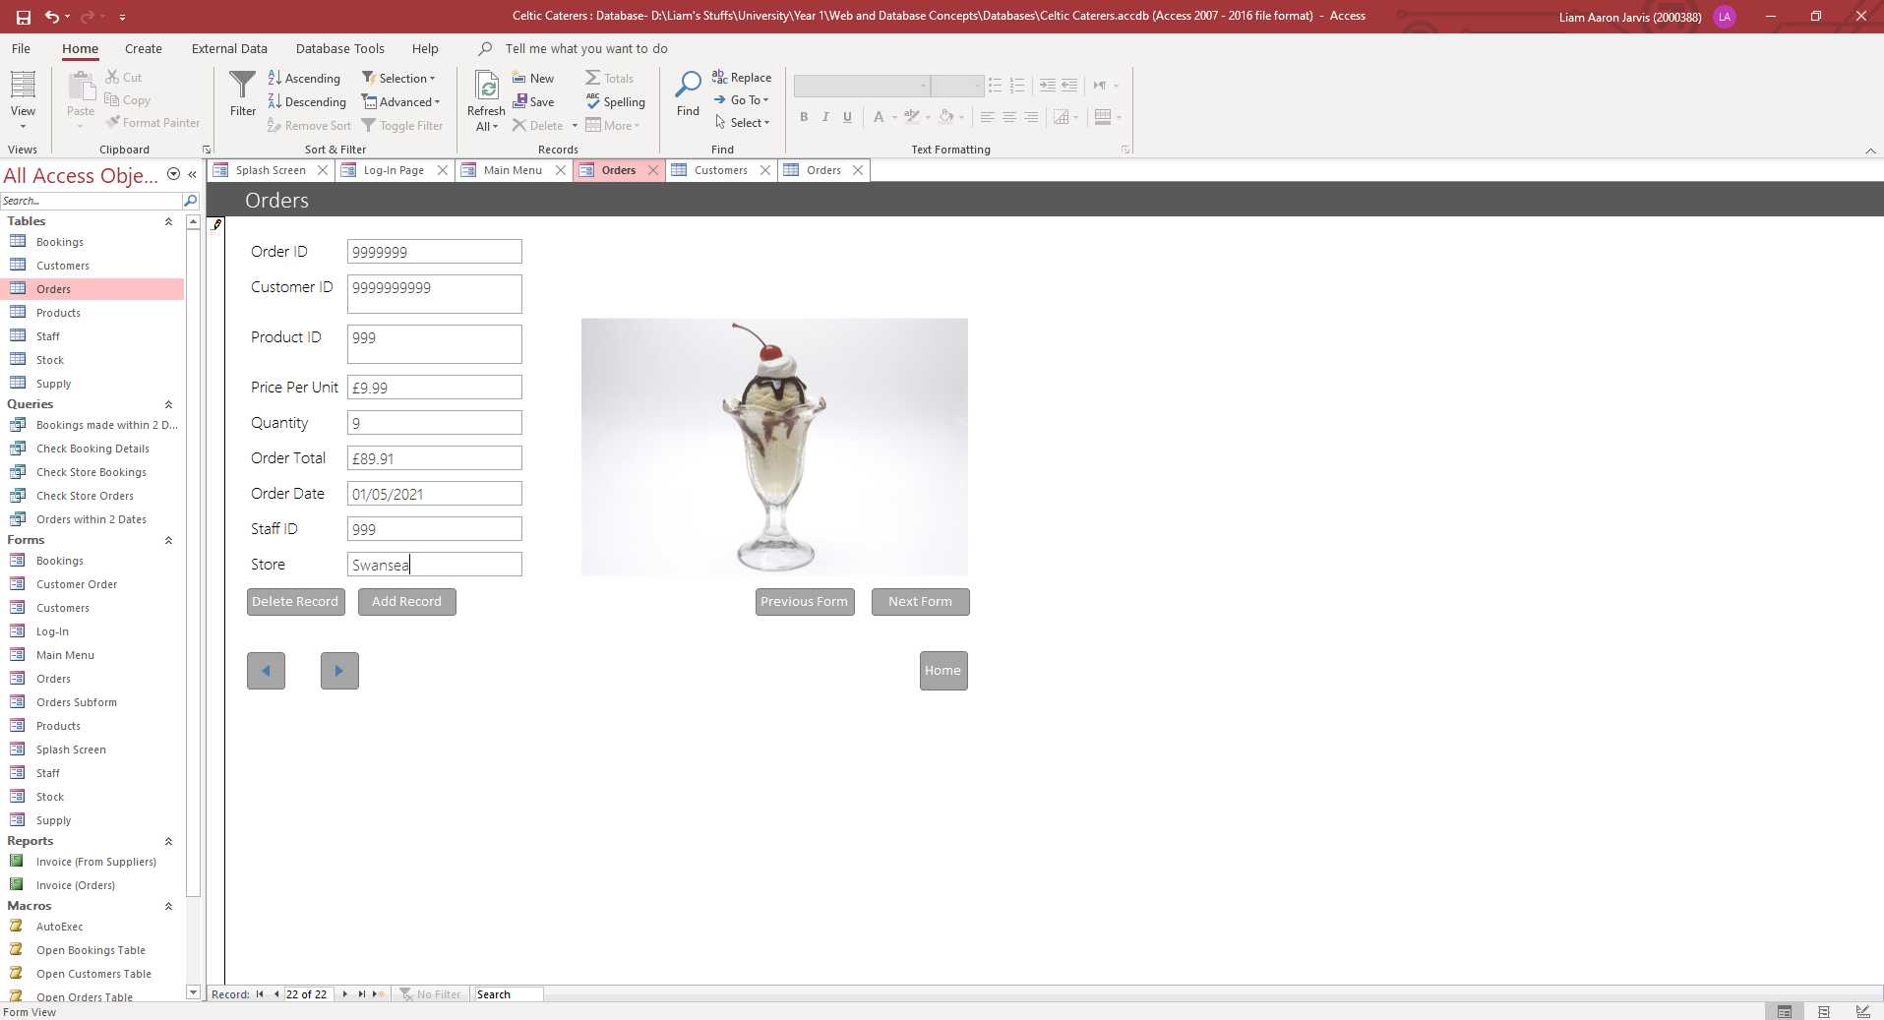
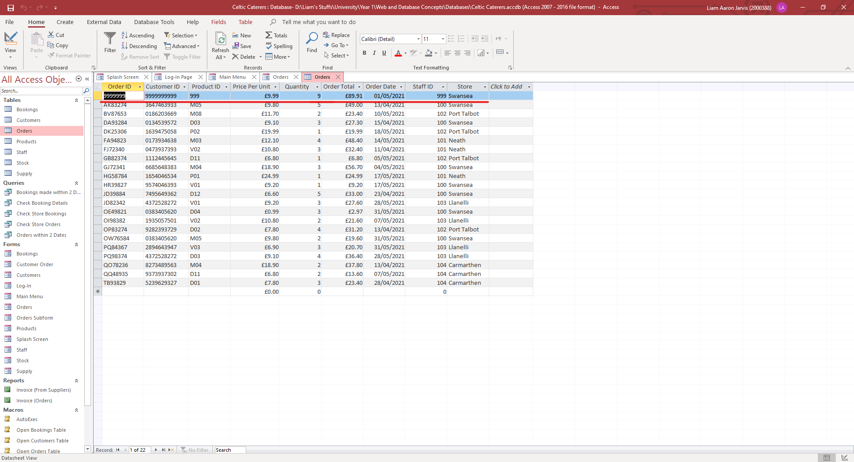
Then save the form and open the corresponding table. The new record should be present, as shown below:
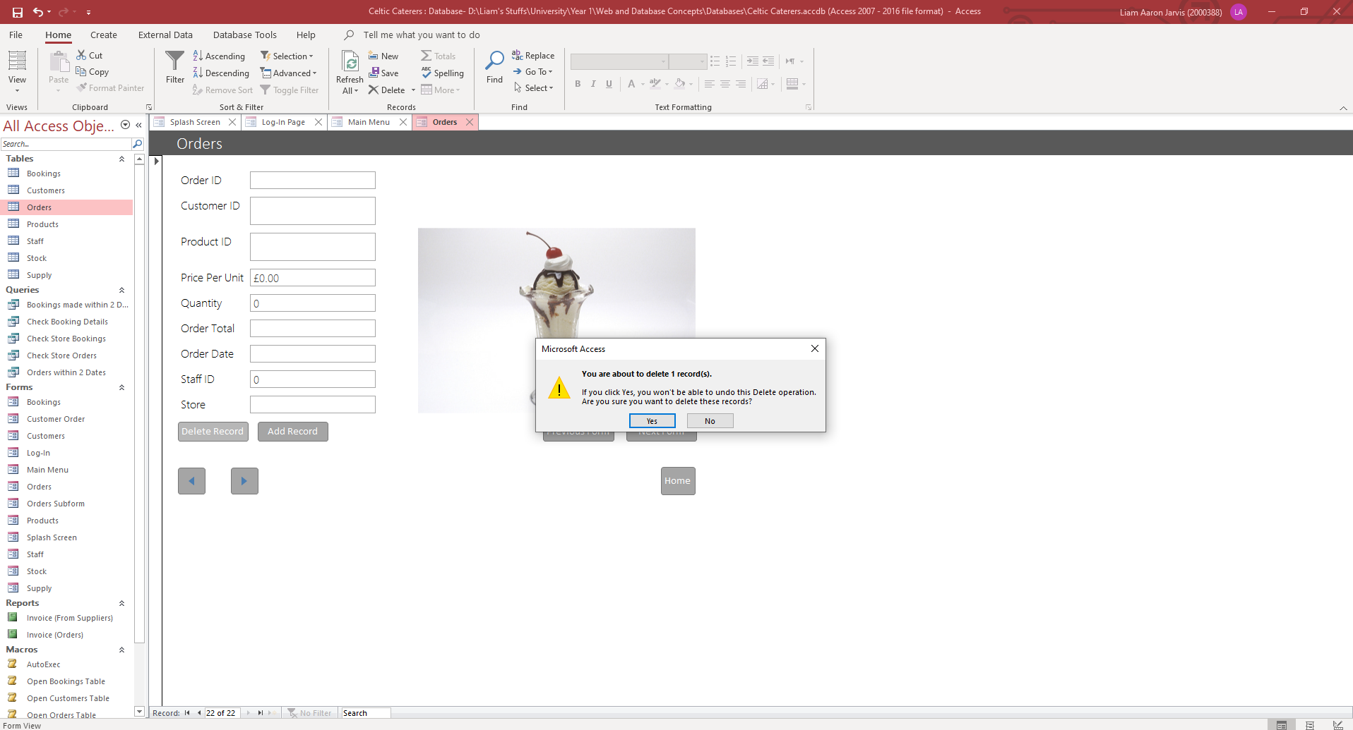
The user can also delete records from the table with the form. For example, the customer who we just entered data for has requested for their data to be removed. To do this, navigate to the record in question, and then select the “Delete Record” button.

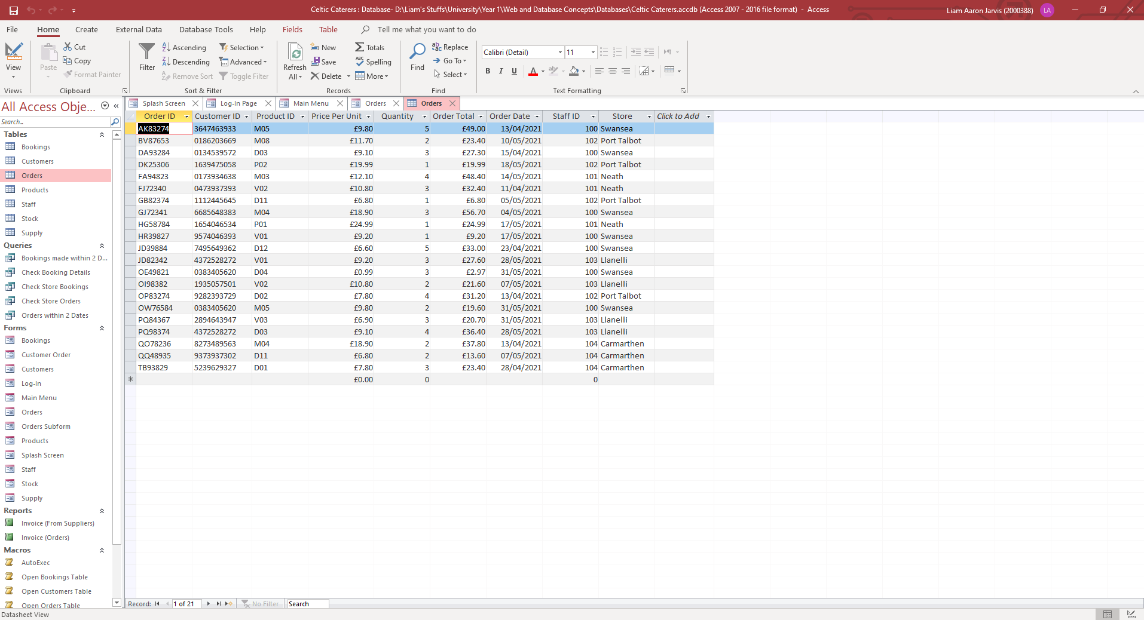
Now save the form and open the table. The record should be deleted as shown below:
I have also added to buttons labelled “Previous Form” and “Next Form” which will open the previous or next form in a predetermined order I made. This order is: Customers> Staff > Stock > Supply > Products > Bookings > Orders. For example, if I was on the Stock table, selecting the “Next Form” button would open the Stock Form, and the “Previous Form” button would open the Orders Form. This allows the user to cycle through these 7 forms, rather than going back to the main menu and then selecting the form they wish to open. If the user did want to go back to the main menu however, they can do so by selecting the “Home” button which opens the Main Menu form. The subform button opens the Customer Order form which contains the Orders subform, shown below:

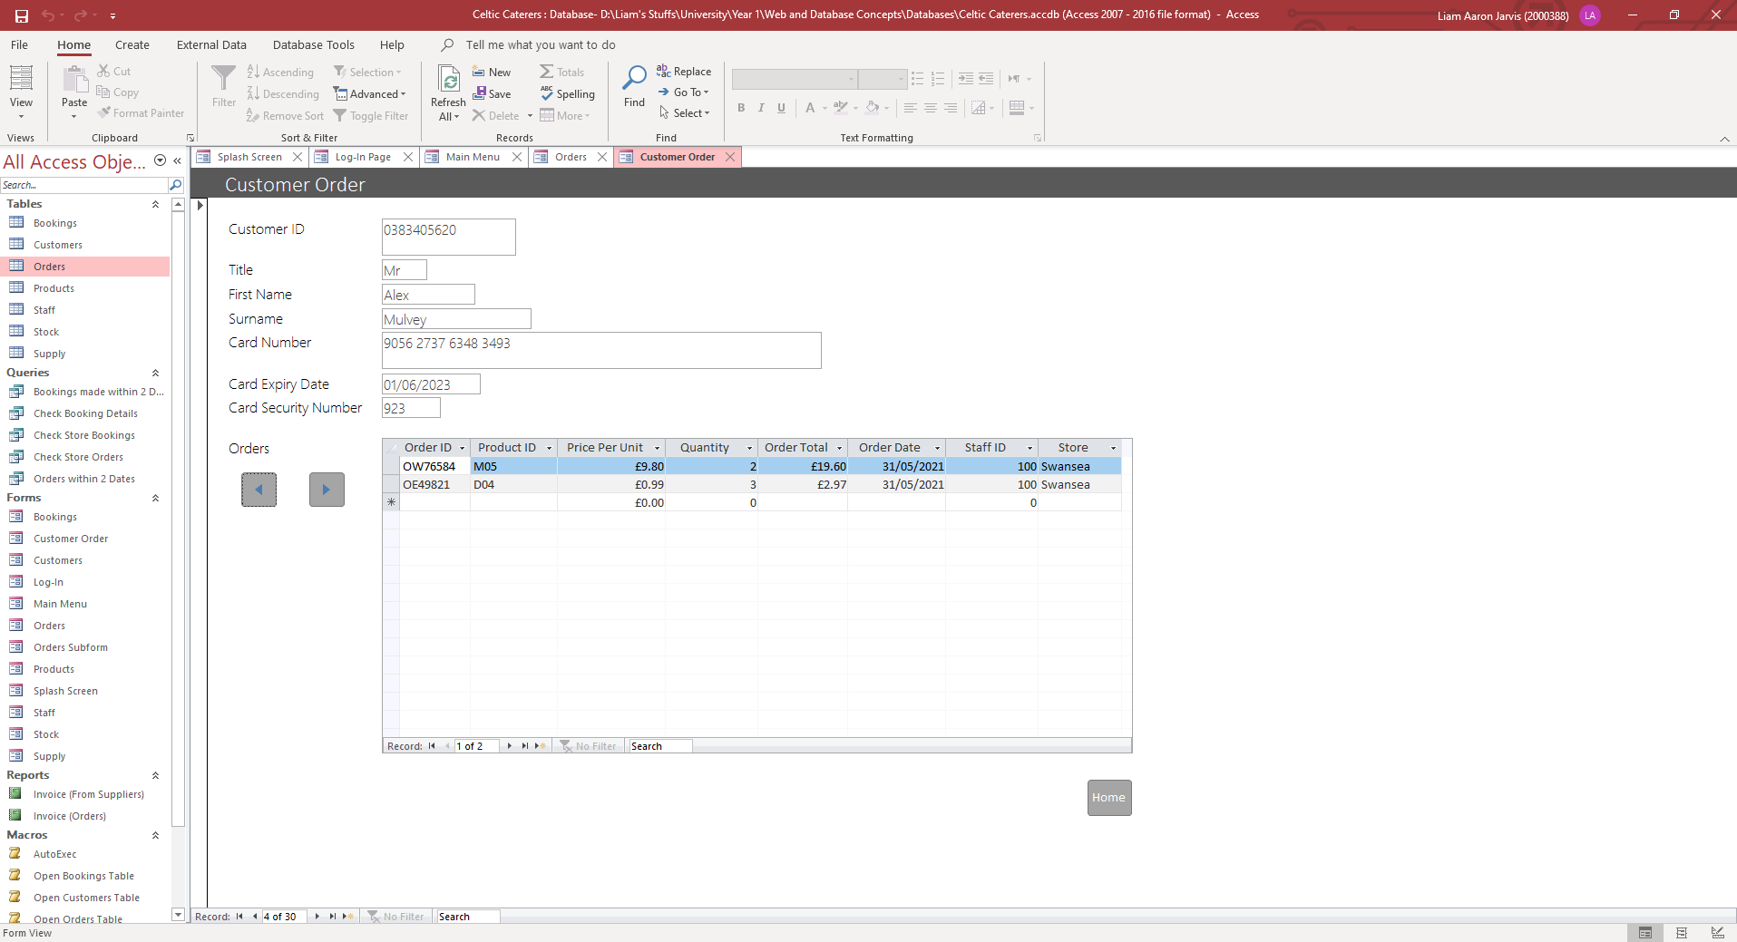
“A subform is a form that is nested inside of another form. It usually contains data that is relevant to the record that is currently open in the main form.” [5]. This form allows the user to cycle through customers and see their orders within the subform, if they have any.
The user can also access the 2 Reports, showing an Invoice of purchases from suppliers, and an invoice of orders they have received.
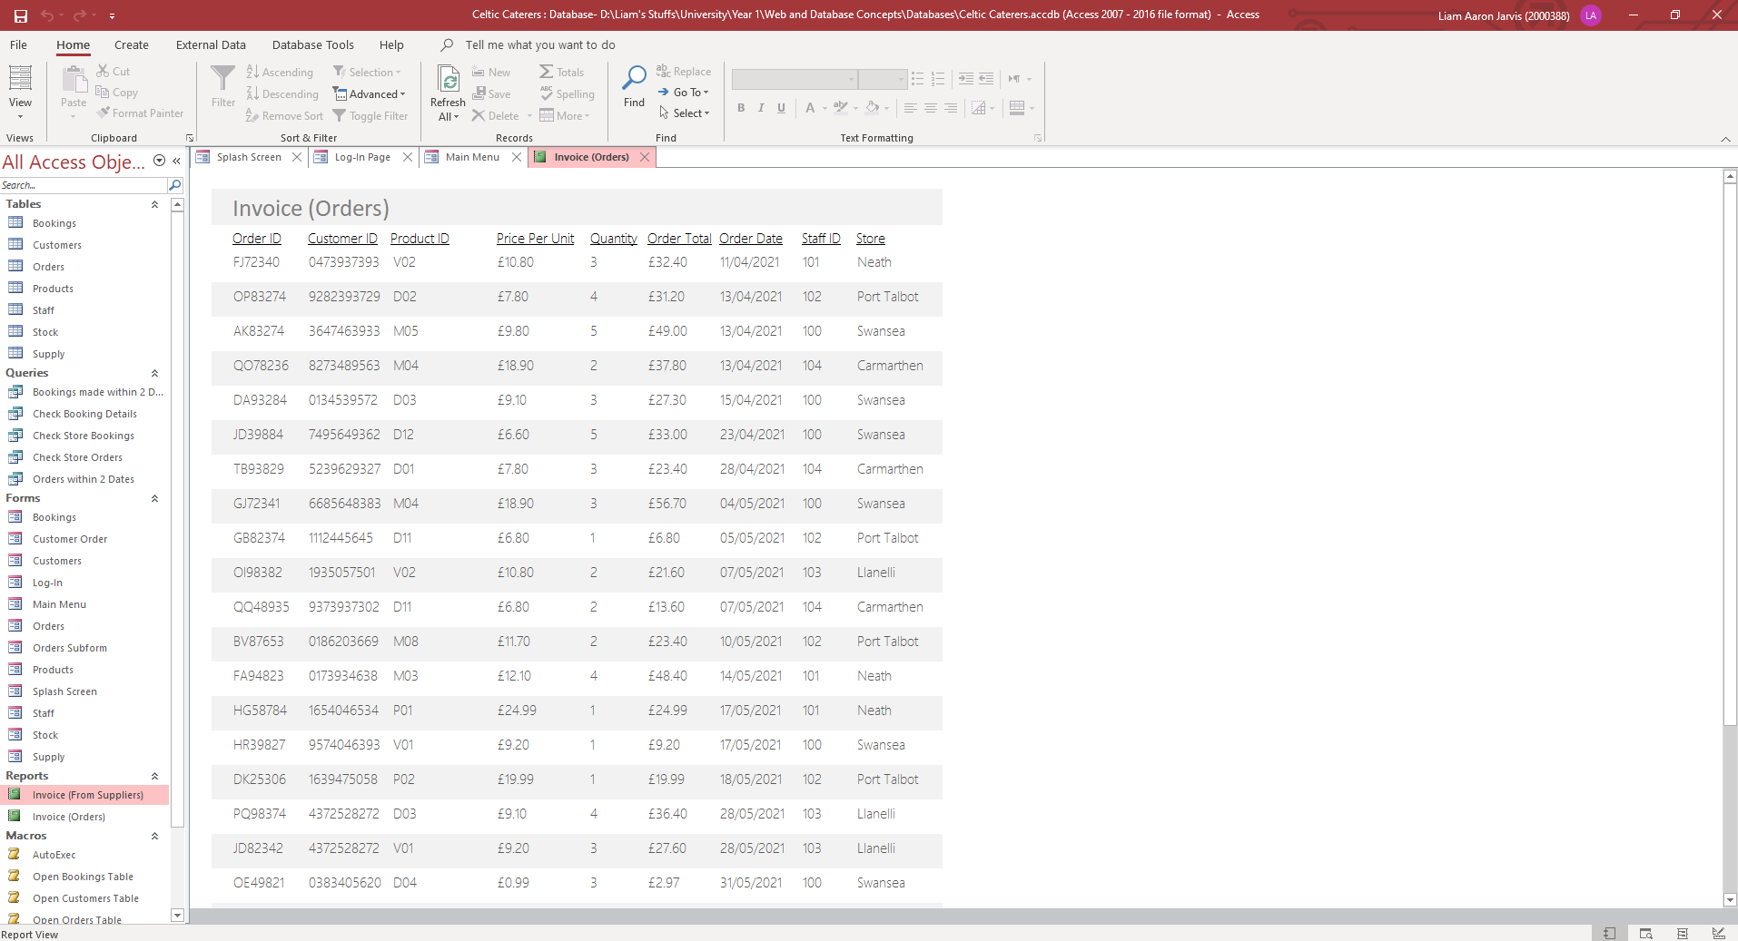
Invoice (Orders):
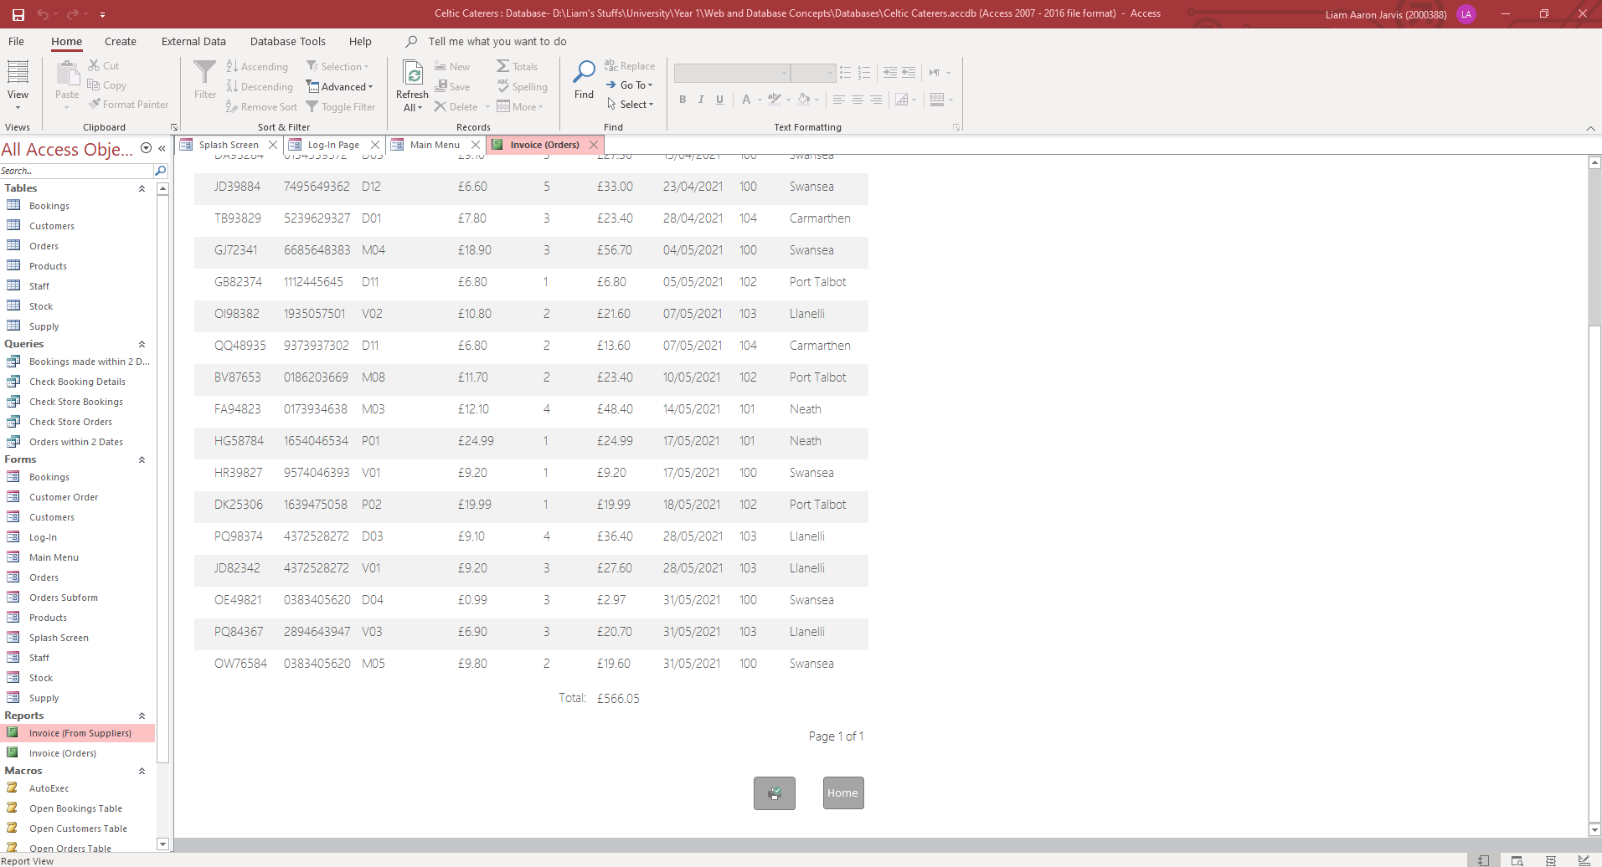
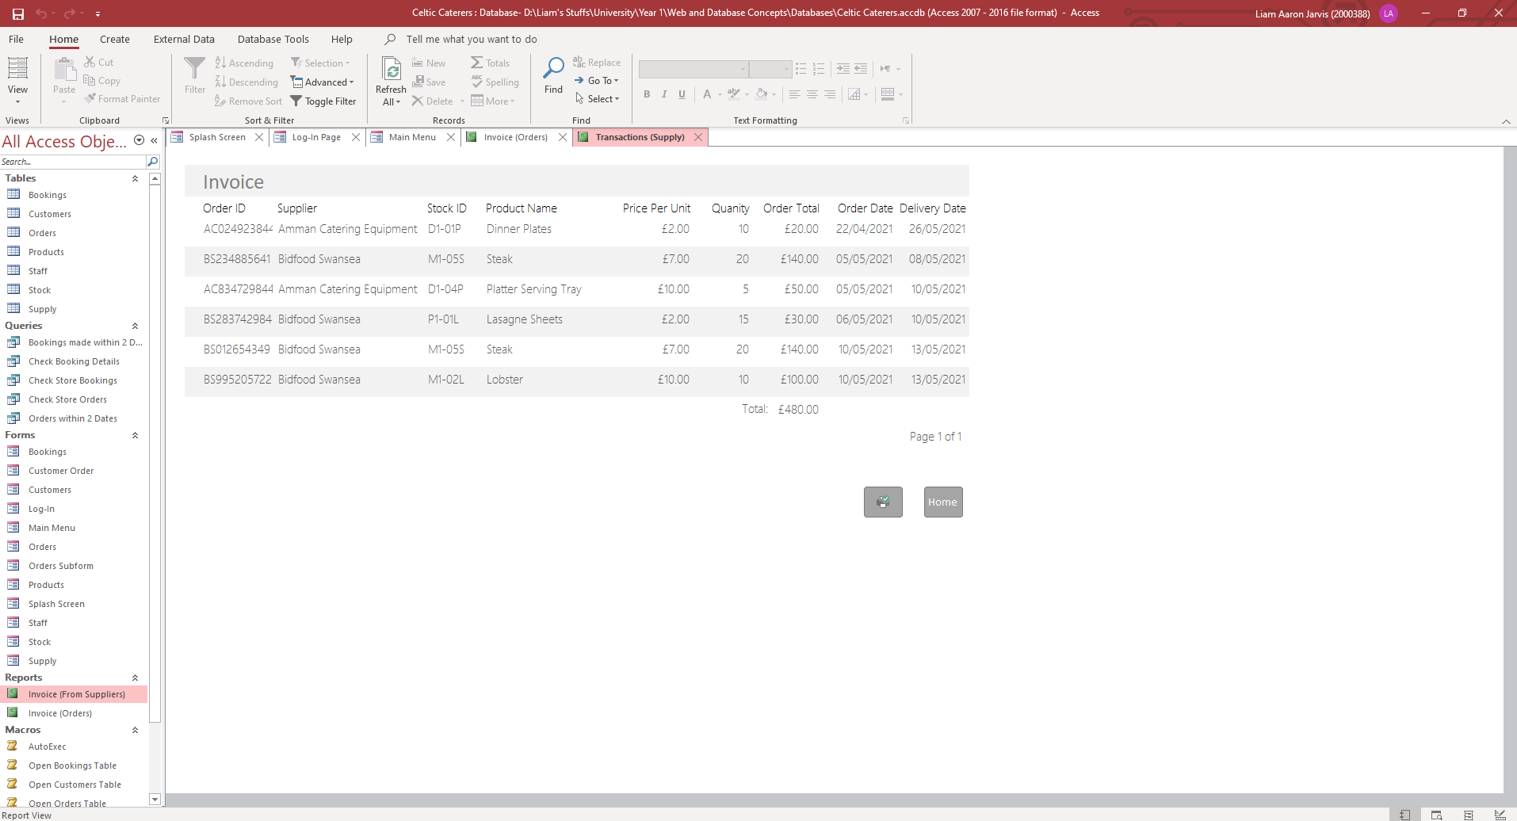
Invoice (From Suppliers):
I have also included a total calculation, that adds up all the Order Totals from each record and displays it at the bottom of the report for each Report.

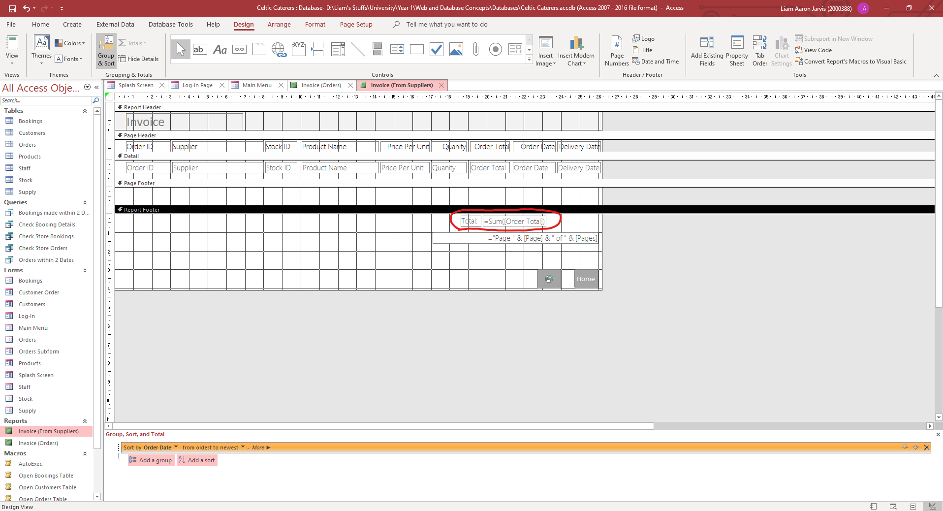
I also added a Home button, and a print button, which allows the user to easily print the Report if needed.

Queries
Queries make “it easier to view, add, delete, or change data in your Access database. Some other reasons for using queries:
- Find specific quickly data by filtering on specific criteria (conditions)
- Calculate or summarize data
- Automate data management tasks, such as reviewing the most current data on a recurring basis.” [6]
I have used Parameter Queries to allow the user to quickly search for specific details within some of the tables. Parameter queries allow the user to enter the criteria for the query, rather than it being predetermined. An example of this would be the “Check Store Orders” button, which runs the related query. This query asks the user to enter the location of the store they want to see orders for. This could be helpful as it allows Celtic Caterers to check which stores are the busiest and have more stock for them, and for less popular stores, they can provide less stock. To create a parameter query, go to the criteria you want to be filtered, and then add an open and closed bracket. Within these, type a message to indicate what the user needs to enter. This is all shown below:

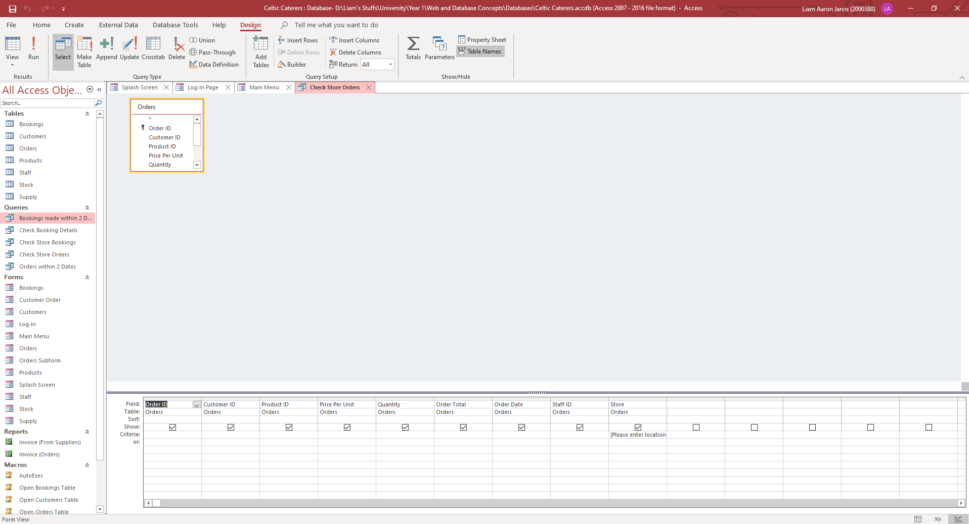
Design view of the “Check Store Orders” query:

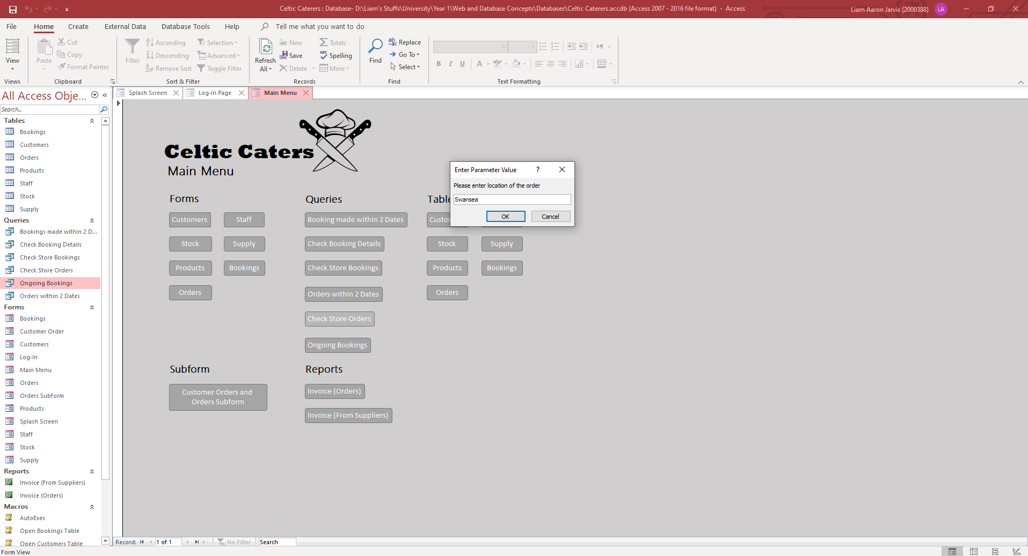
Running the query:

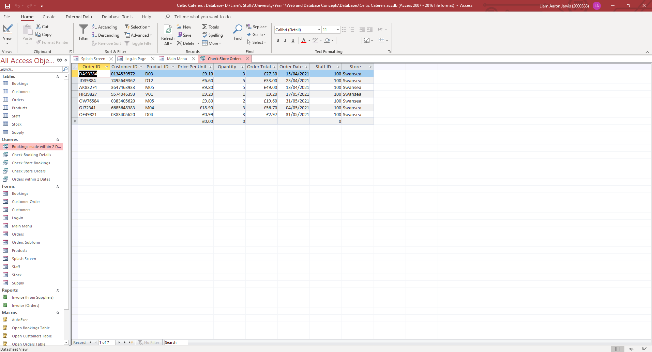
I have also made a single query that checks for bookings that are ongoing and booked for future dates from the current date. To do this, I added the Bookings table to a query, and set the criteria for the field “Booked For” to “>Date()” shown below. Date() will used the current date, and > will check ensure the query checks for all days after the current date:
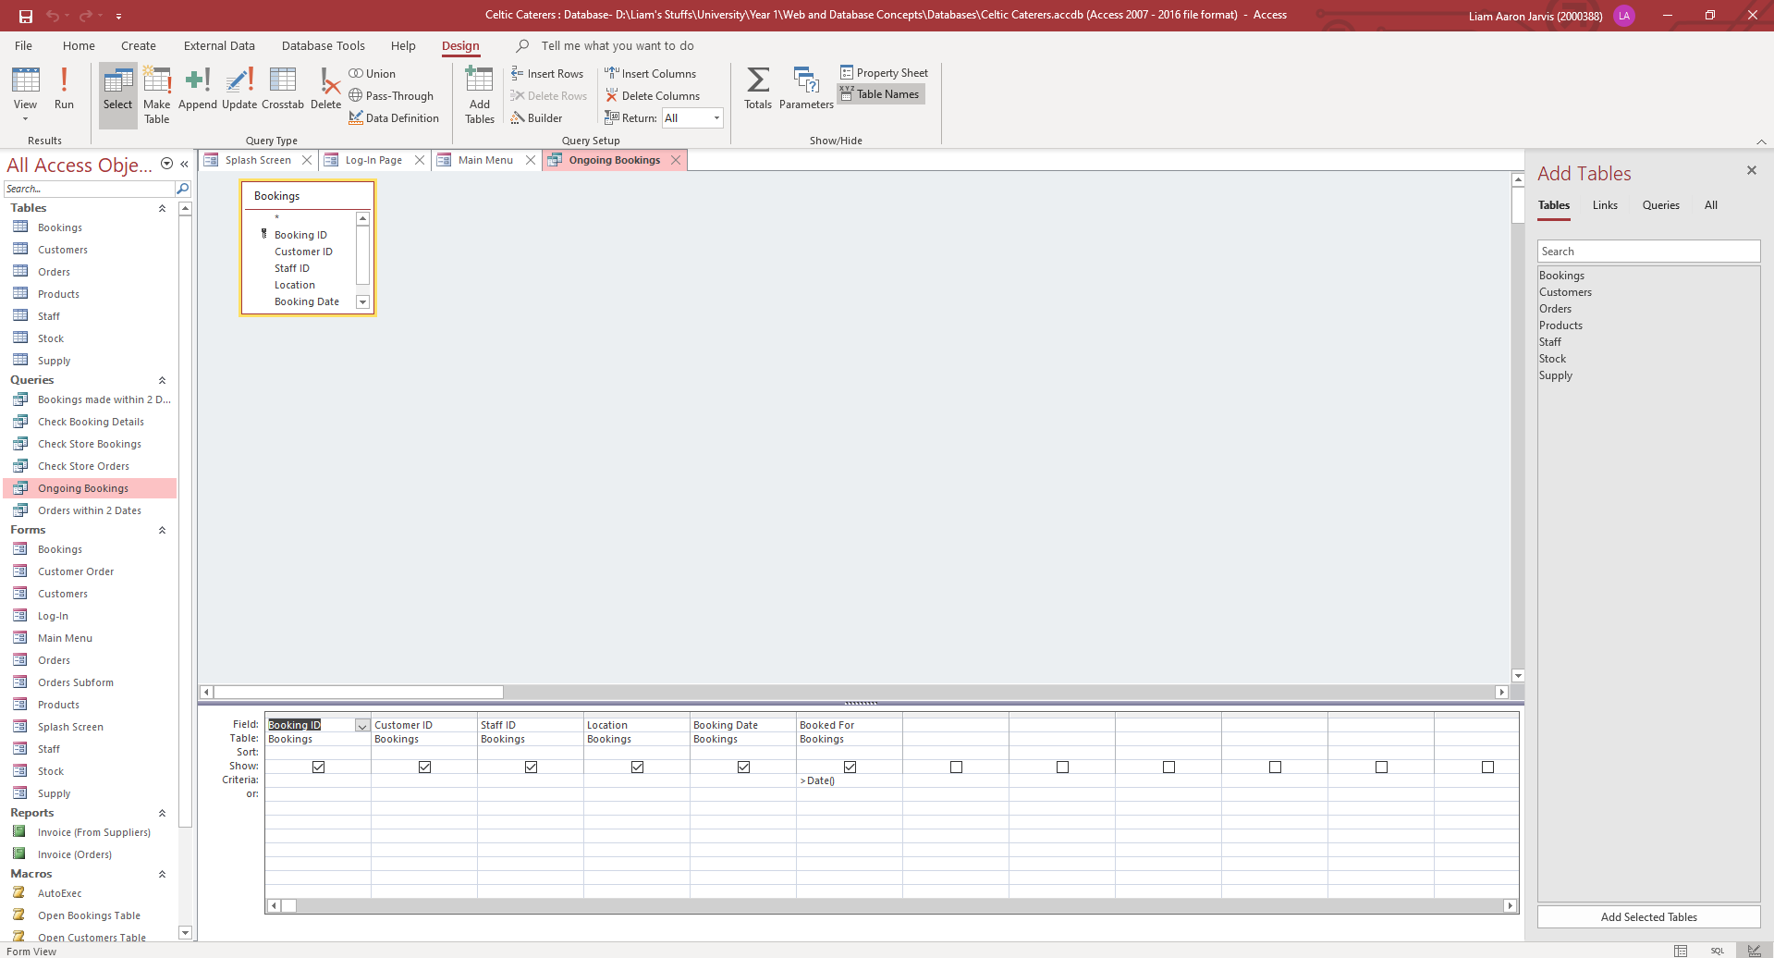
Design View of the Query:
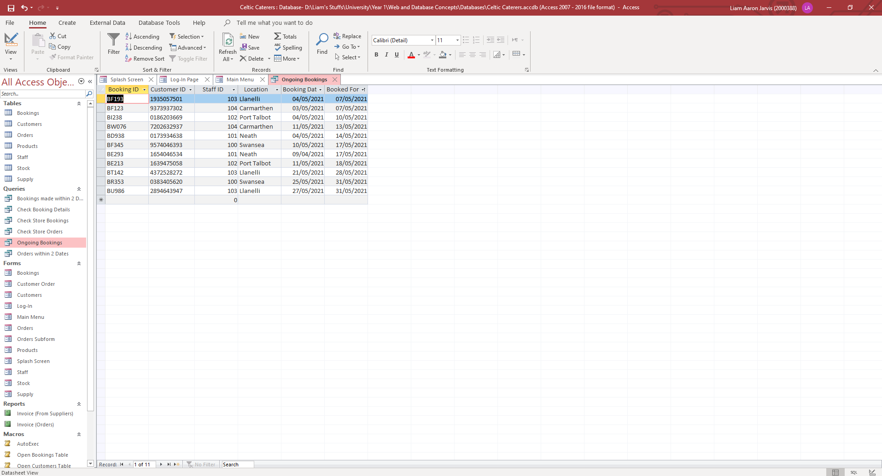
Running the Query (Ran on the 5th of May, therefore showing bookings from May 6th and onwards):

ERD (Entity Relationship Diagram)
An ERD “is a diagram that displays the relationship of entity sets stored in a database. In other words, ER diagrams help to explain the logical structure of databases. ER diagrams are created based on three basic concepts: entities, attributes and relationships. ER Diagrams contain different symbols that use rectangles to represent entities, ovals to define attributes and diamond shapes to represent relationships.” [7] I have made one within Access itself, but also within Visio with included annotation for each of the relationships:
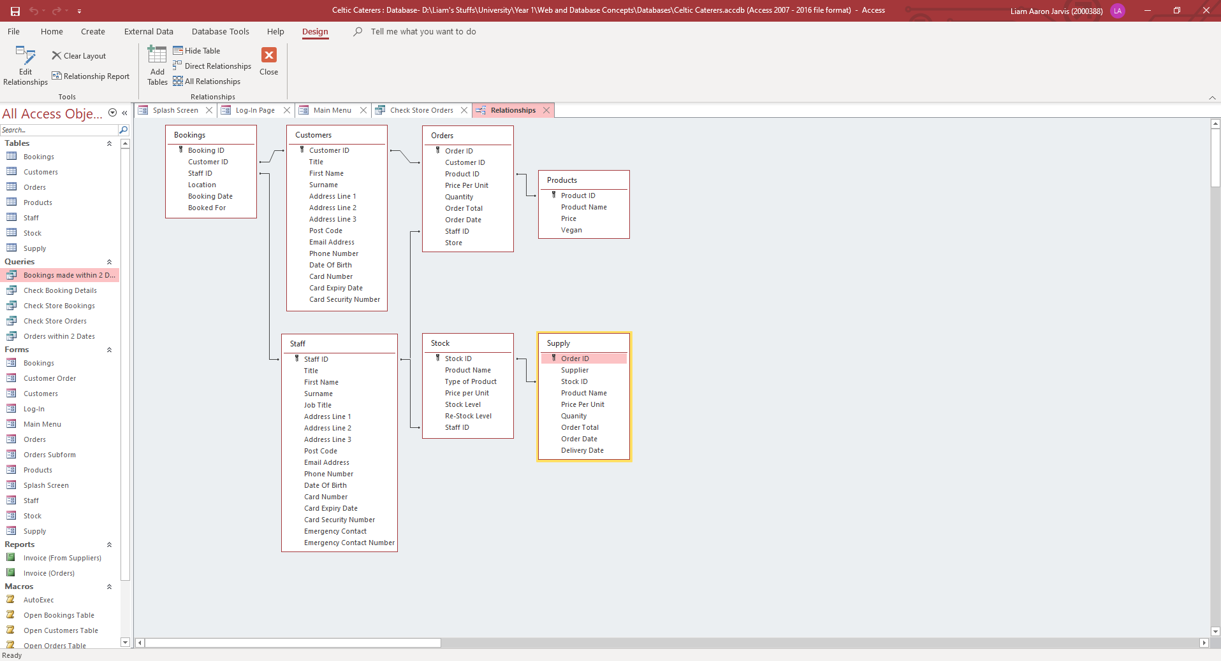
ERD Within Access:

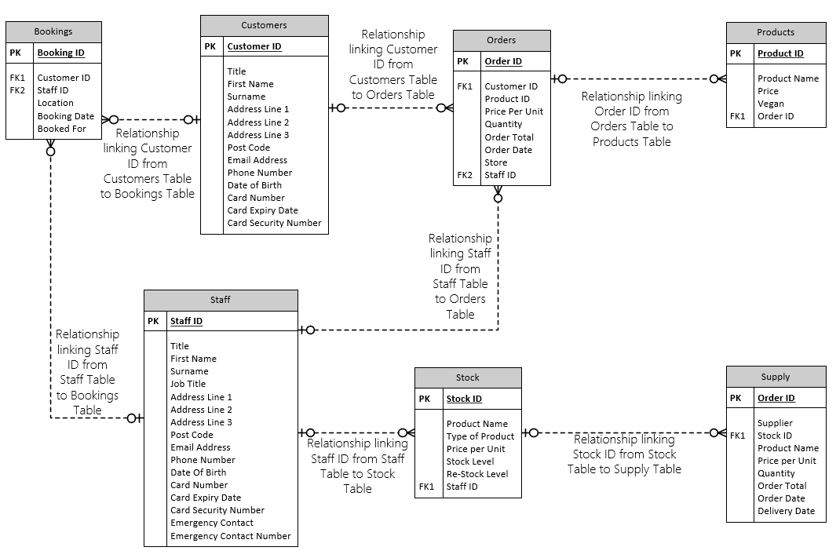
ERD within Visio:

Conclusion
To conclude, I believe I have created a database system that meets and excels the requirements outlined by Celtic Caterers, allowing them to speed up the efficiency of their data processing provisions, and allows them to better display and keep track of their finances, with the use of Reports displaying their incoming and outgoing. I also believe I have shown excellent database analytic and design skills, and documented this well, providing the tables, forms, Reports of the system and showing a clear user guide that could be used to guide anyone through my database. I also used appropriate techniques and tools such as input masks and validation rules to help minimise any data entry errors that could have occurred. Lastly, I have shown a clear grasp of some of the concepts of database systems, such as Context Diagrams, Level 0 DFDs, and ERDs.

Reference List
[1] MSc-IT Study Material, “Context Diagrams”, University of Cape Town, Jan. 2011. [Online] Available: https://www.cs.uct.ac.za/mit_notes/software/htmls/ch06s06.html
[2] Learn MS Access Absolute Beginners, “MS Access - Data Types”, TutorialsPoint, [Online] Available: https://www.tutorialspoint.com/ms_access/ms_access_data_types.htm
[3] Goodwill Community Foundation, “Modifying Tables”, gfcglobal.org, [Online] Available: https://edu.gcfglobal.org/en/access2013/modifying-tables/1/
[4] Microsoft Support, “Control data entry formats with input masks”, Microsoft, [Online] Available: https://support.microsoft.com/en-us/office/control-data-entry-formats-with-input-masks-e125997a-7791-49e5-8672-4a47832de8da
[5] Quackit, “How to Add a Subform to a Form in Access 2016”, quackit.com, [Online] Available: https://www.quackit.com/microsoft_access/microsoft_access_2016/howto/how_to_add_a_subform_to_a_form_in_access_2016.cfm
[6] Microsoft Support, “Introduction to Queries”, Microsoft, [Online] Available: https://support.microsoft.com/en-us/office/introduction-to-queries-a9739a09-d3ff-4f36-8ac3-5760249fb65c
[7] Guru99, “ER Diagram: Entity Relationship Diagram Model | DBMS Example”, guru99.com, [Online] Available: https://www.guru99.com/er-diagram-tutorial-dbms.html

