James Doward (2307692)

ADVANCED CHARACTER ANIMATION – ASPects of identity

Contents
Animation Research 1
Test animations 1
Final animation 1
References 1

Animation Research
Video of transformations in transformers G1
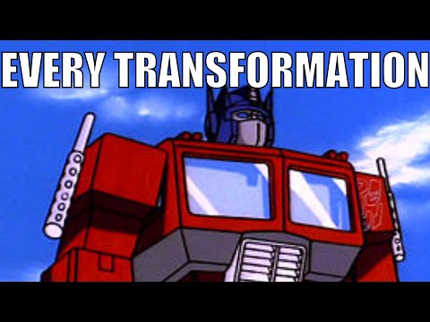 [1]
Fights in G1 Transformers
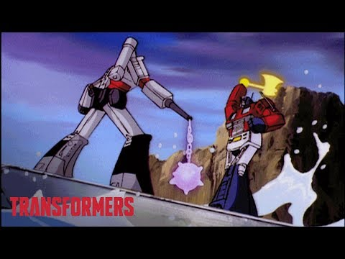 [2]
Video on stop motion animation
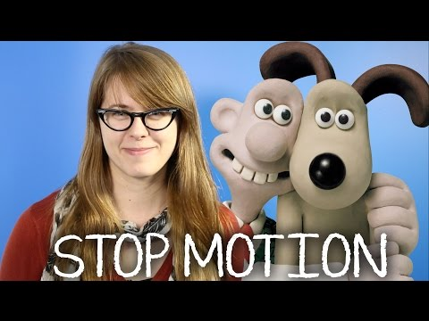 [3]

Test animations
https://youtu.be/7kzD0vOMk9I - First test of stop motion
https://youtu.be/DDjSca-YjUs - Second test with a figure preforming an action
https://youtu.be/wM8ouTpj5L8 - Third test of stop motion
https://youtu.be/3XyDiiL68oI - Fourth test of a figure transforming
https://youtu.be/hS83Qe3L6-Q - Fifth test of a fight between my figures

Final animation
https://youtu.be/QD8gNl1AqC0 - My Final Animation

References
[1] PaperPlane, Every transformation from The Transformers, YouTube, https://www.youtube.com/watch?v=i1Nj1pEz6A0&t=2780s, 30,01,16. (Accessed Nov. 17, 2024).
[2] Transformers Official, Optimus Prime vs. Megatron Top 5 Fights | Series Mashup | Generation 1 | Transformers Official, YouTube, https://www.youtube.com/watch?v=gisNllos7Zk, 21,12,17. (Accessed Nov. 17, 2024).
[3] Mashable, What Is Stop Motion Animation and How Does It Work? | Mashable Explains, YouTube, https://www.youtube.com/watch?v=wVjMFU11hVA, 18,09,14. (Accessed Nov. 17, 2024).

