

Postgraduate Dissertation coversheet&feedback form:

THIS SHEET MUST BE THE FIRST PAGE OF THE ASSIGNMENT YOU ARE SUBMITTING (DO NOT SEND AS A SEPARATE FILE)
For completion by student:
Student Name: Martha H. Noyes

Student UniversityEmail: 1002440@student.uwtsd.ac.uk
Module code: AHAN7025 | Student ID number:  1002440 |  |  |  | Educational support needs:  Yes/No
Dissertation title: Precontact Hawaiian Cultural Astronomy Associated with Kukaniloko, the Piko of the Island of O'ahu in the Hawaiian Islands: Sun Stations and Stars of Cosmogony
Supervisor: Alie Bird |  |  | Word count: 21,030
I confirm that this is my original work and that I have adhered to the University policy on plagiarism.
Signed …Martha H. Noyes…………………………………………………………
For completion by the first marker:
Comments:This dissertation is focused on the precontact Hawaiian cultural astronomy of Kukaniloko exploring its cosmological relationship with the sun and a set of acknowledged cosmogony stars.
This has been a huge but important project, and your strength has been your knowledge and devotion to the subject. However, at times this very knowledge has let you down as you have not ensured that your reader can follow you on your journey. Greater attention therefore needed to be paid to the very structure of your dissertation, along with being pedantic concerning defining your terms as well as being clear with location and describption in your field work. However, that said your work has revealed a sky, landscape, calendar and myth skyscape that, although at times you have leapt to conclusion you have provided enough to hopefully open a new page in this area.

Structure and Relevance – some key problems
Lack of definition of terms
On page 6 you use the terms sun’s stations and sun’s nadir but do not offer a definition of these terms so the reader is not able to follow your argument. You also talk of the location of sunsets in the landscape on the nadir but without definitions of what you mean by the nadir your meaning is lost. Later on page 17 you state, ‘Ruggles discussed the, in his assessment, general opinion among scholars that although the solar zenith was important to Hawaiians, it is uncertain that solstices were’. But without any clarity as to the terms of solar zenith and nadir this is difficult to understand the point you were seeking to make.

You thus needed to make the point early in the dissertation that the solar zenith was the date that the sun’s declination matched the latitude of the location and as such at noon, no shadows would be cast. Then also give that date in the modern calendar. Remember that fFor people that do not live in the latitudes between 23.5 north to 23.5 south, this would be a foreign concept.

Another example of this difficulty is on page 26 where you present a good discussion on the Hawaiian notion of sacredness but you end by writing, ‘One way to try deciphering 'sacred' in Hawai'i is to consult the Pukui and Elbert dictionary. For 'sacred' the following translations appear – kapu, laʻa, laʻahia, ano, ʻihi, ʻiu, poʻiu, ʻula. The definition for each of these words differs in significant ways from each of the others.’ But this does not help the reader, what are the actual translations of these words?

Ethnographical Section and introduction
Parts of your dissertation are written as a journey in that you bring the reader into your world and reveal the research as a serious of discoveries. In many parts the work reads like a novel, which is a valid technique although when doing such a reflexive piece it is essential that terms are clearly explained so the reader is not excluded from parts of your journey.

Additinally this is not helped by you begining your auto ethnographical material without any introduction of who you are, male, female, black, white, age and so forth. When you do introduce yourself this is unfornutaly placed later in your literature review. Thus within your literature review you move back and forth between personal comments, almost diary entries, and then attempt to link your feelings back to some literature. In parts this is very good but the difficulty is that in many places it does not seem to relate to the topic at hand.

Literature Review
Apart from this section containing your reflexive introduction there were other problems. You present an unnecessary short history of archaeoastronomy, unnecessary as you do not need to justify the existence of the subject for your dissertation. You then list a large number of works but tend to focuses on Clive Ruggles’ comments on the role of the role of the sun and then Ruggles comments on Warther’s work. You make the comment that you are familiar with Warther’s work and that you are not in agreement with his conclusion. However, you needed to cite his work directly and comment for yourself on Warther’s work. The reader is thus left wondering as to the role of Warther’s work in your research.

You do make an excellent point concerning Kirch’s views on the nature of the etic and emic issues citing where he uses the distinction to consider the archaeological records at etic and the oral traditions as emic. This is an extremely good point which you could have used as a major bases of your choice of methodology. However instead of building on this point you move to an extensive literature review on the insider/outsider issue in research but this also is not necessary. Your literature review needed to actually focus on the topic of the dissertation. You end your literature review with a topic based bibliography, which should not be in the main part of your dissertation.

Additionally you are working with stars and their movement so your work would have benefited by some of the literature in this field. For example you cite in your bibliography Brady’s paper on the cultural importance of star phases in the Egyptian society, you needed to present some of that material here since you are dealing with star rising and setting. Also based on that paper you would have seen references to Ptolemy’s phases of the stars, and could have followed that source and used it to help discuss the way the stars move through the heavens.

Methodology Section
This begins will with your description of the Hawaiian idea of unstructured free talk (noa) as a means of engaging with people and listening to the stories around the site. This is well done and could have been made central to your methodology. You then move into a generally discussion on quantitative means of taking measurement going back to critics of Alexander Thom and moving onwards from there. Yet your dissertation did not have to establish the arguments around problems of taking measurement all you needed to do was to say that you follow the methodology of measuring a site as promoted by Ruggles or one of the other scholars.

Your employed methodology for working with a star’s altitude also needed to be more carefully researched. It is unclear as to whether you are talking about viewing a star at sea (as you mention navigators) or on land? Normally a star’s visibility is a reflection of its magnitude. Schaefer showed that, for example, if a star had a magnitude of +3, then it would be visible when it was at 3 degrees of elevation above the horizon. However, a star with magnitude +1 would be visible 1 degree above the horizon. Thus your rough measurement of 6 degrees of elevation for the lowest point of a constellation or asterism is not supported by the literature. You could have sought to establish this by observing the phenomena of different stars rising at your key sites, then you could have made your case, but as it is I doubt very much that you would have still use an orb of 6 degrees.

However you present an excellent section on indigenous methodologies, which is one of the strengths of your dissertation. It would have served you to have expanded on these methodologies.

Your Field work Chapter
One of the well done parts of your field work is your linking of the place names to the actual positions of the different sunrise and sunset in the landscape. You have not mention however that this landscape was at Kukaniloko. With any such work the place of observation is central to the field work this needed to be stress, were you standing at the navel stone, or one of the birth stones? Or were you standing in some other location since you later argue that Kulaniloko was the back sight not the foresight.

Also you speak of sunrise and sunsets over mountains so you needed to discuss the elevation of these mountains as that would affect the dates of sunrise or sunset. From the look of the photos that you have included these elevations appear to be quite low, as the mountains are distance, but you did need to address this point in the main body of your paper.

Some questions around the stars
It is not clear how you choose or where you acquired the list of Hawaiian calendar stars? Since these seem to be central to your research you needed to discuss the list in a little more detail. Table 4.2 does not help with this as it seems to be missing some parts. The table implies that all of the events are for when Cancer is at the zenith at sunset, but this would not be the case for the dates of Nov to May which you list. So clearly something is missing from this table.

Star phasing
I note that you are using my suggested terms for the star phases so you needed to cite my paper on this topic. But more importantly you have not really understand the role of curtailed passage stars. You define it as a star that ‘rises the evening of the day star sets at sunrise’ which is a statement which is difficult to understand. The correct definition is a star that is never absent from the sky but will on some evenings be seen to set and rise in the same evening while at other times in the year will behave like a circumpolar star.
Additionally apart from listing the different stage of the phasing for each star it is uncertain as to what use you are making of these star phases. You have five stars that undergo the phase of Curtailed Passage and four that move through the phase of Arising and Lying Hidden (using Ptolemy’s terms) was this significant in any way?

Also you discuss Betelgeuse and talk of its ‘passing over’ a mountain. What do you mean by this term? Betelgeuse would rise quite high in the sky, an altitude of 72⁰, so it would pass over a great deal of the landscape so it is unclear how you could claim it relationship to any one particular mountain.

Thus although your ethnographical work is really interesting and useful for future researchers, plus your ability to write autoethnographical material generally good it is your lack of attention to the finer details of field work that undermines your later conclusions.

Chapter Five
This chapter contains a wealth of oral traditions, name and myths which is well presented, indeed this section is one of the strengths of your dissertation. If you rework this material it would be most useful to give the reader images of the landscape with the different names and myths marked on the images to allow for the reader to appreciate the complex and interrelated nature of the cosmology that you are seeking to present. Most readers will not be familiar with the Hawaiian words and names so you need to give them as much help as possible to make your arguments clear. However you make some good points in this chapter, your finding that,
‘It is apparent that both the names of celestial objects and the names of their landscape markers were purposeful. The names served to recite mo'olelo (stories) and to describe, by implication and references, cultural functions. This provides additional knowledge about precontact Hawaiian culture and its astronomy.’

Is insightful also your finding that the cosmology of the island seems to use the landscape, sky and stories to create pairs. These are findings that would be well worth continuing to research.
There is much in this dissertation which calls out for futher work however the actual structure of the dissertatin, the inattention to the details of defining terms and being clear concerning fieldwork descriptions and the assumption in the fieldwork all do undermine your potentially very useful conclusions.
First Marker’s Mark: 54%  Signature: Bernadette Brady |  |  |  | Date: February 2015
For completion by the second marker:

Comments:

Second Marker’s Mark:  Signature: |  | Date:
NB.All marks are provisional until confirmed by the final examination board.

For completion by the External Examiner:

Comments:

Proposed Mark:

Signature of External Examiner:

Final Agreed Mark:

Precontact Hawaiian Cultural Astronomy Associated with Kūkaniloko, the Piko of the Island of O'ahu in the Hawaiian Islands: Stars of Cosmogony and Sun Stations

Martha H. Noyes

Dissertation submitted in partial fulfillment
of a M.A. in Cultural Astronomy and Astrology
University of Wales Trinity Saint David
2015

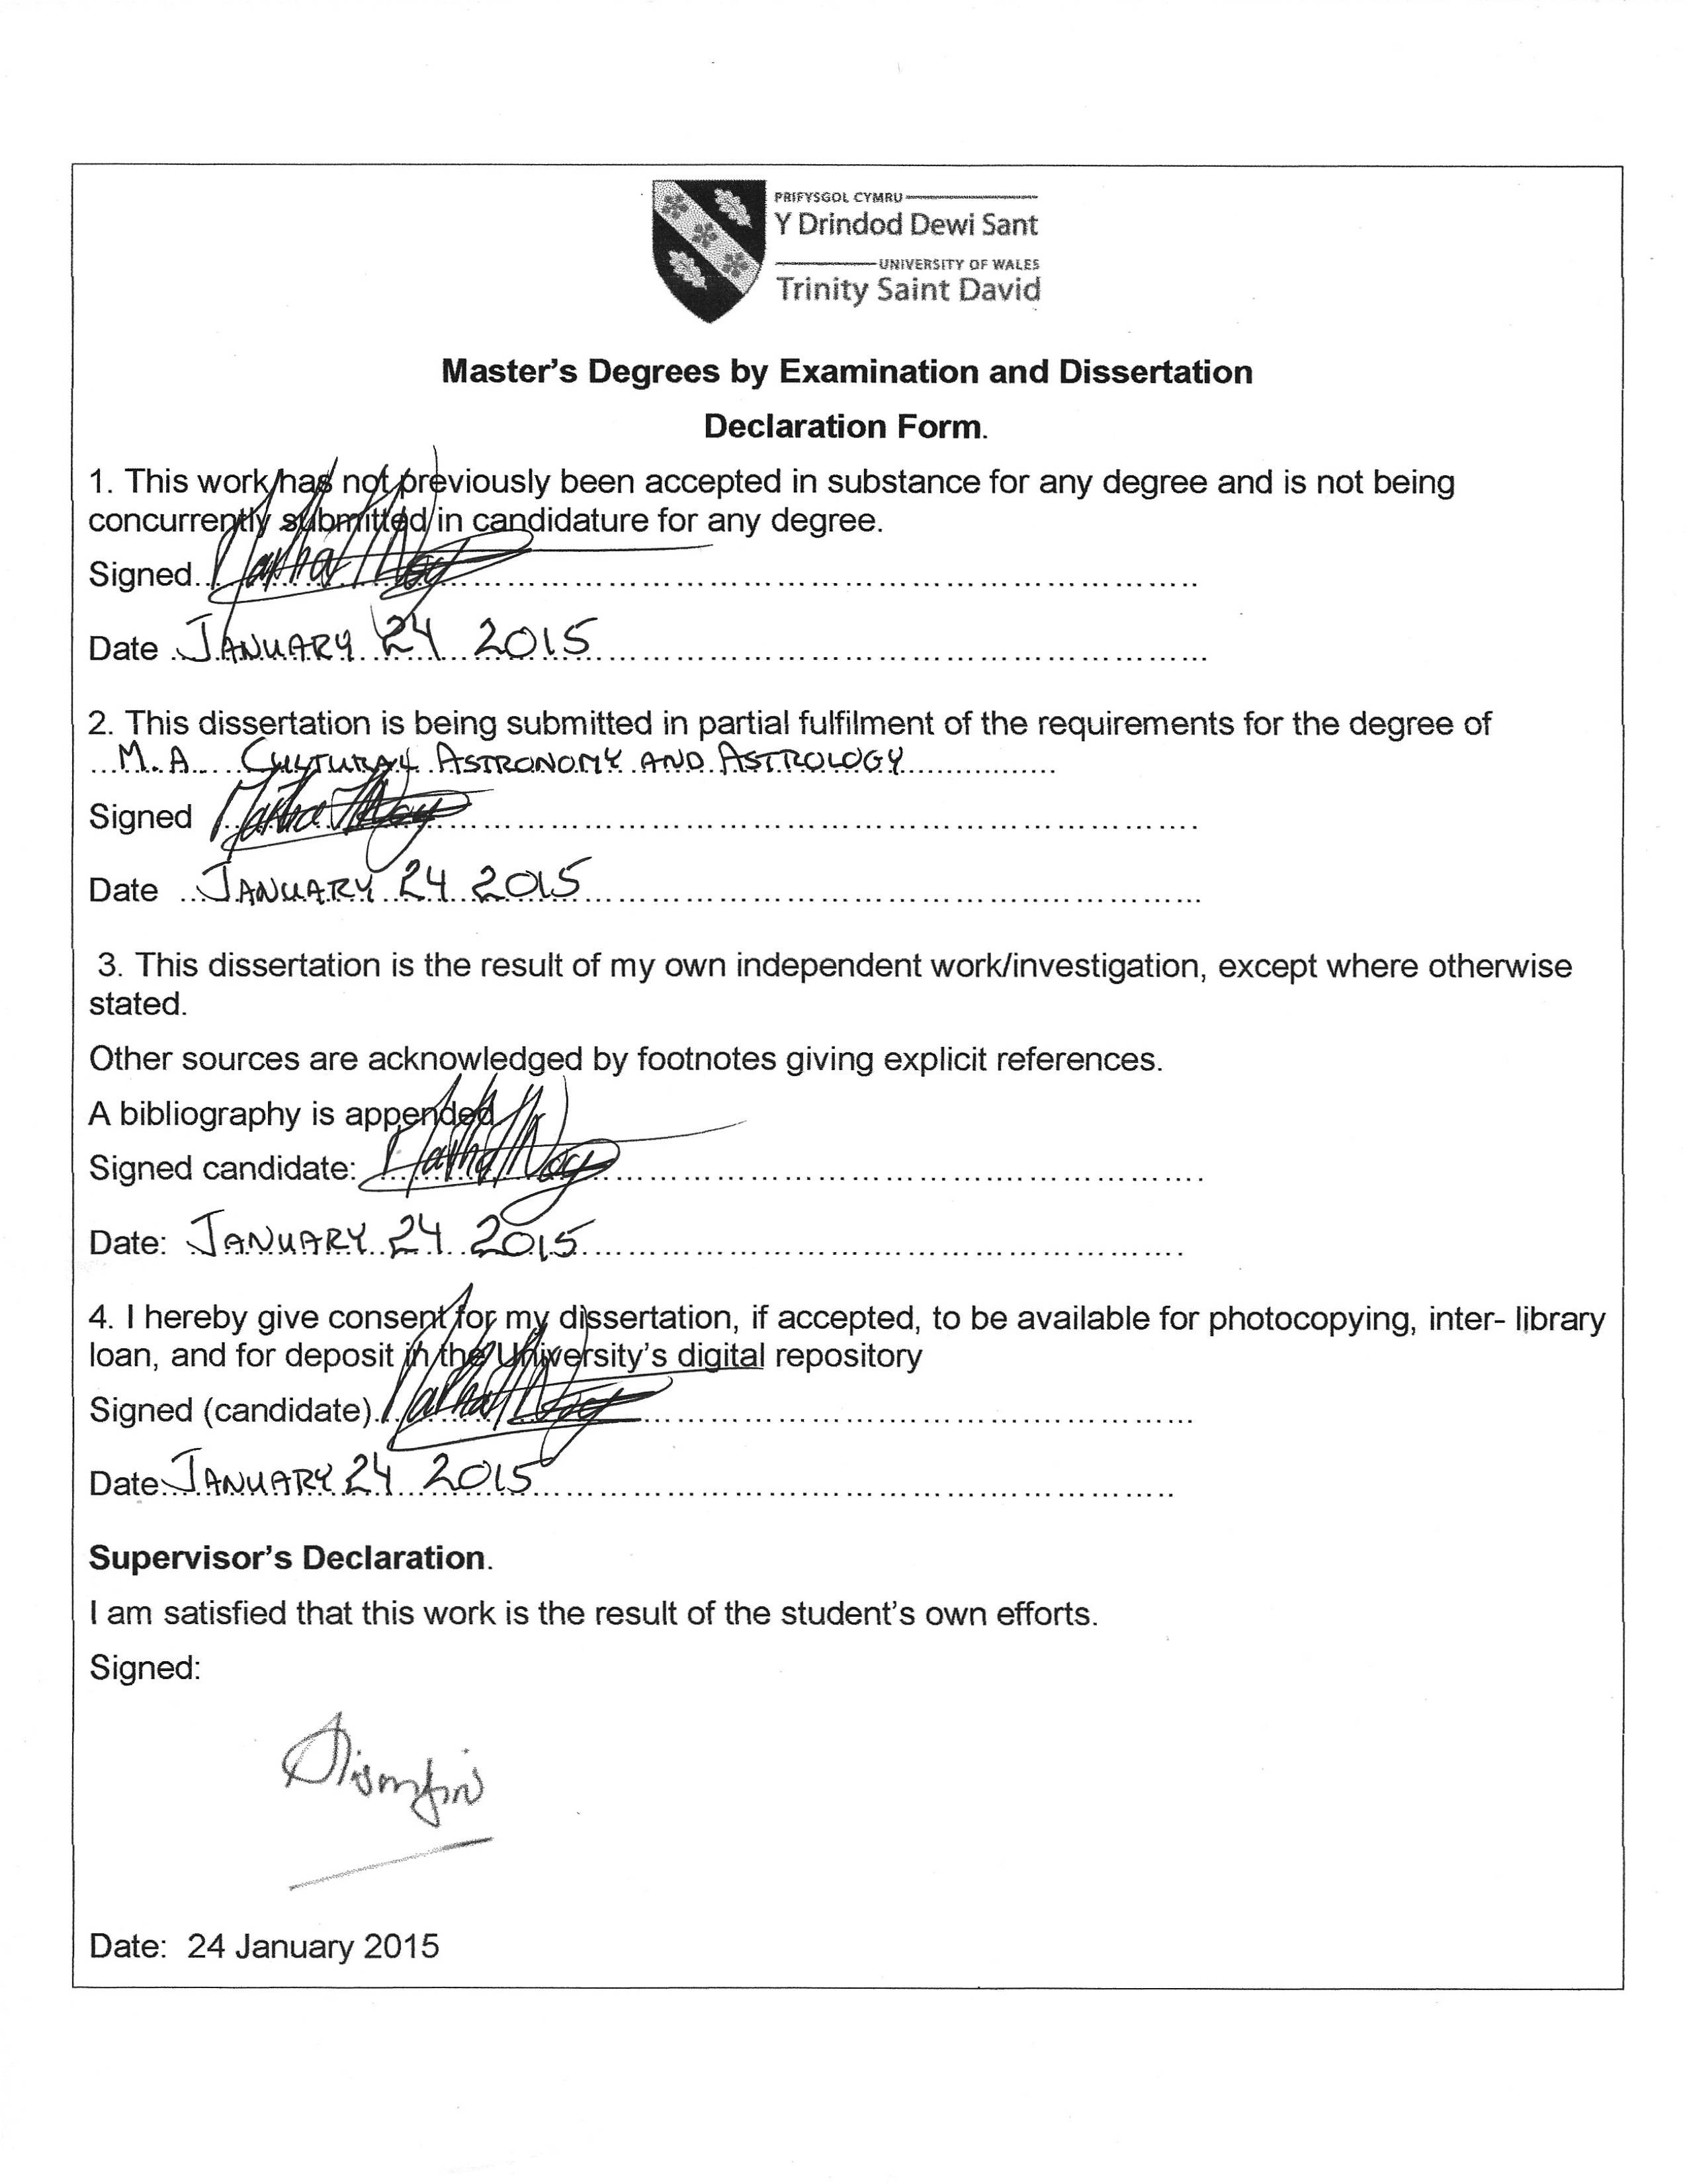
Acknowledgements

First and foremost acknowledgement is offered to Kūkaniloko. She has been, and continues to be, an exciting, inspiring, and astonishing source and center of learning, insight, and understanding. Acknowledgement is also offered to the mentors now gone but whose guidance prepared the way for this work. Among these are Roberto Moreno, Lei Lundberg, Andy Smith, Moe Keale, Bob and Natalie Rivera, and Kalua Kaiahua.
Special appreciation goes to Tom Lenchanko, the kahu of Kūkaniloko. I will always be grateful for his kindness as well as his deep knowledge. The Hawaiian Civic Club of Wahiawā and the Friends of Kūkaniloko are also due my appreciation. Others who have provide advice, information, and supportive friendship include Glen Kila, Keale, Reno Villaren, Alika Poe Silva, and Lani Yamasaki.
I also owe gratitude to those whose emotional support and enthusiasm for my work were a source of constant encouragement. Among these are memberes of the Society for Hawaiian Archaeology, the members of the Pacific Spaces and Sacred Buildings group of the Assocation for Social Anthropology in Oceania, and the History of Astronomy listserve.
Appreciation is more than owed to my dissertation supervisors, Alie Bird and Fabio Silva. Their guidance, and the patience with which they repeated it many times over, their kindness, and their willingness to engage in discussion of fine and not so fine points is what shaped my research into a dissertation, and without that all I would have is piles and piles of paper filled with words and numbers. Mahalo nui loa to Nick Campion who allowed me to be part of the MCAA and who has been very supportive of my efforts not only in the coursework leading to the dissertation but also in my pursuit of knowledge about Hawaiian cultural astronomy.
Last, but not least, my appreciation goes out to my family and my neighbors. They tolerated a lot over the course of the writing, including my incessant babbling about my research.

Table of Contents

Chapter 1: Introduction 1
Chapter 2: Literature Review 13
Chapter 3: Methodology 29
Chapter 4: Data and Findings 40
Chapter 5: Discussion 63
Chapter 6: Conclusion 81
References 85
Appendix 1: Glossary: Hawaiian to English 96
Appendix 2: Place Names 98
Appendix 3: Cosmogony – a very brief outline 108

List of Figures

1.1 Kūkaniloko in Wai'anae Uka on O'ahu, Hawaiian Islands 1
1.2 Oceania 3
1.3 Kūkaniloko 8
1.4 The Wai'anae Mountain Range from Kūkaniloko 9
1.5 Location of Kūkaniloko, USGS Map of O'ahu 9
1.6 The piko stone 10
1.7 The birth stone 10
1.8 Site plan 11
4.1 Stars' Motions 42
4.2 The wide summit of Mauna Kaala 44
4.3 The calendar stars and their location 49
4.4 The stars of Kete 57
4.5 The Regulus stone 60
5.1 The orientation of Kūkaniloko 64
5.2 Map of Wai'anae Moku 66
5.3 Fire plow and fire drill 68
5.4 O'ahu, with star rise and set azimuths relative to Kūkaniloko 71
5.5 Regulus in the sun, daylight turned off 72
5.6 Close up of Regulus in the sun 73
5.7 Regulus in the sun with daylight turned on 73

Table of tables

4.1 The sun stations and their landscape markers 43
4.2 Sunset landscape markers for the day of a star's evening rise 47
4.3 June solstice sun in Gemini 51
4.4 Cosmogonic stars and their landscape markers visible from Kūkaniloko 52
4.5 Cosmogonic stars and their landscape markers not visible from Kūkaniloko 52
5.1 Pattern of pairs 78

Abstract

This project investigated possible precontact (before first European contact in AD 1778) astronomy associated with Kūkanailoko, a site in central O'ahu in the Hawaiian Islands. Because of the extensive and still expanding data, the scope was narrowed to stars associated with Hawaiian cosmogony and the stations of the sun for this dissertation. Both quantitative methods used in archaeoastronomy and qualitative methods, including the emerging Indigenous methodologies and bricolage, were employed to gather and interpret data. The research found that landscape markers were named for, or to symbolize or represent, stars and sun stations at the rise and set azimuths of the sun at the sun eight stations and for the cosmogonic stars, Betelgeuse, the Belt of Orion, Taurus, Gemini, and Regulus. Each of the stars has more than one name in Hawaiian and these names together with the landscape marker names provide information about the cultural function(s) of each star and sun station. An unexpected finding was evidence that the god Io and the period and place in which he existed were known on O'ahu and associated with the solar nadirs and cosmogony. Some principles of Hawaiian precontact astronomy were developed from the project and are included in the dissertation.

1. Introduction

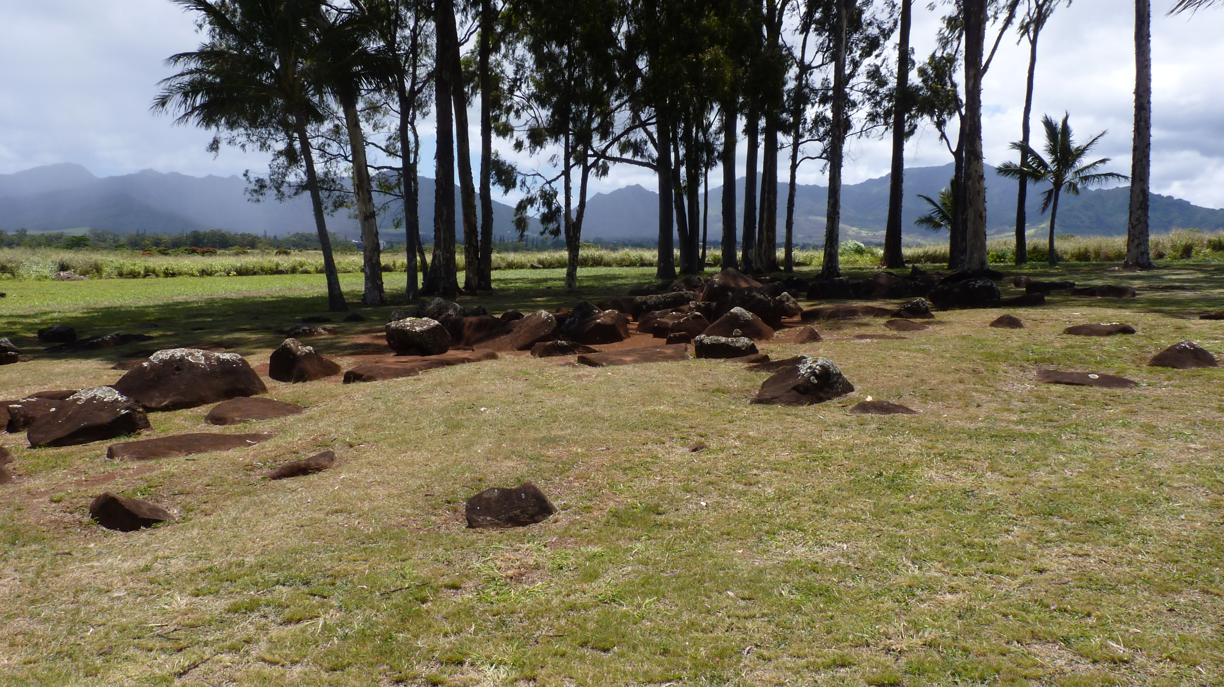
Figure 1.1 Kūkaniloko in Wai'anae Uka on O'ahu, Hawaiian Islands, photograph by the author

The primary purpose of my research for this project was to investigate whether the pre-AD 1400 site Kūkaniloko on the Hawaiian island of O'ahu had been located and constructed with astronomical inentions. Kūkaniloko is the piko (navel, center) of O'ahu, was a birthing site for high chiefs and a pu'uhonua (place of refuge), and quite likely had other functions as well. A stone within the site, known as the piko stone, was thought to be related to astronomy and navigation and perhaps to have been used in teaching those arts. It was also known by the site's kahu (honoured caretaker) and others familiar with the site that the equinox sun rose over Puu Kaaumakua (ancestral guardian mountain) and set over Mauna Ka'ala (sun's path mountain). It thus seemed likely that there were astronomical associations.
There is no previously published work regarding Kūkaniloko's astronomical associations. Three scholars had, however, suggested that astronomy must have been associated with the site. Two of the scholars, Rubellite Johnson and Harry Kurth, focused on the piko stone. Will Kyselka, the third scholar, wrote an unpublished memorandum in which he urged research into astronomical alignments at Kūkaniloko. Kurth died before he finished writing his ideas, and Johnson wrote an unpublished paper from his notes.
I was familiar with the site and with Kāne tradition sites in the coastal region of the moku (land district). I knew people involved with the site and enquired whether they thought it might be a good idea if I embarked on the research. They said yes.Hilo ʻia ke aho o ka ʻike: na kākou ke kuleana e noiʻi noelo aku i ka ʻike kupuna.Braided are the cords of knowledge: it is our responsibility to search for ancestral wisdom. This 'ōlelo no'eau (wise saying, proverb) served as guide and incentive throughout my project.

Hawaiian and other Polynesian contexts and history are not well known beyond Oceania. This chapter, then, is an introduction to Hawai'i and the Polynesian region. Following that is an ethnographic introduction to Kūkaniloko.

1.1 Polynesia generally and Hawai'i specifically
Polynesia is the largest of three regions of islands in the Pacific Ocean. With a few exceptions, all of the islands within these regions are between the Tropic of Cancer (23.5 degrees N latitude) and the Tropic of Capricorn (23.5 degrees S latitude).
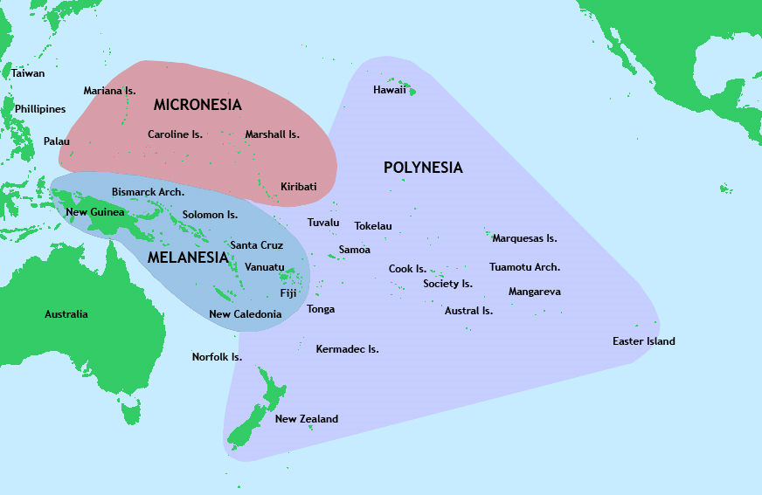
Figure 1.2 Oceania, from Wikipedia Commons

Polynesia covers about 800,000 square miles. The people who became Polynesians are believed to have entered the Pacific from Taiwan and island Southeast Asia between BC 3000 and 1000. By BC 1400, the Lapita culture emerged in part of Melanesia. Lapita culture expanded eastward into Samoa and Tonga around BC 1000 – BC 900, and a Polynesian culture evolved. Polynesians slowly colonised other islands in what is now called the Polynesian Triangle, with Rapanui (Easter Island), Aotearoa (New Zealand), and Hawaiʻi being the last islands settled.
The date of first settlement in the Hawaiian Islands is, according to the most recent studies, approximately AD 800-1000. Over the next few hundred years small chiefdoms expanded their reach. Robert Hommon's and Patrick Kirch's studies place a further expansion, with the transition from chiefdoms to nascent states, in the period from AD 1100-1500.Long distance voyaging to and from Hawaiʻi ceased, or at least greatly dimished, around 1400. In the 1600s the chiefs of Maui and Hawaiʻi islands, apparently eager to claim the wealth of resources on the islands of Oʻahu and Kauaʻi, repeatedly invaded the two northern islands. In the 1780s, Kamehameha, an ambitious war chief of Hawaiʻi Island, united the island of Hawaiʻi under his rule and was ready to move north.
In 1778 British Captain James Cook arrived in Hawaiʻi, making the first contact between Hawaiians and Europeans. When, soon after, other European ships began arriving, Kamehameha captured muskets and cannons along with two men who knew how to use them. By 1810, Kamehameha had succeeded in uniting all the islands under his rule, and the Hawaiian Kingdom was created.
Kamehameha died at the end of 1819. In March of 1820, the first party of American missionaries arrived. In 1893, missionary descendants and American businessmen, with the support of a U.S. warship and a company of Marines, overthrew the monarchy. A republic was formed, but lasted only until 1898, when the United States annexed the Hawaiian Islands as a territory. Hawaiʻi became a U.S. state in 1959.
The frequently used term precontact refers to the time before 1778. Postcontact refers to the time after 1778. The monarchy period, territory period, and statehood period all followed, in that order.

1.3 Introduction to the project
Kūkaniloko is a significant and sacred cultural site. It is situated on the plain of central O'ahu and is considered the piko, or navel, of O'ahu. I also knew, or at least believed so strongly that it felt like knowledge, that Kūkaniloko had astronomical associations. I did not know, though, how to begin investigating these.
Two experiences early in my investigation suggested a course of research. The first was when the project began. I went to Kūkaniloko and stayed there less than a half an hour. I walked around, then sat on the grass to one side, looked at the mountain ranges. Then I went home.
I woke up about three in the morning. I spread a large scale USGS (United States Geographic Survey) map of Oʻahu on the floor. I saw a mountain in the Waiʻanae Range called Puu Kumakalii – Mountain (puʻu) Pleaides (Makaliʻi) Rising (kū). That was intriguing and perplexing. Puu Kumakalii is west of Kūkaniloko. Stars rise in the east. It was impossible from the point of view of Kūkaniloko for the Pleiades to rise over Puu Kumakalii.
Planetarium software showed that on the day the Pleiades rose the sun set over Puʻu Kūmakalii. This was both exciting and annoying. It was annoying because I had not encountered anything in archaeoastronomical literature that said the setting of the sun was associated with a star's rise, and I thought the idea would meet with resistance. It was exciting because it seemed consistent with the importance of Kāne on Oʻahu. Kāne's principal celestial manifestation is the sun. Thus it seemed that the use of the sun to announce the rising of a star was a confirmation of the importance of the sun in Hawaiian astronomy.
The second experience involved another landscape feature visible from Kūkaniloko. Kolekole Pass is a dramatic gap in the Wai'anae Mountain Range. It is so noticeable that it seemed to me that it must have been used to mark something. Kolekole means raw, red, as a wound or earth and to be weak and spent. These meanings did not fit anything I knew about the stars and sun stations I was concerned with. Once again, though, I awoke about three in the morning, this time to get the dictionary. Kolekole is early Hawaiian for 'ole'ole, meaning nothing, negative, suggesting the solar nadir. Again, I went to the computer's planetarium program, this time looking for the location of the sunset on the days of the solar nadir from the point of view of Kūkaniloko. The sun indeed set in Kolekole on the days of the nadir.

1.4 Kūkaniloko: an ethnographic introduction
It is twenty-three miles from my house to Kūkaniloko. That is a long drive on an island of only 597 square miles. I time my trips to avoid the rush hours, leaving home after nine am and leaving Kūkaniloko by two pm. The journey takes slightly less than an hourand takes me on three freeways to Wahiawā town – a little town with remnants of the plantation era alongside fast food outlets, used car lots that cater to the military from nearby Schofield Army Barracks, and mom and pop stores. It is not a wealthy town, but it once had a charm that is being reclaimed.
Once through the town and its traffic lights, the road drops down to the Karsten Thot Bridge over the eastern end of Lake Wilson and Kaukonahua Stream. On the far side of the bridge the road rises with the land for about a quarter mile and flattens onto the Lihuē plain. There is a stoplight where the road levels, at the T-junction of Kamehameha Highway and Whitmore Avenue. Whitmore Village is to the east. To the immediate west is Kūkaniloko, out of sight from the highway.
I start to feel, I don’t know what I feel – anticipation? – as I drive over the bridge and up to the intersection. I wait for the left turn arrow to turn into the red dirt lane. The feeling increases.
Kūkaniloko knows me. Never, not once, have I felt that Kūkaniloko judged me by my appearance or genealogy. Others, though, do judge by appearances. That is part of the feeling of anticipation, anticipation seasoned with some anxiety.
I retrieve the backpack that holds the various tools I might use that day –compasses, clinometer, camera, cell phone and iPad with theodolite apps. I give Stella, my service dog, permission to get out of the car.
We walk around the side of one of the metal posts that hold the chain and padlocks keeping vehicles out, continue down the red dirt road toward the second chain. Bits of black plastic weed barrier stick out of the dirt. On either side of the road tall grass obscures views to left and right.
Just beyond the second chain the view widens. The stones of the site are about fifty yards to my northeast. I see Japanese tourists, one with her hands reverently placed on one of the two stones placed on the southeast just beyond the chain while her partner takes her photograph. They do not know that those stones have only been there a dozen or so years.
Stella and I continue toward the stones, walking between two lines of eighteen small boulders each, placed some years ago to represent the thirty-six chiefs in attendance to witness a chiefly birth. Where the lines of stones end I stop briefly. I do not make a show of my pule – my prayer. I offer my breath, and silently ask permission to enter and explain my purpose in coming.
For now Stella and I are the only ones at Kūkaniloko. Maybe I should get to work gathering data. I do not. I go to the north side of the side, put a kihei – length of cloth – on the ground, and Stella and I sit on it.
I am not really waiting. I am just . . . there.
I see three people coming. I get up, move the cloth and my dog into the shade of the eucalyptus trees on the opposite side of the stones. I do not know why I do that. Maybe it is because my dog and I feel less conspicuous in the shade.
The three people are Hawaiian, a grandmother and her moʻopuna – grandchildren – two boys maybe nine and eleven years old. They have an iPhone and Tutu takes her moʻopuna slowly through the site while the site’s kahu instructs them from a video on the iPhone. The boys, I think, are either home-schooled or students in a Hawaiian culture-based charter school.
I take my iPad from the backpack. Tutu and the boys have gone to the canoe-steering stone. Stella and I go to the piko stone. I crouch to get to eye level with the top of the piko stone. I use the theodolite app to sight across the puka (hole) in the larger of the two sets of concentric circles on the stone’s surface to the birth stone and to the Waiʻanae Range in the distance. I take a few photos through the app, even though the eucalyptus trees obstruct view of the mountains.
I see that the piko (center hole mark) of the piko stone is due east of the birth stone, in other words, and more to the point, the birth stone is due west of the piko stone. Pau – finished – with that small task, I rise and realize Tutu is watching me. I nod.
She approaches, going to a nearby stone. I am sure she is curious about me and what I am doing here. I tell her that I heard Uncle Tom's voice on the phone. She tells me she is homeschooling her moʻopuna.
I can feel her question, so I tell her I am doing some research about how stars were used at Kūkaniloko. I tell her Tom knows about the research. She asks my name. I tell her and fish in Stella’s backpack for a business card. She takes it and I know she will check me out with somebody.

'E o Auntie!' I know that voice. Here comes my nephew. We honi – forehead and nose to forehead and nose. We sit under the eucalyptus trees. We talk, about Kuaokala – the back and/or burden of the sun, the name of the ridge that runs from the top of Kaʻala toward the Point. We talk about the bog/marsh at the top of Kaʻala, about the stones that were carried from Waiʻanae to Kailua on the other side of the island to be used at Ulupō Heiau. We talk about the possible zenith marker on Ka'ena Point.
We leave together. We both want to beat rush hour. Less than ten minutes later we run into each other again inside Tamura Market, at the plate lunch counter. He gets katsu chicken. I get dried ahi. This time we really head to our respective homes.
A good day.

1.5 Site information

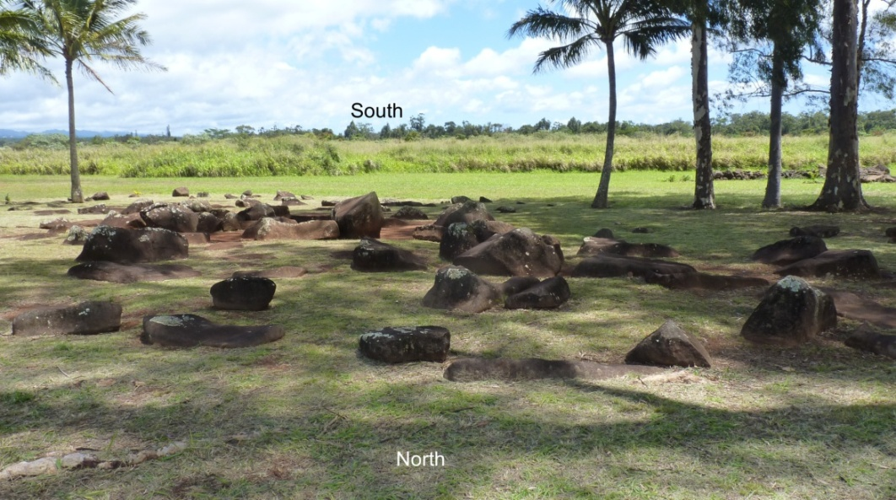
Figure 1.3 Kūkaniloko, photograph by author

Kūkaniloko, thought to have been founded between AD 1200 and 1400, is at 21 degrees 30'29'' N latitude and 158 degrees 02'20'' W longitude, at an elevation of 900 feet.The Waiʻanae Mountain Range is seven miles west, the Koʻolau Mountain Range nine miles east. Both mountain ranges are characterized by a ridgeline running lengthwise. This means that views from the range crests are unobstructed by other mountains and that views from Kūkaniloko extend as far as the crestline and not to the sea. The data, however, show that places beyond the view of Kūkaniloko were nevertheless named as though they were visible.
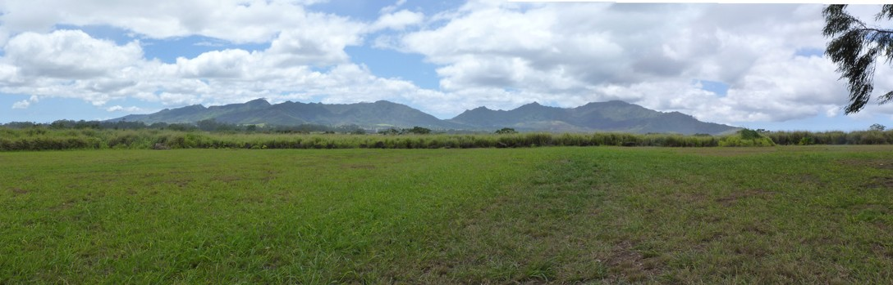
Figure 1.4 The Waiʻanae Mountain Range from Kūkaniloko, photograph by author

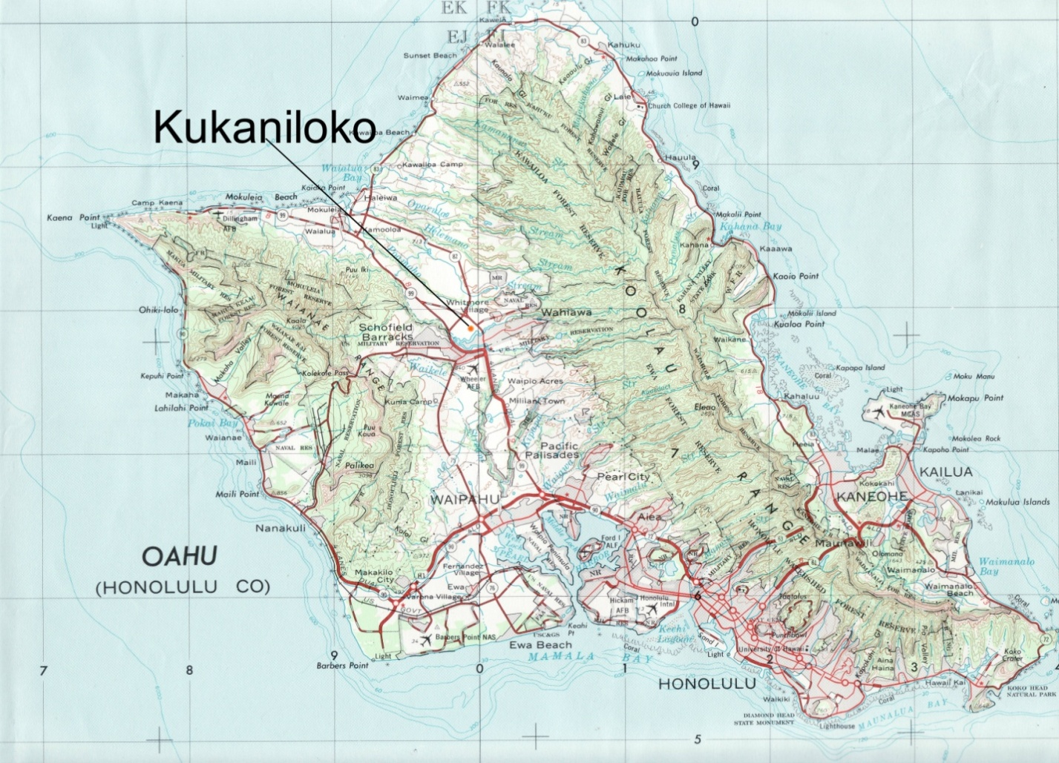
Figure 1.5 Location of Kūkaniloko, USGS map of O'ahu

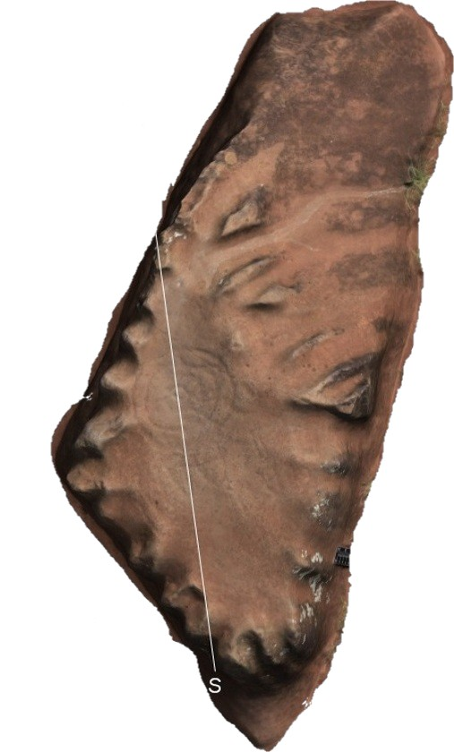
Figure 1.6 The piko stone. The white line runs true north-south.
Photo courtesy of Mike Desilets of Garcia and Associates.

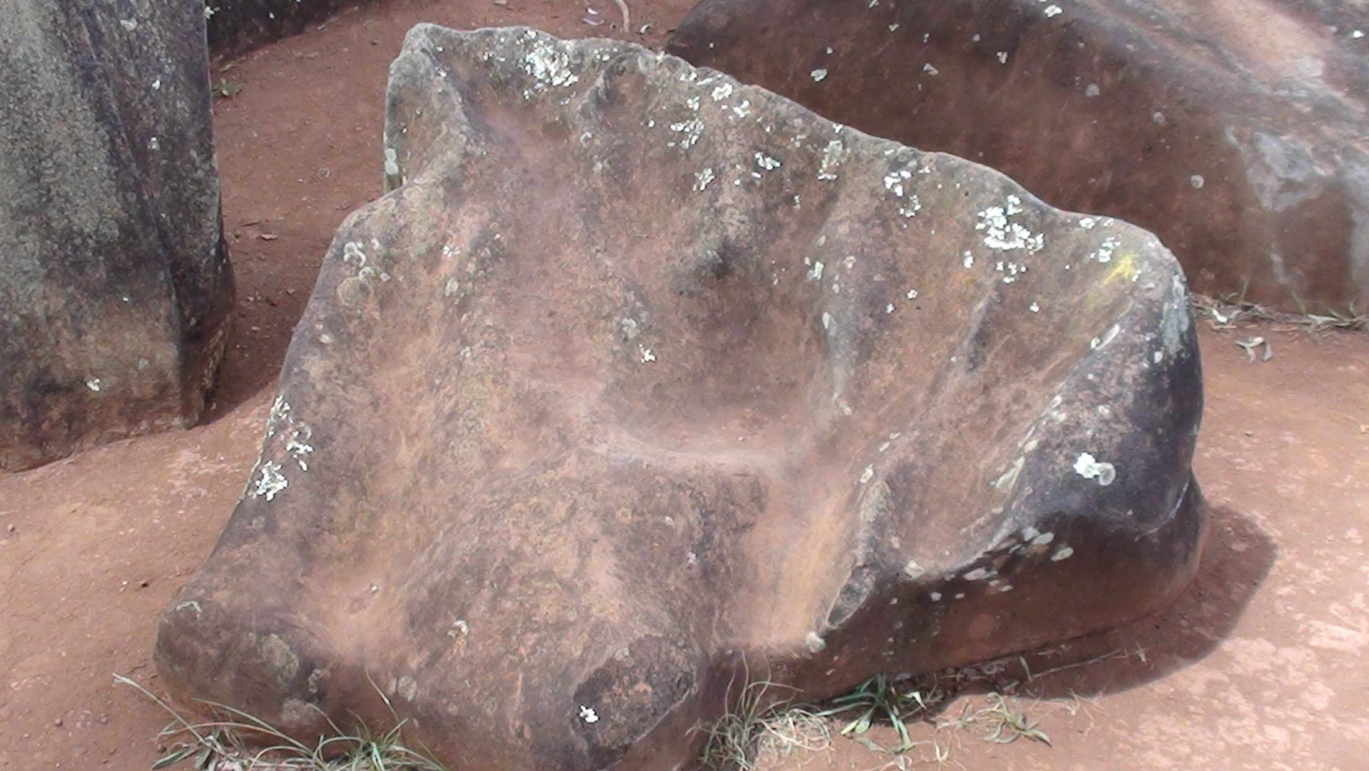
Figure 1.7 The Birth Stone

The following is from nineteenth century newspaper articles by Samuel Kamakau:
A line of stones was set up on the right hand and another on the left hand, facing north. There sat thirty-six chiefs. There was a backrest, a kuapu'u, on the upper side, this was the rock Kukaniloko, which was the rock to lean against. If a chiefess entered and leaned against Kukaniloko and rested on the supports to hold up the thighs in observance of the Liloe kapu [prescribed regulations for birthing], the child born in the presence of the chiefs was called an ali'i, an akua, a wela -- a chief, a god, a blaze of heat.

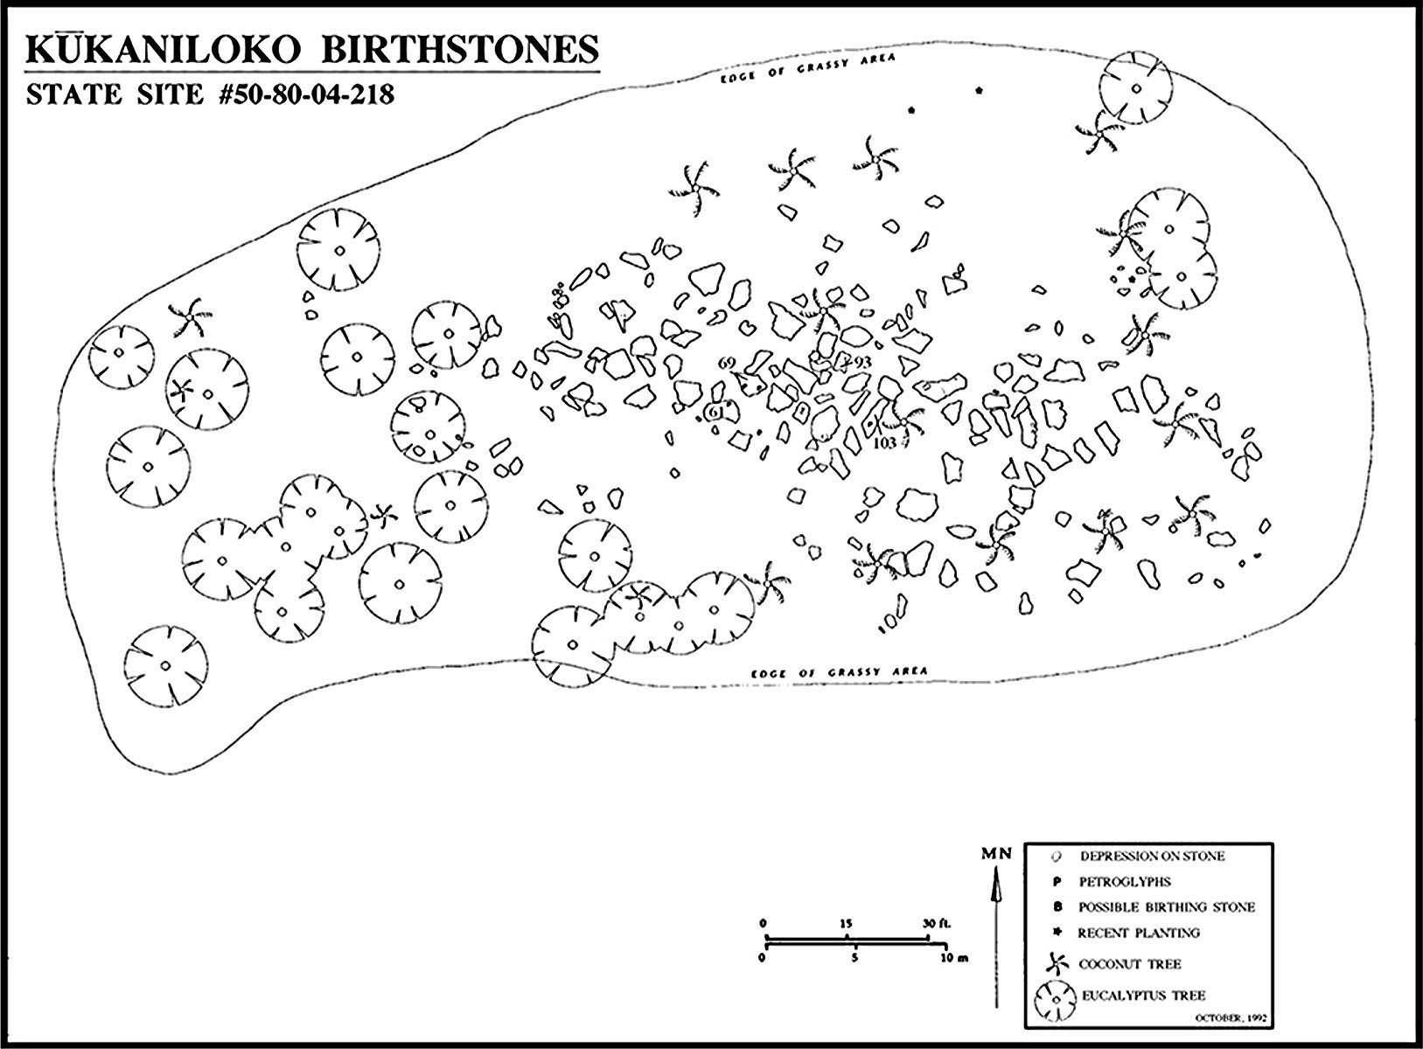
Figure 1.8 Site Plan, State of Hawaii Department of Land and Natural Resources, State Parks Division archaeological survey

Kūkaniloko's importance is recorded on the nomination form for the National Register of Historic Places as follows:
Along with Holoholokū on Kauai, Kūkaniloko is one of only two places specifically designated for the birth of high ranking children. Kūkaniloko is particularly celebrated in recorded traditions as it is repeatedly called upon in commemorating the life-histories of important paramounts in the chiefly lines of Oahu. In ancient Hawaii, genealogical descent from the gods gave chiefs their lofty status and hence, established their right to be leaders of society. Birth within the ritual setting of Kūkaniloko served to legitimize this genealogical descent and their godly status was further enhanced if the rituals and prohibitions performed at birth were completed successfully.

1.6 Organization of the Dissertation
The next chapter reviews literature relevant to the study. Chapter 3 outlines the methodology used in the research. Chapter 4 presents the data and findings. Chapter 5 discusses the data interpretations and analysis. Chapter 6, the final chapter, presents conclusions and suggested directions for future research.
Notes:
- Unless otherwise stated, all Hawaiian word definitions are taken from the Pukui and Elbert Dictionary of the Hawaiian Language.
- Diacritical marks follow a convention that omits them for place names and names for which diacritical marks are uncertain, such as star names, which were rendered in writing before diacriticals were in use.

2. Literature Review
2.1 Introduction
My project was to research possible astronomical associations of Kūkaniloko, the precontact site that was (and still is) the piko (navel) of the Hawaiian island of O'ahu. This required resources across several fields. Cultural astronomy/archaeoastronomy was one, but it had to be informed by Hawaiian language, ethnologies, precontact history of O'ahu, and Hawaiian and other Polynesian cultural knowledge resources. It also called for literature from anthropology on insider-outsider considerations, notions of sacred space, and epistemological foundations of Hawaiian and Pacific Islander knowledge-gathering and knowledge-making.
Many references were required for simple data such as dates, god names, star names, and so on. These non-contentious works are recorded to back up my study. Other works prompt discussion of concepts relevant to my project.

2.2 Cultural Astronomy/Archaeoastronomy
British archaeoastronomer Clive Ruggles wrote that 'archaeoastronomy can be defined as the study of beliefs and practices concerning the sky in the past and the way people used their understanding of the skies'. The Center for Archaeoastronomy, distinguishing archaeoastronomy from the history of astronomy, described it as 'the anthropology of astronomy'. The University of Wales Trinity Saint David's Masters degree programme in cultural astronomy and astrology defines cultural astronomy 'as the study of the application of beliefs about the stars to all aspects of human culture, from religion and science to the arts and literature. It includes the new discipline of archaeoastronomy: the study of astronomical alignments, orientation and symbolism in ancient and modern architecture'.Nick Campion defined cultural astronomy as 'the use of astronomical knowledge, beliefs or theories to inspire, inform or influence social forms and ideologies, or any aspect of human behaviour. Cultural astronomy also includes the modern disciplines of ethnoastronomy and archaeoastronomy'. In short, my research project involved, by any definition, a multidisciplinary approach to the question of astronomy associated with Kūkaniloko.
The first person to use the word archaeoastronomy in print was Elizabeth Chesley Baity in 1972. The activities associated with archaeoastronomy are, however, older than the coining of the word. Gerald Hawkins wrote Stonehenge Decoded in 1965, using an early computer to aid his study of alignments at Stonhenge. Hawkins's contemporary, Alexander Thom, used tools and techniques of surveying at megalithic sites in England in order to assess astronomical alignments. Thom's work has been much criticized, but, as R.J.C. Atkinson wrote in his obituary for Thom, 'It is not often that a man can be said to have created, single-handed, a whole new academic discipline . . . had it not been for his relentless pursuit . . . it is doubtful whether the subject of archaeoastronomy would have existed at all'.
Archaeoastronomy matured and a division between Old World and New World approaches to the subject emerged. Dubbed 'brown' for the New World and 'green' for the Old World by Anthony Aveni because of the color of the covers of the two books resulting from the 1981 Oxford International Symposium on Archaeoastronomy, the division centred on the absence of ethnological and anthropological information about the builders of Europe's megalithic sites and the relatively ample presence of such information about cultures in the Americas.
Several scholars have noted – among them David Tuggle and Patrick Kirch, (archaeologists whose work has largely been in Hawai'i and the Pacific), Will Kyselka, (lecturer at the Bishop Museum in Honolulu), and British archaeoastronomer Clive Ruggles – that little research regarding cultural astronomy/archaeoastronomy has been conducted in Hawaiʻi. Foundational to the research that has been done are works by New Zealand born Elsdon Best (1865-1931) on Maori astronomical knowledge, Vassar College professor and astronomer Maud Makemson (1891-1977) on Hawaiian astronomical concepts, and the almost-always-referenced canonical nineteenth century Hawaiian writers Samuel Kamakau and David Malo. Kamakau (1815-1876) was a Hawaiian scholar and historian, educated on Maui at the Lahainaluna Seminary. Reverend Sheldon Dibble instructed Kamakau and other Lahainaluna students to gather and record Hawaiian language, culture, and history. David Malo (1793-1853) was a member of the first class of Lahainaluna students. He gathered information and made notes on Hawaiian religion and culture, and his book Moolelo Hawaii (Hawaiian Antiquities is the English title), along with the works of John Papa I'i, Kepelino, and Kamakau, make up the major portion of the Hawaiian 'canon'.
Patrick Kirch carried out archaeological work on Maui in which he incorporated archaeoastronomy. Resulting from this work were two papers on celestial alignments, one written with Clive Ruggles and Warren Sharp, while the other he wrote as sole author. There are a couple of problems with Kirch's papers. He assumed that alignments to each cardinal direction corresponded to one of the four 'principal' gods, Kū, Lono, Kāne, and Kanaloa. That correspondence, however, is not entirely correct. Kirch was relying on Valerio Valeriʻs Kingship and Sacrifice. However, Valeri was speaking of the cultural mechanisms and functions of human sacrifice, a practice almost exclusively associated with the god Kū. On O'ahu, Kāne was the dominant god, at least until the late 1700s when the chiefs from Maui and Hawai'i islands began efforts to conquer O'ahu. Further, Kirch assumed that as Kāne was the sun or associated with the sun that an orientation to the east and indicated a Kāne temple. The sun, though, also sets, and it sets in the west, a direction associated not only with Kāne but also with Hawaiian ancestors and origins.
Ruggles noted Kirch's determinations but expressed doubt, concerned that in some cases the azimuth did not match the cardinal direction and that another assumption, that the Pleiades were indicated by a site alignment toward a rise azimuth, was likewise not close to the temple's alignment. In the same chapter, Ruggles discussed the, in his assessment, general opinion among scholars that although the solar zenith was important to Hawaiians, it is uncertain that solstices were. Here, as in the case of Kirch, specific knowledge of the Kāne traditions might have led to a different conclusion. The June solstice had particular importance in the Kāne traditions as it was at this time that the deceased were able to return to earth to visit with the living.
Ruggles referenced Warther's and Meech's work which posited that distant topographic sites, together with hula chants, may have had astronomical associations. Elsewhere he referred to Warther's and Meech's work as presenting some valuable considerations. He wrote:
Warther's work . . . has opened up several new avenues of enquiry that can be addressed by combining archaeoastronomical and historical research. In particular, it has suggested that:
- Astronomical alignments involving distant topographic foresights, viewed from heiau, formed an important component of Hawaiian sacred geography;
- Certain sacred ceremonies, performed at particular heiau, were scheduled in relation to observable astronomical events; and
- Observations of the zenith sun, and estimates of the time of nadir (anti-zenith) passage, were of importance for calendrical regulation.
I am familiar with Warther's work, had corresponded with him for several years prior to his death in 2013, and he sent many of his papers to me. Although I often privately questioned his conclusions, I was impressed by his attention to cultural traditions not usually consulted for in cultural astronomy. The questions and considerations Warther's work inspired in Ruggles were questions and considerations that helped inform my research.

2.3 Hawaiian Cosmogony
The usual sources for Hawaiian cosmogony are Martha Beckwith's translation of the Kumulipo creation chant and Beckwith's Mythology, chapters one, nineteen, twenty, and twenty-one. There are other translations and other cosmogonic genealogies, and the mo'olelo (stories) involving events and characters of cosmogony appear in many collections of Hawaiian myths and legends, including Fornander and Kalākaua.
The first seven wā (eras) of the creation chant take place during pō, the period of darkness preceding the advent of humankind. Ao, the world of light, begins with wā eight. A generalized outline of the people and events follows.
Pō is the realm of darkness, the period of the creation and development of forms in ascending order of complexity. Pō comes to a close when dogs and dog-men are created. Ao is the realm of light and humankind.
Pō does not end, however. It continues as the realm of the deceased, ancestors, gods, the unknown, and the unborn. The terrestrial boundaries of pō and ao are the Tropic of Cancer at 23.5° north and the Tropic of Capricorn at 23.5° south. The realm of ao, then, is defined by the limits of the ecliptic, the sun's annual path called in Hawaiian ke ala a ke kuukuu, the path of the spider. Beyond the Tropics is pō.
Early in ao came Wākea (Sky Father) and Papa (Mother Earth). In some versions they are the parents of the male gods, Kāne, Kanaloa, Kū, Lono, and others. Wākea and Papa have a daughter, Ho'ohokukalani. Wākea wants to lie with Ho'ohokukalani and institutes kapu that separate men and women at certain times. While Papa is in a separate dwelling, Wākea sleeps with Ho'ohokukalani. Papa finds him with their daughter. Angry, Papa leaves Wākea and takes the name Haumea.
Ho'ohokukalani is pregnant with her father's child. The child, a boy, is premature and stillborn, named Hāloa, and is buried in a corner of the yard where the first kalo (taro) plant then grows. Ho'ohokukalani is pregnant a second time, this time giving birth to a healthy boy, also named Hāloa, from whom all Hawaiians are descended. Thus kalo is the older brother of Hawaiians.
La'ila'i, the first human woman, and Ki'i, the first human man, appear. Kāne intends to father La'ila'i's first child, but Ki'i sleeps with her first, and a boy is born. Through the Polynesian tradition of primogeniture this event makes humankind's line senior to that of the gods', thus setting up the reciprocal relationship between humankind and deities.
The next section addresses the literature consulted regarding the insider-outsider issue, an issue that has bearing on 'insider knowledge' also known as 'local knowledge', matters that have impact on knowledge of and access to knowledge of culture.

2.4 The Insider-Outsider Debate
I am not Hawaiian. I moved to Hawai'i with my parents and brother when I was fifteen. Before moving to Hawai'i we had never lived anywhere for more than three years. I have at the time of this writing lived in Honolulu forty-nine years.
I do not think of myself as an insider or an outsider. I think of myself, when I think of myself in anything close to those terms, as inhabiting the interstices – the space between and connecting cultures. That is where I have always lived, no matter what neighborhood my house was in.
It was linguist Kenneth Pike who coined the terms emic and etic and Marvin Harris who developed their use in anthropology. Pike intended the terms to define two research orientations in acknowledgement that researchers were situated in relation to their fields of study and not necessarily objective. The terms emic and etic, however, do not have firm definitions or clear boundaries. One approach has been to look at the researcher's position relative to the culture she/he researches. Is the researcher a cultural insider or a cultural outsider, or somewhere between?
Those distinctions, however, do not settle the matter. In a recent book, archaeologist Patrick Kirch, much of whose work has been in Oceania and who grew up in Honolulu, described the difference between emic and etic in terms of the kinds of materials the researcher uses. He takes the archaeological record to be etic, but the use of oral tradition, myths, chants, indigenous cosmogonies, and materials written by members of the culture being researched to be emic.
Kekuewa Kikiloi, a native Hawaiian archaeologist, defines the terms differently. He writes that 'there are some important conditions that should be considered when investigating and interpreting Hawaiian oral traditions. The researcher should have (a) an emic (insider) understanding of cultural context, meaning, and metaphor; (b) a level of fluency in the native language. . .; and (c) a familiarity with ‘āina (land, source) as the critical point of reference to orient and position . . . Also . . . preference should be given whenever possible to testimonies in the ethno-historic record that were (a) recorded first in the Hawaiian language, and (b) written by native Hawaiian people or recorded first hand from their testimony'.
Insider and outsider, however, are not fixed positions. Abdi M. Kusow writes that
The insider/outsider distinction lacks acknowledgment that insiders and outsiders, . . . are frequently situational, depending on the prevailing social, political, and cultural values of a given social context. In other words . . . we cannot permanently locate individuals according to a singlesocial status.. . .One individualcan occupy an insider status in one moment and an outsider in another.

Sonya Dwyer and Jennifer Buckle challenge the insider-outsider dichotomy as simplistic and say 'accepting this notion [that sameness and differentness are always in relationship to another person or group] requires that noting the ways in which we are different from others requires that we also note the ways in which we are similar. This is the origin of the space between. It is this foundation that allows the position of both insider and outsider'. They write that insider and outsider can be 'bridged or brought together to conjoin with a hyphen'. This is close to what I understand my position to be. I am between, or both, or neither, but I am not one or the other.
This both-neither-between status is my familiar territory. It is an existential constant in my life because I was adopted as an infant. That made me from the outset both, neither and between an insider and an outsider. It is an ineradicable part of meand it has shaped how other people see me. That I was adopted was part of every form that asked for familyhistory – adopted, no family history. It also allowed me to reshape my identity repeatedly, to choose and be chosen by other people to whom I was no more related than I was to those who had adopted me, but with whom there was a mutual affinity. Thus, although I am not native, my life and status in the interstices places me largely beyond the western non-native category, a position that sometimes resembles that of a culturally indigenous researcher.
Abby Forster writes of the 'unique positioning' of native researchers. Not only is their status fluid and changing with context, but there are also felt loyalties split between their worlds – that of the academy and that of their culture group. She writes, 'not only do native anthropologists have to consider how to translate their work for their community members, they also have to translate native knowledge to academics who are entrenched in dominant Eurocentric ways of knowing. In other words, native anthropologists have to determine how to make the information accessible and acceptable for both an academic and a lay audience'.
Mary F. Rogers recognized this not so much as a matter of dual loyalties as a 'cultural displacement'. Referring to Dorothy Smith's work, Rogers wrote that such researchers 'typically experience bifurcated consciousness, a mode of experiencing not unlike W.E.B. Du Bois's (1903) double consciousness[Rogers's italics]'.
W.E.B. Du Bois, the first African-American to receive a PhD from Harvard University, wrote that between him 'and the other world there is ever an unasked question . . . How does it feel to be a problem?' He continued,
The Negro is a sort of seventh son, born with a veil, and gifted with second-sight in this American world, —a world which yields him no true self-consciousness, but only lets him see himself through the revelation of the other world. It is a peculiar sensation, this double-consciousness, this sense of always looking at one’s self through the eyes of others . . . One ever feels his twoness,—an American, a Negro; two souls, two thoughts, two unreconciled strivings. [My italics]
Although I am not Hawaiian, I research, think, and write with an awareness of and affinity for the indigenous culture. I work knowing that my elders, those living and those gone, are watching. I know that those to whom I answer for what I do are indigenous.
Anna-Liisa Aunio points to generational differences in response to the debate about the position of researchers in relation to their fields of study. In the case she refers to the insiders and outsiders adopted cooperation as a strategy for change. I like to think that cooperation is the research strategy I adopted to pursue this research. It was not a conscious strategy. It is more likely a natural consequence of having pre-existent relationships with the site, the siteʻs kahu, (keeper, caretaker) and others who have cultural and/or genealogical ties to Kūkaniloko.
In any case, I was researching the astronomy associated with the site. Much of my research time was spent in determining azimuths and bearings, and examining the names of landscape features whose bearings matched the stars' or sun's azimuth. Interpreting the data involved researching the literature and sometimes talking with the kahu or others about the emerging results. At all times I was aware of the obligations I owe to my communities, to Hawai'i, my friends and family, and Kūkaniloko.
When I was seven, my family camped at Big Sur. Each morning the whole group of parents, aunts, uncles and cousins headed out for whatever adventure the adults had chosen, but I spent every day with Roberto Moreno, a Chumash elder (indigenous Californian). All day Roberto Moreno and Iwalked, talked, listened, sat quietly and lived in/experienced the world around us. He showed me how to feel the breath and blood flow of trees, to hear the stories stones tell and waters whisper. Roberto Moreno was the first person I recall to whom I felt truly connected.
There were other mentors and guides along the way. Mama Lei Lundberg guided me through high school. Andy Smith (Cherokee, married to Navajo) taught me through words, touch, sight, and spirit. Papa Kalua Kaiahua made me his student in Hawaiian healing. Bob and Natalie Rivera (Chumash) informally adopted me, and I saw how they lived the honor of tradition and traditional knowledge. Moe Keale knew how to know and taught me, showed me, and trusted me to do the same. This small list of friends, family, and teachers only begins a list of people to whom I am indebted.
What I learned with them was experiential knowledge. Perhaps building upon Maurice Merleau-Ponty's Phenomenology of Perception, Marsha Schubert and Thomasina J. Borkman defined experiential knowledge as knowledge that is gathered by direct experience; it is a lived experience. It inhabits one, absorbed into flesh and bones and blood. It also contextualizes and expresses a fundamental division between indigenous thought, at least in the Americas and Oceania, and post-Cartesian Western thought. There is knowledge to be had from books and lectures: it is linear and non-experiential. There is knowledge to be had from other sources: it is experiential and non-linear.
The next section discusses sacred space, understanding(s) of which tend to differ depending on the scholar's cultural affiliation(s). It begins with a sequence of events I experienced and which is presented as one example of the difficulties in determining both sacred and place.

2.5 Sacred Place
Twenty-two years ago I lived in a quiet valley in an old tin roofed shack among a group of tin roofed shacks on twelve acres of land at the end of a dirt road. There was a lot of archaeology on those twelve acres, especially along the 'river' (a stream). There were also a lot of 'Hawaiian things', the sound of ancient drums, the monthly passing of the Marchers of the Night, feelings, winds, whispers, presences. It was,and remains, sacred land.
A huge storm knocked branches off trees, boulders rolled and bumped in the rush of water, pounding like drums, and the swollen river roared. When the weather cleared, I went past the vegetable patches and taro ponds and down to the river. It was roiling, frothing, spilling over the banks. I picked my way across the stream, started walking downstream toward the banana patch and the Kāne stone. Out of nowhere, a white-haired man from an older era and dressed only in a white malo and a dried ti-leaf cape appeared in front of me. I stopped, staring at the man. There was a tremendous crack, and a huge tree branch fell to the ground in front of me. I ran home, across the river, past the gardens, into my shack and phoned my friend. I blurted what had happened. He said, 'Say thank you. That was a Hawaiian in a raincoat. He was protecting you'.
Later that year a developer bought the adjoining property with the intent to construct a complex for elderly housing. The valley residents were not pleased, and I became one of the spokespeople opposing the development. The developer's representative assured me the developer would put lighted walking paths along the stream and protect our 'sacred waterfall'.

Jane Hubert wrote, 'What does the term 'sacred site' actually mean – to the Aymara and to other peoples in countries throughout the world? . . . Can people of one cultural group know what other people in other cultures mean when they talk about their sacred sites? What does the word "sacred" mean, anyway?'
Mircea Eliade's answer was that a principal attribute of the sacred is power. He wrote, 'man of the archaic societies tends to live as much as possible in the sacred or in close proximity to consecratedobjects.. . . For primitives as for the man of all premodern societies, the sacred is equivalent to a power,and, in the last analysis, to reality'.The sacred and the profane, concepts Durkheim demarcated as opposite states or conditions, Eliade described as two 'modalities of experience'that are in opposition.
Pukui and Handy wrote, 'The subjective relationships that dominate the Polynesian psyche are with all nature, in its totality, and all its parts separately apprehended and sensed as personal'.Two words in that sentence are especially significant – relationship(s) and personal. The experience derives from a personal relationship with the place or object understood as sacred, and the experience is thus subjective. This is similar to Yi-Fu Tuan's topophilia, what he called 'the affective bond between people and place or setting. Diffuse as concept, vivid and concrete as personal experience'.
There is not an opposition between sacred and profane in Hawai'i. There are conditions relating to the burden and responsibilities accompanying the condition of kapu, generally glossed as sacred, and there are freedoms from those burdens and responsibilities when the condition is noa (glossed as free).These are, however, two states, two conditions and not permanent states. One way to try deciphering 'sacred' in Hawai'i is to consult the Pukui and Elbert dictionary. For 'sacred' the following translations appear – kapu, laʻa, laʻahia, ano, ʻihi, ʻiu, poʻiu, ʻula. The definition for each of these words differs in significant ways from each of the others.
I think part of the difficulty in grasping an indigenous sense of sacred place is that it, like most other experience, including the gathering and production of knowledge, is, as Pukui and Handy said, personal and informed by relationship. This crosses 'religion' with epistemology. Eugene V. Walter introduced a 'doctrine of haptic perception', which he defined as 'an entire perceptual system conveying sensations of pressure, temperature, pain, and the sense of movement within the body as well as the feelings of the body moving through space', that simultaneously involves both feeling and doing. He wrote that all over the body there are receptors out of which the 'haptic sense' creates a 'unity of function', comprising a perception that 'grasps the qualities of places'.David Gegeo, a scholar from the Solomon Islands, and his wife, Karen Watson-Gegeo, wrote of indigenous epistemology of Kwaraʻae, a village in Malaita. They explained and described Kwara'ae epistemology, noting that there are Hawaiian parallels. They explained that the Kwara'ae recognize that the entire body knows and is 'an organ of knowledge'.
Finally, the designation of 'place' is itself problematic. American archaeologist Thomas F. King pioneered the concept of traditional cultural property, which is now encoded in the United States Department of the Interior's National Park Service's 'Guidelines'. Parker and King wrote that 'in defining boundaries, the traditional uses to which the property is put must be carefully considered. For example, where a property is used . . . for contemplative purposes, viewsheds are important and must be considered in boundary definition'.
A 'place' thus may not have distinct boundaries and may contain invisible qualities, such as for meditating, praying, experiencing, and so on. A place may not qualify as sacred in the western sense, yet be critical to a culture. King expressed concern about the use of the word 'sacred', and chose to follow guidance given him by tribal elders to use 'spiritual' rather than 'sacred'. That may be a more fitting word, just as cultural property may be more fitting than place.

2.6 Orality and Wordplay
The use of language, particularly of literary devices, is an important aspect of orality in Polynesia. Walter Ong's Orality and Literacy addresses the contrast between exclusively oral cultures and cultures with writing. Ong wrote that 'the effects of oral states of consciousness are bizarre to the literate mind', a point that becomes clear in the way land was named for stars and meanings associated with stars discussed in this dissertation. Ong also said that literacy permits more 'original, more abstract thought'. J. Peter Denny criticized Ong on this point, referring to Levi-Strauss's statement that non-western cultures often employ different forms of classification and categories than do western cultures, a criticism valid from the point of view of classificatory notions associated with Kūkaniloko.
Other scholars, including John Charlot, 'Classical Polynesian Thinking'; Kareva Mateata-Allain, 'Orality and Maʻohi Culture';Samuel Elbert, 'Hawaiian Literary Style and Culture,' were consulted for Hawaiian and Polynesian oral traditions.

2.7 Other sources
The works in this section were consulted for facts, such as dates and place names. They are listed, but they are not discussed as their contributions to the research and to the dissertation are akin to consulting an encyclopedia or dictionary.
History and Chronology: The following works were consulted for dates and history - Matthew Spriggs, An Outline of Archaeological Prehistory; Patrick V. Kirch, When Chiefs Became Kings;Robert J. Hommon, The Ancient Hawaiian State; Ross Cordy, The Rise and Fall of the O'ahu Kingdom.
Place Names: The following works were consulted for names of places on the landscape - Mary Kawena Pukui, Samuel H. Elbert, and Esther T. Mookini, Place Names of Hawai'i; USGS Map of O'ahu; State of Hawai'i Department of Accounting and General Services, Survey Division.
Mo'olelo, Chants, Genealogies: The following works were consulted for myths, legends, chants, and genealogies - William Westervelt, Hawaiian Legends of Old Honolulu; Thomas Thrum, Hawaiian Folk Talesand Thrumʻs Hawaiian Annual; Martha Beckwith, Hawaiian Mythology; Martha Beckwith, The Kumulipo; Elsdon Best, Maori Religion and Mythology Part 2; Dorothy Barrere, 'Cosmogonic Genalogies of Hawaii'; Benjamin K. Namakaokeahi, translated & edited by Malcolm Naea Chun, The History of Kanalu - Mo'oku'auhau 'Elua.
Precontact Hawaiian and Polynesian Culture: resources consulted for precontact Hawaiian and Polynesian culture follow – E.S. Craighill Handy and Mary Kawena Pukui, The Polynesian Family System in Ka'ū, Hawai'i; Samuel Kamakau, The People of Old; Valerio Valeri, Kingship and Sacrifice; Te Matorohanga and Nepia Pohuhu,The Lore of the Whare-Wānanga,; Mike Lee, kilo hoku; J. Gilbert McAllister, Archaeology of Oahu; Arthur Grimble, Migrations, Myth and Magic from the Gilbert Islands; Elspeth P. Sterling and Catherine C. Summers, Sites of Oahu.
Dictionaries: the following were consulted - Mary Kawena Pukui and Samuel H. Elbert, Hawaiian Dictionary, Revised & Enlarged Edition; Lorrin Andrews, A Dictionary of the Hawaiian Language; Edward Tregear, Maori-Polynesian Comparative Dictionary.
Kūkaniloko: these works provided archaeological and historical information about Kūkaniloko - 'Monument'; State of Hawaii National Register application; Kūkaniloko Interpretive Plan, Division of State Parks; Martha Yent, ‘Kūkaniloko Birthstones Monument'; Rubellite Kawena Johnson and Harry Kurth, 'The Birthstones of Kukaniloko Heiau: Are They Oriented to Sky Phenomena?';Will Kyselka, 'Preliminary Thoughts on Ku-kani-loko'.
This chapter presented and discussed literature consulted for my project. The next chapter discusses the methods employed.

3. Methodology

3.1 Introduction

Two styles of inquiry were adopted to consider whether there was astronomy associated with the precontact O'ahu site Kūkaniloko. One was quantitative and involved the use of technological tools to gather hard data. The other was qualitative: I spent many hours at the site, observing the stones and the viewscape. I consulted relevant literature to assist in analysing and interpreting the quantitative data. I also spent many hours at the site, observing the stones and the viewscape, and sometimes in conversation with friends or family members who have lineal or cultural connections to the site. Conversations occurred organically when I was with a friend or friends, sometimes at Kūkaniloko, sometimes in the course of a phone conversation, sometimes in the course of a social event. This conversational engagement is known in Polynesian Indigenous Methodologies as talanoa, unstructured free (noa) talk.

3.2 Quantitative Methods
3.2.1 Background
Debate concerning methods in archaeoastronomy and cultural astronomy began when the disciplines first emerged and continues still. At a 1996 meeting in London organized by Clive Ruggles and D. McNally discussion of methods began with a recapitulation of the shortcomings of Thom's and Hawkins's work in the 1960s and 1970s, the outcome of which was the call for more objectivity in methodology. That objectivity turned out to have its limitations as well. Ruggles wrote, 'they [approaches emphasizing statistical rigour] take no account of the way practices differed from one region to another or from one ritual monument to another'. Anthony Aveni then addressed archaeoastronomy in Mesoamerica and Peru, with particular attention to Maya archaeoastronomy for which there is a considerable body of ethnographic literature as well as writings and inscriptions by the Mayan monument builders and an extant living culture. Aveni said that in the Americas 'non-astronomical disciplines tend to generate testable archaeoastronomical hypotheses' and further that the ethnographic knowledge leads to field investigations that 'differ considerably from those that might have been arrived at based on alignment studies alone'.
Scholars prominent in the debates over the last three decades include Anthony Aveni, Clive Ruggles, J. McKim Malville, and Sephen McCluskey. Tellingly, most of the debates center on specific sites rather than on general principles of methodology. While once there was a considerable divide between 'green' and 'brown' methodologies, with the green Old World scholars looking to statistical methods and the brown New World scholars requiring anthropological/ethnological resources, the gap between the two has diminished, as the trajectory of Ruggles's work from Astronomy in Prehistoric Britain and Ireland to his more recent works investigating cultural astronomy in Hawai'i, show.
Data selection and interpretation of data are the two principle subjectsdebated, but it is interpretation that causes the greater body of debate. Giulio Magli wrote that Thomʻs errors were the result of 'the data selection criteria used along with the involuntary prejudices intrinsic to such choices'. Ruggles wrote of questions as to what constitutes 'fair' data selection. Regarding interpretation of data, Aveni asked how a researcher can know whether alignments are just coincidental. While these scholars and others ask the questions, no one has supplied a universally accepted set of standards for data selection.
This is also the case for interpretation. Aveni and Brad Schaeffer differ over interpretations of the Caracol in Mexico. J. McKim Malville and Ruggles differ over interpretations of Chankillo in Peru. Ruggles, though, pointed to common agreement that 'a word of ethnography is worth a thousand alignments', and 'replication is important in deciding whether an alignment was intentional or not', and 'alignments cannot be divorced from their cultural context'.These three points very much informed my work, were in fact central to analysis and interpretation of the data.
As noted above, it is telling that the disputes center on specific sites. Sites differ from one another even within a single culture, as, for example, Pu'u Koholā and Koa Heiau Holomoana, both on the island of Hawai'i, show. Pu'u Koholā is a Kū (one of the major gods) temple, monumental, and constructed for Kamehameha's acts of unifying Hawai'i Island, while Holomoana is a voyaging/navigation temple associated with Kanaloa (another of the major gods) the most noticeable features of which are individual standing stones. Cultures differ from one another also, so that the context of an Aztec site in Mexico is different than the context of Kūkaniloko on O'ahu. Enlightening context for many New World sites is anthropological material, and in some cases, such as sites of Maya regions, the presence of a written language extends the access to the makers' own words. The greater contextualization, though, while it enlightens researchers regarding a specific site or culture, also makes generalizing more difficult. To use Kūkaniloko as an example, contexts include Polynesia, the Hawaiian Islands, the island of O'ahu, and the nature of a piko. Ethnological resources regarding Hawaiian culture may or may not provide information that fits all of Kūkaniloko's contexts. As Ruggles wrote, 'the combined field of "cultural astronomy" has to deal with an extraordinarily wide range of scientific and cultural data and to work constantly to improve techniques for their collection, analysis, integration and interpretation'.
Ruggles also noted that to the extent that cultural astronomy is engaged in by Western scholars it is a science that asks social questions. He continued, saying that 'in order to adequately ‘ʻbridge the gap" —to open up the discourse to those whose views of the world are of interest for the very reason that they themselves operate outside Western norms—we are forced to re-examine this whole approach. The shifts in focus that this may imply are of relevance not only to us as ethnographers but also as historians and archaeologists'. Sites like Kūkaniloko have role to play in refining, even generating those shifts in focus.

3.2.2 Literature consulted
Clive Ruggles's 1999 book, Astronomy in Prehistoric Britain and Ireland, set out methodology for archaeoastronomy at megalithic and other prehistoric sites. However, his 2010 chapter in Skywatching in the Ancient World specifically addresses Hawai'i. Hawai'i does not have the same types of sites Britain and Ireland have, and there is a wealth of Hawaiian cultural literature as well as a living culture with an intact language to use and refer to in both the research and the analysis. Ruggles wrote
The problem of interpreting temple orientations in ancient Hawai‘i brings a number of these issues into sharp focus. The alignment data must be considered not only in the light of a range of other archaeological evidence relevant to the meaning and function of the temples in question—including . . . the location within the natural and cultural landscape—but also in the light of strands of evidence from oral history and ethnography.. . . Nor can we ignore surviving indigenous practices and beliefs . . . Linguistic evidence also informs the broader picture.
Ruggles also makes specific mention of the role of landscape and topography. He notes that 'elements of cosmology can be reflected in a variety of ways in the cultural landscape, with astronomical relationships (along with many others) being encapsulated and symbolized in, for example, the location of sacred places within the natural topography and the design of temple sites, including their orientation'.
Ruggles reports that he wanted to find a balance between what he calls two extremes, one of which amounts to 'arbitrarily selected orientation data (or, more generally, spatial patterning in the material record) merely to support or refute conjectures based on informants' accounts' and the other a sort of 'abstract statistical analysis (as epitomized in Aveni’s “green” archaeoastronomy) that is likely to ride roughshod over critical differences in function and local context and thereby to demonstrate nothing'.
I appreciate Ruggles's recognition that Hawai'i's cultural astronomy needs an approach significantly different from that of ancient Britain and Ireland. I also think that cultural fluency requires an awareness of Hawaiian orality and of the interwoven strands of Hawaiian knowledge systems as well as of the nature of Polynesian epistemology. I therefore combined different research styles in a manner which has been refered to as bricolage, which term is explained below. Adopting this style I was able to incorporate indigenous methodologies which are detailed below.

3.2.2 Instrumentation, altitude, and dating
Instrumentation
Theodolite applications on my cell phone and iPad provided landscape marker bearings to compare to star and sun rise and set azimuths. Compasses corrected to True North (9 degrees 39 minutes East, using the National Oceanographic and Atmospheric Administration online calculator) were also used, alone and in conjunction with maps. The theodolite applications and the compasses were in agreement with each other and with the bearings taken from the USGS map (map scale 1:62,500) and Google Earth. The USGS map and Google Earth provided landscape marker bearings as well as the names of landscape markers. For additional names, survey maps from the Territorial (1893-1959) and Monarchy periods (1850-1893) housed at the State Department of General Services Survey Office were consulted. Starry Night Enthusiast 6 planetarium software set to the latitude and longitude of Kūkaniloko and the year AD 1300 were employed to determine the rise and set azimuths of stars and the sun. The data thus gathered were made into lists, tables and charts to enable me to see patterns and categories.
Climate and refraction were not taken into account. Climate was not noted because the rises and sets of celestial objects were not directly observable from Kūkaniloko, as there are mountain ranges, the Ko'olau Mountain Range about nine miles east and the Wai'anae Mountain Range about seven miles west, between Kūkaniloko and the coast. Refraction likewise would not have been a factor from the point of view of Kūkaniloko for the same reasons.
Altitude and azimuth
Polynesian navigators, two planetarium technician/managers and celestial navigators were consulted to determine at what altitude stars' and the sun's azimuths should be taken. The consensus among navigators was that 6° was as low as a star could be certain to be visible. One planetarium technician/manager also said 6° was the lowest altitude usable and that 10° was often better. The other answered in a way I do not know how to use. He said that a star would not be visible until thirty-five to forty-five minutes before sunrise or after sunset; this contention has not been followed up. One of the celestial navigators also said that 6° was the lowest altitude at which a star could be seen. The other had never sailed in Hawaiian waters, but provided a link to tables and described the calculations that should be done for each star depending on its magnitude. As an example he said that 'somewhere between 3.5° and 4.5° altitude, a star of magnitude 2.5 (without extinction) will become barely visible to the unaided eye'. The difference in altitudes results from the varying sizes of asterisms/constellations, in light of which altitude was not taken for the purposes of this research until the lowest part of an asterism/constellation was at least at 6° in altitude.
Dating for solstices, equinoxes, solar zeniths and nadirs
Solstices and equinoxes were not dated the 21st day of the appropriate month, where these sun stations occur today. They were adjusted to AD 1300, using a season calculator. Those dates are March 12 (equinox), June 13 (solstice), September 15 (equinox), and December 13 (solstice). Zeniths and nadirs are not included in the season calculator because the number of days distant from the solstices varies with the observer's latitude. I determined zenith and nadir dates for AD 1300 using Starry Night Explorer 6 – November 28 nadir, January 6 nadir, May 26 zenith, July 9 zenith.

3.3 Qualitative Methods
3.3.1 Bricolage
The approaches I took to the research were Indigenous methodologies and that of the bricoleur as described by Matt Rogers. Bricolage research, derived from Claude Levi-Strauss's distinction between bricoleurs and engineers, is an approach to qualitative research refered to by Rogers that uses flexible and open-ended processes. It is eclectic and fluid, permitting multiple methodologies. As explained by Denzin and Lincoln, 'bricolage is typically understood to involve the process of employing these methodological strategies as they are needed in the unfolding context of the research situation'. Among the advantages of the bricolage research process, according to Joe Kincheloe, is that 'bricoleurs move beyond the blinds of particular disciplines and peer through a conceptual window to a new world of research and knowledge production'. Rogers wrote that bricolage research 'can be considered a critical, multi-perspectival, multi-theoretical and multi-methodological approach'.
Openness, fluidity, and multidisciplinarity were critical to my research process. I used maps and measurements, site photography, technologies (planetarium software, clinometer, theodolite, etc.), ethnographic materials, resources for precontact astronomical knowledge, mo'olelo (stories, myths, legends), chants, cosmogonies, Hawaiian language, casual conversation, participation in on-site activities, histories, archaeological surveys in gathering data and in analyzing and interpreting it. I was aware that I was doing research that to the best of my knowledge had not been previously been conducted in Hawai'i, and I was also aware that Clive Ruggles's archaeoastronomical research on Kaua'i, conducted methodologically much like his and other researchers' work on European sites, had not resulted in the kind or number of results that I felt might be present at Kūkaniloko. Bricolage, then, provided an appropriate multidisciplinary kaleidoscope through which to view and re-view my subject repeatedly. This methodological approach also allowed me to incorporate Indigenous methodology.

3.3.2 Indigenous methodology
The kahu and several other people knew I was looking into astronomy at Kūkaniloko. At the beginning I had no standing, was not part of an organization, not yet a graduate student. I had studied cultural astronomy on my own for more than a decade, and I felt certain I could find some astronomy associated with Kūkaniloko beyond the little that was known. When I enrolled in my current studies and had an offer from Mike Desilets of Garcia and Associates to provide ground-penetrating radar technology and a three-dimensional photographic rendering of the piko stone, I realized I needed to get permission from the Friends of Kūkaniloko and the Hawaiian Civic Club of Wahiawa to continue my research. It was not a legal requirement; it was a cultural and personal requirement.
I also knew I was not going to conduct interviews. There were reasons for that decision. One is that I was not going to know what I wanted to find out until I had already done much of the research. Another reason is that, based on my experience in writing and producing fourteen documentaries about Hawaiian subjects for local (Hawai'i) television, I have not found formal or scripted interviews effective means for gathering information. Third, I knew that I would have many unplanned unscheduled conversations and those conversations would flow in their own ways and in their own directions and would certainly lead somewhere relevant. In place of interviews I used the Polynesian methodology called Talanoa, a culturally comfortable way of communicating through conversation.Timote Vaioleta described Talanoa as a method that 'allows people to engage in social conversation which may lead to critical discussions or knowledge creation that allows rich contextual and inter-related infonnation to surface as co-constructed stories'.
A little over twelve years ago my friend Nani and I were driving along Ala Moana Boulevard beside Ala Moana Beach Park. Nani said that Makua (Halealoha Makua, a Lono priest and the kahu of Kumukahi in Puna on Hawai'i Island) told her Ala Moana did not mean the road (ala) by the sea (moana); it meant the gathering of eagles, and it was at the Ala Moana that the chiefs met periodically. Nani and I knew there are no eagles in Hawai'i, but Makua had said the eagles were chiefs and the eagles met at the place now thought of as the road by the sea, and Makua was Makua so even though what he said could not be true it nevertheless had to be true.
Makua passed away before either Nani or I had a chance to ask him about the eagles. A few months after Makua's death I came across an announcement that scientists from the Smithsonian Institution had found eagle bones in a cave on Maui. I found their paper, and it said that eagle bones, dated to a period when Hawaiians were already living in the Islands but well before European contact, had been discovered in a cave called Makua Cave.
I have frequently shared with Kūkaniloko's kahu and others reports of what I have found in my research. I have also used the opportunity to present my research at the annual Society for Hawaiian Archaeology conferences. I have treated the feedback received as a casual meter to gauge the cultural soundness of my findings and, while there has been little feedback from most older white male archaeologists, there has been positive, sometimes enthusiastic, feedback from Hawaiian and young archaeologists and other cultural resource management professionals.
My style of research has followed the guidelines of Indigenous methodology. Margaret Kovach urges conversation as a method. She writes that ' the conversational method is a means of gathering knowledge found within Indigenous research . . . because it is based on oral story telling tradition . . . [and] involves a dialogic participation . . . it is relational at its core'. She references Hawaiian scholar K. Kahakalau's comment that the flexibility inherent in the conversational method that is consistent with Hawaiian epistemology. Kovach also noted that conversation is a method within western research, but when it is used in an indigenous 'framework . . . a) it is linked to a particular tribal epistemology (or knowledge) and situated within an Indigenous paradigm; b) it is relational; c) it is purposeful (most often involving a decolonizing aim); d) it involves particular protocol as determined by the epistemology and/or place; e) it involves an informality and flexibility; f) it is collaborative and dialogic; and g) it is reflexive'.
Renee Pualani Louis, a Hawaiian geography scholar, suggests that 'Indigenous methodologies are alternate ways of thinking about research processes . . . they are fluid and dynamic and emphasise circular and cyclical perspectives'. She writes that it is crucial to accept/advocate Indigenous knowledge systems as these systems, because as they often do not conform to Western academic standards, are underrepresented. Indigenous knowledge systems, she wrote
are poly-rhetorical, contextually based, and rooted in a specific place and time. . . metaphysical phenomena are highly regarded and are integral to the learning process . . .oral histories, narratives, and spiritual practices and rituals are important avenues for knowledge transmission . . . [and] contain numerous nuances that only certain community members are privileged to understand. Attempting to decipher this rich code and to represent it adequately requires that the researcher becomes an advocate of the Indigenous knowledge system and at the very least incorporates the "Indigenous voice" in their work.

What these scholars have written I have tried to do throughout the research and writing process.

3.4 Conclusion
Adopting bricolage and Indigenous methods did not mean abandoning rigor. Every bit of insight or traditional knowledge was tested by quantitative methods, using theodolite applications, Starry Night, maps, and so on. If information gleaned by any means could not be quantitatively corroborated it was not included in the results. The missing information may well, like Makua's eagles, find their own evidence.
This chapter discussed both quantitative and qualitative methodologies used in my research. The next chapter presents the data and findings of my research.

Chapter 4: Data and Findings

4.1 Introduction
The question the research was seeking to answer was whether there was astronomy associated with the precontact central O'ahu site Kūkaniloko. Data was gathered and interpreted and is reported in tables and charts in the next section.
(Notes1: Hawaiian culture and language are unlikely to be familiar to most readers. To make references to culture related to stars and landscape markers some reference lists are attached asappendices.
Note 2: explanation of the altitude used for celestial events is provided in the Chapter 3, Methodology.)
Very little cultural astronomy or archaeoastronomical research has been done in Hawai'i. No cultural astronomy or archaeoastronomy investigations regarding Kūkaniloko have previously been conducted. Thus the research presented in this dissertation is new material.
Star Names
Hawaiian and Maori (New Zealand) names of celestial objectswere gathered from multiple sources. I translated the names using the Pukui and Elbert Hawaiian Dictionary, the Lorrin Thurston Dictionary of the Hawaiian Language, and the Edward Tregear Maori-Polynesian Comparative Dictionary. In this paper names of celestial objects do not contain diacritical marks because the various star lists, except for a few compiled after the 1960s, do not use them.
The Hawaiian word for star is hoku, and it applies equally to individual stars, asterisms, constellations, and planets. In this paper the word 'star' follows Hawaiian usage, and thus may mean a star, an asterism, or a constellation. Almost all stars and planets have multiple names.
The Star Priests
The History of Kanalu: Mo'okuauhau 'Elua, a Genealogical History of the Priesthood of Kanalu gives some suggestions about star observations. Kanalu was name of the first kahuna of a lineage of priests 'who used the stars for navigation and prophecy'.The History of Kanaluis difficult to read and its meanings are not easily discerned, but the genealogy makes it clear that star knowledge was important and that the knowledge was extensive. The following quotes are illustrative –
It was the responsibility of the observers of the stars and prieststo take care of the young chiefs.
'Aikapule said to his chief, "You have seenhow the starshave been set up. Thereare ninety-oneof themup above.You know wherethey are positioned in eachmonth of the year.Welu [probably Welo – the Belt of Orion] and Hinaia'ele'ele [Taurus] were the most prominentmonthsin the year and that is why they were used to count from before the sea-flood of Kahina'aimalamaand Kahinali'i according to the many types of stars, their individual meanings that were understood by our ancestral observers of the stars and seers [my emphasis]
Hear me, my chiefs, to my instructions which were directed like Ka'ie'ie('s) whose [chart] was accurate. And so I teach you what is correct, that is the knowledge given to you and for you to pass down to the later generations. This skill of observing the stars and the knowledge of the signs should be maintained (kawowo).

The Effect of Tropical Latitudes on Star Paths
Kūkaniloko is much closer to the equator than are sites in Europe or the continental United States. The two major effects of this are 1) there are two solar zeniths and two solar nadirs each year, one zenith before and one after the June solstice, and one nadir before and one after the December solstice and 2) the paths of stars across the sky are nearly horizontal to the equator and thus the azimuths for any one star do not change dramatically as they rise as they do farther north or south. Thus, for example, a star is at an azimuth of 62 degrees at 0 degrees of altitude, it will be at 62 degrees plus some minutes of azimuth at 4 degrees of altitude.
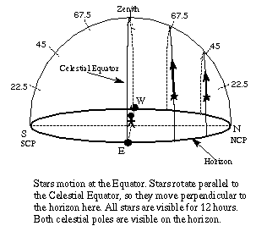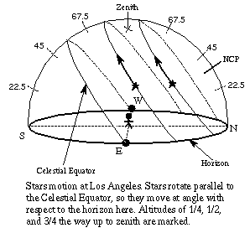
Figure 4.1 Stars' motons. These imagesare courtesy of Nick Strobel at www.astronomynotes.com

4.2. The sun
Table 4.1 The sun stations and their landscape markers: sunrise azimuth taken when lower limb reaches horizon; sunset az taken when upper limb reaches horizon; *az over mountains visible from Kūkaniloko taken at horizon altitude.
SUN STATIONS | Event/Date  (Gregorian) | Rise az | Marker az | Set az | Marker az
Nadir | 6 Jan | 114 | 114 Ulupo | 247  247  245  246 | 245 Kaupuni Stream  246 Kaneilio  246 Puu Kailio*  246-247 Kolekole*
Nadir | 21 Nov | 114 | 114 Ulupo | 247  247  245  246 | 245 Kaupuni Stream  246 Kaneilio  246 Puu Kailio*  248 Kolekole*
Zenith | 15 May | 68 | 68 Puu Piei  68 Kila | 292 | 293 Kamananui*
Zenith | 13 July | 69 | 68 Puu Piei  68 Kila | 292 | 293 Kamananui*
Equinox | 12 March | 91 | 91 Puu Kaaumakua* | 268 | 268-272 Mauna Kaala*
Equinox | 15 Sept | 91 | 91 Puu Kaaumakua* | 268 | 268-272 Mauna Kaala*
Solstice | 13 June | 65 | 68 Puu Piei  68 Kila | 295 | 293 Kamananui*
Solstice | 13 Dec | 116 | 114 Kamana | 243 | 247 Puu Hapapa*

There are eight sun stations in the tropics, two solstices, two equinoxes, two solar zeniths, and two solar nadirs. Both events of sudden insight described earlier (the sunset over Puu Kumakalii marking the rise of the Pleiades and Kolekole being where the nadir day sunset occurred) involved the position of the sun. As the setting sun over Puu Kumakalii announcing the rise of the Pleiades shows, the sun was also associated with stars.
Equinoxes
The landscape markers for the both equinoxes are the same – Puu Kaaumakua in the Koʻolau Range in the east and Mauna Kaala in the Waiʻanae Range in the west.
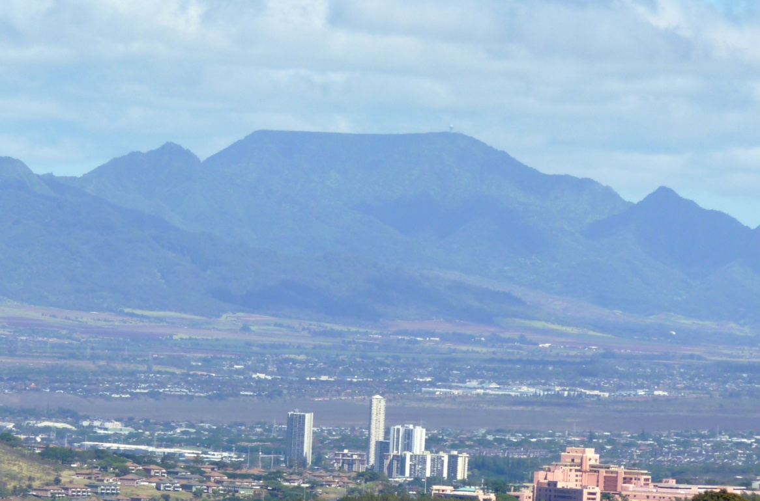
Figure 4.2 The wide summit of Mauna Kaala, author's photograph

Mauna and puʻu both mean mountain, although puʻu can also apply to a hill. Kaaumakua means the (ka) ancestral guardian (ʻaumakua). Kaala is usually translated as 'fragrant' (ʻala) mountain, but it also means the (ka) path (ala) or rolling (kaʻa) sun (la), or the path of the sun. These meanings are affirmed by the set of the equinox sun over Mauna Kaala and by the name Kuaokala – the back(bone) of the sun – for the ridge that runs from the west side of Kaala's summit towards the sea.
Solstices
The December solstice sun rises over Puu Kamana – the mana – and sets over Puu Hapapa. Hapapa has several meanings/interpretations. A hapapa is a hawk-catching/snaring stick, gummed at one end to catch and hold a hawk captive. In many cultures the sun is associated with a raptor, often an eagle and sometimes a hawk. The Pukui and Elbert dictionary relates chiefs to hawks: 'Iolani – 'royal hawk (the high flight [symbolising closeness to the sun] of the hawk symbolised royalty)'. The sun is the highest of celestial chiefs, as evidenced by one of the names for Mercury, Ukali-alii – follower of the chief. Maui, the demigod, is understood by some cultural practitioners to be the son of the sun. The well-known story of Maui capturing the sun tells of one of his many 'strifes':
Everyone knows about the battle of Maui with the sun
With the loop of Maui's snaring-rope
Winter became the sun's
Summer became Maui's

Among Maui's kino lau (body forms) is the hawk, and the hawk is related to the sun. That the hawk is stuck on the stick suggests the solar standstill.
Hapapa as ha-papa is the breath (hā) of Papa (Mother Earth). The December solstice marks the start of the sun’s northward journey, warming Papa (Mother Earth) in the northern hemisphere and reviving her hā, breath, a symbol for life. As hapa-pa it is half (hapa) of an enclosure (pā). The world of humankind – ao – is enclosed by the solstices/Tropics, as Kikiloi pointed out in his work on Mokumanamana. One hapa-pa is thus the half-year from the December solstice to the June solstice, and the other hapa-pa is the half-year from the June solstice to the December solstice.
The June solstice is of great importance in the Kāne traditions as it is during the period of the June solstice that the deceased are able to return to earth to visit with their living loved ones. The June solstice sun rose in Gemini (perceived in Hawai’i as elsewhere as twins, as the words mahoe and mahana, both meaning twins and occurring in several of their names, attest) over Makaua (We Two) east of the Koʻolaus. As the sun set, still in Gemini, it passed over Puu Kamananui – Great Mana – then over Mahoe Pali (Twins Cliff), then over Alau (Branching). Alau is probably a reference to the ʻulu (breadfruit) tree the spirits of the deceased climb on their way to the afterlife. On either side of Alau are lands called ‘ulu – Uluhulu (Esteemed ‘Ulu) and Ulunui (Great ‘Ulu), repeating and emphasizing the relationship of the June solstice with the deceased.
The names Puu Kamana for the December solstice sunrise and Puu Kamananui for the June solstice sunset register a reciprocal relationship between the two events. Such relationships, usually referred to as a duality or a union of opposites, are complements such that one event/place/thing/person is completed by the other. The names also reflect the relative importance of the events, Kamana being important, Kamananui being more important, but both are events of mana.
Solar zeniths and Solar nadirs
Both of the solar zeniths and both of the solar nadirs are marked on the landscape, as shown in Table 4.1. The nadir sunrise took place over Alala Point. Alala has several meanings, one of which is the path (ala) [of the] sun (lā).
The nadir sun then passed over Ulupo, a heiau the name of which means 'inspiration growing in the night'. The nadir is a potent time during which inspiration is increased. The nadir, though, also connected chiefs to the sun/Kāne through a chief's nethermost piko, the genitals, just as the zenith connected people to the sun/Kāne through the manawa, the piko on the top of the head. The sun then passed over Iolekaa – in a state of being negative (the solar nadir) and Io in a state of (ka'a) doing nothing (le), as inactivity is a property of Io.
As the nadir sun set, it passed through Kolekole Pass (Protopolynesian meaning negative, nothing, kore in Maori, 'ole'ole in modern Hawaiian) marking the nadir as it set. Kolekole is also the Hawaiian transliteration of the Maori Korekore, also called Te Kore. Korekore, and thus kolekole, is the era before pō. It is the abyss, the nothing, in which dwelled only Io, the pith, seed, essence, the inactive parentless all-parent. This was an unexpected finding. As dean of Te Tumu and professor at the University of Otago (New Zealand) Michael P. J. Reilly wrote, 'Io, the supreme atua [god] is controversial'.' Even among Hawaiians today, I can attest from personal experience in conversations with friends and associates, there are differences of opinion about Io's precontact presence. The research data from this project, however, supports the idea that Io was known and that as was the case with the nadir, knowledge of Io was restricted to higher chiefs.
The sun then dropped into the sea near Kaneilio (Kāne’s Dog) and Pokai Bay, realm of the gods (pō) lift up and carry (kaʻi), the action of offering to the god(s) and the god(s) acceptance of it. To reiterate, a person has three pikos (navels). One is on the crown of the head at the juncture of the skull plates (the fontanel of an infant) and called the manawa in both infants and adults. The second piko is the belly button. The third is the genitals.
At the zeniths the sun, a manifestation of Kāne who is, among other things, the source of highest knowledge, is directly above the manawa. At this time the connection between Kāne and a person is at its most direct. Knowledge, insight, and intuition can flow directly from the sun into the lolo (brain) of a person. Lolo is, not incidentally, also one of the words for zenith (see the Pukui and Elbert Dictionary for lolo).
At the nadir the sun is directly underneath a person. At this time the mana of Kāne/the sun flows into one's genitals. The genitals are the carriers of ancestry and the source of descendants. The genitals of chiefs were especially important as they were linked with the fertility of the land and society.

Sunset landscape markers for the rise of stars
Table 4.2 Sunset landscape markers for the day of a star's evening rise
Calendar  star | Evening rise date | Star rise az | Mountain  Name/translation | Mountain azimuth | Sunset azimuth
Gemini  Nana | Dec 26 | 58-61 | Puu Kailio/Dog Mtn. | 246 | 244
Orionʻs Belt  Welo | Dec 11 | 93-95 | Puu Kailio/Dog Mtn | 246 | 243
Regulus  Ikiiki | Feb 6 | 76 | Puu Kalena/ Yellow Mtn | 261 | 260
Cancer (at zenith)  Kaaona | Jan 15 | 67 | Puu Pane/ Summit Mtn | 279 | 280 – April 9, Cancer at zenith at sunset
Taurus  Hinaiaeleele | Nov 20 | 75-76 | Puu Kailio/Dog Mtn | 246 | 245
Castor  Mahoe Mua | Dec 25 | 57 | Puu Kailio/Dog Mtn | 246 | 244
Pollux  Mahoe Hope | Dec 30 | 61 | Puu Kailio/Dog  Mtn | 246 | 245
Antares  Ikuwa | May 19 | 119 | Kaupakuhale/ house ridgebeam, greatest | 289 | 292
Antares  Welehu | " | " | " | " | "
Pleiades  Makalii | Nov 6 | 69 | Puu Kumakalii/ Pleiades Rise Mtn | 252 | 248
Betelgeuse  Kaelo | Dec 14 | 85 | Puu Kailio/Dog  Mtn | 246 | 243
Sirius  Kaulua | Jan 4 | 110 | Puu Kailio/Dog  Mtn | 246 | 245

It is noticeable that the sunset azimuths cluster. The stars of the calendar are, except for Antares, all in one part of the sky. Most of the evening rises of the closely spaced stars are in December (December 11 to January 4). Figures 5.2 and 5.3 below show the closely spaced stars. This begs the question why the calendar used these closely spaced stars and not, except for Antares, stars on the other side of the sky as cultures that use the western zodiacal constellations do. I think the answer is that the stars used in the Hawaiian calendar are, for the most part, involved with cosmogony. Figure 4.2, on the next page, shows the calendar stars and how all except Antares are close together.

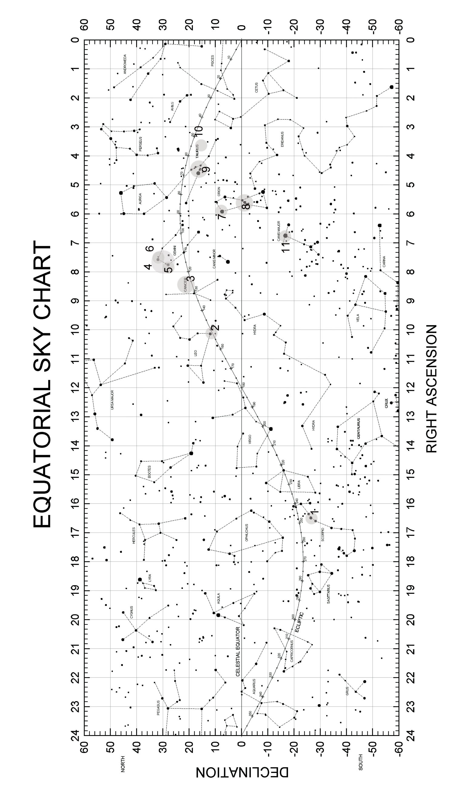
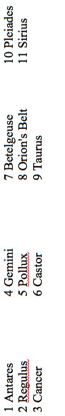
Figure 4.3 The calendar stars and their location
The sunsets over Puu Kailio, Dog Mountain, marked the rise of both Gemini and Sirius. Gemini and Sirius are two of the three Kaulua stars, all three of which are associated with death and the afterlife (the third Kaulua star is Orionʻs Belt). Castor of Gemini opens ‘the portal to the afterlife,’ and a dog or dogs function as psychopomps in Hawaiʻi as they do in other cultures. In addition, as stated earlier, the deceased who kept the kapu in their lives can go to Kānehunamoku, which is guarded by a dog and/or can turn itself into a dog.
There is more to this dog association, however. At the evening rise of Taurus and of Orion's Belt the sun also sets over Puu Kailio. These two stars, as well as Betelgeuse, recite cosmogony through their landscape markers, as do one of the names of Aldebaran and the position of Mintaka (of Orion's Belt). The association with cosmogony is shown in the Kumulipo, Hawai'i's best known cosmogonic chant. There are sixteen wā in the chant. The first six take place in the eras of pō, before there were humans. The seventh wā introduces dogs and dog-men, called 'olohe. The 'olohe were a feared class of warriors. The word also means ghost. A synonym for 'olohe as ghost is mauli, a word that also means the seat of life. With the eighth wā, ao, the world of humans, begins. Dogs are thus liminal creatures, at, or within, the threshold between pō and ao and between life and death.
The day Antares rose the sun set over Puu Kaupakuhale, meaning house (hale) ridge pole (kaupaku), the highest part of a house, and figuratively meaning 'greatest'. One of the Polynesian conceptions of the sky is that of a Polynesian house (hale). One of the names for Antares translates as 'the pillar in front,' while Aldebaran is 'the pillar behind (or in back)'. 'Greatest' refers to the status of Antares as the senior star in the sky. He is, depending on the story variant, either the brother of Wākea or the brother of Kāne (a son of Wākea). It is Antares from whom permission must be gained for access to Io, the ineffable, parentless all-parent, and the only one who received that permission was Kāne. This repeats and reinforces the relationship between Kāne and Io.
Puu Kumakalii, where the sun set when the Pleiades rose in October-November, means, as mentioned earlier, Mountain Pleiades (Makaliʻi) Rise (kū). The rise of the Pleiades has the only landscape markers named using a star's name. The other landscape marker is Makalii Point, east of the Koʻolau Range, over which the Pleiades rise. The Pleiades were and are season markers, marking the change from ho'oilo (winter) to kau (summer) and from kau to ho'oilo. The Pleiades had among their duties the signaling of the start and the end of the annual Makahiki festival in which the entire population participated. This could be a reason the rise of the Pleiades had markers in which the name for the Pleiades appears, as the knowledge of the Pleiades and Makahiki was public, not hidden or restricted knowledge as much of sky knowledge was. However, O’ahu Kāne tradition practitioners, including Kahele who was trained by his kupuna as kahu of the Waianae temple Kāneikapualena, say Makahiki was not recognised on O’ahu until the southern Hawaiian chiefs, from Maui and Hawai’i, imposed it on O’ahu.

The June solstice sun in Gemini
Table 4.3 June Solstice sun in Gemini
Event | Date | rise az | Marker az | Set az | Marker az
Solstice sun in Gemini | June 13 | 65 | 68 Puu Piei – peer , a pun on Nana (to look, observe)  68 Kila – a high place, sun travel | 295 when sun sets  299 when twins set | 293 Puu Kamananui – Great Mana  290 Alau - branching  290 Alei – when beloved/leap  291 Uluhulu – esteemed ulu  288 Kaleinakauhane – the leaping off place of souls
Solstice sun rise (when bottom limb reaches horizon) 66°
Solstice sun set (when top limb reaches horizon) 296°

My research showed that the June solstice sun rose over Puu Piei and Kila. Piei means to peer, a pun on Nana, the name of Gemini as a calendar star. Nana has several meanings, one of which is to see, observe. Kilaʻs most well-known meaning is a high place. This sort of word play is typical of Hawaiian orality.
The June solstice sun set first over Puu Kamananui – Great Mana Hill – reflecting the great importance of the June solstice within the Kāne traditions. The sun then passed over Alei – when (ā) beloved (lei) leap (also lei) – and Alau – branching – a reference to the ‘ulu (breadfruit) tree the spirits of the deceased climb on their way to the afterlife, and over Uluhulu – esteemed (hulu) ʻulu. Finally, the sun passed over Kapōhakukaleinakauhane, the stone from which souls make their leap.

4.3 The Cosmogonic stars
4.3.1 Introduction
My research showed that the stars most directly involved with Hawaiian cosmogony are Betelgeuse, the Belt of Orion, and the Hawaiian Taurus. Gemini and Regulus cannot be omitted, though, as Gemini directly relates to the realm of pō, and Regulus determines whether a child born at Kūkaniloko inherits particularly exalted status through his/her connection to the god Kāne.
In the next section each of the stars involved with cosmogony is addressed. The first table provides the data for stars and their landscape markers visible from Kūkaniloko.
Table 4.4 Cosmogonic stars and their landscape markers visible from Kūkaniloko
Using horizon altitude
STAR | Rise/set dates  R=rise, s=set | Type | Rise az | Rise marker azimuth | Set az | Set marker azimuth
Nana – Gemini  CP | AM r 29 June,  s 24 Dec  PM r 26 Dec,  s24 June | MR  HS  AR  ES | 56-59 |  | 301-305 | 293-300 Puu Kamananui – Great mana
Welo – Orionʻs Belt  ALH | AM r 16 June,  s 16 Nov  PM r 16 May,  s11 Dec | HR  MS  ER  AS | 93-95 |  | 264-  266 | 268-272 Kaala – sunʻs path
Kaaona – Cancer  CP | AM r 20 July,  sJan 7  PM r 15 Jan,  s7 July | MR  HS  AR  ES | 67 |  | 293
Ikiiki – Regulus  CP | AM r 12 Aug,  s 26 Jan  PM r 6 Feb,  s 261 July | MR  ES  AR  ES | 76 |  | 284
Kaelo – Betelgeuse  ALH | AM r 17 June,  s 22 Nov  PM r 14 Dec,  s 20 May | HR  MS  ER  AS | 85 |  | 276 | 276 Kamaohanui – beloved child
Hinaiaeleele – Taurus  ALH | AM r 23May,  s5 Nov  PM r 20 Nov,  s1 May | HR  MS  ER  AR | 75-76 | 79 Pauao - mediator | 283-284
Mahoe Mua – Castor  CP | AM r 29 June,  s22 Dec  PM r 25 Dec,  s 21 June | MR  HS  AR  ES | 57 |  | 303
Mahoe Hope – Pollux  CP | AM r 3 July  s 23 Dec  PM r 30Dec,  s 22 June | MR  HS  AR  ES | 61 |  | 301 | 293-300 Kamananui – Great Mana
Makalii – Pleiades  CP | AM r 8 May,  s30 Oct  PM r 6 Nov,  s 25 April | MR  HS  AR  ES | 69 |  | 291
Ikuwa and Welehu – Antares  ALH | AM r 21 Nov,  s 2 May  PM r 19 May,  s 1 Nov | HR  MS  ER  AS | 119 |  | 241 | 239-241 Puu Hapapa – Hawk-catching stick
CP = Curtailed Passage (rise the evening of the day star sets at sunrise)
AR = rises at sunset, still in sky at dawn
HS = sets at sunrise, visible high in sky at next sunset
MR = rises just before dawn the day after sets in early evening
ES = sets with sunset, rises before sunrise
ALH = Arising and Lying Hidden (is absent from the sky for more than one day)
AS = absent from sky after sunset set
HR = after absence rises just before sun
MS = sets at sunrise after having risen during the night
ER = rises earlier each evening and sets before sunrise, eventually rises at sunset and sets that night

The next table, Table 7.5, shows the rise and set azimuth of stars and the bearings of landscape markers beyond view from Kūkaniloko, on the ocean side of the mountain ranges. The first evidence that stars beyond view from Kūkaniloko were marked on the landscape was pointed out to me by a friend who showed me Makalii Point on the east shoreline of the island. That led to the investigation of other possible markers that were also not within view of Kūkaniloko. The columns provide the same types of data as in Table 4.4.

Table 4.5 Cosmogonic stars and their landscape markers, not visible from Kūkaniloko
AD 1300 All azimuths taken when the star was at ~6° altitude
STAR | Rise/set dates  R=rise, s=set | Type | Rise az | Rise marker azimuth | Set az | Set marker azimuth
Nana – Gemini  CP | AM r 29 June,  s 24 Dec  PM r 26 Dec,  s24 June | MR  HS  AR  ES | 56-59 | 60-65 Makaua – We Two  54-59 Kaluanui – great double | 299  303 | 293 Puu Kamananui – Great mana  301 Aukuu – long rest  290 Alau – Branching  290 Alei – to leap; beloved  288 – Kaleinakauhane – soulʻs leap  292-293 Mahoe Pali – Twins cliff
Welo – Orionʻs Belt  ALH | AM r 16 June,  s 16 Nov  PM r 11 Dec  s16 May | HR  MS  ER  AS | 93-95 | 89-94 Waikane – Kaneʻs Water | 266-  268 | 268-272 Kaala – sunʻs path  264-276 Keaau – Wakeaʻs era
Kaaona – Cancer  CP | AM r 20 July,  sJan 7  PM r 15 Jan,  s7 July | MR  HS  AR  ES | 67 | 68 Puu Piei – Peer  68 Kila –high place | 293 | 290 Alei – to leap; beloved  290 Alau - branching  291 Uluhulu – esteemed ulu
Ikiiki – Regulus  CP | AM r 5 Aug,  s 26 Jan  PM r 6 Feb,  s 261 July | MR  ES  AR  ES | 76 | 75 Kuloa – long waiting | 284 | 284 Kaluakauila – double lightning
Kaelo – Betelgeuse  ALH | AM r 17 June,  s 22 Nov  PM r 14 Dec,  s 20 May | HR  MS  ER  AS | 85 | 82 Kaoio – Ioʻs container  80-85 Kanehoalani – Wakea  83 Puu o Kila –sun travel, high place | 275 | 276 Kamaohanui – beloved child  275 Kaneana – Kaneʻs Cave  264-276 Keaau – Wakeaʻs era  276-280 Makua – parent, progenitor  278 Pohaku Lailai – Lailaiʻs rock
Hinaiaeleele – Taurus  ALH | AM r 23May,  s5 Nov  PM r 20 Nov,  s1 May | HR  MS  ER  AR | 75-76 | 71-77 Kahana – turning point, the work  74-80 Kaaawa – the premature infant, blazing kava, rolling kava  80-85 Kanehoalani – Wakea  79 Pauao - mediator | 283-284 | 280-284 Kahanaiki – small cutting/line drawn, turning point  283-287 Keawaula – the sacred premature infant  278 Pohaku Lailai – Lailaiʻs Rock
Mahoe Mua – Castor  CP | AM r 29 June,  s22 Dec  PM r 25 Dec,  s 21 June | MR  HS  AR  ES | 57 | 54-59 Kaluanui – great double | 303 | 301 Aukuu – time of being at peace or rest
Mahoe Hope – Pollux  CP | AM r 3 July  s 23 Dec  PM r 30Dec,  s 22 June | MR  HS  AR  ES | 61 | 60-65 Makaua – We Two | 299 | 293-300 Kamananui – Great Mana  290-291Alei Pali - Beloved, Leap  290 Alau – Branching  295-298 Kawaihapai – pregnancy water  292-293 Mahoe Pali – Twins cliff
Makalii – Pleiades  CP | AM r 8 May,  s30 Oct  PM r 6 Nov,  s 25 April | MR  HS  AR  ES | 69 | 65 Makalii Pt – Pleiades Pt | 291 | 290-291 Alei  290 Alau
Ikuwa and Welehu – Antares  ALH | AM r 21 Nov,  s 2 May  PM r 19 May,  s 1 Nov | HR  MS  ER  AS | 119 | 119 Halekou – house of kou, prosperity, male potency  119 Kahanalii – chiefʻs work, chiefʻs place  118-120 Kahiakahoe – alone at the paddle, work the fireplow | 241 | 239-241 Puu Hapapa – Hawk-catching stick

4.3.2 Betelgeuse
Betelgeuse rose over Kaoio Point, one meaning of which is the container (ka) belonging to (o) Io. Io is the parentless all-parent, the pith, essence, or source. Kāne journeyed to Antares to receive permission to approach Io in order to receive the baskets of knowledge to bring to humankind. Betelgeuse then passed over Kānehoalani, which is a name for Wākea. Thus, Io, the formless deity, the pith and essence who existed before creation, and Wākea and Papa, the male and female gods whose child Kāne was the creator of life, are invoked through the landscape markers.
As Betelgeuse began to set, it passed over Kamaohanui, the beloved child (who is Kāne). It then passed over Makua Valley. Makua is parent and progenitor. Betelgeuse also crossed Keaau. The most common meaning for kea is white or clear. It is also part of Wākea’s name. Wā of Wākea means time, era, epoch, period of time, and space or interval. Au also means time, era, epoch, period of time. Astronomically, then, Keaau speaks of Wākea, the space he occupies (the wide sky) and his era(s). Betelgeuse then set on the horizon in front of Kāneana, Kāne's Cave, which is the entrance to the womb of Papa (Mother Earth). To be a chief one must be a descendant of Wākea and Papa and of their son Kāne.
In the water off Makua Beach is a boulder called Pōhaku Kūlaʻilaʻi. Among the many meanings of the word kū are 'to anchor' and the months of pregnancy. Laʻilaʻi was the first human woman. As Dorothy Barrere wrote, 'Lailai is the first female in the era of Ao, or Day, and appears (is “born”), at the same time as Kii, a man (he kane), and Kane, a god (he akua)'. Kiʻi, a man, rather than Kāne, a god, fathered her first child, making humankind's line senior to that of the gods.

4.3.3 The Belt of Orion
Welo, Orion's Belt, rose over Waikane, Kāne's Water. Kāne's water, usually called the Water of Kāne, is life-giving water. The water revives the dead and returns youth to the old. Welo, like Betelgeuse/Kaelo, set over Keaau. The celestial equator is Ke ala i ka piko o Wakea, the path to the piko (navel) of Wākea. Mintaka, the star in Orion’s Belt that sits on the celestial equator, is the actual celestial piko of Wākea.Adding to the symbolism, one of the names for Betelgeuse is Aua, meaning thin, and Wākea’s home is 'the thin land'.

4.3.4 Taurus
In this study Taurus is understood to be made up of the stars of the Rapanui (Easter Island) constellation Kete – Alpha tauri (Aldebaran), and Delta, Theta, and Epsilon Tauri. Kete means basket. Hawaiian words for basket include ‘eke (the glottal stop substituting here for the Rapanui 'k'), and hina’i, which is part of the month star name Hinaiaeleele. Hinaiaeleele is thus a receptacle, a container, and in the cosmogonic sense, a mother.

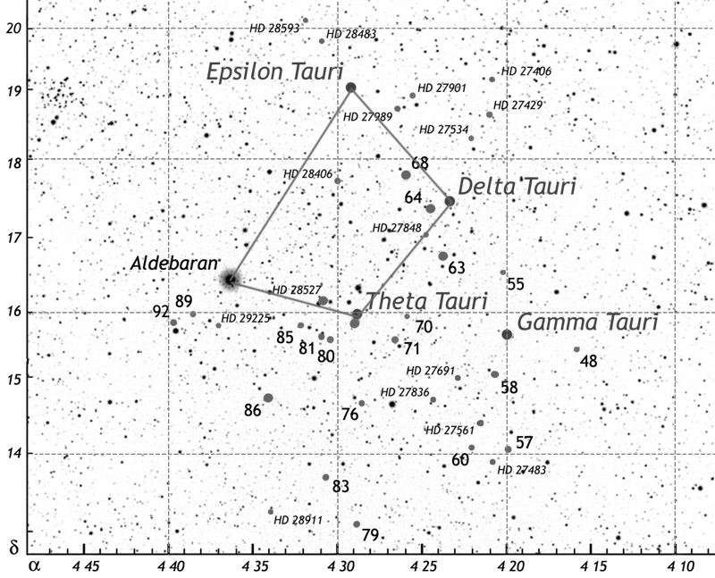
Figure 4.4the stars of Kete, map from Wikipedia Commons, Creative Commons Attribution, lines connecting the stars of Kete added by the author

There are several interrelated stories braided together here. Aldebaran, the bright red star in Taurus, has among her names Haumea. Haumea is one of the names of Papa (Mother Earth). In some stories she refers to herself as Hina. She is at times also equated with the first human woman, Laʻilaʻi. Taurus rose over Kahana and Kaaawa and set over Kahanaiki and Keawaula. There are connections between the names of the rise markers and the set markers. The words kahana and awa appear in one rise and one set marker name each. This joins the eastern and western sides of the island through Taurus. 'Awa is best known as the Hawaiian word for Piper methysticum, known as kava in much of Polynesia. 'Awa, though, also means a premature infant, a reference to the story of Ho'ohokukalani, the daughter of Papa and Wākea. Wākea wanted to lie with his daughter and therefore instituted some kapu that separated husband and wife. Ho'ohokukalani became pregnant, and the boy was stillborn and premature, named Hāloa and buried in a corner of the yard, and where he was buried the first kalo (taro) plant grew. Ho'ohokukalani became pregnant a second time, this time giving birth to a healthy boy, also named Hāloa. When Papa learned of the incest, she and Wākea divorced, after which she took the name Haumea. Haumea, as mentioned earlier, is one of the names for Aldebaran. Keawaula adds to 'awa the color red ('ula) which also means sacred, and ula means a flame or to blaze. 'Ā is also to burn or blaze. Fire and blaze refer to the burning back of high chiefs, to the chiefs as a blaze. This royal premature infant is again a reference to the story of Ho'okukalani. Also, at a place within Keawaula the spirits of people who had just died could be returned by the dead personʻs 'aumakua to the deceasedʻs body so that he/she could continue to live. This connects cosmogony (Betelgeuse, the Belt of Orion, Taurus) to life and death (Castor, Pollux), and expresses the relationship of pō to ao.
The name Kahanaiki has multiple meanings. It is an implex, a word or phrase with multiple lines, even webs, of meaning. Kaha is to desolate, to turn and go on and kahana is a turning point. Certainly Wākea's acts of incest desolated Papa and she chose to turn from him and go on as Haumea. Hana has among its meanings 'incident', here referring again to the incest. Hānā is a ridgepost that holds up one end of a ridgepole, relating to Aldebaran's name as the pillar in back and Antares's name as the pillar in front, reinforced by the landscape marker Kaupakuhale (ridgepost) for Antares.Iki in the Andrews Dictionary has among its meanings to suffer, which Papa did. Naike (Andrews Dictionary), a pun on naiki, is anger and being repelled from someone. The Pukui and Elbert Dictionary has nāī'ike, meaning to refuse to see a relative and to disown someone. Indeed, Papa was angry and left – refused to see – Wākea and divorced – disowned – him. Kā has 'container' among its meanings, in this instance perhaps referring to Papa and Haumea as the mothers of many children.
Taurus (Kete) also rose over Pauao. There are several ways to interpret this place name as a reference to Haumea/Papa/Hina/Laʻilaʻi. As pāʻu ao it is skirt (pāʻu), a woman's garment, plus of realm/day (ao), which is also the word for the world of humankind and the realm between the Tropics. As pā ʻuao it is a place (pā) of reconciliation/intercession/peacemaking (ʻuao). My friend 'Ike explained ʻuao this way.

'Uao/'uwao-to reconciliate, to arbitrate positively or to intercede towards...perhaps a favourable outcome.Pā can mean rest but it can also mean an intermission or a shortened version of a "wā" [that] equals dispensation. So, taken in astrological terms, it could be pa 'uwao/pa'uao, to bring about a positive intermediate rest or intercession. To move backward or retire into a favourable /beloved place.The meaning does not map onto the word retreat but rather connotes an intended destination of rest/peace and an intentional stop to refresh, refuel, redirect.

Both as Haumea and as Hina, Papa had many husbands and many children. As La'ila'i she was the first human woman and the mother of the first fully human child. She is, then, the mediating receptacle between pō and ao as it is through her womb that chiefs and humankind left the pō of the unborn and entered the ao of the living. This was repeated symbolically every time a chiefess gave birth at Kūkaniloko. In addition, celestially, her setting is between Wākea (Betelgeuse and the Belt of Orion) and the leina(leaping off place for the souls of the deceased) at Ka'ena, thus continuing the association of cosmogony with pō.
The May (first) zenith sun takes place when the sun is in Taurus. The marker name Puu o Kila recognizes this relationship in two ways. One meaning of kila is a high place, a zenith for example. The zeniths occur on either side of the June solstice, on Oʻahu in May and July. The zenith sun is a potent time, when mana, insight, inspiration, even wisdom, flow from the sun, a symbol of Kāne, to a human being through the personʻs manawa (the piko on the head). In addition, the May zenith heralds the June solstice, another high place.

4.3.5 Regulus
The kahu of Kūkaniloko told my nephew, who was being initiated as a kahu of the site, that on one day in August, a shadow a shadow dagger was thrown from the western edge of a stone I have called the Regulus stone and lengthened until it reached a pecked hole several inches toward the center of the stone. A child born at Kūkaniloko when that event occurred was destined to be the highest of chiefs. My nephew was able to observe the event in 2012 and reported to me what day and time of day it had occurred. Using Starry Night set for that date in 2012 I was able to see that the shadow fell on the afternoon of the day Regulus rose 'in' the sun. I then reset Starry Night to the year 1300 and found the day Regulus rose in the sun, in August also, although several days earlier in the month than in 2012. Regulus rose over Kuloa, which means a long waiting, such as would have transpired between births occurring when the shadow dagger was thrown. Regulus set over Kaluakauila, the (ka) double (lua) lightning (kauila). Double lightning is a sign of a high chief.

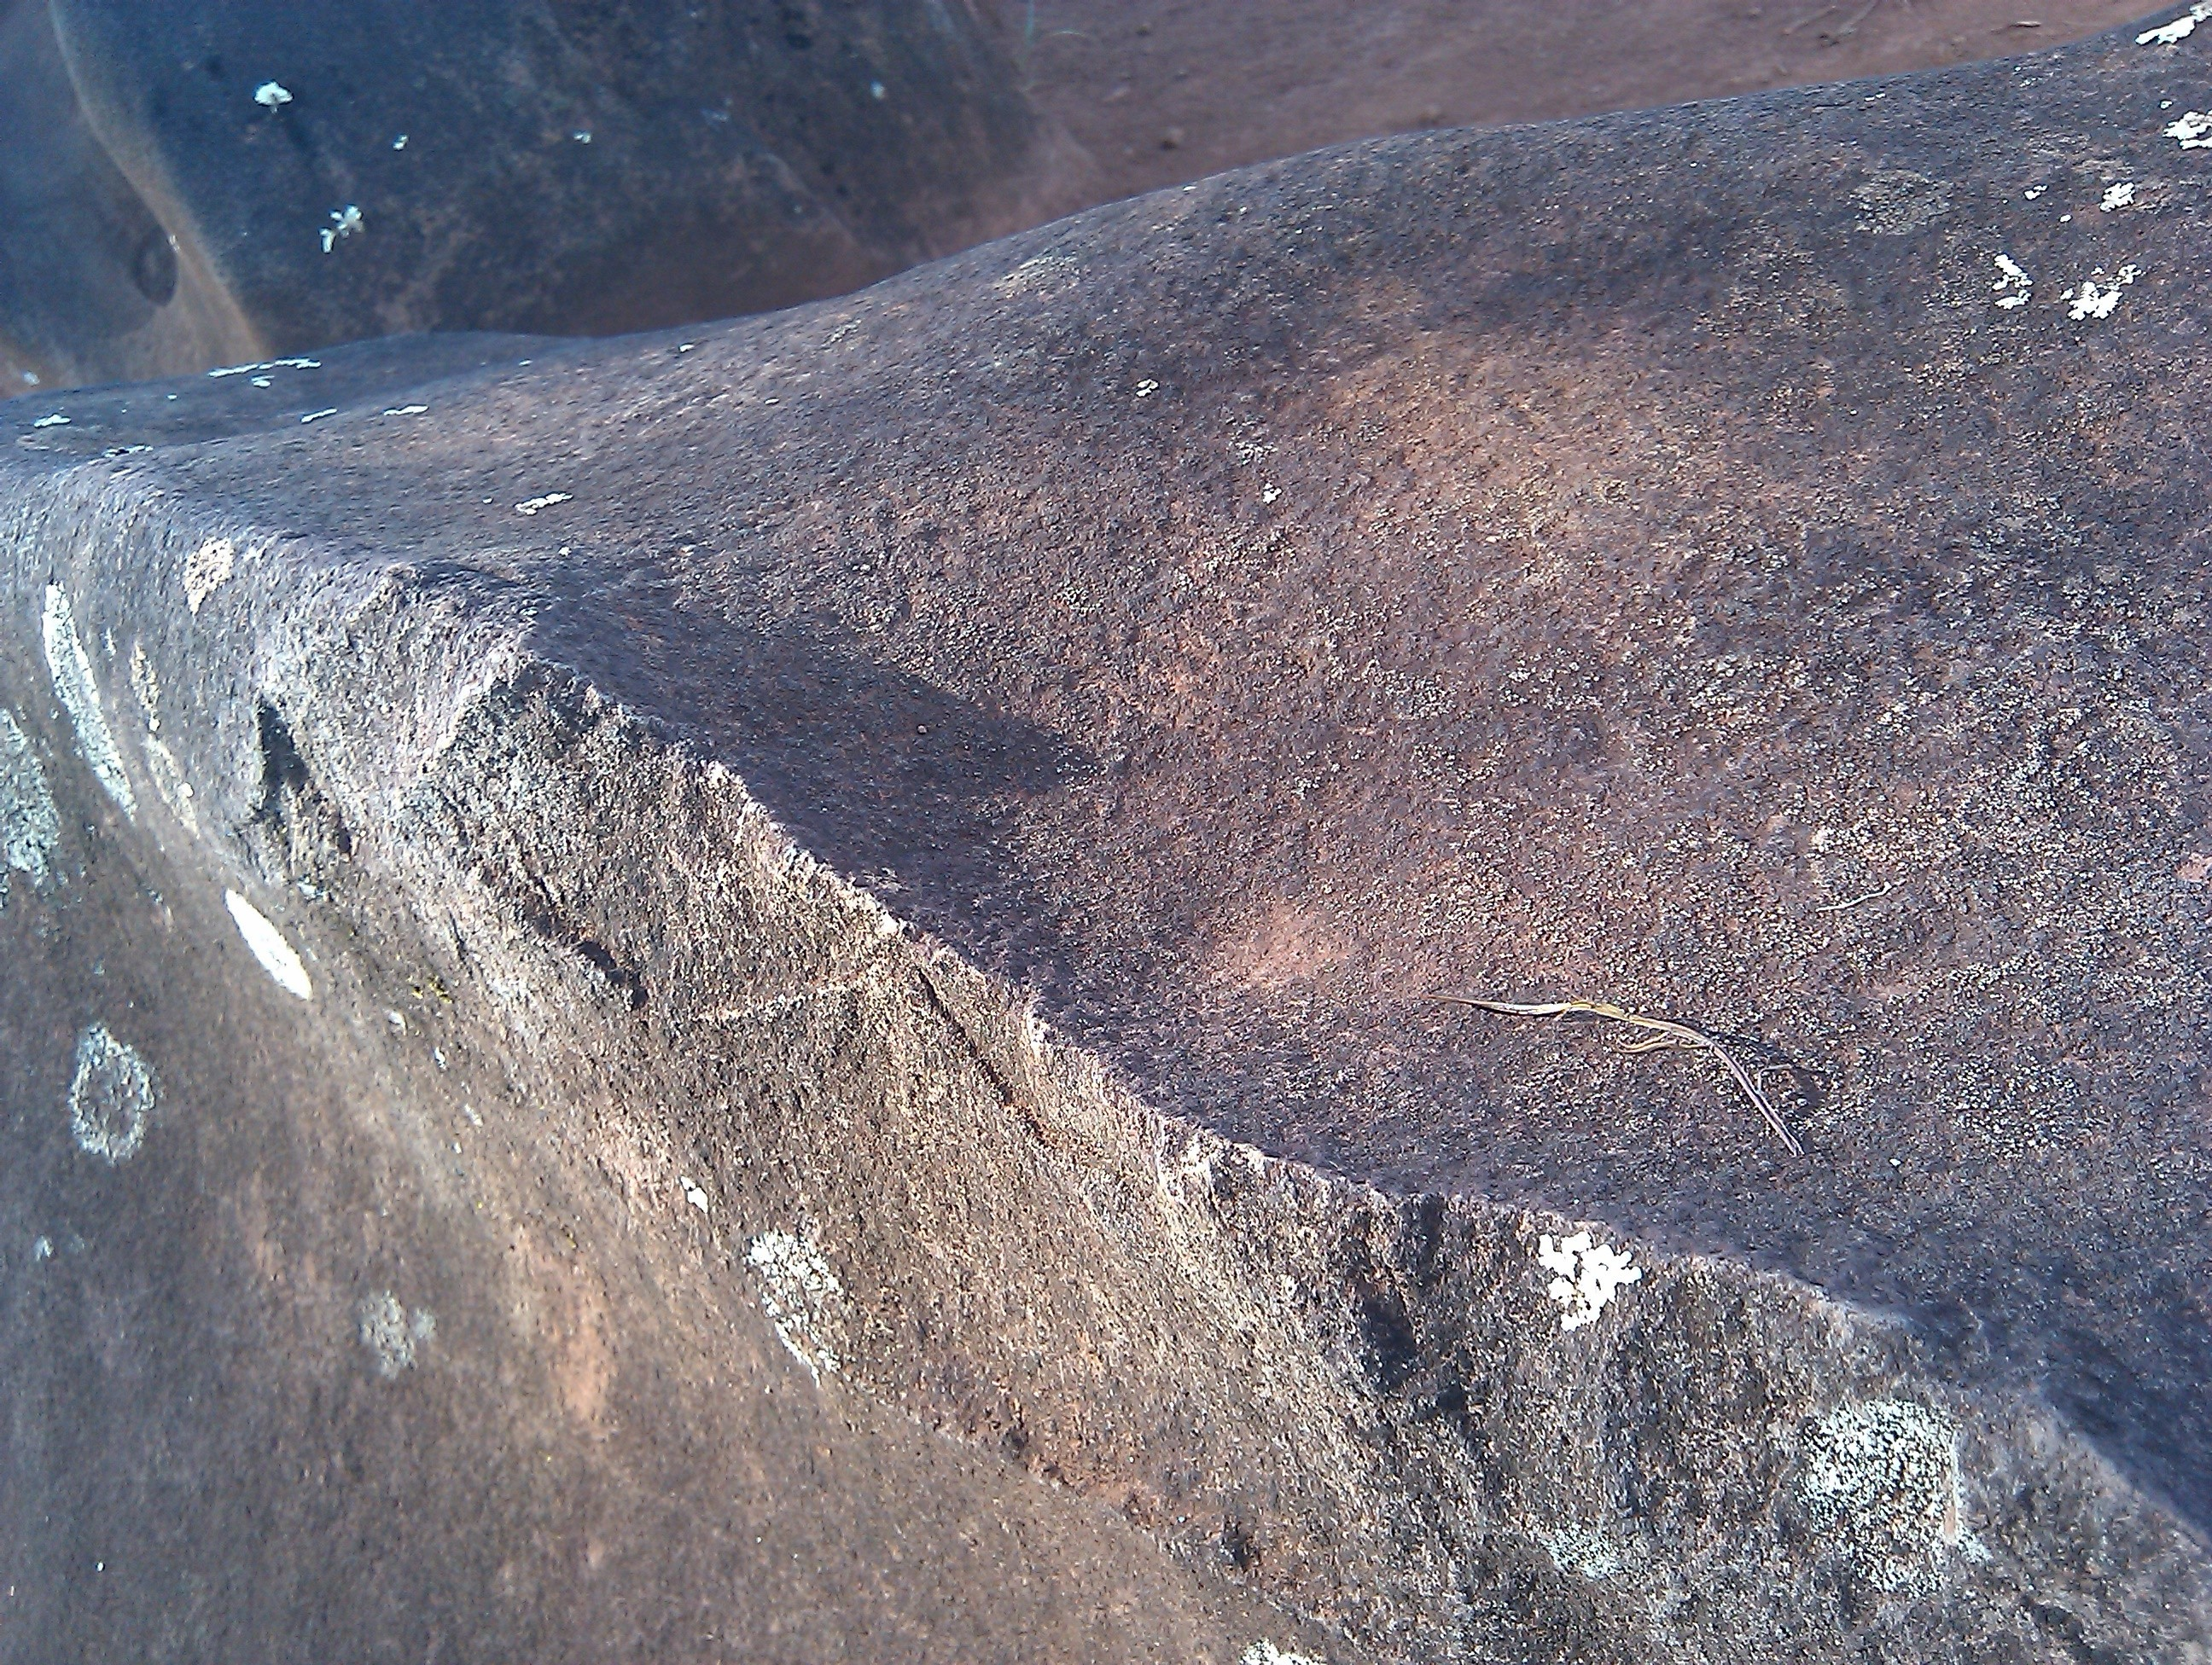
Figure 4.5 The 'Regulus Stone', showing
the shadow dagger, photo by Keale, used by permission

4.3.6 Gemini as an asterism and Castor and Pollux individually
My research showed that death and the afterlife are represented by the stars. Three Kaulua stars, Sirius, The Belt of Orion, and Gemini, relate to death and thus to pō. What happens after death, where we go when we are no longer on earth, are universal concerns, and Hawaiian culture addressed these concerns. Castor of Gemini was the opener of the gate to the afterlife.
Castor rose over Kaluanui – the great (nui) two/double (lua). There is some wordplay in the name. Lua means, among other things, two, referencing the Gemini Twins. The place on the horizon where a celestial object rises or sets is also called a lua, a pit or hole. Castor, the first of the Gemini Twins to rise, is important in part because of his (Castor is male) relationsip with the sun at the June solstice.One might say that the most significant lua are the rise and set lua of the June solstice sun. Castor thus references the solstice sun. Lua, though, also can be a grave, again related to death and pō.
He is, though, also nui (great) because it is he who opens the portal to the afterlife. The portal is two-way. The deceased pass through it to enter the realm of pō, and those already in pō are able to leave through it to return to earth to visit for a while. Further, at birth an infant leaves pō and enters ao.
Castor set over Aukuu. An auku’u is a bird, the black-crowned night heron. It is also au-ku’u, the time or era (au) of being at peace (kuu) in pō. For some people the auku’u is an ‘aumakua, an ancestral guardian deity. A friend described an illustrative experience, thus:
When I brought tutu Alice down near camp Erdman she began her 'oli [chant] until we could drive no further and had to walk. We took off for the ocean side and there she picked up her 'oli once again but each time it would "die off" as we resurfaced back on to the trail. Upon reaching the leina [the leaping off place for the spirits of the deceased] I remember her turning back to Camp Erdman calling the 'auku'u [here it is the black crowned night heron] to fly out of the darkness to take her prayers to her 'ohana [family] awaiting on the other side. So yes the kaona [hidden meaning] can also mean a diminished fervor of ending a chant and an "asking" of the 'aumakua 'auku'u to come and to act as a go between of the different realms.

Pollux rose over Makaua, We Two, a reference to the twin-ness of Gemini. Pollux set over Pu’u Kamananui, Great Mana Hill. She (Pollux is female) then set over Kawaihapai. Kawaihapai – ka (the) wai (liquid) hāpai (pregnant, carry) – has several meanings, the most widely known of which saysthe name refers to carrying water from a source at the base of the ridge that runs from Mauna Ka’ala to the point of Ka’ena Point. Kawaihapai is, though, also the wai (liquid) associated with birth. It thus reflects association with births at Kūkaniloko.

4.4 Conclusion
In this chapter the research data were presented. The next chapter discusses and interprets the data.

Chapter 5 Discussion
5.1 Introduction
My research shows that Kūkaniloko was situated and organized with astronomical intention. Stars' rises and sets and the rises and sets of the sun were marked on the landscape, both within view and beyond view from the site, so that the nexus of rises and sets was Kūkaniloko. Cosmogony, through stars and the sun and their markers, was centered at Kūkaniloko. Particular attention was paid to the sun; not only were all eight sun stations marked, but my data show that the location of the sunset on the evening rise of stars was also marked. As demonstrated in precending chapters, concepts, including wā, mana, piko, pō and ao and kolekole, and la'a, are part of the cultural expression of meanings of celestial phenomena associated with Kūkaniloko. (See Appendix 1 for a glossary of terms.)
This chapter will first address some conclusions reached in recent works on Hawaiian archaeoastronomy by Patrick Kirch and Clive Ruggles, referred to in the literature review. The section that follows considers orality as it is in evidence at Kūkaniloko. The next section is about interwoven knowledge sets. Next is a discussion of Kūkaniloko as the piko, followed by a discussion of sacred space/place. Next is a section on the attributes and characteristics of the stars addressed in this dissertation. Following that is a segment about celestial pairs. After that there is a brief discussion of Io, and then the chapter conclusion.

5.2 Recent works on archaeoastronomy in Hawai'i
The lengthwise axis of Kūkaniloko runs from the direction of the December solstice sunrise (SE) to the June solstice sunset (NW). Ruggles, however, noted reasons

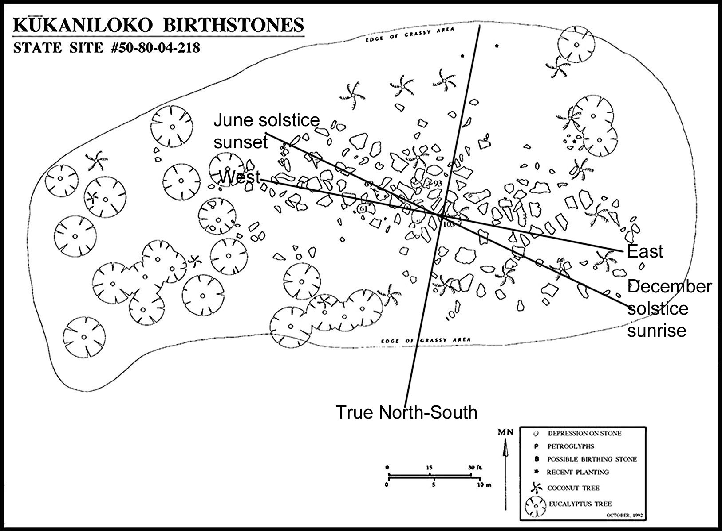
Figure 5.1 The orientation of Kūkaniloko

to be suspicious of purported alignments of temples to the solstices or equinoxes. He observed that'the concept of the equinox is a western one, ambiguous in the first place and tied to abstract conceptions of space and time that are generally inapplicable in other cultural contexts.' Kūkaniloko, however, as my research shows, was associated with all eight sun stations through either or both landscape markers and stars that announce the stations. Thus, while there is no Hawaiian word known to mean 'equinox,' the evidence suggests the phenomenon was known.
There are, in my view, a few reasons the importance of sun stations has not been recognized in archaeoastronomy research in Hawai'i. Part of the difficulty is that Hawaiian culture was not as uniform a culture as the literature seems to suggest. As Cordy makes clear, O'ahu was a separate kingdom, as was Kaua'i. For both of these islands Kāne was the dominant and principal deity. The legend of Keaomelemele makes the point. Kāne and Kanaloa lived in Waolani, a tributary valley within Nu'uanu Valley in the Kona district of O'ahu. Kū and Hina and Lono were still 'in the heavens' and had not yet come to 'live' on O'ahu, meaning that Kāne and Kanaloa were the gods for people, and Kū, Lono, and Hina were not yet worshipped on the island. Kāne traditions differ from those of Kū and Lono, both of whom were, generally speaking, associated with public rituals. As earlier stated, Kāne was represented and symbolised by the sun. Another reason sun stations have been overlooked is that while much has been written about traditions associated with Kū and Lono temples, very little has been written about Kāne temples.
Kirch's studies assume a relationship between cardinal directions and the gods that applies to temple orientations. Relying on Valeri's directional associations, Kirch understood east to represent Kāne. That is, however, not entirely correct as will be shown in this and subsequent paragrpahs. Kāne is also associated with north – the northern tropic, the Tropic of Cancer, is the Black Shining Road of Kāne. West is also associated with Kāne. Not only does the sun set in the west, but the June solstice sunset takes place in the northwest. As Kamakau wrote, names for the direction west include Kaulana-a-Kāne (the resting place of Kāne) and Kāne-ne'ene'e (Kāne moving along).A chant from Kaua'i asks 'where is the Water of Kāne', and among the many, all correct, answers is at Lehua. Lehua is a small island west of Kaua'i, and where the sun sets from the point of view of Kaua'i.
The Wai'anae Moku (district) has two subsections, Wai'anae, a long section of land west of the mountain range, and Wai'anae Uka, a narrow section east of the mountain range that extends to Puu Kaaumakua. Kūkaniloko is in Wai'anae Uka.

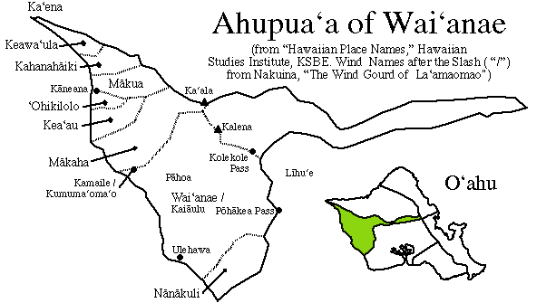
Figure 5.2 Map of Wai'anae Moku, from http://apdl.kcc.hawaii.edu/oahu/graphics/waianaeahupuaa.gif

Wai'anae has many sites associated with Kāne. Among these are Kāneikapualena (also known as Kamaile), Kāneilio, Kāneana, Kāneaki, Kahoalii (short for Kānehoalii), and Ukanipo, both a near pun with kani and Kāne and a reference to sound in the night which, in turn, refers to an echoing that occurs in the area and to the association of Kāne with sound.The location of these temples indicates a western association of Kāne. Further, as A. Mouritz said, 'Kaala [Mauna Kaala] was the guardian or sentinel of the Komohana or west . . . The Komohana or west is where the tired sun lies down to sleep. The west is Kane ne'ene'e, the departing son [sun?]'.

5.3 Orality, Redundancy and Memory
The naming of sun station and star rise and set markers with the apparent purpose of veiling the name of the star or sun event indicates that star knowledge was knowledge restricted to specialists. Further, the place names often are references to lesser known names of stars. For example, Haumea is not the most commonly known name for Aldebaran, and several of her other names indicate parts of her story,her association with a zenith (May) and association with childbirth. Sirius's many names describe his cultural functions, such as Hokukelewaa (canoe steering star), Kapoulena (the yellow pillar), Lonomai (Lono coming), Aa and Aaa (both meaning booby bird), and Kauopae (shrimp season).
Elements of orality include techniques of wordplay such as puns, opposites, symbolism, metaphors, and incorporation of elements from mo'olelo (stories, myths, legends, history). Speaking of chants, Valeri wrote words that could as well apply to the stars' landscape markers – 'The very multivocality of their expression, the stratifications of meaning that they contain, and the multiple interpretations that they allow facilitate the use of the same chants for different purposes and even, it seems, for different people'.These qualities are present in the place names and star names. Redundancy is another quality of orality, and there is abundant redundancy in markers for stars.
The landscape markers for any one star or event are multiple in part because 'oral only' cultures use redundancy to aid memory and protect and preserve knowledge.The multiple names also served to recall different cultural qualities or characteristics of a star. In the case of Kūkaniloko, the use of multiple markers, together with the several names for each celestial object/event, allowed several elements of a story or body of knowledge to be recorded and thus recalled. Last, but not least, the veiling of meanings insured that the kaona, the inner meanings, were hidden except to those who by status and education had the right to understand them.

5.4 Interwoven knowledge sets
The interwoven knowledge sets nearly defy linear explanation. They are implexes, a word or phrase with compressed,and multiple lines of, meaning. One example from Kūkaniloko centres on the word ulu. Ulu means to grow, increase, to protect, inspired by a god, to enter in and inspire. It also means the centre. 'Ulu is the breadfruit tree. Three place names contain u-l-u, Ulupo, for the solar nadirs and zeniths, 'Ulunui (great 'ulu) and 'Uluhulu (esteemed 'ulu) on Ka'ena Point and associated with Gemini and the June solstice sunset. 'Ulu, the tree, is one of the kino lau (body form) of Haumea. Haumea is also one of the names for Aldebaran in Taurus, where the May solar zenith takes place. Haumea is also Papa, Lahilahi, and Hina, each of whom leads to a set or sets of mo'olelo (stories), many of which do not have an immediate association with Kūkaniloko. However, the breadfruit tree is the tree the spirits of the deceased climbed before being able to enter pō. This further associates Haumea with cosmogony. It also associates her with the June solstice.
There are two types of 'ulu tree of concern here, the upright (or tall) 'ulu tree called 'ulu-kū and the low spreading 'ulu tree called 'ulu-hapapa (see the solstices paragraphs in section 4.2 in Chapter 4). The landscape marker Puu Hapapa marks both the set of Antares and the December solstice sunset. This adds to the relationship between Antares (male) and Aldebaran (female) evidenced in the names Pillar in Front (Antares) and Pillar in Back (Aldebaran) and increases an understanding of Antares as working a fireplow (one of his landscape marker names) and Aldebaran's names as an oven, with the Hyades as the hearth.

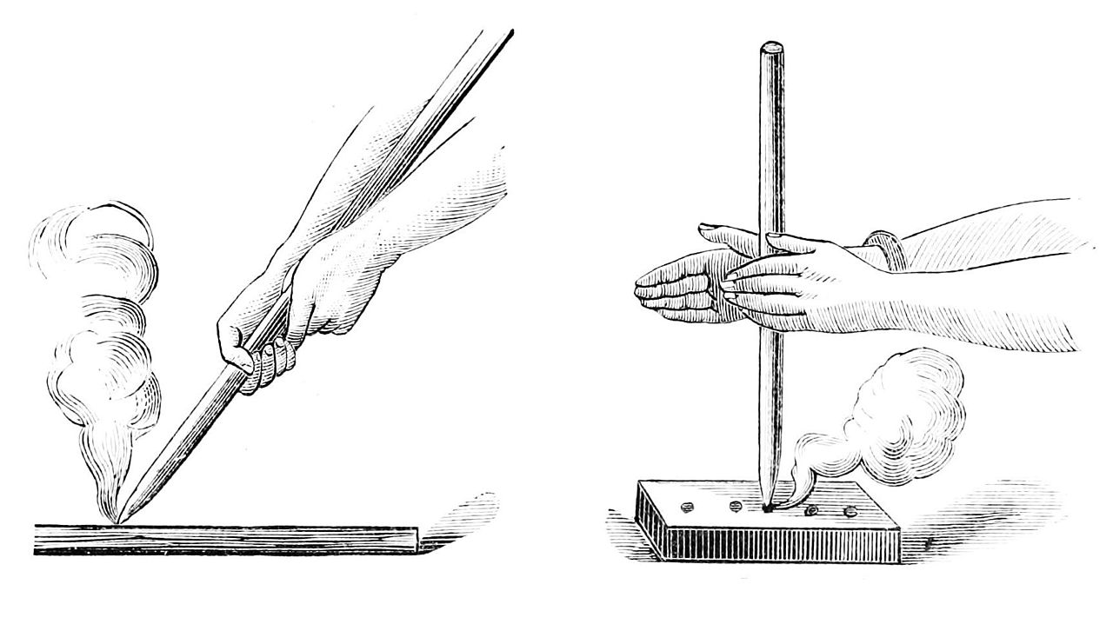
Figure 5.3 Fire plow on the left, fire drill on the right.
Illustration in the public domain.

Haumea is, among other things, the goddess of childbirth. This, of course, associates her with Kūkaniloko as a royal birthing site and with the ulu that signifies growth (both in the womb and of the infant after it is born). It also associates her with Pollux through Pollux's landscape marker Kawaihapai, water of pregnancy. She is, then, part of cosmogony, part of the cycle of human birth and death, part of the yearly cycle, part of a relationship with Antares.
Implexes such as this are plentiful in the astronomy associated with Kūkaniloko. Theseare but two examples. They also point out a reason that alignments, while they may indicate a star or solstice, are not sufficient in themselves to offer understanding of the cultural use and function of precontact astronomical knowledge.

5.5 Kūkaniloko as the Piko of O'ahu
The word piko means navel/umbilicus, and figuratively the center. It not only means piko (navel), but also the manawa (fontanel) and ma'i (genitals) of a human being. As the geographic-cultural center of O'ahu, the intellectual/insight center (manawa), the umbilical center connecting the living generations, and the center of fertility (ma'i) and thus the future, Kūkaniloko simultaneously speaks of individual human beings and of the culture's intellectual life, knowledge systems, the biological birth of new chiefly infants, and of a continuity of genealogy deep into the past and into the future.The piko/navel also connects the body to its limbs and similarly Kūkaniloko connects, through the calendar stars, the center to the periphery. Places distant from Kūkaniloko, including places beyond view from Kūkaniloko, are connected to Kūkaniloko through place names that reference the stars.
All of these characteristics refer to the Polynesian concept of wā (Hawaiian) or vā (Samoan). The wā is many things, but all related. It is the space between objects or points in time. It means to talk and to reason. It means era, period of time, epoch. Samoan writer and educator Albert Wendt said that wā is 'not space that separates but space that relates, that holds separate entities and things together in the Unity-that-is-all'.Wā connects places and it connects moments in time, no matter howfar apart they are. It is, then, also about relationships, about connections. Albert Refiti wrote:
This 'knowing/placing who you are' involves the understanding that your body, your being is woven flesh, a gene-archaeological matter made of ancestors/land/community/ family. Therefore your body does not necessarily belong to you as an individual. Because you are woven from the flesh of the dead, your body belong to the ancestors, to your fanua,the place of birth, and to the community that shaped and cared for you. So as a consequence of your 'being there' allows them (these ancient bodies) to be present there/here too, this gives meaning to what I am proposing here as vā relationships, vā spaces, what is in-between us that is more than you and me, what is in you that is more than you.
One of the ways Kūkaniloko expresses the wā is through the stars and sun and their landscape markers. Not only does the center connect the periphery geographically, it connects the past to the present through the stars associated with cosmogony. It likewise connects the present to the future through stars associated with ontology.
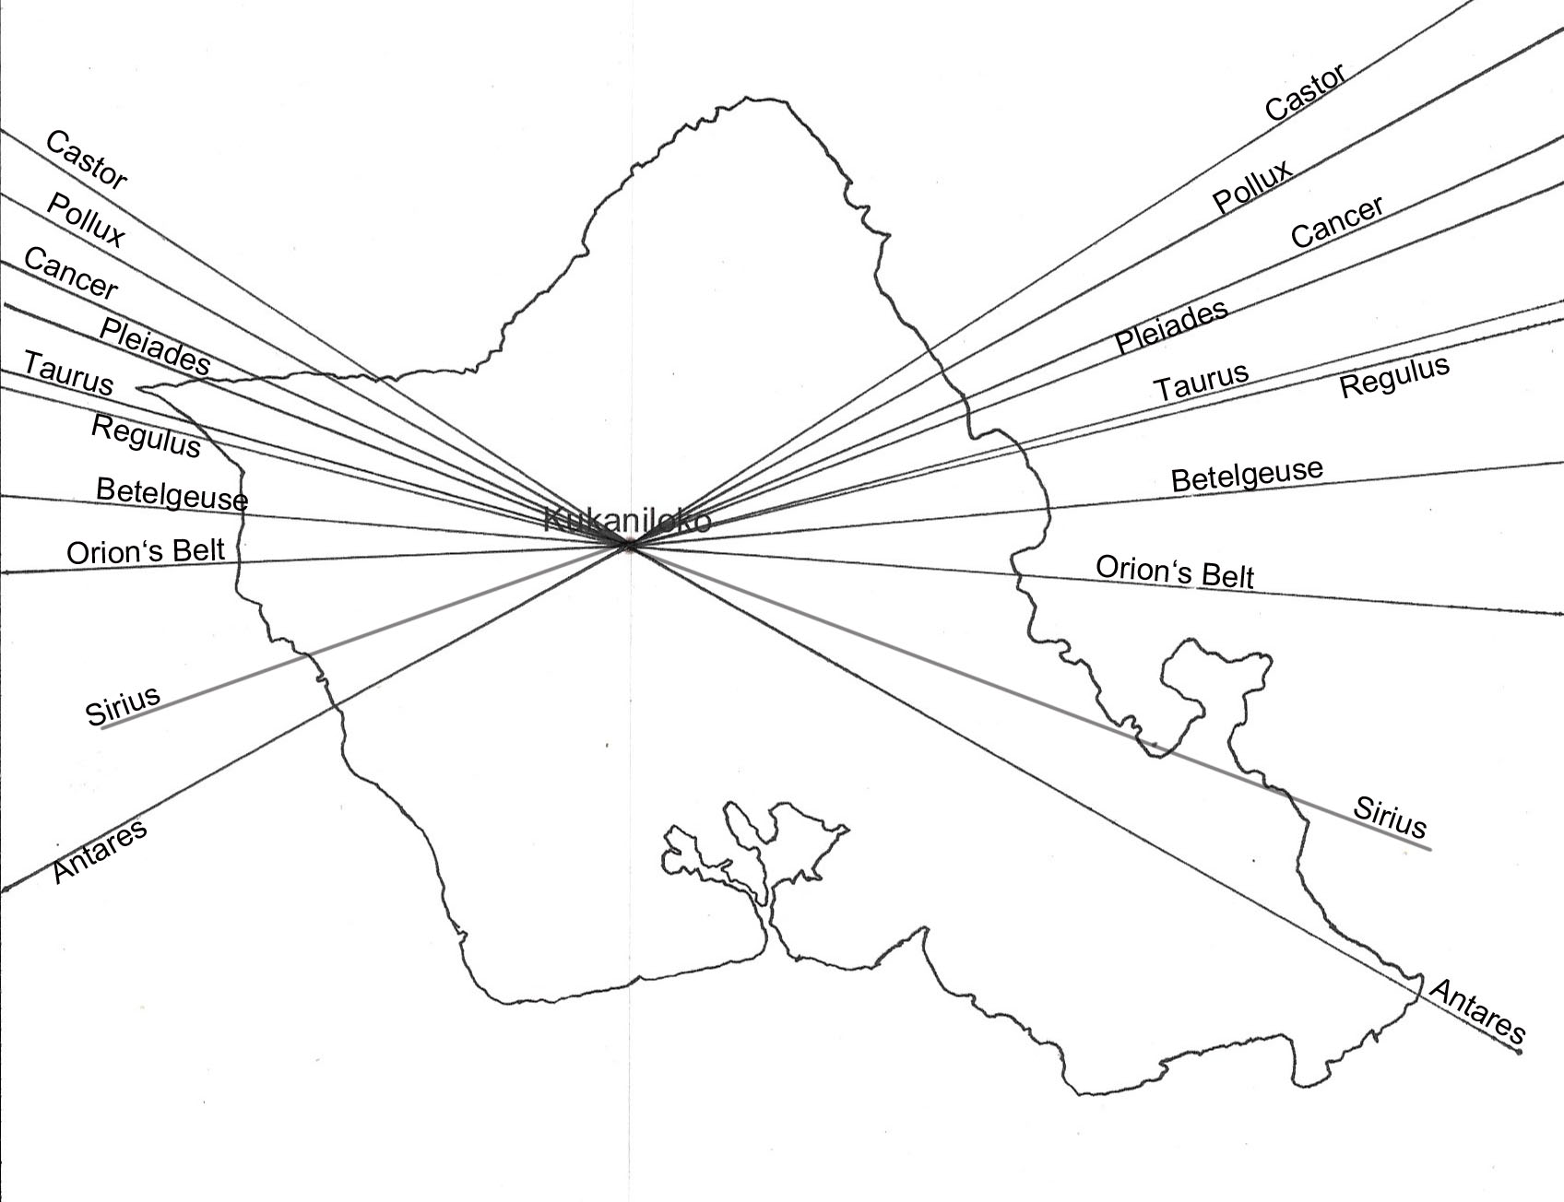
Figure 5.4 Oahu, with star rise and set azimuths in relation to Kūkaniloko

5.6Kūkaniloko, Cosmogony, Stars, Landscape and Sacred Space
Archaeoastronomy has usually looked at the built structures' orientations, such as what direction a temple faced, what direction a wall indicated, and foresights and backsights within a site. The data from the Kūkaniloko study show that most of the astronomical alignments were not site orientations (other than the solstitial alignment) or orientations of walls, but rather the association and relationship of a star's rise/set landscape marker(s) with Kūkaniloko. In other words, Kūkaniloko itself was the backsight, the place upon which stars and sun stations were centered, and the landscape markers were the foresights.
Kaelo (Betelgeuse), Welo (the Belt of Orion), and Hinaiaeleele (the Hawaiian Taurus) reflect cosmogony. They do this both through the names of landscape markers and through an additional name for Betelgeuse, Aua, and Aldebaran of Taurus, Haumea. Aua (thin) represents 'the thin land', the first home of Wākea (Sky Father and the first chief). Haumea is Papa (Mother Earth) and is sometimes also meant by the names Hina and La'ila'i. There are additional stars also involved with the calendar stars whose relationships to cosmogony are slightly different than the first three named in this section. Ikiiki (Regulus) is one of these stars.
Regulus pronounced a newborn at Kūkaniloko the highest of chiefs if that child was born when the shadow dagger fell on the 'Regulus Stone'. Regulus is 'in' the sun that day and cannot be seen.
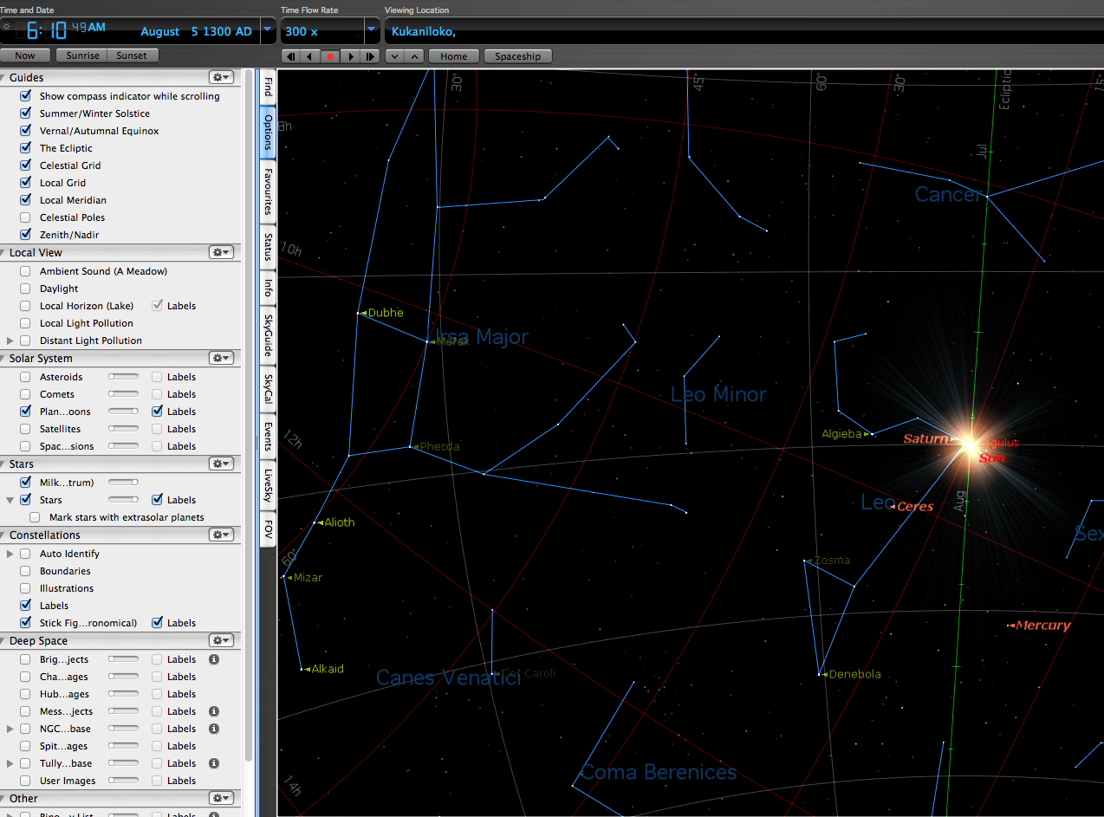
Figure 5.5 Regulus in the sun with date and time visible and daylight turned off
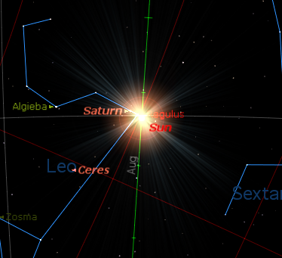
figure 5.6 close up of Regulus in the sun
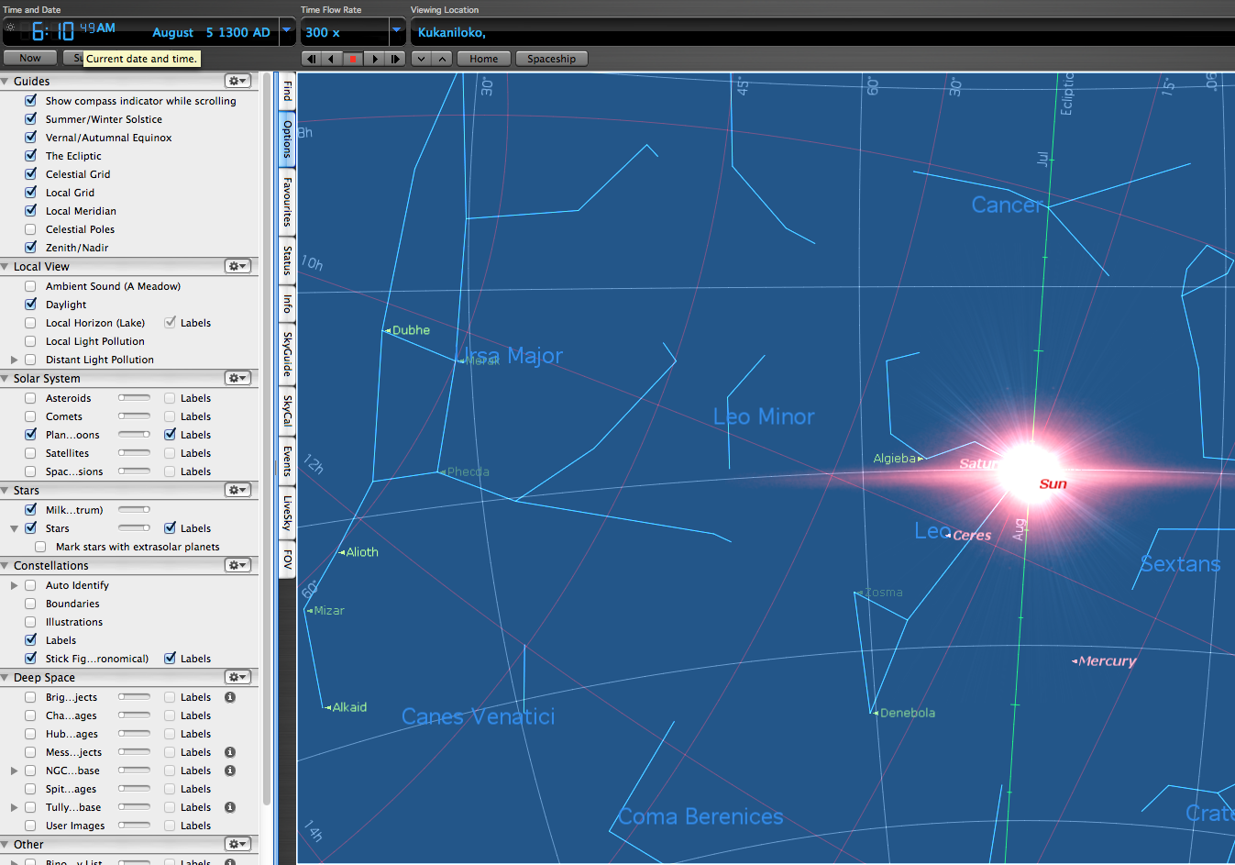
Figure 5.7 Regulus in the sun with daylight turned on

That it was in the sun, though, related the child both to rulership and to Kāne, the demiurge and son of Wākea and Papa and god of the highest wisdom, whose symbol/representative is the sun.
This organization of the landscape, both visible and beyond view, using stars to center the landscape on Kūkaniloko and establish Kūkaniloko as the center/piko of the island, constantly recreated cosmogony, made it real and embodied in the present. Ernst Cassirer said that mythic conception comprehends a unity, a convergence, of symbol and meaning, of image and object, of name and thing. However, as the implexes show, the 'unity' is actually a compression of divergences.
Eliade wrote, 'CONSECRATION OF A PLACE=REPETITION OF THE COSMOGONY.[sic] It must be understood that the cosmicization of unknown territories is always a consecration; to organize a space is to repeat the paradigmatic work of the gods'.Organizing O'ahu using cosmogony as represented/symbolized by stars and their landscape markers was a kind of 'repetition' of the work of the gods. It may or may not be true that 'cosmicization' of 'unkown territories' was a consecration. Kūkaniloko was not an unknown territory when the temple was established. The island had been populated for several hundred years before Kūkaniloko was founded, and the region around Kūkaniloko was populated by a class of chiefs, the Lo chiefs.There was a network of trails throughout the island and as the State Parks website says, 'Major trails crossed the island and intersected near Kukaniloko'.
Eliade also wrote that the making of sacred spaces was a kind of cosmogony in 'imitation of the world itself having been created from a center'. Indeed Hawaiian cosmogony was placed on the land in the landscape marker names for the cosmogonic stars, but the center was both more and less than a world navel. It was more because the actual piko was the star Mintaka in the sky, and thus could be imitated on the ground anywhere natural markers for these stars could be found or human-made ones constructed – in Hawaiʻi or Tahiti, or even in Europe or Africa. It was less for the same reason. There were no Hawaiians until Polynesians from elsewhere came to these Islands. They brought Polynesian cosmogonies and myths with them, and they brought Polynesian knowledge of the heavens.
A project across disciplines in the academy was the development of universalizing theories and fitting specific knowledge into those universals. Universals produced by Eliade and Cassirer only partially apply to Kūkaniloko. Arguments by non-Western scholars say that universalizing theories do not recognize or correctly conceptualize non-Western phenomena. Edward Said spoke of this in Orientalism. Speaking of the Said's book, Joseph Massad wrote, 'few books unraveled the archeology [sic] of Western identity the way Orientalism did.' Massad continued, writing that the West's construction of Orientalism was less about the Orient than it was about 'producing the West and its identity and culture.' David Lamrosch, writing of Said's 'Traveling Theory,' wrote 'Said calls into question the appropriation and transplantation of ideas and theories from one space and time to another, a process that raises issues of representation and institutionalization specific to the host culture'. This is understood and recognized in Indigenous methodogies which, as several scholars, including Margaret Kovach and Renee Pualani Louis, have stated, has among its purposes the assertion and advocating of native knowledge systems.
Eliade also wrote that 'every holy place, every place that bore witness to an incursion of the sacred into profane space, was also regarded as a "centre"'. This assumes a difference between sacred space and profane space, and, as discussed above in the literature review, Hawai'i and other parts of Polynesia did not assume such a difference. If we look at Eliadeʻs statement through the lens of the Polynesian wā, the boundary between sacred and profane dissolves. Further, the Polynesian notions of sacred are somewhat fluid in that kapu (sacred) and noa (free of kapu) are alternate states or conditions and not permanent states.
There is, however, another word for sacred. The Pukui and Elbert dictionary defines kapu as 'taboo, prohibition; special privilege or exemption from ordinary taboo; sacredness; prohibited, forbidden; sacred, holy, consecrated; no trespassing, keep out' and defines the word la'a as 'sacred, holy, devoted, consecrated, set apart or reserved as for sacred purposes, dedicated'. When Kūkaniloko was established it became la'a. This is not, however, an 'incursion of the sacred', but, rather, a particular quality of sacred.
Kūkaniloko in the present continues to be la'a. Those who frequent the site, who have a personal and/or genealogical and/or cultural connection do, as Pukui and Handy expressed it, and as I have observed in the course of research at the site,'apprehend and sense [it] as personal'. The site's kahu often says of Kūkaniloko 'we love them for all time', a statement in tune with Tuan's 'affective bond between people and place'. I think, though, that the 'affective bond' of people with genealogical and cultural ties to Kūkaniloko is more than affective and more than between the people and the place. I think that it bindspersonal and cultural identity, provides a sense of personal connection to the past as well as to the present, enhancesa feeling of cultural unity and an awareness of one's kuleana.

5.7Cosmogony, status, calendar, attributes/characteristics of stars
The cosmogonic stars' and sun stations' association with Kūkaniloko indicate some of the functions of the site. They also indicate some of the cultural functions of precontact astronomy at Kūkaniloko. Cosmogony is, clearly, very much a part of Kūkaniloko's purpose. Not only did the cosmogonic stars through their relationship with Kūkaniloko connect the lineage of chiefs all the way back to pō and even to kolekole, but they continually established/re-established the sacredness of the high chiefs. The particularly exalted status of a chiefly child born when the shadow dagger appeared (Regulus) also evidences the hierarchical nature of the culture and it connects high status to the stars.
The research also points out attributes of the stars, their culturally understood characteristics and purposes. This revelation, while suggested in some of the names of the stars, is clearer when those names are 'explained' by the words naming the landscape markers. The stars' landscape markers provide a wealth of knowledge about the ways in which the sky was understood and used in precontact times. Aldebaran, for example, has among her names Keoma (the oven), Ana-muli (pillar in back), Unu (altar, growth), Kapuahi (fireplace, oven, and sacred fire). Oven, fireplace, and sacred fire are probably references to the May zenith sun which takes place when the sun is near Aldebaran. Lilioma, another of her names, is jealous with having lost her former attractiveness, a famed characteristic of Haumea after a string of rejuvenations during which she married sons and grandsons. The Kumulipo says of her at this stage
Kio was born, Haumea was recognized,
Haumea was recognized as withered up,
She was old, she was not desired, . . .
She was shown by Uaia to be worn out,
Dried up back and front,
She stamped on the ground, left Nu‘umea,
The earth shook, the woman ceased living with many husbands.

Her landscape markers tell the story of her betrayal by Wākea, and of the two infants, one stillborn and premature, the other healthy, that Wākea fathered by Ho'ohokukalani, Wākea's and Papa's daughter.
Among the names for Orion's Belt are Nakao (the darts, referring to Maui the demigod's weapons), Maui-a-ka-malo (Maui of the loincloth), Kolu (three, referring to the three stars of the Belt), Welo (his name as a month star, and it means ancestry and progeny), and Aua (thin, referencing the name of Wākea's first home). These names fall into three categories – the Maui stories, a description of the Belt, and cosmogony. His landscape markers all relate to cosmogony.
It is apparent that both the names of celestial objects and the names of their landscape markers were purposeful. The names served to recite mo'olelo (stories) and to describe, by implication and references, cultural functions. This provides additional knowledge about precontact Hawaiian culture and its astronomy.

5.8 Paired relationships
Table 5.1 Pattern of Pairs
A | B | Condition
Sun | Stars | Unity of opposites (sun set, star rise)
Sun | Regulus
Rise | Rise in the sun | Unity
Betelgeuse | Orionʻs Belt
Wākeaʻs home | Piko of Wākea | similarity
Castor | Pollux
Male | Female | Opposite/duality
Death | Birth | Opposite/complementary
Antares | Aldebaran
Male | Female | Opposite/duality
Pillar in front | Pillar in back | Opposite/complementary
Fireplow | Oven | Unity/complementary
Pō | Ao
Dark | Light | Opposite/duality/complementary
Before humans | Humans | Different
The deceased | The living | Opposites/complementary
Wākea | Papa
Husband | Wife | Unity of opposites/complementary
Kāne separates |  | separation
Wākeaʻs incest |  | Divorce - disunion
Ulupo | Pokai
Nadir | Nadir | Same
Zenith | Zenith | Same
Kaaawa | Keawaulua
Stillborn baby | Stillborn baby | Same
East coast | West coast | Opposites/unity of opposites
Puu Kamana | Puu Kamananui
Dec S sunrise | Jun S sunset | opposite
Alala | Kaala
Sunʻs path | Sunʻs path | same
Sunʻs path at N and Z | Sunʻs path at equinoxes | Different
Kila | Puu o Kila
July Z (Cancer) | July Z (Betelgeuse) | same
Puu Kailio | Kaneilio
Z, N | Z, N | same
Kanehoalani | Keaau
Wākea | Wākea | Same/opposite (east coast, west coast)
Makalii Point | Puu Kumakalii
Pleiades rise | Sunset at Pleiades rise | Different (sea/mountain), (star rise, sun set)
Legend:
Complementary: completing something
Unity: a condition of harmony, accord
Duality: having two parts
Opposite: located across from something
Same: not different
Different: not the same
N: nadir
Z: zenith

I suggest that a core principle of Hawaiian cultural astronomy is evident in relationship(s), especially in sets of pairs. Aldebaran and Antares have a relationship, or, more accurately several relationships – female (Aldebaran) and male (Antares); pillar in front (Antares) and pillar in back (Aldebaran); firestarter (Antares) and oven (Aldebaran). The sun has relationships with stars, setting on a mountain named to represent a star that rises in the evening. Pō has a relationship with ao (complementarity). Wākea has a relationship with Papa (unity of opposites) that is broken twice, once when Kāne separates them so that there is room between sky and earth, and again when, because of Wākeaʻs incest with their daughter, husband and wife separate. Castor (male) has a relationship with Pollux (female) that represents them as death and entrance to pō (Castor) and birth and entrance to ao (Pollux). Ulupo Heiau and Pokai Bay have a relationship, expressed by zeniths and nadirs and the respective duality/complementarity of the pikos (head, mind – zenith; genitals, body – nadir) and share in common the accessibility of potent inspiration (sameness).
Regulus has a special relationship with the sun, reflected in their unity (Regulus rising in the sun), an event that separates an infant from all other chiefly children born at Kūkaniloko. The child born at Kūkaniloko when the shadow dagger forms has a special relationship with Kāne (the sun), Regulus (the 'annointer' by means of the dagger), and with the whole of cosmogonic lineage. Kaaawa and Keawaula have a relationship of unity in that both represent the stillborn infant, and of opposites as Kaaawa is on the east coast and Keawaula on the west coast. Alala and Kaala have a relationship through the sun, Alala, on the east shoreline, representing the relationship between the zenith and the nadir and Kaala, O'ahu's tallest mountain and in the west, representing the equinoxes, two more of the sun's stations. These pairs show a pattern of celestial relationships.

5.9 Implications regarding Io
Completely unexpected were the place names that suggest that, despite several previous scholars' investigations having concluded that Io was not known in Hawai'i, that in fact Io was recognized in precontact Hawai'i, at least on O'ahu. The landscape marker Kolekole for the nadir furthers the argument that Io and kolekole (Maori Korekore and Te Kore) were known. There are additional stars and landscape markers that take the argument even further, and it is anticipated that these will be the subjects of future papers that build upon this research report.

This chapter has reviewed the data and outlined the inferences I have drawn from them. The next chapter concludes this paper with a summary of the research and its key findings before recommending areas for future research.

6. Conclusion
My project set out to investigate whether there was discoverable precontact astronomy associated with the site Kūkaniloko. This is the first such study done of Kūkaniloko and is one of the few projects conducted to have researched precontact astronomy in the Hawaiian Islands. The data collected during the project yielded a wealth of information about precontact cultural astronomy on O'ahu. Extrapolating from my analysis of data I have developed and presented for consideration some general postulates for precontact astronomy on O'ahu.
The first of these is that it is necessary to know or have access to the multiple names most celestial objects and events have. It follows that translating/interpreting those names is likewise imperative. This is necessary because the names provide information about the object or event. For example, among the many words signifying the solar zenith is lolo (brain). When the sun 'bites the brain' it is the solar zenith, and the phrase refers both to the heat of the zenith sun and that the sun is directly above one's head, allowing mana, insight, and inspiration to enter the brain. As another example, among the many names for Aldebaran are several containing the word oma, meaning oven. In AD 1300 the May solar zenith took place when the sun was near Aldebaran, and she is thus associated with heat. Another of Aldebaran's names, Haumea, is of particular importance as Haumea is not only the goddess of childbirth but Haumea is also the name Papa took upon divorcing Wākea thus equating Haumea with Papa.
Another postulate derived from my research is that celestial objects have relationships. As Table 5.1 shows, may of these relationships are in the form of pairs. Aldebaran is a good example. Aldebaran and Antares have a paired relationship with Antares as the 'pillar in front' and Aldebaran as the 'pillar in back'. Aldebaran's oven names also pair her with Antares as Antares works the fire plow or fire drill, a tool using friction to start a fire, as one of his landscape marker names points out. Castor and Pollux have relationships, one as twins, another as male (Castor) and female (Pollux), another as the entrance to pō from ao (Castor) and the entrance to ao from pō (Pollux). Castor and Pollux as the constellation Gemini have a relationship with the sun at the June solstice. Pollux has a relationship with Aldebaran through childbirth. Betelgeuse and the Belt of Orion have a relationship with each other through their association with Wākea and the cosmogonic references in their landscape marker names. Regulus has a relationship with the sun when Regulus rises 'in' the sun in August to proclaim a child born at Kūkaniloko that day the highest of chiefs.
The relationship of Regulus with the sun points to the postulate, also derived from my research, that precontact sky experts knew the sun's annual cycle and the relationship of star cycles with the sun's cycle. That knowledge is also evidenced in the use of the location of a sunset to announce the evening rise of a star. Another postulate is that stars are gendered. Antares and Castor, for example, are male and Aldebaran and Pollux are female.
A further postulate is that celestial objects and events have culturally meaningful characteristics/qualities. The solar nadir, for example, was more than a sun station or an element of calendrics for precontact sky experts. It served as a connection to cosmogony and to creation before the advent of humankind. The nadir connects chiefly lineages to the realm and era of pō and beyond pō to kolekole and Io. A similar principle is that cosmogony is connected to and associated with stars. In particular Taurus and Aldebaran, Betelgeuse, and the Belt of Orion, and also Gemini and Regulus are associated with cosmogony.
That considerable attention to the sun is another postulate, already somewhat evident in the previously paragraphs. My research showed that all eight sun stations were noted and given named landscape markers. The path of the sun, the ecliptic (ke ala a ke kuukuu – the path of the spider), was known and its northern and southern limits were the boundaries of ao (between the limits) and pō (outside the limits) were recognized. Recognition and knowledge of the celestial equator (ke ala a ka piko o Wākea – the path to the navel of Wākea) as well as the ecliptic and the eight sun stations evidences precontact knowledge of celestial architecture.
The next group of postulates are specific to Kūkaniloko, although possibly repeated in whole or in part at other sites. Star rise and set azimuths connect sites to/through Kūkaniloko by means of landscape markers and thus sites are related to one another through stars. For example, Ulupo and Pokai are connected to one another by the solar nadir. Another example is Kanehoalani and Kaneana,sitesthat are connected by Betelgeuse. A further postulate is that each of the cosmogonic stars had landscape marker(s) the name(s) of which indicated a quality or characteristic of the star and those markers recorded all of the essential story elements of cosmogony.Haumea/Papa (Aldebaran) has two landscape markers that speak of the stillborn premature child of Wākea and Ho'ohokulani. Another of her landscape markers is La'ila'i whose union with Ki'i produced a son, establishingthe lineage of human beings as senior to that of the gods. Landscape markers for Betelgeuse include those naming Wākea, Kāne and the womb of Papa. Unexpected was the finding of evidence that Te Kore/kolekole and Io were known on O'ahu, as reported above in both the data and discussion chapters. The research found landscape marker names for the sun at the nadir and for Betelgeuse that contain Io's name as well as his condition of inactivity. Further, Kolekole, where the sun sets on the day of the nadir, is the Hawaiian transliteration of the Maori korekore (also called Te Kore).
In the absence of a written language star knowledge was inscribed in star rise and set markers on the land, stars' relationships with one another and with the sun, and the multiple names for any one star. This is particularly apparent in the landscape marker names. Examples of these names are Kolekole for the nadir, Kaala and Alala for equinox and nadir respectively, Kuloa and Kaluakauila for Regulus, Kamaohanui and Keaau for Betelgeuse.Conceptual and abstract thought are evidenced by stars' and their markers' names and stars' relationship to the piko. Ao and pō, wā, kolekole, are among these concepts.
The findings suggest that cultural fluency matters. Cultural particulars matter and universalising can, by presupposing a universal, curtail attention to and investigation of cultural particulars. Using works written by indigenous scholars helps in recognizing and understanding the epistemology and ontology that are at work in precontact Hawaiian sky knowledge. Knowledge and understanding of implexes is also useful, as demonstrated in the discussion chapter above.
There is much more work to do at Kūkaniloko, but I am confident that my project has provided substantial evidence that astronomy was of significance in precontact Hawai'i. I suggest that additional research should focus on the remaining month stars, followed by more research regarding the solar nadir. Relationships between Kūkaniloko and other sites through use of stars should be researched. Sites that are not pikos may not have as extensive celestial relationships as Kūkaniloko has, but the depth and breadth of astronomical knowledge evidenced at Kūkaniloko can suggest and perhaps even inform research at other sites.
I opened this paper with a reference to Hilo ʻia kea ho o ka 'ike – the braided cords of knowledge opened my dissertation. That 'ōlelo no'eau (wise saying, proverb) has been the underlying theme of the Kūkaniloko project. What I uncovered at Kūkaniloko is knowledge that was never lost. I had an opportunity to dust off some signs and signals, but the knowledge was long ago inscribed on the land and written in the sky.

Bibliography

Americaʻs Library, http://www.americaslibrary.gov/jb/modern/jb_modern_hawaii_1.html. (accessed February 11, 2014).

Andrews, Lorrin,A Dictionary of the Hawaiian Language, Honolulu: H.M. Whitney, 1865.

Atkinson, R.J.C., 'Obituary – Alexander Thom.' Journal for the History of Astronomy, Vol. 17, No.1:48(February 1986):73-75.

Aunio, Anna-Liisa, 'Mobilizing the Generation Gap: Transnational Coalitions and Insider/Outsider Strategy in the Climate Action Network,' in Strategies for Social Change, ed. Gregory M. Maney, pp. 93-115, St. Paul, University of Minnesota Press, 2012.

Aveni, Anthony, 'Archaeoastronomy in the Ancient Americas.'Journal of Archaeological Research, Vol. 11, No. 2 (June 2003):141-191.

Barrere, Dorothy, 'Cosmogonic Genealogies of Hawaii.' Journal of the Polynesian Society, Vol. 70, No. 4(1962): 419-428.

Bausch, Christia, 'Po and Ao, An Analysis of Ideological Conflict in Polynesia.'Journal de la Societe des Oceanistes, No. 61, Vol. 34, (1978): 169-185.

Beckwith, MarthaHawaiian Mythology, Honolulu: University of Hawaii Press, 1976.

Beckwith, Martha, trans., ed., The Kumulipo: A Hawaiian Creation Chant, Honolulu: University of Hawaii Press, 1971.

Berg, Marlene J., 'Experiential Knowledge', in The Sage Encyclopedia of Qualitative Research Methods: A-L, ed. Lisa M. Given, pp. 321-322, Thousand Oaks: Sage Publications, 2008.

Best, Elsdon, 'The Polynesian Method of Generating Fire.'Journal of the Polynesian Society, Vol. 33 No. 130 (1924):87-102.

Best, Elsdon,Astronomical Knowledge of the Maori, Wellington: Dominion Museum, 1922.

Best, Elsdon,Maori Religion and Mythology Part 2, Wellington: P.D. Hasselberg, 1982.

Best, Elsdon,The Maori as He Was; A Brief Account of Life as It Was in Pre-European Days, Wellington: Dominion Museum, 1934.

Best, Elsdon, The Maori Division of Time,Wellington: R.E. Owen, 1959.

Best, Elson, Maori Religion and Mythology, Part 1, Wellington: A.R. Shearer, 1976.

Brady, Bernadette, 'Star Phases: the naked-eye astronomy of the Old Kingdom Pyramid Texts', in Skyscapes: the role and importance of the sky in archaeology, ed. Nick Campion and Fabio Silva, Oxford: Oxbow Press, in press.

Buckova, Martina, 'Io – The Supreme God of Polynesians?' Asian and African Studies, 17, (2008):74-89.

Campion, Nick, 'Teaching Cultural Astronomy: On the Development and Evolution of the Syllabus at Bath Spa University and the University of Wales, Lampeter,' in African Cultural Astronomy: Current Archaeoastronomy and Ethnoastronomy research in Africa, ed. Jarita Charmian Holbrook‬, Rodney Medupe‬, Johnson O. Urama‬, pp. 109-119,London: Springer, 2008.‬‬‬‬‬‬‬‬‬‬‬‬‬‬‬‬‬‬‬‬‬‬‬‬‬‬‬‬‬‬‬‬‬‬‬‬‬‬‬‬‬‬‬‬‬‬‬‬‬‬

Casper College,http://wind.caspercollege.edu/~marquard/astronomy/celestial_sphere.htm. (accessed November 7, 2014).

Cassirer, Ersnt, Language and Myth, New York: Dover Publications, 1946.

Charlot, John, 'Classical Polynesian Thinking,'in A Companion to World Philosophies, ed. Eliot Deutsch and Ron Bontekoe, pp. 49-62, Cambridge: Blackwell, 1997.

Chun, Malcolm, comments on Amazon.com regarding Benjamin Namakaokeahi,The History of Kanalu: Mo'okuauhau 'Elua, a Genealogical History of the Priesthood of Kanalu.

Cordy, Ross, The Rise and Fall of the O'ahu Kingdom, Honolulu: Mutual Publishing, 2002.

Damrosch, David, editor, World Literature in Theory, Hoboken: Wiley-Blackwell, 2014.

Daws, Gavin,The Shoal of Time, Honolulu: University of Hawaii Press, 1989.

Denny, J. Peter, 'Rational Thought in Oral Culture and Literate Decontextualization,' in Literacy and Orality, ed. David R. Olson and Nancy Torrance, pp. 66-90, Cambridge: Cambridge University Press, 1991.

Denzin, Norman K. and Yvonna S. Lincoln, 'Rethinking Critical Theory and Qualitative Research,'The Sage Handbook of Qualitative Research, pp. 303-342, Thousand Oaks: Sage Publications, 2005.

Du Bois, W.E.B.,The Souls of Black Folk, Electronic Classics Series Publication, first published in 1903.

Dwyer, Sonya Corbin, and Jennifer L. Buckle, 'The Space Between: On Being an Insider-Outsider in Qualitative Research.' International Journal of Qualitative Method8(1) (2009): 54-63.

Edwards, Edmundo, and Alexandra Edwards, 'Rapanui Archaeoastronomy and Ethnoastronomy', Flag #83 Expedition Report, February-June 2010, Pacific Islands Research and Education Fund, Friday Harbor, Washington,http://www.pacificislandsresearchinstitute.org/Flag_83_Report.pdf. (accessed September 14, 2014).

Elbert, Samuel, 'Hawaiian Literary Style and Culture.' American Anthropologist Vol. 53, (1951): 345-354.

Eliade, Mircea, Images and Symbols, Princeton: Princeton University Press, 1991.

Eliade, Mircea, The Sacred and the Profane: The Nature of Religion, translated by Willard R. Trask, New York: Harcourt, Brace and World, 1959, https://www.dmt-nexus.me/doc/the%20sacred%20and%20the%20profane.pdf. (accessed October 11, 2014).

Emory, Kenneth P., Kapingamarangi:Social and Religious Life of a Polynesian Atoll, Bernice P. Bishop Museum Bulletin 228, Honolulu: Bishop Museum Press, 1965.

English Encyclopedia at http://www.encyclo.co.uk/define/Implex. (accessed November 10, 2014).

Fleischer, Robert C., Storrs L. Olson, Helen F. James, and Alan C. Cooper, 'Identification of the Extinct Hawaiian Eagle (Haliaeetus) by mtDNA Sequence Analysis.'Auk Vol. 117 (4)(2000): 1051-1056.

Fornander, Abraham,An Account of the Polynesian Race: Its Origins and Migrations, and the Ancient History of the Hawaiian People to the Times of Kamehameha, London: Trubner and Company, 1878.

Fornander, Abraham, and Thomas Thrum, Fornander Collection of Hawaiian Antiquities and Folklore, Honolulu: Bishop Museum Press, 1920.

Gegeo, David Welchman, and Karen Ann Watson-Gegeo, '"How We Know": Kwara'ae Rural Villagers Doing Indigenous Epistemology.' The Contemporary Pacific(Spring 2001):55-88.

Ghezzi, Ivan and Clive Ruggles, 'Chankillo: A 2300-Year-Old Solar Observatory in Coastal Peru.' Science Vol. 315, No. 5816 (March 2007): 1239-1243.

Green, Laura C. and Martha Warren Beckwith, 'Hawaiian Customs and Beliefs Relating to Sickness and Death.' American Anthropologist N. S., 28, (1926):176-208.

Grimble, Arthur,Migrations, Myth and Magic from the Gilbert Islands, London: Routledge and Keagan Paul, 1972.

Handy, E.S. Craighill and Mary Kawena Pukui, The Polynesian Family System in Ka'ū, Hawai'i, Rutland: Charles E. Tuttle, 1958.

Hanson, F. Allan and Louise Hanson, Counterpoint in Maori Culture, London: Routledge and Kegan Paul, 1983.

Harris, Annie, 'Traditions of Oahu' at http://apdl.kcc.hawaii.edu/oahu/stories/kona/waiakeakua.htm. (accessed December 10, 2014).

Hawaii State Parks, http://www.hawaiistateparks.org/parks/oahu/index.cfm?park_id=24. (accessed June 11, 2014).

Hawass, Zahi, 'Horus the Falcon God', http://guardians.net/hawass/horus.htm. (accessed August 11, 2014).

Hawkins. Gerald and John B. White, Stonehenge Decoded, New York: Doubleday, 1965.

Henry, Teuira, 'Tahitian Astronomy.'Journal of the Polynesian Society Volume 16, No. 2 (1907): 101-104.

Hommon, Robert J.,The Ancient Hawaiian State, Oxford: Oxford University Press, 2013.

Hubert, Jane, 'Sacred Beliefs and Beliefs of Sacredness,' in Sacred Sites, Sacred Places, ed. David Carmichael, Jane Hubert, Brian Reeves, Audhild Schanche, pp. 9-19, New York, NY: Routledge, 1994.

Isbell, Billie Jean, 'Culture Confronts Nature in the Dialectical World of the Topics', Ethnoastronomy and Archaeoastraonomy in the American Tropics, ed. Anthony Aveni and Gary Urton, pp. 353-363, New York: The New York Academy of Sciences, 1982.

Johnson, Rubellite Kawena and Harry Kurth, 'The Birthstones of Kukaniloko Heiau: Are They Oriented to Sky Phenomena?,’ no date, manuscript in the Division of State Parks, State of Hawaii;

Johnson, Rubellite Kawena and John Kaipo Mahelona, Na Inoa Hoku,Honolulu: Topgallant Press, 1976.

Johnson, Rubellite Kawena,The Kumulipo Mind,Honolulu: privately published, 2000.

Kamakau, Samuel, 'Instructions in Ancient Astronomy as Taught by Kaneakahoowaha', Thrum's Hawaiian Annual for 1891, (Honolulu, 1891): 142-43.

Kamakau, Samuel, Tales and Traditions of the People of Old, Honolulu: Bishop Museum Press, 1993.

Kamakau, Samuel, The People of Old, Honolulu: Bishop Museum Press, 1964;

Kamakau, Samuel, The Works of the People of Old, Honolulu: Bishop Museum Press, 1976.

Kameʻeleihiwa, Lilikalā, 'Hawai‘i-nui-akea Cousins: Ancestral Gods and Bodies of Knowledge are Treasures for the Descendants.' Te Kaharoa vol. 2 (2009): 42-63.

Kikiloi, Kekuewa, 'Rebirth of an Archipelago: Sustaining a Hawaiian Cultural Identity for People and Homeland.' Hūlili Volume 6 (2010): 70-115, http://www.ksbe.edu/spi/Hulili/Hulili_vol_6/5_Rebirth_of_an_Archipelago.pdf. (accessed July 17, 2014).

Kincheloe, Joe, 'On to the Next Level: Continuing the Conceptualization of the Bricolage.' Qualitative Inquiry, Vol. 11, No. 3(2005): 323-350.

King, Thomas F.,Places That Count: Traditional Cultural Properties in Cultural Resource Management, Lanham, MD: Alta Mira Press, 2003.

Kingsley-Smith, C.,Maori Star Lore, A talk to the Whakatane Astronomical Society, New Zealand, 1966, www.transitofvenus.co.nz/docs/MaoriStarLore.doc. (accessed January 23, 2014).

Kirch, Patrick V.,'Temple Sites in Kahikinui, Maui, Hawaiian Islands: their orientations decoded.' Antiquity (March 2004): 102-114.

Kirch, Patrick V.,A Shark Going Inland Is My Chief, Berkeley: University of California Press, 2013.

Kirch, Patrick V. and Marshall Sahlins, Anahulu: The Anthropology of History in the Kingdom of Hawaii, Volume 1, Chicago: University of Chicago Press, 1994.

Kirch, Patrick V. and Green, Roger C., Hawaiki, Ancestral Polynesia: An Essay in Historical Anthropology, Cambridge: Cambridge University Press, 2001.

Kirch, Patrick V., Clive Ruggles, and Warren D. Sharp, 'The Pānānā or "Sighting Wall" at Hanamauloa, Kahikinui, Maui: Archaeological Investigation of a Possible Navigational Monument.'Journal of the Polynesian Society Vol. 122, No.1(March 2013): 45-68.

Kirch, Patrick V.,When Chiefs Became Kings, Berkeley: University of California Press, 2010, pp. 127-128;

Kovach, Margaret, 'Conversational Method in Indigenous Research.' First Peoples Child and Family Review Vol. 5, No. 1 (2010): 40-48.

Kūkaniloko Interpretive Plan, Division of State Parks, State of Hawaii, 1999.

Kukendall, Ralph,The Hawaiian Kingdom, Volumes 1, 2, and 3, Honolulu: University of Hawaii Press, 1965.

Kusow, Abdi M., 'Beyond Indigenous Authenticity: Reflections on the Insider/Outsider Debate in Immigration Research.' Symbolic Interaction, Vol. 26, No. 4 (2003): 591-599.

Kyselka, Will,'Preliminary Thoughts on Ku-kani-loko,' Memorandum at State Historic Division, Department of Land and Natural Resources, State of Hawaii, 1993.

Nomination Form for the National Register of Historic Places Inventory, p. 3 at http://pdfhost.focus.nps.gov/docs/NRHP/Text/73000674.pdf. (accessed December 5, 2012).

Levard, A., translator, 'The Tahitian Version of Tafa’i.'Journal of the Polynesian Society Volume 21, No. 1 (1912): 1-12.

Levi-Strauss, Claude,The Savage Mind, Chicago: University of Chicago Press, 1966.

Levine, Victoria Lindsay, 'Feathers in Southeast American Indian Ceremonialism.'Expedition Vol. 33, No. 2 (1991): 3-11.

Louis, Renee Pualani, 'Can You Hear us Now? Voices from the Margin: Using Indigenous Methodologies in Geographic Research.'Geographical Research 45(2)(June 2007):130-139.

Magli, Giulio,Mysteries and Discoveries of Archaeoastronomy: From Giza to Easter Island, Gottingen: Copernicus, 2009.

Makemson, Maud,'Hawaiian Astronomical Concepts I.'American Anthropologist Vol. 40, No. 3(July-September 1938):370-383.

Makemson, Maud, 'Hawaiian Astronomical Concepts II.'American Anthropologist Vol. 41, No. 4(October-December 1939): 589-596.

Makemson, Maud, The Morning Star Rises, New Haven: Yale University Press, 1941.

Malo, David,Hawaiian Antiquities, Honolulu: Bishop Museum Press, 1987.

Malville, J. McKim 'Astronomy and Ceremony at Chankillo: An Andean Perspective', Oxford IX International Symposium on Archaeoastronomy Proceedings IAU Symposium No. 278, ed. Clive Ruggles, Cambridge: Cambridge University Press, pp. 154-161, 2011.

Manu, Moses, and Puakea Nogelmeier,ed.,Mary Kawena Pukui, trans., Keaomelemele: He Moolelo Kaao No Keaomelemel/the Legend of Keaomelemele, Honolulu: Bishop Museum Press, Bilingual edition, 2002.

Massad, Joseph, 'The Intellectual Life of Edward Said.'Journal of Palestine Studies XXXIII, No. 3(Spring 2004): 7-22.

Mateata-Allain, Kareva, 'Orality and Maʻohi Culture.' Shima: The International Journal of Research into Island Cultures Vol. 3 No. 2 (2009): 2-9.

McAllister, J. Gilbert,Archaeology of Oahu, Honolulu: Bishop Museum Press, 1933.

Meech, Karen J., and Francis X. Warther. Kumu Kahi. First beginnings: astronomy and cosmic architecture in ancient Hawai'i. na, 1996.

Merleau-Ponty, Maurice, Phenomenology of Perception, Colin Smith translator, London: Routledge and Kegan Paul, 2002, at https://wiki.brown.edu/confluence/download/attachments/73535007/Phenomenology+of+Perception.pdf;

Namakaokeahi, The History of Kanalu: Mo'okuauhau 'Elua, a Genealogical History of the Priesthood of Kanalu, Malcolm Chun, translator, Honolulu: First Peopleʻs Productions, 2004.

National Oceanic and Atmospheric Administration, http://www.ngdc.noaa.gov/geomag-web/#declination. (accessed October 2012).

National Park Service, Pu'ukohalā Heiau, at http://www.nps.gov/puhe/historyculture/olohana.htm, accessed December 23, 2014;

Nomination form, National Register of Historic Places, 1994.

Ong, Walter J., Orality and Literacy, London: Routledge, 2002.

Papahānaumokuākea Marine National Monument, http://www.papahanaumokuakea.gov/education/pdf/pmnm_map_poster.pdf. (accessed December 19, 2014).

Paraone, Tiwai, 'A Maori Cosmogony.'Journal of the Polynesian Society Vol. 16 No. 3, (1907):109-119.

Parker, Patricia and Thomas F. King, Guidelines for Evaluating and Documenting Traditional Cultural Properties, at http://www.nps.gov/nr/publications/bulletins/nrb38/. (accessed September 29, 2014).

Pike, Kenneth, Language in Relation to a Unified Theory of the Structure of Human Behavior, The Hague: Mouton, 1954.

Marvin Harris, 'History and Significance of the EMIC/ETIC Distinction.' Annual Review of Anthropology Vol. 5 (1976): 329-350.

Polynesian Voyaging Ttraditions at http://pvs.kcc.hawaii.edu/ike/moolelo/discovery_and_settlement.html. (accessed January 18, 2014).

Porteus, Stanley, Calabashes and Kings: In Introduction to Hawaii, North Clarendon: Tuttle Publishing, 1970.

Pukui, Mary Kawena, and Elbert, Samuel, Hawaiian Dictionary, Honolulu: University of Hawaii Press, 1986.

Pukui, Mary Kawena, Samuel H. Elbert, and Esther T. Mookini, Place Names of Hawai'i, Honolulu: University of Hawaii Press, 1976;

Refiti, Albert, 'Forked Centre.'AlterNative Special Edition, Special Issue (2008): 98-105.

Reilly, Michael P. J., 'Te tīmatanga mai o ngā autuaʻ, in Ki te whaiao: An introduction to Māori culture and society, ed. T.M. Ka'ai, J.C. Moorfield, M.P.J. Reilly, and S. Mosely, pp. 1-12, Auckland: Pearson Education, 2004.

Rjabchikov, Sergei, 'The Astronomical and Ethnological Components of the Cult of Bird-Man on Easter Island', The Sergei Rjabchikov Foundation, Research Centre for Studies of Ancient Civilizations and Cultures, Krasnodar, Russia, no date, p. 2, 5 at http://arxiv.org/pdf/1309.6056.pdf. (accessed August 11, 2014).

Rogers, Mary F., 'Outsiders/Within and In/Outsiders: Varieties of Multiculuralism.' Journal of Educational Controversy Volume 5 Number 2 (Summer 2010),http://www.wce.wwu.edu/Resources/CEP/eJournal/v005n002/a001.shtml. (accessed July 21, 2014).

Rogers, Matt, 'Contextualizing Theories and Practices of Bricolage Research.'The Qualitative Report Vol. 17(2012): 1-17.

Ruggles, Clive and Gary Urton, editors, Skywatching in the Ancient World, Boulder: University of Colorado Press, 2010.

Ruggles, Clive, 'Archaeoastronomy', in Archaeology: The Key Concepts, ed. C. Colin Renfrew and P. Bahn,pp. 8-11, London: Routledge, 2005.

Ruggles, Clive,'Cosmology, Calendar, and Temple Orientations in Ancient Hawaiʻi', Skywatching in the Ancient World: New Perspectives in Cultural Astronomy, ed. Clive Ruggles and Gary Urton, pp. 287-330, Boulder: University of Colorado Press, 2010.

Ruggles, Clive, 'Current Issues in Archaeoastronomy.' The Observatory Vol. 116 (1996): 278-285.

Ruggles, Clive, 'Pushing Back the Frontiers or Still Running Around the Same Circles? "Interpretive Archaeoastronomy" Thirty Years On,' inProceedings of the Oxford IX Symposium on Archaeoastronomy, ed. Clive Ruggles, pp. 1-18, Cambridge: Cambridge University Press, 2011.

Ruggles, Clive,Astronomy in Prehistoric Britain and Ireland, New Haven: Yale University Press, 1999;

Said, Edward,Orientalism, New York: Vintage Books, 1978.

Seidel, Dian J., Qiang Fu, William J. Randel, Thomas J. Reichler, 'Widening of the tropical belt in achanging climate.' Nature Geoscience Vol 1 (January 2008): 21-24.

Silva, Noenoe K., 'Pele, Hi'iaka, and Haumea: Women and Power in Two Hawaiian Mo'olelo.'Pacific Studies Vol. 30, Nos. 1, 2 (March/June 2007): 159-181.

Sinclair, R. M. 'The Nature of Archaeoastronomy', in Current Studies in Archaeoastronomy: Conversations Across Time and Space, ed. John W. Fountain and Rolf M. Sinclair, pp. 3-13, Durham: Carolina Academic Press, 2005.

Spriggs, Matthew, 'The Lapita Culture and Austronesian Prehistory in Oceania,’ in Austronesians: Historical and Comparative Perspectives, Ed. Peter Bellwood, James J. Fox, and Darrell Tryon, Canberra: Australian National University Press, 2006, http://epress.anu.edu.au/austronesians/austronesians/mobile_devices/ch06s02.html. (accessed August 9, 2013).

Stair, John B., Rev., 'The Names and Movements of the Heavenly Bodies, as Looked at from a Samoan Point of View.' Journal of the Polynesian Society Volume 7 No. 1 (1898): 48-49.

State of Hawai'i Department of Accounting and General Services, Survey Division.

State of Hawaii, Department of Education, www.k12.hi.us/~waianaeh/qtvr/Kaneana.html‎.(accessed December 9, 2012).

State of Hawaii National Register application for Kūkaniloko at http://pdfhost.focus.nps.gov/docs/NRHP/Text/94001640.pdf. (accessed November 20, 2012).

Sterling, Elspeth P. and Catherine C. Summers, Sites of Oahu, Honolulu: Bishop Museum Press, 1978.

Te Matorohanga and Nepia Pohuhu, The Lore of the Whare-Wānanga, Part I, transcriber H.T. Whataboro, trans. S. Percy Smith. New Plymouth: Polynesian Society, 1913,http://sacred-texts.com/pac/lww/index.htm. (accessed February 21, 2013).

The Center for Archaeoastronomy at http://terpconnect.umd.edu/~tlaloc/archastro/cfaar_as.html. (accessed December 10, 2014).

Thrum, Thomas, Hawaiian Folk Tales, Chicago: A.C.McClurg & Co., 1907.

Thrum, Thomas, Thrumʻs Hawaiian Annual, Vols. 44-47, Honolulu: Star Bulletin Print Co., 1918.

Timeanddate.com, http://www.timeanddate.com/calendar/seasons.html?year=1300&n=0. (accessed May 15, 2014).

Tregear, Edward,Maori-Polynesian Comparative Dictionary, Wellington: Lyon and Blair, 1891.

Tuan, Yi-FuTopophilia: A Study of Environmental Perception, Attitudes, and Values, New York: Columbia University Press, 1990.

Tuggle, Dave, 'Lady Mondegreenʻs Hopes and Dreams', in Research Designs for Hawaiian Archaeology, ed. Tom Dye,pp. 157-184, Honolulu: Society for Hawaiian Archaeology, 2010.

United States Geographical Survey, Topographic Map of the Island of Oahu, 1:62,500, 1970.

University of Wales Trinity Saint David, http://www.uwtsd.ac.uk/ma-cultural-astronomy-astrology/. (accessed December 10, 2014).

Vaioleti, Timote M., 'Talanoa Research Methodology: A Developing Position on Pacific Research.' Waikato Journal of Education Vol. 12 (2006): 22-34.

Valeri, Valerio, 'Constitutive History: Genealogy and Narrative in the Legitimation of Hawaiian Kingship', in Culture Through Time, ed. Emiko Ohnuki-Tierney, pp. 154-192, Stanford: Stanford University Press, 1990.

Valeri, Valerio,Kingship and Sacrifice: Ritual and Society in Ancient Hawaii, Chicago: University of Chicago Press, 1986.

Voth, H.R., 'Notes on the Eagle Cult of the Hopi.' Publications of the Field Musuem of Natural History Anthropological Series Vol. 11, No. 2, Brief Miscellaneous Hopi Papers, The Stanley McCormick Hopi Expedition, (1912): no page numbers.

Walter, Eugene Victor,Placeways: A Theory of the Human Environment, Chapel Hill: University of North Carolina Press, 1988.

Webster's Online Dictionary at http://www.webster-dictionary.org/definition/Implex. (accessed December 11, 2014).

Wendt, Albert, 'Tatauing the Post-Colonial Body.' Span, 42-43 (April-October 1996): 15-29, reproduced at http://www.nzepc.auckland.ac.nz/authors/wendt/tatauing.asp. (accessed January 6, 2013).

Westervelt, William,Hawaiian Historical Legends, New York: Fleming Revell Co., 1923.

Westervelt, William,Hawaiian Legends of Old Honolulu, Boston: G.H. Ellis Press, 1915.

Wright, Handel Kashope and Meaghan Morris, editors, Cultural Studies of Transnationalism, London: Routledge, Reprint Edition, 2013.

Yent, Martha, 'Kūkaniloko Birthstones Monument,' Division of State Parks, Department of Land and Natural Resources, State of Hawaii, 1995.

APPENDIX 1: Glossary: Hawaiian to English

The meanings provided here are the meanings as they are used in the dissertation. To look at additional meanings, one can consult the Pukui and Elbert Dictionary online at
http://wehewehe.org.

Ahi fire
Ala path, road
Ao day, light, realm of the living
Au era, epoch
'Aumakua ancestral guardian
'Awa premature infant
'Eke container, basket
Hā breath (a symbol for life)
Hale house, shed
Hāpai carry, pregnant
Hina'i basket
Holua sled
'Iki small, little
'Īlio dog
Ka the
Kā container
Ka'a in a state of; rolling
Kahu caretaker, administrator, honored attendant
Kahuna priest, expert in a profession
Kalo taro
Kani sound
Kaona hidden meaning
Kapu sacred, forbidden
Kī ti plant
Kila high place
Kino lau body form
Kolekole negative, nothing
Kū anchor, the months of pregnancy, rise
Ku'u beloved
Kuleana responsibility, authority, function
Kupuna elder, ancestor
Lā the sun; day
La'a sacred, consecrated, set aside for sacred purposes
Le listless, inactive
Lei necklace; beloved
Leina leaping off place for the spirit of the deceased
Lolo brain; zenith
Lua two; pit, hole, grave
Ma'i genitals
Mahana twin(s)
Mahoe twin(s)
Makahiki annual period of tribute and ceremony, approximately October –
February
Makua parent, progenitor
Malo loincloth
Mana spiritual power
Manawa fontanel
Mauna mountain
Mo'olelo story, tale, myth, legend
Mo'opuna grandchild
Nana observe, see, look at
Noa free from kapu
Nui large, big, great
'Ohana family
'Ole'ole negative, nothing
'Oli chant
'Olohe dog men; dog warriors
Oma oven
Pā enclosure, fence, wall
Papa flat surface, foundation
Pā'u skirt
Pau finished, ended
Piko navel, center
Pō night, the realm of gods, spirits, deceased, unborn, and unknown
Pu'u hill, mountain
Pu'uhonua place of refuge
Puka hole
Tutu grandparent
'Ula red, sacred
'Ulu breadfruit
Ulu growth
Wā interval between things, people, places in time or space
Wai warer; any liquid other than salt water

Appendix 2: Place Names

(Note: mauna means mountain; pu'u can be either a mountain or a hill)

Alala
Most common meaning: Alalā – the Hawaiian crow (Corvus tropicus), an 'aumakua for some people. To bawl, cry, wail, scream. A style of chanting.
Also two words: 1) a and lala, 2) ala and lā. 1) Ā – when, at the time when, 'ā – fiery, burning, fire, to glitter; booby bird. Lala – bright, shining; four corners of a house.Lālā – branch, limb, fig.children, offspring. 2) Ala – path. Lā – the sun.
Star – Sirius. Among the names for Sirius are 'ā and a'ā, and both words mean the booby bird.
Associations: Sirius is associated with human sacrifice, thus to cry, wail, scream. It is bright glittering star, thus glitter. The sky is sometimes represented as a house, with the walls at the horizon and the roof overhead, and the rises and sets of Sirius mark the two zeniths and the two nadirs, thus the four corners of a house. The two zeniths and two nadirs are also notable places/times along the path of the sun, thus ala-lā.

Alau
Branching, dividing.
Stars – Gemini, Pollux
Associations: the spirits of the deceased climb a branching ulu (breadfruit) tree.

Alei
Two words, a and lei. Ā – when, at the time when.'Ā – fiery, burning, fire, blaze, fig.to glitter; booby bird. Lei – garland, wreath, given as a symbol of affection, fig.beloved person; to leap, to rise.
Stars – Gemini, Pollux
Associations: At death oneʻs deceased loved one, the lei, leaps into pō.

Aukuu
Most common meaning: the black-crowned night heron a bird that is an 'aumakua for some people.
Also two words: au and kuu. Au – period of time, era, epoch, cycle. 'Au – to travel by sea, swim, to reach out into the sea. Ku'u – to release, let go, to finish, fig. to be at peace.
Star – Castor
Associations: When a person dies his/her life is finished, and he/she enters pō and a time period of peace. Those left behind let go of their loved one, and they, too, can be at peace.

Eleao
Time of light (daylight), used in a prayer to free a new house from kapu and make it fit to occupy.Door at the leeward (west) end of a house.
Star – Sirius
Associations: the west is the direction of ancestors and the place of origin for Polynesians who crossed Oceania from west to east. Sirius, particularly through its association with nadir and thus pō, connects the living with their ancestors.

Halekou
Two words, hale and kou. Hale – house, building, hall. Kou – a native tree with beautiful and soft wood. Kōū – to look about in all directions. Ko'u – conception, male potency. Ko'ū – damp, moist, fig. thriving, prosperous.
Star – Antares
Associations: One of the names for Antares translates as the ʻpillar in front,ʻ while Aldebaran is the ʻpillar in backʻ. Antares is male. He is the senior star to whom other celestial beings look for counsel, thus he is thriving and prosperous. The soft wood of the kou tree makes it suitable for, among other things, making fire by the friction of the fireplow against a piece of kou wood (this refers to another of the place names for Antares).

Hapapa
Can be hapapa, hā-Papa, hapa-pā. Hapapa is a hawk-catching stick, gummed at one end to hold a hawk captive. Hā-Papa is to return breath (ie life) to Papa (Mother Earth). Hapa-pā is half of an enclosure, the enclosure being the solar year.
Stars – the sun, Antares
Associations: hawk is a symbol of a high chief, and the sun is a very high chief. Antares is also a very high chief (depending on the version Antares is either Kāne's older brother or Kāne's uncle). The December solstice sun sets on Hapapa. Antares also sets there.

Kaaawa
Most common translation: ka – the; 'a'awa – wrasse fishes.
Also two words: kaa and awa. Ka'a – in a state of; rolling. Awa – port, harbor, channel. 'Awa – kava (Piper methysticum); rain, mist, fig.tragic misfortune or ordeal; a premature infant.
Star – Taurus
Associations: Aldebaran is the brightest star in this constellation. As Papa she endures the ordeal of her husbandʻs incest with their daughter, an act which result in the birth of a stillborn premature infant. As a result of her husband Wākeaʻs infidelity, the pair separate and Papa takes the name Haumea, one of the names for Aldebaran.

Kahana
Most common meaning: cutting, drawing of a line; turning point.
Also two words: 1) ka and hana; 2) kaha and na. 1) ka – the and hana – work; 2) kaha – mark, draw, cut; place; stage of a foetus when limbs begin to form and na – nā – calmed, quieted, settled; to moan, groan, wail.
Star – Taurus
Associations: Aldebaran, who is Papa/Haumea, reached a turning point because of Wākeaʻs affair with their daughter, an affair which resulted in a partially formed premature stillborn son. The misery of Papa/Haumea and of the mother of the stillborn child likely caused groaning and wailing.

Kahanaiki
Most common translation: small kahana.
For other meanings see Kahana above plus iki – small, little.
Star – Taurus
Associations: see Kahana above.

Kahanalii
Two versions: 1) Ka – hana – li'i, 2) kaha – nali'i.
Li'i – small; short for ali'i (chief), common after nā, as nāliʻi for nā ali'i.
1) the (ka) small (li'i) work (hana); the (ka) chiefʻs (li'i) work (hana); 2) kaha – to draw or plan [of] chief(s).
Star – Antares
Associations: Antares is the senior star and counsels and plans, as that is his work as a high chief in the heavens.

Kahiakahoe
Versions: 1) Ka-hia-ka-hoe; 2) Kahi-a-ka-hoe; 3) Kahi-aka-hoe.
1) the (ka) fireplow (hi'a) strike (kā) paddle, fig. get to work, continue working (hoe); 2) first, alone (kahi) to (a) the (ka) paddle, fig. get to work; 3) first, alone (kahi) image, likeness, shadow (aka) give, go, transfer (hō) beforehand, in advance ('ē).
Star – Antares
Associations: Antares works the fireplow, creating fire which can heat the oven that is Aldebaran (among the words for Aldebaran are several for oven). It may also be that the December solstice takes place close to Antares, and he is thus figuratively relighting the sun. Antares is also rather alone in the sky, and of the calendar stars he is the only one on his side of the sky. As the location of the December solstice he is also the to go in advance.

Kaleinakauhane – the stone/boulder from which the spirits of the newly deceased leaped into pō.

Kaluakauila
Two words: Kalua and kauila.
Kalua – double. Kauila – lightning.
Star – Regulus
Associations: The afternoon of the day Regulus rises ʻinʻ the sun in August, a shadow dagger runs from a peak on the western edge of the Regulus stone to a pecked hole in its interior. A child born at Kūkaniloko at this time was destined to be the highest of chiefs.

Kaluanui
Three words – ka (the) and lua (two, pit) and nui (great, large).
Star – Gemini
Associations: twins (lua), June solstice rise (pit and great).

Kamana
Two words – ka (the) mana.
Star – the sun, December solstice sunrise
Associations – the solstices are events of great mana, as are all the sun stations.

Kamananui
Three words – ka (the) nui (great) mana.
Star – the sun, June solstice sunset.
Associations – both solstices are events of mana, but the June solstice is of greater mana than the December solstice.

Kamaohanui
Three words: Kama, oha, and nui.
Kama – child. Oha – love, affection; growing lush; as 'ohā it is the corm growing from an older root (thus the reason for 'ohana meaning family), and fig. meaning offspring. Nui – great. In other words, the much loved child.
Star – Betelgeuse
Associations: The much beloved child is Kāne, whose emblem/representation is the sun. In some versions of the cosmogony Kāne and other gods are the children of Wākea and Papa, and it was Kāne who separated the parents and then created much of the life in the universe and world, including the first human beings. In other versions of the cosmogony Kāne was already in existence before Wākea and Papa were born. In either set of versions, for a person to be a chief, he/she had to be able to claim descent from Kāne. The family lineage is represented by the 'ohā.

Kaneana
Two words: Kane and ana.
Kāne – the god.
Ana – cave; to measure, survey.
Star – Betelgeuse
Associations: the cave Kaneana – Kāne-ana – is, or represents, the womb of Papa. Before World War II there were two adzes, one at either side of the cave entrance. However, the the military at the time blasted the original entrance of the cave, so while the adzes no doubt marked something, it is unknown what they marked. I suspect it may have had to do with the sun as the word for adz – ko'i – is also the word for solstice. If that is the case the cave may also have served to ʻmeasureʻ the year.

Kanehoalani
The name of Peleʻs father and one of the names of Wākea.
Stars – Taurus, Betelgeuse
Associations: One version of Peleʻs birth has Haumea as her mother. Haumea is the name Papa took after she and Wākea divorced. She is also associated with heat, and among her children as Haumea are the volcano deities. Thus Kanehoalani is associated with Kāne, Wākea, Papa, and Haumea.

Kaneilio
Two words: Kane and ilio.
Kāne – the god; man.
'Īlio – dog.
Star – Sirius
Associations: Kāne created dogs. They appear in the Sixth Wā of the Kumulipo creation chant, along with the 'ōlohe, the dog-men, in the last Wā of pō, after which, in the Seventh Wā humankind emerges. Dog, then, is a liminal character, at threshold between pō and ao, the relam of the deceased and the unborn and the realm of the living. In addition, Kānehunamoku, the mystical hidden (huna) island (moku) of Kāne is where the deceased who kept the kapu properly in their lifetimes go, and Kānehunamoku, depending on the story variant, is guarded by a dog or can turn into a dog. Sirius is associated with death and with pō, both through sacrifice and through marking the nadirs.

Kaoio
Most common meaning: the 'oi'o (procession of ghosts of departed chief and his company), more commonly called huaka'i pō in Hawaiian and Marchers of the Night in English.
Ka-o-Io – basket, container (kā) of, belonging to (o) Io (a god).
Star – Betelgeuse
Associations: Betelgeuse is one of the stars intimately involved with cosmogony. In some versions of the cosmogony, Kāne went to Antares, whose permission and assistance was necessary in order to approach the god Io, and received Antaresʻs help to go to Io to receive the baskets/containers of knowledge.

Kauaopuu
Kaua-o-puu: battle, fight (kaua) of (o) hill (pu'u); outcaste (kaua) of (o) hill (pu'u).
Star – Sirius
Associations: Sirius is associated with human sacrifice, and a person to be offered in sacrifice could be taken from the kaua.

Kaupakuhale
Two words: Kaupaku and hale.
Kaupaku is a variant of Kaupoku. Kaupoku – ridgepole, highest point, roof, fig.greatest.
Hale – house, building.
Star – Antares
Associations: Antares is the senior star, hence the greatest. As the ʻpillar in frontʻ he also supports the ridgepole of the celestial ʻhouse.ʻ

Kaupuni Stream
Two words: Kau and puni.
Kau – season, period of time.
Puni – ten-month year; completed, terminated, as a period of pregnancy.
Star – Sirius
Associations: Sirius marks the nadirs and zeniths, and it seems likely that the months from the first (January) nadir to the second (November) nadir were the ten months that made up the puni, the ten-month year. The second nadir marked the end, the completion or termination, of the puni.

Kawaihapai
Three words: ka-wai-hapai.
The (ka) liquid (wai) [of] pregnancy (hapai).
Star – Pollux
Associations: Pollux is female, and while Castor, the other twin of Gemini, opens the portal between pō and ao, Pollux seems to be associated with birth, the means by which a life enters ao from pō. This also relates her to the royal birth function of Kūkaniloko.

Keaau
Two words: kea-au.
Kea – white, clear; short for Wākea.
Au – time, era.
Stars – Orionʻs Belt, Betelgeuse
Associations: These two stars are involved with cosmogony. Wākeaʻs time or era begins at the beginning of ao, or the realm of humankind, light, the living, in the Kumulipo creation chant with the Seventh Wā.

Keawaula
Three words: ke-awa-ula.
Most common translation: the red awa fish (milkfish).
The (ke) premature infant (awa) royal (ula).
Star – Taurus
Associations: The premature stillborn child of Wākeaʻs incest with his and Papaʻs daughter Ho'hokukalani.

Kila
A high place.
Travel (ki) sun (lā).
Star – Gemini
Associations: The sun travels to a high place – the June solstice – in Gemini.

Kolekole
Most common: raw, red as a wound or red earth.
Also an earlier version of 'ole'ole (with the glottal stop representing the absent consonant), meaning nothing, negative.
Hawaiian transliteration of the Maori Korekore, the realm prior to Pō.
Stars – Sirius, Sun
Associations: The nadir sun and Sirius set in Kolekole, marking the solar nadir and the connection of chiefs from ao through pō to kolekole, the abyss/nothing before pō and thus all the way back to Io.

Kuloa
A long waiting.
Star – Regulus
Associations: There was a long waiting between births that took place when the shadow dagger fell on the Regulus stone, announcing the exalted status of a child born at Kūkaniloko when the shadow dagger was present.

Mahoe Pali
Twins (mahoe) Cliff (pali).
Stars – Gemini, Pollux
Associations: The stars of Gemini are twins.

Makalii
The Pleiades.
Associations: Makalii means the Pleiades.

Makaua
Most common: eye(s) (maka) rain (ua). As ma- kaua it means we two.
Stars – Gemini, Pollux
Associations: We two, the twins of Gemini, Castor and Pollux.

Makua
Parent; progenitor.
Star – Betelgeuse
Associations: The progenitors are not only the human ancestors, but the gods of cosmogony – Kāne, Wakea, Papa, Haumea, and the first humans, La'ila'i and Ki'i.

Mauna is mountain.

Mauna Kaala
Most common translation: fragrant mountain.
Three versions: 1) Ka-ala, 2) kaa-la, 3) ka-ala-la.
1) the (ka) path (ala); 2) to reach, to be located at, to pass (ka'a) sun (lā); 3) the (ka) path (ala) [of the] sun (lā).
Stars – Sun, Orionʻs Belt
Associations:

Mauna Kuwale
Kuwale – to rise alone.
Star – the sun at solar nadir
Association – Mauna Kuwale has a burial cave next to a holua slide.

Nanaikaalaea
Nana-i-kaalaea – look at Kaalaea (a place).
Nana (look, observe) i (at) ka (the) path (ala) [of] life, sovereignty, rule (ea).
Nana (look, observe) i (at) the condition/state of (ka'a) sun (lā) life, sovereignty, rule (ea).
Star – Sirius

Paheehee
To flee; slippery; a shallow grave.
Star – Sirius

Pauao
Star – Taurus

Pohaku Lailai
La'ila'iʻs rock (pōhaku)
Stars – Betelgeuse, Taurus

Pokai Bay
Star – Sirius

Pu'u is a hill or protruberance.

Puu Hapapa
Stars – Sun, Antares

Puu Kaaumakua
Two words – ka (the) and 'aumakua (ancestral guardian).
Star – the sun rise at equinox.
Associations – this is among the markers referring to cosmogony and genealogy.

Puu Kailio
The (ka) dog ('īlio).
Star – Sirius

Puu Kamananui
The (ka) mana great (nui).
Stars – Sun, Gemini, Pollux

Puu Kumakalii
Rise (kū) Pleiades (Makalii)
Star – Pleiades

Puu o Kila
Kilaʻs hill.
High place hill.
Star – Betelgeuse

Puu Pahu
Drum.
Star – Sirius

Puu Pane
Summit.
Star – Cancer

Puu Papaa
Burned, cooked (pāpa'a).
Star – Sirius

Puu Piei
Peer.
Star – Gemini

Ulupo
Most common meaning: inspiration growing (ulu) [in the] night (pō).
Star – Sirius

Waikane
Kāneʻs water.
Star – Orionʻs Belt

Appendix 3: Cosmogony – a very brief outline

1. Kolekole: the nothingness, the abyss
a.) Io alone resides in Kolekole
2. Kolekole gives way to Pō
a) during this period forms develop in an ascending order of complexity
b) in the final period of Pō dogs ('īlio) and dog men ('olohe) appear
3. Ao begins
a) Wākea (male) and Papa (female) become husband and wife
b) among their offspring – Kāne, Kanaloa, Kū, Lono, and Ho'ohokukalani (the
only female)
c) Kāne pushes his father up, separating his parents and making room for his
siblings to move about
d) Wākea institutes kapu. In Papaʻs period of seclusion, Wākea sleeps with
their daughter, Hoohokukalani
- first born of the union is Hāloa, male, premature and stillborn. He is buried in a corner of the yard, and ther the first kalo (taro) plant grows
- second born of the union is also named Hāloa, a healthy boy. From this Hāloa Hawaiians descend. The kalo is thus the older brother of
Hawaiians.
e) Ki'i, a human man, and La'ila'i, a human woman appear.
1) Kāne intends to father La'ila'iʻs first child, but Ki'i sleeps with her first,
and the union produces a boy. Through primogeniture, humankind
becomes the senior line and the gods the junior line.
f) Papa discovers Wākea with Ho'ohokukalani, Papa and Wākea divorce, and
Papa takes the name Haumea.

Dian J. Seidel, Qiang Fu, William J. Randel, Thomas J. Reichler, 'Widening of the tropical belt in a changing climate', Nature Geoscience, Vol 1,January(2008): p. 21.
Matthew Spriggs, 'The Lapita Culture and Austronesian Prehistory in Oceania,' An Outline of Archaeological Prehistory, (2013), http://epress.anu.edu.au/austronesians/austronesians/mobile_devices/ch06s02.html, (accessed August 9, 2014).
Spriggs, 'An Outline.'
Polynesian Voyaging Traditions at http://pvs.kcc.hawaii.edu/ike/moolelo/discovery_and_settlement.html, (accessed January 18, 2014).
Patrick V. Kirch, When Chiefs Became Kings, (Berkeley: University of California Press, 2010), pp. 127-128; Robert J. Hommon, The Ancient Hawaiian State, (Oxford: Oxford University Press, 2013), p. 218.
Kirch, When Chiefs, p. 127-128; Hommon, The Ancient Hawaiian State, p. 221.
Kirch, When Chiefs, p. 88.
Patrick V. Kirch and Marshall Sahlins, Anahulu: The Anthropology of History in the Kingdom of Hawaii, Volume 1, (Chicago: University of Chicago Press, 1994), pp. 36, 40.
National Park Service, Pu'ukohalā Heiau, at http://www.nps.gov/puhe/historyculture/olohana.htm, accessed December 23, 2014; Stanley Porteus, Calabashes and Kings: In Introduction to Hawaii, (North Clarendon: Tuttle Publishing, 1970), no page numbers.
Kirch and Sahlins, Anahulu, p. 2.
http://www.americaslibrary.gov/jb/modern/jb_modern_hawaii_1.html, accessed February 11, 2014.
See Ralph Kukendall, The Hawaiian Kingdom, Volumes 1, 2, and 3, (Honolulu: University of Hawaii Press, 1965); Gavin Daws, The Shoal of Time, (Honolulu: University of Hawaii Press, 1989).
'Traditions of Oahu' at http://apdl.kcc.hawaii.edu/oahu/stories/kona/waiakeakua.htm, accessed December 10, 2014; Kahele, personal communication.
Martha Yent, 'Kūkaniloko Birthstones Monument,' (Honolulu: Division of State Parks, 1995).
Application for Listing on the National Register of Historic Places at http://pdfhost.focus.nps.gov/docs/NRHP/Text/94001640.pdf, (accessed June 18, 2013).
Application for Listing on the National Register of Historic Places at http://pdfhost.focus.nps.gov/docs/NRHP/Text/94001640.pdf, (accessed June 18, 2013).
Mary Kawena Pukui and Samuel H. Elbert, Hawaiian Dictionary, (Honolulu: University of Hawaii Press, 1986).
Clive Ruggles,'Archaeoastronomy', in Archaeology: The Key Concepts, ed. C. Colin Renfrew and P. Bahn, (London: Routledge, 2005), p. 11.
The Center for Archaeoastronomy at http://terpconnect.umd.edu/~tlaloc/archastro/cfaar_as.html, (accessed December 10, 2014).
University of Wales Trinity Saint David, http://www.uwtsd.ac.uk/ma-cultural-astronomy-astrology/, (accessed December 10, 2014).
Nick Campion, 'Teaching Cultural Astronomy: On the Development and Evolution of the Syllabus at Bath Spa University and the University of Wales, Lampeter', in African Cultural Astronomy: Current Archaeoastronomy and Ethnoastronomy research in Africa', ed. Jarita Charmian Holbrook‬, Rodney Medupe‬, Johnson O. Urama‬, (London: Springer, 2008), p. 109.‬‬‬‬‬‬‬‬‬‬‬‬‬‬‬‬‬‬‬‬‬‬‬‬‬‬‬‬‬‬‬‬‬‬‬‬‬‬‬‬‬‬‬‬‬‬‬‬‬‬‬‬‬‬‬‬‬‬‬‬‬‬‬‬‬‬
R.M. Sinclair, 'The Nature of Archaeoastronomy,' in Current Studies in Archaeoastronomy: Conversations Across Time and Space, ed. John W. Fountain and Rolf M. Sinclair, (Durham: Carolina Academic Press, 2005,) p. 17.
Gerald Hawkins and John B. White, Stonehenge Decoded, (New York: Doubleday, 1965).
R. J. C. Atkinson, 'Obituary – Alexander Thom', Journal for the History of Astronomy, Vol. 17, No. 1:48, (February 1986): p. 73.
Clive Ruggles and Gary Urton, Skywatching in the Ancient World, (Boulder: University of Colorado Press, 2010): p. 13.
David Tuggle, "Lady Mondegreenʻs Hopes and Dreams', in Research Designs for Hawaiian Archaeology, ed. Tom Dye,(Honolulu: Society for Hawaiian Archaeology, 2010);Patrick Vinton Kirch, 'Temple Sites in Kahikinui, Maui, Hawaiian Islands: Their Orientations Decoded', Antiquity, Vol. 78, No. 299, (2004); Will Kyselka, 'Preliminary Thoughts on Ku-kani-loko,' Memorandum at State Historic Division, Department of Land and Natural Resources, State of Hawaii, (1993); Clive Ruggles, 'Cosmology, Calendar, and Temple Orientations in Ancient Hawaiʻi', in Skywatching in the Ancient World: New Perspectives in Cultural Astronomy, ed. Clive Ruggles and Gary Urton, (Boulder: University of Colorado Press, 2010).
Elson Best, Astronomical Knowledge of the Maori, (Wellington: Dominion Museum, 1922); Maud Makemson, 'Hawaiian Astronomical Concepts I', American Anthropologist, Vol. 40, No. 3, (July-September 1938), and 'Hawaiian Astronomical Concepts II', American Anthropologist, Vol. 41, No. 4, (October-December 1939); Samuel Kamakau, Tales and Traditions of the People of Old, (Honolulu: Bishop Museum Press, 1993); David Malo, Hawaiian Antiquities, (Honolulu: Bishop Museum Press, 1987).
Patrick Vinton Kirch, 'Temple Sites in Kahikinui, Maui, Hawaiian Islands: Their Orientations Decoded', Antiquity, Vol. 78, No. 299 (2004): pp. 102-114; Patrick V. Kirch, Clive Ruggles, and Warren D. Sharp, 'The Pānānā or "Sighting Wall" at Hanamauloa, Kahikinui, Maui: Archaeological Investigation of a Possible Navigational Monument', Journal of the Polynesian Society, Vol. 122, No.1, (March 2013): pp. 45-68.
Valerio Valeri, Kingship and Sacrifice: Ritual and Society in Ancient Hawaii (Chicago: University of Chicago Press, 1986).
See 'Traditions of Oahu' at http://apdl.kcc.hawaii.edu/oahu/stories/kona/waiakeakua.htm, accessed December 10, 2014; William Westervelt, Hawaiian Historical Legends (New York: Fleming Revell Co., 1923): pp. 143-161.
Clive Ruggles, 'Cosmology, Calendar, and Temple Orientations in Ancient Hawaiʻi',Skywatching in the Ancient World: New Perspectives in Cultural Astronomy, ed. Clive Ruggles and Gary Urton, (Boulder: University of Colorado Press, 2010): pp. 306-307, 314.
Ruggles, 'Cosmology, Calendar', pp. 315, 316, 317.
Hana, Pohaku, Eiwa, Kahele, personal communication.
Ruggles, 'Cosmology, Calendar', p. 316; Meech, Karen J., and Francis X. Warther,'Kumu Kahi. First beginnings: astronomy and cosmic architecture in ancient Hawai'i',in Astronomical Traditions in Past Cultures, ed. Vesselina Koleva and Dimiter Kolev (Sofia: Bulgarian Academy of Sciences 1996).
Ruggles, 'Cosmology, Calendar', p. 320.
Martha Beckwith, translator and editor, The Kumulipo: A Hawaiian Creation Chant, (Honolulu: University of Hawaii Press, 1971); Martha Beckwith, Hawaiian Mythology, (Honolulu: University of Hawaii Press, 1977).
Abraham Fornander, An Account of the Polynesian Race: Its Origins and Migrations, and the Ancient History of the Hawaiian People to the Times of Kamehameha, (London:Trubner and Company, 1878); The Kalakaua Text of the Kumulipo at http://www.sacred-texts.com/pac/ku/ku31.htm and the Queen Liliuokalani translation of The Kumulipo at http://www.sacred-texts.com/pac/lku/index.htm, both accessed November 9, 2014.
Kekuewa Kikiloi, , 'Rebirth of an Archipelago: Sustaining a Hawaiian Cultural Identity for People and Homeland',Hūlili, Volume 6, (2010): p. 89
http://pvs.kcc.hawaii.edu/ike/hookele/celestial_sphere.html, (accessed December 23, 2014).
Regarding primogeniture in Hawai'i see Patrick V. Kirch and Roger C. Green, Hawaiki, Ancestral Polynesia: An Essay in Historical Anthropology, (Cambridge: Cambridge University Press, 2001): p. 230
Kenneth Pike,Language in relation to a unified theory of the structure of human behavior (2nd. ed.). The Hague: Mouton; Marvin Harris, 'History and Significance of the EMIC/ETIC Distinction',Annual Review of Anthropology, Vol. 5, (1976): pp. 329-350.
Patrick V. Kirch, A Shark Going Inland Is My Chief, (Berkeley: University of California Press, 2013): p. 18.
Kekuewa Kikiloi, 'Rebirth of an Archipelago: Sustaining a Hawaiian Cultural Identity for People and Homeland',Hūlili, Volume 6, (2010): p. 80.
Abdi M. Kusow, 'Beyond Indigenous Authenticity: Reflections on the Insider/Outsider Debate in Immigration Research',Symbolic Interaction, Vol. 26, No. 4(2003): p. 592.
Sonya Corbin Dwyer and Jennifer L. Buckle, 'The Space Between: On Being an Insider-Outsider in Qualitative Research',International Journal of Qualitative Methods, 8(1) (2009): p. 60.
Dwyer and Buckle, 'Space Between', p. 60.
Forster, 'We Are All', p. 21.
Forster, 'We Are All', p. 21.
Mary F. Rogers, 'Outsiders/Within and In/Outsiders: Varieties of Multiculuralism',Journal of Educational Controversy, Volume 5 Number 2, (Summer 2010),http://www.wce.wwu.edu/Resources/CEP/eJournal/v005n002/a001.shtml, accessed July 21, 2014.
Mary Rogers, 'Outsiders/Within'.
W.E.B. Du Bois, The Souls of Black Folk, Electronic Classics Series Publication, first published in 1903, p.7.
Du Bois, The Souls, p. 9.
Anna-Liisa Aunio, 'Mobilizing the Generation Gap: Transnational Coalitions and Insider/Outsider Strategy in the Climate Action Network', inStrategies for Social Change, ed. Gregory M. Maney(St. Paul, University of Minnesota Press, 2012): p. 94.
Maurice Merleau-Ponty, Phenomenology of Perception, trans. Colin Smith (London: Routledge and Kegan Paul, 2002), at https://wiki.brown.edu/confluence/download/attachments/73535007/Phenomenology+of+Perception.pdf; Marlene J. Berg, 'Experiential Knowledge', in The Sage Encyclopedia of Qualitative Research Methods: A-L, ed. Lisa M. Given (Thousand Oaks: Sage Publications, 2008): pp. 321-322.
Jane Hubert, 'Sacred Beliefs and Beliefs of Sacredness',in Sacred Sites, Sacred Places, ed. David Carmichael, Jane Hubert, Brian Reeves, Audhild Schanche (New York, NY: Routledge, 1994): p. 10.
Mircea Eliade, The Sacred and the Profane: The Nature of Religion, trans.Willard R. Trask(New York: Harcourt, Brace and World, 1959): p. 12 at https://www.dmt-nexus.me/doc/the%20sacred%20and%20the%20profane.pdf.
Mircea Eliade, The Sacred and the Profane, p. 14.
E.S. Craighill Handy and Mary Kawena Pukui, The Polynesian Family System in Ka'u, Hawai'i(Rutland: Charles E. Tuttle Company, 1972): pp. 117-118.
Yi-FuTuan, Topophilia: A Study of Environmental Perception, Attitudes, and Values(New York: Columbia University Press, 1990): p. 4.
F. Allan Hanson and Louise Hanson,Counterpoint in Maori Culture (London: Routledge and Kegan Paul, 1983): pp. 49-56, 72-75.
Eugene Victor Walter, Placeways: A Theory of the Human Environment (Chapel Hill: University of North Carolina Press, 1988): p. 134.
Walter, Placeways, p. 135.
David Welchman Gegeo and Karen Ann Watson-Gegeo, '"How We Know": Kwara'ae Rural Villagers Doing Indigenous Epsitemology',The Contemporary Pacific(Spring 2001): p. 65.
Gegeo and Watson Gegeo, p. 63.
Patrica Parker and Thomas F. King,Guidelines for Evaluating and Documenting Traditional Cultural Properties, at http://www.nps.gov/nr/publications/bulletins/nrb38/, (accessed September 29, 2014).
Parker and King, Guidelines.
Thomas F. King, Places That Count: Traditional Cultural Properties in Cultural Resource Management (Lanham, MD: Alta Mira Press, 2003): p. 9.
Walter J. Ong, Orality and Literacy, (London: Routledge, 2002): p. 26.
J. Peter Denny, 'Rational Thought in Oral Culture and Literate Decontextualization', in Literacy and Orality, ed. David R. Olson and Nancy Torrance (Cambridge: Cambridge University Press, 1991): p. 78.
John Charlot, 'Classical Polynesian Thinking',in A Companion to World Philosophies, ed. Eliot Deutsch and Ron Bontekoe, Blackwell Companions to Philosophy series, (Cambridge: Blackwell, 1997); Kareva Mateata-Allain, 'Orality and Maʻohi Culture',Shima: The International Journal of Research into Island Cultures, Vol. 3 No. 2(2009); Elbert, Samuel, 'Hawaiian Literary Style and Culture',American Anthropologist, Vol. 53(1951).
Matthew Spriggs, 'The Lapita Culture and Austronesian Prehistory in Oceania'; Patrick V. Kirch, When Chiefs Became Kings: Robert J. Hommon, The Ancient Hawaiian Stat; Ross Cordy, The Rise and Fall of the O'ahu Kingdom(Honolulu: Mutual Publishing, 2002).
Mary Kawena Pukui, Samuel H. Elbert, and Esther T. Mookini, Place Names of Hawai'i(Honolulu: University of Hawaii Press, 1976); USGS Map of O'ahu; State of Hawai'i Department of Accounting and General Services, Survey Division.
William Westervelt, Hawaiian Legends of Old Honolulu(Boston: G.H. Ellis Press, 1915); Thomas Thrum, Hawaiian Folk Tales, Chicago: A.C. McClurg $ Co.(1907): Thomas Thrum, Thrumʻs Hawaiian Annual, Vols. 44-47 (Honolulu: Star Bulletin Print, 1918); Martha Beckwith, Hawaiian Mythology (Honolulu: University of Hawaii Press, 1976); Martha Beckwith trans.,The Kumulipo(Honolulu: University of Hawaii Press, 1981); Elsdon Best, Maori Religion and Mythology Part 2(Wellington: P.D. Hasselberg,1982); Dorothy Barrere, 'Cosmogonic Genealogies ofHawaii', Journal of the Polynesian Society, Vol. 70, No. 4(1962); Benjamin K.Namakaokeahi,transl. ed. Malcolm Naea Chun, The History of Kanalu - Mo'oku'auhau 'Elua(Honolulu: First People's Productions, 2004).
E.S. Craighill Handy and Mary Kawena Pukui, The Polynesian Family System in Ka'ū, Hawai'i(Rutland: Charles E. Tuttle, 1958); Samuel Kamakau, The People of Old(Honolulu: Bishop Museum Press, 1964); Valerio Valeri, Kingship and Sacrifice(Chicago: University of Chicago Press, 1985); Te Matorohanga and Nepia Pohuhu, S. Percy Smith translator, The Lore of the Whare-Wānanga, at http://sacred-texts.com/pac/lww/index.htm; Mike Lee, kilo hoku, testimony at OHA meeting of Beneficiary Advocacy and Empowerment) Committee Meeting 7/ 1/ 2009; J. Gilbert McAllister, Archaeology of Oahu (Honolulu: Bishop Museum Press, 1933); Arthur Grimble, Migrations, Myth and Magic from the Gilbert Islands (London: Routledge and Keagan Paul, 1972); Elspeth P. Sterling and Catherine C. Summers, Sites of Oahu (Honolulu: Bishop Museum Press, 1978).
Mary Kawena Pukui and Samuel H. Elbert, Hawaiian Dictionary (Honolulu: University of Hawaii Press, 1986); Lorrin Andrews, A Dictionary of the Hawaiian Language (Honolulu: H.M. Whitney, 1865, reprinted by Honolulu: Island Heritage Publishing, 2003); Edward Tregear, Maori-Polynesian Comparative Dictionary (Wellington: Lyon and Blair, 1891) at http://nzetc.victoria.ac.nz/tm/scholarly/tei-TreMaor.html.
'Monument'; State of Hawaii National Register application for Kūkaniloko at http://pdfhost.focus.nps.gov/docs/NRHP/Text/94001640.pdf, accessed November 20, 2012; Kūkaniloko Interpretive Plan, (Honolulu: Division of State Parks, State of Hawaii, 1999); Martha Yent, 'Kūkaniloko Birthstones Monument,' Division of State Parks, Department of Land and Natural Resources, State of Hawaii,1995; Rubellite Kawena Johnson and Harry Kurth, 'The Birthstones of Kukaniloko Heiau: Are They Oriented to Sky Phenomena?,’ no date, manuscript in the Division of State Parks, State of Hawaii; Will Kyselka, 'Preliminary Thoughts on Ku-kani-loko,' Memorandum at State Historic Division, Department of Land and Natural Resources, State of Hawaii, 1993.
Clive Ruggles, 'Current Issues in Archaeoastronomy,' The Observatory, Vol. 116 (1996): p. 278.
Ruggles, 'Current Issues', p. 279.
Ruggles, 'Current Issues', p.279.
Ruggles, 'Current Issues', p. 280.
Clive Ruggles, Astronomy in Prehistoric Britain and Ireland (New Haven: Yale University Press, 1999); Clive Ruggles and Gary Urton, ed., Skywatching in the Ancient World (Boulder: University of Colorado Press, 2010).
Clive Ruggles, 'Pushing Back the Frontiers or Still Running Around the Same Circles? "Interpretive Archaeoastronomy" Thirty Years On', Proceedings of the Oxford IX Symposium on Archaeoastronomy, ed. Clive Ruggles (Cambridge: Cambridge University Press, 2011): pp. 5, 8, 12, 13.
Giulio Magli, Mysteries and Discoveries of Archaeoastronomy: From Giza to Easter Island (Gottingen: Copernicus, 2009): p. 44
Ruggles,'Pushing Back,' p. 13.
Anthony Aveni, 'Archaeoastronomy in the Ancient Americas', Journal of Archaeological Research, Vol. 11, No. 2 (June 2003): p. 155.
Ruggles, 'Pushing Back,' p. 11.
Ivan Ghezzi and Clive Ruggles, 'Chankillo: A 2300-Year-Old Solar Observatory in Coastal Peru', Science, Vol. 315, No. 5816 (March 2007): pp. 1239-1243; J. McKim Malville, 'Astronomy and Ceremony at Chankillo: An Andean Perspective', Oxford IX International Symposium on Archaeoastronomy Proceedings, Clive Ruggles, ed.,IAU Symposium No. 278, Clive Ruggles, (2011): pp. 154-161.
Ruggles,'Pushing Back', p. 11.
Ruggles,'Pushing Back', p. 2.
Ruggles,'Pushing Back', p. 2.
Clive Ruggles, Astronomy in Prehistoric Britain and Ireland, New Haven: Yale University Press, 1999.
Clive Ruggles, 'Cosmology, Calendar, and Temple Orientations in Ancient Hawaiʻi,'Skywatching in the Ancient World: New Perspectives in Cultural Astronomy, Clive Ruggles and Gary Urton, Editors, Boulder: University of Colorado Press, 2010.
Ruggles, 'Cosmology, Calendar', p. 288.
Ruggles, 'Cosmology, Calendar', p. 291.
Ruggles, 'Cosmology, Calendar', p. 294.
Compass corrections from http://www.ngdc.noaa.gov/geomag-web/#declination (accessed October 2012).
United States Geographical Survey, Topographic Map of the Island of Oahu, 1:62,500 (1970).
Latitude and longitude were determined from the Nomination Form for the National Register of Historic Places Inventory, p. 3 at http://pdfhost.focus.nps.gov/docs/NRHP/Text/73000674.pdf, (accessed December 5, 2012) and from Google Earth.
http://www.timeanddate.com/calendar/seasons.html?year=1300&n=0 (accessed May 15, 2014).
Billie Jean Isbell, 'Culture Confronts Nature in the Dialectical World of the Topics' inEthnoastronomy and Archaeoastraonomy in the American Tropics, ed. Anthony Aveni and Gary Urton (New York: The New York Academy of Sciences, 1982): p. 355.
Matt Rogers, 'Contextualizing Theories and Practices of Bricolage Research', The Qualitative Report, Vol. 17(2012): pp. 1-17.
Claude Levi-Strauss, The Savage Mind(Chicago: University of Chicago Press, 1966); Matt Rogers, 'Contextualizing', p. 3.
Norman K. Denzin and Yvonna S. Lincoln, The Sage Handbook of Qualitative Research(Thousand Oaks, California: Sage Publications, 2005): p. 316.
Joe Kincheloe, 'On to the Next Level: Continuing the Conceptualization of the Bricolage', Qualitative Inquiry, Vol. 11, No. 3, (2005): p. 323.
Matt Rogers, 'Contextualizing Theories and Practices of Bricolage Research', p. 1.
Clive Ruggles, 'Cosmology, Calendar, and Temple Orientations in Ancient Hawai'i', in Skywatching in the Ancient World: New Perspectives in Cultural Astronomy, ed. Clive Ruggles and Gary Urton (Boulder: University of Colorado Press, 2010): pp. 287-330.
Timote M. Vaioleti, 'Talanoa Research Methodology: A Developing Position on Pacific Research,' Waikato Journal of Education, 12 (2006): p. 23.
Vaioleti, 'Talanoa', p. 24.
Robert C. Fleischer, Storrs L. Olson, Helen F. James, and Alan C. Cooper, 'Identification of the Extinct Hawaiian Eagle (Haliaeetus) by mtDNA Sequence Analysis', Auk, Vol. 117 (4) (2000): pp. 1051-1056.
Martha Noyes, 'Some Preliminary Thoughts on Landscape in Hawaiian Cultural Astronomy at Kūkaniloko,' 24th Annual Society for Hawaiian Archaeology Conference, University of Hawaii Maui, Septermber 30 – October 2, 2011; Martha Noyes, 'Landscape, Sun, and Stars: Hawaiian Cultural Astronomy at Kūkaniloko,' 25th Annual Society for Hawaiian Archaeology Conference, Kona, Hawai'i, October 19 – 21, 2012; Martha Noyes, 'Stars and Stones at Kūkaniloko,' 26th Annual Society for Hawaiian Archaeology Conference, Honolulu, Hawai'i, October 12 -13, 2013; Martha Noyes, 'Writing the Heavens on the Earth: Hawaiian Cultural Astronomy at Kūkaniloko,' 78th Annual Meeting of the Society for American Archaeology, Honolulu, April 15 – 19, 2013; Martha Noyes, 'Centered Space at Kūkaniloko,' Pacific Spaces and Sacred Buildings Session, Association for Social Anthropology in Oceania Annual Conference, Kona, Hawai'i, February 5 – 8, 2014.
Margaret Kovach, 'Conversational Method in Indigenous Research', First Peoples Child and Family Review, Vol. 5, No. 1 (2010): p. 40.
Kovach, 'Conversational', p. 43.
Kovach, 'Conversational', p. 43.
Renee Pualani Louis, 'Can You Hear us Now? Voices from the Margin: Using Indigenous Methodologies in Geographic Research', Geographical Research, 45(2) (June 2007): p. 131.
Louis, 'Can You Hear', p. 134.
Louis, 'Can You Hear', p. 134.
Clive Ruggles,'Cosmology, Calendar, and Temple Orientations in Ancient Hawai'i', p. 391.
Johnson and Mahelona, Na Inoa Hoku (Honolulu: Topgallant Press, 1976); Rubellite Johnson, The Kumulipo Mind(Honolulu: privately published, 2000); C. Kingsley-Smith, Maori Star Lore, A talk to the Whakatane Astronomical Society, New Zealand, 1966 at www.transitofvenus.co.nz/docs/MaoriStarLore.doc; Elsdon Best, The Astronomical Knowledge of the Maori(Wellington: Dominion Museum, 1922); Teuira Henry, Tahitian Astronomy, Journal of the Polynesian Society, Vol 16, No. 2 (1907): 101-104; Maud Makemson, 'Hawaiian Astronomical Concepts II,'American Anthropologist, Vol. 40 (1939): 370-383; Samuel Kamakau, 'Instructions in Ancient Astronomy as Taught by Kaneakahoowaha', Thrum's Hawaiian Annual for 1891, (Honolulu, 1891): 142-43; Stair, John B., Rev., 'The Names and Movements of the Heavenly Bodies, as Looked at from a Samoan Point of View', Journal of the Polynesian Society, Volume 7, No. 1 (1898): 48-49; Makemson, Maud, The Morning Star Rises, (New Haven: Yale University Press, 1941); Levard, A., translator, 'The Tahitian Version of Tafa’i', Journal of the Polynesian Society, Volume 21, No. 1 (1912); Pukui, Mary Kawena, and Elbert, Samuel, Hawaiian Dictionary, (Honolulu: University of Hawaii Press, 1986); Tregear, Edward, Maori-Polynesian Comparative Dictionary (Wellington: Lyon and Blair, 1891); Emory, Kenneth P., Kapingamarangi: Social and Religious Life of a Polynesian Atoll, Bernice P. Bishop Museum Bulletin 228(Honolulu: Bishop Museum Press, 1965); Fornander, Abraham, An Account of the Polynesian Race: Its Origins and Migrations, V. I(London: Trubner and Co., 1878); Best, Elsdon, The Maori Division of Time(Wellington: R.E. Owen, 1959): Martha Beckwith, translator, The Kumulipo: A Hawaiian Creation Chant (Honolulu: University of Hawaii Press, 1951).
Benjamin Namakaokeahi, The History of Kanalu: Mo'okuauhau 'Elua, a Genealogical History of the Priesthood of Kanalu, Malcolm Chun, trans. (Honolulu: First Peopleʻs Productions, 2004).
Malcolm Chun, Namakaokeahi, The History of Kanalu: Mo'okuauhau 'Elua, a Genealogical History of the Priesthood of Kanalu, comments on Amazon.com.
Namakaokeahi, The History of Kanalu, pp. E12, E87, E101.
H. R. Voth, 'Notes on the Eagle Cult of the Hopi', Publications of the Field Musuem of Natural History. Anthropological Series, Vol. 11, No. 2, Brief Miscellaneous Hopi Papers, The Stanley McCormick Hopi Expedition, 1912, pp., Plate XLVIII, unnumbered pages preceding p. 109 and p.109; Victoria Lindsay Levine, 'Feathers in Southeast American Indian Symbolism', Expedition, Vol. 33, No. 2 (1991); Zahi Hawass, 'Horus the Falcon God', http://guardians.net/hawass/horus.htm (accessed August 11, 2014); Sergei Rjabchikov, 'The Astronomical and Ethnological Components of the Cult of Bird-Man on Easter Island', The Sergei Rjabchikov Foundation, Research Centre for Studies of Ancient Civilizations and Cultures, Krasnodar, Russia, no date, p. 2, 5 at http://arxiv.org/pdf/1309.6056.pdf(accessed August 11, 2014).
Kahele, personal communication.
Martha Beckwith, translator, The Kumulipo, p. 136.
Elsdon Best, 'The Polynesian Method of Generating Fire', Journal of the Polynesian Society, Vol. 33 No. 130(1924): p. 91.
Pukui and Elbert, Hawaiian Dictionary.
Kekuewa Kikiloi, 'Rebirth of an Archipelago', p. 89.
Kahele, Eiwa, Hana, personal communication.
Beckwith, Mythology, pp. 156-158.
F. Allan Hanson and Louise Hanson, Counterpoint in Maori Culture (London: Routledge and Kegan Paul, 1983): pp. 19-36.
Valerio Valeri,Kingship and Sacrifice, p. 316.
Martina Buckova, 'Io – The Supreme God of Polynesians?',Asian and African Studies, 17 (2008): p. 83; Tiwai Paraone, 'A Maori Cosmogony', Journal of the Polynesian Society, Vol. 16, No. 3 (1907): pp. 113-114.
Michael P.J. Reilly, 'Te tīmatanga mai o ngā autuaʻ, in T.M. Ka'ai', J.C. Moorfield, M.P.J. Reilly and S. Mosely (eds.) Ki te whaiao: An introduction to Māori culture and society, ed. T.M. Ka'ai', J.C. Moorfield, M.P.J. Reilly and S. Mosely (Auckland: Pearson Education, 2004): p. 1.
Best, Maori Religion and Mythology, Part 1 (Wellington: A.R. Shearer, 1976): p. 143.
Pukui and Elbert, Hawaiian Dictionary.
Elsdon Best, The Maori as He Was; A Brief Account of Life as It Was in Pre-European Days(Wellington: Dominion Museum, 1934): p. 38.
Mike Lee, kilo hoku, testimony at OHA meeting of Beneficiary Advocacy and Empowerment) Committee Meeting 7/ 1/ 2009, http://www.oha.org/images/stories/files/pdf/trustees/minutes/bae/baemin090701.pdf
Martha Beckwith, The Kumulipo, at http://www.sacred-texts.com/pac/ku/ku18.htm (accessed June 12, 2014).
Beckwith, Kumulipo, at http://www.sacred-texts.com/pac/ku/ku19.htm (accessed June 12, 2014).
Pukui and Elbert dictionary
Maud Makemson, 'Hawaiian Astronomical Concepts I', p. 376.
Teuira Henry, 'Tahitian Astronomy', Journal of the Polynesian Society, Volume 16, No. 2.(1907): pp. 101-104.
Elsdon Best, Maori Religion and Mythology Part 2, pp. 223-224.
Kahele, personal communication; see also Ross Cordy, The Rise and Fall of the O'ahu Kingdom, (Honolulu: Mutual Publishing, 2002): pp. 42-44.
John Charlot, 'Classical Polynesian Thinking', p. 52; Kareva Mateata-Allain, 'Orality and Maʻohi Culture', Shima: The International Journal of Research into Island Cultures, Vol. 3 No. 2(2009): p. 7; Samuel Elbert, 'Hawaiian Literary Style and Culture', American Anthropologist, Vol. 53(1951): pp. 345-354.
Christia Bausch, 'Po and Ao, An Analysis of Ideological Conflict in Polynesia', Journal de la Societe des Oceanistes, No. 61, Vol. 34(1978): p. 172.
Best, Maori Religion and Mythology Part 2, pp. 223-224.
Beckwith, Hawaiian Mythology, p. 321.
Lilikalā Kameʻeleihiwa, 'Hawai‘i-nui-akea Cousins: Ancestral Gods and Bodies of Knowledge are Treasures for the Descendants', Te Kaharoa, vol. 2(2009): p. 48.
For Wākea as the wide expanse of sky see http://www.papahanaumokuakea.gov/education/pdf/pmnm_map_poster.pdf (accessed December 19, 2014).
www.k12.hi.us/~waianaeh/qtvr/Kaneana.html‎(accessed December 9, 2012).
Beckwith, Mythology, p. 49.
Dorothy Barrere, 'Cosmogonic Genealogies', p. 421.
Thomas G. Thrum, p. 23; Valeri, Kingship and Sacrifice, p. 16.
Martha Beckwith, Hawaiian Mythology, pp. 67-68.
Abraham Fornander, An Account of the Polynesian Race Vol. 1 (London: Trubner and Co., 1878): p. 127; also the Pukui and Elbert Hawaiian Dictionary.
Kameʻeleihiwa, 'Hawaii-nui-akea,' p. 47.
William Westervelt, Hawaiian Legends of Old Honolulu(Boston: G.H. Ellis Press, 1915): p. 5.
Edwards, Edmundo and Edwards, Alexandra, 'Rapanui Archaeoastronomy and Ethnoastronomy', Flag #83 Expedition Report, February-June 2010, Pacific Islands Research and Education Fund, Friday Harbor, Washington, http://www.pacificislandsresearchinstitute.org/Flag_83_Report.pdf(accessed June 13, 2104).
Beckwith, Hawaiian Mythology, pp. 287-288; Kikiloi, 'Rebirth', p. 83.
See Beckwith, HawaiianMythology, pp. 276-291.
Beckwith, Mythology, pp. 296-298.
Kamakau, Tales and Traditions, p. 38.
Mary Kawena Pukui, Samuel H. Elbert, and Esther T. Mookini, Place Names of Hawaii (Honolulu: University of Hawaii Press, 1976): p. 105.
'Ike, via facebook.
Beckwith, Mythology, p. 521; Abraham Fornander and Thomas Thrum, Fornander Collection of Hawaiian Antiquities and Folklore (Honolulu: Bishop Museum Press, 1920) at http://books.google.com/books?id=j8MqAQAAIAAJ&pg=PA108&lpg=PA108&dq=thunder+lightning+a+sign+of+chief+hawaii&source=bl&ots=e1LmXNg-OZ&sig=V395BOaM-P0fixGtc_XPZhciM2U&hl=en&sa=X&ei=5QlLVL6xMIWsyAS9tYKgDQ&ved=0CDoQ6AEwBA#v=onepage&q=thunder%20lightning%20a%20sign%20of%20chief%20hawaii&f=false (accessed October 23, 2014).
Mike K. Lee, OHA testimony.
Mike K. Lee, OHA testimony.
Mike K. Lee, OHA testimony.
'Ike, via facebook.
Mike K. Lee, OHA testimony.
Roy Kukulu Alameida, ʻKawaihāpai: A Place in Timeʻ, The Hawaiian Journal of History, Vol. 30, (1996): pp. 77-81.
Ruggles, 'Calendars', p. 315.
Ruggles, 'Calendars', pp. 315-316.
Cordy, The O'ahu Kingdom.
Keaomelemele: He Moolelo Kaao No Keaomelemele/the Legend of Keaomelemele, ed. Moses ManuandPuakea Nogelmeier, trans. Mary Kawena Pukui(Honolulu: Bishop Museum Press, Bilingual edition, 2002).
Keaomelemele.
Kirch, 'Temple Sites in Kahikinui, Maui, Hawaiian Islands: their orientations decoded', Antiquity (March 2004): p.10.
Beckwith, Mythology, p. 63.
Samuel Kamakau, The Works of the People of Old (Honolulu: Bishop Museum Press, 1976): p.4.
Hana, personal communication.
A. Mouritz, quoted in Elspeth P. Sterling and Catherine C. Summers, Sites of Oahu (Honolulu: Bishop Museum Press, 1978): p. 68.
Patrick V. Kirch, 'Temple Sites in Kahikinui', p. 102.
Beckwith, Mythology, p. 110; Noenoe K. Silva, 'Pele, Hi'iaka, and Haumea: Women and Power in Two Hawaiian Mo'olelo', Pacific Studies, Vol. 30, Nos. 1, 2 (March/June 2007): p. 168.
Valeri, 'Constitutive History: Genealogy and Narrative in the Legitimation of Hawaiian Kingship', in Culture Through Time, ed. Emiko Ohnuki-Tierney (Stanford: Stanford University Press, 1990): p. 176.
Ong, Orality and Literacy, pp. 39-41.
Ong, Orality and Literacy, p. 40.
Webster's Online Dictionary at http://www.webster-dictionary.org/definition/Implex; English Encyclopedia at http://www.encyclo.co.uk/define/Implex, both accessed November 10, 2014.
Beckwith, Mythology, pp. 283-284.
Albert Wendt, 'Tatauing the Post-Colonial Body', Span, 42-43 (April-October 1996): 15-29, reproduced at http://www.nzepc.auckland.ac.nz/authors/wendt/tatauing.asp (accessed January 6, 2013).
Albert Refiti, 'Forked Centre', Alternative, Special Edition, Special Issue (2008): p. 99.
Ernst Cassirer, Language and Myth (New York: Dover Publications, 1946): pp. 45-46.
Eliade, The Sacred and the Profane, p. 32
Ross Cordy, The Rise and Fall of the Oahu Kingdom, pp. 17-18.
Kamakau, Tales and Traditions of the People of Old, p. 40; The People of Old, p. 5.
http://www.hawaiistateparks.org/parks/oahu/index.cfm?park_id=24, (accessed June 11, 2014).
Mircea Eliade, Images and Symbols (Princeton: Princeton University Press, 1991): p. 52.
Handel Kashope Wright and Meaghan Morris, ed., Cultural Studies of Transnationalism (London: Routledge, Reprint Edition, 2013): p. 34.
Edward Said, Orientalism (New York: Vintage Books, 1978).
Joseph Massad, 'The Intellectual Life of Edward Said', Journal of Palestine Studies, XXXIII, No. 3 (Spring 2004): p. 9.
Massad, 'Intellectual Life', p. 9.
David Damrosch, ed., World Literature in Theory (Hoboken: Wiley-Blackwell, 2014): p.115.
Kovach, 'Conversational', p. 43; Louis, 'Can You Hear', p. 131.
Eliade, Images and Symbols, p. 51.
Hanson and Hanson, pp. 40-74.
Handy and Pukui, The Polynesian Family System, p. 117-118.
Pohaku; Tuan, Topophilia, p. 4.
Beckwith, The Kumulipo, p. 117.
Michael P.J. Reilly, 'Te tīmatanga mai o ngā autua', p. 1.

