  Component One:  What are the key skills required when working in the housekeeping team? 750 words (+/- 10%)  Contribution to Overall Module Assessment: 25% | Student No: | 2215561
 | Module Title: | Operating Hotel Facilities
 | Module Code: | BMIH4006
 | Lecturer: | Muhammad Cassamo
Introduction
The operations and activities of housekeeping is defined in the hospitality industry. The department of housekeeping works to maintain safe environment in hotel (Yousuf et al., 2021). The hotel management is responsible to hire efficient workforce for housekeeping services who work for laundry services, cleaning of dirty rooms, and making beds for guests in hotels. It also provides the importance of housekeeping services in the hospitality industry.
Skills of Housekeeping Teams
The skills of housekeeping teams that are essential to get success in the hotel operations are given as under:
Organising Nature: It is essential for a housekeeper to organise all the equipment used in the cleaning services (Sharma and Kaushik, 2021). In a hotel, it is essential to double-check the housekeeping cart and ensure to provide the right supplies. There must be 360-degree process while entering in a room. It will be helpful to pinpoint and organise the top cleaning services as priorities for the guests. It is necessary to work on desired goals and objectives.
Time Management: The housekeeping staff in hotel must be responsible to manage all the tasks within the given time. The staff must get into the habit towards planning before completing daily activities. The members must jot down the most important tasks that must be finished at the workplace. Therefore, a perfectionist must work hard to finish tasks in efficient manners (Sadhale, 2021). A staff member must try to focus on time for every service.
Self-Discipline: A housekeeping member should be self-discipline while keeping all of the devices with using out of sight. He must be responsible of managing work with using effective time table.
There must be some consistency, healthy diet management, efficient supervision. They must take good care of the services that are energised and focused towards hotel services.
Interpersonal Communication:
Housekeepers plays a vital role to manage services with others. The process is dependent on the management of scope or a definite size of considering a job. The practices and activities are working with considering services of other housekeepers (Ramu, 2021). Therefor, it is essential to implement a friendly, polite, and appropriate system for the success of a business.
Interpersonal skills are considered as important for the management of housekeeping job that helps to maintain a single household (Panggabean and Hasibuan, 2020).
Physical Strengths: Housekeeping are involved in a lot of definite lifting. The process helps to rearrange the pieces of furniture with the services based on cleaning a room, or dragging around the heavy pieces of related equipment from services. There are some cleaning duties that are involved in plenty of stretching and bending system (Pakpahan, 2022). Therefore, it is helpful to become successful in defining the good shape. Housekeeping must stand on the tip-toes with using a dust hard-to-reach system and bend over towards a sweep up services with a definite broom and dustpan.
Importance of Housekeeping in Hospitality Industry
The Housekeeping services in the Hotel Industry is based on creation of some definite system from home (Nimri et al., 2020). The Housekeeping team is responsible of taking immense processes for maintaining the definite standards related to the cleanliness and quality. The target identifies the accommodation establishment is that offers the clients with using hygienic, pleasant process, serene ways, and welcoming surroundings that are used to offer appropriate value for the services and money of the client (Yousuf et al., 2021). Housekeeping is one of the important departments of the hotel industry that is considered as responsible for the aspects of cleanliness, aesthetic management of upkeep of the desired rooms, maintenance process, managing public area, back area and also surroundings. The process of cleanliness is based on the quality of the rooms where a hotel solely is based in survive on the concerned sale of room, food services, and different amenities in hotel. The department offers services such as health club, gymnasiums, and relaxing spas for the customer stay in the hotel. Sharma and Kaushik (2021) stated that the team is responsible to manage room services while implementing the hotel’s margin with respect to the profits. The provision of effort and hard work from the housekeeping department helps in managing the clients to get the desirable experience with implementing a direct bearing process on stays at the hotel.
Conclusion
It has seen that housekeeping is one of the essential departments for the services in hospitality industry. The services of department help to manage different operations in hotel regarding guest management such as room services, cleanliness, food supply etc to the guests and make them satisfied with their stay in the hotel. It is considered as essential for the department to hire skilled people for maintaining efficiency in the housekeeping services and satisfaction of the guests.

Word Count | 787

Component Two:
Contribution to Overall Module Assessment: 25%
In this scenario – You have just been promoted to team leader for a floor within the hotel. A guest complains that on their arrival, their room had not been properly cleaned. Create an action plan and answer the following questions.

Problem | Why did it happen? | What are you going to do? | How will you prevent this from happening in the future? | What measures would you introduce to improve team effectiveness?
Low Quality Furnishing | It happens when the hotel management buys cheaper products for the rooms where guests stay and make their experiences. It seems in making negative experiences from housekeeping department (Khymdeit, 2022). | I will initially work to check all the rooms and make a list of things that will need a change. The record keeping act will help in managing quality of the services and products offered in the hotel. | For future services, I will ensure the buying quality of the products for the rooms in hotel. I found that for maintaining good position in the market, it is essential to work on improving quality of products and services. | To bring effectiveness in team members, I will appoint workers who are solely dependent on monitoring and recording the changes need in the room before and after the stay of guests.
Broken Lights | It happens due to the use of lower quality products used in hotel rooms to reduce the expenses. It seems that the rooms are not properly checked after leaving of the guests (Jaykumar, 2020). | I will monitor the activities of guests everyday at the time of cleaning rooms and ensure that the guests are not using any bad kind of things within the stay that harm the rooms or equipment. | For the future services, I will allocate different people for the services of room that can ensure the guests to manage rooms as they are given at the time of check-in to the time of check-out. | I will introduce efficient improvements in services that will manage rooms in daily basis and change broken equipment as well.
Lower Cleanliness in Rooms | It happens due to the negligence of housekeeping team to maintain cleanliness and time management in the services. The people must be organised to perform duties in a given time (Davras and Caber, 2019). | As a leader, I make people responsible and helps them to manage their time and schedule efficiently. It ensures cleaning habits as well. | For the success in future, I will make a list of work with allocated timing that will help housekeeping staff to manage services efficiently. | I will introduce training act for housekeeping staff in which cleanliness is defined from basic. The training will help to lean about room making activities that are used to satisfy customers and make their experiences positive.
Lack of Toiletries | It happens due to the lack of stock in the hotel that will be supplied to every room as demanded. | I make a list of things that are essential for the rooms and toiletries such as soap, towel, shampoo that needs to be re-filled on regular basis (Dar et al., 2021). | For future services, I ensure hotel management before ending of the stock that will help them in re-filling before the time. | I will work with staff to introduce a process of lodging complaints for the products needed in the hotel. It will help to satisfy customers on their stay at hotels.
Unprofessional Appearance | The issue occurs due to the changes in looks of housekeeping team. The unprofessional attire and attitude cause negativity in the reviews of guests (Chiang et al., 2021). | I ensure that the workers in housekeeping department must wear a uniform that helps them to look smart at work. It is essential for the staff to wash and iron the uniforms themselves on regular basis. | For future services, I will check all the workers to wear clean uniform and shoes. They must be well-dresses while presenting in front of the guests. | The effectiveness will bring improvements with hiring good staff members who are skilled and able to manage them and their appearances efficiently.

Component Three:
Contribution to Overall Module Assessment: 50%
Your task is to create and prepare a presentation following the detailed scenario provided below.

As the floor housekeeping manager and given the recent guest complaints you need to put together a basic training presentation for your colleagues within the housekeeping team to get the best out of them, ensure that brand standard is being achieved and that Health and Safety procedures are also being followed.

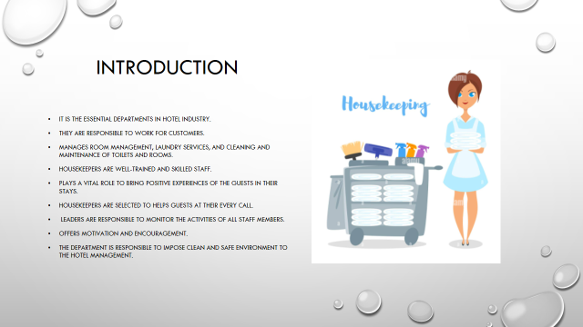
Introduction:
The department of housekeeping is one of the essential departments in hotel industry. They are responsible to work for customers regarding room management, laundry services, and cleaning and maintenance of toilets and rooms as well. Housekeepers are well-trained and skilled staff who play a vital role to bring positive experiences of the guests in their stays. Housekeepers are selected to helps guests at their every call where leaders are responsible to monitor the activities of all staff members with motivation and encouragement. Thus, the department is responsible to impose clean and safe environment to the hotel management.

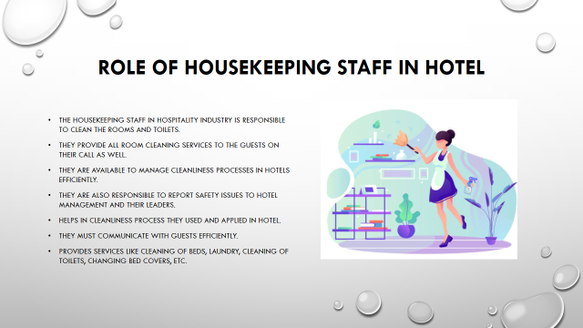

Training Notes:
Role of Housekeeping Staff in Hotel
The housekeeping staff in hospitality industry is responsible to clean the rooms and toilets of guests staying in hotel. They provide all room cleaning services to the guests on their call as well. They are available to manage cleanliness processes in hotels efficiently. They are also responsible to report safety issues to hotel management and their leaders due to the cleanliness process they used and applied in hotel. They must communicate with guests efficiently to provide services like cleaning of beds, laundry, cleaning of toilets, changing bed covers, etc.

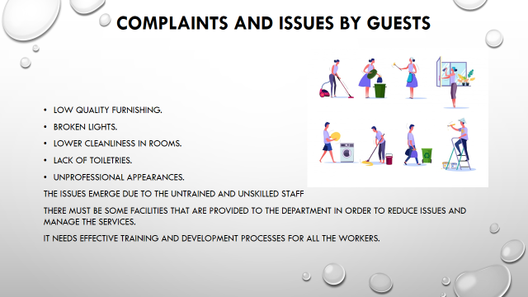

Training Notes:
Complaints and Issues by Guests
There are different complaints that are launched by guest while living in the hotels related to hospital housekeeping department such as:
- Low quality furnishing.
- Broken lights.
- Lower cleanliness in rooms.
- Lack of toiletries.
- Unprofessional appearances.
The issues emerge due to the untrained and unskilled staff hired for the housekeeping facilities and are unable to combat the arising issues with the guests. There must be some facilities that are provided to the department in order to reduce issues and manage the services in an efficient manner. It needs effective training and development processes for all the workers.

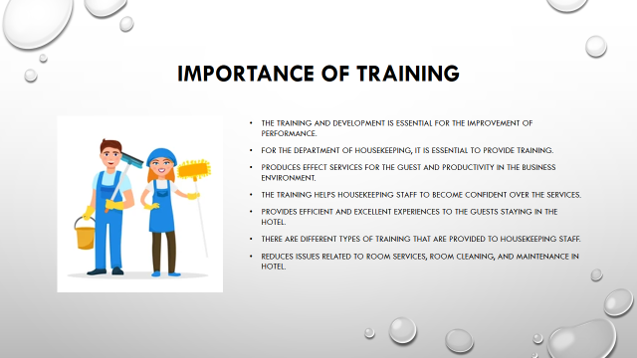

Training Notes:
Importance of Training
The training and development is essential for the improvement of performance and operations in the hotel industry. For the department of housekeeping, it is essential to provide training in order to produce effect services for the guest and productivity in the business environment. The training helps housekeeping staff to become confident over the services and provide efficient and excellent experiences to the guests staying in the hotel. There are different types of training that are provided to housekeeping staff in order to reduce issues related to room services, room cleaning, and maintenance in hotel.

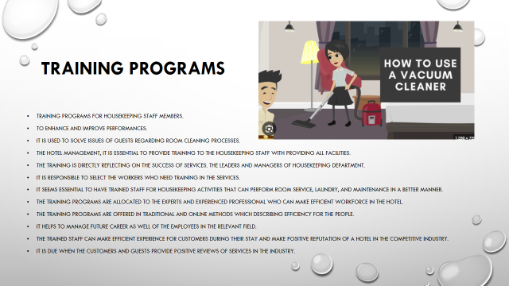

Training Notes: Training Programs
Training programs for housekeeping staff members are used to enhance and improve performances. It is used to solve issues of guests regarding room cleaning processes. Therefore, for the hotel management, it is essential to provide training to the housekeeping staff with providing all facilities. The training is directly reflecting on the success of services. The leaders and managers of housekeeping department is responsible to select the workers who need training in the services. It seems essential to have trained staff for housekeeping activities that can perform room service, laundry, and maintenance in a better manner. The training programs are allocated to the experts and experienced professional who can make efficient workforce in the hotel. The training programs are offered in traditional and online methods which describing efficiency for the people. It helps to manage future career as well of the employees in the relevant field. The trained staff can make efficient experience for customers during their stay and make positive reputation of a hotel in the competitive industry. It is due when the customers and guests provide positive reviews of services in the industry.

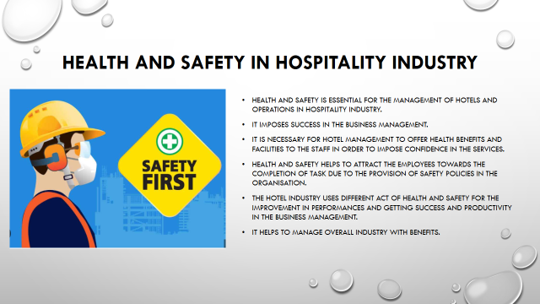

Training Notes:
Health and Safety in Hospitality Industry
Health and safety is essential for the management of hotels and operations in hospitality industry that imposes success in the business management. It is necessary for hotel management to offer health benefits and facilities to the staff in order to impose confidence in the services. Health and safety helps to attract the employees towards the completion of task due to the provision of safety policies in the organisation. The hotel industry uses different act of health and safety for the improvement in performances and getting success and productivity in the business management. It helps to manage overall industry with benefits.

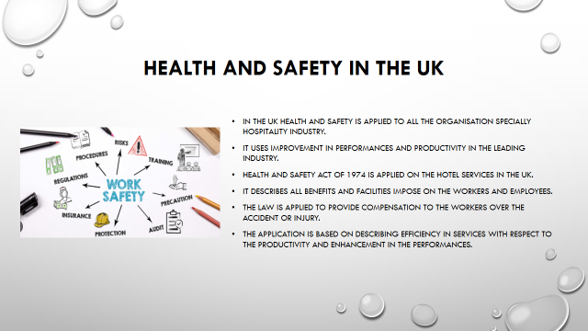

Training Notes:
Health and Safety in the UK
In the UK health and safety is applied to all the organisation specially hospitality industry for the improvement in performances and productivity in the leading industry. Health and Safety Act of 1974 is applied on the hotel services in the UK with describing all benefits and facilities impose on the workers and employees. The law is applied to provide compensation to the workers over the accident or injury. The application is based on describing efficiency in services with respect to the productivity and enhancement in the performances.

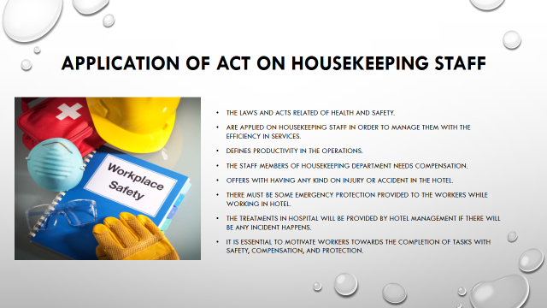

Training Notes:
Application of Act on Housekeeping Staff
The laws and acts related of health and safety are applied on housekeeping staff in order to manage them with the efficiency in services and productivity in the operations. The staff members of housekeeping department needs compensation and offers with having any kind on injury or accident in the hotel. There must be some emergency protection provided to the workers while working in hotel. The treatments in hospital will be provided by hotel management if there will be any incident happens while maintaining rooms or doing laundry for guests. It is essential to motivate workers towards the completion of tasks with safety, compensation, and protection.

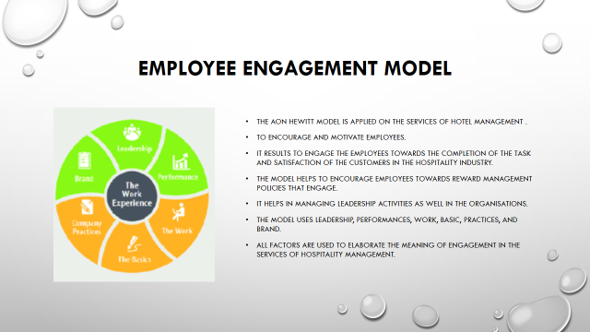

Training Notes:
Employee Engagement Model
The AON Hewitt Model is applied on the services of hotel management to encourage and motivate employees. It results to engage the employees towards the completion of the task and satisfaction of the customers in the hospitality industry. The model helps to encourage employees towards reward management policies that engage them in efficient working activities. It helps in managing leadership activities as well in the organisations. The model uses six different factors that are applied to manage services of staff members in hospitality industry such as leadership, performances, work, basic, practices, and brand. All factors are used to elaborate the meaning of engagement in the services of hospitality management.

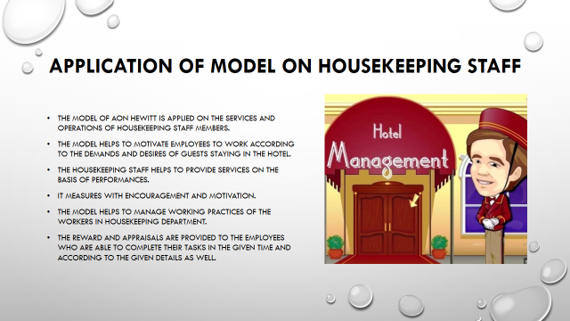

Training Notes:
Application of Model on Housekeeping Staff
The model of AON Hewitt is applied on the services and operations of housekeeping staff members. The model helps to motivate employees to work according to the demands and desires of guests staying in the hotel. The housekeeping staff helps to provide services on the basis of performances that are measured with encouragement and motivation. The model helps to manage working practices of the workers in housekeeping department. The reward and appraisals are provided to the employees who are able to complete their tasks in the given time and according to the given details as well.

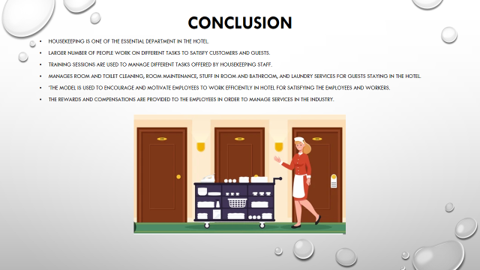

Conclusion:
To summarise, it has seen that housekeeping is one of the essential department in the hotel where lathe number of people work on different tasks to satisfy customers and guests. Training sessions are used to manage different tasks offered by housekeeping staff such as room and toilet cleaning, room maintenance, stuff in room and bathroom, and laundry services for guests staying in the hotel. The model is used to encourage and motivate employees to work efficiently in hotel for satisfying the employees and workers. The rewards and compensations are provided to the employees in order to manage services in the industry.

References:
Nimri, R., Kensbock, S., Bailey, J., Jennings, G. and Patiar, A., 2020. Realizing dignity in housekeeping work: Evidence of five star hotels. Journal of Human Resources in Hospitality & Tourism, 19(3), pp.368-387.
PAKPAHAN, M.D., 2022. SERVICE AND FACILITY IMPROVEMENT TO INCREASE CUSTOMER'S SATISFACTION AT DEDY JAYA CILEDUG HOTEL.
Panggabean, R. and Hasibuan, N.A., 2020. Penerapan Preference Selection Index (PSI) Dalam Sistem Pendukung Keputusan Pengangkatan Supervisor Housekeeping. Resolusi: Rekayasa Teknik Informatika dan Informasi, 1(2), pp.85-93.
Ramu, R., 2021. STUDY ON IMPACT OF HOUSEKEEPING SERVICES IN THE HEALTH SECTOR. PalArch's Journal of Archaeology of Egypt/Egyptology, 18(1), pp.4588-4594.
Sadhale, M., 2021. The Changing Role of Housekeeping Department in Hotels Post COVID-19 Pandemic. Eureka Publications.
Sharma, S. and Kaushik, T., 2021. Aesthetically clean to clinically clean–A study on new housekeeping practices in Delhi hotels beyond COVID-19 pandemic. Worldwide Hospitality and Tourism Themes, 13(5), pp.646-659.
Yusuf, M., Irwanti, N.D. and Indonesia, B., 2021, February. Implementation of 5S in the Pantry Housekeeping of Hotels to Increase Work Productivity. In ICONEBS 2020: Proceedings of the First International Conference on Economics, Business and Social Humanities, ICONEBS 2020, November 4-5, 2020, Madiun, Indonesia (p. 281). European Alliance for Innovation.

References:
Chiang, C.F., Chen, W.Y. and Hsu, C.Y., 2021. Classifying technological innovation attributes for hotels: an application of the Kano model. In Future of Tourism Marketing (pp. 28-39). Routledge.
Dar, H., Kamal, M., Tanahy, E. and Salem, D., 2021. Offshore Vessels employees' perception of Housekeeping Service: Impact on Job Satisfaction and Productivity. المجلة العلمية لکلية السياحة و الفنادق جامعة الأسکندرية, 18(Vol. 18-Issue 2), pp.181-201.
Davras, Ö. and Caber, M., 2019. Analysis of hotel services by their symmetric and asymmetric effects on overall customer satisfaction: A comparison of market segments. International Journal of Hospitality Management, 81, pp.83-93.
Jaykumar, P., 2020. THE TRIUMPHS & CHALLENGES IN THE PATH OF GREEN HOTEL HOUSEKEEPING. Journal of Services Research, 20(1).
Khymdeit, J., 2022. Project work on entrepreneurship topic: Housekeeping
References:
Alcalde-González, V., Mozo, A.G. and Bustos, A.V., 2021. No clean rooms, no hotel business: Subversion tactics in Las Kellys’ struggle for dignity in hotel housekeeping. Annals of Tourism Research, 91, p.103315.
Aldabbagh, A., Neyazi, D., Alsahafi, M., Sarhan, A. and Palaniswamy, T., 2022. Improving the Quality of The Housekeeping Management Process for Stay at Bridge Suites Hotel. Journal of Advances in Humanities Research, 1(1), pp.26-41.
Alwadood, Z., Noor, N.M. and Mainor, N.A., 2021. An optimization model for hotel housekeeping personnel scheduling in pandemic outbreak. Menemui Matematik (Discovering Mathematics), 43(2), pp.83-92.
Bhatnagar, E. and Dheeraj, N., 2019. Impact of housekeeping services and practices on customer satisfaction and repeat business. Prabandhan: Indian Journal of Management, 12(8), pp.46-57.
Brody, D., 2019. Housekeeping by design: Hotels and labor. University of Chicago Press.
Chan, J., Gao, Y.L. and McGinley, S., 2021. Updates in service standards in hotels: how COVID-19 changed operations. International Journal of Contemporary Hospitality Management, 33(5), pp.1668-1687.
Chatterjee, P., Role of Housekeeping Cleaning Equipment and Agent in the world of Hospitality Industry.
Chaudhari, M.P.S., 2021. Hotel Housekeeping Services And Customer Satisfaction. Ilkogretim Online, 20(1), pp.5837-5844.

