A critical evaluation and the identification of next teaching and learning steps
focusing on a case study of an individual learner or a group of learners, based on an
observed critical incident

Module code: ECAD6007
Student number: 2100298
Word count: 4412 with 1,000 word equivalence for lesson observations

Introduction
The term ‘critical incident’ refers to a typical or atypical event that occurs in everyday professional teaching practice which may go by unnoticed unless one decides to question and examine the event critically, producing a detailed description (Tripp, 2012). According to Tripp, the incident perceived as significant by the researcher, is noted down in detail, and is rendered critical through analysis where one attempts to understand the incident by viewing it “in a wider context” (2012, pp. 27-28). Subsequently, critical incidents have become a widely used qualitative research method in education and teaching (Shapira-Lishchinsky, 2011) and are used as a tool for reflection.
This essay is a critical evaluation and the identification of next teaching and learning steps focusing on a case study of an individual learner, based on an observed critical incident. Firstly, this essay will explain the meaning of critical reflection whilst looking at Schön and Kolbe’s reflective models. It will also look at the importance of critical reflection in the developing role of teaching as a profession. Secondly, the critical incident that was observed will be described in detail and the incident will be linked with three of the four purposes which are an ambitious, capable learner, healthy confident individual and creative contributor. From observing the critical incident, the literature review will analyse two theories, positive reinforcement and growth mindset, that may explain the reasons ‘under the hood’ of the critical incident. Lastly, the essay will reflect on the critical incident and evaluate the next teaching steps.
The Role of Critical Reflection
When an incident is documented the teacher is able to reflect on the experience which allows them to gain more from the experience than if it went by unnoticed. This is known as critical reflection. Critical reflection is recognized by several researchers as an essential part of teaching as it encourages teachers’ professional development, improves the quality of teaching and learning, increases education standards, and links theory to practice (Dervent, 2015; Mathew, Mathew, and Peechattu, 2017). Critical reflection also plays a vital role in the Initial Teacher Education programme (Welsh Government 2021). Through reflection, the teacher is able to ensure that the students are achieving their full educational potential.
There are several models of critical reflection. Schön introduced ‘reflection-on-action’ which involves documenting, looking back and analysing the incident after it has happened. The incident is analysed by looking at one’s reaction to the event, examining reasons around the event, the outcome of one’s actions and finding a solution (Schön, 1987 in Zwozdiak-Myers, 2012). According to Zwozdiak-Myers, Schön’s critical reflection offers a way for teachers to evaluate their teaching and actions, query the educational aims and principles “which give shape, form and purpose to what they do” (2012, p. 16). Kolb’s reflective model has four stages. The four stages include observing an incident, reflecting upon it, learning from the experience through reading and research and then transforming the knowledge you have learnt into practice by trying out new teaching methods (Kolb 1984 in Zwozdiak-Myers, 2012).
According to Dewey open-mindedness, responsibility and wholeheartedness are vital attributes for teachers when reflecting (Dewey in Farrell, 2012). When researching into literature, the teacher needs to be open-minded as they may discover theories that challenges, alters or confirms their teaching methods and beliefs (Zwozdiak-Myers, 2012) and in turn question whether the outcomes of their teaching practice are successful for whom and why (Farrell, 2012). Furthermore, Brookfield (1998) suggests that from reflecting and reading literature, the information that is discovered will impact on what a teacher does next. This response shows responsibility as the teacher is open to change. Critical reflection is an important part of teaching and the Initial Teacher Education programme because it allows student-teachers to continuously learn and develop their practice to suit the changing situation. This in turn leads to high-quality standards of teaching and growth (Brookfield, 1998; Dervent, 2015). By trying out new concepts, a new incident is created which the teacher observes and the reflective models begin again. Reflection therefore allows a teacher and student-teacher to learn from their practices.
The ability to regularly reflect on one’s lesson in order to improve the students learning experience is vital to one’s development as a teacher and self-improvement (Cruickshank and Applegate, 1981). By doing so, the teacher or student teacher is able to reflect on the planned learning objectives, the content and pedagogical methods used, the engagement of individuals and what the students have understood (Zwozdiak-Myers, 2012). Matthew, Matthew and Peechattu (2017) have also noted the importance of considering emotions in the list of responses from the student when reflecting. Additional research, developing new techniques and reflection are also important for student-teachers as they are part of the Welsh Government’s Professional Standards for Teaching and Leadership standards (Welsh Government, 2017). Therefore through critical reflection, it allows teachers and student-teachers to further their knowledge because they are involved in a profound process of inquiry (Mathew, Mathew, and Peechattu, 2017) which in turn offers opportunity for growth.

Observation School and Class Context
This assignment will be following the British Educational Research Association (BERA) guidelines that state “the confidential and anonymous treatment of participants’ data is considered the norm for the conduct of research” (BERA 2018).Thus the school, staff, and the pupils will remain anonymous throughout this essay and the pupil that was observed will be referred to as student Z.
The observation took place in a mixed-gendered Welsh medium Primary and Secondary school for 3 to 19 year olds based in Rhondda Cynon Taf. As of the 2017 Estyn report there are 631 pupils in total. The secondary department includes 412 students, 63 of which are sixth-form students and the primary department have 107 students. The school has confirmed that 9% of the students have additional learning needs with very few having a statement of special educational needs. Furthermore, 8% of pupils are eligible for free school meals (Estyn 2017). The 2017 Estyn report also states that the school is a “pioneer school” and is therefore working closely with the Welsh Government and local authority in relation to developing the new curriculum into schools. The school offers a variety of valuable opportunities for students to “develop culturally, physically and creatively” (Estyn 2017).

Critical Incident Linked to Donaldson’s Four Purposes
The basis of the observation I observed is the positive attitude and work ethic of a year 9 pupil (13-14 years old) during a business lesson, referred to in the appendices as ‘cyfnod 1’. I will be referring to this pupil as student Z and using plural pronouns such as ‘them’ and ‘they’ rather than ‘him’ or ‘her’ to protect the anonymity of the pupil for the rest of the assignment. Overall student Z was positive, motivated and engaged throughout the lesson. The business lesson I observed started at 11:20 and was the third lesson of the day. There were 15 pupils in the classroom and although some students were late from their music class, this did not impact the environment of the classroom and the pupils settled quickly.
At the beginning of the lesson, the teacher went over the main points from the previous lesson. The teacher did this by asking the students questions. Student Z was engaged with the lesson from the beginning and put their hand up several times to answer the starter questions. Student Z continued to contribute to class discussions, questions, group and individual work with a positive attitude, and was highly engaged throughout. Each time student Z got a question correct or showed enthusiasm the teacher gave praise and encouragement. On one occasion student Z did get a question wrong. However, the teacher responded to the incorrect answer by saying ‘not the exact answer I am looking for but you are on the right track, try again’. From observing student Z, I could see that this feedback from the teacher encouraged them to try again and not give up. Furthermore, it was clear that they wanted to do well, were pushing themselves and at one point the teacher came over and gave student Z further questions that were more challenging. Student Z reacted to these challenging questions in a positive way and did not hesitate when attempting the harder work. In addition, I observed the teacher praising student Z saying that they expect a lot from them.
At the heart of the Welsh Government’s new curriculum, created by Graham Donaldson, are the Four Purposes. As shown in Figure 1, the Four Purposes will support children and young people to be
“ambitious, capable learners, ready to learn throughout their lives; enterprising, creative contributors, ready to play a full part in life and work; ethical, informed citizens of Wales and the world” and lastly “healthy, confident individuals, ready to lead fulfilling lives as valued members of society” (Donaldson, 2015 p. 29).
The aim of the new curriculum is for schools to create a holistic teaching environment that enables their students to develop the skills outlined in the Four Purposes. According to the Welsh Government the Four Purposes are “the starting point and aspiration for every child and young person in Wales” and will be incorporated into the educational experience for all children in Wales (Welsh Government, 2020).
There is a link between the critical case that has been observed and the four purposes in several ways. Firstly, student Z’s enthusiasm during the lesson and positive attitude when receiving harder questions shows that student Z is an ambitious, capable learner. Moreover, student Z’s aim in the classroom was to not only succeed but to a high standard. By setting high standards they were challenging themselves whilst building on their prior knowledge from the previous lesson, applying that knowledge to the classroom task and evaluating how the skills they have learnt can be used in the outside world. Lastly student Z was grasping opportunities to further their learning and is a healthy confident individual who overcame a challenge when they got the question wrong and did not give up.
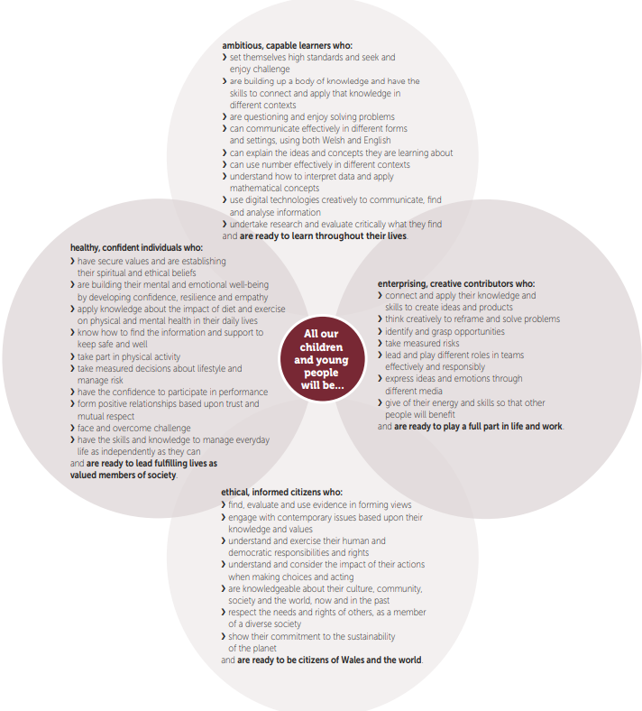
Figure 1: The Four Purposes (Donaldson, 2015, p. 31)

Literature Review
From observing the critical incident two theories will be explored that explain the reasons behind why student Z was enthusiastic, motivated and wanted to do well in the classroom. What motivating factors and teaching strategies create positive outcomes for these learners and have a positive impact on raising educational standards of learners? The following literature review which explores the use of positive reinforcement in the classroom and student’s growth mindset.
Positive Reinforcement
Positive reinforcement introduced by B. F. Skinner is a type of operant conditioning and is used to increase the probability of a specific response or action happening by adding something positive (Kelly and Pohl 2018). Psychologist Edward L. Thorndike argued that if an action is followed by satisfaction, it will strengthen the action reoccurring in the future (Thorndike in Walinga, 2019). According to Walinga (2019) giving praise or offering a reward are the most popular forms of positive reinforcement. By offering positive praise, this reinforces the desired response. The pupil is therefore rewarded with incentives (Silverman et al, 2016). It is important to note that in order for positive reinforcement to succeed, the pupil must first display a desired behaviour or action that can be rewarded. This creates an association between the action and the consequence (Dunsmoor and Murphy 2015).
It could be argued that verbal reinforcement is the most successful and effective tool to use in the classroom (Morin, 2017). According to Cherry (2020) positive reinforcement plays a vital role in everyday learning. Parsonson (2012) expands on Cherry’s argument stating that positive reinforcement creates a positive and efficient learning environment because through regular use of praise it increases pupils’ engagement and their achievements are rewarded. Furthermore, positive reinforcement has a positive impact on pupils’ self-esteem as it helps students to see their strengths which gives them confidence in their ability to achieve (Morin, 2017). This indicates that positive reinforcement not only increases pupils’ confidence but also encourages academic learning as it inspires students to reach their full potential. Morin claims that verbal praise can have a long-lasting effect on students, thus “positive reinforcement is a method in which no child can have too much of” (2017, pp. 5-6). Walinga (2019) proposes that positive reinforcement also allows both the student and the teacher to look at the positive side of a situation as it highlights what the student has achieved and increases their confidence. Therefore, positive reinforcement is a motivator that is used to encourage learning within a classroom environment and is highly effective because it offers a reward as a stimulus to encourage engagement with the topic. Additionally, it motivates students to take control of their own learning which shows they are ambitious, capable learners and healthy, confident individuals.
However, although some argue that positive reinforcement is an effective instrument to use in the classroom, Coon, Mitterer (2010) and Degeling (2012) all argue that positive reinforcement is not always successful and is therefore not the best method to use. Moreover, Degeling (2012) furthers this argument by claiming that the problem with positive reinforcement such as tokens or rewards is that they are bribes. Instead pupils should do something in the classroom because they want to. This suggests that students may only do their homework for example because they will receive a reward and not because it interests them or they can see the long term benefits. According to Mader (2009) and Parsonson (2012) rewards that are promised in advance if the work is completed can have a negative impact on pupils’ internal motivation, particularly those who already enjoy the subject because they will take less risks in order to succeed. Mader (2009) continues stating that students may also become less interested in the subject due to the use of positive reinforcement because rewards may decrease the importance of the task. Although positive reinforcement may be effective for some students, it may not always work and may have the complete opposite effect and demotivate some students to complete the task (Degeling, 2012).
It is also important to note that if a student stops receiving continuous positive reinforcement, they may stop the action completely. This is known as extinction (Hulac et al, 2016). For example, if the teacher stops offering positive praise after each time a student answers a question, the student may stop trying in the classroom. Stangor and Walinga (2019) build on this argument by suggesting that in the real world, the majority of reinforcers are not constant and may only appear on a partial reinforcement schedule — this is when an action is only sometimes rewarded. This suggests that offering positive praise every time an action happens is unrealistic because in the real world not everyone is rewarded when they do something positive. Although continuous positive reinforcement may lead to a positive response at the beginning, once the positive reinforcement occurs less regularly it will have a negative impact on the student carrying out the desired action. Instead positive reinforcement should be rewarded when it is deserved and not when the students seek for it (Cherry, 2021).
Growth Mindset
Dweck was interested in finding out why some pupils enjoyed learning even if they found the work challenging, whilst other pupils were apprehensive or reluctant to attempt a difficult task. Through this research, Dweck (1999; 2006) introduced the theory of mindset that includes a scale varying from fixed mindset to growth mindset. Dweck (1999; 2006) argues that pupils who react in a positive way towards a challenging question have a growth mindset because they understand that their capabilities and intelligence can be developed. On the other hand, students who see challenging questions as something negative or do not try and solve the question have a more fixed mindset. According to Armstrong (2019), pupils with a fixed mindset believe that their academic abilities cannot progress. Pupils with a growth mindset are not only deeply engaged with solving the question but understand that making mistakes is part of the learning process (Moser et al, 2011).
Growth mindset can be developed from teachers giving praise. However, when giving praise the teacher should focus on the students’ journey and effort. This includes the students’ method for solving a question, their determination, their development and the obstacles that they have overcome (Rhew et al, 2018). Dweck (2014) refers to this praise as “process praise” and by offering “process praise” it creates pupils that are willing to take risks and attempt to solve the more difficult questions in the future. Carroll and Yeager (2020) claim that if a teacher or school introduce growth mindset it offers everyone the potential to learn, even if the work is difficult. According to Blackwell, Trzesniewski and Dweck (2007) by giving pupils harder questions it pushes them out of their comfort zone to learn something new. This in turn allows the neurons in the brain to form new and stronger connections and “the meaning of effort and difficulty are transformed” (Dweck 2014). Subsequently, when students with growth mindset get given harder questions, they view this as a challenge and make an effort to answer the question. Therefore growth mindset increases students’ persistence, tenacity and resilience which will help their journey into the working world.
It could be argued that by introducing students to growth mindset, students can become ambitious learners as they start to believe in themselves and will want to push themselves to do better. Inchamnan and Chomsuan (2020) propose that growth mindset can be developed not only from a student putting in the hard work but also having the right approach and attitude when completing the work. Saunders (2013) argues that when pupils develop a growth mindset it has a positive impact on their self-efficacy and motivation. Pajares and Schunk (2001) suggest that self-efficacy is essential to students’ academic growth because it creates a desire for learning and allows students to persist through difficult questions resulting in academic success. Consequently it would seem reasonable for teachers to use such an effective tool as growth mindset as it creates independent learners and has a significant effect on academic attainment and achievement.
On the other hand, growth mindset is not always successful because changing students’ mindsets is a lot harder when pupils do not believe that they can improve. American University’s School of Education (2020) state that an important factor to consider with the growth mindset theory is that a student may have a growth mindset for one subject and a fixed mindset for another. For example a student who has a passion for sport may have a growth mindset for subjects such as Physical Education but have a fixed mindset for English. Therefore, a student may push themselves in one subject but are reluctant to try in another subject, simply because they do not enjoy it. This could be a contributing factor for certain subject areas within the same school having vastly differing pass rates at GCSE and A-level. American University’s School of Education (2020) further their argument by claiming that in order for growth mindset to be successful, students need to work to the best of their ability. This suggests that merely applauding students’ effort is not effective and could have a negative effect on the student if they are unsuccessful. Additionally Murphy, Logel and Carroll (2020) argue that even if a student has a growth mindset, they will not succeed if the teacher or school do not adopt this approach as it does not allow the student to learn and develop.
Moreover, psychologist Bates of the University of Edinburgh suggest that growth mindset does not work and has no impact on pupils results (Bates in Denworth, 2019). Instead the research and results of growth mindset “overpromised and underdelivered” (Denworth, 2019). American University’s School of Education (2020), highlight that only a small number of researchers have received the same results as Dweck and that the majority of the validating research has been carried out by either Dweck or her colleagues. This indicates that we need to question the reliability of the growth mindset theory.

Reflection / Evaluation and Next Steps
The focus of my critical incident was student Z being enthusiastic and highly motivated in the classroom and wanting to achieve. This included answering questions, responding well to praise and encouragement, and completing the work to a high standard. This section will evaluate the critical incident, linking the incident to the literature and identify the next steps. The next steps will include what I will consider and take forward in my own professional and personal development.
By using Kolb’s four stage reflective module, the next stage would be reflecting upon the critical incident by looking at the reasons behind student Z wanting to achieve. Skinner’s positive reinforcement theory suggests that the teacher praising student Z for answering questions at the beginning of the lesson and completing the classroom work to a high level, reinforces the desired behaviour. The pupil will continue to answer questions and put in the work in order to recieve praise. As Parson (2012) and Morin (2017) argue, positive reinforcement has a positive impact on students’ academic success because it allows students to see their strengths and are able to work on these strength in order to succeed. This in turn increases students’ confidence and will create confident and healthy individuals which is one of the four purposes. Furthermore, positive reinforcement allows students to become ambitious, capable learners as shown by student Z at the beginning of the lesson when they were answering questions. By receiving verbal praise for their answer, student Z was able to develop their knowledge and apply that knowledge later on in the classroom task.
Subsequently, I will be using positive praise in the classroom in order to increase a specific response from a student. For example, offering verbal praise when a student completes classroom and homework tasks. However, as Stangor, Walinga (2019) and Hulac et al (2016) noted I will be careful to not overuse positive reinforcement as it may decrease its value to students which may lead to extinction of the specific action. Instead I will strategize when to use positive reinforcement effectively.
As well as the use of positive praise, the teacher used the following phrase when student Z got an answer wrong; “Not the answer I was looking for, but you are on the right track, try again”. As Dweck (1999; 2006) argues growth mindset is developed from students learning from their mistakes and they are encouraged to try the more difficult questions. This has an effect on a student’s quality of resilience and tenacity needed to succeed as an independent learner. It is important that schools create independent, resilient and tenacious learners and as Inchamnan, Chomsuan (2020) and Saunders (2013) suggest the concept of growth mindset encourages and promotes these qualities. The teacher therefore created a positive learning environment for student Z which developed a growth mindset for student Z. The phrase the teacher used in responding to the incorrect answer is one that I will adopt in future teaching practice because it creates a positive environment of answering classroom questions whilst not being afraid to get the answer wrong. Additionally, I would research into other teaching responses that would contribute to a learning environment where pupils can respond without fear and progress into growth mindset.
Moreover, the teacher recognized that student Z had an intrinsic motivation for learning and was keen to progress. Because of this the teacher then gave student Z additional questions. According to Blackwell, Trzesniewski and Dweck (2007) difficult questions are used to challenge and motivate students. The use of difficult questions are promoted in the growth mindset module because by giving students harder questions, it allows them to see that their abilities can be developed. This in turn changes their mindset from fixed to growth mindset (Dweck 2006).
From reflecting on the critical incident, it could be argued that the teacher gave student Z further questions so that the student could increase confidence in their ability resulting in growth mindset. Subsequently, growth mindset creates ambitious, capable learners because students are not only setting themselves high standards but are enjoying a challenge and also problem solving. Growth mindset therefore allows teachers to challenge and stimulate students. Furthermore, growth mindset allows a teacher to consider all pupils according to their abilities including Special Education Needs. In relation to going forward with my own teaching methods I would adopt the growth mindset module. I would do this by recognising the need to challenge and push students out of their comfort zone, offering difficult questions and praising their efforts. These extension tasks will help keep the student interested and may motivate them to do independent work and will also help students to develop the four purposes. Growth mindset therefore encourages students to creative contributors as it allows students to grasp opportunities and overcome challenges.
The critical incident observed was a recognition of good teaching practice and what a good response to a wrong answer looks like without putting the child down and does not discourage the pupil.
Conclusion
To conclude, this assignment has shown that through using Kolb’s critical reflection learning cycle, there were ‘under the hood’ elements that explained student Z’s positive attitude in the classroom, student Z’s high engagement throughout and student Z’s motivation and need to achieve classroom tasks to a high standard. Positive reinforcement such as praise encouraged pupil Z to answer questions confidently and also be involved in the classroom task. Additionally, the reason that student Z was motivated throughout the lesson and attempted the harder additional questions with a positive attitude is because student Z has a growth mindset and the lessons allowed growth mindset to be developed.
Critical reflection allows student-teachers to see the importance of the ‘Professional Standards for Teaching and Leadership’. For example providing challenges that motivate learners is one of the pedagogy elements. Moreover, pedagogy is important to student-teachers and teachers because it goes beyond just teaching, as it also encompasses everything a teacher does to help students learn and succeed. Professional learning is developed by reflecting on an incident as it allows student-teachers to research further into a variety of literature and theories or ask other teachers for their advice. This in turn may alter their views and teaching method on what to do next. Developing new techniques links to ‘innovation’ which is also one of the ‘Professional Standards for Teaching and Leadership’. Therefore, reflection allows ongoing learning which encourages further growth. Critical reflection is vital to teachers because through reflection they are able to gain deeper understanding, develop their teaching methods and in turn the quality of their teaching is improved.
From reflecting on the critical incident and researching into different theories, I will be using positive reinforcement in the classroom as well as encouraging growth mindset. Both positive reinforcement and growth mindset link to the four purposes as it helps students to become ambitious, capable learners who contribute to class discussions, and are healthy, confident individuals (Donaldson, 2015).

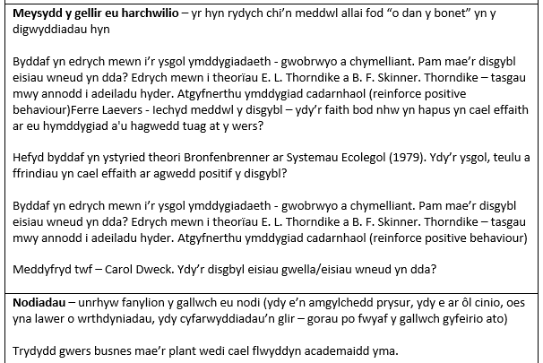

Appendices
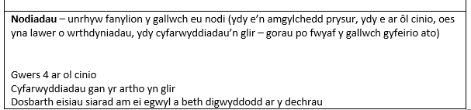
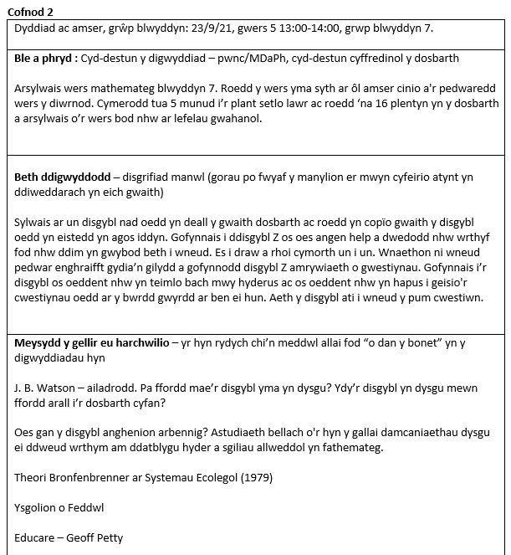

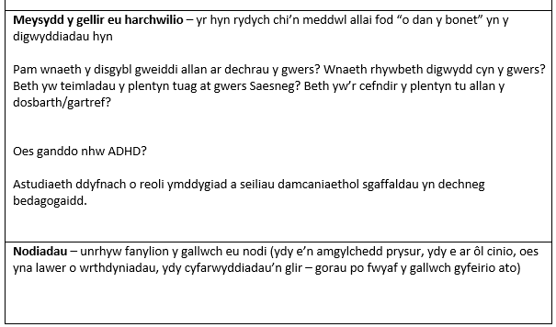
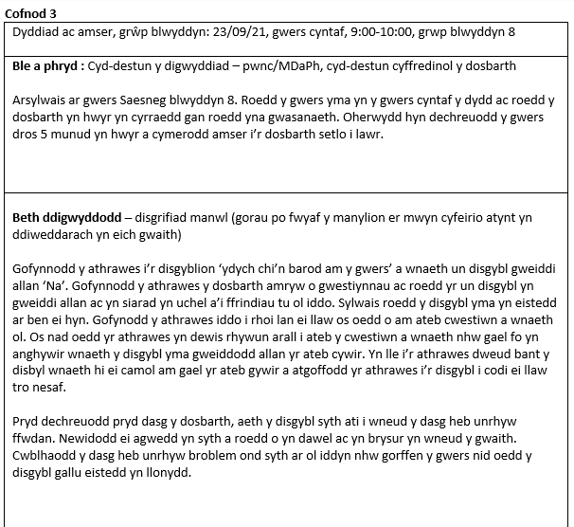
Reference List
American University’s School of Education. (2020) How to Foster a Growth Mindset in the Classroom. Available at: https://soeonline.american.edu/blog/growth-mindset-in-the-classroom (Accessed 10 October 2021)
Armstrong, K. (2019) Carol Dweck on How Growth Mindsets Can Bear Fruit in the Classroom. Available at: https://www.psychologicalscience.org/observer/dweck-growth-mindsets (Accessed 10 October 2021)
Blackwell, L., Trzesniewski, K. and Dweck, C. (2007) ‘Implicit theories of intelligence predict achievement across an adolescent transition: A longitudinal study and an intervention’, Child Development, 78(1), pp. 246–263. DOI: 10.1111/j.1467-8624.2007.00995.x
BERA, Ethical Guidelines for Educational Research (4th ed.) Available at: https://www.bera.ac.uk/publication/ethical-guidelines-for-educational-research-2018-online (Accessed 6 October 2021)
Brookfield, S. (1998) ‘Theoretical foundations: critically reflective practice’, The Journal of Continuing Education in the Health Professions, 18.4, pp. 197–205. https://doi.org/10.1002/chp.1340180402
Carroll, J.M and Yeager, D. (2020) How Teachers Can Build a Growth-Mindset Classroom, Even at a Distance. Available at : https://www.edweek.org/education/opinion-how-teachers-can-build-a-growth-mindset-classroom-even-at-a-distance/2020/07 (Accessed 11 October 2021)
Cherry, K. (2021) Positive Reinforcement and Operant Conditioning. Available at: https://www.verywellmind.com/what-is-positive-reinforcement-2795412 (Accessed: 25 September 2021).
Cherry, K. (2020) Positive and Negative Reinforcement in Operant Conditioning: How Reinforcement Is Used in Psychology Available at: https://www.verywellmind.com/what-is-reinforcement-2795414 (Accessed: 25 September 2021).
Coon D and Mitterer J.O.(2010) Introduction to Psychology: Gateways to Mind and Behavior. 12th edn. Wadsworth Cengage Learning.
Christensen, C. M., Horn, M. B., and Johnson, C. W. (2008). Disrupting class: How disruptive innovation will change the way the world learns. New York, NY: McGraw-Hill.
Cruickshank, D. and Applegate, J. (1981) ‘Reflective teaching as a strategy for teacher growth’, Educational Leadership, 38(7), pp. 553-554.
Degeling, J. (2012) ‘Positive reinforcement in the classroom – how to make reinforcment work for you’, pp 1-4. Available at: https://www.josephdegeling.com.au/wp-content/uploads/2011/09/Positive-Reinforcement-in-the-classroom.pdf (Accessed 24 September 2021)
Denworth. L. (2019) Scientific America, Debate Arises over Teaching “Growth Mindsets” to Motivate Students. Available at: https://www.scientificamerican.com/article/debate-arises-over-teaching-growth-mindsets-to-motivate-students/ (Accessed 10 October 2021)
Dervent, F. (2015) ‘The effect of reflective thinking on the teaching practices of preservice physical education teachers’, Issues in Educational Research, 25(3), pp. 260-275. Available at: https://www.semanticscholar.org/paper/The-effect-of-reflective-thinking-on-the-teaching-Dervent/a70d1f0304d312f6e84786bb745fc3bb3fa8c0c1?p2df (Accessed 3 October 2021)
Donaldson, G. (2015) Successful Futures: Independent Review of Curriculum and Assessment Arrangements in Wales. Available at: https://gov.wales/sites/default/files/publications/2018-03/successful-futures.pdf (Accessed 7 October 2021)
Dunsmoor J.E, Murphy G.L. (2015) ‘Categories, concepts, and conditioning: how humans generalize fear’, Trends in Cognitive Science, 19(2), pp-73-77. DOI:https://doi.org/10.1016/j.tics.2014.12.003
Dweck, C.S. (1999) Self-theories: Their role in motivation, personality, and development Philadelphia, PA: Psychology Press
Dweck, C.S. (2006) Mindset: The new psychology of success. New York, NY: Random House.
Dweck, C.S. (2014) TedTalk: The Power of believing that you can improve. Available at: https://www.ted.com/talks/carol_dweck_the_power_of_believing_that_you_can_improve#t-3326 (Accessed 10 October 2021)
Estyn (2017) Ysgol Llanhari school report. Available at:
https://www.estyn.gov.wales/system/files/2020-08/Ysgol%2520Llanhari%2520en.pdf (Accessed 14 October 2021)
Farrell, T.S.C. (2012) ‘Reflecting on Reflective Practice: (Re)Visiting Dewey and Schön’, TESOL Journal, 3(1), pp. 7-16 DOI http://dx.doi.org/10.1002/tesj.10
Hulac, D et al, (2016) ‘Using variable interval reinforcement schedules to support students in the classroom: An introduction with illustrative examples’, Journal of Educational Research and Practice, 6(1), pp 90–96. Available at: https://files.eric.ed.gov/fulltext/EJ1132273.pdf (Accessed 5 October 2021)
Inchamnan, W. and Chomsuan J. (2020) ‘Gamification Workflow for Growth Mindset Processes’, 18th International Conference on ICT and Knowledge Engineering (ICT&KE) pp. 1-6, DOI: 10.1109/ICTKE50349.2020.9289879
Kelly, J. and Pohl, B. (2018) ‘Using Structured Positive and Negative Reinforcement to Change Student Behavior in Educational Settings in order to Achieve Student Academic Success’, Multidisciplinary Journal for Education, Social and Technological Sciences, 5(1), pp. 17-29 DOI: https://doi.org/10.4995/muse.2018.6370
Mathew, P., Mathew, P. and Peechattu, P. (2017) ‘Reflective Practices: A Means to Teacher Development’, Asia Pacific Journal of Contemporary Education and Communication Technology, 3(1), pp. 126-131. Available at: https://apiar.org.au/wp-content/uploads/2017/02/13_APJCECT_Feb_BRR798_EDU-126-131.pdf (Accessed 7 October 2021)
Mader, C.E. (2009) ‘ "I Will Never Teach the Old Way Again": Classroom Management and External Incentives, Theory Into Practice , 48(2), pp. 147-155, Available at: https://www.jstor.org/stable/40344605 (Accessed 3 October 2021)
Morin, D. (2017) The Effects of Inclusion and Positive Reinforcement Within the Classroom, Honors Program Contracts. 4. Available at: https://scholarworks.merrimack.edu/honors_component/4 (Accessed 5 October 2021)
Moser, J.S, et al. (2011) ‘Mind Your Errors: Evidence for a Neural Mechanism Linking Growth Mind-Set to Adaptive Posterror Adjustments’, Psychological Science, 26, pp. 784–793. DOI: https://doi.org/10.1177/0956797615571017
Murphy, M.C, Logel, C. and Carroll, J.M. (2020) Three Teacher-Tested Ways to Encourage a Growth Mindset. Available at: https://www.edweek.org/education/opinion-three-teacher-tested-ways-to-encourage-a-growth-mindset/2020/07 (Accessed 10 October 2021)
Parsonson, B.S. (2012) ‘Evidence-based Classroom Behaviour Management Strategies’, Kairaranga, 13(1), pp. 16-23. Available at: https://files.eric.ed.gov/fulltext/EJ976654.pdf (Accessed 4 October 2021)
Pajares, F. and Schunk, D. (2001) ‘The development of academic self-efficacy’. in Wigfield A. and Eccles J. (Ed). Development of achievement motivation. San Diego: Academic Press.
Rhew, E. et al, (2018) ‘The effects of a growth mindset on self-efficacy and motivation’, Cogent Education, 5(1), pp. 1-16. DOI: 10.1080/2331186X.2018.1492337
Saunders, S.A. (2013) The impact of a growth mindset intervention on the reading achievement of at-risk adolescent students. Unpublished PhD Thesis. University of Virginia Available at: file:///C:/Users/Brons/Downloads/Saunders_StephenAllan_2013%20(2).pdf
Silverman K et al. (2016) ‘Incentives and Motivation’, Translational Issues in Psychological Science, 2(2), pp. 97-100. doi:10.1037/tps0000073 https://doi.apa.org/fulltext/2016-29368-001.html
Shapira-Lishchinsky, O. (2011) ‘Teachers’ critical incidents: Ethical dilemmas in teaching practice’, Teaching and Teacher Education, 27(3), pp. 648-656. DOI:10.1016/j.tate.2010.11.003
Tripp, D. (2012) Critical incidents in teaching: developing professional judgement, Classic ed. New York Routledge; Abingdon, Oxon
Walinga, J. (2019) ‘Behaviourist Psychology’ in Cummings, J.A. and Sanders, L. (ed.) Introduction to Psychology. Saskatoon, SK: University of Saskatchewan Open Press
Welsh Government (2020) Curriculum for Wales: overview. Available at: https://gov.wales/curriculum-wales-overview (Accessed 14/10/21)
Zwozdiak-Myers, P. (2012) The teacher's reflective practice handbook: becoming an extended professionnal through capturing evidence-informed practice. London: Routledge

