University of Wales Trinity Saint David

School of Engineering

Prioritised Improvement Plan

Basic Quality Tools



Quality & Business Improvement

(ACMA4004)

Jordan Hessey

2315713

08/03/2024
Table of Contents
1 Introduction 1
1.1 Current Problem 1
1.2 Objectives 1
2 Machine & Product Overview 2
2.1 Overview of the Carousel 2
2.2 Overview of Final product being produced 3
3 Data collection & Analysis 4
3.1 Basic quality tool 1 – Check sheets 4
3.2 Basic quality tool 2 - Pareto Analysis 6
3.3 Basic quality tool 3 – RCA 5 Whys 8
4 Improvement Plan 10
5 Prioritisation 12
6 Performance Indicators (KPIs) 14
7 Anticipated Barriers and Challenges 15
8 Conclusions 16
9 References 17

List of Figures
Figure 1 – Rainin1000 Carousel 2
Figure 2 - Diagram of Phytip (Biotage,2024) 3
Figure 3 - Thin weld 3
Figure 4 - Correctly welded tip 3
Figure 5 - Failure mode descriptions 5
List of Tables
Table 1 - Check sheet findings of recent batch 5
Table 2 - Check sheet with added frequency calculations 6
Table 3 - Pareto analysis of failure modes 7
Table 4 - 5 Why Analysis (Biotage Template,2024) 8

Introduction
This report was created to show the improvement plan that was carried out to identify the problems within the process running on a particular automated carousel within Biotage, producing Phytip columns. This carousel is crucial to meeting demands within our manufacturing operations, producing parts with better quality and at a faster rate than manual labour. However, the high occurrence of failures, is negatively impacting product quality and increasing rework efforts. The improvement plan aims to address these issues through the utilisation of three basic quality tools: Check Sheets, Pareto Analysis, and Root cause analysis 5 whys.

Current Problem
Quality control have reported that there appears to be a high number of failures within the batches being produced from the carousel. As a result of this, Biotage are having to spend a lengthy period re-working or even completely scrapping product. This is leading to decreased product quality, increased production delays and customer satisfaction.

Objectives
- 100% Inspect the most recent batch from the machine to identify failure modes.
- Use check sheets to record data.
- Pareto Analysis to identify the highest failure modes.
- Carry out 5 whys analysis to figure out why the failure mode is occurring.
- Develop improvement plan to implement.
- Discuss key performance indicators & Prioritisation.

Machine & Product Overview

Overview of the Carousel
The carousel is designed to produce product from a bought in Rainin1000 Pipette tip. Once the cycles are completed, a final “Inner” is produced which entails a welded mesh on the end of the tip. This tip is a sub-assembly part within the biotage product range. Failure to produce quality welds upon the mesh on the inner, would lead to failure of the overall product.
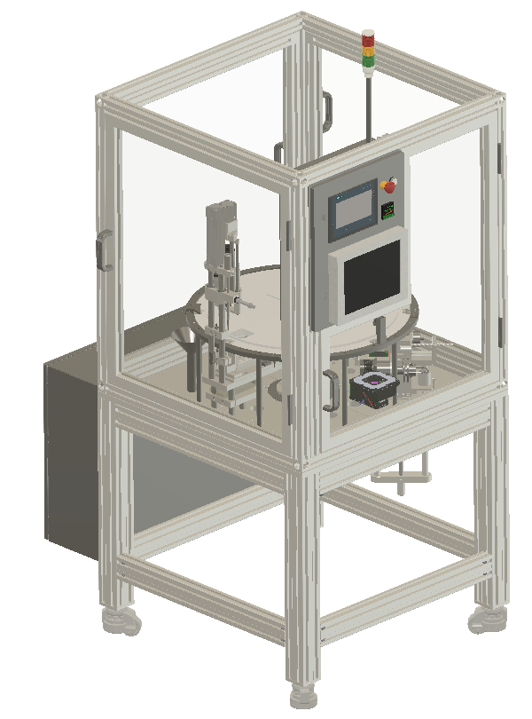
The carousel is fully automated, combined of 8 stations around a turntable which is fed with a bowl feeder of parts. Cycle time to produce a completed Pipette tip is 15 seconds. The 8 stations comprise of;
- Bowl feeder - Pipette enters turntable.
- Cutting station – Pipette gets cut to initial length.
- Weld Station – Pipette has a mesh welded to the bottom.
- Inspect Station – Pipette gets inspected for weld integrity.
- Reject Station – Pipette leaves the table here if inspection fails.
- Cutting station – Pipette gets cut to final length & the insert is caught into a pass bin.
Figure 1 – Rainin1000 Carousel
- Eject station – Pipette body leaves the table and gets caught into bins.
- Spare station – Allowing future addition if needed.

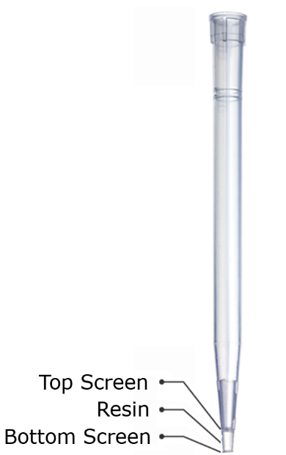
Overview of Final product being produced
The final product is marked as the "Inner" component which includes the attachment of the "top screen". This inner piece is positioned within the "Outer" tip and is inserted after the application of resin. “Phytip columns purifies samples by repeated back-and-forth cycles - a process called dual flow chromatography - allowing complete binding interactions in each purification step for excellent protein purification results.” (Biotage,2024)
The screen acts as a filter, allowing only media between 20-50 microns to pass. Any damage or incorrect welding will result in the failure of its intended function.
Figure 2 - Diagram of Phytip (Biotage,2024)
Example below between a correctly welded tip and a ‘Thin Weld’. Looking for full coverage of the mesh infused within the tube. As can be seen on the ‘thin weld’ around 30% of tip on the left-hand side is very thin, potentially allowing blow out within customer tests.
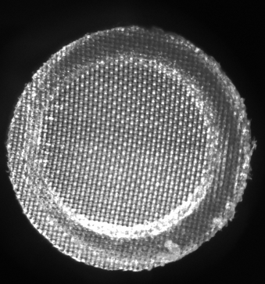
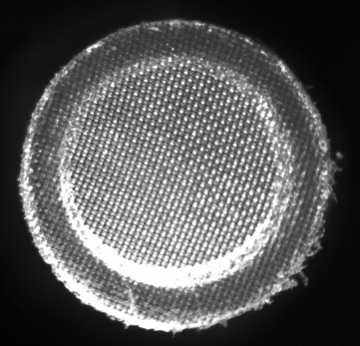

Figure 3 - Thin weld
Figure 4 - Correctly welded tip

Data collection & Analysis
To effectively carry out the improvement plan, it was important to implement a few of the ‘seven basic quality tools’. These tools are known as Ishikawa’s tools (Ishikawa,1976), the 7 Basic QC tools of Quality and have been widely utilized in quality management programs. The 7 tools include;
- Check sheets
- Histograms
- Pareto analysis
- Cause and effect diagrams (C&E)
- Control charts
- Scatter diagrams
- Stratification analysis
(Tague, 2005). This ensured that industrial standard techniques were used to manage the quality by identifying, analysing, and solving quality-related problems.

Basic quality tool 1 – Check sheets
Data had to be collected to identify areas in which the efforts for improvement needed attention. To collect such data, check sheets were chosen for the simplicity and effectiveness. Also proving effective insight into the failure modes to help other tools which were used further in the plan such as pareto analysis.
As Thomas Pyzdek also states “Although they are simple, check sheets are extremely useful process-improvement and problem-solving tools.
Their power is greatly enhanced when they are used in conjunction with other simple tools, such as histograms and Pareto analysis. Ishikawa (1985) estimated that 80% to 90% of all workplace problems could be solved using only the simple quality improvement tools.” (Six sigma handbook,2003)
Table 1 - Check sheet findings of recent batch
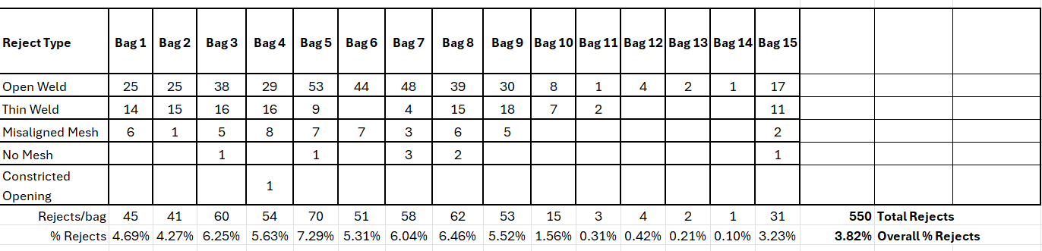
Figure 5 - Failure mode descriptions
Using a structured approach to the check sheets, a recent batch of 15 bags (960 tips per bag) which were produced on the machine, 100% of the batch was inspected and recorded to produce the table as shown above in Table 1.
Key features to identify were;
- Failure modes, 5 in total.
- How many fails within a bag of 960.
- Total rejects per bag & whole batch.

Basic quality tool 2 - Pareto Analysis
After the data collection process, although 5 modes were identified, it was decided that another step needed to be actioned to identify the highest frequency failure modes to concentrate on. Looking through the 7 basic quality tools, the pareto principal rule appeared best fit as the 80/20 rule could apply.
80/20 rule explained by John Oakland, “if the symptoms or causes of defective output or some other ‘effect’ are identified and recorded, it will be possible to determine what percentage can be attributed to any cause, and the probable results will be that the bulk (typically 80 per cent) of the errors, waste or ‘effects’, derive from a few of the causes (typically 20 per cent).” (Total Quality management and operational excellence)
Table 2 - Check sheet with added frequency calculations
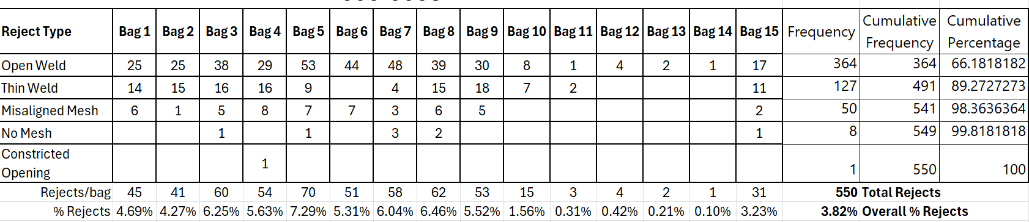
As seen in Table 2, all frequencies were calculated on the existing check sheet allowing this data to be transferred into a pareto analysis chart. Which is shown below in Table 3.
Table 3 - Pareto analysis of failure modes
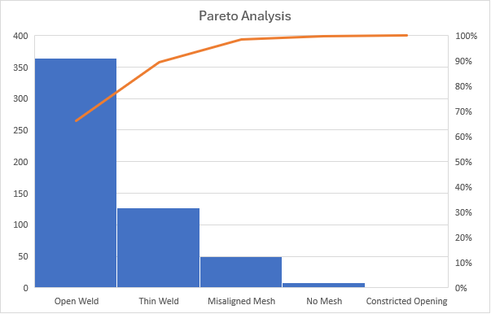
The Pareto graph gives a visual aid to the failures within the batch and therefore is easily identifiable to which failure mode(s) to concentrate efforts upon. As Quality guru Joseph Juran emphasized the concept of the "vital few" versus the "trivial many (Juran 1993).
With efforts focused on the “vital few”, Open weld and thin weld stood out to be the main concentration for this improvement plan going forward. Although thin weld is more than half the amount of fails open weld had, from experience within biotage, open welds tend to form from thin welds.

Basic quality tool 3 – RCA 5 Whys
To allow the team to get to the root cause of the problem seen on the carousel, the 5 whys tool within root cause analysis (RCA) was chosen. Reason for choosing this method is that it allows the underlying problems to be revealed, opening the thought process, and covering avenues the team may not have thought of before the use of such tools. Repeatedly asking "why" until the underlying cause is revealed. “Prevents a team from being satisfied with superficial solutions that won’t fix the problem in the long run” (The lean six sigma pocket tool book)
“Peeling the onion” to get down to root causes and fundamental drivers in order to remove those causes and fix the problem at its core—removing or reducing the waste in the as-is process; the historic/ current process data are the key source of data and insight. (The lean six sigma black belt handbook)
Table 4 - 5 Why Analysis (Biotage Template,2024)
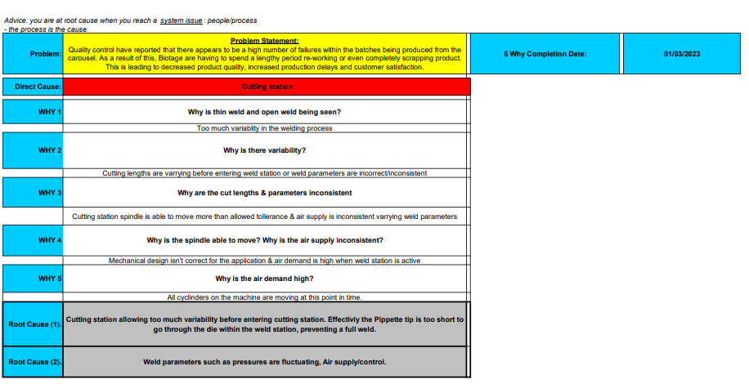
As seen in Table 4, key stakeholders were involved to create the 5 whys analysis to cover all basis of the machine, asking the correct questions needed to get to the root cause of the problem. The root causes that the team came too was the cutting station & Weld station.
Root cause 1: Effectively the cutting lengths are varying too much. With this variance, when the cut length is too short, protrusion through the die isn’t enough, not allowing enough contact with the weld plate, leading to open weld/thin weld.
Root cause 2: Welding parameters are varying from tip to tip, allowing the weld to be complete on one tip, but the next tip have open weld/thin weld.

Improvement Plan
A comprehensive improvement plan has been devised for the Rainin1000 Carousel in line with Biotage's manufacturing objectives. The primary goal of the plan is to enhance product quality and tackle any prevailing issues through the adoption of crucial quality tools. The involvement of all relevant stakeholders guarantees effective implementation, while also ensuring that the improvements are long-lasting. Quality improvement of any significance nearly always involves multiple departments and levels in the organization. (Thomas Pyzdek,2003)
- Root cause analysis
  - Conduct a pareto chart to identify the highest failure modes to concentrate efforts upon.
  - Utilise the 5 why analysis tool to discover root causes within the system.
  - Two root causes identified, cutting station variation & weld parameters.
- Develop corrective actions
  - Adjust welding parameters to optimize weld quality, considering temperature, pressure, and speed. Investigate air consumption.
  - Implement stricter quality control measures during welding operations, including real-time monitoring and inspection.
  - Re-visit mechanical design within station 2, cutting station to eliminate the variation.
  - Enhance equipment maintenance procedures to ensure optimal performance, focusing on calibration and preventive maintenance.
  - Implement preventive maintenance schedules to minimize equipment downtime and prevent potential issues.
- Implement improvement measures
  - Begin implementation within one month of completing RCA.
  - Assign responsibilities for each corrective action
    - Welding parameter & cutting station adjustments: Engineering department.
    - Quality control measures: Quality control department.
    - Preventative maintenance schedules: Maintenance department.
  - Ensure clear communication of changes are recorded and released to all relevant stakeholders.
- Monitor and Evaluate
  - Monitor weld quality metrics and defect rates regularly.
  - Conduct periodic reviews to evaluate the sustained effectiveness of implemented changes.
  - Make further adjustments as needed based on performance metrics and feedback.
- Document and standardise
  - Document all improvement efforts, including root cause analysis, corrective actions, and outcomes.
  - Standardize procedures and best practices to ensure consistency and sustainability.
  - Update documentation as needed to reflect changes and improvements.
- Continuous improvement
  - Foster a culture of continuous improvement by encouraging feedback, collaboration, and innovation.

Prioritisation
- Optimising weld parameters
This opportunity directly addresses the root cause of open welds and thin welds by adjusting weld parameters such as temperature, pressure, and speed.
Feasibility: Relatively feasible as it involves adjustments within the existing welding process.
Cost-effectiveness: Likely cost-effective compared to other solutions, as it mainly requires adjustments to existing equipment and processes.
Potential benefits: Improving weld quality directly leads to a significant reduction or elimination of defects.
- Reducing cutting station variability
Standardising cutting station operations reduces variability, ensuring consistent material quality and alignment for welding, thus reducing defects.
Feasibility: Feasible with process standardisation, and equipment calibration.
Cost-effectiveness: While it may require some investment initially for mechanical parts and calibration, the long-term benefits outweigh the costs.
Potential benefits: Consistent material quality and alignment lead to a reduction in defects, improving overall product quality.

- Enhancing quality control measures
Strengthening quality control measures can catch defects early, preventing defective units from reaching customers.
Feasibility: Feasible with additional inspection points and training for quality assurance personnel.
Cost-effectiveness: While it may require some investment in training and inspection equipment, it helps prevent costly rework and warranty claims.
Potential benefits: Early detection of defects reduces scrap, rework, and warranty costs, contributing to overall cost savings.

Performance Indicators (KPIs)
KPIs - They are the keyways by which that item is measured and are usually used to set performance standards and continuous improvement objectives. (The lean six sigma black belt handbook)
Although implementing the improvement plan is a great addition, tracking the performance of this improvement plan is just as important. This will allow analysis of the current performance vs the future performance of the carousel. This will allow all stakeholders to monitor performance and see whether the improvement plan was successful.
Key performance indicators being
- Focus on percentage of open welds and thin welds detected per batch or production run.
- Number of defective tips identified during quality control inspections.
- Consistency of dimensions at the cutting station.
With these KPIs in mind, further quality tools could be implemented to further monitor progressions such as Statistical process control (SPC), scatter diagrams & machine capability study. These quality controls will give an insight to the machine’s capability live if implemented correctly.

Anticipated Barriers and Challenges
Before all improvement initiatives begin, all potential barriers and challenges are to be considered. By proactively identifying potential barriers and implementing strategies to mitigate them, we can enhance the likelihood of successful implementation and achieve the desired outcomes of improving weld quality on the Biotage Rainin1000 Carousel.
One potential challenge that may be encountered during improvement initiatives is limited resources. As the project progresses, it may exceed the designated budget or face a shortage of manpower, making it difficult to complete certain tasks. To overcome this issue, it is important to prioritize the initiatives before implementing them. This allows the organization to assess the feasibility of each improvement in the plan, ensuring that high-impact, low-cost initiatives are focused on initially. Additionally, utilizing cross-functional teams can help address potential manpower shortages.
Another potential challenge the organization may face is the need for specialized knowledge or expertise to optimize welding parameters or address equipment maintenance issues that are not readily available within the organization.

Conclusions
In conclusion, this report details an improvement plan designed to tackle the high occurrence of failures within the Biotage Rainin1000 Carousel's production of Phytip columns. Through the systematic utilization of basic quality tools including Check Sheets, Pareto Analysis, and 5 Whys, we identified root causes such as cutting station variability and welding parameter issues.
The improvement plan focuses on optimizing weld parameters, enhancing quality control measures, and improving equipment maintenance procedures. Key performance indicators (KPIs) have been identified to monitor progress, ensuring continuous evaluation and adjustment.
Despite potential challenges such as resource constraints and the need for specialised knowledge, mitigation strategies have been proposed to overcome these obstacles. The plan emphasizes a proactive and collaborative approach to drive significant improvements in weld quality, production efficiency, and customer satisfaction.
By implementing these measures and fostering a culture of continuous improvement, we are poised to achieve our objectives and enhance the overall performance of the Biotage Rainin1000 Carousel.

References
- Oakland, J. S. (2014). Total quality management and operational excellence : text with cases (4th ed.). Routledge.
- Voehl, F. (2014) The lean six sigma black belt handbook : tools and methods for process acceleration. 1st edition. Boca Raton: CRC Press.
Available at: https://doi.org/10.1201/b15163.
- Ishikawa, K. (1976). Guide to Quality Control. Tokyo: Asian Productivity Organization.
- Juran, J. M. (1993). Juran on Quality by Design: The New Steps for Planning Quality into Goods and Services.
New York: The free press.
- Vanzant, ST 2019, Leaner Six Sigma : Making Lean Six Sigma Easier and Adaptable to Current Workplaces, Productivity Press, Oxford.
Available from: ProQuest Ebook Central. [17 March 2024].
- George, D.R, M.P, J.M (2005) The lean six sigma pocket tool book.
New York: McGraw-Hill Education
- Pyzdek, T. (2003) The Six Sigma Handbook: A complete guide for green belts, black belts, and managers at all levels.
New York: McGraw-Hill Education
- Biotage (2024) 5 whys Analysis
Internal Templates. Unpublished.
- Biotage, 2024. Normal Phase Phytip Columns. [Online]
Available at: Normal phase PhyTip columns for mass spectrometry desalting (biotage.com)
[Accessed 17 March 2024]
- Automatic root cause analysis in manufacturing. [online]
Available at: Automatic root cause analysis in manufacturing: an overview & conceptualization | Journal of Intelligent Manufacturing (uwtsd.ac.uk)
[Accessed 17 March 2024]

